PACIFIC REGION CCG VESSEL -POST CRUISE REPORT

NAME OF SHIP/PLATFORM: John P Tully

DATE: FROM: 30 May 2007 TO: 19 June 2007

SCIENCE CRUISE NUMBER: 2007-13 SHIP’S PATROL NUMBER: 07-03

CHIEF SCIENTIST[S]: Marie Robert

SCIENTIFIC PERSONNEL:

Female | Male
Janet Barwell-Clarke | Patrick A’Hearn (NOAA-PMEL)
Reyna Jenkyns (UVic) | Doug Anderson
Maria Kavanaugh (OSU) | Michael Arychuk
Martine Lizotte (U Laval) | Kevin Bartlett (UVic)
Anissa Merzouk (UBC) | Michael Bentley (CWS)
Marie Robert | Steve Emerson (UW)
Shani Rousseau (UVic) | Eric Kunze (UVic)
Sarah-Jeanne Royer (U Laval) | Chris MacKay (UVic)
 | David Zimmerman (NOAA-PMEL)

AREAS OF OPERATION: North East Pacific.

CRUISE TRACK:
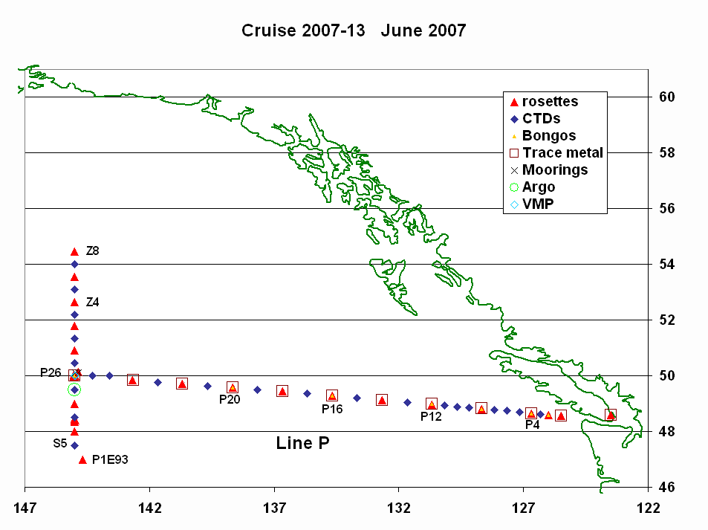
INTRODUCTION/PROGRAM BACKGROUND: Line P is a long standing program which surveys a 1400 km long section 3 times annually. Data have been collected along this line since 1956 and shows evidence of the impact of climate variability on ocean productivity. It is the only Canadian long time-series that allows scientists to monitor climate changes in the Pacific Ocean. It is also the best opportunity for other programs (e.g. Universities) to do research in the Pacific since the Line P data give them background as well as current water properties. In addition, it is the best occasion for other projects (e.g. CWS) to access offshore waters.

CRUISE OBJECTIVE/OBJECTIVES: Repeat hydrography sections, deploy 2 moorings, and deploy an Argo float.

DAYS ALLOCATED: 21 DAYS OF OPERATION: 19

DAYS LOST DUE TO WEATHER: ~ 1.5 days. No station cancelled.

RESULTS:

- The Line P survey was successful. No casts were cancelled due to weather.
- A good portion of Line Z was surveyed, which will greatly help the following cruise (2007-14).
- Two moorings were deployed (see Science section).
- The samples collected include:
- Underway: T, S, fluorescence, pCO₂, acoustic sounder, ADCP, size fractioned pigment analysis, pulse-amplitude modulated (PAM) fluorometry (to quantify the electron transport rate and approximate photosynthesis) and continuous measurements of surface adsorption and light attenuation with a Wetlabs AC-S, water vapour, N₂, O₂, Ar, CO₂, DMS.
- Discrete (casts): T, S, fluorescence, oxygen, transmissivity, irradiance.
- Water: oxygen, salinity, nutrients, chlorophyll, HPLC, DIC, Alk, C13, DMS, DMSP, ONAR (Oxygen, Nitrogen, ARgon), Iron, Bacterial genomic.
- Zooplankton using vertical net hauls.
M. Robert: Temperature, Salinity and Sigma-t data

The surface waters along Line P were colder than usual along the whole line, with anomalies ranging between 1 and 2 °C. They were also slightly fresher.

Eric Kunze: Vertical Microstructure Profiling - ZOOM JUN 2007

The Vertical Microstructure Profiler (VMP) is a tethered freefall instrument for collecting fine- and microscale (turbulence) measurements as a function of depth in the upper ~1000 m of the ocean. Sensors include Seabird temperature, conductivity and pressure as well as microscale shear, an FP07 thermistor and a micro-conductivity cell. Our principal goal was to determine whether we could detect a turbulence signal associated with vertical migration of the acoustic backscatter layer. To this end, we collected 6 2-3 h long time-series, 3 at dawn and 3 at dusk. Measurements were confined to the upper 400 m of the water column and more often less (150-200 m) to reduce the time between consecutive casts. A total of 62 profiles were collected in order to obtain sufficient statistics to distinguish biologically generated turbulence from internal wave shear-driven turbulence. Four time-series were at Ocean Station Papa. The remaining 2 were conducted at stations to the south of Papa due to weather. Each time-series was preceded and followed by a CTD cast to collect nitrate samples by UVic Masters student Shani Rousseau. The instrument performed well with dissipation rate noise levels of O(10^{–10} W/kg). The winch and linepuller were able to operate effectively in 30-knot winds (though not a fully developed sea) despite the height of the block on the Tully’s A frame. Chris MacKay thought he could operate in higher winds with a tighter spring in the linepuller. Shear probe M303 was swapped out for M300 after the third time-series because it was showing intermittent signs of much higher noise levels.
The bridge and deck crew were very professional, skillful and helpful in maintaining ship underway, deploying and recovering the instrument, and assisting in level winding the cable onto the winch during recovery.
Steve Emerson: Carbon Cycles in the North Pacific—Progress Report for Tully Cruise 2007-13

Non-IOS Scientists/Engineers involved in this project on this cruise:
Steven Emerson, University of Washington
David Zimmerman, NOAA-PMEL
Patrick A’Hearn, NOAA-PMEL
Maria Kavanaugh, Oregon State University

The North Pacific Carbon Cycle Science Program is a U.S. - Canadian collaboration involving scientists at the University of Washington and NOAA’s Pacific Marine Environmental Laboratory (PMEL) in Seattle, Oregon State University in Corvallis and the Institute of Ocean Sciences (IOS) in Sidney, B.C.. The goals of the project are to understand the processes controlling the flux of carbon between the atmosphere and ocean in the North Pacific.
The North Pacific Carbon Cycle Program includes a mooring deployment at Ocean Station Papa (Stn. P) and ship-board measurements in the vicinity. This program is a collaboration between Canadian and U.S. oceanographers and will occur during the three annual station P cruises carried out by IOS. The present cruise (CCGS Tully 2007-13) marked the beginning of a two year endeavor to maintain subsurface and surface moorings in the immediate vicinity of Stn P and determine chemical and biological parameters in the local waters. In the week of June 5 two moorings were successfully deployed about 5 km to the northeast of Stn. P. The subsurface mooring consists of an upward-looking Acoustic Doppler Current Profiler (ADCP) and an acoustic “rain gage” at about 140 meters depth. The surface mooring includes a meteorological package on the surface buoy, instruments in and immediately below the buoy to determine hourly variations in surface water T, S, pCO₂, pH, O₂ and N₂ gas. Sensors also populate the upper 150 meters of the mooring wire to determine T, S, O₂, N₂ and currents in the upper ocean.
The ship-board program that accompanied the mooring deployment consisted of sampling surface waters to determine the concentrations of O₂, N₂, dissolved inorganic carbon (DIC) and alkalinity (Alk). Each of these measurements is designed to calibrate analyses by in situ sensors on the mooring (pH can be calculated from DIC and Alk). The biological component of this research investigated variability in the surface phytoplankton community at and around Stn. P. The ship’s continuous-flow surface-seawater system was sampled for size fractioned pigment analysis, pulse-amplitude modulated (PAM) fluorometry (to quantify the electron transport rate and approximate photosynthesis) and continuous measurements of surface adsorption and light attenuation with a Wetlabs AC-S. The effects of photo-acclimation through the day and phytoplankton community structure on primary production were studied with the first two of these analyses. Data from the AC-S measurement will be compared with MODIS ocean color-derived products and discrete HPLC samples to ground-truth the satellite data.

The purpose of the mooring chemical and biological measurements is to monitor reactions that lead to export of organic and inorganic carbon from the surface ocean. Oxygen and nitrogen measurements can be used to determine the net biological oxygen production, which is proportional to organic carbon export. pCO₂ and pH changes indicate the formation of calcium carbonate (CaCO₃) shells of microscopic algae that are known to exist in abundance in this location of the ocean. These two processes dominate the biological component of the marine carbon cycle and have never before been monitored together in a time series program.

We greatly appreciate the hard work and skill of Tully crew for their ability to perform difficult mooring-deployment tasks in the unruly seas of the North Pacific. We are also grateful for the excellent work of the oceanographers on the Station P Program staff at IOS. Special thanks goes to Chief Scientist Marie Robert for her skill in organizing and carrying out these cruises.

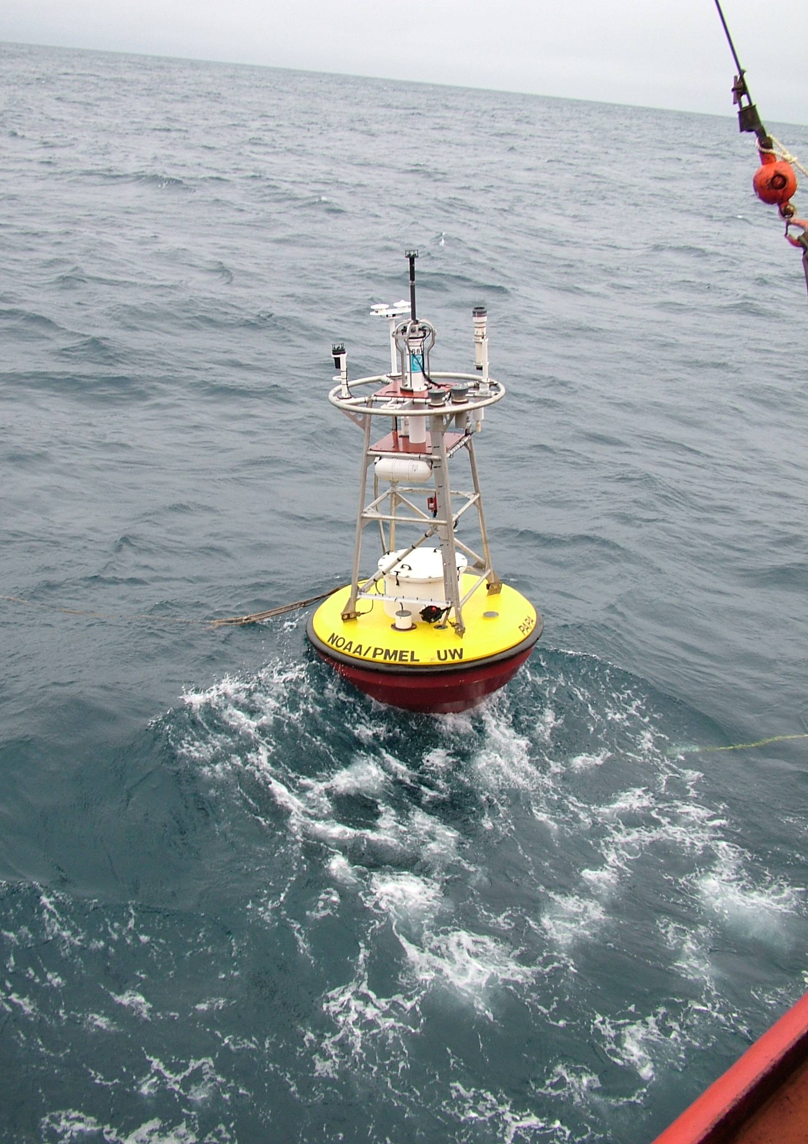

The new Station P surface mooring immediately after deployment

Sarah-Jeanne Royer: DMSP and DMS bacterial rate processes and genomics - Line P Cruise Report (2007-13)

Team members: Martine Lizotte and Sarah-Jeanne Royer

Dimethysulfide (DMS) is the most important biogenic sulfur compound emitted from the ocean to the atmosphere. DMS is responsible for the formation of cloud condensation nuclei which scatter solar radiation and participate in the cooling of the atmosphere. Bacteria are thought to be responsible for most of the production of DMS by their consumption of dimethylsulfoniopropionate (DMSP) a compound produced by marine phytoplankton. Many oceanic regions such as the North-East Subarctic Pacific are well known as High Nutrients Low Chlorophyll (HNLC) where iron limits the growth of phytoplankton. The coastal to oceanic iron gradient found on Line P is thought to have an influence on the functional groups (bacteria and phytoplankton) that produce DMS.

Over 750 samples of DMSP pools (total, particulate and dissolved), DMSP rates (using radioisotope ³⁵S), phytoplankton and bacteria (identification, enumeration and molecular probing using Card-FISH and Micro-FISH) as well as iron were sampled from trace metal clean 10 litres Go-Flo bottles and 12 litres Niskin-X bottles. Incubations for the determination of DMS(P) production and consumption were undertaken using seawater from the mixed layer (ca. 10m) at stations P1, P4, P8, P12, P14, P16, P18, P20, P22, P24, P26. Incubations lasted a maximum of 36 hours. Water sampling as well as laboratory manipulations ran smoothly for the entire length of the cruise. The only difficulty we encountered occurred towards the end of the cruise when an electrical problem on the portable scintillation counter prevented us from analysing the last of the wipe tests for radioactivity. Based on satisfactory wipe tests from the previous cruise (LaPerouse 2007-12) as well as a thorough cleaning of the work area the decision to analyse the wipe tests upon our return to IOS was taken and approved by the resident ROS Janet Barwell-Clarke. Analysis of bacteria, phytoplankton, molecular samples and DMSP concentrations will be done at Laval University in Quebec City. Radioisotope samples (along with wipe tests) will be processed and analysed on the scintillation counter upon our return to IOS. Overall, data collected during Line P contains pertinent information on DMS(P) pathways and bacterial community consumption of DMSP that will help elucidate questions concerning the effect of iron on DMS production.

We wish to acknowledge and give special thanks to Marie Robert without whom our participation in this project would not have been possible. For their help and patience we wish to express our sincere gratitude to Janet Barwell-Clarke, Mike Arychuk and Keith Johnson. Thanks are also given to Melanie Quenneville, Anissa Merzouk and Philippe Tortell for their collaboration. And last but not least, thanks to the captain and crew of the John P. Tully for their assistance.

On behalf of Dr. Levasseur and the Laval University team, a big MERCI!
Martine Lizotte and Sarah-Jeanne Royer

Radioisotope Use:

Some work was done with radioisotopes (³H-thymidine) by the UBC personnel, and by the Université Laval personnel (³⁵S DMSP). The lab was cleaned and decommissioned as soon as their work was completed. Measurements on background radioactivity were made using a hand-held Geiger counter and all readings were satisfactory. The scintillation counter could not be used to measure the wipe-tests because of an electrical problem with the machine. The wipe-tests will be measured once back at IOS. Copies of the decommission lab report and other related paperwork were handed to the first officer on board the Tully as well as to the IOS RSO.

PROBLEMS [SCIENTIFIC GEAR AND OPERATIONS]:

The Portasal could not be used on board because it was very unstable again. It will be interesting, after the swap between the actual ship’s office and the data room, to see if it is really movement and temperature that are causing the problems of if the Portasal is really not working.

We lost communication between the computer and the rosette during a few casts. In all these instances we had to reboot the computer since only exiting the software was not enough to solve the problem. It is important to determine why this happened.

SUCCESSES [SCIENTIFIC]:

Last February one of the science tables in the lab collapsed. Following this incident the Water Properties Group ordered new metal tables. One of these was delivered just on time to be used during the cruise. It is really stable and solid, and with the sheet of plywood on top it makes it easy to lash things on it. These tables were a good choice.

We had many teams from outside of British Columbia on this cruise: 2 people from Université Laval in Québec, one person from Oregon State University in Corvallis, and 3 people from University of Washington and PMEL/NOAA in Seattle. Despite the distance, the planning and preparation of the cruise went really good. Thanks to everyone for starting the preparations months in advance so that no last minute surprises were encountered.

PROBLEMS [SHIP’S EQUIPMENT/OPERATIONS/PLATFORM SUITABILITY]:

The Science1 to Science8 email accounts were used by some of the science crew, but only one seemed to be receiving email. For most of them the outgoing email was not a problem, but no incoming email was received.

We are looking at buying a -80°C freezer in order to store some samples. The original plan, approved by the Science Vessel User’s Committee, was to put the freezer permanently in the Hydrographic Chart Room on the Tully. Because of the width of the doors, the only place where the freezer would fit is in the main lab (only room with double-door). The new location will have to be discussed at the next SVUC meeting in August. The new suggested location will be to the right of the UPS, where the actual phone panel is situated.

SUCCESSES [SHIP]:

Special thanks to the galley crew for dealing so well with so many scientists. Thanks also for a wonderful barbecue.

DELAYS [OTHER THAN WEATHER]:

1 day lost to fuelling

SAFETY CONCERNS:

None.

HAZARDOUS OCCURRENCES:

None.

EVENT LOG:

DATE OPERATIONS

Tuesday 29 May: Start loading at IOS.
Wednesday 30 May: Saanich Inlet cast. Leave Pat Bay. Anchor off Esquimalt.
Thursday 31 May: Fuel in Esquimalt. Leave around 1600.
Friday 1 Jun: Start Line P.
Wednesday 6 Jun: Arrive Station P. Deploy NOAA ADCP mooring. First Kunze cast.
Thursday 7 Jun: Deploy NOAA surface mooring.
Saturday 9 Jun: Leave Papa, heading south to P1E93.
Monday 11 Jun: Last Kunze cast.
Thursday 14 Jun: Leave Line Z. Start heading towards Prince Rupert.
Sunday 17 Jun: Arrive at Prince Rupert.
Tuesday 19 Jun: Crew change Prince Rupert.

SUMMARY/FINAL COMMENTS:

- Many thanks to the whole crew of the Tully for all their help in making this cruise such a success.

