EXPEDITION PLAN AND ITINERARY

DEPARTMENT: DFO, Ocean Sciences and Productivity Division

MISSION NO: 2007-13 CCG PATROL NO: 07-03

MISSION AREA: Line P, Station Papa, Line Z

MISSION OBJECTIVE: Repeat hydrography section, deploy moorings, deploy Argo float.

SHIP: John P. Tully

DATE, FROM: 29 May 2007 (Pat Bay) TO: 19 June 2007 (Prince-Rupert)

SENIOR SCIENTIST: Marie Robert

SCIENTIFIC PERSONNEL: 17 berths required (** stay on for Line Z cruise.
All the others leave in Prince-Rupert).
Female | Male
Janet Barwell-Clarke (IOS) | Doug Anderson (IOS)
Marie Robert (IOS) ** | Michael Arychuk (IOS)
Shani Rousseau (UVic) | Michael Bentley (CWS) **
Reyna Jenkyns (UVic) | Kevin Bartlett (UVic)
Maria Kavanaugh ((OSU) | Eric Kunze (UVic)
Martine Lizotte (U. Laval) | Chris Mackay (UVic)
Anissa Merzouk (UBC) | Steve Emerson (UW)
Sarah-Jeanne Royer (U. Laval) | Patrick A’Hearn (NOAA)
 | David Zimmerman (NOAA)

SHIP EQUIPMENT REQUIRED: depth sounder, sea water supply to lab and heli-deck, heave compensator, tugger winch, crane.

DECK MACHINERY REQUIRED:

Note: The details are on the deck plan, at the end.

OTHER EQUIPMENT TO BE LOADED: Scientific gear (lab instruments, sampling equipment, etc.). Container to be loaded Tuesday May 29 first thing in the morning.

ANTICIPATED LOADING TIME: One day. Most winches and rosettes/CTD equipment will already be there from the prior cruise (La Perouse). Container, UVic winch and mooring gear to be loaded on May 29.

DANGEROUS CHEMICALS:
[INCLUDING MATERIAL SAFETY DATA SHEETS AND WHMIS LABELS]
Separate list to follow, to be handed to the Chief Officer before departure.
Radioisotopes will be used.

Station List:

Station | Latitude  deg min N |  | Longitude  deg min W |  | Bottom Depth m |  | Sampling
Saanich Inlet
SI03 | 48 35.60 |  | 123 30.00 |  | 220 |  | Rosette B-10
Underway sampling survey
JF1 | 48 16.00 |  | 123 30.00 |  | 150 |  | under way
JF2 | 48 18.00 |  | 124 00.00 |  | 180 |  | under way
JF3 | 48 27.00 |  | 124 30.00 |  | 230 |  | under way
JF4 | 48 32.30 |  | 125 00.00 |  | 60 |  | under way
Line P CTD and water sampling survey
P1 |  | 48 34.5 |  | 125 30.0 |  | 120 |  | CTD B-10
P2 |  | 48 36.0 |  | 126 00.0 |  | 114 |  | Rosette B-10, Bongo
P3 |  | 48 37.5 |  | 126 20.0 |  | 730 |  | CTD B-10
P4 |  | 48 39.0 |  | 126 40.0 |  | 1300 |  | Rosette B-10, Bongo,  Go-flos
P5 |  | 48 41.5 |  | 127 10.0 |  | 2100 |  | CTD 2000 m
P6 |  | 48 44.6 |  | 127 40.0 |  | 2500 |  | CTD 2000 m
P7 |  | 48 46.6 |  | 128 10.0 |  | 2450 |  | CTD 2000 m
P8 |  | 48 49.0 |  | 128 40.0 |  | 2440 |  | Rosette 2000 m, Bongo
P9 |  | 48 51.4 |  | 129 10.0 |  | 2340 |  | CTD 2000 m
P10 |  | 48 53.6 |  | 129 40.0 |  | 2660 |  | CTD 2000 m
P11 |  | 48 56.0 |  | 130 10.0 |  | 2700 |  | CTD 2000 m
P12 |  | 48 58.2 |  | 130 40.0 |  | 3300 |  | Rosette B-10, Bongo,  Go-flos
P13 |  | 49 02.6 |  | 131 40.0 |  | 2875 |  | CTD 2000 m
P14 |  | 49 07.4 |  | 132 40.0 |  | 3275 |  | CTD 2000 m
P15 |  | 49 12.0 |  | 133 40.0 |  | 3200 |  | CTD 2000 m
P16 |  | 49 17.0 |  | 134 40.0 |  | 3550 |  | Rosette B-10, Bongo,  Go-flos
P17 |  | 49 21.0 |  | 135 40.0 |  | 3200 |  | CTD 2000 m
P18 |  | 49 26.0 |  | 136 40.0 |  | 3775 |  | CTD 2000 m
P19 |  | 49 30.0 |  | 137 40.0 |  | 3850 |  | CTD 2000 m
P20 |  | 49 34.0 |  | 138 40.0 |  | 3890 |  | Rosette B-10, Bongo,  Go-flos
P21 |  | 49 38.0 |  | 139 40.0 |  | 3840 |  | CTD 2000 m
P22 |  | 49 42.0 |  | 140 40.0 |  | 3880 |  | CTD 2000 m
P23 |  | 49 46.0 |  | 141 40.0 |  | 3970 |  | CTD 2000 m
P24 |  | 49 50.2 |  | 142 40.0 |  | 3910 |  | CTD 2000 m
P25 |  | 50 00.0 |  | 143 36.3 |  | 3890 |  | CTD 2000 m
P35 |  | 50 00.0 |  | 144 18.2 |  | 4170 |  | CTD 2000 m
P26 |  | 50 00.0 |  | 145 00.0 |  | 4250 |  | Rosette B-10, Bongo,  Go-flos, Argo, moorings
P1E93 |  | 47 00.0 |  | 144 40.20 |  | 4685 |  | Rosette
S5 |  | 47 30.0 |  | 145 00.0 |  | ? |  | CTD
S4 |  | 48 00.0 |  | 145 00.0 |  | ? |  | Rosette
S3 |  | 48 30.0 |  | 145 00.0 |  | ? |  | CTD
S2 |  | 49 00.0 |  | 145 00.0 |  | ? |  | Rosette
S1 |  | 49 30.0 |  | 145 00.0 |  | ? |  | CTD
P41 |  | 50 27.0 |  | 145 00.0 |  | 4268 |  | CTD
P32 |  | 50 54.0 |  | 145 00.0 |  | 4267 |  | Rosette
Z1 |  | 51 21.00 |  | 145 00.00 |  | 4175 |  | CTD
Z2 |  | 51 47.50 |  | 145 00.00 |  | 3850 |  | Rosette
Z3 |  | 52 12.00 |  | 145 00.00 |  | 4090 |  | CTD
Z4 |  | 52 39.00 |  | 145 00.00 |  | 4073 |  | Rosette
Z5 |  | 53 06.00 |  | 145 00.00 |  | 4095 |  | CTD
Z6 |  | 53 33.00 |  | 145 00.00 |  | 4067 |  | Rosette
Z7 |  | 54 00.00 |  | 145 00.00 |  | 4039 |  | CTD
Z8 |  | 54 27.00 |  | 145 00.00 |  | 4123 |  | Rosette
Z9 |  | 55 00.00 |  | 145 00.00 |  | 4106 |  | CTD
Z10 |  | 55 30.00 |  | 145 00.00 |  | 4007 |  | Rosette
Z11 |  | 56 00.00 |  | 145 00.00 |  | 3902 |  | CTD
Z12 |  | 56 30.00 |  | 145 00.00 |  | 3859 |  | Rosette
Z13 |  | 57 00.00 |  | 145 00.00 |  | 3839 |  | CTD
Z14 |  | 57 30.00 |  | 145 00.00 |  | 3962 |  | Rosette
Z15 |  | 58 00.00 |  | 145 00.00 |  | 3874 |  | CTD,
Z16 |  | 58 30.00 |  | 145 00.00 |  | 3989 |  | Rosette
Z17 |  | 58 50.00 |  | 145 00.00 |  | 3905 |  | CTD
Z18 |  | 59 10.00 |  | 145 00.00 |  | 4071 |  | Rosette
Z19 |  | 59 30.00 |  | 145 00.00 |  | 1010 |  | CTD
Z20 |  | 59 50.00 |  | 145 00.00 |  | 140 |  | Rosette
Z21 |  | 60 05.00 |  | 145 00.00 |  | 172 |  | CTD

Note: We will not have the time to do all the Line Z stations. What cannot be done during this cruise will be completed during the following cruise, 2007-14, from June 19 to July 3 2007.

Itinerary

May 29 Load at IOS all day
May 30 Do Saanich Inlet cast. Depart to P1 when sampling completed.
June 6 Arrive at Station Papa.
Deploy moorings and do dawn/dusk experiment for 3 days.
When time permits during day or night, sail to S stations.
June 9 After dusk experiment: leave Station P to complete Line S or start Line Z.
June 15 Start heading to Prince Rupert.
June 19 Crew change in Prince Rupert..

Cruise track
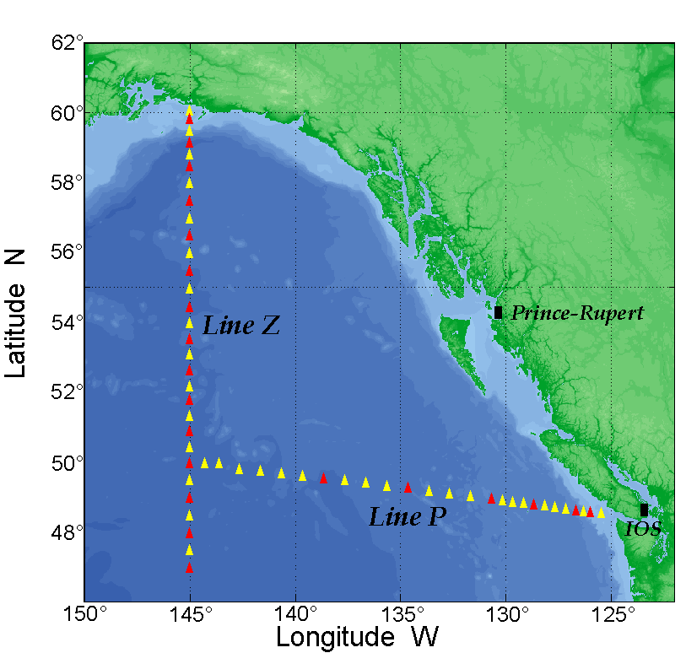

CCGS John P. Tully
Deck Lay Out: M. Robert,
Station P Cruise
Cruise ID: 2007-13 – 2007-14
Date: May 29 – July 3, 2007
A: | Not Required
B: | Hydro Winch 310 #1082 c/w 4730m X 5/32” X 3x19 wire
C: | Work Winch 331 #1231 c/w 2395m X ½” X 3x19 Drag Wire
D: | Work Winch 589 #515c/w  2910 m X 5x16” X 3x19 wire
E: | CTD Winch #17027c/w 5800m  X .322” X 3cdr cable
F: | CTD Winch #17026 c/w 3280m  X .322” X 7cdr cable
G: | Not Required
H: | Not Required
I: | U-Vic MVP winch
J: | Not Required
K: | Capstan Required
L: | Heave Compensator Required
Crane |  | Required
Aft A-Frame |  | Required
Stbd. A-Frame |  | Not Required
20' Container |  | Required
Comments:
- NOAA PMEL Surface Flux mooring will require a 12m^2 deck area pre-deployment and may use the Capstan.
- Please also load, 2 Osco 20” CTD blocks, and an Omron counter for each winch.
- The Heave Compensator and Tully Tugger operational c/w spares are required. (Ship's Engineers, please)
- Trace-Metal sheave and rollers needed for breeze-way hydro winch 310 #1082

