PACIFIC REGION CCG VESSEL CRUISE PLAN

DEPARTMENTS: Fisheries and Oceans, Canada

SCIENCE CRUISE NUMBER: IOS2007-12

NAME OF SHIP/PLATFORM: John P Tully

SURVEY AREA/AREA OF OPERATION: West coast of Vancouver Island

CRUISE OBJECTIVE[S]:

- Biological/physical/chemical oceanography time series, west coast Vancouver Island
- Further testing of new profiling echosounder in conjunction with the MultiNet

DATE: FROM: 22 May 2007
TO: 29 May 2007

SENIOR SCIENTIST[S]/CONTACT TEL. #’S:

Doug Yelland, tel 363-6321, e-mail: yellandd@pac.dfo-mpo.gc.ca

SCIENTIFIC PERSONNEL: BERTHS REQUIRED: 15

MALE [NAMES] |  | FEMALE[NAMES]
Doug Yelland (IOS) |  | Marie Robert (IOS)
John Dower (UVic) |  | Wendy Richardson (IOS)
Stephen Romaine (IOS) |  | Sheila Sloman nee Toews(IOS)
Nick Hall-Patch (IOS) |  | Deborah Faust (IOS)
Akash Sastri (UVic) |  | Kelly Young (UVic)
Gerald Rohatensky (CCG) |  | Valeria Willers (UVic)
 |  | Sarah-Jeanne Royer (U.Laval)
 |  | Martine Lizotte (U. Laval)
 |  | Anissa Merzouk (UBC)

SHIP EQUIPMENT REQUIRED:
- depth sounders
- heave compensator, tugger winch, and main aft A-frame
- aft deck crane for loading/unloading
- capstan
- seawater sampling pump(s)

DECK MACHINERY REQUIRED: See attached deck plan [same as DECK PLAN for cruise 2007-xx-Thomson/Juhasz]
CTD/BIONESS winches (2, #s 17026 & 17027), aft deck
Hydro winch 310 #1082, stbd chains
Net tow/Work Winch 589 #515

OTHER EQUIPMENT TO BE LOADED:
scientific equipment into lab, chart room

SPECIAL REQUIREMENTS:

- seawater supply to lab at a minimum flow rate of 20 L per min

DANGEROUS CHEMICALS: (possibly more details to follow)
[INCLUDING MATERIAL SAFETY DATA SHEETS AND WHMIS LABELS]
Separate list to follow, to be handed to the Chief Officer before departure.

ANTICIPATED LOADING TIME:
1/2 day. We will be staging for both this cruise and Line P (IOS2007-13) survey.

LOGISTICS:

LOAD VANS AND TRUCKS: May 18, 2007 (Friday)
COMMENCE LOADING TULLY [DATE/TIME]: Tuesday 22 May 2007
SAILING [DATE/TIME]: afternoon/evening of 22 May
EXPECTED OPERATIONS PROFILE: 24 h per day
RETURNING [DATE/TIME]: 29 May, 2007
OFFLOADING: [DATE/TIME]: at IOS 29 May, 2007

DATE GENERAL AREA OF OPERATIONS
[LINES/MOORINGS/STATIONS]
22 May- test cast in Saanich Inlet upon departure, then transit to Cape Scott line, inshore end (likely via inside passage, dependant on weather forcast)
23-28 May– standard WCVI lines off Cape Scott, Estevan Point, Barkley Sound, and Brooks Peninsula (LC, LD, LG, BP) plus additional off-line Vancouver Island plankton sampling stations. Order of lines will depend on weather conditions. Additional work on outer station at each line, testing new profiling echosounder and MultiNet
29 May - return to IOS for offloading of some scientific gear and loading remainder of Line P equipment
PROPOSED CRUISE
ITINERARY:

N.B.: ALSO ATTACH LIST OF
STATIONS, MOORING
OPERATIONS, OR SURVEY
LINES IDENTIFYING EXACT
POSITIONS.
Station List (stations may be added or deleted, depending on conditions, and operations at each station may not be as indicated)

Southern Vancouver Island PLANKTON STATIONS:
A1 (=LC8) 48 29.45 126 07.1 200 CTD/Bongo
A2 48 22.7 126 03.8 400 CTD/Bongo
A3 (~LC9) 48 24.7 126 15.8 900 CTD/Bongo
A4 (=LC12) 48 15.0 126 40.0 >1000 CTD/Bongo
B3 48 51.08 125 39.2 45 CTD/Bongo
B5 (~LC5) 48 40.6 125 46.25 90 CTD/Bongo
B6 (=LC6) 48 36.46 125 54.0 95 CTD/Bongo
B7 (=LCB4) 48 32.0 125 35.5 76 CTD/Bongo
B8 (=LCB3) 48 34.5 125 30.0 120 CTD/Bongo
C1 48 28.93 125 15.3 150 CTD/Bongo
C2 (=LBA2) 48 25.4 125 07.8 115 CTD/Bongo
C3 (=LBA3) 48 23.45 125 20.8 120 CTD/Bongo
E1 (=LBA1) 48 31.7 125 03.8 100 CTD/Bongo
____________________________________________________________________________________
B-LINE
LB1 48 40.40 124 59.48 30 CTD/DO2
LB2 48 39.00 125 02.40 55 CTD/DO2
LB3 48 37.32 125 05.58 92 CTD
LB4 48 35.67 125 08.72 105 CTD/DO2
LB5 48 34.00 125 12.00 95 CTD
LB6 48 32.18 125 15.51 110 CTD/DO2
LB7 48 28.68 125 22.10 152 CTD
LB8 48 25.30 125 28.65 145 CTD/DO2
LB9 48 22.0 125 34.8 135 CTD/DO2
LB10 48 18.57 125 41.35 150 CTD
LB11 48 15.2 125 47.75 200 CTD/DO2
LB12 48 12.92 125 51.9 510 CTD/DO2
LB13 48 10.6 125 56.12 810 CTD
LB14 48 08.48 126 00.0 1180 CTD/DO2
LB15 48 04.36 126 08.46 1450 CTD
LB16 48 00.53 126 17.00 1530 CTD
____________________________________________________________________________________
C-LINE
LC1 48 50.44 125 27.73 90 CTD/DO2
LC2 48 48.68 125 30.95 105 CTD/DO2
LC3 48 46.95 125 34.24 130 CTD
LC4 48 43.43 125 40.8 162 CTD/DO2
LC5/B5 48 39.94 125 47.4 90 CTD/Bongo
LC6/B6 48 36.46 125 54.0 95 CTD/Bongo
LC7 48 32.96 126 00.5 125 CTD/DO2
LC8/A1 48 29.45 126 07.1 197 CTD/DO2/Bongo
LC9/A3 48 25.94 126 13.7 660 CTD/DO2/Bongo
LC10 48 22.4 126 20.2 1150 CTD
LC11 48 18.95 126 26.7 1470 CTD/DO2
LC12/A4 48 15.0 126 40.0 ? CTD/Bongo

D-LINE
LD1 49 0.1 125 43.8 33 CTD/DO2
LD2 48 58.35 125 47.05 42 CTD/DO2/Bongo
LD3 48 56.61 125 50.4 46 CTD
LD4 48 53.16 125 57.0 62 CTD/DO2/Bongo
LD5 48 49.65 126 3.6 91 CTD
LD6 48 46.18 126 10.2 137 CTD
LD7 48 42.67 126 16.8 520 CTD/DO2
LD8 48 39.17 126 23.4 768 CTD/
LD9 48 35.69 126 30.0 999 CTD/DO2/Bongo
LD10 48 32.2 126 36.6 1474 CTD
LD11 48 28.76 126 42.94 1560 CTD/DO2/Bongo

G-LINE (ESTEVAN POINT)
LG1 49 20.5 126 35.0 55 CTD/DO2
LG2 49 18.7 126 38.1 105 CTD/DO2/Bongo
LG3 49 15.0 126 43.7 112 CTD
LG4 49 11.3 126 49.4 146 CTD/DO2/Bongo
LG5 49 07.4 126 55.3 258 CTD
LG6 49 03.5 127 01.2 866 CTD/DO2
LG7 48 59.4 127 07.2 1061 CTD/Bongo

LG8 48 55.30 127 13.30 2070 CTD
LG9 48 51.2 127 19.4 ~2100 CTD/Bongo

J-LINE
LJ1 49 44.3 127 02.5 63 CTD/DO2
LJ2 49 42.6 127 05.3 79 CTD/DO2/Bongo
LJ3 49 39.1 127 11.1 128 CTD
LJ4 49 35.5 127 16.9 154 CTD/DO2/Bongo
LJ5 49 31.66 127 22.56 ? CTD
LJ6 49 27.9 127 28.58 ? CTD/DO2/Bongo
LJ7 49 24.05 127 34.72 ? CTD
LJ8 49 20.11 127 40.96 ? CTD/DO2/Bongo
LJ9 49 16.07 127 47.33 ? CTD

BP-LINE (BROOKS PENINSULA)
LBP1 50 04.8 127 52.8 32 CTD
LBP2 50 04.0 127 54.2 105 CTD/Bongo
LBP3 50 03.2 127 55.3 172 CTD/Bongo
LBP4 50 01.4 127 58.1 1106 CTD
LBP5 50 00.0 128 00.0 1230 CTD/Bongo
LBP6 49 56.2 128 05.5 ? CTD
LBP7 49 52.4 128 11.2 ? CTD/Bongo
LBP8 49 48.6 128 16.8 ? CTD
LBP9 49 45.0 128 22.6 ? CTD/Bongo

Cape Scott/Triangle Island line:
CS1 50 34.9 129 41.5 >2000 CTD/Bongo
CS2 50 41.3 129 28.0 approx 1800 CTD/Bongo
CS3 50 45.6 129 20.0 200 CTD/Bongo
CS4 50 49.2 129 13.0 100 CTD/Bongo
CS5/CS2B 50 56.0 129 00.0 64 CTD/Bongo
CS6 51 00.0 128 50.0 65 CTD/Bongo
CS7 51 04.5 128 44.0 65 CTD/Bongo
CS8 51 08.5 128 36.0 138 CTD/Bongo
CS9 51 12.5 128 28.0 195 CTD/Bongo
CS10 51 16.5 128 20.0 78 CTD/Bongo
__
COPRA stations:
ODAS | 50 | 51.5 | 129 | 55 | ? | CTD/Bongo
LQ03 | 50 | 39.8 | 129 | 1.9 | ? | CTD/Bongo
JI22 | 50 | 39.8 | 129 | 17.6 | ? | CTD/Bongo
CPE2 | 50 | 43 | 128 | 40 | ? | CTD/Bongo
CS3B | 51 | 0 | 129 | 27 | ? | CTD/Bongo
CS1B | 50 | 53 | 128 | 40 | ? | CTD/Bongo
CPE1 | 51 | 0 | 127 | 50 | ? | CTD/Bongo

CCGS John P. Tully
Deck Lay Out: D. Yelland,
LaPerouse Cruise
Cruise ID: 2007-12
Date: May 22 – May 29, 2007
A: | Not Required
B: | Hydro Winch 310 #1082 c/w 4730m X 5/32” X 3x19 wire
C: | Work Winch 331 #1231 c/w 2395m X ½” X 3x19 Drag Wire
D: | Work Winch 589 #515c/w  2910 m X 5x16” X 3x19 wire
E: | CTD Winch #17027c/w 5800m  X .322” X 3cdr cable
F: | CTD Winch #17026 c/w 3280m  X .322” X 7cdr cable
G: | Not Required
H: | Not Required
I: | Not Required
J: | Not Required
K: | Capstan Required
L: | Heave Compensator Required
Crane |  | Required
Aft A-Frame |  | Required
Stbd. A-Frame |  | Not Required
20' Container |  | Not Required
Comments:

- Please also load 2 Osco 20” CTD blocks, and an Omron counter for each winch.
- The Heave Compensator and Tully Tugger operational c/w spares are required. (Ship's Engineers, please)

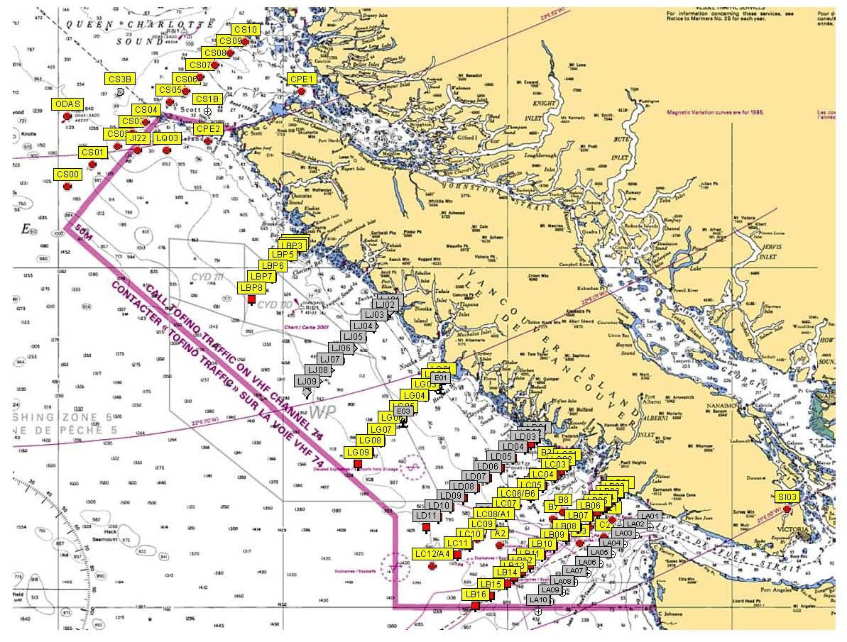

Note : Yellow labels are the highest priority stations.

