Canada’s Three Oceans
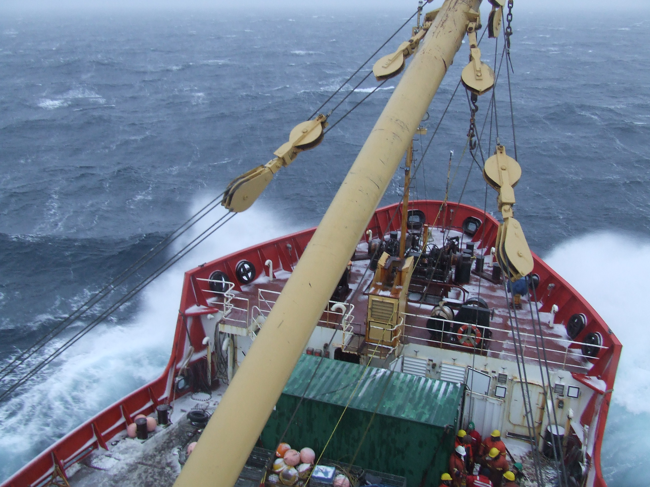
2007 Arctic-Pacific Leg
CCGS Sir Wilfrid Laurier
September 22 – October 15, 2007
Institute of Ocean Sciences Cruise 2007-03
Humfrey Melling – Chief Scientist
Fisheries & Oceans Canada
Supported by the Government of Canada Programme for International Polar Year
IPY 2006-SR1-CC-138
Also supported by Japan Agency for Marine-Earth Science and Technology, Federal Programme on Energy Research and Development, Canadian Foundation for Climate and Atmospheric Sciences, US National Oceanic and Atmospheric Administration, IMV Projects Limited

Canada’s Three Oceans
Arctic-Pacific Leg
Cruise Leg #3, CCGS Sir Wilfrid Laurier
September 22 – October 15, 2007

Overview
During this homebound leg of the 2007 Arctic Patrol, CCGS Sir Wilfrid Laurier supported the activities of several research initiatives co-ordinated within the Canada’s Three Oceans project (C3O: IPY 2006-SR1-CC-138) of the Government of Canada Programme for International Polar Year. The research included:
- An Arctic-to-Pacific link for the Canada’s Three Oceans, involving the continuous measurement of surface ocean variables, the measurement of key hydrographic sections and the servicing of moored instruments providing year-round observations at points along the C3O necklace encircling Canada
- A long-term study of Pacific inflow to the Arctic Ocean initiated in 1999. This project uses moored instruments and classical hydrography to determine the inflow and impact of Pacific-derived waters within the Arctic
- The Arctic ice monitoring project, an international initiative started in 2002 to study the mass balance of the Arctic pack ice
- The Beaufort ice hazards study, an observational project begun in 1990 to determine the character and recurrence interval of rare ice events posing hazard to ships, offshore structures, sea-bed and coastal infrastructure
- A new study of iron supply in the Arctic Ocean and its effect on productivity, carbon cycling and emission of climatologically active gases
- A new study of Arctic deep-water formation using trace elements thorium and protactinium to quantify renewal rates and possible changes associated with climate change
- The initiation of a long-term study of change in Arctic seabird distributions
This international partnership has strong emphases on long term observations and on climate change.
Supporting agencies include Fisheries and Oceans Canada, the Government of Canada Program for International Polar Year, the Japan Agency for Marine-Earth Science and Technology (JAMSTEC), the Canadian federal Programme of Energy Research and Development (PERD), Canadian Foundation for Climate and Atmospheric Sciences (CFCAS), the US National Oceanic and Atmospheric Administration (NOAA) and IMV Projects Calgary.
Staff and equipment were contributed by the following collaborating organizations: Institute of Ocean Sciences (DFO), Fresh-water Institute (DFO), Canadian Wildlife Service (EC), School of Earth and Ocean Sciences (University of Victoria), Department of Earth and Ocean Sciences (University of British Columbia), Japan Agency for Marine-Earth Science and Technology, Pacific Marine Environmental Laboratory (US NOAA), ASL Environmental Sciences Inc (Sidney BC), IMV Projects Ltd (Calgary AB)

Objectives
The primary objective for Leg 3 was the recovery, servicing and re-deployment of internally recording instruments on sub-sea moorings. The instruments operate autonomously, recording new data at intervals ranging between 1 second and 30 minutes during deployments ranging from one to three years in duration. The variables to be measured and recorded were ice thickness, ice ridging, ice drift, storm waves, storm surge, ocean current, temperature, salinity, dissolved oxygen and planktonic acoustic back-scatter. There were nineteen moorings scheduled for recovery during this leg and seventeen scheduled for deployment.

The secondary objective was the mapping of selected properties of seawater, both continuously at the surface along the path of the ship and from surface to seabed at selected locations. Such include the sites of oceanographic moorings and key cross-sections running from shallow shelf to deep basin waters. There were three cross-sections planned for Leg 3, one running north-west from the Tuktoyaktuk peninsula, one running north-east from the Barrow sea valley and the third following the 1000-m isobath along the perimeter of the Canada Basin. Mapping was to be conducted using expendable CTD probes (X-CTDs), recoverable CTD probes with added sensors, water-sampling bottle rosettes (one ultra-clean for trace metal sampling), wire-deployed submersible pumps and an under-way pumped surface sampling system.
Variables to be measured by the recoverable CTD package included ocean temperature, salinity, dissolved oxygen, dissolved nitrate (some stations), light back-scatter, chlorophyll fluorescence and photo-synthetically active radiation (PAR). Water sampling from the rosette was planned for analysis of concentration of salt, alkalinity, nitrate/nitrite, ammonium, phosphate, silicate, oxygen, oxygen-isotope anomaly, barium, total dissolved iron (pH 1.7, 0.22-micron filtered) and total iron (pH 1.7, unfiltered), aluminum (filtered) and aluminum (unfiltered). Large volume samples were to be collected for determination of thorium-230, protactinium-231 concentrations. Sensors in the continuous stream pumped from the ship’s sea bay were to measure the temperature, salinity and dissolved gas concentrations (O₂, CO₂) of near-surface water.
Systematic observations of seabirds and marine mammals were planned when the ship was underway during daylight hours.

Personnel

Already on board on September 22
Nes Sutherland, from the Institute of Ocean Sciences DFO
Eric Manchester, IPY-sponsored writer
2 persons

Embarking at Cambridge Bay on September 22
Humfrey Melling and Ron Lindsay, from the Institute of Ocean Sciences DFO
Jo Poole, from ASL Environmental Sciences Inc
Koji Shimada, Akinori Murata, Hideyuki Kitabata and Tomohidi Noguchi, from JAMSTEC
Jay Cullen and Tim Giesbrecht, from the University of Victoria
Roger Francois, Kristina Brown and Maureen Soon, from the University of British Columbia
Martin Renner, from the University of Washington
13 persons

Disembarking at Barrow AK on October 9
Melling, Lindsay, Poole, Shimada, Cullen, Giesbrecht, Francois, Brown and Soon
9 persons

Disembarking at Dutch Harbour on October 15
Renner, Murata, Kitabata, Noguchi
4 persons

Disembarking at Victoria on October 23
Manchester, Sutherland
2 persons

Activities
The map above summarizes the ship’s activity within the Beaufort and Chukchi Seas. The dark yellow line is the ship’s track, stars mark locations of XCTD drops, circles indicate the sites of instrumented moorings, where CTD profiles were also acquired and crosses show locations where seawater was sampled for trace metal measurement. The shaded area approximates the domain of pack ice at greater than 4 tenths concentration on 17 September.
The following list summarizes our activities and accomplishments:
- 16 sub-surface oceanographic moorings were recovered, each with one or more instruments yielding data records of 1-2 year duration
- 1 mooring was recovered from shallow water near the Mackenzie delta on behalf of the Geological Survey of Canada (Steve Solomon, AGC); this mooring supported instruments for the measurement of storm waves and sediment movement
- 14 sub-surface oceanographic moorings were deployed, bringing the number that will operate under the IPY/C3O umbrella to 18 in the western Arctic, plus 2 the vicinity of Bellot Strait; the variables measured include ice thickness, ice drift, storm waves, storm surge, ocean current, temperature, salinity, dissolved oxygen, planktonic back-scatter.
- 28 CTD-rosette casts were completed. The SBE25 CTD was equipped with supplementary sensors and recorded pressure, temperature, conductivity, dissolved oxygen, dissolved nitrate (some stations), light transmission and chlorophyll fluorescence; water samples were acquired from 6 of these casts
- 7 casts with a specialized “trace metal” CTD-rosette with sampling for iron and aluminum at 12 levels to 1200-m depth; in addition, samples were withdrawn for analysis of concentration of salt, alkalinity, nitrate/nitrite, ammonium, phosphate, silicate, oxygen, oxygen-isotope anomaly and barium
- 7 casts with the CTD-rosette to acquire large samples of water for analysis of dissolved thorium-230 and protactinium-231
- 7 casts with submersible pumps for in situ filtering of seawater for particulate thorium and protactinium
- 23 X-CTDs were deployed along the 1000-m isobath of the southern Beaufort Sea
- Salinity and temperature of surface water drawn from the ship’s sea-bay were recorded at 10-second intervals along the cruise track (22 days)
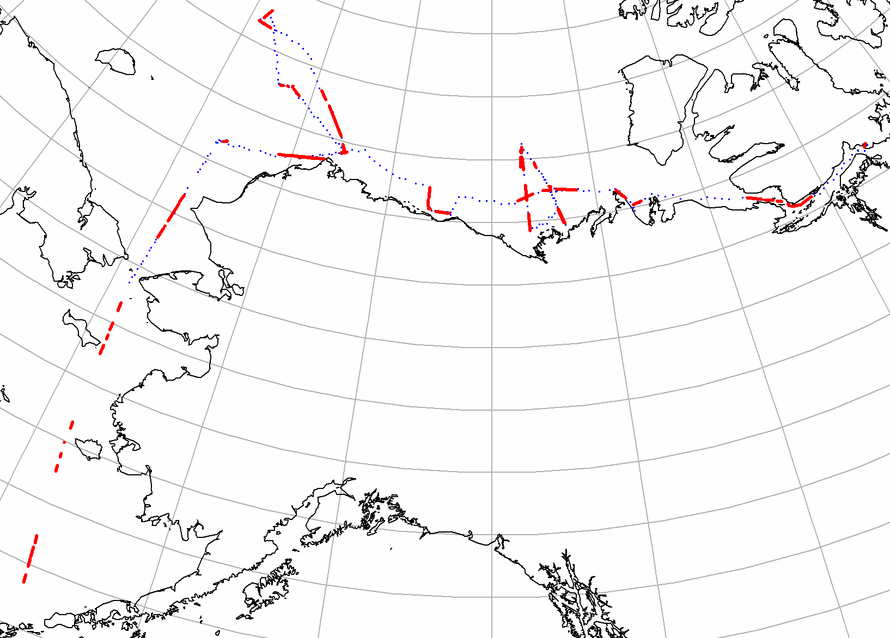
- 16 days of continuous measurement dissolved gas concentration (O₂, CO₂) in surface water drawn from the ship’s sea-bay were recorded at intervals along the cruise track (16 days: the system failed shortly before the southward transit to Dutch Harbour)
- 22 days of seabird and marine mammal observing when the ship was underway during daylight hours (3202 birds, 40 seals, 23 whales)
Figure 1. Locations of seabird survey transects in red along the ship’s track.

Methods
Oceanographic moorings in Arctic waters do not have components within 25-30 m of the surface to reduce risk from drifting ice. Moorings are recovered through acoustic activation of an electromechanical hook that separates the buoyant part of the mooring from a dead-weight anchor. A successful recovery is contingent on the ship being able to reach the site (not always practical in heavy ice) and on the presence of sufficient ice-free surface over the mooring to ensure its appearance at the sea surface following release. A careful assessment of risk based on ice cover and acoustic ranging precedes each decision to release. Ideally, moorings are equipped with tandem releases for increased reliability. Since the moorings of this project are simple in design, they were recovered and deployed within relatively small ice-free patches, with deployment via a free fall to the seabed from the surface.
In several instances, a mooring did not surface when the acoustic command was sent to separate the buoyant part of the mooring from its anchor. This was the case for four moorings in Camden Bay, where ORE CART release units were defective, for one in Barrow Canyon, where Viny floats had imploded under pressure and for one in the Chukchi Sea, where ORE-8242XS and Nichiyu releases malfunctioned. In such circumstances, grappling gear (heavy chain, large open hooks and small line-snagging grapnels) was deployed via the A-frame on 3/8” 3x19 wire from a 50-hp Swann work winch mounted near the port rail. Typically 2000 m of wire would be laid in a loop of about 100-m radius around the mooring, with the ship moving slowly astern, first into the drift, then across it, then down it and finally back up into it for 200-600 m. At this point the ship would hold station and the wire would be winched back in.
Both the IOS and the JAMSTEC mooring teams used the ‘tween-decks space to prepare their moorings and instruments. The “green container” workshop on the well deck was used by the pumping people during much of the mooring work.
Compasses on ADCPs used to measure current and ice drift in Camden Bay were calibrated in weak geomagnetic field by rotation at Tuktoyaktuk. Two personnel travelled with equipment via helicopter to the beach near the NTCL base. The work was completed in two hours using a precise turntable designed and built by DFO at the Institute of Ocean Sciences.
X-CTDs were deployed at cruising speed using a launcher clamped in the stern-most port-hole on the main deck, port side. X-CTDs typically reported data to 1000-m depth.
A CTD (Sea Bird SBE25/SBE33) and rosette sampler (12x8-litre Model 1010 Niskin bottles, General Oceanics) was operated from the boom roughly midships on the boat deck, port side. It was lowered on steel-jacketed conducting cable deployed from a Hawboldt winch with Scantrol automatic wire speed control. The CTD provided continuous profiles of temperature, salinity, dissolved oxygen, light transmission and chlorophyll fluorescence. This rosette was used to acquire samples for conventional seawater chemical analysis. Sampels for dissolved oxygen and ammonium were analyzed on board. Those for dissolved nutrient, salinity, oxygen isotope and barium analysis were stored for analysis on return (nutrient samples flash frozen).
A CTD (Sea Bird SBE25/SBE11) and rosette sampler (12x10-litre Model 1080 GO-FLO bottles, General Oceanics) was operated from the A-frame on the well deck, starboard side. It was lowered on vinyl-jacketed Kevlar conducting cable deployed from a second Swann winch mounted near the port rail and passing over a special “trace-metal” snatch block. The CTD provided continuous profiles of temperature, salinity and dissolved oxygen. This rosette was used to acquire samples for trace metal (Fe, Al) chemical analysis. The rosette was housed in a portable field lab built into a 10-foot shipping container secured to the deck just forward of the house on the starboard side. Ship’s personnel built wooden ramps and a trolley to facilitate movement of the rosette between the lab space and the A-frame. Concentrations of trace metals were determined by analysis in the poly-sheet-isolated forward section of the Laurier’s main science lab.
Large volumes of water for analysis for thorium-230 and protactinium-231 were captured in two ways. For the dissolved component, the rosette on the boat deck was used to acquire water. Samples from three 8-litre bottles closed at the same depth were combined in plastic jerry cans and filtered by gravity into cubitainers (over several hours). Filtered seawater was weighed, acidified with HCl, spiked with Fe, ²²⁹Th and ²³³Pa and left to equilibrate overnight. Seawater samples were then neutralized with concentrated ammonia to precipitate Fe(OH)₃ and left to decant over several hours. Precipitates were recovered by suction and centrifugation, returning to UBC in centrifuge tubes; supernatants were discarded.
For the particulate component, large volumes of seawater were filtered in situ using submersible pumps (McLane WTS 6-1-142LV). The battery pack, pump, plumbing and filter unit are built into a stainless steel cage approximately 70x36x64 cm; the unit weighs 51 kg in air (34 kg in water). There were seven such pumps on board, with six in use and one kept in reserve. They were deployed on the 3x19 dragging wire programmed to start up after a delay chosen to get the pump to the correct depth before start-up. Sometimes the forecast was correct; sometimes it was not. Once at depth, the pump operated for two hours, or until the back pressure indicated a clogged filter. With the winch handling wire at about 0.5-1.0 m/s, the time for a cast to 2500 m was 4-5 hours. To sample 12 levels, two casts were required at each station, with an interval of 1-2 hours between to replace filters and batteries and to re-programme the pump (12 hours per station). Filters were removed from the filter holders and stored in the freezer. Pumps were prepared and stored in the 20-foot “green container” lab on the well deck, more or less precluding the usual use of this space for preparation of moorings.
The underway surface-water measurement systems (Sea Bird SBE45 / SBE38 for temperature and salinity; custom “cooler” for gas tensions) were set up in the aft section of the main science lab, using water piped there from a sea bay via a pump in the engine room. The transit time within the ship (a time lag relative to position) and degree of amount of re-circulation and storage within the plumbing (a low-pass filter on the temperature and conductivity signals) is not known. The warming of water between the engine room and the lab was measured and is appreciable (several tenths of a degree). The warming of water between the environment and the sensor in the engine room is not known.

Ice conditions across the Arctic, September 2007
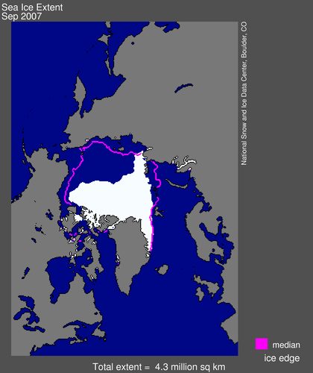
The adjacent map display Arctic ice extent in September 2007 measured from satellite using microwaves (http://nsidc.org/data/seaice_index/ ). Within our working domain particularly in the eastern Chukchi Seas, the ice edge was far to the north of its median position for the past 30 years. The principal retreat from climatology occurred in the Western Chukchi, East Siberian and Laptev Seas (and also in the southern Canadian Archipelago). The total extent of Arctic ice in August and September was a record 1.1 million square kilometres below the previous minimum value.

Impact of ice conditions and weather
Ice had no direct impact on completion of the science plan for 2007. CCGS Sir Wilfrid Laurier was able to reach all locations without difficulty. Indirectly, however, the extreme retreat of the ice opened wind fetch dramatically for both easterly and westerly winds. We experienced no storms with strong westerly winds, but were repeatedly subject to strong winds from the east and south-east. These were associated with the interaction between the strong high pressure system, stationary over the Canadian Archipelago and Greenland since July, and lows moving west to east in the Bering Sea and Gulf of Alaska. With strong (30-40 kt) winds and open fetch we had large (3-4 m) waves that slowed work on several days and prevented the recovery of two moorings in the northern Chukchi Sea during our brief window of opportunity there. These moorings AIM-06 and NCS-06 both have operating capability for at least another year, and will be on the cruise plan again in 2008.
Temperatures were below zero for much of the trip (down to -4°C). However, the weather was not cold enough to cause serious difficulties in the operation of the CTD/rosette systems, their open-air winches and cable blocks. Prior experience indicates a rapid worsening of conditions for this work as temperature drops below -6°C.

Planned activities that were not completed
Recovery of the AIM06 mooring at 74.6°N 168.8°W: Explanation – heavy weather
Recovery of the NCS6 mooring at 74.0°N 167.6°W: Explanation – heavy weather
Completion of hydrochemical sampling line at 155°W: Explanation – Out of time

Activities not in the science plan
Salvage of an 6-m aluminum boat stranded on the delta of the Horton River (Franklin Bay) – ½ day
Salvage of a shallow-water mooring near Gary Island – ½ day
Standby with helicopter at Toker Point in support of visit by Honourable Chuck Strahl, Minister of Indian Affairs and Northern Development, 26-27 September – 1½ days

Preliminary Scientific Highlights
Included here are two illustrations of the dramatic inter-annual variability in ocean conditions in the southern Beaufort and northern Chukchi Seas. These have been gleaned from a cursory inspection of the large volume of data acquired during the C3O expedition in September.

Surface salinity on the margins of the Beaufort & Chukchi Seas
The illustration on the following page (Figure 1) depicts the salinity of surface water drawn into the ship’s sea-bay during transit between Amundsen Gulf and the Chukchi Sea. Ship’s latitude is plotted in the upper frame and near-surface salinity in the lower frame; the abscissa is longitude. Data are shown for both 2006 (red) and 2007 (black) along similar ship tracks at the same time of year. The ship followed the 1000-m isobath for much of the distance in both years.
It is immediately obvious that the near-surface salinity was higher over the entire domain in 2007 than in 2006. A typical difference is 1-2 ppt, although larger discrepancies occur near 127°-138° and 150°-162° W. The former zone the receives inflow from the Mackenzie River, whereas the latter occurs where the low salinity Alaska Coastal Current enters the Beaufort Sea. The impact of fresh-water inflow into both of these zones is evident in 2006 in the low surface salinity. In 2007, somewhat freshened surface water was encountered during the transit across the delta front to the vicinity of Gary Island, but no such freshening was measured across the outflow near Point Barrow.
In both years surface salinity typically increased with approach to the coast. The gradient is most obvious during the cross-shelf transit into and out of Camden Bay at 145°W, but it is also evident from the sorties to Wainwright at 159°W in both years and to Toker Point at 133°W in 2007. The surface salinity at Toker Point well within the Mackenzie estuary was more than 32.
The obvious question is: If rivers were flowing as in 2006 and pack ice was melting to an unprecedented minimum in coverage in 2007, what happened to all the fresh-water this year? If it is out in the Canada Basin this year, as suggested by the seaward decrease in salinity observed by CCGS Sir Wilfrid Laurier, how did it get there? Will the resulting increased stability of the upper Canada Basin promote recovery of the ice cover? What are the implications of high shelf-water salinity for renewal of the cold halocline of the Canada Basin during the coming winter? We will be working towards answers when data from all the C3O legs can be examined together.
Figure 2. Surface salinity measured continuously along the cruise track of CCGS Sir Wilfrid Laurier during 2006 and 2007 (late September into early October). Not the dramatic difference in conditions between the two years.

Figure 3. Trajectories of ice drift measured at Site 1, about halfway across the Mackenzie shelf north of Kugmallit Bay, between October 21 and May 30 of the 2005-06 and 2006-07 winters. Note that the net displacement of ice during the second winter was twice that during the first, and that there were far fewer reversals in drift direction.

Two winters’ ice drift in the southern Beaufort Sea
The illustration on the preceding page (Figure 2) displays the displacement of ice moving past Site 1 at the middle of the Mackenzie shelf (70.33°N 133.75°W). The displacement is the result of integrating the velocity of pack-ice movement measured by Doppler sonar. Separate trajectories have been calculated for the winters of 2005-06 and 2006-07 between October 21 and May 30.
Both displacements are upwelling favourable, but there are obvious differences between the two years. Net displacement during the 2005-06 winter was more or less parallel to the shelf edge whereas that during the second was biased towards the off-shelf direction by about 20°. The net displacement during 2006-07 (1240 km) was almost twice that during the preceding year. It is also clear that there were appreciably more reversals in the direction of ice drift during 2005-06 (13 events) than in the following year (8 events). Both factors suggest that conditions during the 2006-07 winter may have preconditioned shelf waters to higher than average salinity via upwelling.
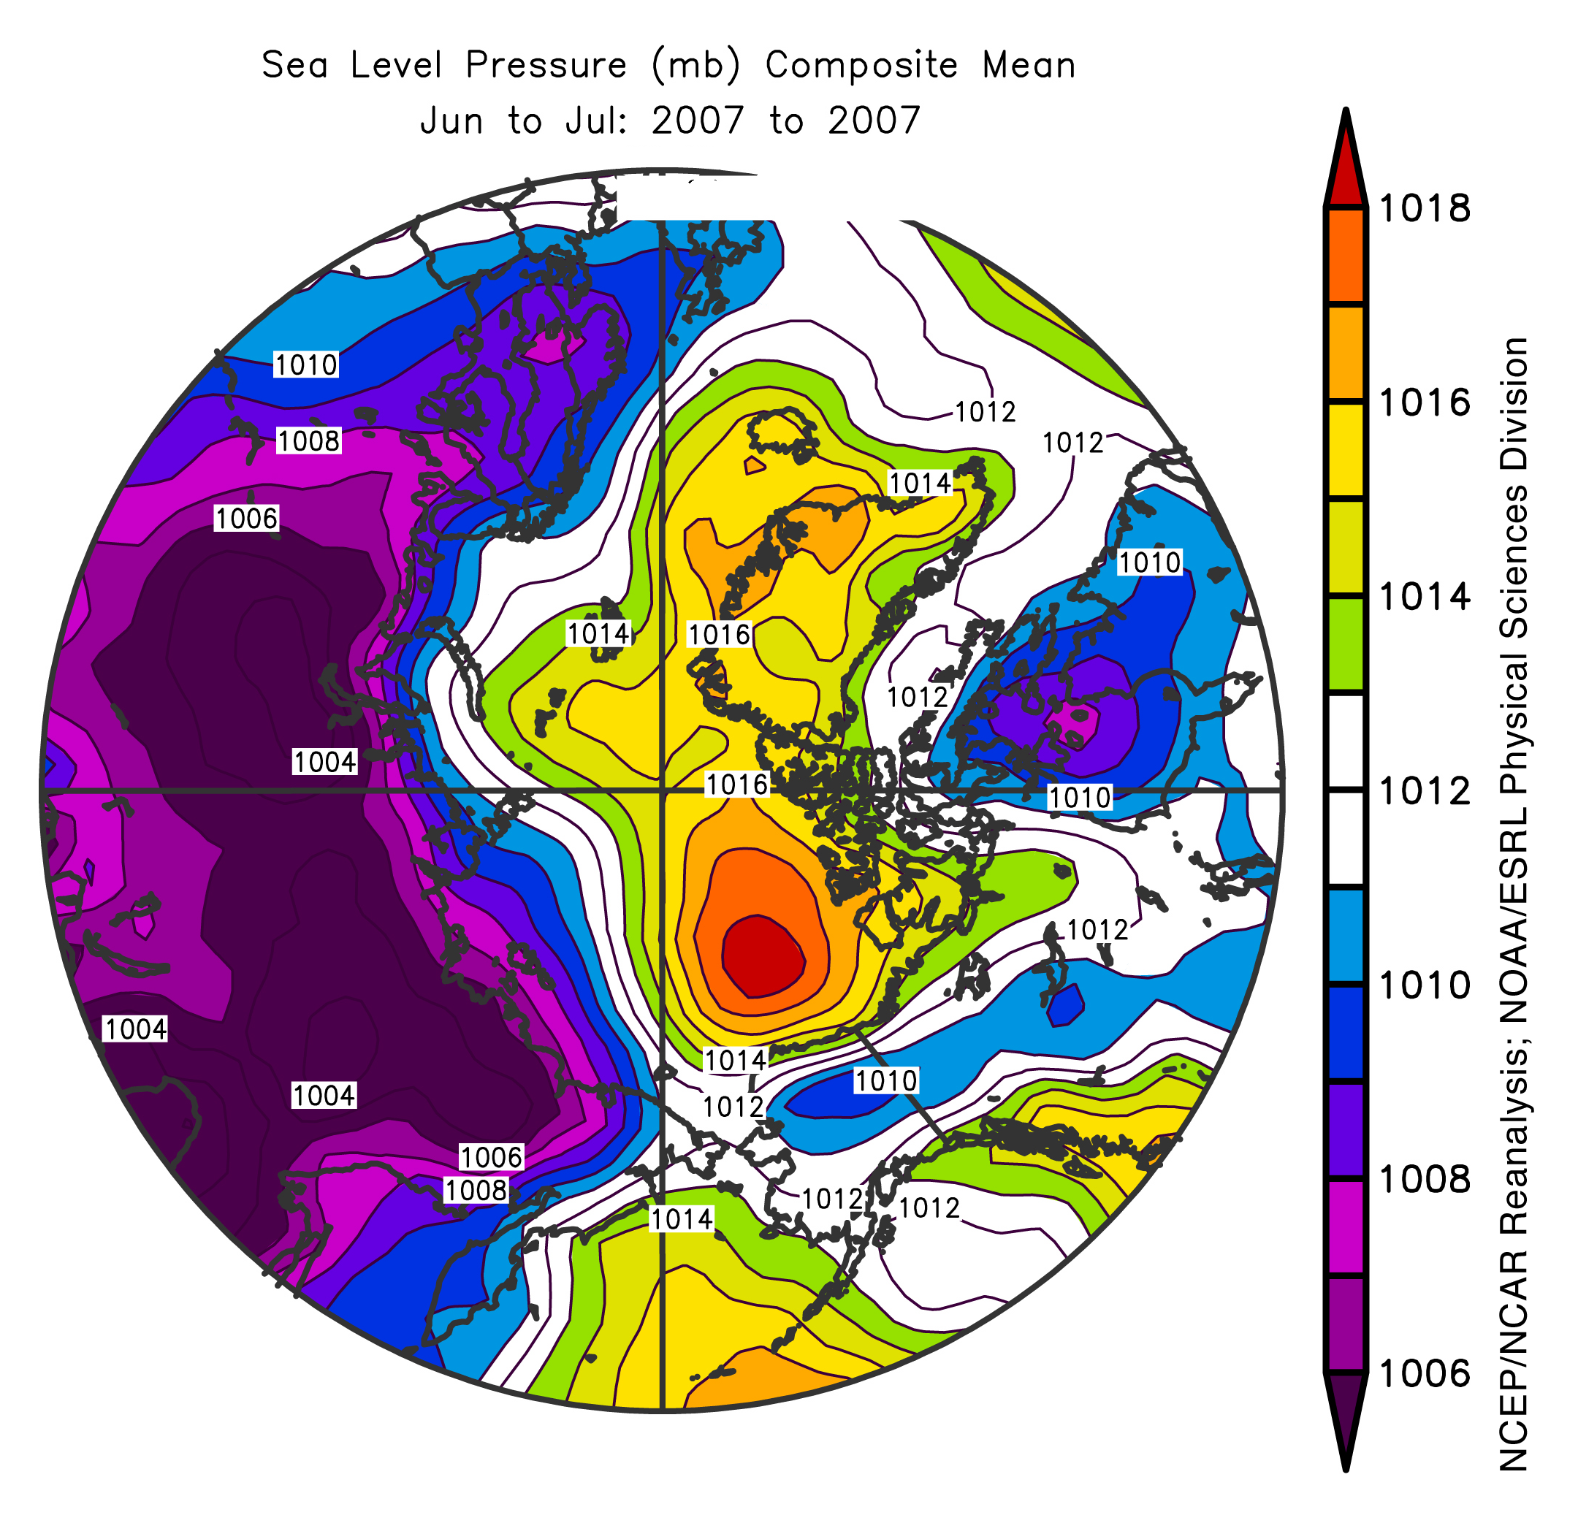
Pack ice drifted off Site 1 in early June 2007, precluding continued direct measurements of the drift of ice. However, wind conditions favouring upwelling were sustained from June through October. The average of conditions during June and July is revealed in the map of sea-level atmospheric pressure at the right. Stable high pressure over the Beaufort Sea favoured easterly wind along the coast. Moreover, it acted in conjunction with persistent low pressure over northern Siberia to create a southerly airflow in the Chukchi and East Siberian Seas that played a role in driving pack ice well to the north in this sector during July and August.
Figure 4. Sea-level air pressure over the north polar region, averaged over June and July. Note the easterly winds across the southern Beaufort Sea. A similar pattern of SLP persisted through August, September and into October.

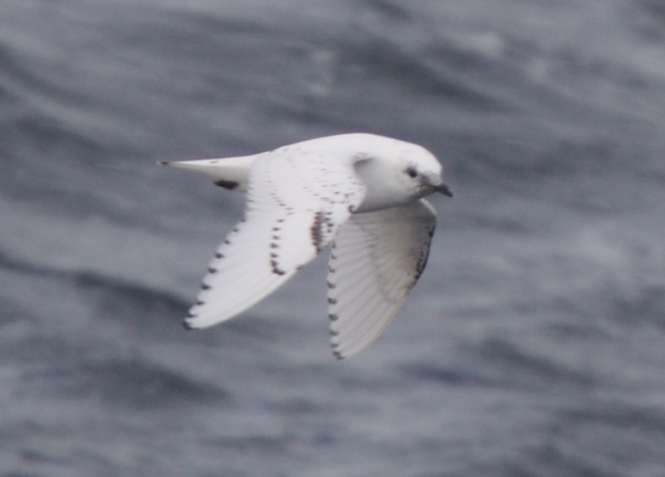
Seabirds
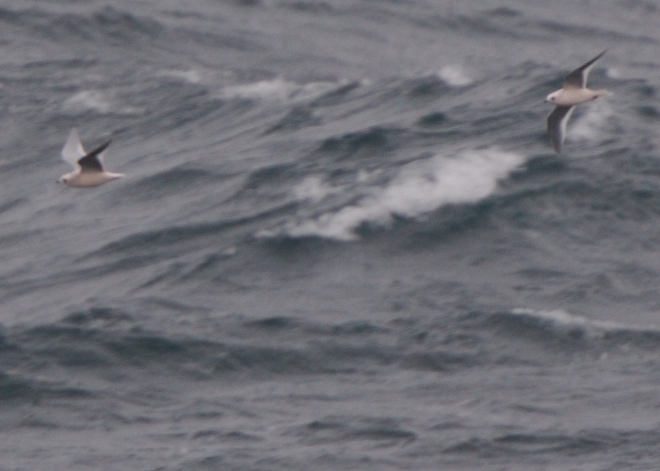
Figure 5. Two rare gulls were observed in the north-eastern Chukchi Sea: Ross’ gulls (left) and ivory gull (right). 96 of the former and 4 of the latter were counted during this survey (photos by Martin Renner).
The presence of seabirds was highly non-uniform. Preliminary results reveal a dramatic change in the population density at Point Barrow. As shown on the adjacent map, seabird density (proportional to the size of the black circles) was much lower at all survey locations east of Point Barrow than that at locations to the north-west, west and south of Barrow.

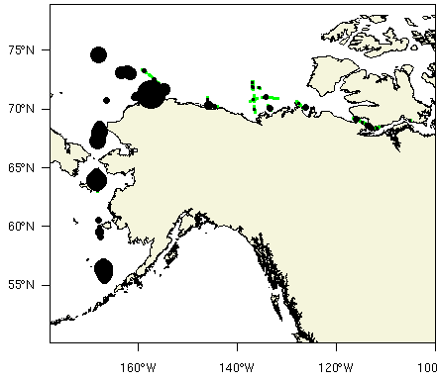
Thanks to CCGS Sir Wilfrid Laurier …
- Improvised trolley and ramps for moving the trace-metal rosette.
- Improvements to the block used with the trace-metal rosette, preventing cable jumping.
- Improvised ballast weight for the trace-metal rosette.
- Trouble-shooting of the sea cable and slip rings for the trace-metal rosette.
- Tedious recovery of moorings by dragging – 4 successes.
- Skilled work and enthusiastic support from all in the many routine aspects of the C3O scientific programme.
Captain Norm Thomas and the members of the Laurier’s Red Crew, in their diverse capacities, can take credit for the success of this expedition and the scientific knowledge that will emerge from it.

Issues 2007
We recommend …

Ship’s concern
- A wider separation of mounting pads for winches opposite the A-frame on the well deck. At present the pads are too close to permit use of two Swann work winches side by side. This capability was required for the C3O expedition in 2007 (winch with 3x19 wire for dragging inch with plastic jacketed Kevlar for the trace-metal rosette).
- A 16-foot cargo container mounted on the starboard boat deck for accessible storage of equipment and samples during multi-disciplinary projects such as the C3O expedition in 2007. The loading of a cargo container from C-GBN to this location can have negative impact on the Laurier’s science programme..
- A separate containerized workspace for pump casts during multi-disciplinary cruises. During the C3O expedition in 2007, it was necessary to move mooring preparations to the ‘tween decks to accommodate the pumping activity.
- A dragging wire 3500 m in length for Arctic mooring projects. The present wire is 2500 m long. This initiative would facilitate the inevitable need to grapple moorings in water of several hundred metres depth.
- A fool-proof procedure for processing personnel landing to the US when leaving CCGS Sir Wilfrid Laurier. It is not clear that the correct paperwork is being filed and the correct procedure being followed. Personnel landing at Barrow and reporting to US Immigration in Anchorage were harassed, reprimanded and delayed so that connecting flights were missed.

Science’s concern

CTD Systems
- An end-to-end check-out of CTD systems, completed prior to loading of this equipment to the ship (computer to deck unit to slip rings to sea cable to CTD).
- Dedicated technical support for the CTD and rosette systems used on multi-disciplinary cruises such as the C3O expedition in 2007. A number of systems could not be maintained for lack of staff to troubleshoot and repair them (PAR sensor, ISUS, continuous flow gas-tension sensors, CTD priming and pumping).
- Reassessment of the plumbing for the SBE25 and auxiliary sensors on the boat-deck rosette. Is the pump producing an appropriate rate of flow through the sensors?
- A well considered integration of the dissolved nitrate sensor ISUS into the CTD system, with particular attention to the power supply and data stream.

Trace Metals Rosette System
- Inspection of the slip-ring end of the sea cable on the trace-metal winch, with particular attention to the feed through the winch drum. Two of four conductors appear to be shunted to ground.
- A floor drain installed in the trace-metal sampling container, to reduce seepage of corrosive salt water into the walls and steel structural components of the container
- Capability (compressed air fitting) to strip water from the trace-metal rosette wire in freezing conditions. This will prevent a dangerous build-up of ice on the shallow grooved block used for this work.

Large-volume Pumping System
- Preparation of a reliable procedure for shipment of radioactive material to the North. Can we introduce redundancy in shipments to make this fool-proof?
- Investigation of possibilities for faster deployment of wire during pump casts, to allow more efficient use of ship time.
- More pumps for pump casts. With Laurier station time costing $1200 per hour and Amundsen costing $1800, additional capital expenditures may be easily justified.
- Replacement of leak prone Impulse connectors on the pumps with a design better suited to cold weather.
- Time-and-motion optimized hardware for changing batteries in pumps. This slow process makes for inefficient use of wire time.
- A less trouble prone method of starting pumps than preset delays (perhaps acoustic or inductive signalling). Re-programming of pumps is slow and allowances for mishap make for inefficient use of ship time.

IOS Moorings
- Redesigned release mechanism for the ORE CART release units used on moorings in Camden Bay.
- Assessment of the need for more buoyancy on moorings using CART release units.
- Diagnosis and correction of susceptibility to crevice corrosion in the CART release units.
- Diagnosis of the faulty “Release upright” signal from the CART transponding release units.
- Assessment and possible re-tuning of band filters defining the four communication channels of the Mesotech acoustic deck units.
- Acquire a reliable AM radio for detecting pulsed transmissions by ADCP and IPS at frequencies 100-900 kHz.
- Document the procedure for moving recorded data from narrow-band ADCPs to compatible (Pentium PCs running Win95) to modern data storage media (e.g. USB memory sticks).
- Diagnosis and correction of communication dysfunction between the IPS5 and some laptops (e.g. Dell D400).
- Correct the memory-check function within the new version 5 of the ice-profiling sonar (IPS5). Presently, it does not recognize an 8-Gb flash card.
- Installation of wire snagging features on moorings to increase the likelihood of success in dragging.
- Modify the sonar mooring frames using five Viny 12B3 floats so that fasteners used in their assembly are more readily accessible.
- Stock type 316 stainless steel pear rings (magnetically neutral) for use in connecting ADCPs in long-line ice-monitoring moorings.

Issues surviving from earlier years
- The release hooks of ORE (EdgeTech) release units (both 8242XS and CART models) do not always swing free after activation of the release; diagnosis and re-design is required (delays in releasing were encountered in 2006 and 2007; dragging has been required for this reason in each of the last three years).
- Impulse connectors on the Sea Bird CTD are a continuing problem with leakage common when operating at low temperatures. Complete conversion to a more cold-tolerant connectors is the best procedure. Alternatively, we need to create and maintain distinct well equipped and well maintained inventories of spare connectors (pig tails & bulkheads) to travel with each such CTD in use at sea.
- Safe and effective operation of the Hawboldt CTD winch in cold weather, when the pulley, spooling gear and drum accumulate ice remains unresolved; there was no cold (-10°C) weather this year to test a compressed air diffuser for stripping the cable clean of water before reaching the pulley. This issue will also be a serious concern when operating the trace metal rosette from the foredeck in cold weather.
- Both the seawater pump and the seawater drain for the thermo-salinograph operation freeze up when surface water reaches freezing temperature; if such data are to be of routine interest, this issue needs attention (and money).
- There is a need for secure 110-volt plug-ins for refrigerators and chest freezers used to store samples in the ‘tween-decks space of the hold; during 2006-02, freezers were accidentally unplugged for some time, allowing undesirable thawing and partial thawing of stored samples.

Narrative
22 September, Saturday
CCGS Sir Wilfrid Laurier at Cambridge Bay. Thirteen science supernumeraries join the ship. Expected delivery by air of short-lived radioactive tracers delayed by out-dated paperwork. Delivery re-routed to Inuvik to avoid delaying the ship.
23 September, Sunday
CCGS Sir Wilfrid Laurier westbound. Scientific team preparing work spaces and equipment.
24 September, Monday
Trial run of the submersible large volume pump string in Franklin Bay (126°W) – deployment, operation and recovery successful. Trial run of the trace-metal rosette – deck activity successful, issue with winch hydraulics solved, but no signal from the CTD via the sea cable; activity aborted for trouble-shooting. Proceed to CCG salvage activity – small boat stranded on the Horton River delta. Overnight travel (170 miles) to IOS Site 2, at the 100-m isobath near 134°W.
25 September, Tuesday
Recover IOS ice-measuring mooring at Site 2; deploy replacement mooring. Proceed north to the 500-m isobath. Complete one cast with 6 submersible pumps. A second trial of trace-metal rosette was aborted after the line jumped the block. Overnight travel (50 miles) to IOS Site 1, at mid self near 134°W
26 September, Wednesday
Recover two IOS ice-measuring mooring at Site 1. Proceed to anchor station off Toker Point at noon, on standby near CCGS Louis St St-Laurent for Ministerial visit. Calibration of ADCP compasses for IOS on land at Tuktoyaktuk during the afternoon.
27 September, Thursday
On standby near CCGS Louis St St-Laurent for Ministerial visit until 18:30. Proceed to IOS Site 1 and deploy two ice-measuring moorings. Overnight run (105 miles) to the vicinity of Gary Island near 136.5°W
28 September, Friday
Emergency recovery of moored instruments for storm wave measurement, on behalf of the Geological Survey of Canada. Proceed north (170 miles) to the seaward end of the hydrographic section at the 2700-m isobath.
29 September, Saturday
Sampling the 2700-m hydrochemical station begins after midnight – 2 casts with CTD rosette from the boat deck, 1 cast with the trace-metal CTD rosette, 4 submersible pump casts for 25 pumped levels in total –complete 05:00 on September 30, including a 4-hour interruption for SAR.
30 September, Sunday
Sampling the 2000-m hydrochemical station beginning at 10:00 am – 2 casts with CTD rosette from the boat deck, 1 cast with the trace-metal CTD rosette, 2 submersible pump casts for 12 pumped levels in total – complete by 11:30 pm.
1 October, Monday
Trace-metal casts at 1500 and 1000-m isobaths overnight. Subsequent sampling with boat-deck CTD-rosette at 500-m isobath (2 casts) and the trace-metal CTD-rosette at the 500-m and 200-m isobaths (1 casts at each) – complete by 03:00 pm. Proceed overnight (250 miles) along the 1000-m isobath towards Camden Bay, dropping X-CTD probes at 30-mile spacing.
2 October, Tuesday
Servicing moorings ice-sonar moorings in Camden Bay. Three moorings retrieved with grappling gear, two at Site B and one at Site K. Anchor overnight at Site K.
3 October, Wednesday
Two unsuccessful attempts to retrieve the second mooring at Site K. Two moorings deployed at Site K. Two moorings recovered at Site A, two deployed at Site A and two at Site V. Proceed overnight (210 miles) along the 1000-m isobath towards Barrow Canyon, dropping X-CTD probes at 30-mile spacing.
4 October, Thursday
At Site BC-E at dawn. CTD-rosette cast completed and mooring located. Mooring recovery aborted in face of rapidly rising east wind, 35 kt. Proceed north-west (320 miles) along the 1000-m isobath towards the Chukchi Plateau, dropping X-CTD probes at 30-mile spacing.
5 October, Friday
At Site AIM06 at dawn. Recovery of mooring not practical in with 30-35 kt wind and 3-4 m seas. Continue north to Site AIM05. Standby in 3-4 m seas for abatement of weather. Mooring recovered at dusk in somewhat reduced seas. CTD-rosette cast. Proceed south-east overnight (140 miles) to JAMSTEC moorings in Herald sea valley, bypassing JAMSTEC mooring at Site NC-S on the northern Chukchi shelf.
6 October, Saturday
At Site HC-W by dawn. Mooring recovered, CTD-rosette cast. Proceed to HC-E. Mooring recovered, CTD, replacement mooring deployed. Proceed south-east overnight (150 miles) to JAMSTEC moorings in Barrow Canyon.
7 October, Sunday
Recover moorings at BC-W, BC-C and BC-E and deploy replacement moorings. Complete CTD-rosette casts. Proceed south-west overnight (85 miles) to JAMSTEC mooring at the head of Barrow Canyon.
8 October, Monday
Recover JAMSTEC mooring in 80-m of water by dragging, completed at 02:00 pm (mooring failed via imploding floats). Deploy replacement mooring, CTD-rosette. Back at Barrow by late evening, anchoring overnight.
9 October, Tuesday
Nine members of the science team, plus the helicopter pilot and engineer, leave the ship at dawn and return home by air. CCGS Sir Wilfrid Laurier proceeds south-west overnight (250 miles) to JAMSTEC mooring in the central Chukchi Sea.
10 October, Wednesday
Troublesome recovery of mooring at CC-C – ORE release unit indicated correct function but failed to let go of the anchor. Mooring appeared unexpectedly at the surface while grappling gear was being rigged. Proceed south overnight.
11 October, Thursday
Southward progress towards Bering Strait.
12 October, Friday
Pass through Bering Strait.
13 October, Saturday
Southward progress towards Dutch Harbour.
14 October, Sunday
Southward progress towards Dutch Harbour.
15 October, Monday
Arrive Dutch Harbour in the morning.

Appendix 1: Locations of Moorings in the Beaufort and Chukchi Seas, 2007-08

Appendix 2: Locations of CTD profiles
§ Samples were collected for alkalinity analysis on cast #’s 27, 29-32, 34. ISUS was operated on cast #’s 27-34.

Appendix 3: Locations of Trace Metal Sampling

Appendix 4: Locations of Thorium/Protactinium Sampling

Appendix 5: Locations of XCTD profiles

PACIFIC REGION CCG VESSEL -POST CRUISE REPORT

NAME OF SHIP/PLATFORM: CCGS Sir Wilfrid Laurier
DATES: 22 September - 15 October 2007
SCIENCE CRUISE NUMBER: 2007-03 SHIP’S PATROL NUMBER:
CHIEF SCIENTIST[S]: Humfrey Melling, DFO/IOS
AREAS OF OPERATION: Beaufort and Chukchi Sea

INTRODUCTION/PROGRAM BACKGROUND:
Canada’s Three Oceans (C3O) is a project within the Government of Canada Programme for International Polar Year. It is an multi-disciplinary joint research program between the Department of Fisheries and Oceans Canada and various partners from other research institutes, government departments, nations and universities.
This component involved scientists from the Institute of Ocean Sciences (Sidney, B.C.), the Japan Marine Science and Technology Center (JAMSTEC), the Canadian Wildlife Service, the University of Vicotira, the University of British Columbia and ASL Environmental Sciences Inc.

CRUISE OBJECTIVE/OBJECTIVES:
The primary objective of this expedition was the recovery, servicing and re-deployment of internally recording instruments on sub-sea moorings. The instruments operate autonomously, recording new data at intervals ranging between 1 second and 30 minutes during deployments ranging from one to three years in duration. There were nineteen moorings scheduled for recovery during this leg and seventeen scheduled for deployment.
The secondary objective was the mapping of selected properties of seawater, both continuously at the surface along the path of the ship and from surface to seabed at selected locations. Mapping was to be conducted using expendable CTD probes (X-CTDs), recoverable CTD probes with added sensors, water-sampling bottle rosettes (one ultra-clean for trace metal sampling), wire-deployed submersible pumps and an under-way pumped surface sampling system.
Systematic observations of seabirds and marine mammals were planned when the ship was underway during daylight hours.
DAYS ALLOCATED: DAYS OF OPERATION:
xx 22 including homebound transit
DAYS LOST DUE TO WEATHER:
1-2
RESULTS:
Nearly all of the objectives of the program were completed. Sea ice cover did not inhibit work this year, but rough seas prevented the recovery of two moorings in the extreme north-west of the study area, near the Chukchi Plateau. There were five dysfunctional moorings where dragging was required. We were unsuccessful in grappling only one of these. Time did not permit the completion of a second hydrochemical section planned to run into deep water north-east from Barrow. Approximately two days of expedition time were lost to support the visit by the INAC Minister to the CCGS Louis S St-Laurent off Tuktoyaktuk.
Radioisotope Use:
Low activity radioactive tracers were used by UBC scientists to ‘spike’ samples acquired by filtering large volumes of seawater.
PROBLEMS [SCIENTIFIC GEAR AND OPERATIONS]:
More widely separated mounting pads are required for winches opposite the A-frame on the well deck. At present the pads are too close to permit use of two Swann work winches side by side.
A 16-foot cargo container mounted on the starboard boat deck is required as accessible storage for equipment and samples during multi-disciplinary projects such as the C3O expedition in 2007.
A separate containerized workspace for pump casts is recommended on multi-disciplinary cruises. This activity displaced mooring preparations from the green container workshop to the ‘tween decks during this leg.
Dragging wire 3500 m in length could be useful to support Arctic mooring projects, particularly in addressing the inevitable need to grapple moorings in water of several hundred metres depth.
A fool-proof procedure for processing personnel landing to the US when leaving CCGS Sir Wilfrid Laurier. It is not clear that the correct paperwork is being filed and the correct procedure being followed..
SUCCESSES [SCIENTIFIC]:
16 sub-surface oceanographic moorings were recovered, each with one or more instruments yielding data records of 1-2 y duration.
1 mooring was recovered from shallow water near the Mackenzie delta on behalf of the Geological Survey of Canada.
14 sub-surface oceanographic moorings were deployed, bringing the number that will operate under the IPY/C3O umbrella to 18 in the western Arctic, plus 2 the vicinity of Bellot Strait.
28 CTD-rosette casts were completed. The SBE25 CTD was equipped with supplementary sensors and recorded pressure, temperature, conductivity, dissolved oxygen, dissolved nitrate (some stations), light transmission and chlorophyll fluorescence.
7 casts with a specialized “trace metal” CTD-rosette with sampling for iron and aluminum at 12 levels to 1200-m depth; in addition, samples were withdrawn for analysis of concentration of nine other seawater constituents.
7 casts with the CTD-rosette to acquire large samples of water for analysis of dissolved thorium-230 and protactinium-231
7 casts with submersible pumps for in situ filtering of seawater for particulate thorium and protactinium
23 X-CTDs were deployed along the 1000-m isobath of the southern Beaufort Sea
Salinity and temperature of surface water from a sea-bay were recorded at 10-second intervals along the cruise track (22 days)
16 days of continuous measurement dissolved gas concentration (O2, CO2) in surface water drawn from a sea-bay were recorded at intervals along the cruise track
22 days of seabird and marine mammal observing when the ship was underway during daylight hours
PROBLEMS [SHIP’S EQUIPMENT/OPERATIONS/PLATFORM SUITABILITY]:
See: PROBLEMS [SCIENTIFIC GEAR AND OPERATIONS]
SUCCESSES [SHIP]:
CCGS Sir Wilfrid Laurier is an excellent platform for multi-tasked operations that include scientific research in the Canadian Arctic. The advantage of multi-tasking in reducing the average cost per operational science day should not be over-looked. Cost comparisons with dedicated Arctic science vessels such as Amundsen or USCG Healy are very favourable.
DELAYS [OTHER THAN WEATHER]:
Half day for salvage of stranded boat at Horton River. Two days in support of the INAC Ministers visit to the CCGS Louis S St-Laurent. Four hours on abortive SAR call.
SAFETY CONCERNS:

HAZARDOUS OCCURRENCES:.
None
EVENT LOG:

SUMMARY/FINAL COMMENTS:
Near the end of the short Arctic summer, as sudden storms and rough seas become frequent and difficult to predict, and daylight hours rapidly get shorter, it is frequently a challenge to complete the science mission objectives. Our special thanks go to the tireless work of the captain, officers and crew without whose contribution we would not have been able to work so productively.

