PACIFIC REGION CCG VESSEL -POST CRUISE REPORT

NAME OF SHIP/PLATFORM: CCGS Sir Wilfrid Laurier

DATE: 10-21 July 2007 FROM: Dutch Harbor, Alaska, USA TO: Barrow, Alaska, USA

SCIENCE CRUISE NUMBER: 2007-Leg1 Dutch Harbor-Barrow SHIP’S PATROL NUMBER:

CHIEF SCIENTIST[S]:
Dr. Jackie M. Grebmeier, Department of Ecology and Evolutionary Biology, Marine Biogeochemistry and Ecology Group, 10515 Research Dr., Bldg. A, Suite 100, The University of Tennessee, Knoxville, Tennessee 37932, USA; ph.+1 (865) 974-2592; fax +1 (865) 974-7896; email: jgrebmei@utk.edu

AREAS OF OPERATION: Bering and Chukchi Sea to Canada Basin/Arctic Ocean

INTRODUCTION/
PROGRAM BACKGROUND:
In 2007 and 2008 hydrographic and ecosystem research was undertaken within the International Polar Year (IPY) effort called C3O: Canada’s Three Oceans. The key objectives of the C3O program are: 1. To obtain a snapshot and establish the scientific basis for a long-term, legacy-based monitoring of the subarctic and arctic waters around Canada, their unique biogeographic domains, and the response of these interconnected domains to climate change; 2. To integrate all of Canada’s three oceans; 3. Address the interconnectedness of arctic and subarctic domains and how such domain boundaries may be impacted in a changing climate, and 4. To a advance Arctic sovereignty by establishing a scientific fence around all of Canada’s oceans. In addition, annual hydrographic and benthic sampling at selected sites in the Bering Sea north and south of Bering Strait are part of our time series studies in the northern Bering and Chukchi seas that have occurred during annual July sampling since 1998 through a collaborative agreement between the US collaborators Drs. Jackie Grebmeier and Lee Cooper (via NSF/NOAA support) and DFO collaborator Dr. Eddy Carmack (Institute of Ocean Sciences, IOS), in cooperation with the the Canadian Coast Guard Ship Sir Wilfrid Laurier en route to its duties in the Canadian Arctic A summary of recent results of this continuing project is included in a paper published in Science in March 2006 (http://arctic.bio.utk.edu/#AEO).

CRUISE OBJECTIVE/OBJECTIVES:
The key objectives of the cruise were to undertake a hydrographic survey, along with water column and sediment process measurements. Both underway and station sampling occurred to collect physical, chemical and biological data during the cruise. The following is a brief outline of the type of sampling and objectives for projects during the cruise.

Our core scientific measurements during the cruise included:
- ADCP tow (for currents) between stations
- Underway sampling of hydrographic parameters from the seawater loop, and XBTs
- CTD (conductivity-temperature-depth) sensors on station
- water sampling (chemistry and biology)
- bongo nets (zooplankton)
- van Veen grab (macrofaunal population structure)
- Haps corer (sediment respiration and tracer measurements)
- box core sampling (for downcore sediment measurements)
- epibenthic video camera survey with hand-held camera system

A. Participants
- Dr. Jackie Grebmeier-U Tennessee, Knoxville, USA
- Dr. Lee Cooper-U Tennessee, Knoxville, USA
- Rebecca Pirtle-Levy-U Tennessee Knoxville, USA
- Corrine Warren-U Tennessee, Knoxville, USA
- Dr. Peter Lee-U of Charleston, South Carolina, USA
- Betty Carvellas- Essex High School, Vermont, USA
- Monica Seynsche-Germany Public Radio
- Glenn Cooper-U Victoria, BC, Canada
- Orla Osborne-Iqaluit, Nunavut
- Doug Anderson, DFO
- Phil Benoit-U Victoria, BC, Canada
- William Burt-U Victoria, BC, Canada
- Sharon Edmunds-IOS technical support
- Markus Janout-U Alaska Fairbanks
- Dr. Charles Gobeil-INRS-ETE, Université du Québec
- Dannielle Dubien- INRS-ETE, Université du Québec
- Mike Bentley-DFO contractor

DAYS ALLOCATED: 7 days for science, 5 days used DAYS OF OPERATION: 10

DAYS LOST DUE TO WEATHER: 0

RESULTS:
As part of our continuing collaborative effort, including a time series project, we collected water column and benthic data at stations from Unimak Pass, a basin-shelf transect in the SE Bering Sea, Alaska, northward through the Bering and Chukchi Seas to the Arctic Ocean (Figure 1). The core observatory sites included 16 water column and benthic stations in an area SW of St. Lawrence Island (5 stations-SLIP), north of SLI below Bering Strait (4 stations-UTBS), Bering Strait (12 stations, BRS), and north of Bering Strait (7 stations-UTN). We then occupied four sites between the UTN sampling and Barrow Canyon. In 2007 we also occupied a transect across Anadyr Strait to the international border with Russia and a shelf-to-basin line down Barrow Canyon.

CTD/rosette (R) deployment occurred at each station occupied during the cruise (see Figure 2). In addition, an ADCP unit was deployed between stations for current measurements. XBT’s were deployed during the transit as well as glass bottles for tracking current flow. Bongo nets were deployed at process stations for population and genetic studies. A 0.1 m² van Veen grab, a box core and a 133cm² singe HAPS corer were deployed at process stations for biological and sedimentological measurements. Subsequently, a handheld video camera system was deployed at each shallow station on the continental shelf in the Bering and Chukchi Sea to document benthic epifaunal communities. This video imaging system was also used in a focused upper Barrow Canyon region to document some of the highest benthic diversity and biomass in this region.

The following list briefly outlines the results, with further documentation given on two website http://arctic.bio.utk.edu/nbs2007 and http://pulson.seos.uvic.ca/c3o.html
- six CTD stations, with 2 box core deployments on the basin-shelf line in the SE Bering Sea
- five hydrographic and process stations south of St. Lawrence in a “hot spot” region
- five hydrographic stations in Anadyr Strait
- four hydrographic and process stations in the northern Bering Sea
- thirteen CTD stations across the eastern side (US) of Bering Strait, eight with water collections
- four-hr stop on Little Diomede for sample pick-up and for community outreach (Bering Strait Environmental Observatory)
- seven stations in the SE Chukchi Sea
- four hydrographic stations in transit to Barrow
- six hydrographic and process stations on a shelf-to-basin transect from upper Barrow Canyon (~80m) to the lower slope of the Arctic Ocean (~2000m)
- a 3 hr benthic video survey of the epibenthos at the head of Barrow Canyon

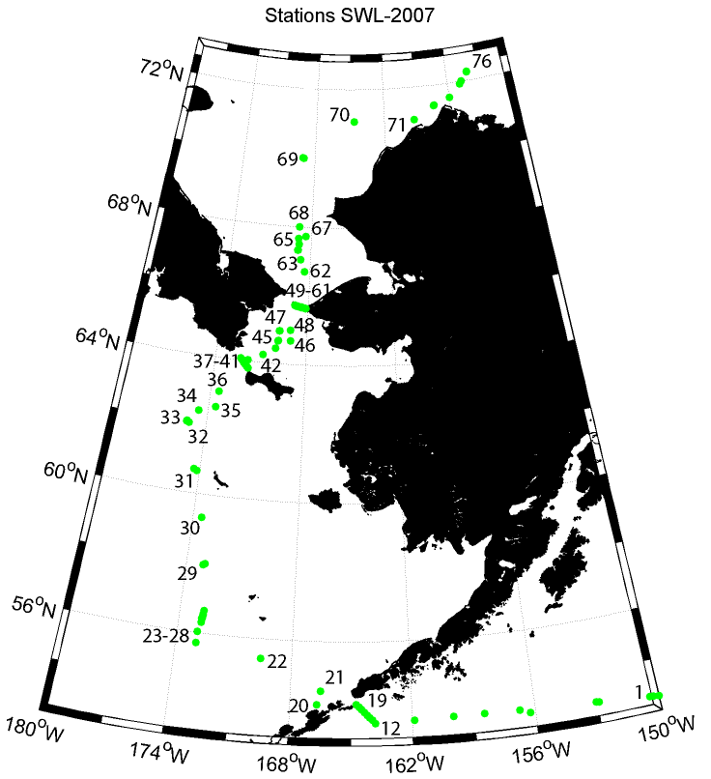
Figure 1. Station location for the Dutch Harbor to Barrow, Alaska portion of Leg 1 during July 2007.

C. Sediment box cores
Sediment box-cores were collected at depths of 200-2100 m at eleven stations (BS2, SLIP1, SLIP3, SLIP4, UTN3, UTN5, UTN7, BC2, NC3, BC4 and BC5. The regions sampled include the southern part of Bering Sea, the Chukchi Sea and the Barrow Canyon. The box-corer used for the sampling had a collection area of 600 cm². All cores were immediately sectioned horizontally in 0.5 cm thick slices from the surface to 2 cm depth, and then in progressively ticker layers of 1, 2 and 3 cm, down to 35-45 cm depth. Sediments samples were stored in plastic bags and containers and kept frozen for later chemical analysis. (210Pb, 137Cs, redox-sensitive elements such as Mn, Fe, reduced S, Re, Mo, U, S, and Cd,, organic carbon, aliphatic and aromatic hydrocarbon, Pb and stable Pb isotopes).
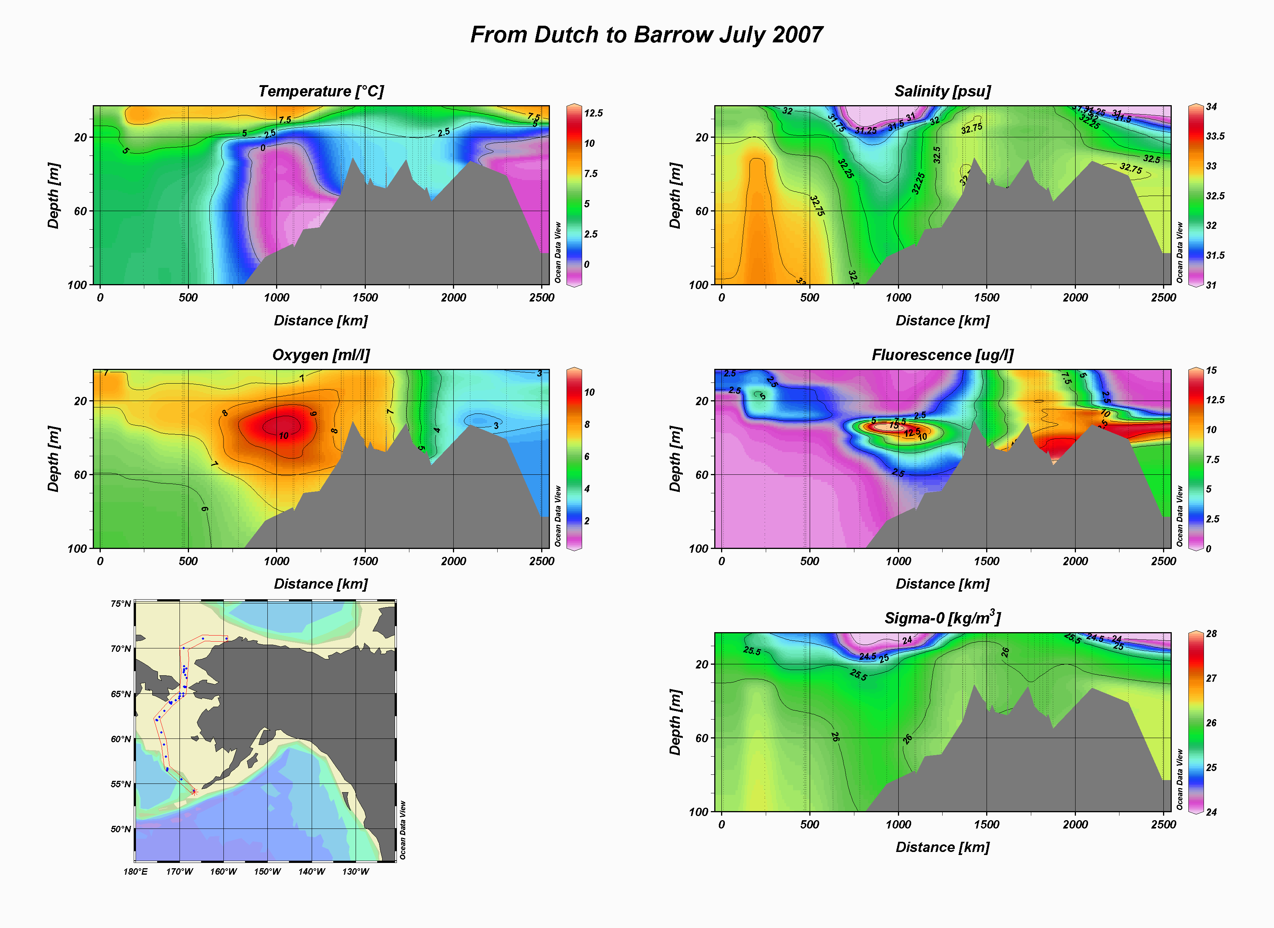
Figure 2. Distribution of hydrographic parameters collected during the Dutch Harbor to Barrow portion of Leg 1, July 2007.

Radioisotope Use: No

Decommission lab and report ANY use to IOS RSO

PROBLEMS [SCIENTIFIC GEAR
AND OPERATIONS]:

None

SUCCESSES [SCIENTIFIC]:
We successfully occupied all the planned stations, In addition, we occupied additional stations in Anadyr Strait and along a shelf-to-basin transect down Barrow Canyon. We were able to do a scientific and community visit at Little Diomede Island for both discussion on our Bering Strait Observatory project and to interact socially with the local Alaska citizens.

PROBLEMS [SHIP’S EQUIPMENT/
OPERATIONS/PLATFORM SUITABILITY]:
None

SUCCESSES [SHIP]:
We occupied all the originally planned stations as well as opportunistic stations. A large quantity of water column and sediment field measurements was made.

DELAYS [OTHER THAN WEATHER]:
None

SAFETY CONCERNS:
None

HAZARDOUS OCCURRENCES:
None

EVENT LOG: revise, add correct stn numbers, lat long

SUMMARY/FINAL COMMENTS:

We would like to thank Captain Norman Thomas, the officers and crew of the CGCS Sir Wilfrid Laurier for their excellent support to make this cruise such a successful mission. Support by colleagues at the Institute of Ocean Sciences in Sidney, BC, especially Bon von Hardenburg, Eddy Carmack, Fiona Maclaughlin, and Jane Eert provided the cruise planning and effort necessary to make this a successful mission.

