PACIFIC REGION CCG VESSEL -POST CRUISE REPORT

NAME OF SHIP/PLATFORM: John P Tully

DATE: FROM: 7 February 2007 TO: 27 February 2007

SCIENCE CRUISE NUMBER: 2007-01 SHIP’S PATROL NUMBER: 06-12

CHIEF SCIENTIST[S]: Marie Robert

SCIENTIFIC PERSONNEL:

Female | Male
Janet Barwell-Clarke | Doug Anderson
Jian Guo (UBC) | Michael Arychuk
Hollie Johnson (Volunteer) | Michael Bentley (CWS)
Lora Pakhomova (UBC) | Keith Johnson
Marie Robert | Benoît Montpetit (Volunteer)
 | Doug Moore
 | David Semeniuk (UBC)

AREAS OF OPERATION: North East Pacific, Queen Charlotte Sound, Rivers Inlet, Hakai Passage, Strait of Georgia

INTRODUCTION/PROGRAM BACKGROUND: Line P is a long standing program which surveys a 1400 km long section 3 times annually. Data has been collected along this line since 1956 and shows evidence of the impact of climate variability on ocean productivity. It is the only Canadian long time-series that allows scientists to monitor climate changes in the Pacific Ocean. It is also the best opportunity for other programs (e.g. Universities) to do research in the Pacific since the Line P data give them background as well as current water properties. In addition, it is the best occasion for other projects (e.g. CWS) to access offshore waters.

CRUISE OBJECTIVE/OBJECTIVES: Repeat hydrography sections, study eddies.

DAYS ALLOCATED: 20 DAYS OF OPERATION: 17

DAYS LOST DUE TO WEATHER: ~ 2 days, 7 stations cancelled

RESULTS:

- The Line P survey was successful. No casts were cancelled due to weather.
- Unfortunately Line R could not be completed because of bad weather.
- Two eddies were situated north of Line P which were sampled on the return route.
- The samples collected include:
- Underway: T, S, fluorescence, pCO2, acoustic sounder, ADCP.
- Discrete (casts): T, S, fluorescence, oxygen, transmissivity, irradiance.
- Water: oxygen, salinity, nutrients, chlorophyll, HPLC, DIC, Alk, C13, DMS, ONAR (Oxygen, Nitrogen, ARgon), Iron.
- Zoo-plankton using vertical net hauls.

M. Robert: Temperature, Salinity and Sigma-t data

The mixed layer depth seems to have returned to more ‘normal’ values for February at around 100-110 dbar.
The signature of the eddies situated just north of Line P, as we were going west, are reflected in the temperature and salinity profiles. It will be interesting to look at the results from the two eddy studies.

W. K. Johnson: Iron/Trace metal Sampling JP Tully 2007-01, February 8th – 23rd

Line P, and Eddy trace metal sampling was carried out with IOS’s normal clean sampling methods using the Asti all Teflon pump for 5 to 40m samples and 12L X-Niskins for 75m to 800m. The HEPA hood was set up in the wet lab to sample 5-40m samples for both unfiltered and filtered (0.2u Opti cartridge). Zodiac hand sampling was undertaken where conditions permitted for surface samples which were filtered in U. Vic.’s clean hood using pre-cleaned Durapore o.2u membrane filters. Sampling was focused on the surface mixed layer with only a few stations down to 800m. No iron analysis was completed onboard and the clean tent was not constructed, rather sample handling was facilitated using 2 clean hoods. Shallow profiles were collected for IOS (filtered and unfiltered Fe) and U. Vic. (Dr. Jay Cullen) for filtered Cd and Cu. A line P transect sampling at 10m and 25 m was undertaken at most of the line P stations (major stations plus P05, P06, P07, P10, P11, P12, P15, P19, P22, P24 and P25). Trace metal clean seawater was also collected for Valeria Willers of U. Vic (75L filtered 0.2u at 10m station P26) and Jun Nishioka of Hokkaida university (3 – 20L carboys 0.2u 10 m). All IOS samples were acidified with 1 ml of 1:1 conc. Baseline HCl per 125ml seawater. U. Vic. samples were similarly acidified. Salinities were collected from all sample depths greater than 50m to confirm depth of sample, although the mixed layer was below 100m.

Sampling Summary for Fe, Cd and Cu profiles

Depth P04 P12 P16 P20 P26 PEddy Eddy2
0m X
5m X XX
10m X X X X XX X X
25m X X X X XX X X
40m X X X X XX X X
75m X X X X XX X X
100m X X X X XX X X
150m X X X XX X X
200m X X X XX X X
300m XX X X
400m XX X X
600m XX X X
800M X X X
Notes:
- The shive on the hydro winch was not turning freely and started to stick at P26. Depths were recalculated using the wire for readings as the shive was operational under load. After P Eddy the Bosun had the shive routered and the inside of the casing bead blasted to remove any rust and to smooth the inner surfaces. Subsequently the shive worked fine at the next Eddy station. Many thanks to the crew who were exceptionally helpful on this expedition.
- Rough weather (high winds and large waves) made station keeping very difficult especially at the second eddy (Eddy2). This resulted in some large wire angles so salinity must be used to estimate depth.
- We ran out of bottles for U. Vic. sampling after P26 so no samples were collected at the eddies for Cu and Cd. We did collect duplicate filtered samples for IOS (250ml) and these could be used if needed by U. Vic.

W. K. Johnson, Mike Arychuk and Hollie Johnson: Carbonate Studies JP Tully 2007-01, February 8th – 23rd

Three aspects of carbonate sampling and analysis were undertaken for the February 2007 expedition to OSP. The normal underway continuous automated pCO2 and the sampling for DIC and C13 were complimented by discrete pH analysis.

1) pCO2
pCO2 was run using the seawater loop system for the entire expedition up until 0930 on Feb. 22nd. The system was set up by Hollie, Marty and Mike using Mike’s SOP. The atmospheric intake was modified so that only the forward air intake line was connected. Previously the aft air intake had normally been shut off at all times so it was thought we should disconnect the “T” to prevent accidental mixing of air intakes. We were worried about contaminated air being sampled from loose fittings so care was taken to ensure fittings on air intake were tightened appropriately.
Due to thorough mixing in the SML (down to >100m) caused by high winds and low productivity (at this time of year) the air and seawater often tracked remarkably close to one another. They were so close together that it was a concern at one point. Spikes in the air due to stack gas contamination did not influence the seawater signal. There was some problem with measuring seawater flow to the equilibrator as the vanes in the meter sometimes stuck. This did not mean there was no flow to the equilibrator so the zero flows should be ignored. At one point the NMEA connection to the computer loosened and no position data etc was collected for some hours before it was reconnected. This happened at OSP area.

2) DIC/alkalinity sampling
DIC/alkalinity samples were collected in 500ml bottles at all major stations on line P. One duplicate was collected at each station between 1000 and 3000m. A calibration cast was conducted at R11S (south of R11) with 5 bottles tripped at 2005m and each sampled in duplicate. Station P26 was sampled in duplicate so that C13 could be measured as well.

3) pH
pH was conducted at major line P stations using the new Agilent (HP) spectrophotometer and the m-cresol purple technique of Clayton and Burne. Cells (100mm cylindrical glass) were filled directly from Niskins. They were stabilized at 25º C using a Neslab constant temperature bath (only adjustable to 0.1 º) and the IOS aluminium block. Profiles were collected from all major line P stations as well as R12 and Eddy2 (just south of line R). Duplicates gave a precision between .003 and .007 while replicates of 4 or more gave a precision of .002 to .005. A comparison test with Ocean optics showed the Agilent to be superior as the precision of the ocean optics was .009 to .016.

Dave Semeniuk, Jian Guo

Background: It has been well documented that high latitude, HNLC regions are iron (Fe) and light co-limited during the winter months. Iron and light are intimately linked in phytoplankton, where typically greater than 90% of cellular Fe requirements are utilized within the chloroplast during photosynthesis. Furthermore, recent findings in our lab and during the previous Line P cruise in September suggests copper (Cu) plays an intimate role in Fe metabolism such that cellular Cu demands increase during Fe-limitation. These higher Cu requirements represent an increased demand for Cu in Fe-transport via a high affinity reductase/multiple-containing Cu oxidase/permease system, a replacement of Fe for Cu in various metabolic pathways, or both. Therefore, it is possible that Cu may play in integral role in maintaining phytoplankton standing stocks in Fe and light co-limited regions of the global ocean.

Objective: We aimed to determine whether increasing Cu availability to Fe-light-co-limited natural phytoplankton assemblages was capable of relieving growth limitation of these phytoplankters.

Specific Goals: We performed canonical on-deck bottle incubations with 10L carboys, supplementing the water with Fe, Cu, or both under high and low light regimes. Each day we sampled the carboys for size-fractionated Chl a, bacterial abundance, phytoplankton species composition, Fv/Fm (a measure of photosynthetic “stress”), and nutrients. Furthermore, using H¹⁴CO₃⁻, we measured carbon fixation as a function of light availability (P vs I curve) to determine the maximum photosynthetic capacity and relative rates of photosynthesis under each experimental treatment.

We would like to thank IOS for letting us join them on another cruise, Keith for collecting the 100+ liters of clean seawater using his pump on the chains, as well as Janet for analyzing our nutrient samples promptly. Although our initial cruise objectives did not turn out as planned, it was a very pleasant (albeit bumpy) trip. Lastly, we would like to thank the entire crew for their professional and cordial service during this expedition. Thank you!

Radioisotope Use:

Some work was done with radioisotopes (55-Fe, 14-C, 3-H) by the UBC personnel. The lab was cleaned and decommissioned as soon as their work was completed. Copies of the decommission lab report and other related paperwork were handed to the first officer on board the Tully as well as to the IOS RSO.

PROBLEMS [SCIENTIFIC GEAR AND OPERATIONS]:

We had to cancel some stations because of weather.

The science server had to be re-booted twice. On the first re-boot it worked properly but the second re-boot resulted in not all software working properly. Thanks to the Second Officer, Bryen McGuire for all his help with our computer problems.

The EK60 Acoustic Sounder ran out of disk space twice. Users have to ensure to copy then delete their data on the sounders/server hard drives at the end of their cruise.

The Portasal could not be used on board because of a problem with the pump clutch.

The spare CTD had to be used along Line P in the stand-alone set-up because of rough weather. One of the temperature sensor was not working properly and had to be changed after the cast. It is unknown at the moment if the data for that cast can be calibrated or not.

During rough weather one of the tables in the lab, on which the UBC gear was set up, crashed, along with all the gear. Another of the IOS tables had to be tightly roped so that it would not collapse. It is time for IOS to build new and solid sea-going tables. The same can be said about the compressed tank holder. The wood started to splinter and a new one should be made.

SUCCESSES [SCIENTIFIC]:

Thanks to the crew, we managed to do some rosette and bongo casts in quite rough weather. There were times when we found ourselves working in conditions somewhat above our threshold.
We also had time to do a few extra casts for other groups: 6 bongo tows in Rivers Inlet for Evgeny Pakhomov at UBC, 5 stations in Hakai Passage for Eddy Carmack at IOS, 2 rosette casts for Diane Masson at IOS, and 1 CTD/Bongo station for John Dower at UVic.

PROBLEMS [SHIP’S EQUIPMENT/OPERATIONS/PLATFORM SUITABILITY]:

We had problems with the shive of the hydro winch (310, #1082). See note 1) from W.K. Johnson.

SUCCESSES [SHIP]:

A huge “Thank You” to the bosun Mel Hull and all his crew who helped us with our science work. Because of lack of science personnel the ship’s crew gave us a huge hand on deck.
And thank you again to the second officer Bryen McGuire for all his help with computer problems.

DELAYS [OTHER THAN WEATHER]:

None.

SAFETY CONCERNS:

None.

HAZARDOUS OCCURRENCES:

None.

EVENT LOG:

DATE OPERATIONS

Wednesday 7 Feb: Load the ship at IOS.
Thursday 8 Feb: Leave Pat Bay. Two casts in Saanich Inlet.
Friday 9 Feb: Start Line P.
Thursday 15 Feb: Arrive at Station P then leave for Line R. Do 1st eddy stn.
Friday 16 Feb: Start Line R.
Sunday 18 Feb: Second eddy stn.
Monday 19 Feb: Stop work on Line R because of weather.
Tuesday 20 Feb: Sample eastern half of SS Line and Rivers Inlet.
Wednesday 21 Feb: Sample Koeye River/Hakai Passage stations. Finish sampling SS Line.
Thursday 22 Feb: Sample 3 stns in Strait of Georgia.
Friday 23 Feb: Offload at IOS.

CRUISE TRACK:

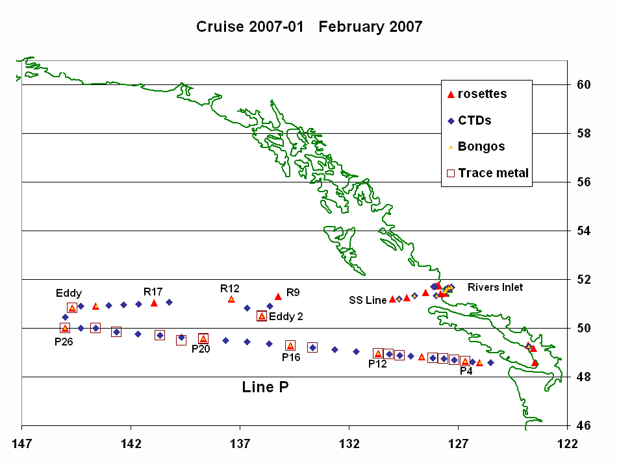

SUMMARY/FINAL COMMENTS:

- Many thanks to the whole crew of the Tully for all their help in making this cruise such a success. Thanks also to the two volunteer students who helped standing watches.
- Special thanks to the galley crew for preparing vegetarian meals! Hollie Johnson

