EXPEDITION PLAN AND ITINERARY

DEPARTMENT: DFO, Ocean Sciences and Productivity Division

MISSION NO: 2007-01 CCG PATROL NO: 06-12

MISSION AREA: Line P, Station Papa, Line R, North-East Pacific, Rivers Inlets

MISSION OBJECTIVE: Repeat hydrography section.

SHIP: John P. Tully

DATE, FROM: 7 Feb TO: 27 February 2007

SENIOR SCIENTIST: Marie Robert

SCIENTIFIC PERSONNEL: 12 berths required
Female | Male
Janet Barwell-Clarke | Doug Anderson
Jian Guo (UBC) | Michael Arychuk
Hollie Johnson | Michael Bentley
Lora Pakhomova (UBC) | Keith Johnson
Marie Robert | Benoît Montpetit
 | Doug Moore
 | David Semeniuk (UBC)

SHIP EQUIPMENT REQUIRED: depth sounder, sea water supply to lab and heli-deck, heave compensator, tugger winch, Zodiac and/or 733.

DECK MACHINERY REQUIRED:

Note: The details are on the deck plan, at the end.

OTHER EQUIPMENT TO BE LOADED: Scientific gear (lab instruments, sampling equipment, etc.), containter.

ANTICIPATED LOADING TIME: Half-day. Loading will start at 1300 on February 7 after the Dewey cruise will be offloaded.

DANGEROUS CHEMICALS:
[INCLUDING MATERIAL SAFETY DATA SHEETS AND WHMIS LABELS]
Separate list to follow, to be handed to the Chief Officer before departure.
Radioisotopes will be used.

Station List:

Station | Latitude  deg min N |  | Longitude  deg min W |  | Bottom Depth m |  | Sampling
Underway sampling survey
JF1 | 48 16.00 |  | 123 30.00 |  | 150 |  | under way
JF2 | 48 18.00 |  | 124 00.00 |  | 180 |  | under way
JF3 | 48 27.00 |  | 124 30.00 |  | 230 |  | under way
JF4 | 48 32.30 |  | 125 00.00 |  | 60 |  | under way
Line P CTD and water sampling survey
P1 |  | 48 34.5 |  | 125 30.0 |  | 120 |  | CTD B-10
P2 |  | 48 36.0 |  | 126 00.0 |  | 114 |  | Rosette B-10, Bongo
P3 |  | 48 37.5 |  | 126 20.0 |  | 730 |  | CTD B-10
P4 |  | 48 39.0 |  | 126 40.0 |  | 1300 |  | Rosette B-10, Bongo,  Go-flos
P5 |  | 48 41.5 |  | 127 10.0 |  | 2100 |  | CTD 2000 m
P6 |  | 48 44.6 |  | 127 40.0 |  | 2500 |  | CTD 2000 m
P7 |  | 48 46.6 |  | 128 10.0 |  | 2450 |  | CTD 2000 m
P8 |  | 48 49.0 |  | 128 40.0 |  | 2440 |  | Rosette 2000 m, Bongo
P9 |  | 48 51.4 |  | 129 10.0 |  | 2340 |  | CTD 2000 m
P10 |  | 48 53.6 |  | 129 40.0 |  | 2660 |  | CTD 2000 m
P11 |  | 48 56.0 |  | 130 10.0 |  | 2700 |  | CTD 2000 m
P12 |  | 48 58.2 |  | 130 40.0 |  | 3300 |  | Rosette B-10, Bongo,  Go-flos
P13 |  | 49 02.6 |  | 131 40.0 |  | 2875 |  | CTD 2000 m
P14 |  | 49 07.4 |  | 132 40.0 |  | 3275 |  | CTD 2000 m
P15 |  | 49 12.0 |  | 133 40.0 |  | 3200 |  | CTD 2000 m
P16 |  | 49 17.0 |  | 134 40.0 |  | 3550 |  | Rosette B-10, Bongo,  Go-flos
P17 |  | 49 21.0 |  | 135 40.0 |  | 3200 |  | CTD 2000 m
P18 |  | 49 26.0 |  | 136 40.0 |  | 3775 |  | CTD 2000 m
P19 |  | 49 30.0 |  | 137 40.0 |  | 3850 |  | CTD 2000 m
P20 |  | 49 34.0 |  | 138 40.0 |  | 3890 |  | Rosette B-10, Bongo,  Go-flos
P21 |  | 49 38.0 |  | 139 40.0 |  | 3840 |  | CTD 2000 m
P22 |  | 49 42.0 |  | 140 40.0 |  | 3880 |  | CTD 2000 m
P23 |  | 49 46.0 |  | 141 40.0 |  | 3970 |  | CTD 2000 m
P24 |  | 49 50.2 |  | 142 40.0 |  | 3910 |  | CTD 2000 m
P25 |  | 50 00.0 |  | 143 36.3 |  | 3890 |  | CTD 2000 m
P35 |  | 50 00.0 |  | 144 18.2 |  | 4170 |  | CTD 2000 m
P26 |  | 50 00.0 |  | 145 00.0 |  | 4250 |  | Rosette B-10, Bongo,  Go-flos
P41 |  | 50 27.00 |  | 145 00.00 |  | 4270 |  | CTD 2000 m
P32 |  | 50 54.00 |  | 145 00.00 |  | 4270 |  | CTD 2000 m
P49 |  | 50 54.00 |  | 144 17.20 |  |  |  | CTD 2000 m
P33 |  | 50 54.00 |  | 143 35.50 |  | 3660 |  | Rosette to 2000 m
R20 |  | 50 55.70 |  | 143 01.00 |  | 3620 |  | CTD 2000 m
R19 |  | 50 58.00 |  | 142 20.00 |  | 3930 |  | CTD 2000 m
R18 |  | 51 00.00 |  | 141 39.00 |  | 3900 |  | CTD 2000 m
R17 |  | 51 02.00 |  | 140 56.00 |  | 3900 |  | Rosette to 2000 m
R16 |  | 51 04.00 |  | 140 14.00 |  | 3800 |  | CTD 2000 m
R15 |  | 51 06.00 |  | 139 30.50 |  | 3000 |  | CTD 2000 m
R14 |  | 51 09.00 |  | 138 47.50 |  | 2910 |  | CTD 2000 m
R13 |  | 51 11.00 |  | 138 06.00 |  | 3680 |  | Rosette to 2000 m
R12 |  | 51 13.00 |  | 137 23.00 |  | 3670 |  | CTD 2000 m
R11 |  | 51 15.00 |  | 136 40.30 |  | 3650 |  | CTD 2000 m
R10 |  | 51 17.00 |  | 135 57.60 |  | 3660 |  | CTD 2000 m
R9 |  | 51 19.00 |  | 135 15.00 |  | 3515 |  | Rosette to 2000 m
R8 |  | 51 21.20 |  | 134 32.70 |  | 3370 |  | CTD 2000 m
R7 |  | 51 23.50 |  | 133 49.60 |  | 3200 |  | CTD 2000 m
R6 |  | 51 25.50 |  | 133 06.60 |  | 3000 |  | CTD 2000 m
MJ5 |  | 51 27.50 |  | 132 24.00 |  | 2765 |  | Rosette to 2000 m
MJ4 |  | 51 35.60 |  | 132 06.50 |  | 2564 |  | CTD
MJ3 |  | 51 43.50 |  | 131 50.00 |  | 2320 |  | Rosette B-10
MJ2a |  | 51 47.50 |  | 131 40.70 |  | 2065 |  | CTD
MJ2 |  | 51 51.60 |  | 131 32.00 |  | 2115 |  | CTD
MJ1a |  | 51 55.70 |  | 131 22.70 |  | 1880 |  | CTD
MJ1 |  | 52 00.00 |  | 131 14.00 |  | 639 |  | CTD
MJ0 |  | 52 02.00 |  | 131 10.30 |  | 79 |  | CTD
JS01 |  | 51 55.00 |  | 130 59.50 |  | 76 |  | CTD
JS02 |  | 51 53.30 |  | 130 56.10 |  | 90 |  | CTD
JS03 |  | 51 50.40 |  | 130 51.50 |  | 189 |  | CTD
JS04 |  | 51 47.90 |  | 130 46.50 |  | 251 |  | CTD
JS05 |  | 51 44.00 |  | 130 39.30 |  | 730 |  | CTD
JS06 |  | 51 39.60 |  | 130 31.70 |  | 1119 |  | Rosette B-10
JS07 |  | 51 32.40 |  | 130 18.80 |  | 989 |  | CTD
JS08 |  | 51 24.30 |  | 130 03.90 |  | 680 |  | CTD
JS09 |  | 51 16.10 |  | 129 49.30 |  | 260 |  | CTD
JS10 |  | 51 07.90 |  | 129 34.80 |  | 265 |  | CTD
JS11 |  | 51 00.00 |  | 129 20.80 |  | 183 |  | CTD
JS12 |  | 50 53.00 |  | 129 08.30 |  | 61 |  | Rosette B-10
JS13 |  | 50 49.60 |  | 128 58.30 |  | 114 |  | CTD
JS14 |  | 50 47.30 |  | 128 47.70 |  | 113 |  | CTD
JS15 |  | 50 46.70 |  | 128 30.90 |  | 71 |  | CTD
SS1 |  | 51 12.00 |  | 130 00.00 |  | 490 |  | Rosette B-10
SS2 |  | 51 13.00 |  | 129 43.00 |  | 580 |  | CTD, Bongo
SS3 |  | 51 15.00 |  | 129 21.30 |  | 285 |  | Rosette B-10
SS4 |  | 51 21.00 |  | 129 00.00 |  | 235 |  | CTD, Bongo
SS5 |  | 51 28.00 |  | 128 30.00 |  | 195 |  | Rosette B-10
SS6 |  | 51 20.00 |  | 128 00.00 |  | 170 |  | CTD, Bongo
SS7 |  | 51 24.70 |  | 127 47.60 |  | 120 |  | Rosette B-10
Ri 1 |  | 51 26.4 |  | 127 38.1 |  | 327 |  | Rosette B-10, Bongo
Ri 2 |  | 51 31.25 |  | 127 33.6 |  | 322 |  | CTD, Bongo
Ri 3 |  | 51 35.9 |  | 127 32.1 |  | 316 |  | CTD, Bongo
Ri 4 |  | 51 38.9 |  | 127 26.7 |  | 294 |  | Rosette B-10, Bongo
Ri 5 |  | 51 40.7 |  | 127 19.9 |  | 194 |  | CTD, Bongo
M2 |  | 51 46.46 |  | 127 53.20 |  | 170 |  | Rosette
M3 |  | 51 46.27 |  | 127 54.60 |  | 325 |  | Rosette
M4 |  | 51 44.65 |  | 128 00.20 |  | 420 |  | Rosette
M5 |  | 51 43.40 |  | 128 03.60 |  | 330 |  | CTD
M6 |  | 51 42.65 |  | 128 07.40 |  | 245 |  | CTD

Note: Only some MJ and JS stations will be chosen depending on how much time is left at the end of the cruise. Some might be added if the weather is too rough to go offshore at start of cruise.
Itinerary

Feb 7 Load at IOS at 1300 (might be earlier, will know closer to Feb 7)
Feb 8 Do Saanich Inlet rosette casts for UBC. Depart to P1 when sampling completed.
Feb 15 Arrive at Station Papa.
Feb 16 Start Line R
Feb 22 Start Line SS.
Feb 23 Sample Rivers/Fitz Hugh Sound.
Feb 24 Start heading to IOS (maybe via the West Coast of Vancouver Island)
Feb 26 Arrive to IOS and offload.

Cruise track
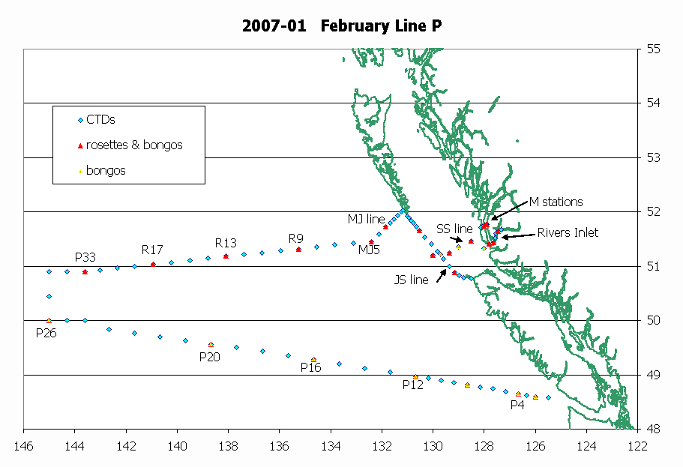
Tasks:
Doug Anderson: Watch, CTD, TSG, Oxygen
Mike Arychuk: DMS, DICs
Janet Barwell-Clarke: Nutrients, help sampling
Michael Bentley: Birds & Mammals observer
Jian Guo: Help with sampling rosette, UBC
Hollie Johnson: Watch, help with pH and DMS
Keith Johnson: Trace-metal sampling and analysis, DICs
Benoît Montpetit: Watch.
Doug Moore: Watch, bongos, salinity
Lora Pakhomova: Half-watch (6-hours), UBC
Marie Robert: Chief scientist, data, rosettes, sampling, Watch
David Semeniuk: Half-watch (6-hours), UBC
List of rosette casts, Cruise 2007-01, February Line P:

Station | Depth of cast | samples | # of niskins
P2 | 114 | Oxy, Nut, Sal, Chl (6) | 8
P4 | 400 | Nut, DMS, Chl (12) | 14
P4 | 1300 | Oxy, TCO₂, Nut, Sal | 19
P8 | 2000 | Oxy, Nut, Sal, Chl (6) | 20
P12 | 400 | Nut, DMS, Chl (12) | 14
P12 | 3300 | Oxy, TCO₂, Nut, Sal | 23
P16 | 400 | Nut, DMS, Chl (12) | 14
P16 | 3550 | Oxy, TCO₂, Nut, Sal | 24
P20 | 400 | Nut, DMS, Chl (12) | 14
P20 | 3890 | Oxy, TCO₂, Nut, Sal | 24
P26 | 400 day | Nut, DMS, Chl (12) | 14
P26 | 400 evening | Nut, DMS, Chl (12) | 14
P26 | 400 night | Nut, DMS, Chl (12) | 14
P26 | 4250 | Oxy, TCO₂, C¹³, Nut, Sal | 24
P26 | 1500 calib | TCO₂, Sal | 24
P33 | 2000 | Oxy, Nut, Sal(4), Chl (6) | 19
R17 | 2000 | Oxy, Nut, Sal(4), Chl (6) | 19
R13 | 2000 | Oxy, Nut, Sal(4), Chl (6) | 19
R9 | 2000 | Oxy, Nut, Sal(4), Chl (6) | 19
MJ5 | 2000 | Oxy, Nut, Sal(4), Chl (6) | 19
MJ3 | 2000 | Oxy, Nut, Sal, Chl (6) | 19
JS06 | 1100 | Oxy, Nut, Sal(4), Chl (6) | 17
JS12 | 61 | Oxy, Nut, Sal(4), Chl (1) | 5
SS1 | 490 | Oxy, Nut, Sal(4), Chl (1) | 19
SS3 | 295 | Oxy, Nut, Sal(4), Chl (1) | 13
SS5 | 200 | Oxy, Nut, Sal(4), Chl (1) | 11
SS7 | 125 | Oxy, Nut, Sal(4), Chl (1) | 9
Ri1 | 327 | Oxy, Nut, Sal(4), Chl (1) | 14
Ri4 | 294 | Oxy, Nut, Sal(4), Chl (1) | 13
M2 | 170 | Oxy, Nut, Sal(4), Chl (1) | 10
M3 | 325 | Oxy, Nut, Sal(4), Chl (1) | 14
M4 | 420 | Oxy, Nut, Sal(4), Chl (1) | 16

Oxygen samples: ~ 400
Salinity samples: ~ 315, so 14 cases (including loops).
Nutrient samples: ~ 600 (including loops and duplicates, 1 per cast)
Chlorophyll samples: ~220 (including loops)

CTD setting:

The instruments needed on the primary CTD are the oxygen sensor, the fluorometer, the transmissometer, PAR and the altimeter (<1000 m casts). Please make sure that all those instruments can be mounted on the secondary CTD if needed.
CCGS John P. Tully
Deck Lay Out: Station P Cruise,
M. Robert
Cruise ID: 2007-01
Date : Feb. 7 – 27, 2007
A: | Not Required
B: | Hydro Winch 310 #1082 c/w 4730m x 5/32” (3x19) wire
C: | Not Required
D: | Work Winch 589 #515c/w  2910 m x 5x16” (3x19) wire
E: | CTD Winch #17027c/w 6100m  x .322” x 3cdr cable
F: | CTD Winch #17026 c/w 3280m  x .322” x 7cdr cable
G: | Not Required
H: | Not Required
I: | Not Required
J: | Not Required
K: | Capstan Required
L: | Heave Compensator Required
Crane |  | Required
Aft A-Frame |  | Required
Stbd. A-Frame |  | Not Required
20' Container |  | Required
Comments:
- Please also load, 2 Osco 20” CTD blocks, and an Omron counter for each winch.
- The Heave Compensator and Tully Tugger operational c/w spares are required. (Ship's Engineers, please)
- Trace-Metal sheave and rollers needed for breeze-way hydro winch 310 #1082

