REVISION NOTICE TABLE
DATE | DESCRIPTION OF REVISION
6 Feb. 2019 | Bottle spreadsheet converted to searchable BOT files.

PROCESSING NOTES
Cruise: 2006-31
Agency: PBS, Salmon and Freshwater Ecosystems, Nanaimo, BC
Location: North-East Pacific
Project: High Seas Salmon
Party Chief: Morris J., Trudel M.
Platform: W.E. Ricker
Date: November 7, 2006 – December 5, 2006
Processed by: Germaine Gatien
Date of Processing: February 15, 2007 – 3 March 2007
Number of original CTD casts: 116 Number of CTD casts processed: 116

INSTRUMENT SUMMARY
A SeaBird Model SBE 911+ CTD (#0506) was mounted with a Seapoint Fluorometer (#2229) with a 10X cable. The deck unit was a model 911 (#0471). The salinometer used was a model 8400B Autosal (serial number 68572).

SUMMARY OF QUALITY AND CONCERNS
There was no loop calibration sampling for the Thermosalinograph and Niskin bottle sampling was well below the intake level, so calibration is based on previous uses. The salinity is very noisy during the record but this is probably due to the fact there was a large gradient close to the TSG intake. There was a 6-day gap in the record near the end of the 3rd file. Following the gap there were just a few records; these were removed so that the track plot would not indicate a straight-line track over the 6 days. A few other bad values in longitude and latitude were replaced with pad values. TSG salinity is considered ±0.02.

There was no deep salinity calibration sampling.
The stops for bottles were often shorter than 20s; a wait of 30s is recommended before firing.
No recalibration was applied to the CTD salinity which is considered ±0.002.

PROCESSING SUMMARY

1. Seasave
This step was completed at sea; the raw data files have extension DAT.

2. Preliminary Steps
The Log Book was obtained and notes were found about problems with the CTD being frozen at the surface for many of the northernmost casts. In some cases the CTD was lowered to 10m and returned to the surface, so care will be needed to ensure the right data are selected at the DELETE stage. The secondary channels were more affected than the primary.
The bottle salinity and chlorophyll data were obtained in spreadsheet format. There was no deep bottle sampling. The nutrients were not available at the time of processing.

The cruise summary sheet was completed. The histories of the conductivity and pressure sensors were obtained as well as that of the thermosalinograph conductivity and temperature.
Calibration constants were checked. The only error was in the serial number of the pressure sensor. After that correction the con file was named 2006-31-ctd.con.

3. Conversion of Raw Data
All data were converted using the con files given above.
One file was named 2006-31-0123dat.* so after conversion the “dat” was removed from the file name.
A few casts were examined and all expected channels are present and look reasonable. It is assumed that sampling was done by a Niskin bottle mounted 5m above the CTD as usual. However, a test attempt to create rosette files produced files from the beginning of the downcasts. Examination of the CTD data makes it clear that the Niskin bottles were fired at about 10m, so these surface files are not useful for comparison with the bottles. Surface data may be useful for comparison with the TSG, but the data in the ROS files are from a time when the pumps were not operating and the differences between the two T and S channels are large. The ROS files will not be processed.

4. WILDEDIT
Program WILDEDIT was used to remove spikes from the pressure, temperature and conductivity channels only.
Parameters used were: Pass 1 Std Dev = 2 Pass 2 Std Dev = 5 Points per block = 50

5. CELLTM
Tests were run on 3 casts using a variety of settings for CELLTM to determine the best choice of parameters. CELLTM was run using (0.02, 9) for the primary and (0.0245, 9.5) for the secondary conductivity for all casts.

6. DERIVE
Program DERIVE was run twice:
on all casts to calculate primary and secondary salinity.
on all casts to calculate the differences between primary and secondary channels for temperature, conductivity and salinity. These were placed in a test directory and will not be archived.

7. Test Plots and Channel Check
Three casts were plotted to check for agreement between the pairs of T and C sensors. The following values are rough estimates from downcast data:
Cast # | Press | T1-T0 | C1-C0 | S1-S0 | Descent Rate
54 | 180 | -0.0007 | -0.00032 | -0.0027 | High, very steady
 | 240 | -0.00068 | -0.0003 | -0.0026 | High, very steady
102 | 180 | -0.0005 | -0.00048 | +0.0047 | High, steady
156 | 180 | -0.00055 Noisy | X Noisy | X Noisy | High, steady
 | 240 | -0.0005 | -0.00041 | -0.004 | High, steady
312 | 180 | -0.0005 | -0.00050 | +0.0050 | High, steady
 | 240 | -0.0005 | -0.00054 | +0.0052 | High, steady
321 | 180 | -0.0005 | -0.00060 | -0.0058 | High, fairly steady
 | 240 | -0.0005 | -0.00060 | -0.006 noisy | High, fairly steady
The conductivity and salinity differences were noisy. There appears to be a drift in the conductivity calibration of at least one conductivity sensor. There is no significant pressure dependence.

8. Conversion to IOS Headers
The IOSSHELL routine was used to convert SEA-Bird 911+ CNV files to IOS Headers.
CLEAN was run to add event numbers and to replace pad values in the Pressure channel using linear interpolation based on scan number.

9. Checking Headers
The header check was run and no errors found.
The header summary was run and station names were checked against the log as well as a random sampling of positions and times to ensure that the GPS was working well. No errors were found.
The track plots (using event #s and station names) were produced and added to the end of this report.
The average surface pressure is 4.3db which is reasonable for the Ricker. Calculations were made of mixed-layer depth based on salinity value change relative to 4db and 10db. These may be useful in deciding which salinity bottles are most useful for calibration of the TSG and CTD salinity.

10. SHIFT
Fluorescence
In the past it has been found appropriate to advance the Fluorescence by +24 records (1s) relative to the other channels. A few casts were examined to compare the offset between the upcast and downcast fluorescence with that of the temperature traces to ensure this setting is appropriate. However, the fluorescence was so low that the noise obscured the offset; while +24 looks reasonable it is hard to judge.
A shift of +24 records (1s) was applied since this is the usual for this equipment. (Output: SHFFL)

Conductivity
Tests were run on the primary and secondary conductivity channels using a variety of settings. The best results overall were with a choice of -0.6s for the primary and +1.5 for the secondary. The secondary shift is larger than usual. All casts were put through SHIFT using those settings.

11. DELETE
The following DELETE parameters were used:
Surface Record Removal: Last Press Min Maximum Surface Pressure (relative): 10.00
Surface Pressure Tolerance: 1.0 Pressure filtered over 15 points
Swells deleted. Warning message if pressure difference of 2.00
Drop rates < 0.30m/s (calculated over 11 points) will be deleted.
Drop rate applies in the range: 10db to 10db less than the maximum pressure
Sample interval = 0.042 seconds. (taken from header)
The output files were checked for 5 casts for which the log mentions that the CTD was lowered and returned to the surface before the full cast because the instrument was frozen: #249, 252, 261, 276 and 279. For the last three of these files the data chosen by DELETE all come from after the initial soak, but for #249 and #252 there is a patch with some surface data from early in the initial soak and some from the full downcast. The SHFC1 files for those two casts were edited to remove the initial section and DELETE was rerun. The 5 casts mentioned plus #231, 234, 255, 258 and 267 must be checked later to ensure the downcast data near the surface are useful. All had problems with freezing.

COMMENTS ON WARNINGS: All the warnings pertain to upcast data, so are of no concern.

12. REVERSE and DELETE
At this stage salinity profiles were produced for all the northern casts to see how the upcast and downcast data compare. It appears that despite the measures taken to unfreeze the CTD, much of the downcast data from the top 50m or so are of poor quality. For this reason upcast data will be used for casts #231-237, 249 and 255-282. Those casts were put through REVERSE and then DELETE was run again. All casts were put through REVERSE for use in comparison with bottle data. Those casts were clipped to 20db, put through DELETE and bin-averaged in 0.25db bins.

13. COMPARISON WITH BOTTLES
The salinity and chlorophyll data were obtained in spreadsheet format. The original file from the salinity analyst did not have a flag channel so that was added.
The two spreadsheets were combined and saved as 2006-31-sal-chl.csv.

Salinity
There are problems with salinity calibration based on bottles:
- There was no deep sampling.
- The depth of sampling is uncertain for two reasons. The bottles mostly stopped at about 10db but there is some variability in that. The height of the Niskin above the CTD is uncertain, probably 5m but the operator cannot see the CTD while it is being deployed so cannot say for sure.
- Casts with low gradients at about 10m are found mostly in the later part of the cruise. The results of the study in section 8 shows that there is temporal drift in at least one sensor, so we cannot extrapolate from late in the cruise to the rest. Fortunately, there were a few casts in the first half with fairly well-mixed surface waters, so we can place some confidence in the conclusions.
- The stops for bottles were shorter than the recommended 30s.

Plots were made of some casts to check the depth at which the CTD was stopped for sampling. For most casts the stop was at 15db ±0.5db. There was one cast with a stop at 17db and then again at 12db followed by a little sinking, so it is not clear where the bottle was fired. But for most the stopping level is quite consistent. The stops were short, from 10 to 15s each. One cast was examined closely and it appears that as the CTD started upwards again a large shed wake was passing through the level of the CTD. Waiting 10 or 15 more seconds would minimize the possibility of such corruption.

CTD fluorescence and salinity data from 8, 10 and 12db were extracted from CTD files and compared to the salinity bottle data. There is a lot of scatter in the results but the secondary salinity is clearly closer to the bottles than the primary. 14 casts were selected that were well-mixed between 10 and 20db. The primary salinity was found to be high by about 0.0023 and the secondary was low by about 0.0019. When 1 outlier (casts #44) was removed the differences were +0.0027 and -0.0016. A linear fit of differences against event # shows that Sal0-Sal:Bottle has a much higher slope than for Sal1-Sal:Bottle which is fairly flat with time. For the primary salinity any correction would have to be time-dependent since the differences vary from -0.001 at the beginning to 0.006 at the end. The secondary salinity looks like the better choice for this cruise. It is low by about 0.0022 at the beginning of the cruise and by 0.0012 at the end. The average is -0.0016 but more of the comparisons came from later in the cruise, so the midpoint value of -0.0015 is a more appropriate choice. (See 2006-31-comp-10db.xls.)

Checking some of the less well-mixed casts, an attempt was made to estimate what depth the water in the Niskin came from. Results suggest anywhere from 6 to 12db, but for most, 10db does look like a reasonable estimate.

Fluorescence versus titrated chlorophyll
The titrated chlorophyll data were compared with the upcast CTD data from 10db. When CHL is plotted against CTD Fluorescence there is a lot of noise, especially in the earlier part of the cruise. Later, when values were low there is little noise. When restricting the choice of data to the subset of casts identified above as having well-mixed surface waters (10 – 20db), the ratio of FL to CHL is about 1.3, with a range of 1.1 to 1.6. Cast #44 was not included because it stood out as an outlier, as it did during the salinity comparison.

At this point all data from 10db were compared to CTD data to check for outliers. While cast #44 was considered an outlier in the study of well-mixed casts, it is not so far out of line as to justify a flag and there are some doubts about the CTD data. Looking at the CTD data in that file it is not clear at what depth the CTD stopped and the ascent rate was extremely noisy. So the outliers in the comparisons are probably due to poor CTD data, though it is also likely that the water in the Niskin had little time to equilibrate to in situ conditions.

Bottle flags were entered into the combined spreadsheet as follows:
135 – CHL and salinity both flagged “d” since they are out of line in comparison with CTD and nearby sites, with the salinity much lower; looks like a bottle misfire nearer surface than 10m.
252 – CHL and salinity flagged “d”; values way out of line with other stations in area and with CTD. CHL also flagged by analyst as having higher than usual variability. It is presumed there was a Niskin misfire.
255 – CHL and Salinity flagged “d”; values way out of line with other stations in area and with CTD. It is presumed there was a Niskin misfire.

The flags were also entered into 2006-31chlarc.xls after discussion with the analyst.

14. DETAILED EDITING
As discussed above, the secondary salinity is the best choice since the calibration did not vary greatly through the cruise. Page plots were produced using (T1, S1). These were used to guide the editing.
On-screen plots of descent rate and pump status were also used to guide editing.
All casts required editing except for cast #111, with the heaviest applied to files containing upcast data.
Note was made of the editing details in the headers of the relevant files.

15. Other Comparisons
Previous experience with these sensors – The pressure sensor and the two conductivity sensors have not been used since the last factory calibration so there is no history for them.

Historic ranges – Profile plots were made of T and S with local climatology superimposed where available. There were many excursions, but most likely represent real variations. Surface salinity and temperatures were often lower than the local minimum, but this cruise followed a period of very heavy rain and occurred during a period of extremely low temperatures and many of the casts were in inlets. The surface waters for some casts show very deep mixing. Temperatures were a little high at depth for one cast and salinity was high for another, so there is no suggestion of systematic errors.

16. Initial Recalibration
The salinity comparisons suggest that the secondary channel gives salinity that is within ±0.002. Given the limitations in the comparison recalibration is not justified.

17. Fluorescence Processing and special files for Angelica Peña
The EDT files were put through a median filter, size 11, applied to the fluorescence channel only.

Five sets of files were prepared for the use of Angelica Peña:
TWO DOWNCAST DATA SETS
1. The EDT files were clipped to 100db, bin-averaged with 0.25db bins, unwanted channels removed and HEADEDIT used to fix headers, formats, channel names and to add comments. (Output: FCTD1)
2. The EDT files were clipped to 100db, median filtered (width 11 applied to fluorescence only), bin-averaged with 0.25db bins, unwanted channels removed and HEADEDIT used to fix headers, formats, channel names and to add comments. (Output: FCTD2)
THREE UPCAST DATA SETS - Because there were no rosette files special files were prepared with upcast data from around the depths at which chlorophyll was sampled. The SHFC1 files were put through REVERSE. (Output: REV)
3. The reversed files were put through DELETE to create files with upcast data only. Those were clipped so they contain only the top 20db of data, then REMOVE and HEADEDIT were run to remove unwanted channels and fix formats and add a comment. (Output: UPFCTD1)
4. Another set of upcast files were created by applying a median filter of fixed width 11 to the fluorescence channel of the REV files followed by DELETE, CLIP, REMOVE and HEADEDIT. (Output: UPFCTD2)
5. Finally a set of upcast files were created by running DELETE, CLIP, REMOVE, BIN AVERAGE and HEADEDIT. (Output: UPFCTD3) The bins were size 0.25db.

18. BIN AVERAGE of CTD files
The following Bin Average values were applied to the FIL files (output AVG):
Bin channel = pressure Averaging interval = 1.000 Minimum bin value = .000
Average value will be used. Interpolated values are NOT used for empty bins.
After averaging, page plots were examined on screen. No further editing was considered necessary.
Temperature, Salinity and Fluorescence profiles were plotted on-screen and no problems noted.

19. FINAL CTD files steps (REMOVE and HEADEDIT)
The following channels were removed from all casts: Scan_Number, Temperature:Primary, Salinity:T0:C0, Conductivity:Primary, Conductivity:Secondary, Status:Pump, Descent_Rate and Flag.

HEADER EDIT was used to fix formats and channel names, to fix the platform name and geographic description and to add the following comments:
Fluorescence data are nominal and unedited except that
some records were removed in editing temperature and salinity.
The Standards Check routine was run and HEADEDIT adjusted until no further problems were found. The final files were named CTD.

20. Thermosalinograph Data
a.) Checking calibrations
There were 5 identical configuration files so one was renamed as 2006-31-ctd.con. The calibrations were correct. There is only 1 temperature channel and no fluorometer or flow channel. One of the files was misnamed as 2006-22-001.*.

b.) Converting to IOS Headers and adding position headers and time channels
The data were converted to a CNV file using a SeaSoft routine. The channels converted were: Scan_Number, Temperature:Primary, Conductivity:Primary, Latitude, Longitude, Salinity:T0:C0 and Time Julian. There was no channel for Flow Rate, no secondary temperature and no fluorometer.

The data files had non-standard names (just missing a 0 so there were only 3 digits in the event #) so were renamed after conversion.

The files were then converted to IOS HEADER format.
CLEAN was run to add End times and Longitude and Latitude minima and maxima to the headers.
ADD TIME CHANNEL was used to add time and date channels and the output files were named *.ATC.

There was a note with the log book reporting that the TSG data were of poor quality. A preliminary track plot shows a few spikes in position and further plots identified exactly where those occurred. A text editor was used to replace the bad positions in the ATC files with pad values or to remove records, as required:
- File 2006-31-0003: There is a gap (~6 day) between the 3rd record from the end and the last 2 records. The last 2 records were removed using a text editor so that the track plot did not misrepresent the cruise track.
- File 2006-31-0004: Scans #2955 and 8919-8927, latitude and longitude values bad; replaced with pad values.
- File 2006-31-0005: Scan #2677, latitude and longitude values look bad; replaced with pad values.
After the editing CLEAN and ADD TIME CHANNEL were rerun. A track plot was produced and it looks fine as long as no attempt is made to connect files. If the latter is done the plot shows two straight lines that do not reflect actual ship tracks.

A time-series plot was produced. There is a very large range of salinity but this is reasonable given that the ship went into inlets. There are some large spikes. The data from the inlets suggest that the intake must be in a strong gradient region so that it is sometimes in low salinity water and other times in high. The thermosalinograph on the Ricker is quite close to the surface at ~3m. During another recent RICKER cruise there was some evidence to suggest that changes in ship direction could be related to such changes possibly due to the ship heeling over. This could be true here as well. Unfortunately there is little useful CTD data above 5m during the downcasts, but the upcasts do suggest that there is a very high salinity gradient at about 4db for many casts, so slight changes in the depth of TSG intake, relative to the sharp gradient, might well lead to very noisy salinity.

c.) CTDEDIT
CTDEDIT was used to smooth isolated salinity spikes not associated with temperature spikes. Files 1, 2 and 5 required such editing. A few records were also removed from the end of file #4 because there was sudden drop in salinity and no useful positions.

d.) Checking Time Channel
The time was checked by reading off the data from the TSG file at times of a few CTD casts. The positions were compared from the CTD and TSG and none differed by more than 0.0002º of latitude or longitude, so the time appears to be correct as it has been for all recent cruises using this equipment.

e.) Comparison of T and S from TSG and CTD data
- The CTD data are not useful in calibrating the TSG since the pumps were rarely turned on at the level of the TSG during either the upcast or downcast. Moreover, there is not great confidence in the CTD calibration itself.
- There was no intake temperature sensor for comparison with the TSG.
- There are bottle samples from about 10m, but those are too deep to be useful, based on an analysis of the mixed-layer depth relative to 4db.
- There were no loop samples.
- The CTD temperature was compared with the TSG temperature for a few casts but once again there is a lot of noise. For several casts the differences were not believable and for 3 it varied from 0.06 to 0.08 with the TSG higher than the CTD.

f.) Calibration history
The TSG has been used for 8 TULLY cruises and three on the RICKER since it was last recalibrated in January 2005. During 2006-08 the salinity was found to be low by 0.02. Temperature adjustments for the TULLY cruises were on the order of -0.14Cº to -0.22Cº, depending on season. The loop distance is shorter for the RICKER so less heating is expected. An estimate of an error 0.05Cº due to ship heating was made for 2004-32 when this equipment was used on the RICKER. That cruise was in autumn when the temperature difference between ocean and ship would be lower than in December, so we might anticipate a slightly higher ship effect on temperature for this cruise. During 2006-09 (March) when recalibration was based on history and upcast CTD data, the temperature were adjusted by subtracting 0.07Cº and the salinity by adding 0.02 units.

There was a post-cruise calibration that indicates that the salinity would be high by about 0.02 due to the conductivity sensor drift and by about of +0.001 due to the error in the temperature sensor. But the salinity correction includes the effect of ship heating on the salinity reading of the TSG which makes it low by something like 0.06. This would suggest that the salinity correction should be something like +0.04 rather than +0.02. However, the TSG needed repairs and it is unknown when the damage occurred. The adjustments applied for recent cruises are reasonably close to this result, and this analysis suggests that the salinity is likely good to ±0.02.

Conclusions
For salinity the adjustment used for 2006-08 is the best estimate available. For the temperature correction an estimate was made that the heating by the ship would be at least as large as that in February 2006. It could be even greater due to the adverse weather, though that might affect the ship temperature as well. So a choice of -0.07Cº was selected for the heating factor.

f.) Recalibration
File 2006-31-TSG-recal.ccf was used to apply offsets of -0.07 Cº and +0.020 to Temperature:Primary and Salinity:T0:C0.

h.) Preparing Final Files
REMOVE was used to remove the following channels: Scan_Number, Conductivity:Primary and Flag.

HEADER EDIT was used to change the DATA TYPE to THERMOSALINOGRAPH and to add the depth of sampling to the header and the following comment about the data.
The temperature and salinity data have been recalibrated based on past history
since there was no calibration sampling from the loop, no CTD data from the depth
of the CTD and no intake temperature measurements.
As a final check plots were made of the cruise track and data; no problems were noted.

20. Producing final files
A cross-reference listing was produced for CTD files.
HEADER CHECK was rerun and a cruise track plotted and no errors found.
The sensor history was updated for the TSG and CTD sensors.

Particulars: (Notes from log book)
231, 234. Secondary salinity cell frozen at surface, clears at about 10m. Air temp = -8ºC
231-237 – Upcast data selected for archive.
249 - Upcast data selected for archive.
249, 252, 255. T and S slow to work, cycled to 10m and back – surface reading iffy
255-282 - Upcast data selected for archive.
258. CTD frozen at surface – run down to 10m and back. Primary data ok, secondary iffy.
267. CTD frozen at surface – run down to 10m and back. Surface T&S iffy, secondary not right at surface.
276, 279. CTD frozen – surface T and S questionable.

Institute of Ocean Sciences

CRUISE SUMMARY

Cruise ID#: 2006-31
Dates: Start: 7 November 2006 End: 5 December 2006
Location: NE Pacific
Vessel: W.E.Ricker Party Chief: Morris J., Trudel M.
CTD# | Make | Model | Serial# | Used with Rosette? | CTD Calibration Sheet Competed?
1 | SEABIRD | 911+ | 0585 | No | Yes

CTD Calibration Information
Make/Model/Serial#: SEABIRD/911+/0506 Cruise ID#: 2006-31

Calibration Information
Sensor |  | Pre-Cruise |  | Post Cruise
Name | S/N | Date | Location | Date | Location
Temperature | 4484 | 19/03/05 | Factory
Conductivity | 2280 | 23/05/06 | “
Secondary Temp. | 2710 | 07/04/05 | “
Secondary Cond. | 1764 | 23/05/06 | “
Fluorometer | 2229 |  | IOS
Pressure Sensor | 77511 | 26/05/2006 | Factory

TSG Calibration Information
Make/Model/Serial#: SEABIRD/21/2488 Cruise ID#: 2006-31

Calibration Information
Sensor |  | Pre-Cruise |  | Post Cruise
Name | S/N | Date | Location | Date | Location
Temperature | 2488 | 06/01/05 | Factory | 29/12/06 | Factory
Conductivity | 2488 | 06/01/05 | “ | 29/12/06 | Factory
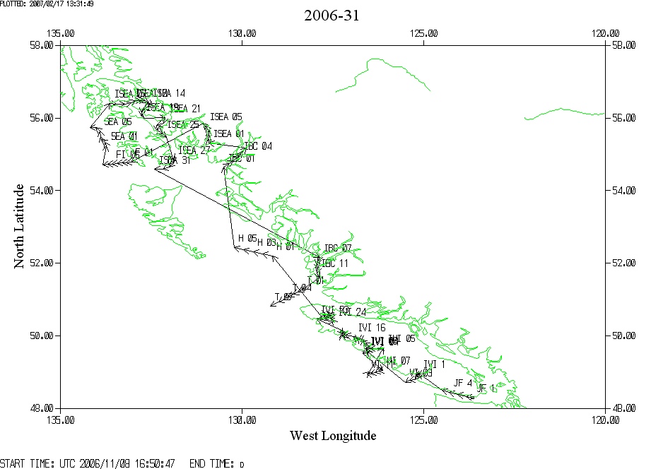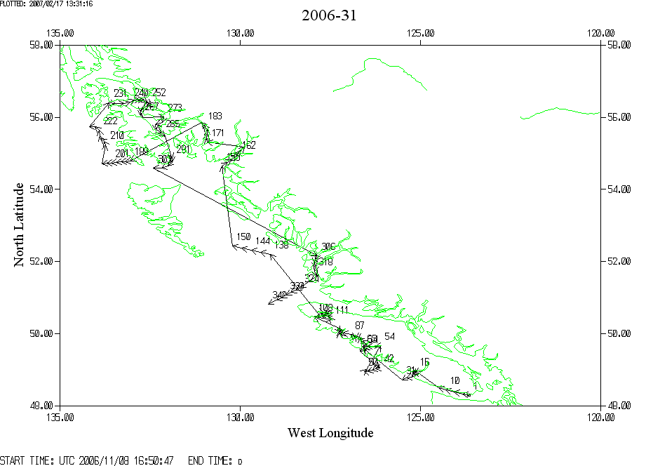

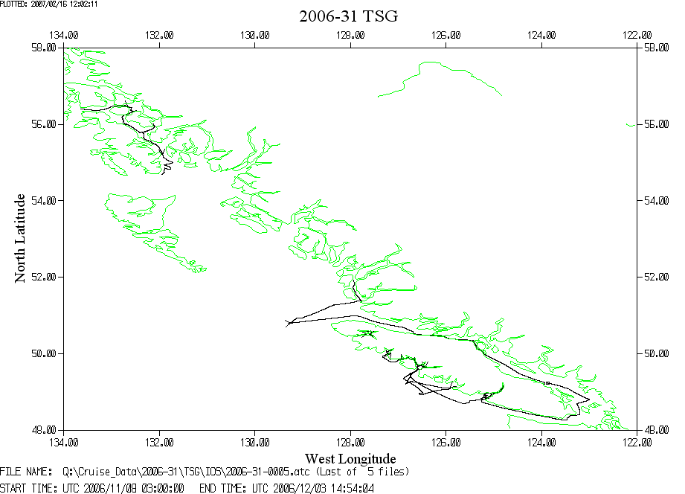

Note that the TSG record has gaps at the end of the 3rd file and between files 4 and 5.

