REVISION NOTICE TABLE
DATE | DESCRIPTION OF REVISION
23 Nov 2021 | Corrected Salinity:Bottle lost during addition of HPLC. S.H.
13 January 2021 | Added HPLC Data. S.H.

PROCESSING NOTES
Cruise: 2006-29
Agency: IOS, Ocean Sciences Division, Sidney, BC
Location: Strait of Georgia, Juan de Fuca Strait
Project: SoG - JdeF
Party Chief: Masson D., Peña A.
Platform: Vector
Date: September 11, 2006 – September 17, 2006

Processed by: Germaine Gatien
Date of Processing: 16 December 2006 – 5 February 2007
Number of original CTD casts: 73 Number of CTD casts processed: 72(1 test file surface only)
Number of rosette casts: 32 Number of rosette casts processed: 28 (no sampling from 4 casts)

INSTRUMENT SUMMARY
A SeaBird Model SBE 911+ CTD (#0443) was mounted with a Chelsea/Seatech transmissometer (#498DR), a PAR sensor (#4565), a surface PAR sensor (#16504) and an Altimeter OA-916D (#1024). A SeaBird dissolved oxygen sensor (#0766) and a Seapoint Fluorometer (#2356) with a 10X cable were mounted on the pumps. The deck unit is unknown. The salinometer was an 8400B model Autosal (S/N 68572).

SUMMARY OF QUALITY AND CONCERNS
The CTD log book and rosette sheets were available. Both include helpful comments on problems encountered. There were problems with sample numbers, but notes on the rosette sheets were helpful in resolving most of them. On several occasions 2 bottles were fired at one depth but only one sample number was assigned. If such sampling is planned (i.e. not accidental) it is clearer and makes processing easier if sample numbers are assigned to both even if no samples are taken from one of them.

The fluorescence dark value was ~0.07ug/l at the mouth of Juan de Fuca Strait and closer to 0.12ug/l in the Strait of Georgia. The higher dark values were also noted with this sensor during 2006-21 in June.

The SBE dissolved oxygen sensor performed well with some detail in the profile and reasonably good correspondence between downcast and upcast. The SBE dissolved oxygen data in the CTD files should be considered, roughly:
- ±0.4ml/l from the surface to 150m
- ±0.2ml/l below 150m

Most stops for rosette sampling lasted about 15s and firing occurred at about the 10s mark, which may have contributed to unusually noisy comparisons between CTD salinity and bottle samples, especially in the higher gradient regions. In some cases it could be observed that a shed wake moved through the level of the bottle just as it was fired increasing the possibility that the CTD and bottle were not measuring the same thing. The appendix contains a few plots to illustrate the problem.

PROCESSING SUMMARY

Seasave
This step was completed at sea; the raw data files have extension DAT.

Preliminary Steps
The Daily Log Book and Rosette Log were obtained. The Daily Log includes useful comments on problems encountered.

The nutrient, chlorophyll and salinity data were each obtained in spreadsheet format.
Individual dissolved oxygen bottle files were obtained with flag channels and comments.

The CTD calibrations were checked. The only problem was in the PAR sensor calibration. After consulting Melanie Quenneville who then contacted SeaBird for confirmation, the offset was changed in the configuration file which was then saved as 2006-29-ctd.con.

The cruise summary sheet was completed.
The histories of the conductivity, DO and pressure sensors were obtained.

Conversion of Raw Data
The files were converted to CNV files. A few files were checked and there are some pressures <0db which appear to correspond to in-water values. Based on observations during 2006-25 an offset of +3.7db looks appropriate so the configuration file was changed and the data was reconverted using that offset.

As usual for this area the descent rate was highly variable; it was very steady for some casts, very noisy and fairly low for others.
Bottle stops typically lasted for 15s which is much lower than the recommended 30s.
The temperature and conductivity channels are farther apart than usual during downcasts and significantly different during upcasts.
Transmissivity shows reasonable agreement between downcast and upcast.

As has been observed with this particular sensor since it was last repaired, the dissolved oxygen looks good; upcast and downcast are offset vertically, but without the sort of hysteresis that was always observed in the past.
The fluorescence looks ok; the dark values are ~0.07ug/l at the beginning of the cruise but higher later in the cruise, ~0.1ug/l.
The altimetry is often extremely noisy but the data look reliable near the bottom.

Rosette files were converted using a start time of -2s and duration of 5s.
All files were then converted to IOS HEADER format. CLEAN was used to add event numbers and the extensions were changed to BOT. Header Check was run on the BOT files and an error was found in the headers of cast #80. The ROS file headers were corrected and the file reconverted and put through CLEAN.

All BOT files were plotted and a few significant outliers were found in the secondary salinity for cast #44 and the primary salinity for cast #60. The bad data was cleaned using CTDEDIT and the output copied to BOT. Note was made in the headers of the editing done.

WILDEDIT
Program WILDEDIT was used to remove spikes from the pressure, temperature and conductivity channels only.
Parameters used were: Pass 1 Std Dev = 2 Pass 2 Std Dev = 5 Points per block = 50

CELLTM
Three casts with a steady descent rate were studied to determine the choice of parameters for CELLTM. Settings of (0.01, 7), (0.01, 9), (0.02, 7), (0.02, 9), (0.03, 7), (0.03, 9) and (0.0245, 9.5) were tried. A choice of (0.02, 7) was best for the secondary sensors but there was little difference among a number of choices for the primary sensors. When the same sensors were used during 2006-25 a setting of (0.02, 7) was found appropriate for both pairs of sensors.
CELLTM was run using (0.02, 7) for both pairs of sensors.

DERIVE
Program DERIVE was run twice:
on all casts to calculate primary and secondary salinity.
on all casts to calculate the differences between primary and secondary channels for temperature, conductivity and salinity. These were placed in a test directory and will not be archived.

Test Plots and Channel Check
A sample of casts was plotted to check for agreement between the pairs of T and C sensors.
Cast # | Press | T1-T0 | C1-C0 | S1-S0 | Descent Rate
1 | 290 | -0.0025 | -0.00002 | +0.0020 | Mostly steady but noisy near bottom
63 | 290 | -0.0025 | -0.00012 | +0.0009 | Moderate, very steady
78 | 290 | -0.0027 | -0.00012 | +0.0011 | Moderate, very steady
The temperature differences are similar to those of 2006-21 and 2006-25.

Conversion to IOS Headers
The IOSSHELL routine was used to convert SEA-Bird 911+ CNV files to IOS Headers.

CLEAN was run to add event numbers and to replace pad values in the Pressure channel using linear interpolation based on scan number.

Checking Headers
The header check was run and an error was found in the headers of cast #30. Scrambled SeaBird headers were fixed and the file was reconverted and put through CLEAN.
The header summary was checked carefully against the log book entries and one error in station name was found and corrected.
Track plots were produced and added to the end of this report.
The average surface pressure is ~1.0db which is low for the Vector but there is only one slightly negative surface value and the measurements taken there show it was very close to the surface, so it appears that the CTD was often started right at the surface with the CTD likely dipping in and out of the water. Any error in pressure appears to be very small, but a pressure test at sea would be useful. No further offset will be applied. The mixed layer calculation shows that surface salinity samples will not be very useful for calibration purposes as the gradients are likely to be large there.

The altimeter values were exported to a spreadsheet; a few casts were examined and the algorithm was found to have worked well.

There were a number of comments in the log book concerning possible errors in headers and data; those were checked at this point:
- Cast #37 – there is a comment that the pump came on while the CTD was out of water. There is no evidence of this in the data file so presumably the data was not being logged at that point.
- Cast #55 headers and display look fine.
- The conductivity and salinity for cast #57 look bad for much of the upcast, but appear to be fine for the downcast. This was not a rosette cast so bottle comparisons will not be affected. The headers look fine.
- Cast #69 water depth was changed to 230 in the header.

BOTTLE FILE PREPARATION
There are a number of unusual aspects to the sampling and sample numbers:
- cast #1 had 24 bottles fired, but no sampling was done so this bottle file will not be processed.
- casts #3, 4, 5 – bottles were fired as tests, no sampling was done; the bottle files will not be processed further.
- cast #7 (station ADCP) – most t-chl samples missing and 1 sf-chl sample missing.
- cast #8 (station 69) – the original sample numbers on the rosette sheet are not the same as those used on the samples. Corrections were entered on the rosette sheet to make them match the labels.
- cast #11 (stations 72) – some of the sample numbers were repeats of numbers used for cast #8 (samples #37 through 44). A note on the rosette sheet indicates that the nutrient sample numbers were renumbered as #937 to #944. The dissolved oxygen and titrated chlorophyll sample numbers were changed to match those of the nutrient samples.
- There was some chlorophyll sampling for which no consecutive sample numbers were assigned; these were done in support of radiometer data. These were given numbers with the format 9XXX or 8XXX. In some cases this is recorded on rosette sheets, sometimes not. The event number listed on the rosette sheets is sometimes the one for the radiometer cast, but the data were actually collected during the CTD cast that preceded each radiometer cast.
- In many cases 2 bottles were fired at one depth but only 1 sample number was assigned. In those cases -99 was entered for sample number of one bottle.

The BOT files were averaged to enable an addsamp file to be created. This file was edited to add sample numbers taken from the rosette sheets. This was saved as addsamp.csv. Because the sample numbers are irregular for this cruise extra steps were required to order the data on sample number. The addsamp data was reordered on event #, then sample # and saved as addsamp2.csv. That file was then converted to CST files to form the framework for the bottle files. Sample numbers were added to the BOT files (output: SAM) which were then bin-averaged (SAMAVG) on bottle number. Those files were then sorted on sample number (SAMSORT).

The salinity data was provided in EXCEL format with flag and comment channels. Flags and comments had been added for one sample. There was no event # entered for one sample but there was a comment from which it was easy to determine that it came from cast #58, so that was entered. Channel names were changed to standard format and the file was saved as 2006-29-sal.csv. The files were converted to individual SAL files.

The extracted chlorophyll data was in spreadsheet format and included a flag channel and comments. The spreadsheet was edited by changing channel names, adding an event number for each sample and adding “Extracted Chlorophyll:” before each of the comments. The sample numbers for cast #11 were changed because some were duplicates of cast #8; the numbers were changed to match what was done for nutrient sampling. The resulting file is 2006-29chl.csv. That spreadsheet was converted to individual files. (Output: CHL)

The analyst asked that the following comment be added to the usual bottle header comment for chlorophyll analysis: “For this cruise the samples were kept frozen for several weeks.”
And a separate note should be entered in the bottle file for cast #7 as follows: “Stn ADCP samples: most t-chl samples are missing, 1 sf-chl is missing.”

The dissolved oxygen data was received in individual files with flag channel and comments. The file names were non-standard so the names were fixed. The file named as cast #1 should be cast #2 so that was changed. For cast #8 the sample numbers were changed to the new ones added to the rosette log sheet (34 through 44). For cast #11 sample numbers 37 – 45 were changed to 937-945 because the former numbers were already used for cast #8. The file was reordered on increasing sample number.

At this point MRGTEM files were prepared by merging SAL, CHL and ADD files with CST files in order to run COMPARE, thus enable processing to proceed without nutrient data being ready. The files used for COMPARE were not the final ones but did contain final SAL, CHL and DO bottle data. Once the nutrient data was ready final bottle files were prepared as described below.

The nutrient data was provided in spreadsheet format with flag channel and comments. Channel names were changed to standard format and lines with no sampling were removed; the files were saved as 2006-29nuts.csv. The data were converted to individual files NUT files. The file named as cast #1 was changed to #2.

The SAL, CHL, ADD and NUTS files were merged with the CST files in four steps. (Output: MRG1, MRG2, MRG3, MRG4.) The MRG4 files were cleaned to reduce the headers to File and Comments. (Output:MRGCLN1) and those files were merged with the SAMAVG files to produce MRG files. MRGCLN1 files for cast #11, 58 and 80 had to be rearranged in reverse pressure order to enable the merge to work.
The MRG files were put through CLEAN, this time to remove SeaBird headers and comments from the secondary files. (Output: MRGCLN2)

11. COMPARE
Salinity
COMPARE was run and there was a lot of scatter in the differences. When samples from above 200m and differences >0.02 were excluded a flat trend line was achieved for both salinity channels when plotted against time or pressure. The following outliers were examined in detail:
- Cast #2, sample #1, Niskin #2. This was a fairly deep sample but from an area of high salinity variability and the stop was short, so the difference (-0.066) between CTD and bottle may be due to lack of time for equilibration. The sample was flagged “c”
- Cast #11, sample #39, Niskin #?. The rosette sheet indicates that the salinity sample taken during cast #11 was from Niskin #2. The salinity analysis sheet gives the bottle as #3. The sample number (39) is the one originally assigned for Niskin #3, but due to duplicates used during the cruise the sample number was changed to 939. The sal file was edited to change the sample number to 939 and COMPARE will be rerun with that change. Some doubt will remain because the two bottles have similar salinity, so this sample should be flagged “c”.
- Casts #23, 27, 42, 62, 65, 73 were shallow with large local gradients and short stops so large differences are not unexpected. No flags were assigned.
- Casts #58 and #80, Niskin #1. These samples were from very close to the bottom. The CTD is higher than the bottles as is often seen near the bottom, possibly due to a bottom boundary layer. These samples will be flagged “c”.
- Cast #73, Sample #266, Niskin #2. The stop was short in a high gradient area and a significant shed wake was seen by the CTD immediately after stopping. It seems likely that the large difference between CTD and bottle is due to the bottle contents not having had time to reach in situ values.

COMPARE was rerun after fixing the sample number for cast #11.
There is a lot of scatter in the results. When bottles from above 200db and those with differences from the CTD of >0.009 are removed, the primary and secondary salinity are low by an average of 0.0058 and 0.0036. These are larger differences than expected, but may reflect that the bottle stops were short. There are only 9 bottles and 3 depths in the comparison.

There is little time dependence when the same 9 bottles are used.

Dissolved Oxygen
Plots of Titrated DO versus CTD Salinity from the bottle files were examined. The only large outlier was sample #245 from cast #68. Other samples that are mild outliers are sample #75 from cast #15 and sample #100 from cast #32.

COMPARE was run excluding any DO samples with “d” flags. Plotting the differences versus CTD DO and pressure and excluding cases where the differences were >1.5 produced reasonably tight fits against pressure and CTD_DO. Four outliers were identified:
- Cast #8 – sample numbers had not been changed to match the numbers on the rosette logs.
- Cast #15, Sample #64 – There were two bottles at the same depth. One was an extreme outlier compared to the other and compared to the CTD_DO. A “c” flag had been assigned to sample #65, but this does not seem appropriate. The flag was removed from sample #65 and a “d” flag was placed on sample #64.
- Cast #68 – Sample #245 is an outlier and was also an outlier in DO vs SAL plot, so flagged “c”.
After these changes COMPARE was rerun.

Excluding only the flagged values mentioned above the fit was:
DOX-BOT = 1.0932 * DOX-CTD + 0.1232
When a few more points were removed based on residuals, the fit was found to be:
DOX-BOT = 1.0968 * DOX-CTD + 0.0931
Given that the stops were short the conditions at the DO sensor may be different from those in the bottles, so we would expect that the fit might be somewhat different from fits from other cruises. Given that difference the fit is reasonably close to that of 2006-21:
DOX-BOT = 1.0866 * DOX-CTD + 0.0412

The fit against pressure excluding the same points has a lot of scatter with the trendline:
DOX-BOT = DOX-CTD -0.0006 * Pressure +0.447
This compares with the results of 2006-21:
DOX-BOT = DOX-CTD -0.0008 * Pressure +0.4361
The fit versus time shows slight temporal drift when the same outliers are excluded as for the other fits, but it is probably no more than would be explained by different DO ranges in different parts of the cruise.

Fluorescence versus Extracted Chlorophyll
COMPARE was run for a quick check on the data. When CHL was plotted against fluorescence there was an excellent fit with
SBE Fluorescence = 0.9720 * Titrated CHL - 0.0799
There were no significant outliers though the scatter is much greater for CHL>2 than for <2, but even at CHL = 7 the fit is good. Work had been done recently on the lab fluorometer which may account for the improved fit.

Fluorescence values at depth are on the order of 0.12ug/l, with a value of 0.11ug/l for the deepest cast, #82, at 423db.

Other Comparisons
Previous experience with these sensors –
- Both conductivity sensors were used many times since they were last calibrated, but there were often either no bottles or a lot of scatter in the comparison. For 2006-11 in April the scatter was large but quite flat when outliers were removed. There were a lot of bottles for 2006-10 in June. The primary salinity was within 0.0009 of the bottles for both cruises with the salinity low if bottom bottles were excluded and a little high if they were included. The secondary was found to be high by 0.0014 and 0.0031.
- This DO sensor was used for 2006-08, 2006-11, 2006-10 and 2006-21, but the first was a very complex processing job as an error was made in the identification of the sensor so recalibration was done twice. However, an analysis of one cast shows that the relationship was something like:
CTD-BOT = 1.08 DOX-CTD - 0.005 (2006-08)
For the other cruises the results were excellent with tighter fits than seen in the past
CTD-BOT = 1.0663 DOX-CTD + 0.0783 with offset of -0.03ml/l applied as a second calibration (2006-11 April)
CTD-BOT = 1.0606 DOX-CTD + 0.1138 with offset of -0.017ml/l applied as a second calibration. (2006-10 June)
CTD-BOT = 1.0866 DOX-CTD + 0.0412 with a pressure dependent second calibration on the order of -0.03ml/l applied. (2006-21 June)

Historic ranges – There are many excursions from the historic ranges with temperatures high near the bottom in the southern Strait of Georgia, often by as much as 0.5Cº. Juan de Fuca Strait has some excursions, mostly temperatures at depth being a little too high. Salinity was slightly high occasionally. In the northern part of the Strait of Georgia there are only minor excursions from the ranges. These excursions are not considered indicative of instrument calibration problems since both pairs of sensors behave the same way and since this region is noted for large variations that are not well represented in the climatology used for the plots.

Post-cruise calibration – The conductivity sensors were recalibrated after this cruise. The primary were found to have no drift in calibration, and secondary had drifted in a way that would produce salinity low by about 0.001.

13. SHIFT
Fluorescence
The usual method for finding what shift is needed for the fluorescence is to examine upcast and downcast profiles to determine the vertical offset of the temperature and fluorescence traces. The differences between these two offsets are treated as a measure of how much the fluorescence needs to be shifted. The “excess” offset for the fluorescence was divided by the averaged descent/ascent rate and divided by 2(since the shift will be applied to both up and downcast) to find the shift (in seconds) to remove that offset. There were a wide range of values (0.5 to 2.5s) perhaps due to low and noisy fluorescence. A shift of 1s has been used in most other cruises and will be used for 2006-29.
All data was shifted by +24 records and a few casts were checked afterwards and found to be shifted appropriately. (Output: SHFFL)

Dissolved Oxygen
Based on the results of other recent uses of this instrument, tests were run using +70 to +120 records on two casts. Judging by how the downcast vs upcast trace offset compares with that of temperature and how features matched, the best choice varied from one depth to another, but overall a choice of +100 or +110 appears to be to be best. A choice of +110 records was found best for all other recent cruises using this equipment.
SHIFT was used to advance the DO channel by +110 records (about 4.5s).
After this step a few casts were plotted and the results are good; the offset between downcast and upcast features in DO looks much like those for temperature.

Conductivity
Tests were run on one cast with a steady descent rate to determine the best shift of the conductivity sensors based on reduction of instabilities in salinity without oversmoothing. The best settings proved to be -0.2 for the primary sensor which is the same result as found during 2006-08, 2006-11 and 2006-21. The secondary conductivity looks best with no change as was found during 2006-11, so no shift will be applied. Both conductivity channels were advanced by -0.2. (Output: *.shfc0 and *.shfc1).

DELETE
The following DELETE parameters were used:
Surface Record Removal: Last Press Min
Maximum Surface Pressure (relative): 10.00
Surface Pressure Tolerance: 1.0
Pressure filtered over 15 points
Swells deleted. Warning message if pressure difference of 2.00
Drop rates < 0.30m/s (calculated over 11 points) will be deleted.
Drop rate applies in the range 10db to 10db less than the maximum pressure
Sample interval = 0.042 seconds. (taken from header)
COMMENTS ON WARNINGS: none

DETAILED EDITING
It was not obvious which sensors to pick. The primary sensors have been selected in all recent uses of this equipment, and in the past primary salinity was closer to bottles. For this cruise the secondary appear to be closer to bottles but there are some doubts about the quality of the bottle comparison. A look at noise levels in the sensors suggests there is no significant difference. The primary were selected based on the history of the sensors.

Page plots were produced and used to guide the editing. On-screen plots of descent rate and pump status were also used
The following casts required fairly heavy editing: 7, 9-17, 21-27.
All other casts required only lightly editing mostly at the surface and bottom of casts.
Note was made of the editing details in the headers of the relevant files.

Initial Recalibration and Fluorescence Filter
Salinity will not be recalibrated. Previous uses of the primary sensors suggest they are within 0.0013 and the post-cruise calibration shows no drift at all in the conductivity sensor. From this cruise the average difference suggests that the salinity is low by 0.0058, but that fit is based on few points and a very limited pressure range. It is possible that there was significant drift in temperature, but this is not likely.

From section 11 we have the following equation for recalibration of DOX:
DOX-BOT = 1.0968 * DOX-CTD + 0.0931
File 2006-29-recal1.ccf was prepared to apply the above correction to the DO channel in the SAM and MRG files. COMPARE was rerun for dissolved oxygen and showed that the recalibration worked well. (See 2006-29-dox-comp2.xls.)
(This step was first done on temporary files because nutrients were not yet available. When the nutrient data became available, this step was repeated on the new MRG files with nutrient data in them.)

The edited downcast files, EDT, were recalibrated using 2006-29-recal1.ccf. (Output:COR1)

The COR1 files were clipped to 100db and set aside to be processed later for Angelica Peña.
A median filter, fixed size=11, was applied to the fluorescence channel in the COR1 files to reduce spikiness. One cast was examined before and after this step and showed that the filter was effective. (Output: FIL)

BIN AVERAGE of CTD files
The following Bin Average values were applied to the FIL files (output AVG):
Bin channel = pressure
Averaging interval = 1.000 Minimum bin value = .000
Average value will be used. Interpolated values are NOT used for empty bins.
After averaging, page plots were examined on screen and no further editing was deemed necessary.

Final DO comparison and calibration
SHIFT addresses errors due to transit time, and the comparison with titrated samples those due to drift in calibration. But there remains an error due to poor time response of the sensor. To analyze that, a comparison is made between the downcast values at the depths of bottles and the titrated DO values.

The FIL files were bin-averaged (0.25db bins) & thinned to usual bottle levels. Then CTD DO values were compared with the upcast bottle DO values. Plots were made of differences against pressure and DOX and outliers were excluded. A fairly flat fit was found by comparing differences against SBE DO values; when outliers were excluded the average difference gave the CTD values as high by 0.038ml/l. (See 2006-29-dox-comp3.xls.) The CTD DO data in the thinned files was recalibrated using file 2006-29-recal2.ccf to apply an offset -0.038ml/l and COMPARE was rerun. The results were satisfactory. (See 2006-29-dox-comp4.xls.)

File 2006-29-recal2.ccf was then applied to the AVG files to lower the SBE DO values by 0.038, but not to the bottle files since this error does not apply to data collected while stopped. (Output: COR2)

Special Fluorometer Processing
All COR1 files were put through CLIP to produce files with data to 100db only for the use of A. Peña.

Those files were then bin-averaged (1/4db bins), recalibrated suing 2006-29-recal2.ccf and put through REMOVE to remove extraneous channels. HEADEDIT was run to fix formats and channel names and the final files (FCTD1) were saved in a separate directory.
A second set of files (FCTD2) were prepared in exactly the same way except that the fluorescence data was put through a median filter with fixed width 11, before bin-averaging.
The recalibrated CTD bottle files (SAMCOR1) were put through REMOVE and HEADEDIT and saved as BOF files in a separate directory.

FINAL CTD files steps (REMOVE and HEADEDIT)
For all casts the following channels were removed from the COR2 files: Scan_Number, Temperature:Secondary, Salinity:T1:C1, Conductivity:Primary, Conductivity:Secondary, Oxygen:Voltage:SBE, Descent_Rate, Status:Pump, Altimeter and Flag channels. (Output: *.REM)

CHANGE UNITS was used to derive Oxygen:Dissolved:SBE in umol/kg.
REORDER was used to get the two SBE DO channels together.

HEADER EDIT was used to fix formats and channel names and to add the following comments:
Transmissivity and fluorescence are nominal and unedited except that
some records were removed in editing temperature and salinity.

The SBE dissolved oxygen data in the CTD files should be considered:
• ±0.4ml/l from surface to 150m
• ±0.2ml/l below 150m
The Standards Check routine was run and HEADEDIT adjusted until no further problems were found. The files were named CTD.

A final check on the dissolved oxygen values was done by calculating DO saturation. Plots show surface values ranged from ~50% to 75% for Juan de Fuca and Haro Strait while in the Strait of Georgia values generally ranged from 90 – 110%. The extremes in DO saturation generally matched those in fluorescence.

Final Bottle Files
The MRGCLN files were put through SORT to rearrange data with increasing pressure.
REMOVE was run to remove Scan_Number, Temperature:Secondary, Salinity:T1:C1, Conductivity:Primary, Conductivity:Secondary, Status:Pump, Oxygen:Voltage:SBE, Descent_Rate, Altimeter and Flag for all casts.
CHANGE UNITS was used to derive Oxygen:Dissolved:SBE in umol/kg.
REORDER was used to get the two SBE DO channels together.
HEADER EDIT was run to fix formats and units and to add a comment about quality flags and analysis methods.

The following note was added to the header of 2006-29-0007.CHE: “CHL samples: most t-chl samples are missing, 1 sf-chl sample is missing.”

Standards check was run on all files and HEADEDIT adjusted until all format problems were resolved. The files were named CHE.

23. Producing final files
The following steps were used to look for processing errors:
a) Track plots were produced using the final CTD and CHE files.
b) A cross-reference listing and header check was produced for CTD and CHE files.

The sensor history was updated for the CTD pressure, conductivity and dissolved oxygen sensors.

Particulars from logs
1. Tested all rosette bottles.
2. Bottle #1 empty. Bottle #3 didn’t fire first time, went up to 105db then down to 125m to try again. Cast # is wrong on rosette sheet.
3. Bottle #3 did not close.
8. DO samples mislabelled. Only 11 samples for DO.
37. Pumps turned on out of water, then turned off until in water.
48. Bottle #17 did not trigger – filled with surface seawater.
51. Bottles 16 and 17 both fired at surface. Bottles 15 and 16 fired at same time ~5m.
55. Pressure display not available on-screen, probably ok in file. There may be header problems due to steps taken to resolve graphic problem.
57. Primary Salinity jumped to a lower value when instrument stopped and stayed lower than secondary until ~100m level of upcast. Only bottom 4db of downcast affected.
68. Rosette log sheet indicates error in sample #s on bottles.
69. Header file has wrong depth (330 instead of 230).

Institute of Ocean Sciences

CRUISE SUMMARY

Cruise ID#: 2006-29
Dates: Start: 11 September 2006 End: 17 September 2006
Location: SoG/JdeF
Vessel: Vector Party Chief: Masson D. & Peña A.
CTD# | Make | Model | Serial# | Used with Rosette? | CTD Calibration Sheet Competed?
1 | SEABIRD | 911+ | 0443 | Yes | Yes

CTD Calibration Information
Make/Model/Serial#: SEABIRD/911+/0443 Cruise ID#: 2006-29

Sensor |  | Pre-Cruise |  | Post Cruise
Name | S/N | Date | Location | Date | Location
Temperature | 2968 | 01/02/05 | Factory  “
Conductivity | 1766 | 07/06/05 | “
Secondary Temp. | 2106 | 08/07/05 | “
Secondary Cond. | 1729 | 12/07/05 | “
Transmissometer | 498DR | 28/03/06 | Factory
SBE 43 DO sensor | 0766 | 24/11/05 | Factory
Altimeter | 1024 | ? | ?
PAR | 4565 | 23/12/04
Surface PAR | 16504 | 02/01/04
Fluorometer | 2356 |  | IOS
Pressure Sensor | 63507 | 25/10/2004 | Factory

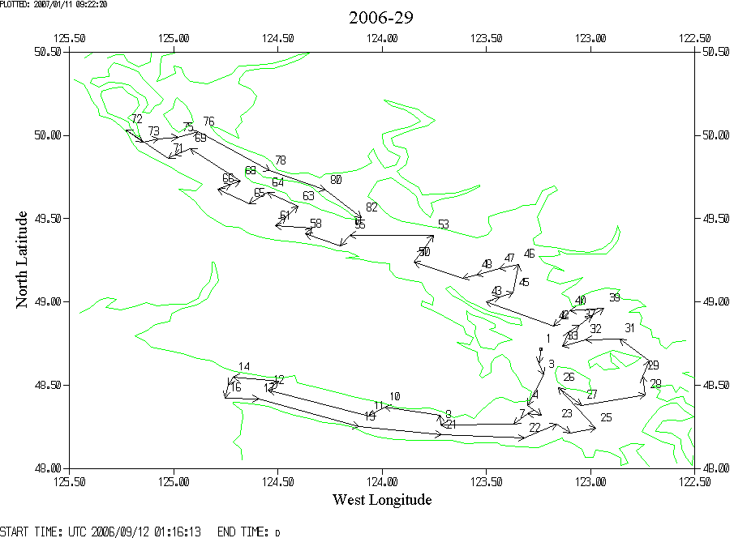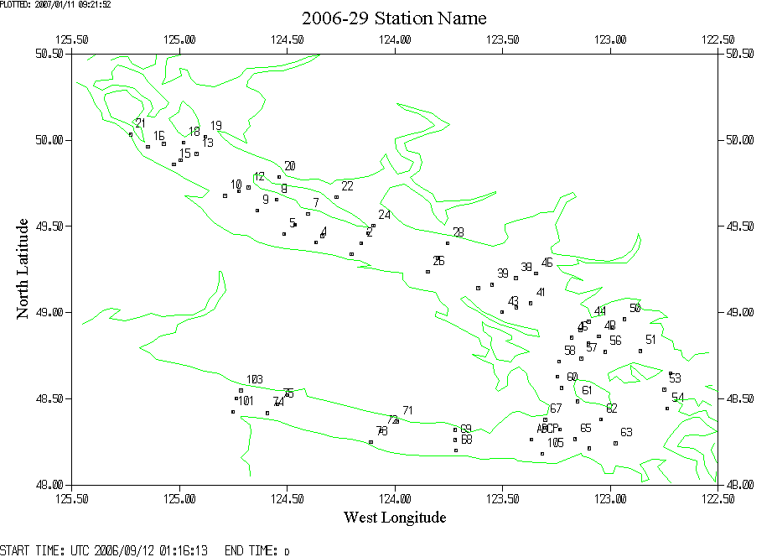

APPENDIX
Problems with short bottle stops
In a study based on data from Line P it was found that waiting 30s before firing a Niskin bottle produced the best comparisons between CTD salinity data and Niskin samples, confirmed by post-cruise calibrations of the CTD sensors. Shed wakes tend to corrupt the CTD data for the first 10 to 20s and there are doubts about whether the water in the Niskin bottles have reached ambient values.
During cruise 2006-29 the bottle stops were only about 15s long and the bottle was fired a few seconds before the CTD started moving up again. The following plots of CTD data taken from upcasts illustrate the problem with quick bottle stops in high gradient regions.

PLOT 1: This plot shows what happened during the stop at 20db during cast #48. The temperature and dissolved oxygen are both noisy and show evidence of shed wakes passing through. It does not look like the CTD temperature had reached ambient values when the Niskin bottle was closed at ~scan 30150 and the DO values were clearly still changing rapidly. Given the large variability it seems unlikely that the Niskin contents would match what the CTD was measuring. The effect at 20db is very large, but even when much smaller, such effects lower the quality of calibrations. This bottle was included in the Dissolved Oxygen comparison because it does not stand out as an outlier, but that may be because so many bottles were cut short in the same way. On the other hand the slow time response of the DO sensor may reduce the impact of the short bottle stops.
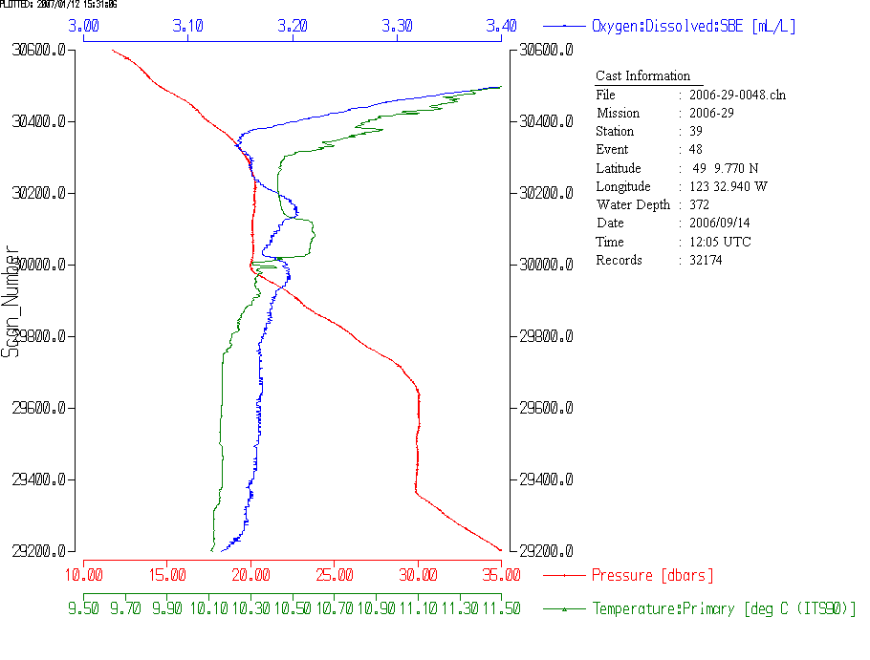
PLOT 2: A bottle was fired at 350db, at scan #15281. The CTD data used in the comparison with bottles is averaged over 120 scans. The average salinity from that section is about 0.003 lower than it would have been if the firing had been a few seconds earlier or later. What is unknown is what water would be found in the Niskin – if it flushes very freely then the comparison may be fine, but if there is a slight delay in flushing then the salinity in the Niksin would be higher than that seen by the CTD by up to 0.009. What the ambient conditions are is not at all clear as the temperature was very noisy while the CTD was slowing down for the bottle stop. 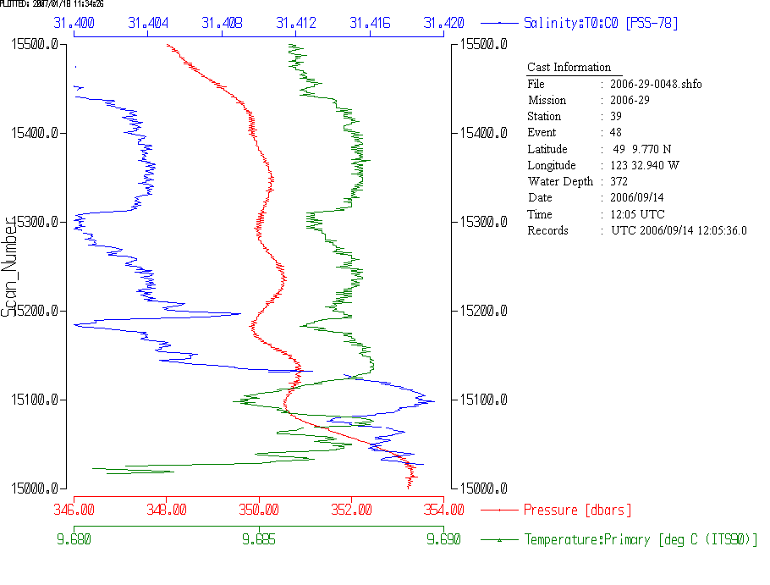
PLOT 3: The bottle was closed at scan #18822. The data used for comparison with the bottles is averaged over 120 scans. There is a lot of noise in the temperature and salinity during that time. The values as the CTD starts upwards again might be due to a shed wake but might reflect ambient conditions. Waiting a few more seconds would likely make this clear.
CO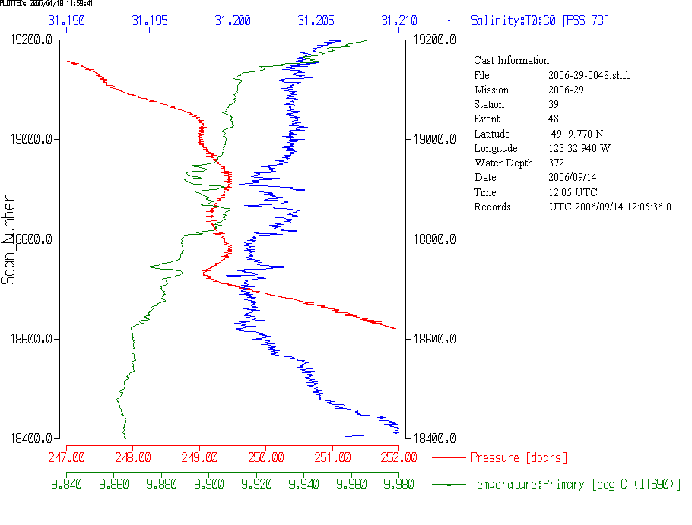
CONCLUSIONS
Only when the gradient is very low is it advisable to shorten bottle stops to less than 30s. A wait of 10s before firing the CTD seems to be the worst possible choice. If the bottle were fired at the instant the CTD stopped it might give good temperature and salinity data, but not good oxygen data due to response delays. However, it is extremely difficult to fire the bottle quickly enough to avoid contamination by shed wakes.

Post-cruise calibration of the conductivity sensor shows no significant error in that quantity. If the temperature sensor was performing well (as it usually does) then the salinity should be good to ±0.001. The comparison between bottles and CTD showed the CTD salinity reading low by about 0.006. Short bottle stops may account for this difference.

With short stops the salinity calibration is compromised and the DO calibration is likely to be affected as well. There will also be some doubts about how well other rosette samples reflect ambient conditions.

