INSTITUTE OF OCEAN SCIENCES CRUISE PLAN

SCIENCE CRUISE NUMBER: 2006-20 (8 to 13 may 2006)

NAME OF SHIP/PLATFORM: GRIZZLY COAST

PROJECT
Pilot study to develop methodologies for sampling the distribution of planktonic sea lice larvae in the Broughton Archipelago
SURVEY AREA/AREA OF OPERATION:
Broughton Archipelago, Tribune Channel and surrounding areas.

CRUISE OBJECTIVE[S]:
- Plankton tows for determination of distribution of planktonic larvae of sea lice in and around the Burdwood finfish farm and at non farm locations (Tribune Channel and Broughton Archipelago)
- Deploy SFU light traps from floating structures where possible.
- CTD profiles at plankton sampling locations and at mid-channel stations when time is available.( Tribune Channel and Broughton Archipelago)

DATE: FROM: 8 May 2006 TO: 13 May 2006

SCIENTIFIC PERSONNEL:
Hugh Maclean – Senior Tech. (IOS – 250 363-6594
Moira Galbraith (IOS 250-363-6692)
Christina ?? (SFU student)
SHIP EQUIPMENT REQUIRED:
Depth sounder
DGPS for accurate positioning of stations
Use of small boat for plankton tows close to shore and in shallow waters.
DECK MACHINERY REQUIRED:
Davit with hydraulic winch to be used for plankton net tows and CTD casts
Submersible pump for washing down plankton nets
Sampling trays for washing and processing plankton samples
OTHER EQUIPMENT TO BE LOADED:
SFU Light traps c/w batteries, electronics and mooring components
Microscope for plankton sample analyses
Self-contained CTD (Seabird SBE25)
Two plankton nets
Niskin water sampling bottles with messenger
Salinity sample bottles and containers for preservation of plankton samples
Lap top computers
DANGEROUS CHEMICALS:
GAS CYLINDERS: NONE
ACIDS: NONE
BASES: NONE
TOXIC: Formalin
FLAMMABLES: Ethanol (2litres)
RADIOISOTOPES: NONE
ANTICIPATED LOADING TIME:
Afternoon of Monday May 8th in Port McNeill.

PROPOSED CRUISE ITINERARY:

Date | General Area of Operations
8 May | - Drive from IOS to Port McNeill with DFO vehicle  - Load sampling equipment onto Grizzly Coast  - afternoon departure for Burdwood Farm  - before docking at accommodation float at Burdwood farm (Mainstream) contact manager of Burdwood farm and request information on biosecurity procedures  - unload personal gear, food stuffs and sampling equipment at accommodations float  - deploy light traps in Burdwood Islands  - plankton tows and CTD sampling at stations near farm site (Fig. 1) and around the Burdwood Islands
9 May | - recover light traps in the AM  - plankton net tows at predetermined locations or at coordinated sampling locations with Marty or Brent  - deploy light traps at the end of the work day  - time permitting mid-channel CTD stations (Appendix A)
10 May- | - recover light traps in the AM  - plankton net tows at predetermined locations or at coordinated sampling locations with Marty or Brent  - deploy light traps at the end of the work day  - time permitting mid-channel CTD stations (Appendix A)
11 May | - recover light traps in the AM  - plankton net tows at predetermined locations or at coordinated sampling locations with Marty or Brent  - deploy light traps at the end of the work day  - time permitting mid-channel CTD stations (Appendix A)
12 May | - recover light traps in the AM  - plankton net tows at predetermined locations or at coordinated sampling locations with Marty or Brent  - deploy light traps at the end of the work day  - time permitting mid-channel CTD stations (Appendix A)
13 May | - recover light traps in the AM  - CTD profiles along route to Port McNeill  - Depart Port McNeill for IOS with DFO vehicle

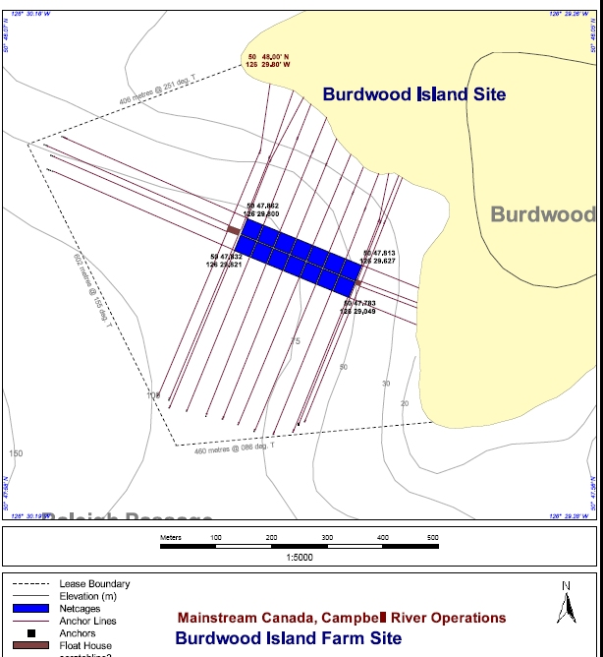
Figure 1. Burdwood Farm
APPENDIX A (if there is time for additional CTD profiles do the following stations)
Mid-Channel CTD Sampling Lines
Line 1. Knight Inlet to Kingcome Inlet .
Station | Lat (N) | Long. (W) | Depth (m)
Kn2 | 50° 39.3’ | 126° 11.0’ | 165
TrC0.5 | 50° 40.8’ | 126° 14.60’ | 145
TrC1^{S} | 50° 43.6’ | 126° 10.9’ | 300
TS1 | 50° 47.21 | 126° 02.23 | 160
TrC1.5 | 50° 45.60’ | 126° 09.05’ | 221
TrC2 | 50° 49.21’ | 126° 12.76’ | 200
BoS1 | 50° 51.81 | 126° 10.82 | 121
TrC2.5^{S} | 50° 50.41’ | 126° 19.75’ | 300
TrC3 | 50° 48.96’ | 126° 25.38’ | 238
PP1 | 50° 48.8’ | 126° 31.5’ | 140
Kin0^{S} | 50° 51.70’ | 126° 37.20’ | 400
Line 3. Tribune Channel to Fife Sound to Queen Charlotte Strait to Knight Inlet (40nm).
Station | Lat (N) | Long. (W) | Depth (m)
TrC3 | 50° 48.96’ | 126° 25.38’ | 238
PP1 | 50° 48.8’ | 126° 31.5’ | 140
FiS^{S} | 50° 47.0’ | 126° 36.7’ | 325
QCS1 | 50° 40.0’ | 126° 46.3’ | 150
BlS | 50° 36.0’ | 126° 43.65’ | 130
Kn0 | 50° 38.28' | 126° 34.98' | 55
Kn1 ^{S} | 50° 38.1' | 126° 25.3' | 247
Line 4. Penphrase Pass. to Sutlej Channel to Wells Passage (20nm).
Station | Lat (N) | Long. (W) | Depth (m)
PP1 | 50° 48.8’ | 126° 31.5’ | 140
Kin0^{S} | 50° 51.70’ | 126° 37.20’ | 400
SC | 50° 53.4’ | 126° 45.7’ | 230
WP | 50° 50.85’ | 126° 56.4’ | 180
Line 5. Penphrase Passage to head of Kingcome Inlet (long run to head of Kingcome Inlet) (30nm).
Station | Lat (N) | Long. (W) | Depth (m)
PP1 | 50° 48.8’ | 126° 31.5’ | 140
Kin0^{S} | 50° 51.70’ | 126° 37.20’ | 400
Kin1^{S} | 50° 53.6' | 126° 34.5' | 476
Kin1.5^{S} | 50° 56.2' | 126° 28.9' | 477
WS1 | 51° 01.06’ | 126° 31.4’ | 200
Kin2 ^{S} | 50° 55.5' | 126° 23.2' | 375
Kin3 | 50° 54.9' | 126° 14.7' | 216
Line 6. CTD stations inside sill of Knight Inlet sill (34nm).
Station | Lat (N) | Long. (W) | Depth (m)
Kn4 ^{S} | 50° 40.9' | 125° 56.2 | 439
Kn5 | 50° 41.6' | 125° 47.0' | 366
Kn6 ^{S} | 50° 45.3' | 125° 41.1' | 512
Kn7 | 50° 48.1' | 125° 37.3' | 523
Kn8 ^{S} | 50° 52.3' | 125° 38.7' | 512
Kn9 | 50° 54.3' | 125° 32.8' | 401
Kn10 ^{S} | 50° 58.6' | 125° 33.5' | 366
Kn11 | 51° 02.5' | 125° 34.0' | 203
Line 7. Outer Knight Inlet and Clio Channel (31nm).
Station | Lat (N) |  | Long. (W) |  | Depth (m)
Kn2 | 50° 39.3' |  | 126° 11.0' |  | 165
CC1 | 50° 36.3' |  | 126° 21.4' |  | 108
CC2 | 50° 34.2' |  | 126° 29.3' |  | 65
Kn1^{S} | 50° 38.1' |  | 126° 25.3' |  | 247
Kn0 | 50° 38.28' |  | 126° 34.98' |  | 55
QCS4^{S} |  | 50° 46.65’ |  | 127° 24.28’ |  | 405
QCS5 |  | 50° 49.43’ |  | 127° 12.04’ |  | 140
QCS6 |  | 50° 52.41’ |  | 127° 21.61’ |  | 145
S , Salinity sample for calibration of CTD at depth.
Current meter mooring locations (for information purposes only)
KiW-02 | 50° 39.38’ | 126° 09.87’ | 180
TCS-02 | 50° 43.18’ | 126° 12.03’ | 200

