INSTITUTE OF OCEAN SCIENCES CRUISE PLAN

SCIENCE CRUISE NUMBER: 2006-20

NAME OF SHIP/PLATFORM: GRIZZLY COAST

PROJECT
Pilot study to develop methodologies for sampling the distribution of planktonic sea lice larvae in the Broughton Archipelago
SURVEY AREA/AREA OF OPERATION:
Broughton Archipelago, Tribune Channel and surrounding areas.

CRUISE OBJECTIVE[S]:
- Plankton tows for determination of distribution of planktonic larvae of sea lice in and around the Burdwood finfish farm and at non farm locations (Tribune Channel and Broughton Archipelago)
- CTD profiles at plankton sampling locations and at mid-channel stations when time is available.( Tribune Channel and Broughton Archipelago)

DATE: FROM: 10 April 2006 TO: 13 April 2006

SCIENTIFIC PERSONNEL:
Darren Tuele – Senior Tech. (IOS – 250 363-6599, cell 250 516-6599)
Moira Galbraith (IOS 250-363-6692)
SHIP EQUIPMENT REQUIRED:
Depth sounder
DGPS for accurate positioning of stations
Use of small boat for plankton tows close to shore and in shallow waters.
DECK MACHINERY REQUIRED:
Davit with hydraulic winch to be used for plankton net tows and CTD casts
Submersible pump for washing down plankton nets
Sampling trays for washing and processing plankton samples
OTHER EQUIPMENT TO BE LOADED:
Microscope for plankton sample analyses
Self-contained CTD (Seabird SBE25)
Two plankton nets
Niskin water sampling bottles with messenger
Salinity sample bottles and containers for preservation of plankton samples
Lap top computers
DANGEROUS CHEMICALS:
GAS CYLINDERS: NONE
ACIDS: NONE
BASES: NONE
TOXIC: Formalin
FLAMMABLES: Ethanol (2litres)
RADIOISOTOPES: NONE
ANTICIPATED LOADING TIME:
Late afternoon or evening of Sunday April 9th in Port McNeill.

PROPOSED CRUISE ITINERARY:

Date | General Area of Operations
9 April | - Drive from IOS to Port McNeill with DFO pickup truck  - Load deck gear and sampling equipment onto Grizzly Coast
10 April | - Depart Port McNeill for Burdwood salmon farm (Mainstream)  - before docking at accommodation float at Burdwood farm contact manager of Burdwood farm and request information on biosecurity procedures (i.e. disinfection of boat deck, sampling equipment, rain gear and footwear with 1% solution of VIRCON)  - unload personal gear, food stuffs and sampling equipment at accommodations float  - commence plankton tows and CTD sampling at stations near farm site (see Appendix A)  - plankton tows and CTD stations at non-farm sites (see Appendix A for some proposed locations)
11 April- | - commence plankton tows and CTD sampling at and near farm site  - plankton tows and CTD stations at non-farm sites (see Appendix A for some proposed locations)  - time permitting mid-channel CTD stations (Appendix B)
12 April | - commence plankton tows and CTD sampling at stations at and near farm site  - plankton tows and CTD stations at non-farm sites (see Appendix A for some proposed locations)  - time permitting mid-channel CTD stations (Appendix B)
13 April | - commence plankton tows and CTD sampling at stations at and near farm site  - plankton tows and CTD stations at non-farm sites (see appendix for some proposed locations)  - time permitting mid-channel CTD stations (Appendix B)  - evening Grizzly Coast departs for Port McNeill
14 April | Depart Port McNeill for IOS with DFO vehicle
APPENDIX A Plankton Sampling Locations
a) Burdwood farm site
Sample downstream of net pens by doing approximately a 100m long horizontal tow at about 2m depth starting away from the net pens and towing towards the net pens into the current. Terminate horizontal tow when 5 to 10m away from net pens. Currents flow at this site is primarily north – south with a small mean flow to the south. However, consult with farm manager for current patterns and safe approach distances.
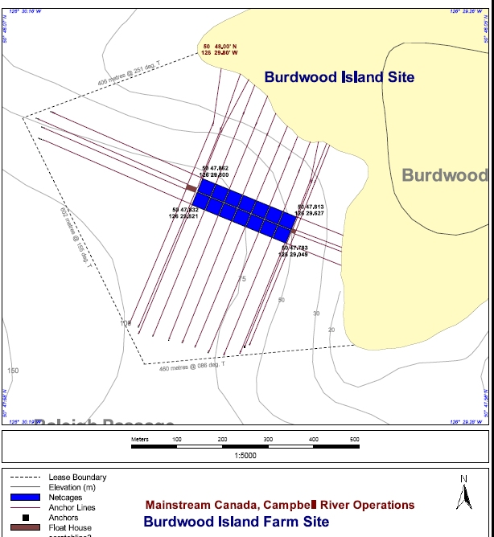
Figure 1. Burdwood Farm
b) Burdwood Island
See Figure 1and check with Alex Morton (250 949-1664 or by radio ) as she has been sampling around the islands
c) Viner Sound
See Figure 2 for possible along shore sweeps 50 to 100m long sweeps.
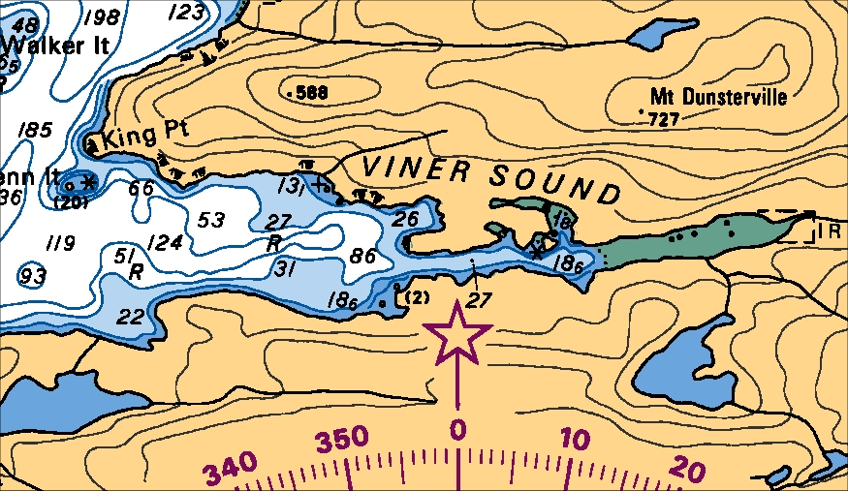
Figure 2. Viner Sound site map with possible shore line sweeps.
d) Bond & Thompson Sound and Tribune Channel, and ???
Consult with Marty (by radio), Brent (250 756-7341) and Alex (250 949-1664 or by radio) for infestation levels on juvenile fish. They may provide you with suggestions for sampling locations. Also keep a watch for locations of schooling juveniles as possible sampling sites.
e) Vertical Plankton net tows downstream of farm
Vertical tows from 50m to surface downstream of farm net pens at location that is in water that is sufficiently deep to avoid anchor lines (see Fig. 1).
f) Night time plankton tows
If you are catching sea lice larvae consistently and/or in significant concentrations then attempt night time tows to determine their presence and depth location in the water column at night.
APPENDIX B (if there is time for additional CTD profiles do the following stations)
Mid-Channel CTD Sampling Lines
Line 1. Knight Inlet to Kingcome Inlet .
Station | Lat (N) | Long. (W) | Depth (m)
Kn2 | 50° 39.3’ | 126° 11.0’ | 165
TrC0.5 | 50° 40.8’ | 126° 14.60’ | 145
TrC1^{S} | 50° 43.6’ | 126° 10.9’ | 300
TS1 | 50° 47.21 | 126° 02.23 | 160
TrC1.5 | 50° 45.60’ | 126° 09.05’ | 221
TrC2 | 50° 49.21’ | 126° 12.76’ | 200
BoS1 | 50° 51.81 | 126° 10.82 | 121
TrC2.5^{S} | 50° 50.41’ | 126° 19.75’ | 300
TrC3 | 50° 48.96’ | 126° 25.38’ | 238
PP1 | 50° 48.8’ | 126° 31.5’ | 140
Kin0^{S} | 50° 51.70’ | 126° 37.20’ | 400
Line 3. Tribune Channel to Fife Sound to Queen Charlotte Strait to Knight Inlet (40nm).
Station | Lat (N) | Long. (W) | Depth (m)
TrC3 | 50° 48.96’ | 126° 25.38’ | 238
PP1 | 50° 48.8’ | 126° 31.5’ | 140
FiS^{S} | 50° 47.0’ | 126° 36.7’ | 325
QCS1 | 50° 40.0’ | 126° 46.3’ | 150
BlS | 50° 36.0’ | 126° 43.65’ | 130
Kn0 | 50° 38.28' | 126° 34.98' | 55
Kn1 ^{S} | 50° 38.1' | 126° 25.3' | 247
Line 4. Penphrase Pass. to Sutlej Channel to Wells Passage (20nm).
Station | Lat (N) | Long. (W) | Depth (m)
PP1 | 50° 48.8’ | 126° 31.5’ | 140
Kin0^{S} | 50° 51.70’ | 126° 37.20’ | 400
SC | 50° 53.4’ | 126° 45.7’ | 230
WP | 50° 50.85’ | 126° 56.4’ | 180
Line 5. Penphrase Passage to head of Kingcome Inlet (long run to head of Kingcome Inlet) (30nm).
Station | Lat (N) | Long. (W) | Depth (m)
PP1 | 50° 48.8’ | 126° 31.5’ | 140
Kin0^{S} | 50° 51.70’ | 126° 37.20’ | 400
Kin1^{S} | 50° 53.6' | 126° 34.5' | 476
Kin1.5^{S} | 50° 56.2' | 126° 28.9' | 477
WS1 | 51° 01.06’ | 126° 31.4’ | 200
Kin2 ^{S} | 50° 55.5' | 126° 23.2' | 375
Kin3 | 50° 54.9' | 126° 14.7' | 216
Line 6. CTD stations inside sill of Knight Inlet sill (34nm).
Station | Lat (N) | Long. (W) | Depth (m)
Kn4 ^{S} | 50° 40.9' | 125° 56.2 | 439
Kn5 | 50° 41.6' | 125° 47.0' | 366
Kn6 ^{S} | 50° 45.3' | 125° 41.1' | 512
Kn7 | 50° 48.1' | 125° 37.3' | 523
Kn8 ^{S} | 50° 52.3' | 125° 38.7' | 512
Kn9 | 50° 54.3' | 125° 32.8' | 401
Kn10 ^{S} | 50° 58.6' | 125° 33.5' | 366
Kn11 | 51° 02.5' | 125° 34.0' | 203
Line 7. Outer Knight Inlet and Clio Channel (31nm).
Station | Lat (N) |  | Long. (W) |  | Depth (m)
Kn2 | 50° 39.3' |  | 126° 11.0' |  | 165
CC1 | 50° 36.3' |  | 126° 21.4' |  | 108
CC2 | 50° 34.2' |  | 126° 29.3' |  | 65
Kn1^{S} | 50° 38.1' |  | 126° 25.3' |  | 247
Kn0 | 50° 38.28' |  | 126° 34.98' |  | 55
QCS4^{S} |  | 50° 46.65’ |  | 127° 24.28’ |  | 405
QCS5 |  | 50° 49.43’ |  | 127° 12.04’ |  | 140
QCS6 |  | 50° 52.41’ |  | 127° 21.61’ |  | 145
S , Salinity sample for calibration of CTD at depth.
Current meter mooring locations (for information purposes only)
KiW-02 | 50° 39.38’ | 126° 09.87’ | 180
TCS-02 | 50° 43.18’ | 126° 12.03’ | 200

