The following comments are from Melanie Quenneville re problems with some sample numbers on nutrient samples.
Cruise 2006-11 Station 6
re: confusion about sample numbers on labels (see email message of July 14, 2006 from W. Richardson)
Plotting nutrients vs depth, as originally labelled, the "duplicates" at 30m are quite different.
If it is assumed that the samples were taken as marked in the rosette sheets, a better profile is obtained.
Note that the mixed layer depth is apparently around 30 m with the original sample numbers, and around 10m when changed.
I agree that we are justified in changing the sample numbers to what was recorded in the sample books. MQ.
Original |  |  |  |  |  | Original:
sample # | Depth | nitrate | silicate | phosphate |  | 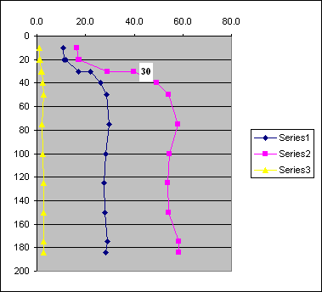
76 | 10 | 10.9 | 16.6 | 1.22
75 | 20 | 11.2 | 17.2 | 1.22
74 | 20 | 11.8 | 17.3 | 1.36
73 | 30 | 17.1 | 29.0 | 1.88
72 | 30 | 22.1 | 39.9 | 2.00
71 | 40 | 26.3 | 49.1 | 2.62
70 | 50 | 28.5 | 54.2 | 2.68
69 | 75 | 29.6 | 58.1 | 2.00
68 | 100 | 28.3 | 54.5 | 2.44
67 | 125 | 27.7 | 53.8 | 2.65
66 | 150 | 28.0 | 54.1 | 2.68
65 | 175 | 29.1 | 58.4 | 2.76
64 | 184 | 28.3 | 58.4 | 2.79
Amended
sample # | Depth | nitrate | silicate | phosphate |  | Amended:
80 | 0 | 10.9 | 16.6 | 1.22 |  | 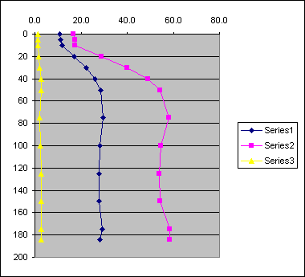
78 | 5 | 11.2 | 17.2 | 1.22
76 | 10 | 11.8 | 17.3 | 1.36
74 | 20 | 17.1 | 29.0 | 1.88
72 | 30 | 22.1 | 39.9 | 2.00
71 | 40 | 26.3 | 49.1 | 2.62
70 | 50 | 28.5 | 54.2 | 2.68
69 | 75 | 29.6 | 58.1 | 2.00
68 | 100 | 28.3 | 54.5 | 2.44
67 | 125 | 27.7 | 53.8 | 2.65
66 | 150 | 28.0 | 54.1 | 2.68
65 | 175 | 29.1 | 58.4 | 2.76
64 | 184 | 28.3 | 58.4 | 2.79

