Project Report

Department of Fisheries and Oceans
Institute of Ocean Sciences
Sidney, B.C., Canada

To: Regional Science Director. Final: Yes

1. Cruise/Project No.: 2005-21 2. Dates: August 15 to September 3, 2005
3. Project Name: Line P
4. Area(s) of Operation: N.E. Pacific to Station P, west of QCI, Rivers Inlet, Queen Charlotte Strait
5. Platform: John P. Tully 6. Master: Murray McGregor
7. Days Allocated: 20 8. Days at Sea: 19
9. Days lost to weather: 0, 1 station cancelled.
- Days lost to other causes: half-day for fuelling
11. Appropriateness of platform: great 12. Safety issues: None
13. Cruise/Project Results (see appendix for details):

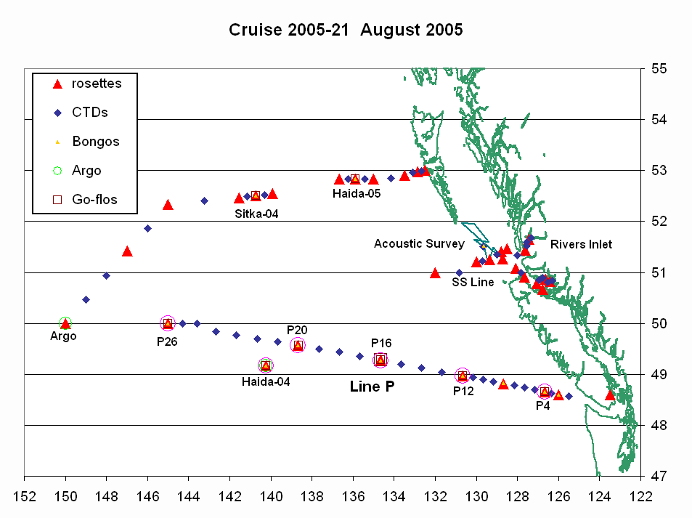
- The Line P survey was successful. No work cancelled due to weather.
- The return line had only one station cancelled due to weather.
- Three Argo floats were successfully deployed.
- We sampled Haida-2004 eddy, situated about 35 miles south-west of station P21 (from the SLHA plot). We also sampled Sitka-2004 and Haida-2005 on the return leg.
- We were able to do the Acoustic Survey for the La Perouse project, as well as sampling some stations for the Broughton Circulation Survey for Dario Stucchi.
- There seemed to be a problem with the Gas Tension Device measuring oxygen in the loop waters.
- The bird and marine mammal survey was very successful (see appendix).
- The samples collected include:
- Underway: T, S, fluorescence, oxygen, pCO2, acoustic sounder
- Discrete (casts): T, S, fluorescence, oxygen, transmissivity
- Water: oxygen, salinity, nutrients, chlorophyll, tCO2, C13, DMS, NH4, Chitobiase Activity (crustacean molting enzyme)
- Zoo-plankton using vertical net hauls and ring net.
14. Primary Institute: Institute of Ocean Sciences, DFO
15. Associated Institutes: University of Victoria, CWS, University of Washington.

16. Chief Scientist/Affiliation: Marie Robert, IOS

17. Science Staff/Affiliations:

Doug Anderson | IOS | Tom Plath | CWS
Mike Arychuk | IOS | Kristina Brown | UVic
Janet Barwell-Clarke | IOS | Marina Chong | UVic
Darren Tuele | IOS | Akash Sastri | UVic
Ian Wrohan | IOS | Lia Ossiander | U W

18. Equipment: ADCP: no Other: sounder, thermosalinograph, SCS, acoustic
sounder, GTD, SAMI, pCO2.

19. Winches:
We had to re-terminate the cable of the mid-ship winch after the rosette sat on the bottom. We switched to the stbd-side winch for a cast. At about 2500 m on the way up the winch started to overheat. It would be good if the back-up winch (Hawboldt SN 17027) would have the same configuration for the oil-cooling system (AMOT valve) as the mid-ship winch (Hawboldt SN 17026) since we would not have been able to use that winch as a constant back-up because of the overheating problem. Also the new bongo winch was not good at slow speed.
20. Equipment Deployed/recovered:

3 Argo floats were deployed.

21. Comments and recommendations:

Science issues:

- The pinger on the rosette was working great on deep casts but it was still hard to get a signal on shallow casts.
- It would be good to have better radios. The radios we are using at the moment don’t seem to keep their charge very well. Also, the radios should be in the charge of the common group of sea-going technician, maybe kept with CTD gear? Somehow they never get loaded automatically, we always have to “remember to bring the radios”. Maybe some radios (and chargers) should live in the lab permanently

Science/Ship issues:

- There seemed to be a problem with the internal email delivery on the ship. Some accounts would receive email coming from land, but would not receive the messages sent from the ship.
- It would be a good idea to have a de-ionized (mQ) water maker on board the Tully. We use great quantities of mQ water during a cruise. For this cruise, a University of Washington scientist had to ship 45 l of mQ water from Seattle to the Tully. Also, the IOS scientists almost ran out of mQ water because we sampled a few more stations than originally planned. To have the system on board would avoid these problems.

Ship issues:

None.

General issues:

- Many thanks to the crew of the Tully for all their help during the cruise. Thanks also for showing such an enthusiasm about our work. Special thanks to Captain McGregor and the officers to adapt so well to the constant changes in plans, and to the galley crew for such a wonderful barbecue while sailing away from Station P.
- Thanks to Coast Guard for the purchase of the new fitness equipment in the gym. It is great to be able to keep training while at sea. We would like to suggest the purchase of a fan, for when it gets too hot, as well as a second treadmill. This seems to be the most used piece of equipment in the gym, with quite often a line-up for its use. Another suggestion was to get a stair-climber.
- Finally, thanks for the science crew for doing so much work even though we were such a small group. The dynamic of the group was excellent.

Appendix: Reports from Participants

1. Physical properties – Marie Robert

Last February (2005) we happened to survey the edge of the Haida-2004 eddy, situated then north of Line P, around station P20. We had seen killer whales in the vicinity of the eddy. In June the centre of Haida-2004 was situated approximately 6 miles south-east of station P21. Once again, the killer whales were seen to the east of the eddy. The temperature signature of Haida-2004 was very strong in the CTD profiles. For the third time this year we sampled this eddy, now situated approximately 35 miles south-west of P21. Unfortunately we visited the eddy during the night, so we don’t know if the killer whales are still in the area. The temperature signature is still very strong, as seen in figure 1.

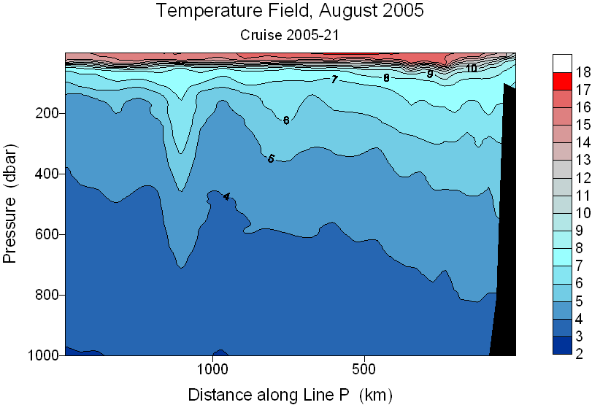

Figure 1: Temperature Field along Line P, clearly showing the Haida-2004 eddy at around 1100 km along the line.

In April 2005 there was a cruise on the R/V Tommy Thompson (with IOS personnel on board) to study eddies. Towards the end of the Line P cruise in June we had the opportunity to re-visit the newly formed Haida-2005 eddy off the coast of the Queen Charlotte Islands, therefore adding to the study already started on the Thompson. Once again the eddy is strongly visible in the CTD data, in temperature (see Figure 2), salinity, density (sigma-t), and dissolved oxygen. Figure 3 shows the ship track and station location with respect to sea-level altimetry.

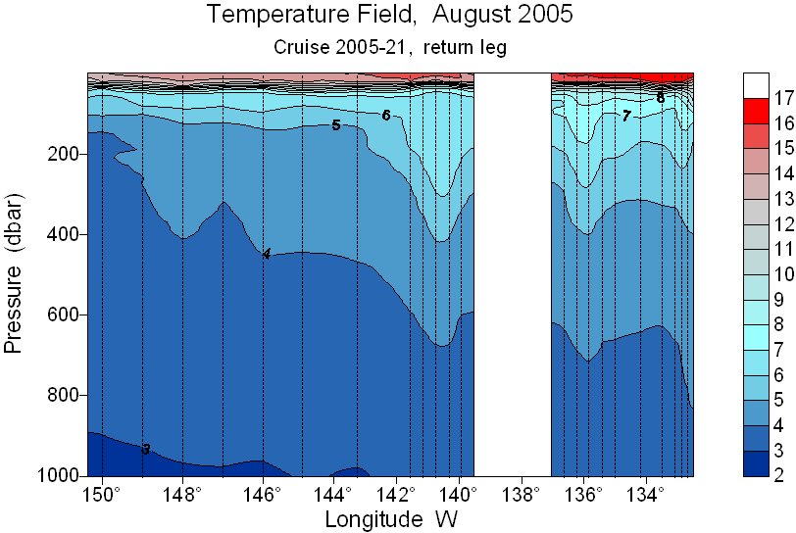

Figure 2: Temperature Field from 150°W to Englefield Bay. Sitka-2004 is situated at 140°45W, and Haida-2005 is at 135°52W.

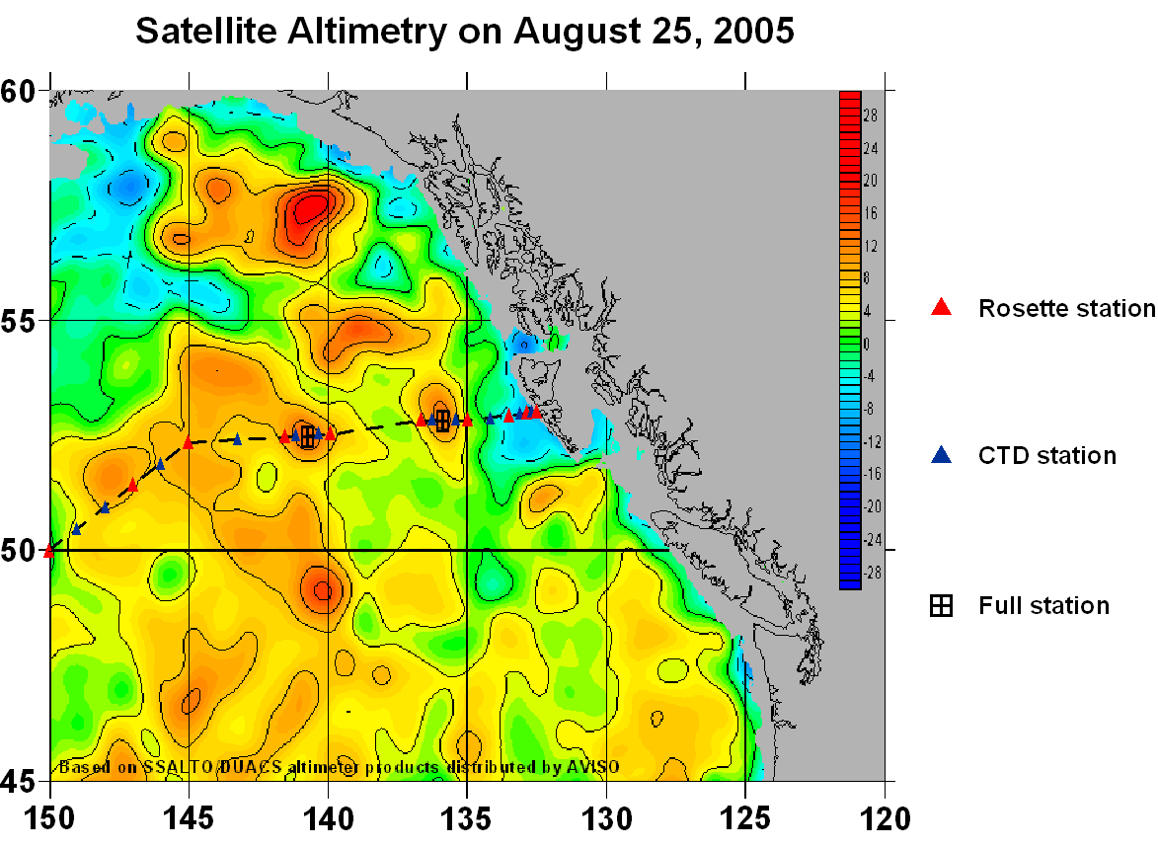

Figure 3: Ship track and station location over sea-level height. The Haida-2004 eddy is also visible at 49°10N, 140°15W.
2. Summary of seabird/mammal observations on "P" cruise Aug 17-Sept 1, 2005 – Tom Plath.

Relatively low winds, absence of fog, and overcast skies (reducing glare) made for ideal viewing conditions during the time period. Seabird surveys are conducted while in transit between stations. All birds detected within 250 m of the vessel, one side only, are identified and counted in 5 minute intervals. If identifiable, any mammal either side of the vessel at any distance is also counted. Survey time varies daily depending upon duration of work at stations. Listed in Table 1 is a summary of observations during surveys.

Birds

Pelagic

A total of 38 species and 2,103 individuals were tallied during transects. Excluding totals from September 1, which was largely "inside" waters, five species accounted for approximately 72% of the birds seen. In order of abundance (# of individuals in parenthesis) they are: Leach's Storm Petrel (591), Sooty Shearwater (167), Black-footed Albatross (151), Northern Fulmar (122) and Fork-tailed Storm Petrel (83).

Though usually seen as singles while the vessel is en route, albatrosses were attracted to the ship when stopped and flocked together behind the boat at most stations. A high of 65 Black-footed Albatross was at E21 a few miles from the Queen Charlottes on the 29th, and 45 at P3 on the 17th. Pterodroma petrels (Dark-rumped and Murphy's) were well offshore, 600+ miles, and most of the Buller's Shearwater with a high of 26 on the 19th. Buller's Shearwater occurring in coastal waters (shelf) is usually found later in the season. Diversity and number of birds are greatest on the shelf/slope which is reflected by the number of shearwaters observed on the 17th: 50+ Northern Fulmars, 40+ Pink-footed Shearwaters, 250+ Sooty Shearwaters and a Flesh-footed Shearwater. Short-tailed Shearwaters first made an appearance in the northern part of the cruise off the Queen Charlottes on the 25th, with two following the boat. This behaviour was noted a few times, by this species the following days. Leach's Petrel was the only bird observed during transects in all days in August. Usually seen as singles, a flock of 40 was flushed off the water on a day where 177 were seen.

Phalaropes are the only true pelagic shorebird with Red Phalarope the most oceanic of all. The majority of phalaropes far offshore were this species (21/30) and most unidentified individuals are also believed to be Red Phalarope.

The height of jaegar migration occurs in September/October with adults moving south first. Of the 22 jaegars seen all but four were adults, the rest juveniles. Most Arctic Terns were adults as was the single Sabine's Gull.

Alcids were notably absent from deeper waters with no sightings between the 18th and 28th, as most have not finished their breeding cycle. Late in the season many winter out to sea. Large numbers were observed off the north end of Vancouver Island close to major breeding localities. Two Xantus Murrelets on the 29th are an example post-breeding dispersal from California waters. This species is seldom recorded in Canada with "P" Cruise sightings accounting for most records due to it's preference for deeper waters.

Non-Pelagic

Autumn migration is well underway in August resulting in a few strays showing up at the boat. A female Northern Shoveller, on the water beside the boat at P4 on the 17^{th,} is very rarely seen in marine environments. Not as unusual was an American Wigeon, on the 27th, and a Green-winged Teal flying low over the water the following day.

Shorebirds are at the peak of fall migration at this time and several species were observed around the boat including two species of "rock" shorebird – a Black Turnstone circling the vessel on the 17th and two Wandering Tattlers, on different days, also visiting the Tully for a potential resting spot. The Pacific Golden Plovers, both juveniles, were calling over the bow which made identification possible. The most exciting stray was an Upland Sandpiper walking about the heli-pad on the 28th. This bird remained onboard for several hours and even landed beside me only two metres away while on Monkey's Island. In BC this bird breeds in grasslands of the Peace River area though there are several coastal records between mid-August and early September.

Three passerines (songbirds) were sighted following the ship briefly, however, the only one identified was a Savannah Sparrow, first observed on the evening on the 27th and still present the following day several hundred miles from shore.

Mammals

During the "P" cruise eight cetacean (whales/dolphins) and two pinniped (seals/sea lions) species were identified. Several whales observed could not be identified to species due to brevity of sighting or distance. Of the cetaceans the most common species in the North Pacific is the Dall's Porpoise and this was the most frequently encountered mammal during the trip. Thirteen pods involving an estimated 56 animals were tallied. All sightings were of groups either at the boat or headed for the boat for some bow riding.

Fourteen Humpback whales, largely singles and pairs were observed. A few people on board were fortunate enough to observe the spectacular sight of a cow and calf Humpback Whale, continuously breaching past the Tully, and only 200 metres away on the 30 August. Of interest two Harbour Porpoises were closely observed greater than 150 miles offshore. This animal usually frequents coastal waters.

A female/young male Northern Fur Seal a few hundred miles offshore on the 25th and Steller's Sea Lion on the 29th were the only pinnepeds seen.

Table1. Summary of seabird/mammal observations on "P" cruise August 17-September 1, 2005.

August 17 18 19 20 21 22 24 25 26 27 28 29 30 31 1 Sep
Survey time (min) 150 390 450 390 320 555 570 520 480 500 310 505 390 580 225

Black-footed Albatross 9 1 3 3 4 7 16 11 10 1 16 30 40
Laysan Albatross 1 2
Northern Fulmar 7 6 1 6 3 19 29 51 8
Dark-rumped Petrel 1 1
Murphy's Petrel 1
Dk. Pterodroma sp 1
Pink-footed Shearwater 2 1 9
Buller's Shearwater 1 26 1 1 2 6 5 1 4
Sooty Shearwater 23 2 1 3 7 131 8
Short-tailed Shearwater 1 2 3 8 7 15
Dk. Shearwater sp 1 3 1 1 1 2 6 7 27
Fork-tailed Shearwater 4 10 5 1 1 20 8 8 3 23 2
Leach's Storm-Petrel 1 34 45 40 18 28 12 6 30 17 9 39 177 135
Storm-Petrel sp 1 1 1 1
Pelagic Cormorant 1 1
Brandt's Cormorant 5
American Wigeon 1
Surf Scoter 1
Pacific Golden Plover 1 1
Semipalmated Plover 1 1
Wandering Tattler 1 1 1
Upland Sandpiper 1
Sanderling 4
Calidris sp 1 3
Red-necked Phalarope 3 1 7 1 24
Red Phalarope 5 4 14 3 1 1 7
Phalarope sp 1 4 19 10 3 5 15
South Polar Skua 1 2 1
Pomarine Jaegar 1 1 1 1 1 1 5
Parasitic Jaegar 1 1
Long-tailed Jaegar 1 1 1 2

Table1. Summary of seabird/mammal observations on "P" cruise August 17-September 1, 2005. (con't)

August 17 18 19 20 21 22 24 25 26 27 28 29 30 31 1 Sep
Survey time (min) 150 390 450 390 320 555 570 520 480 500 310 505 390 580 225

Jaegar sp 1 1 1
Mew Gull 1
California Gull 3 178
Glaucous-winged Gull 2 1 55
Sabine's Gull 1
Arctic Tern 3 1 4 3 1 1
Sterna sp 2
Common Murre 2 203
Pigeon Guillemot 2
Xantus Murrelet 2
Cassin's Auklet 8 8 8 18
Rhinoceros Auklet 2 37 6 24 65
Tufted Puffin 6 1 11
Small alcid sp 1 2 3
Savannah Sparrow 1

Stellar's Sea Lion 1
Northern Fur Seal 1

Humpback Whale 3 2(2) 4(3) 5(3)
Fin Whale 1 2
Minke Whale 1
Sperm Whale 1 1
Killer Whale 14(2)

Pacific White-sided Dolphin *30+
Dall's Porpoise 3 2 4 14(3) 3 9(2) 11(2) 6
Harbour Porpoise 2

Ocean Sunfish 3 1 1 2 9

(#): number of groups if more than one group * 2 Sep

