REVISION NOTICE TABLE
DATE | DESCRIPTION OF REVISION
Sept 7, 2021 | Mission Number corrected. S.H.

PROCESSING NOTES
Cruise: 2005-006
Agency: IOS, Ocean Sciences Division, Sidney, B.C.
Location: Beaufort and Chukchi Sea
Project: Joint Western Arctic Climate Studies
Party Chief: van Hardenberg B.
Platform: Sir Wilfrid Laurier
Date: 20 September 2005 –12 October 2005

Processed by: Germaine Gatien
Date of Processing: 13 August 2020 – 1 September 2020
Number of original HEX files: 44 (1 empty) Number of CTD files: 43
Number of rosette files: 30 planned (2 no sampling) Number of bottle casts processed: 28

INSTRUMENT SUMMARY
A SeaBird Model SBE-25 CTD (#0293) was mounted with a Transmissometer (maybe s/n 139), SBE 43 Dissolved Oxygen Sensor S/N #0615 and Seapoint Fluorometer S/N #2336. The deck unit type was SBE44, S/N is unknown. The fluorometer gain was 3X and it was unpumped.

SUMMARY OF QUALITY AND CONCERNS
No recalibration has been applied to the salinity data. The CTD is considered ±0.002psu when stopped. In motion the salinity is considered ±0.005psu except in areas of rapid temperature change where salinity errors could be larger.

The file names were non-standard but easily fixable. No log book was available at the time of processing.

Fluorescence:URU:Seapoint and Transmissivity data are uncalibrated and unedited except where records were removed due to bad temperature or salinity data.

Comparison with data converted using a post-cruise calibration shows drift in Oxygen:Dissolved:SBE is small at about 2.5%. But a comparison with bottle samples indicates a correction of about 9.5% is required. This is due to slow response so that even after a 30s wait at bottle stops there was not full equilibration. This problem was common with the early SeaBird DO sensors. However, a recalibration provided downcast data that look reasonably close to the upcast bottles. This result is better than expected and may be partly due to the generally low vertical gradients in dissolved oxygen.

The pressure sensor is considered ±1db. An offset of +0.6db was applied to all data during conversion.

PROCESSING SUMMARY
1. Seasave - This step was completed at sea; the raw data files have extension HEX.

2. Preliminary Steps
The file names were not in standard format though they were close enough to make renaming easy.
Note was made at the end of the previous Laurier cruise that the internal clock in SBE25-CTD was 11 minutes off compared to GPS. There is no GPS time in these headers. The times in the CTD files agree with the times in Rosette Chemistry file and there are no other records to check, so no change will be made to times. These data were processed 15 years after collection. No log book was found but there was a post-cruise report that contained useful information. The same equipment was used during cruise 2005-005 which immediately preceded this cruise.

For 2 casts the SPAR channel was included in the configuration but there was no SPAR data acquired.

The cruise summary sheet was completed.

3. Conversion of Raw Data
During the previous cruise the pressure offset in the configuration file was set to +0.6db and the same offset was applied in 2003 and 2004 when the same CTD was used. Tests were run on 8 casts using a configuration file with an offset of 0db was used at sea. The surface pressures were estimated by when conductivity, fluorescence and transmissivity went from out-of-water to in-water values. This is a very rough estimate. For both downcast and upcast all but 2 surface pressures were less than 0. The values ranged from -1db to +0.3db based on downcasts. The average for both downcasts and upcasts was -0.5db and the median values is -0.6db. Since the sensor is considered ±1db, these are within the expected error. But since almost all values are negative, it seems reasonable to apply an offset of +0.6db. The con files were adjusted and the files were reconverted with that offset applied.

File 2005-006-ctd.XMLCON was used to convert most of the hex files but did not work for the files from events #9 and 10. After a few tests it was found that a configuration file with SPAR channel included worked, although there was no signal in the SPAR data. File 2005-006-ctd2.xmlcon was created with SPAR included but that channel was not selected in the conversion.
There was a hex file #23 but it contained no data.

Rosette files were also converted using the same configuration files.
File names were corrected to standard format.

GPS failed for casts #9 and 10, but positions were added to the SeaBird headers after conversion based on information in the rosette spreadsheet.

The temperature, conductivity, transmissivity, dissolved oxygen and fluorescence have reasonable profiles, though there are some very noisy patches that appear to be worse on upcasts. Transmissivity is sometimes significantly different on upcasts from downcast.

Three casts deeper than 500db were checked for hysteresis and the differences between downcast and upcast surface pressures were not systematic and there was no evidence of hysteresis.

Rosette files were converted taking the scan range data from the BL files and using a 10s window around firing time; in cases where several bottles were fired quickly there are fewer scans per bottle.
They were then converted to IOS Header format. A number of files needed corrections to the SeaBird headers to either add position entries or fix their formats.

The files were put through CLEAN to add an event number based on the file name. (Output: BOT) The data were plotted to look for extreme outliers. Problems were found in 3 casts:
- Cast 10 – There were many pressure spikes during this cast between 0 and 15db on the upcast. Fortunately only a few occurred during the 10s window around bottle firing time. Those records were replaced with copies of the previous record. Some derived values were also bad over more records and were replaced with pad values.
- Cast 20 – There was a single pressure spike at 203.8db. That was fixed with a text editor by replacing the bad record with a copy of the previous record. After that the BL file has an entry RESET. Then bottles 1 to 5 appear to have been fired again, perhaps to make the following bottle firings have the right Bottle_Number. However, there is no Bottle #6 entry but there are samples from Bottle 6. The rosette chemistry file includes raw CTD data for bottle #6. It looks as though only the BL file got corrupted, so it was edited to resemble what was in a BTL file created at sea. This produced a sensible file with bottles fired at the planned levels.
- Cast 24 – There was no in-water data in the bottle file for this cast. It appears that 4 bottles were fired at the surface; the only samples reported are for salinity and the values do not make sense for the levels at which the bottles were actually fired. They do make sense for the intended depths. The BTL file matches the BL file and the full profile shows no stops for bottles. Since only salinity was collected and it is unknown if the samples were from a second cast at the site from which no CTD data was acquired, or from bottles fired on the fly during the upcast or downcast, this cast will not be processed further.

The corrected CLN files were bin-averaged and the outputs were used to create an ADDSAMP file. Samples numbers were added to that file.

4. Bottle file preparation
A spreadsheet (2005_06_Rosette_Chemistry.xls) was obtained which included salinity and dissolved oxygen sample analysis results. Barium and nutrient data were obtained in separate spreadsheets.

All the sampling was combined in spreadsheet 2005-006-bottles.CSV. There were no quality flags. Flags were added where there were comments in spreadsheets on matters affecting quality and where there was replicate sampling. There were comments in the spreadsheets for salinity and nutrients but none for the Barium data and dissolved oxygen data.

There were 2 samples for each oxygen sample and sometimes 3. The average difference between replicates 1 and 2 was 0.0014mL/L with a standard deviation of 0.0054. In cases where there were 3 samples, and the differences between the 1st and 2nd samples were >0.004mL/L, the 3 values were examined to see if one of the samples was clearly out of line, but there was no such case, so the average of 3 samples was used.

The nutrient spreadsheet includes a precision study. While replicates were taken, only the first sample was entered in the rosette chemistry spreadsheet, as was the habit in 2005 for Arctic cruises. The values as reported in 2005 will be used in preparing the bottle files. All sampling included replicates but since they were not averaged no flag 6s were attached. Flag 3 was added where there was a report of large differences in replicates; in all cases this applied to Silicate sampling only.

The CSV spreadsheet was converted to MRG1 files.

5. COMPARE
There was a post-cruise calibration available for salinity and dissolved oxygen. A quick comparison suggests a correction of +2.5% would be needed to correct for dissolved oxygen calibration drift and +0.0003psu for salinity calibration drift.

Salinity
COMPARE was run using *.mrg and *.sam files. CTD salinity was generally lower than bottle salinity and it was frequently lower by 0.03psu in the top 300db. The pattern suggests that the effect of incomplete flushing of Niskin bottles is significant. Niskin bottles are believed to flush poorly in areas of protected waters (such as near ice) where descent rates are very steady. When bottles are excluded from the comparison that have a standard deviation in the CTD Salinity >0.0008psu, most of the outliers disappear. Since the standard deviation tends to be highest where vertical gradients are high, this confirms that outliers are likely due to Niskins not flushing well in the presence of high gradients. When outliers with differences >0.025 are also excluded the CTD salinity is found to read low by 0.007psu.

Since the effect of incomplete flushing is of the opposite sign at the bottom of casts, if we only look at those deeper than 900db the vertical gradients are very low so there should be little effect. The CTD is found to be low by 0.0035psu using 10 bottles fired at the bottom below 900db. The bottom bottles at shallower casts tend to show the CTD reading high, as expected due to higher vertical gradients.

Salinity analysis was done within 3 to 6 weeks of collection. There is likely a small increase in bottle values due to evaporation and/or desorption of samples, expected to be no more than 0.004psu. So the CTD salinity is likely not reading as low as it appears in the comparison. A post-cruise calibration shows the CTD salinity to have drifted low by about 0.0003psu. No recalibration is appropriate.

The large outliers at depth were investigated and it was found that all came from event #9. The analyst noted that liners were not used for any of the salinity samples from that event and the differences are very large, so all salinity values from this cast will be padded and flagged 5.

Dissolved Oxygen
The dissolved oxygen samples will also be subject to incomplete flushing of bottles. The effect is harder to judge because of frequent reversals in the vertical profile. Near the surface and below 200db the samples will have higher DO than in situ waters while elsewhere they will read lower.

The DO sensors used in 2005 had a long response time. Stops before firing bottles were about 30s but this may not have been enough time to enable the DO sensor to equilibrate. There is a lot of noise at the beginning of stops and possible real variability during the stops.

The COMPARE results indicate that the SBE DO values are low by about 9.5%. And given that DO was decreasing with depth for large parts of profiles it is likely that incomplete flushing is minimizing the differences. This is out of line with the post-cruise calibration and must be due to poor sensor response. It is still the best we can do to produce reasonable oxygen values for the bottle files. However, while in motion the errors could be different and in large gradients especially so; that will be examined later.

4 outliers were investigated that differed from the trendline by >0.5mL/L. All but 1 came from areas with very complex dissolved oxygen profiles and very noisy CTD DO data. Those reversals combined with a slow response time can explain those outliers. However, one came from a quieter area. For event #2 at 159db the DO value looks like it is from close to the surface and the salinity from that Niskin was also out of line with a near-surface value. There was a note that the Niskin was leaky but these values seem too far out of line to be explained by that. Since the Barium sample does not look out of line in profile, it is more likely that the salinity and oxygen samples were taken from the wrong Niskin bottle. The salinity and dissolved oxygen samples were padded and given flag 5. The Barium sample was flagged 2 due to the leaky Niskin.

The MRG files were recalibrated using file 2005-006-recal1.ccf to apply a correction of 1.095 to the Oxygen:Dissolved:SBE channel.
COMPARE was rerun using the recalibrated files. The results were excellent.

6. WILDEDIT
There were many spikes in the data, so WILDEDIT was run to remove isolated “wild” points using settings:
- Standard Deviations for pass one: 2
- Standard Deviations for pass two: 5
- Scans per block: 15

7. WFILTER
Cosine filters were run on pressure, temperature, conductivity and oxygen raw all with window size 5 scans based on the results of 2001 Arctic cruises which used an SBE25. Plots were made of 2 casts and the filter was found to have smoothed the small steps in pressure and improved salinity somewhat but left many unstable features in T-S space.

8. ALIGNCTD
- To reduce the noisy in salinity a preliminary alignment of conductivity was done by applying an advance of 0.1s based on work done on a previous cruise using the same sensor. Tests were run on a few casts varying this setting slightly and the best results overall were with 0.1s though this varied somewhat from one feature to another. There will be another chance to fine-tune T/C alignment later.
- Dissolved oxygen is best aligned before deriving it in concentration units. The poor response of this sensor leads to a large offset between up and down profiles. Comparing the offset between up and downcast profiles for temperature and dissolved oxygen is helpful but not a perfect solution. Picking out features to compare is inaccurate because the DO profile can never fully resolve those features and stops for bottles complicate the picture, but it gives an idea that an advance of about 11s is needed. Analysis of how long it took DO to settle during a bottle stop is complicated by shed wakes and variations with time, but equilibration appears to take >10s depending on the local gradient. As noted in the bottle comparison the SBE dissolved oxygen is not reliable enough to archive. The DO data were advanced by 11s.

9. CELLTM
SeaBird recommend the use of (α, 1/β) = (0.03, 7) for SBE25s. In previous use of this equipment (0.03, 9) has been used. However, both those settings produced poor results in regions of large temperature gradient. A choice of (0.1, 7) looked much better in such waters and still looked fine at depth. Since many of the casts for this cruise are quite shallow, it is critical to choose parameters that work well in high gradients. CELLTM was run on all casts using (0.1, 7.0).

9. DERIVE
Program DERIVE was run to calculate salinity and dissolved oxygen concentration.

10. Conversion to IOS Headers
The IOSSHELL routine was used to convert both the CNV and ROS files to IOS Headers.

11. Checking Headers
CLEAN was used to add event numbers and to replace pad values in the pressure channel using linear interpolation based on record number.
The header check and cross-reference listing was run and several positions were missing or incorrect and the time was wrong in 2 casts that did not have NMEA input. All problems were corrected in the IOS files which were then put through CLEAN.
Track plots were produced and no errors found.

The surface routine was run and the average found to be +0.03db. The CTD was often turned on out of water, so this is a reasonable result.

The times in the headers are close to those in the rosette log.

12. Test plots
Plots were made to determine how many records should be removed from the surface soak period.
CLIP was run to remove enough records to ensure pressure is >0db and that very unstable sections at the surface were not included.

DELETE was run and T-S plots made to check whether further alignment of any channels are needed:
- Conductivity looks as well aligned as possible. In most plots there appear to only be problems near the surface and some complex features are stable in T-S space. There are a few T-S plots that look poor but that is because they are very well-mixed so the apparent instabilities are very small and may well be real.
- Fluorescence looks well aligned.
- Dissolved oxygen looks well aligned in most casts but results varied from cast to cast.

13. SHIFT
No further alignments were applied.

14. FILTER
In the past a median filter, size 5, had been applied to the salinity channel. Tests were done on a few casts with instabilities and the filter did not improve the data, so this step was skipped.

15. DELETE
DELETE was run on all casts using the following parameters:
Surface Record Removal: Last Press Min and Salinity less than 20psu in the top 20db.
Surface Swell Pressure Tolerance: 1.0
Swells deleted. Warning message if pressure difference of 2.00
Drop rates < 0.3m/s (calculated over 9 points) was deleted from 10db to 10db above the maximum pressure.
The sample interval was taken from the header.
COMMENTS ON WARNINGS: There were no warnings.

16. DETAILED EDITING
The near-surface data generally look bad. Typically the CTD was lowered to between 2 and 3db and soaked. After the soak the data generally look better. However there were some casts during which the CTD was taken to ~6db where it was stopped for ~1 minute during which time temperature and conductivity values gradually fell and then appear to have equilibrated. The higher conductivity at the beginning of those soaks could theoretically have been due to brine from ice but is not seen during upcasts so is more likely of instrumental source. Conductivity often spikes to a high value when the sensor first starts recording and settles to a lower value during soaking. Such spikes are not seen at the surface in the upcasts. So data from above the soak level were usually removed in editing.

For only 1 cast there was a 5db soak followed by a return to 3db before running the full cast. The initial scans clipped were set so that the data from after the return to 3db were selected.

CTDEDIT was used to remove bad surface data. Records were also removed that appeared to be corrupted by shed wakes. Salinity was cleaned where there were spikes or unstable “overshoots” suspected to be due to misalignment of T and C.
All casts except #27 required some editing.
The edited files were copied to *.edt to produce a full set of files, either edited or unedited.

Filtering fluorescence had no noticeable effect, so that step was skipped.
The edited files were bin averaged with 0.5db bins.

T-S plots were examined and for a few casts there are some unstable features, but most are very small and seen in well-mixed casts. In cast #2 there is a larger unstable feature at about 22m but no instrumental cause is obvious and it was also seen in the upcast, so it likely is real.

17. Other Comparisons
Sensor History – This CTD was used for 2005-005. There was no DO sampling so those data were not archived. The CTD salinity was found to be within 0.001psu of bottles so no recalibration was applied. Pressure was adjusted by adding 0.6db at the time of data conversion.
Comparison of nearby casts – Casts #6 and 7 were close but these are shallow casts (~50m) and occurred more than 8 hours apart; below 40 m the differences were small, within 0.1Cº and 0.01psu. Casts 37 and 38 were both deeper than 500db. Near the bottom salinity values differ by ~0.003psu along lines of constant σ_{t} while temperatures vary by about 0.03Cº.
Historic Ranges – Local climatology was not available at the time of processing.

18. Comparison of downcast DO and upcast bottle data
The errors due to poor response in the SBE DO sensor is likely to be larger when in motion than during bottle stops. Where DO is decreasing the error due to the slow response is of opposite sign to that due to calibration drift, but there are many reversals and DO is mostly increasing below 200m though the gradients are low. The question is whether the correction suggested by the bottle comparison will be sufficiently reliable to recalibrate downcast DO.

Bin-averaged downcast CTD files were thinned to the levels of bottle samples. COMPARE was run with samples from the MRG files and thinned CTD files as input. The trendline in the fit after 8 outliers were excluded had a slope of 1.094 when forced through the origin. This is surprisingly close to the results for the upcast bottles. This might be because in areas where DO decreases with depth the poor response error partly offsets the calibration drift error during downcasts while during the upcast the opposite would be true. Another factor is that the vertical gradients are relatively low so slow response is less problematic than it would be in other regions. This is especially true below 200m. As a further check plots were made of downcast DO versus bottle DO before and after applying the correction factor of 1.095 as determined in the fit of bottles versus CTD during bottle stops. The results look good, so that correction will be applied to the downcast data.

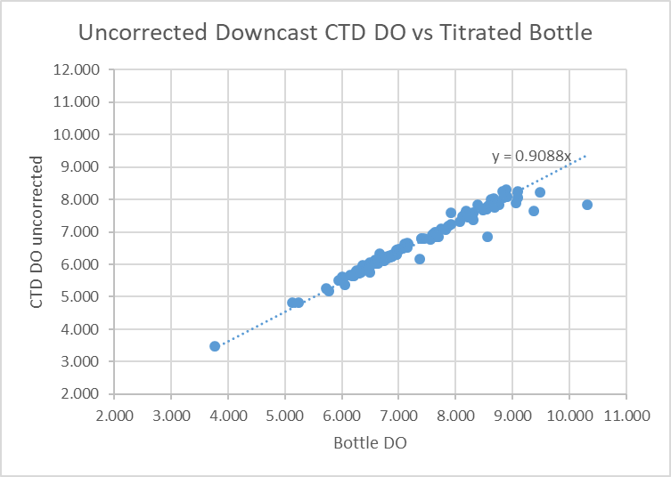
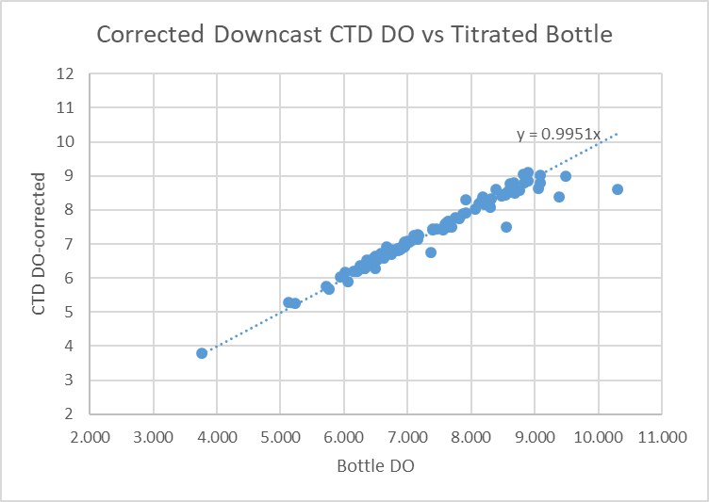

19. Recalibration
The salinity and pressure channels do not require recalibration.
Dissolved oxygen was recalibrated using file 2005-006-recal1.ccf.

20. REMOVE
REMOVE was run to remove Scan_Number, Descent Rate, Oxygen:Dissolved:SBE, Oxygen:Voltage:SBE and Flag channels.

Change Units was run to add DO in mass units and then DO saturation was derived. Surface saturation varied from 90% to 107% with the majority of casts being between 98% and 104%. This shows that the recalibration had reasonable results at the surface.
REORDER was run to get the 2 DO channels together.

21. HEADER EDIT and CTD file creation
Header Edit was used to fix formats and channel names and to add the following note to the headers.
Conductivity and Fluorescence:URU:Wetlabs data are nominal and unedited except
that some records were removed in editing temperature and salinity.

Channel Oxygen:Dissolved:SBE has been recalibrated based on a comparison with
titrated samples. The data have not been edited. The response time of this type
of sensor was long in 2005. The errors caused by this are partly addressed
in the recalibration. The sensor performance was aided by the fact that local
vertical gradients were frequently low.

While the CTD fluorescence data are expressed in concentration units, they
do not always compare well to extracted chlorophyll samples. No chlorophyll
sample data were available for this cruise at the time of processing.

For details on the processing see document: 2005-006_Processing_Report.doc.

The Standards Check routine was run and Header Edit adjusted until no errors remained.
The final files were named CTD.

23. Producing final bottle files
The MRG files were put through CLEAN to remove Sea-Bird headers.
CALIBRATE was run to apply file 2005-006-recal1.ccf to correct dissolved oxygen.
SORT was run to order the records on pressure.

REMOVE was run to remove Scan_Number, Descent Rate, Oxygen:Dissolved:SBE, Oxygen:Voltage:SBE and Flag channels.
Change Units was run to add Oxygen:Dissolved:SBE in mass units. As draw temperatures were not available for DO samples, mass units were not derived for the Oxygen:Dissolved channel.
REORDER was run to get the 2 SBE DO channels together.

HEADEDIT was used to add a comment and to fix formats and channel names.
There were no details available on analysis methods.

The Standards Check routine was run and Header Edit adjusted until no errors remained.
The final files were named CHE.
A header check was produced and it was found that several errors in time or position that had been corrected in CTD bottle files, were wrong in bottle files. When those were fixed no further problems were found.
A cross-reference listing was produced

Particulars
9. No NMEA data. SPAR set to record
10. No NMEA data SPAR set to record
23. Hex file empty.
24. ROS file contains only surface data – no sampling, no CHE file prepared.

Institute of Ocean Sciences
CRUISE SUMMARY

Cruise ID#: 2005-006
Dates: Start: 20 September 2006 End: 12 October 2006
Location: Bering Sea / Bering Strait / Chukchi Sea
Vessel: Sir Wilfrid Laurier
Party Chief: van Hardenberg B.

CTD# | Make | Model | Serial# | Used with Rosette? | CTD Calibration Sheet Competed?
1 | SEABIRD | 25 | 0293 | Yes | Yes

CTD CALIBRATION INFORMATION

Make/Model/Serial#: SEABIRD/SBE25/0293 Cruise ID#: 2005-006

Calibration Information
Sensor |  | Pre-Cruise |  | Post Cruise
Name | S/N | Date | Location | Date | Location
Temperature | 4115 | 10 Dec 04 | Factory
Conductivity | 2607 | 20 Jan 05 | Factory
Fluorometer | 2336 | ? | IOS
Oxygen SBE43 | 0615 | 09Mar04 | Factory
Transmissometer | 139? | 23Apr01 | IOS
Pressure | 0464 | 27Dec02 | Factory

