CRUISE REPORT FOR UW BERING STRAIT MOORING PROJECT 2005
Rebecca Woodgate, University of Washington,woodgate@apl.washington.edu

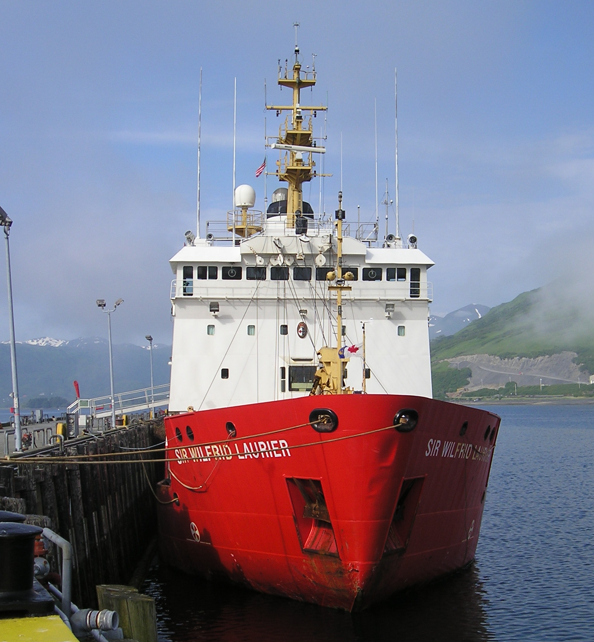

CCGC Sir Wilfred Laurier – 2005-05
Kodiak, 8th July 2005 – Barrow, 22nd July 2005
Science Coordinator: Bon Van Hardenberg, Institute of Ocean Sciences, Sidney, BC
Lead for Canadian Science Team: Ed Carmack, IOS, BC
Lead for US Science Team: Jackie Grebmeier, University of Tennessee

Overview
IOS cruise 2005-05 is part of a on-going Canadian-US collaboration to investigate the ecology and climate of the northern Bering Sea, the Bering Strait and the Chukchi Sea. For full details, see Van Hardenberg/Grebmeier Cruise Report.
In 2005, this research cruise also recovered and redeployed 3 moorings in the Bering Strait region, PIs Rebecca Woodgate and Knut Aagaard, University of Washington, and performed a high resolution CTD section across the Bering Strait and medium resolution CTD lines across the Alaskan Coastal Current in the vicinity of mooring A3, Point Hope and Cape Lisburne. The Bering Strait line has been occupied for several years by Canadian and US researchers. The other three lines have been occupied once a year for many years since 2000 under NSF SBI funding.
Cruise Participants
- Bon van Hardenberg (M)-DFO/IOS Chief Scientist
- Dr. Jackie Grebmeier (F)-U Tennessee, Knoxville, Co-Chief Scientist
- Dr. Lee Cooper (M)-U Tennessee, Knoxville
- Dr. Peter Lee (M)-U of Charleston, SC
- Dr. Rebecca Woodgate (F)-U Washington, Seattle
- Arianne Balsom (F)-U Tennessee Knoxville
- Betty Carvellas (F)- Essex High School, Vermont
- Rebecca Pirtle-Levy (F)-U Tennessee Knoxville
- William Floering (M)-NOAA/PMEL (Jim Overland, lead)
- Jeri Lee Butcher (F) – DFO/IOS

Cruise Map of Stations relevant to UW Mooring work

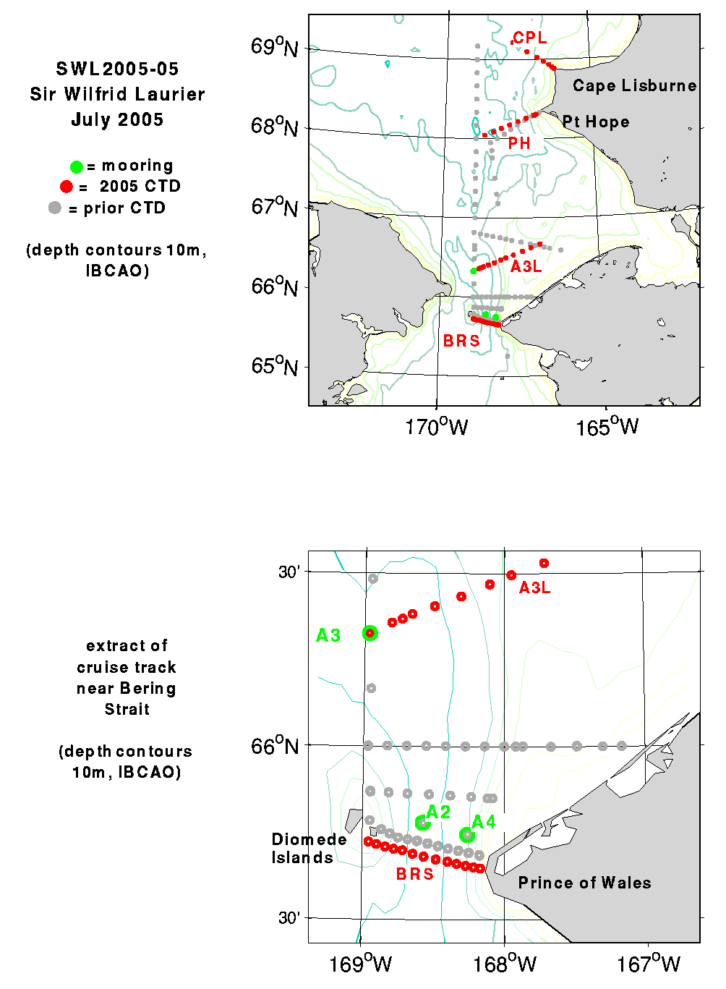

Map of region most relevant to UW Mooring Project. Green = mooring locations A2, A3 and A4 for recoveries and redeployments. Red = CTD stations taken this cruise. Grey = CTD stations taken in previous years. Note that in 2005, the Bering Strait line was run ca. 2 nm south of the prior UW line and the Point Hope line was run slightly north (7 nm or less) of the prior UW line. CTDs were also taken at mooring positions.
Mooring recovery and redeployment
Three physical/biogeochemical Bering Strait moorings were recovered and redeployed during this cruise.
These moorings are part of a multi-year time-series (now 15 years long) of measurements of the flow through the Bering Strait. This flow acts as a drain for the Bering Sea shelf, dominates the Chukchi Sea, influences the Arctic Ocean, and can be traced across the Arctic Ocean to the Fram Strait and beyond. The long-term monitoring of the inflow into the Arctic Ocean via the Bering Strait is important for understanding climatic change both locally and in the Arctic. The last 3 years of data suggest that heat and freshwater fluxes are increasing through the strait - the work completed this summer should tell us if this is a continuing trend.
Three moorings (A2 and A4, in the eastern channel of Bering Strait, and A3, ca. 35nm north of Bering Strait), deployed from the Alpha Helix last year, were funded by ONR/NSF (Aagaard and Woodgate, UW, http://psc.apl.washington.edu/BeringStrait.html ) and are the final field work for the NSF-SBI program (http://sbi.utk.edu). The three moorings deployed this year are NSF funded (Woodgate, UW). All the moorings carry conventional instrumentation - current meters (RCM or ADCP), temperature and salinity sensors (SBE16). In addition, moorings A2 and A3 carry Upward-Looking-Sonars (ULS) (Moritz, UW). The mooring A4 carries an upward-looking ADCP (instead of the RCM) to study the coastal jet. In 2004-2005, mooring A3 also supported a transmissometer, a fluorometer and a PAR sensor, connected to the SBE16 (Whitledge and Weingarter, UAF). For the 2005 redeployment, these latter instruments were placed on mooring A2 rather than A3. The redeployed mooring A2 also carries an ISUS nitrate meter (Whitledge, UAF). The current meters and ULSs allow the quantification of the movement of ice and water through the strait. The nutrient sampler, the transmissometer and fluorometer time-series measurements should advance our understanding of the biological systems in the Bering Strait and Chukchi Sea.
Maintaining the time-series measurements in Bering is important to several national and international programs, e.g. NSF’s Freshwater Initiative (FWI) and Arctic Model Intercomparison Project (AOMIP), and the international Arctic SubArctic Ocean Fluxes (ASOF) program. It also supports regional studies in the area, by providing key boundary conditions for the Chukchi Shelf/Beaufort Sea region; a measure of integrated change in the Bering Sea, and an indicator of the role of Pacific Waters in the Arctic Ocean. Furthermore, the Bering Strait inflow is considered important for the Atlantic overturning circulation and possibly world climate.
In 2004-2006, the mooring work is also in collaboration with the RUSALCA project led by John Calder of NOAA in collaboration with AARI, St. Petersburg, who are maintaining moorings in the western channel of the Bering Strait (Whitledge and Weingartner, UAF).
Despite rough weather, the three mooring recoveries and redeployments were accomplished in one day. The moorings were ranged on and released from the USCGC Laurier, and a small boat was used to attach a line to the moorings, which was passed to the ship. Since the moorings are short (~ 10m), with the long boom of the Laurier, the entire mooring could be recovered or deployed in one pick, making for very speedy work. All operations went smoothly, due to skilled small boat and deck operations. One acoustic release on A2-04 failed to release on command, but after repositioning the ship, the second release on A2 functioned properly and the mooring was recovered in the usual manner. We are still investigating why the first release on A2 failed to release the mooring.
Details of mooring positions and instrumentation and preliminary results are given in the Table and Figures below. Although significant amounts of silt had collected in the mooring floatation, especially at site A4 in the Alaskan Coastal Current, biofouling was only moderate (see photographic appendix).
Although detailed, quantitative analysis is still to be done, the mooring data suggests a warming and freshening especially in the Alaskan Coastal Current.

Bering Strait and Alaska Coastal Current CTD lines
Four CTD lines were taken as per the map above. Preliminary results are shown in Figures below. Strong northerly winds preceding and during the mooring work appear to have reduced the strength of the Alaskan Coastal Current, a conclusion supported by data from the recovered ADCP. The strong northward currents frequently encountered in the region were absent for most of the line. Just off Point Hope however, an approximate 3 knot surface current was evident during the CTD section. Note the very fresh, warm waters in the CTD section at this location (~ 18 psu, 12 deg C). (In comparison to the lines further south, the Cape Lisburne line had less fresh water, suggesting either the bulk of the Alaskan Coastal Current had been diverted away from the coast, or that it had not yet arrived from the south.

Table of Bering Strait Mooring Positions and Instrumentation

ID | LATITUDE (N) | LONGITUDE (W) | WATER DEPTH /m | INST.
Recover
A2-04 | 65° 46.78' | 168° 34.48' | 55 | ULS
 |  |  | (uc 51) | RCM7
 |  |  |  | SBE16
A3-04 | 66° 19.54' | 168° 58.03' | 57 | ULS
 |  |  | (uc 54) | RCM11
 |  |  |  | SBE/TFP
A4-04 | 65° 44.72' | 168° 15.71' | 47 | ADCP
 |  |  | (uc 43) | SBE16
Deploy
A2-05 | 65° 46.78' | 168° 34.50' | 58 | ULS
 |  |  | (uc 53) | RCM7
 |  |  |  | SBE/TFP
 |  |  |  | ISUS
A3-05 | 66° 19.54' | 168° 58.02' | 58 | ULS
 |  |  | (uc 53) | RCM11
 |  |  |  | SBE16
A4-05 | 65° 44.73' | 168° 15.68' | 49 | ADCP
 |  |  | (uc 44) | SBE16

ULS = APL Upward Looking Sonar
RCM7 = Aanderaa Mechanical Recording Current Meter
RCM9 and RCM11 = Aanderaa Acoustic Recording Current Meter
SBE16 = Seabird CTD recorder
SBE/TFP = Seabird CTD recorder with transmissometer, fluorometer and PAR sensor
ISUS= Nutrient Analyzer
ADCP = RDI Acoustic Doppler Current Profiler
uc = uncorrected for ship's draft (3m for Helix; 5 m for Laurier)

Schematics of Mooring Recoveries

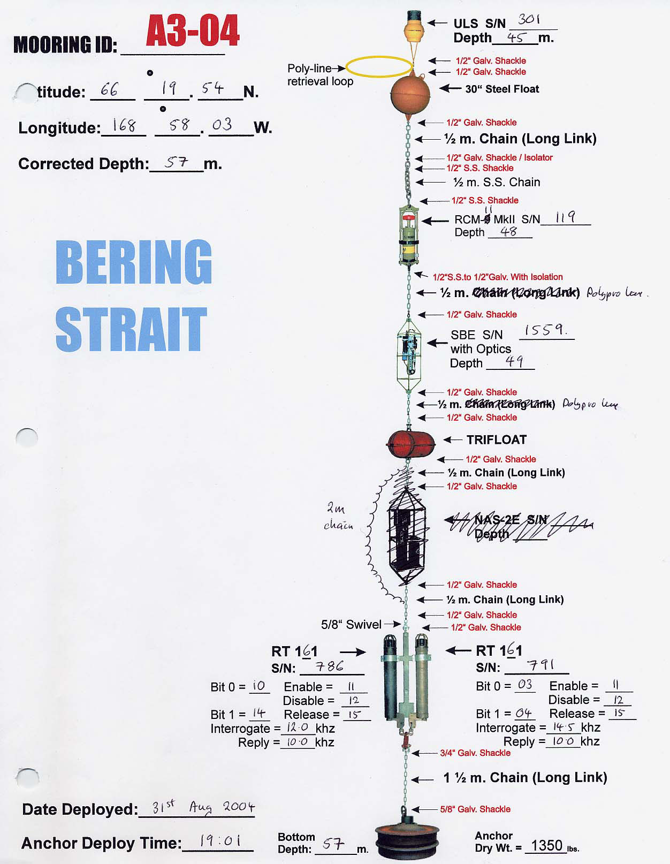

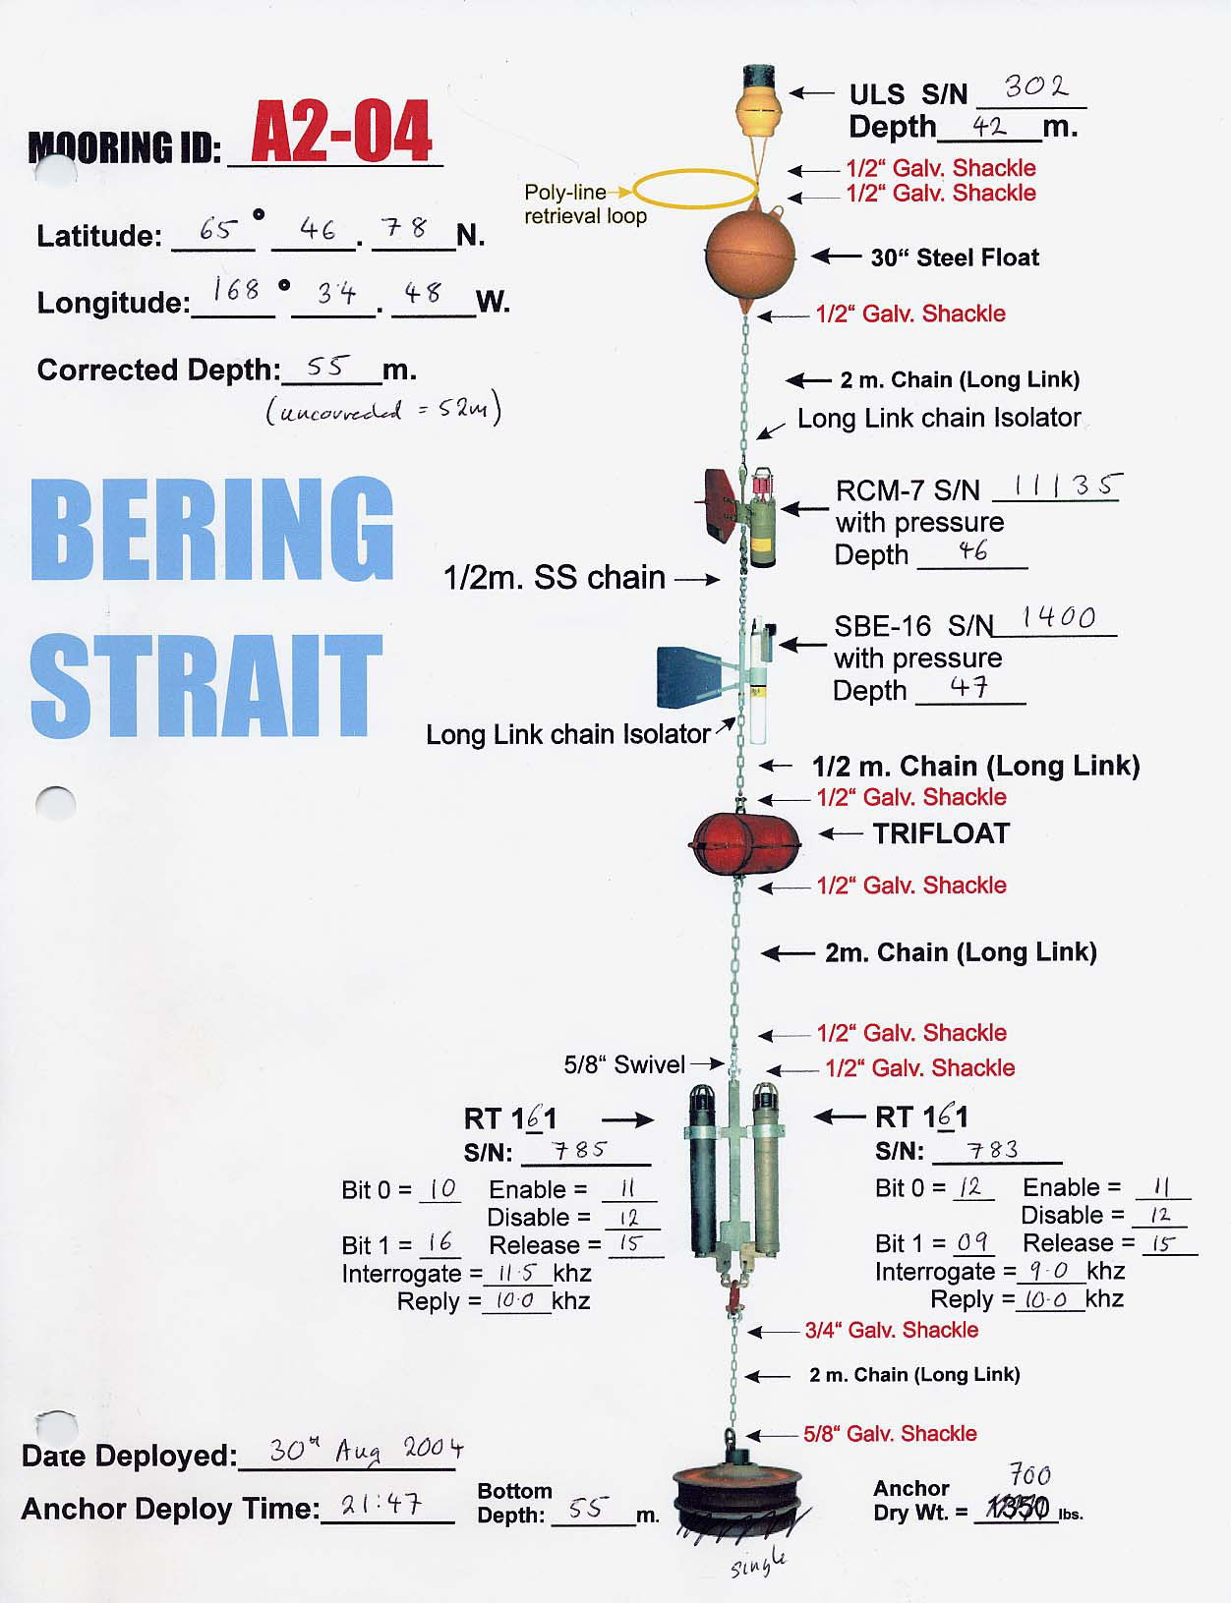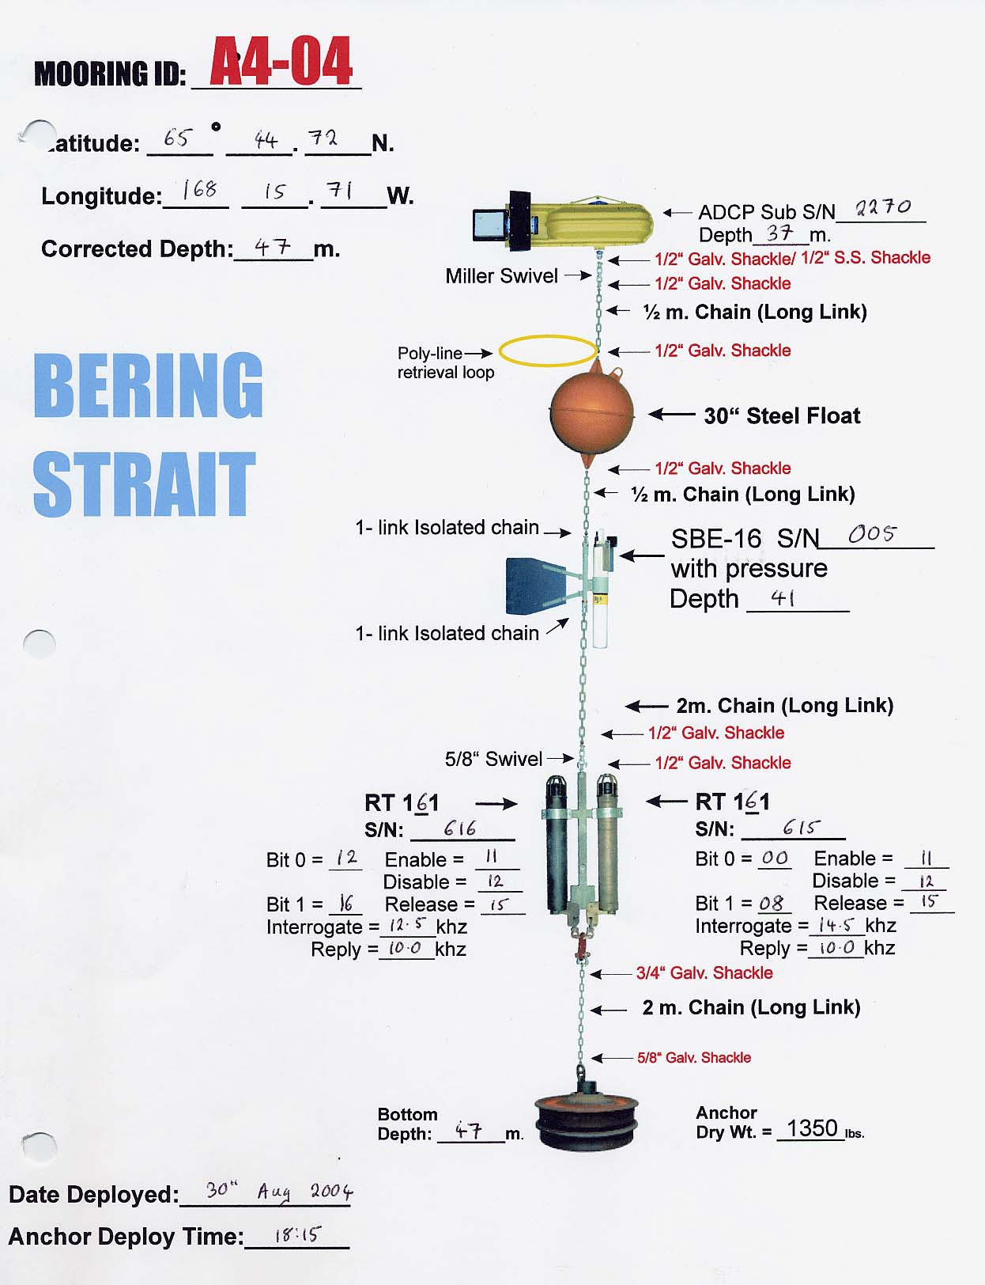

Schematics of Mooring Deployments

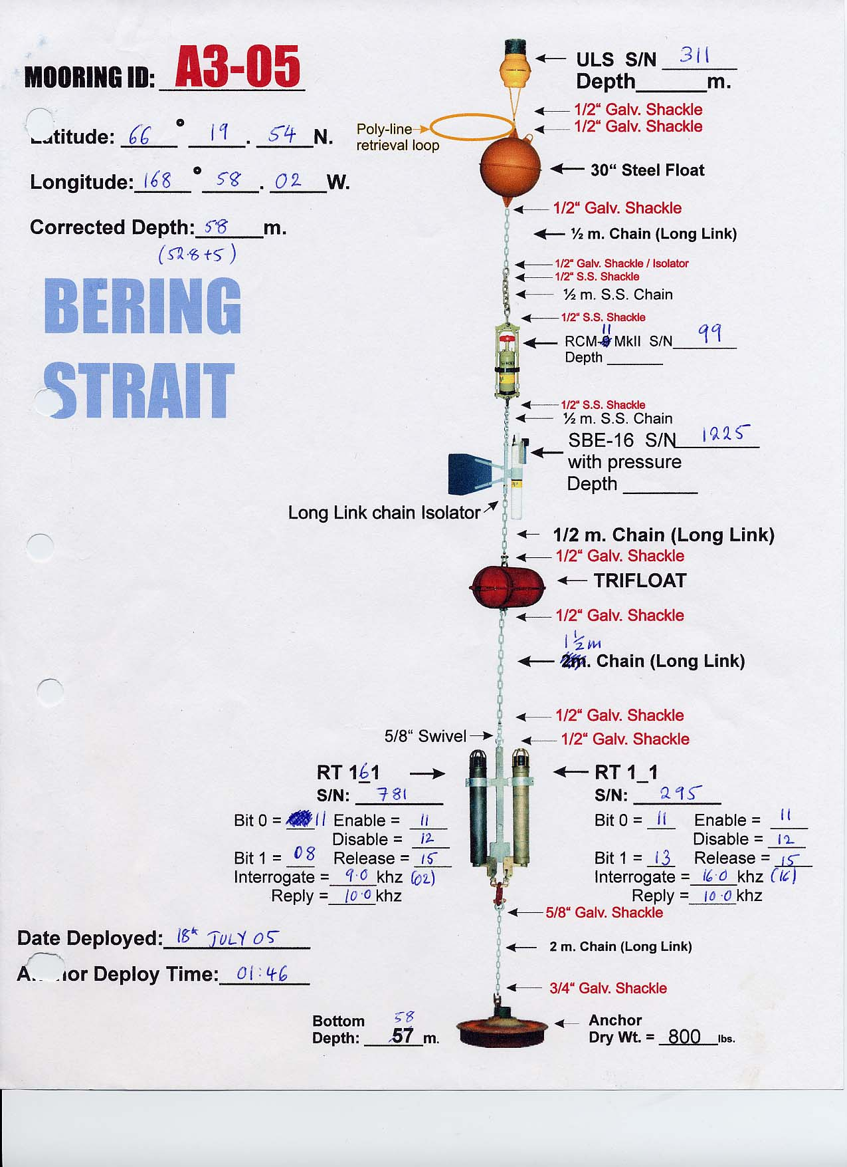

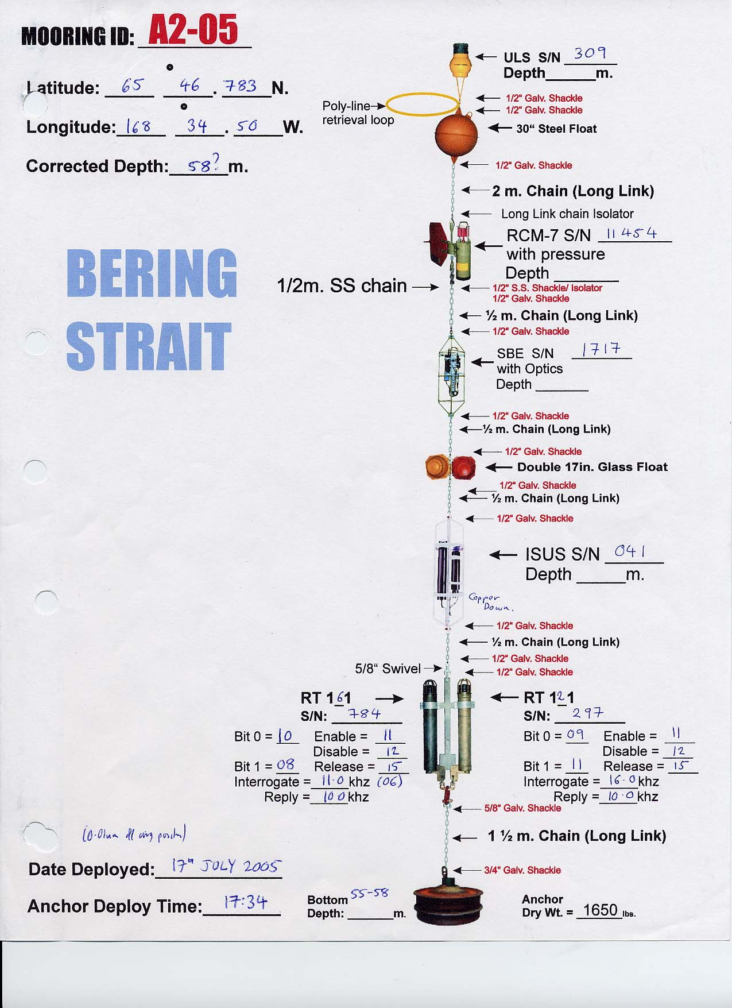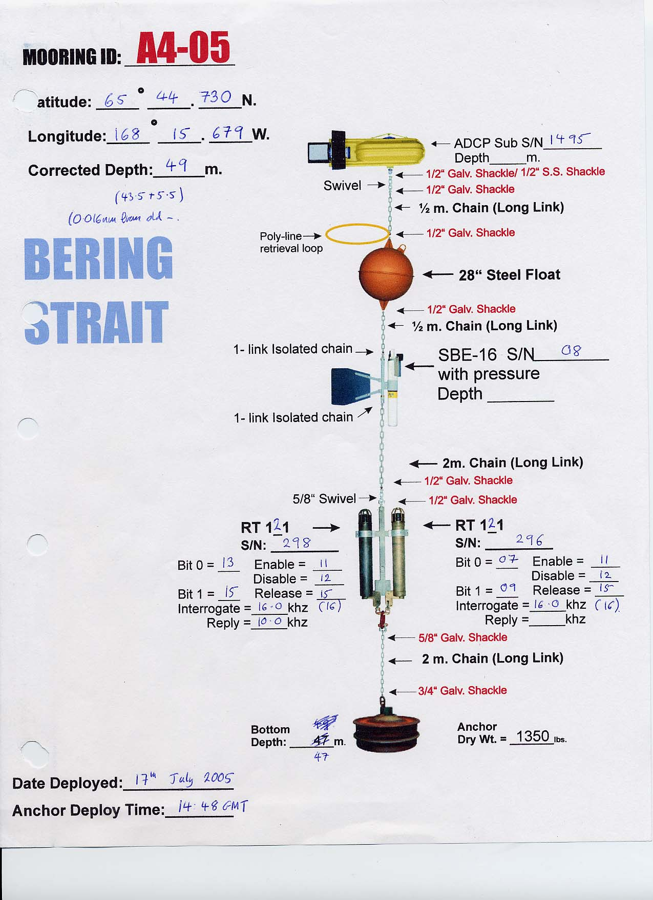

Preliminary Current Meter Results

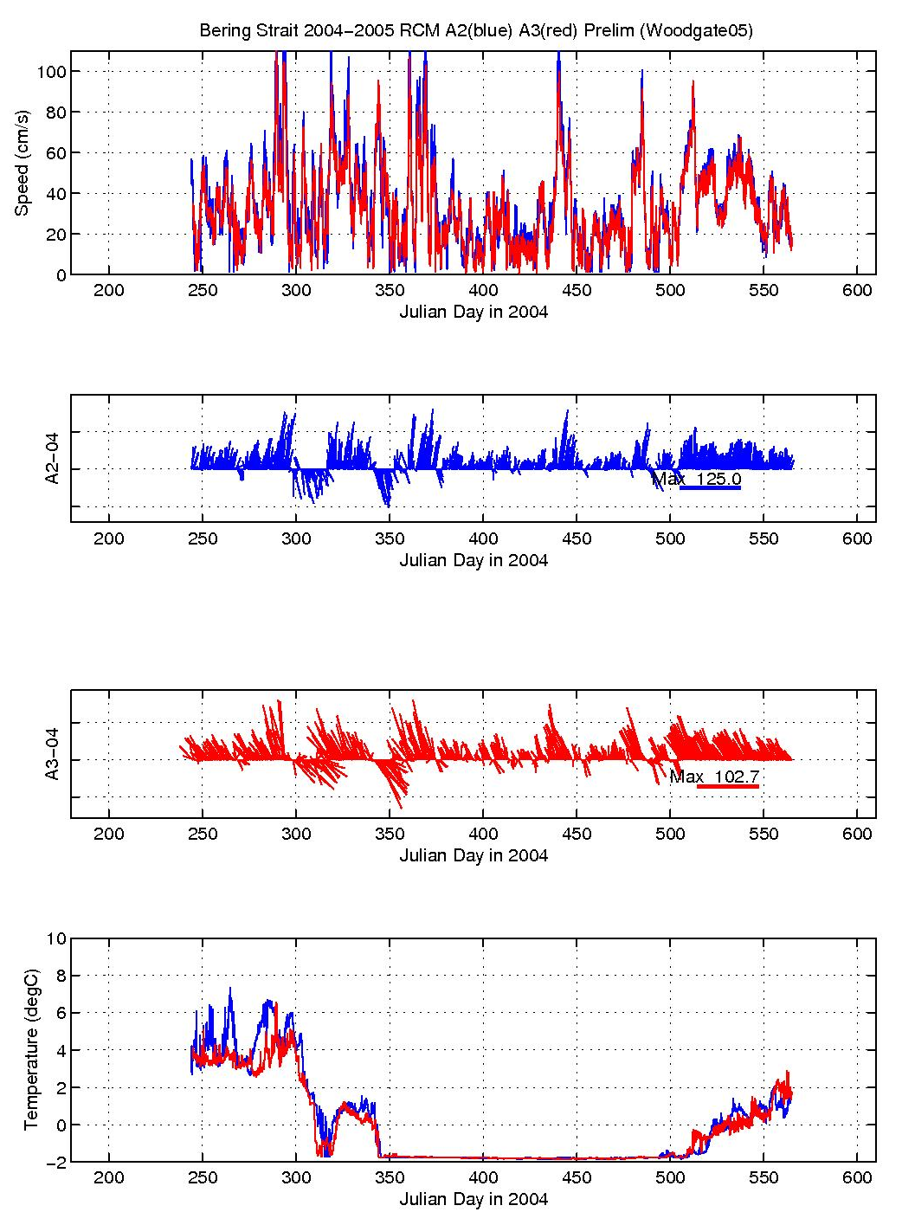
Preliminary Seacat Results

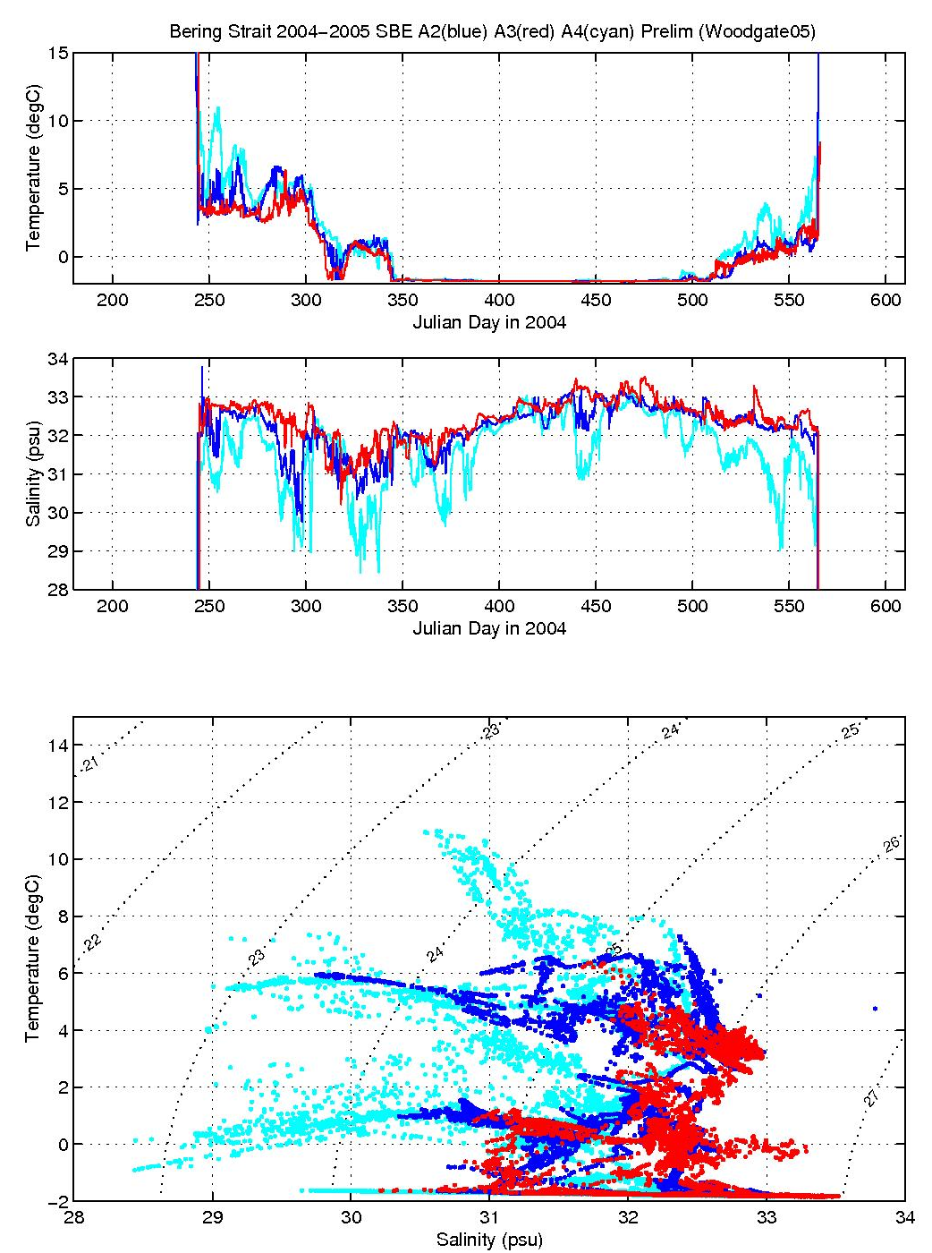

Preliminary CTD Sections - BERING STRAIT (ca. 2 nm S of prior location)

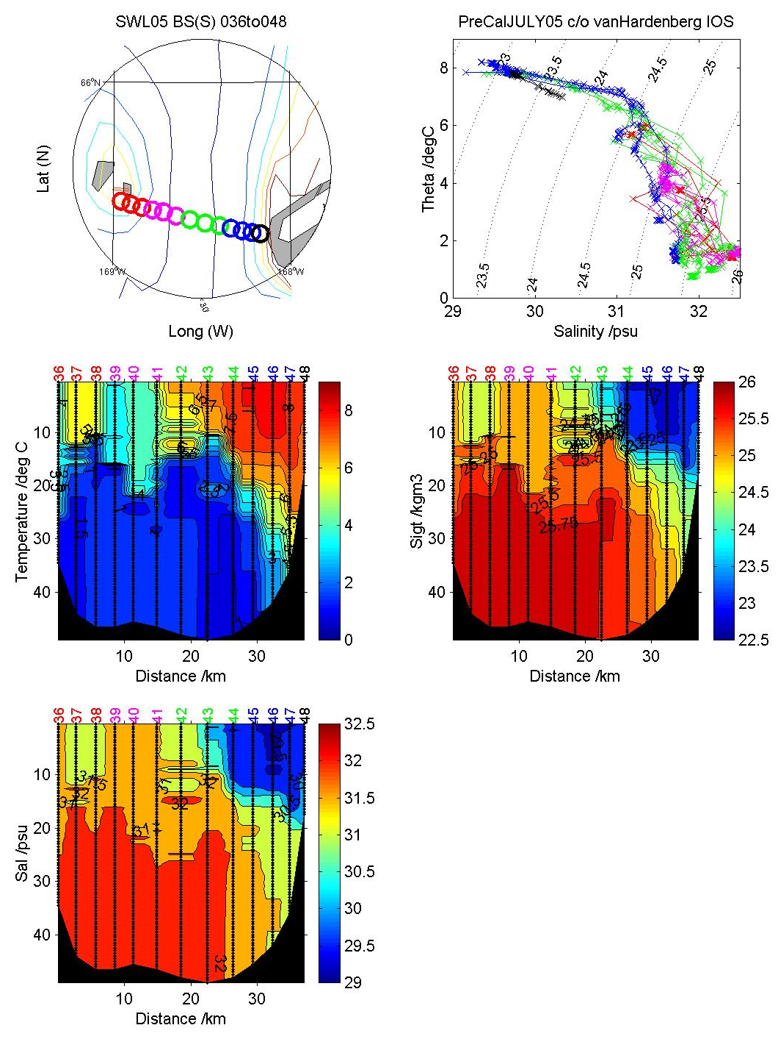

Preliminary CTD Sections - A3-L LINE

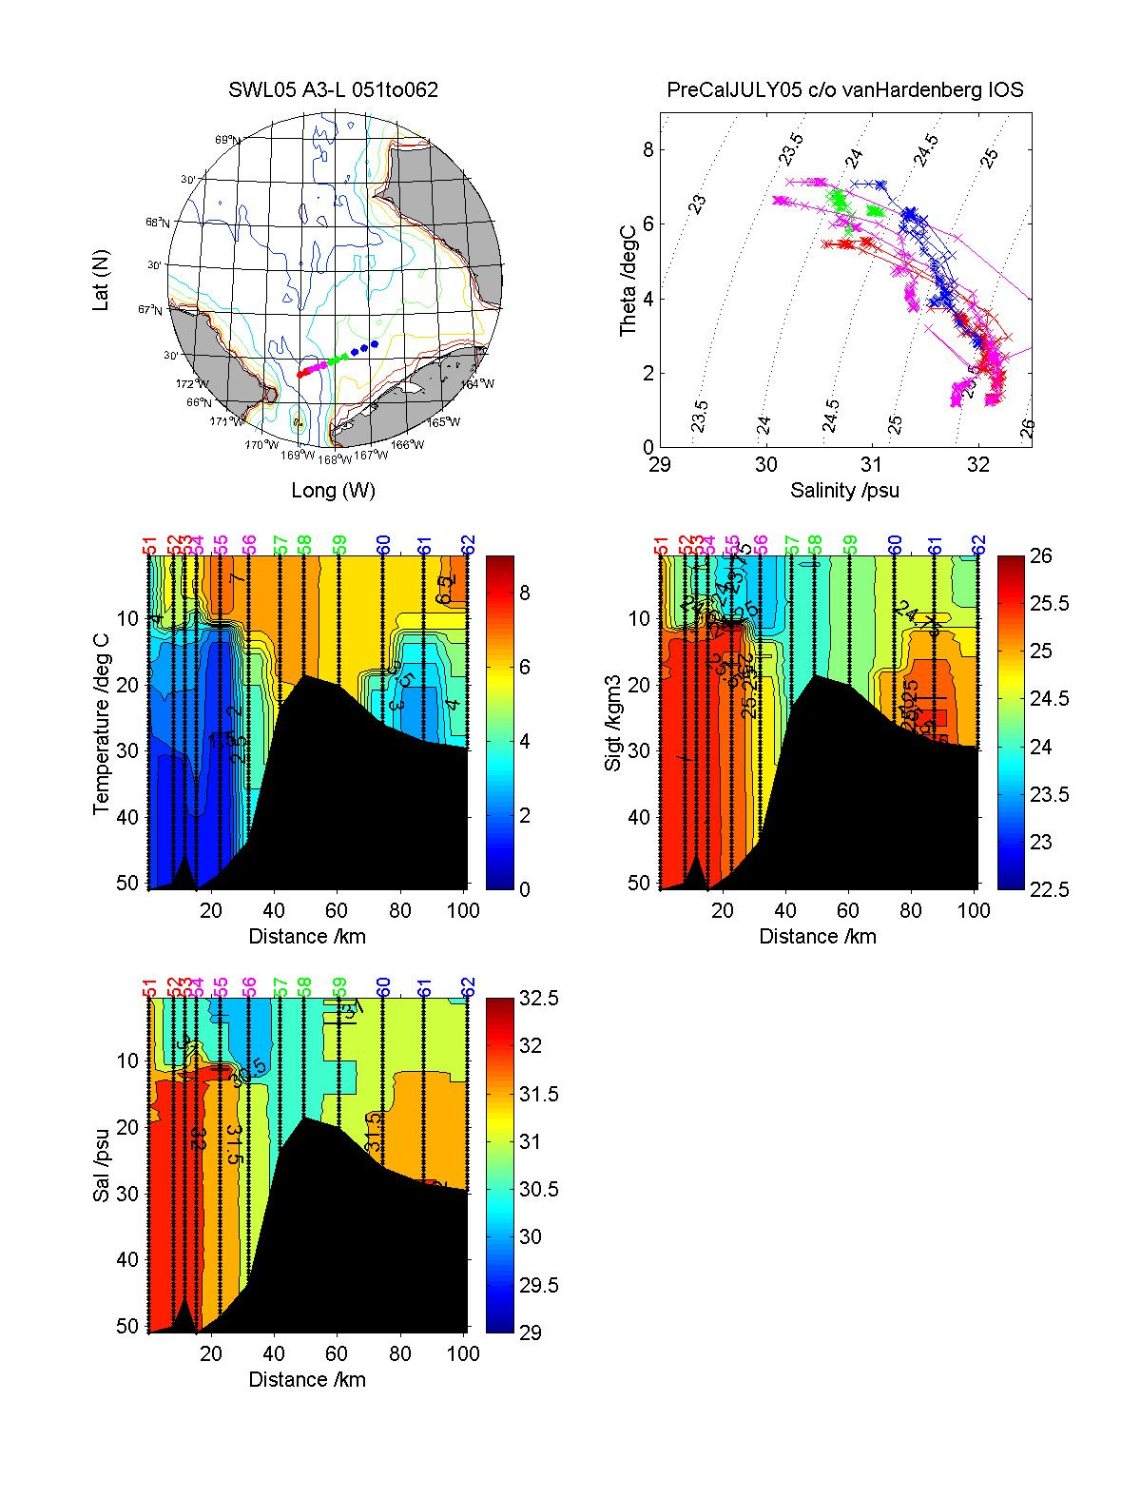

Preliminary CTD Sections - POINT HOPE LINE (7 nm-0 nm N of previous location)

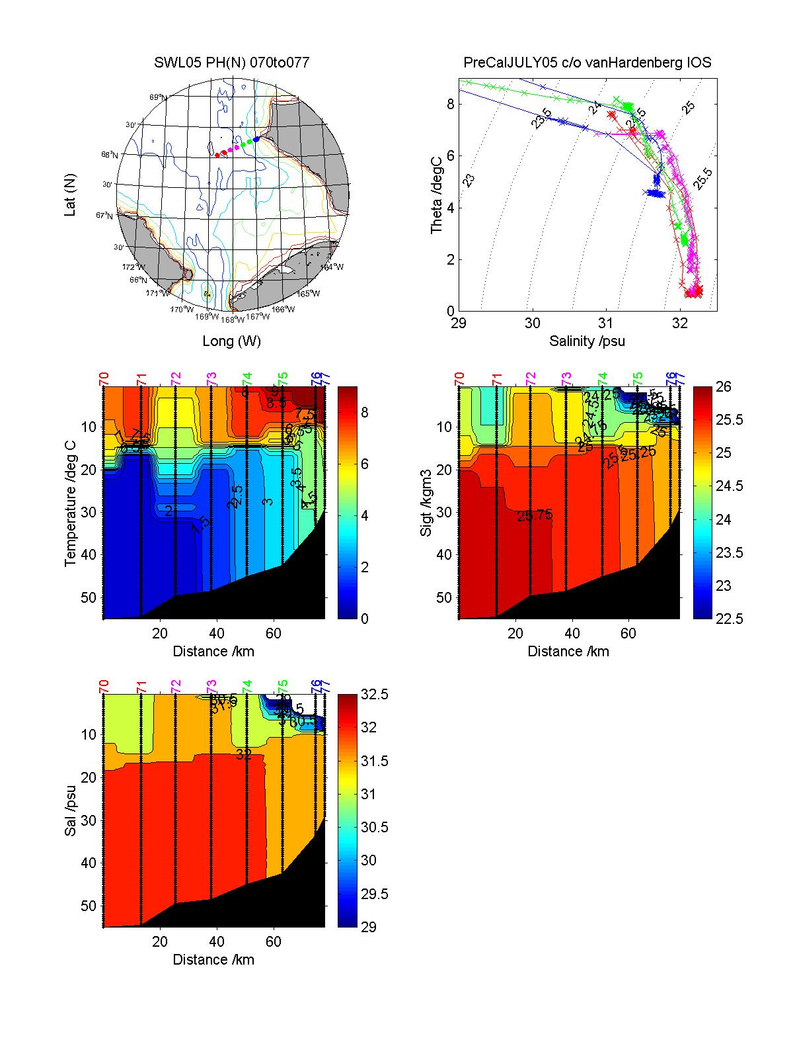

Preliminary CTD Sections - CAPE LISBURNE LINE

