2005 CABOS Mooring Recovery and Deployment Notes

Doug Sieberg and Sarah Zimmermann
17 November 2005

The Canadian Basins Oberservational System (CABOS) mooring is part of the Interantional Arctic Research Center’s (IARC) initiative to monitor the circulation of water from the Nordic Seas within the Arctic. The CABOS mooring is located in the south-east Beaufort Sea, on the continental slope in 1120m of water. The combined CTD and acoustic current meter (McLane Moored Profiler) profiled twice daily from approximately 50 to 1100 m. The depth range allowed the sampling of the Pacific’s summer and winter waters, and the Atlantic Water’s Fram Strait and Barents Sea branches. The mooring was first deployed in 2002 and has been serviced each following year. Below are the recovery, servicing and deployment notes for the August 2005 mooring operations, performed from the CCGS Louis S St-Laurent. The mooring equipment was prepared on shore by Rob Chadwell (IARC) and Mike Dempsey and at sea operations were led by Doug Sieberg, with much appreciated assistance from the WHOI group, and the Captain and Crew of the CCGS Louis S St-Laurent.

Table 1. 2005 Operations, CABOS mooring
Investigator | Recovery | Recovery | Recovery | Deployment | Deployment | Deployment
 | Depth (m) | Location | Time (UTC) | Depth (m) | Location | Time (UTC)
UAF/IARC | 1121 | 71° 46.506'N | 04-Aug-05 | 1110-1112 | 71° 49.676'N | 30-Aug-05
I. Polyakov |  | 131° 52.711'W | 1446 (UTC) |  | 131° 45.663'W | 2112 (UTC)

Table 2. 2004 Operations, CABOS mooring
Investigator | Recovery | Recovery | Recovery | Deployment | Deployment | Deployment
 | Depth (m) | Location | Time | Depth (m) | Location | Time
UAF/IARC | 1120 | 71° 46.672'N | 07-Aug-04 | 1121 | 71° 46.506'N | 30-Aug-04
I. Polyakov |  | 131° 53.195'W | 19:37 UTC |  | 131° 52.711'W | 20:01 UTC

Table 3. 2003 Operations, CABOS mooring
Investigator | Recovery | Recovery | Recovery | Deployment | Deployment | Deployment
 | Depth (m) | Location | Time | Depth (m) | Location | Time
UAF/IARC |  | 71° 23.06'N | 11-Aug-03 | 1120 | 71° 46.64'N | 04-Sep-03
I. Polyakov |  | 134° 03.80'W | 17:00 UTC |  | 131° 53.19'W | 01:10 UTC

Table 4. 2002 Operations, CABOS mooring
Investigator | Recovery | Recovery | Recovery | Deployment | Deployment | Deployment
 | Depth (m) | Location | Time | Depth (m) | Location | Time
UAF/IARC |  |  |  | 1117 | 71° 22.897'N | 16-Sep-02
I. Polyakov |  |  |  |  | 134° 04.14'W | 18:15 UTC

Mooring Recovery

We arrived on site at midnight local time. While waiting for morning to start the mooring operations, we performed a rosette cast, two net casts down to 100m and two bottle flushing study casts, where we also collected water at 1000m for the CFC analyzers.

During the night and morning the ship had a constant drift S to SE of 0.3knt, very light wind (3-4 knots). The water was mostly open although we did have roughly 100m pans of multiyear ice (~1/10). The night temperatures had been below freezing and the deck was icy at the start. Before recovery we had fog, but it lifted just before operations began.

At 7 am we were on site and ranged on the mooring. The ranging was performed using the Woods Hole Oceanographic Institution’s deck box set up in the foredeck container. They now have GPS with their transducer as well as a 12 kHz bottom sounder. Having their own GPS alleviates the mismatch in distances (trying to match the horizontal range given by the transducer and the range on the bridge to the mooring position because the tranducer and GPS antenna are ~10m apart), and keeps it simple by not having to relay positions noted in the bridge to the lab during the ranging. The mooring range difference between the lab and bridge was ~20m.

At 8am we started the mooring recovery operation. The crew was instructed how to use the WHOI Lebus winch, the blocks, lines and water hoses assembled. To remove the hydro/bongo wire from the A-frame, the whole block had to be removed since the wire termination was to large to slide through the block.

The mooring was ranged on just before recovery:
46m from lab, 70m from bridge, bridge position 71 46.476 131 52.571
with the mooring site directly off the bow.

We backed off slightly from the site and took new range:
130 from lab, 166m from bridge, bridge position 71 46.510 131 52.711

The area around the mooring was ice free.

The release command was given at 14:38 UTC (8:38 local). The mooring did not surface although the release gave confirmation that it had opened. The water was open enough not to suspect the mooring had lodged under the ice. After five minutes or so, Doug went back into the lab to open the second release. At 14:43 Doug had confirmation that the second release had opened. At 14:46 the mooring was at the surface, perfectly positioned about 100m forward of the starboard bow. Once on deck, the first release let go of the chain showing the release had opened but it required a jostle to free the chain. We had a similar problem last year, blaming the bar that joined the two releases. The bar was replaced by the chain link from WHOI for this year. Perhaps buoyancy was the problem in the 2004 and 2005 recoveries, with the releases not sitting vertically, or under enough tension, and not the bar?

There was no unusual growth or corrosion on the release assembly and the MMP cable was quite clean and in good condition.

Captain Potts was at the wheel for the recovery. He pulled the ship close to the mooring, and the bosun, Bob Taylor was able to catch the top ring of the float with a hook off of the crane.

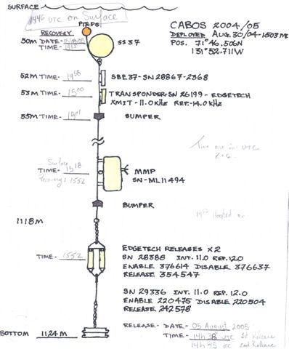
Figure 1. CABOS 2004-2005 recovery, 4 August 2005.

Table 5. Recovery August 4, 2005
Time (UTC) | Notes | Codes
14:46 | surface
14:53 | SS37 Float on board
14:58 | SBE37 sn28867-2368 on board
15:00 | Transponder-sn26199 on board | xmit 11.0 kHz Reply 14.0 kHz
15:01 | Top bumper on board
15:18 | MMP s/n ml11494 surface
15:52 | MMP on deck
15:52 | Bottom bumper and releases (sn 28388 and sn 29336) | Int. 11.0kHz Rep. 12.0kHz  sn 28388 enable 376614  disable 376637  release 354547  sn29336 enable 220475  disable 220504  release 242578

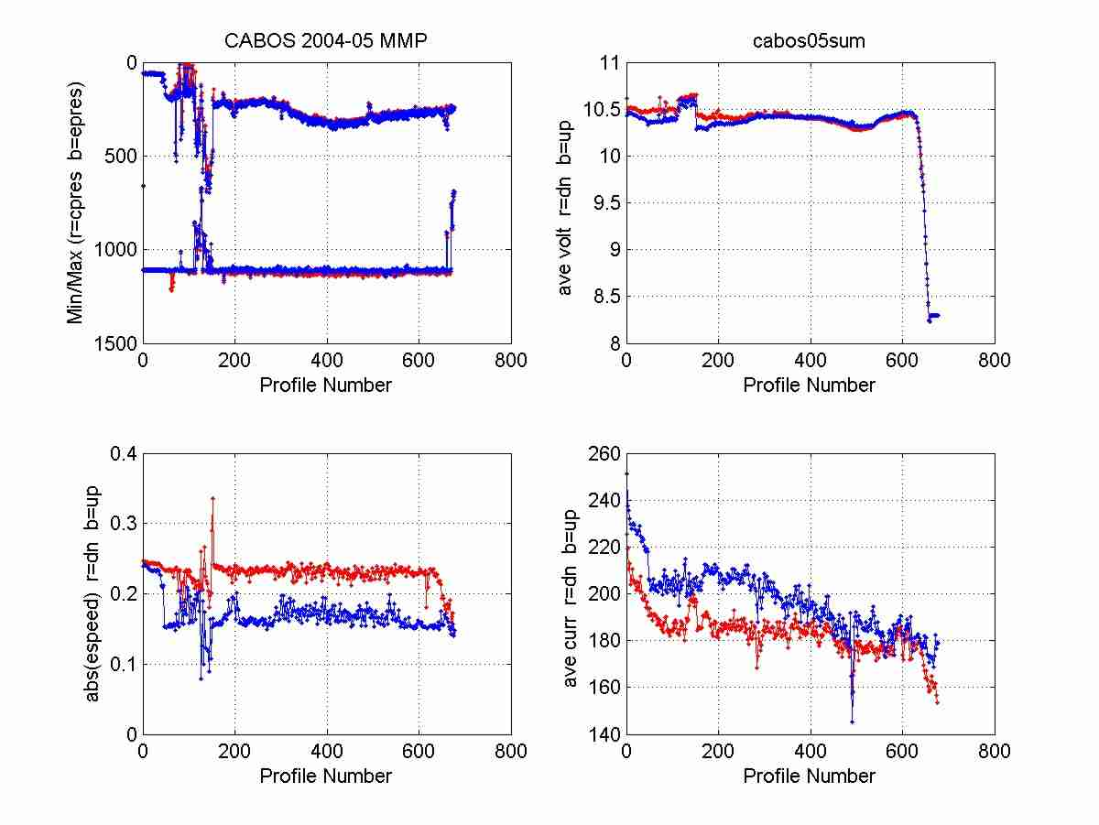
Figure 2. MMP Engineering data

The MMP profiled throughout the year until the battery died after approximately 625 profiles, about 1 month shy of a full deployment. The MMP was set to run 2 profiles per day. After about profile 50 the MMP stopped reaching the top bumper, only reaching 200m for the rest of the deployment, but consistently making it to full depth. The MMP climbed slower and drew more current during the ascents. This may have been caused by being ballasted heavy?

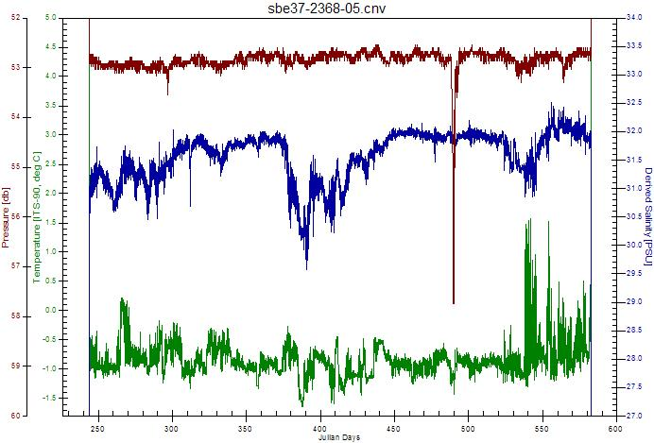
Figure 3. SBE 37 CTD record

The SBE37 CTD pressure looks steady during deployment except for the 5m dip around day 490. Although buoyancy may be a factor for the release, the lack of variations in the CTD pressure show the top of the mooring is steady and not being pulled over by ocean currents.

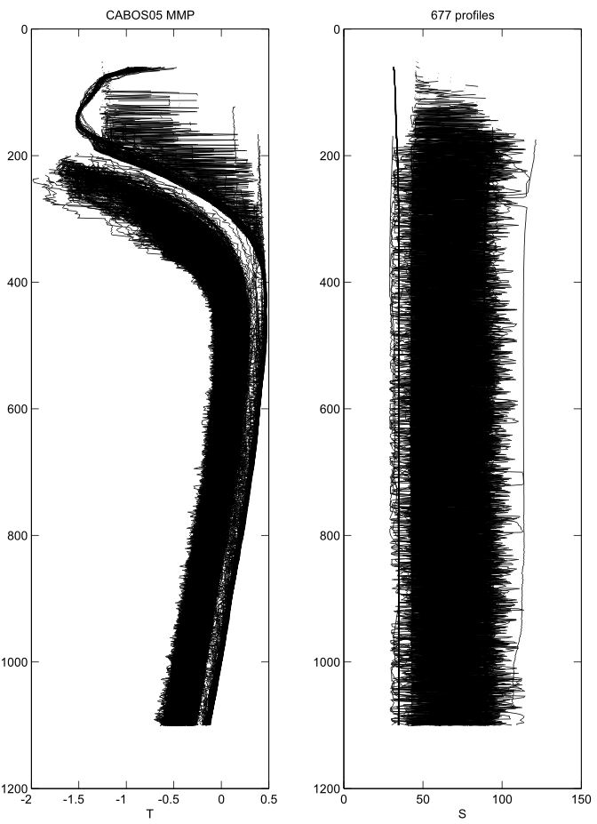
Figure 4. MMP CTD data

The MMP CTD conductivity sensor failed shortly after deployment. The temperature also suffered a problem not long afterwards. The cause of the problems are not known. The CTD was stowed in the hold before the problem in the data were discovered, so it is unknown if leaks or damage had occurred. The MMP and CTD are being returned to McLane for review.

The settings for the 2004-2005 deployment:

SBE37 (Excerpts from sbe37-2368-05.cap)
SBE37-SM V 2.4 SERIAL NO. 2368 04 Aug 2005 21:18:04
sample interval = 900 seconds
samplenumber = 32630, free = 158020
do not transmit real-time data
store time with each sample
number of samples to average = 4
serial sync mode disabled
wait time after serial sync sampling = 30 seconds
temperature = 22.39 deg C

MMP (Excerpt of tests and settings from setup_cabos04mmpdep.log)
Version: MMP-3_01.c S/N: ML11494-00C
Battery trip meter reset to 0 meters
Bench Tests: CTD communication, CTD Average Pressure, Temperature Record, Tilt and Compass, Motor Operation, Test Watchdog IRQ
Standard CTD settings verified.
Standard ACM settings verified.
Z| Scheduled start = 08/31/2004 00:00:00
I| Profile start interval = 000 12:00:00 [DDD HH:MM:SS]
R| Reference date/time = 09/12/2002 00:00:00
B| Burst Interval = Disabled
N| Profiles per burst = Disabled
P| Paired profiles Disabled
F| Profiles / file set = 2
S| Shallow pressure = 60.0 [dbar]
D| Deep pressure = 1110.0 [dbar]
H| Shallow error = 60.0 [dbar]
E| Deep error = 40.0 [dbar]
T| Profile time limit = 01:27:30 [HH:MM:SS]
C| Stop check interval = 5 [sec]
All entries are within allowed ranges.
Calculated minimum profile duration: 01:21:24
Profile schedule selections are consistent.
Burst mode disabled.
Estimated Profile 1 start time: 08/31/2004 12:00:00
Profiling distance will reach 1.0 million meters
on 12/20/2005 after 952 profiles.
System status:
RTC: 08/28/2004 19:59:00 WDC: 08/28/2004 19:58:59 11.4 Vb 0 mA
Sensor warm-up will begin at 08/30/2004 23:58:00
Initial dive to bottom stop will begin at 08/31/2004 00:00:00.
System is ready to deploy.

Servicing

The CABOS mooring for the 2005-2006 deployment had the same instrumentation as the previous year: a SBE-37 CTD and an Edgetech transponder mounted 3 meters below the top float, an MMP consisting of a CTD plus acoustic current meter, and mounted above the anchor are dual Edgetech acoustic releases. The SBE-37 CTD, transponder and releases were used on the 2004-2005 deployment. After recovery, they were cleaned and batteries replaced, making them ready for the 2005-2006 deployment. A new MMP was put on for this year.

Through discussions with Rob Chadwell and Igor Polyakov at the IARC and Doug Sieberg, John Kemp and Rick Krishfield on board the ship, it was decided to modify the mooring design and program the instruments for a 1-year deployment instead of the proposed 2-year deployment. Two 17” glass floats were added immediately above the acoustic releases and another set of two 17” glass floats were added immediately below the top SS37 float. The floatation was added to keep insure the mooring line was taut and the acoustic releases were in vertical position. The pressure readings from the SBE37 did not show big swings in pressure over the 2004-2005 deployment, so the mooring may not have been ‘bobbing’ or leaning in the current as speculated. However, the added floatation removes the doubt that this could be causing the problems encountered with the climbing of the MMP and the opening of the releases. The mooring was going to be installed for 2-years, but with problems in the recovered mooring (CTD malfunctioned) it was felt the mooring was not fail-safe enough to leave for that long. The instrument configuration was performed by Rick Krishfield.

MMP settings (Excerpt from CABOS05_mmp_dep.log)
Version: mmp-2_08.c S/N: ML11286-01
Bench Test: CTD Avg Pressure, ACM Tilt and Compass, Motor Operation, Test System Watchdog
Battery trip meter reset to 0 meters
Standard CTD settings verified.
Standard ACM settings verified.
Sensors initialized and ready for deployment.
1| Scheduled start = 08/31/2005 00:00:00
2| Profile start interval = 001 00:00:00 [DDD HH:MM:SS]
3| Reference date/time = 08/01/2005 00:00:00
4| Burst interval = 000 00:00:00 [DDD HH:MM:SS]
5| Profiles per burst = Disabled
6| Paired profiles Disabled
7| Shallow pressure = 60.0 [dbar]
8| Deep pressure = 1110.0 [dbar]
9| Shallow error = 60.0 [dbar]
A| Deep error = 40.0 [dbar]
B| Profile time limit = 01:27:30 [HH:MM:SS]
C| Stop check interval = 5 [sec]
Calculated minimum profile duration: 01:21:24
Estimated Profile 1 start time: 09/01/2005 00:00:00
Sensor warm-up will begin at 08/30/2005 23:58:00
Initial dive to bottom stop will begin at 08/31/2005 00:00:00.

SBE 37 settings (Excerpt from sbe37-2368-05-dep.cap)
SBE37-SM V 2.4 SERIAL NO. 2368 29 Aug 2005 15:02:48
not logging: waiting to start at 30 Aug 2005 00:00:00
sample interval = 900 seconds
samplenumber = 0, free = 190650
do not transmit real-time data
store time with each sample
number of samples to average = 4
serial sync mode disabled
wait time after serial sync sampling = 30 seconds
temperature = 20.05 deg C

Deployment

The CABOS mooring was deployed the afternoon of the 30th of August, following rosette cast #49 on the site. The position of the 2004 mooring was covered by ice so the 2005 site was shifted slightly to the northeast. At 1pm local (1900 UTC) the drift was 0.3 knt to 60°. The wind was blowing 15 knt from 154°. The area chosen was ice free enough for the ship to maintain its position during the deployment. The mooring was deployed anchor first.

Table 6. Deployment Record, 30 August 2005.
Time (UTC) + 6 from local | Notes | Codes | Depth (based on 1111m bottom depth)
 | Anchor and releases (sn 28388 and sn 29336) over the side | sn 28388:  Int 11.0kHz,  Rep 12.0kHz,  enable 376614, disable 376637, release 354547  sn 29336:  Int 11.0kHz,  Rep 12.0kHz,  enable 220475, disable 220504, release 242578 | 1109m
 | 2 17” Glass Balls attached |  | 1107m
 | Bottom bumper attached |  | 1105m
2003 | MMP SN ML11286-01
 | Top bumper attached |  | 48m
2055 | Transponder SN26199 Edgetech attached | Transmit 11.0kHz, Rep 14.0kHz | 47m
2055 | SBE37 SN2368 attached |  | 46m
 | 2 17” Glass Balls attached |  | 45m
2105 | SS37 Top float and pieps attached |  | 44m
2112 | Mooring Released to bottom

Figure 5. CABOS 2005-2006 deployment, 30 August 2005. (figure curtesy Rob Chadwell)

