BGOS Field Operations in 2005
by Richard Krishfield, John Kemp, Kris Newhall and Chris Linder
P.I. Andrey Proshutinsky
Woods Hole Oceanographic Institution
August 31, 2005

As part of the continuing field program of the Beaufort Gyre Observing System (BGOS; http://www.whoi.edu/beaufortgyre), three deep bottom-tethered moorings were recovered and four deployed during a Joint Western Arctic Climate Study (JWACS) cruise on the Canadian Coast Guard Icebreaker Louis S. St. Laurent (LSL) in August 2005. In addition, a shallow bottom-tethered mooring was deployed on the Beaufort Shelf (BS-3) for P.I. Robert Pickart to continue observations that were begun during the SBI program. Finally, two autonomous Ice Based Observatories, each consisting of an Ice Tethered Profiler (ITP) and Ice Mass Balance Buoy (IMB) were installed on pack ice. The times and locations of the recovery and deployment operations are given in Table 1.
Table 1: Summary of BGOS 2005 Field Operations
Mooring | Water | 2004 | 2004 | 2005 | 2005
Designation | Depth (m) | Location | Recovery | Deployment | Location
BS-3 | 149 |  |  | 6-Aug | 71° 23.732'N
 |  |  |  | 22:12 UTC | 152° 02.175'W
BGOS-A | 3825 | 75° 00.251' N | 9-Aug | 12-Aug | 75° 00.304' N
 |  | 149° 58.108'W | 18:40 UTC | 20:05 UTC | 149° 53.413'W
BGOS-B | 3821 | 78° 01.084'N | 14-Aug | 17-Aug | 77° 59.585'N
 |  | 149° 52.459'W | 15:08 UTC | 19:25 UTC | 149° 57.866'W
BGOS-C | 3722 | 76° 59.452'N | 26-Aug | 26-Aug | 76° 58.251'N
 |  | 139° 58.307'W | 00:01 UTC | 20:50 UTC | 139° 59.539'W
BGOS-D | 3510 |  |  | 28-Aug | 74° 00.146'N
 |  |  |  | 21:10 UTC | 139° 58.985'W
ITP1 & |  |  |  | 14-Aug | 78° 51.1'N
IMB 07949 |  |  |  | 22:00 UTC | 150° 15.9'W
ITP3 & |  |  |  | 23-Aug | 77° 36.1'N
IMB 07950 |  |  |  | 18:00 UTC | 142° 11.8'W
SUMMARY OF BGOS MOORING DESIGN
The BGOS mooring systems include MMP (CTD and velocity) profilers, upward looking sonars (ULS) for ice draft measurements, and bottom pressure recorders (BPR), and are described in detail in Ostrom et al. (2003). First deployed in 2003, the moorings were serviced in 2004 (Kemp et al., 2005) with slight modification to the distribution of the backup flotation in order to reduce tangling of the wire upon recovery. The length of each mooring was individually calculated so that the top sphere would be located at 45 m, but there seemed to be some discrepancies in the actual overall lengths of the moorings recovered in 2004. Therefore, in 2005 the assembled wire segments were measured while under tension using a laser to determine the exact lengths.
In 2004, a sediment trap was installed at 3000 m depth on one mooring (A; Figure 1) for a biogeochemical particle flux study that would be retrieved in 2005 and not reinstalled. In 2005, a fourth mooring system (D) was added to the array that includes that same instrumentation as the other moorings, but also incorporates an upward looking ADCP in the surface sphere to measure currents in the upper 50 m and ice drift.
BGOS 2005 mooring recovery and redeployment operations were performed in the same manner as described in Kemp et al. (2005). In 2004, all of the instruments were refurbished at sea, including in situ EMCTD comparisons with the shipboard CTD. However, in 2005, only the ULSs and two of the BPRs were refurbished at sea. New MMPs and releases were brought to replace the systems that were being recovered, and two new BPRs with increased accuracy were added at two sites (B and D).

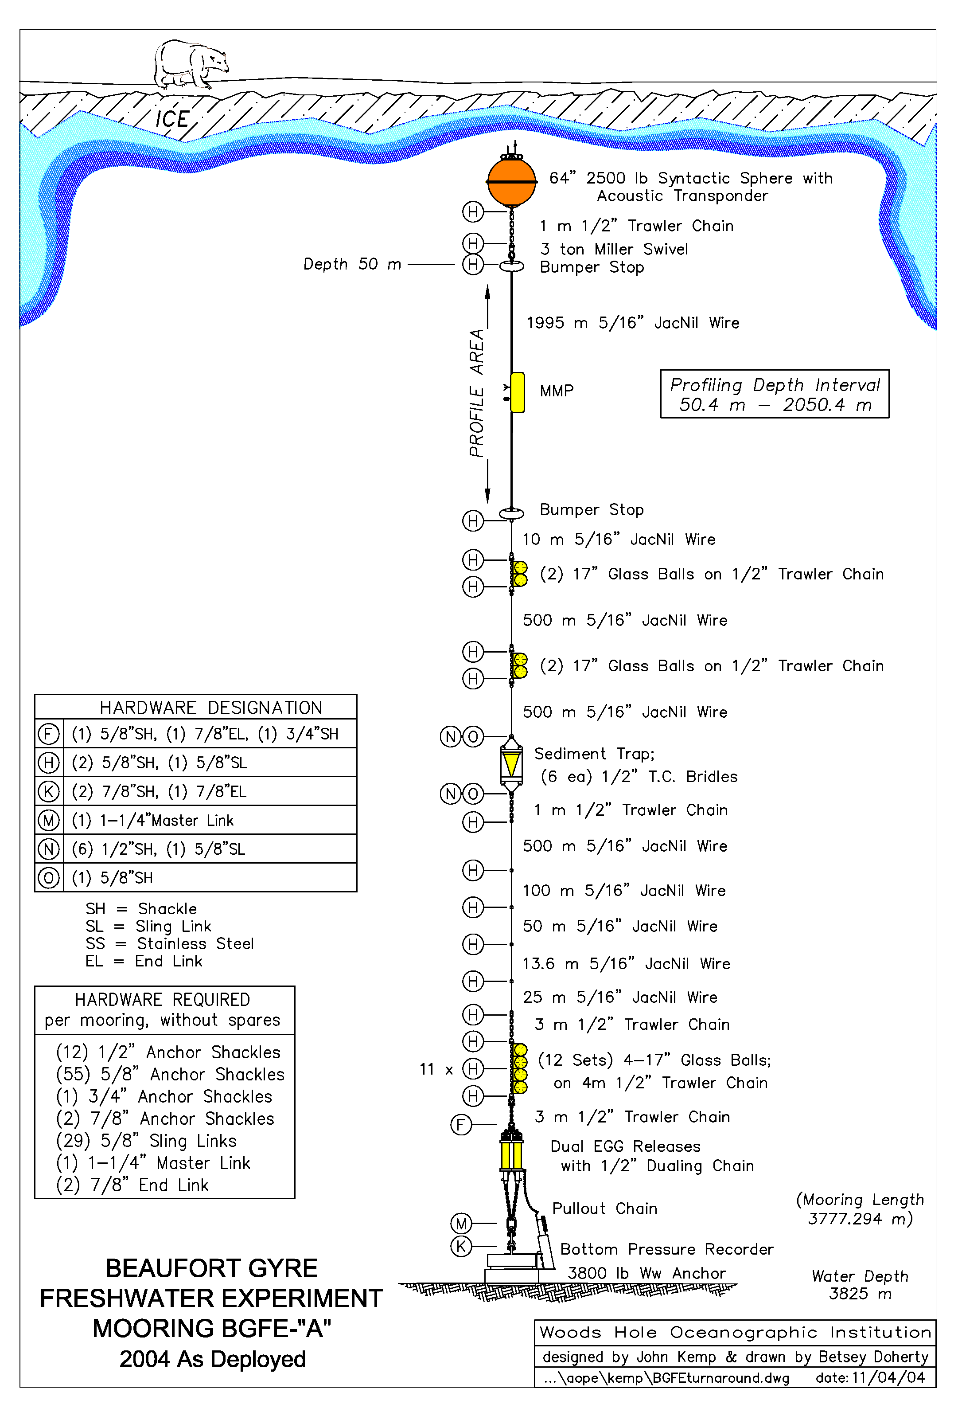
Figure 1: BGOS mooring schematic as redeployed in 2004.

RECOVERY OF BGOS-A MOORING
On August 9, BGOS mooring A (at 75N, 150W) was recovered. An acoustic survey was completed in the morning over a period of about an hour and a half which pinpointed the location of the mooring about 176 m west of last year’s anchor drop site. The ice conditions were much heavier than last year at this site, but with experience gained last year, we are undeterred by the concentrated ice. The LSL spent the remainder of morning clearing ice, so that the actual recovery was begun after lunch.
The day is sunny and clear. When the ship is positioned, the mooring is released, and it surfaces 20 m away. The mooring recovery is smoothly completed in less than 4 hours. The sediment trap worked perfectly. Towards the end of the procedure (after recovering the MMP profiler), we have to cut the wire and retrieve the bottommost instruments from the backup buoyancy. Every instrument acquired all good data for the full year. The only minor drawback is that the top of the mooring was again deeper than intended (about 10 m).

REDEPLOYMENT OF BGOS-A MOORING
On the morning of August 12, we arrived on station A again, and began redeploying the mooring after breakfast. First, the set and drift were calculated and a space to work by the forward A-frame was cleared in the ice. After installing the ULS and transponder in the top floatation sphere, the releases and BPR were attached to the anchor, and the deployment commenced. Less than 5 hours later, the anchor was released. Because the mooring was tailing off significantly due to our drift, we are unable to transpond to the releases while hanging the mooring. Since we have some difficulty communicating with the releases after deployment, we decide to do a post deployment survey to pinpoint the location. Surprisingly, the mooring landed about 570 m from the drop site, which means that it was tailing at about a 9 degree angle (Figure 2).
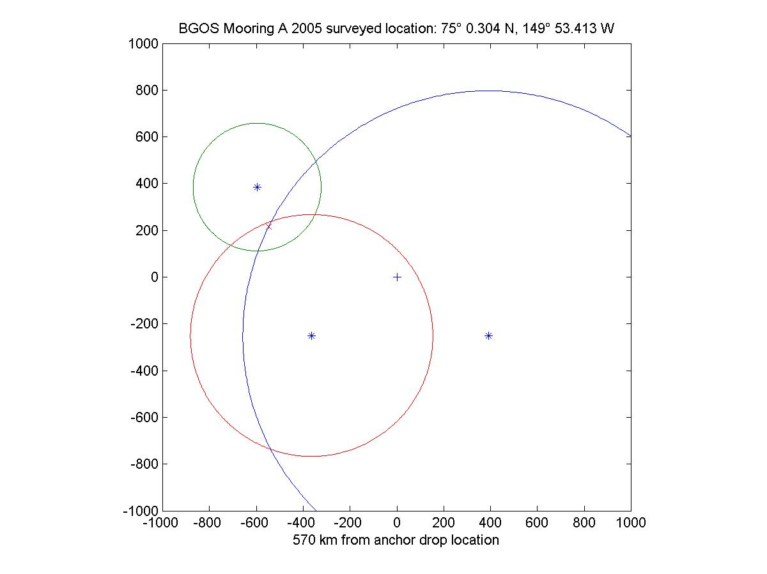
Figure 2: BGOS A 2005 post deployment acoustic survey.

RECOVERY OF BGOS-B MOORING
On mooring B location (78 N, 150 W) at 6 AM on August 14 for an acoustic survey. No problems talking to the releases eventhough their batteries were not changed last year. Four survey points indicate that the mooring is 415 m northwest from last year’s anchor drop location.
We released, the sphere comes up under the corner of a small ice chunk, but is visible. After a few nudges and some persuasion with the bubblers, the float is dislodged from the floe. The ULS protective frame is badly bent, but the instrument is later determined to be otherwise undamaged. The mooring recovery proceeds relatively smoothly, except that one set of 2 floats is tangled in the bottom MMP bumper (but doesn’t harm the instrument). Near the end, we cut a 100 m segment of wire and pick up the backup buoyancy, BPR, and releases only 3.5 hours after sending the release command. All of the instruments obtained and dumped complete sets of quality data.

REDEPLOYMENT OF BGOS-B MOORING
Deployment of mooring B occurs on August 17, a dry, calm, clear, and cold day. In a little over 4.5 hours, we are finished with the routine deployment. Transponding on the releases while holding the sphere on the surface indicates a range of 3764 m. Transponding after deployment indicates a depth of 3812. The difference is 48 m, which indicates that the mooring is probably the right length and that the surface sphere is very close to its design depth. Since we are drifting so little, an acoustic survey to pinpoint the location is omitted.

RECOVERY OF BGOS-C MOORING
Due to a 6 day halt to operations while ship repairs are underway, the recovery and redeployment of mooring C (77 N, 140 W) will have to be expedited in less than 24 hours, without a day to refurbish in between. We can do this for this mooring, because we will use the ULS and glass floats from the next (as yet undeployed) mooring D, and the recovered BPR from mooring B, along with the new MMP and releases, for the subsequent redeployment.
There is considerable difficulty getting through the large concentrated multiyear ice along the southward track. Finally in the afternoon on August 25 we arrive on site and do a 4 point acoustic survey which indicates that the mooring is located only 43 m from last year’s anchor drop location. Though it is late in the day, the Captain agrees to break ice during dinner and assess whether we can work in tonight (with the deck crew working overtime).
After dinner, it is clear, sunny and calm which are beautiful conditions for the recovery. On the other hand, the ice is thick and congested, and we are surrounded by massive ridges. But all we need is a reasonably sized hole to bring the top sphere up in, and the Captain seems to be comfortable with the opening that he can make over our surveyed location, so we decide to recover. Because the hole is smaller than usual (only about 20-30 m wide), we plan to try to send the release command once, and reposition the ship if we need to send it again.
In practice, everything seems to be going okay, the hole looks good, the release confirms that it released on the first attempt, but the top sphere does not emerge through the hole. It must have come up under the ice. [Later we figure that one of the survey points may have been slightly inconsistent, so was biasing the calculated location]. In addition, the transponder on the surface sphere is not working, so we have no way to locate the top of the mooring. Pinging on the releases, we do find that the bottom floats are ascending, so we wait for them reach the surface (about 45 minutes after release).
When the backup floats seem to be at the surface, they are also not visible, but we are able to range on them. The ship heads over to where we think they are, breaking up the ice on the way, and 15 minutes later the glass balls pop to the surface. Now the mooring may be recovered from the bottom up.
It takes awhile to attach to the floats and bring them on deck. On deck we see that several of the balls were broken (probably due to the ice breaking), and it is a mess untangling the wire rope from the floats so that we can pull in the rest of the mooring. The BPR is hauled on deck, and eventually, we start reeling in the rest of the mooring. When the MMP surfaces, John Kemp is lowered down in a basket to tag a line on it so that we can hoist it up. It is fortunate that the MMP did surface, because it could have been damaged if we had to drag it under the ice for recovery. Then the winch overheats, blows a circuit breaker on the ship, and we have to wait 10 minutes for it to restart.
Finally, the surface float pops through the ice rubble, we cut the remaining wire, snag the sphere and bring it on deck. Just after midnight after the 6 hour recovery, all the instruments were retrieved intact and undamaged. During the next several hours, quality information for the entire deployment was dumped from all of the instruments.

REDEPLOYMENT OF BGOS-C MOORING
On August 26, only 8 hours after recovering the last items of mooring C, we are back on deck to redeploy mooring C. Several hours are spent bringing new balls out of the hold, turning over the sphere, installing the BPR and ULS and rigging the deck, and then the mooring begins.
The deployment is for the most part routine, except for one instance when the winch again overheats when spooling the 2000 m wire, but after 10 minutes it starts again. In 4.5 hours the system is deployed.
Transponding on the releases with the sphere at the surface indicates a range of 3675 m. Transponding after deployment indicates a range of 3718. The difference is 43 m, so the mooring again appears to be nearly exactly the right length. Again, no acoustic survey to pinpoint location is performed.

DEPLOYMENT OF BGOS-D MOORING
BGOS-D is a new mooring in 2005 that is to be located at 74 N, 140 W. Since we have not deployed to this location previously, we need to do a bathymetric survey to determine the exact water depth. Using a portable Knudsen system, 6 survey points are taken at and around the intended deployment start site and expected drift. It is determined that the bottom varies from 3522 to 3500 m. We want the surface sphere to be between 40 and 45 m beneath the surface, so that the ADCP and ULS will be in range. Since we need to add our adjustment shots beneath the 2000 m MMP wire, we have to decide on the depth that we expect the mooring to settle in. Despite the fact that we are not drifting much, there is some uncertainty on the accuracy of our depth estimates and where we will drop the anchor drop, but we finally decide on 3510 m.
After everything is deployed in 4 hours, we range on the releases while holding the sphere at the surface, and then range again after the mooring is released and it is sitting on the bottom. The difference is 40 m, which should be perfect. No acoustic location survey.

DEPLOYMENT OF BS-3 MOORING
In order to begin to establish a long-term monitoring site in the center of the boundary current near the shelfbreak in the southern Beaufort Sea, one of the SBI moorings (BS-3) was deployed as part of the BGOS operations. The focus of the mooring would be on the Pacific water, as this location is too shallow to capture the Atlantic water on a regular basis.
The mooring design is the same as for SBI, with a couple of additions (Figure 3). A coastal moored profiler samples the water column from 40m to the bottom every hour. An upward-looking long ranger measures velocity profiles every hour, as well as ice velocity during winter. Beneath the ADCP is a Microcat (for calibrating the moored profiler) and a bottom pressure gauge for tidal information. A ULS is housed in the top sphere, as well as the "arctic winch", which is a tethered profiler that samples the upper 40m of the water column once a day.
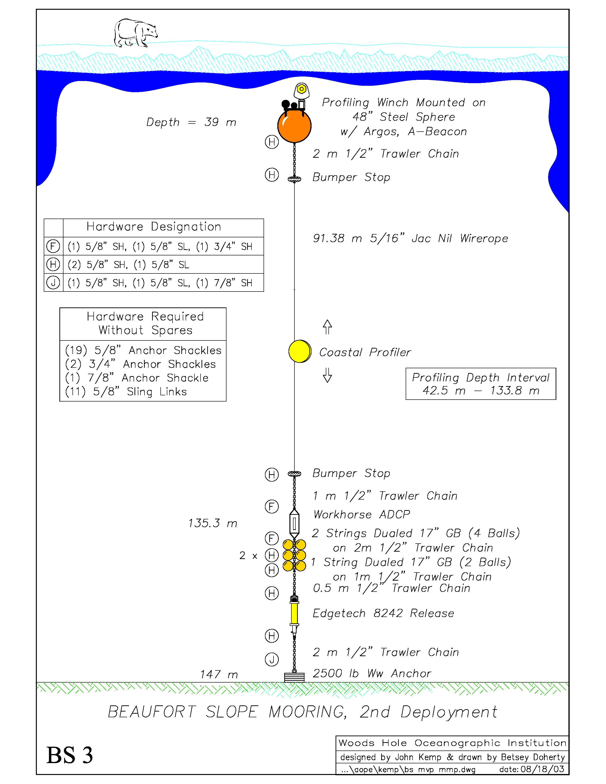
Figure 3: BS-3 mooring schematic as redeployed in 2005.
The deployment of BS-3 occurred on August 6. The ice conditions are thick over the mooring site when we arrive at the site in the afternoon. The ice is extremely dirty, composed mostly of huge blocks of rubble jumbled together, which large melt pond canals winding around snow covered peaks. It takes less than an hour to deploy the 100 m mooring. Occasionally the mooring wire gets brushed by ice during the operation, but nothing is damaged. Afterwards, an acoustic survey is performed to pinpoint the mooring location for recovery next year (Figure 4).
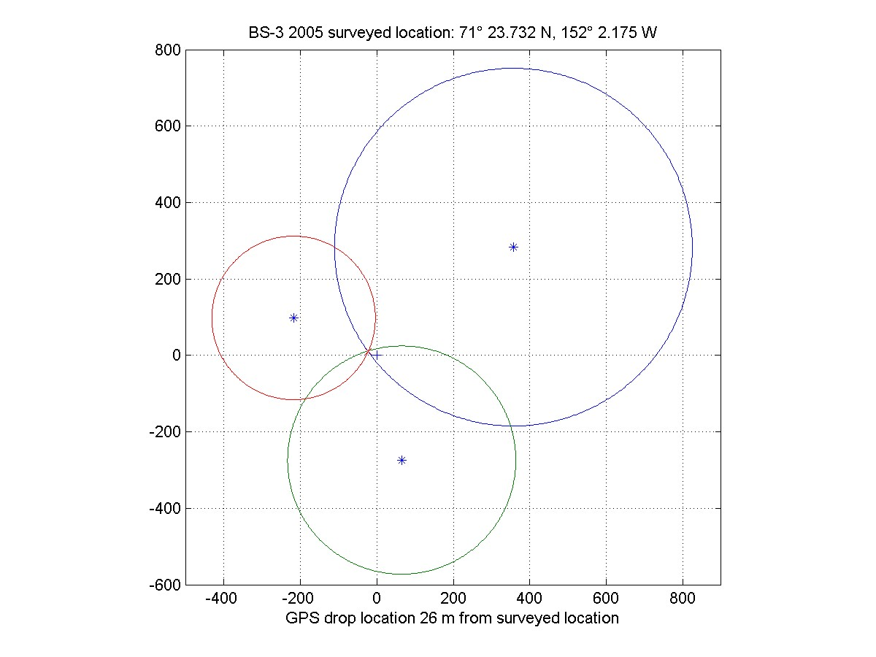
Figure 4: BS-3 post deployment acoustic survey.

DEPLOYMENT OF ITP AND IMB BUOYS
To augment the mooring data obtained by the BGOS mooring systems, two Ice Based Observatories (IBO) were deployed on multiyear icefloes in 2005. Each cluster consisted of an ITP and an IMB buoy. The ITP instruments profile the water column beneath the ice between 10 and 760 m four times per day acquiring seawater temperature and salinity and transmit the information to WHOI via Iridum satellite. The IMB is a CRREL instrument that monitors the state of the multiyear icefloe throughout the year by measuring ice temperature profiles, ice thickness, snow thickness, air temperature and barometric pressure and transmits the data by Argos satellite. Together the instruments are capable of providing vertically coherent time series of the air, ice, and upper ocean in the Arctic pack ice during all seasons.

Deployment 1
The first IBO cluster deployed in 2005 consisted of ITP 1 and IMB 07949. To find a suitable floe for deploying the cluster (a 3-5 m thick study multiyear floe), a helicopter reconnaissance in the region 79 N, 150 W was undertaken in the afternoon of August 14. Besides the pilot (C. Swannell), the Ice Observer (L. Theriault) of the LSL and two WHOI personnel (R. Krishfield and J. Kemp) participated on the all helicopter surveys.
Several candidate floes were identified. One old floe with significant ridging was landed on and drilled with a 2” hand auger. However, the thickness was greater than 5 m, so was too thick for our work. The second floe that we landed on was ridged all around, but had a nice flat are in between. Unfortunately it is small (only about 100 km), and had several large melt ponds. But it is worth a try. When drilled, it measured 4.6 m in thickness with 55 m of freeboard. Satisfied, we mark it with a couple of trash bags filled with snow, take a GPS position and return to the ship.
The next morning (August 15), the ship is already located in the lead next to icefloe, named Camp Smiley due to the distribution of melt ponds on the surface. The trash bags that we used to mark the floe are visible across the lead. A lone seal is spotted swimming around in the lead.
All the gear to be used in the deployment is already in the helicopter hanger and slingloads are prepared by 10 AM (times are Mountain Daylight Time). The Bosun (Bob Taylor who will be the rifle bearer), the Winchman (Peter King), Kemp and Krishfield board the helicopter with assorted gear stored in the back. In a few tens of seconds we are landed on the floe and unloading our gear. Then 4 slingloads of the heavier gear are flown to the ice, another flight delivers Chris Linder and gear packed everywhere else in the helicopter, and 3 more people (Doug Sieberg, student helper Ryan North, and another scientist who wants to run a magnetic compass spin test on his ADCP on the ice) and some more gear arrive. Only one person (Kris Newhall) and the ITP profiler remain to be transported to the site, but the pilot needs to refuel, so they shut down the engine on the helicopter deck, refuel, and decide to pack us lunchs on the ice.
By the time our last person arrives, it is already 11:30 AM. We have started drilling the 10” hole for the ITP and are pleased to find that the ice is much harder than the rotten ice we deployed an ITP through last year. That speaks well for the strength of the icefloe. We set up the tripod, drill through the ice, and break for a bite to eat.
The deployment proceeds smoothly except that initially we were not really through the 4.6 m icefloe, and had to redrill the bottommost ice after the anchor would not drop, the operation proceeded smoothly. The ITP deployment was finished by 12:50 PM.
Over at the IMB site, Sieberg and North were installing the IMB buoy. Since the helicopter was no longer available this day for repairs, one of us had to take a small boat back to the ship to retrieve a working 4” auger, which ended up taking 2 hours. We used it to cut the last hole and then we all had to haul all of our gear to an adjacent icefloe and take the small boat back to the LSL. Everyone was completely onboard by 4:30 PM local time. At 22:00 UTC the systems were located near 78 51.138’ N, 150 15.914’ W (from ship’s GPS).
As of the time of this writing, both the ITP and IMB were acquiring and transmitting data from all sensors on schedule.

Deployment 2
The second IBO cluster (ITP 3 and IMB 07950) was to be deployed in the vicinity of 78 N, 140 W. After repairs, one more reconnaissance flight to identify candidate icefloes in that vicinity was performed on August 18. Numerous superb multiyear floes appeared, but the helicopter had to return to the ship before any could be drilled, and the helicopter would be unavailable for operations afterwards. The same day, the ship was stopped for serious repairs to a shaft bearing, so we were unable to maneuver for the next 6 days. Due to the lack of time thereafter, we were forced to deploy the second ITP and IMB cluster on the best nearby accessible icefloe that we could find.
On August 21, we decide to drill a small (50 m) multiyear floe on the port side to determine its thickness. That morning, Kemp and Krishfield, a rifle bearer and a few others are lowered by man basket onto the ice to examine the floe. Neil Jollymore holds the shotgun, and Linda White and Hugh Maclean are going to collect simple ice samples. On the way over, there is only one wide refrozen crack that we cannot cross on foot, so we have to climb a ridge to get over. We are able to send the equipment in the sled over the thin ice, and decide if we will do a deployment, we will have to build a bridge there. On the floe, we drill two holes through reasonably hard ice that is 3.35 m thick. This ice is thicker than the surrounding floes and is not rotten down deep, so we are content to consider this as a possible deployment site.
The next day, Krishfield, Doug Sieberg, Ryan North, Jeff Carpenter, Chris Linder, and Neil Jollymore (with shotgun) head down on the ice with the IMB buoy to deploy. No sooner do we lug everything over to the floe and drill the first hole then we are called back by the bridge because the icefloe near the ship where we landed has cracked. So it is best to monitor the situation before we get stranded. We lug everything back and will try again the next day.
On August 23, Kemp and Newhall (and Jollymore with rifle) are lowered with planking to build a bridge across the one large 13’ gap between floes that we need to cross with the equipment to reach the deployment site. Meanwhile, Krishfield, Sieberg, North, and Jeff Carpenter are lowered with the IMB gear, and make our way to the floe to deploy the IMB. We rapidly drill the holes for the sensors, install the buoy and sensors, and are basically finished with the IMB deployment in an hour and a half. All that remains is to cover the wires with snow.
Meanwhile, it takes a little less than an hour to deliver all of the ITP gear to the site, about 1.5 hours to deploy the ITP, and another half hour to return with the installation equipment. In all the operation takes only 3.5 hours, and at 18:00 UTC the systems are located near 77 36.1’N, 142 11.8’ W (from ship’s GPS).
All of the sensors on both of these systems (Figure 5) have also been operating on schedule since deployment.

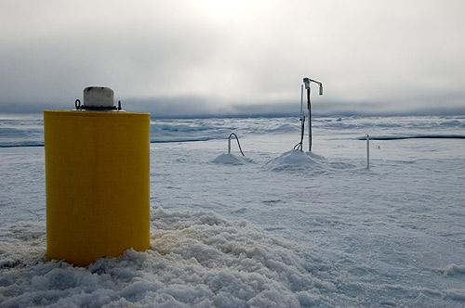
Figure 5. ITP3 and IMB 07950 deployed on August 23, 2005.

SEARCH FOR 2004 ITP AND IMB
One other operation that was attempted was the recovery of an IBO cluster that was deployed the previous year and was expected to be located near 74N, 150 W in early August. ITP2 and IMB 07413 were deployed on a 4 m thick icefloe in August 2004 as part of last year’s BGOS operations. The ITP acquired and transmitted data from 244 profiles until it ceased communicating in October. The IMB also ceased acquiring data early in 2005, but continued to provide locations. As they we installed only 10 m apart, it was hoped that both buoys could be rescued during the present cruise. However, the IMB stopped transmitting locations on August 1, and the LSL did not arrive near the area where the systems may be located until August 8.
That morning, I project the possible drift of the IMB to August 8 from its previous drift, and the Ice Observer (Theriault) projects ice drift from RADARSAT imagery. She sees the ice moving northerly at about 4 nautical miles per day, but the last positions that I obtained from the drift indicate a southwesterly drift. Furthermore, her ice charts begin on August 3, but the buoy drift positions stopped on August 1. Clearly, there is going to be a lot of uncertainty in our projected locations.
We estimate the location of the buoy using my projection for August 3 and adding her projected ice drift from August 3 to 8 from the imagery. The difference between her estimated projection for August 8 and mine (based only on extrapolations from the last buoy drift positions) is about 20 miles in latitude. Allowing for 10 mile boundaries in longitude, we end up with about a 200 square mile search area to be covered by helicopter. It is decided that the Ice Observer, Kemp and Krishfield will join the pilot for the survey. Theriault can obtain GPS locations on a laptop computer and plot them in real time, so we can accurately follow a regular search pattern.
We take off with some fog and a low ceiling. Due to the limited visibility, we start our survey with very closely spaced sections. Soon realizing that this will take forever, we increase our sections to 1 mile apart, knowing that we cannot possibly see all the areas between. Even so, it takes a full hour to complete only half of our search area. Visibility was much better by the end of the hour which is encouraging, but fuel is low, so we turn back to the ship to refuel and also eat lunch.
After lunch, we are at it again. Besides a dead animal in a melt pond, we do not see anything but ice on the 1.5 hour search. Towards the end, the fog creeps in again, and after rapidly covering the remaining area, we head back to ship.
Back on the ship, the Ice Observer has a more current RADARSAT image to compare drifts, and calculates a location that is about 20 miles northeast of the last estimate. The RADARSAT image, though just received, is almost a day old, so we add another 5 miles to the drift track. Too foggy to fly, the ship heads to that position where we complete an expanding box search over an area of about 10 square miles in about 3 hours.
Reconstructing the location projections and search patterns (Figure 6), it appeared that we probably would have needed to cover a search area with a radius of more that 10-15 miles with better spatial resolution than this day. That would mean probably at least 4-5 more helicopter flights over another couple of days, weather permitting. Furthermore, given the differences between the RADARSAT projections, there was no guarantee that even this region was correct.
Given the many uncertainties, including the real possibility that the systems were destroyed, it was necessary to call of the search and get back to the other cruise work. Fortunately, since our search areas were directly along our planned cruise track, only a few hours of shiptime were expended.
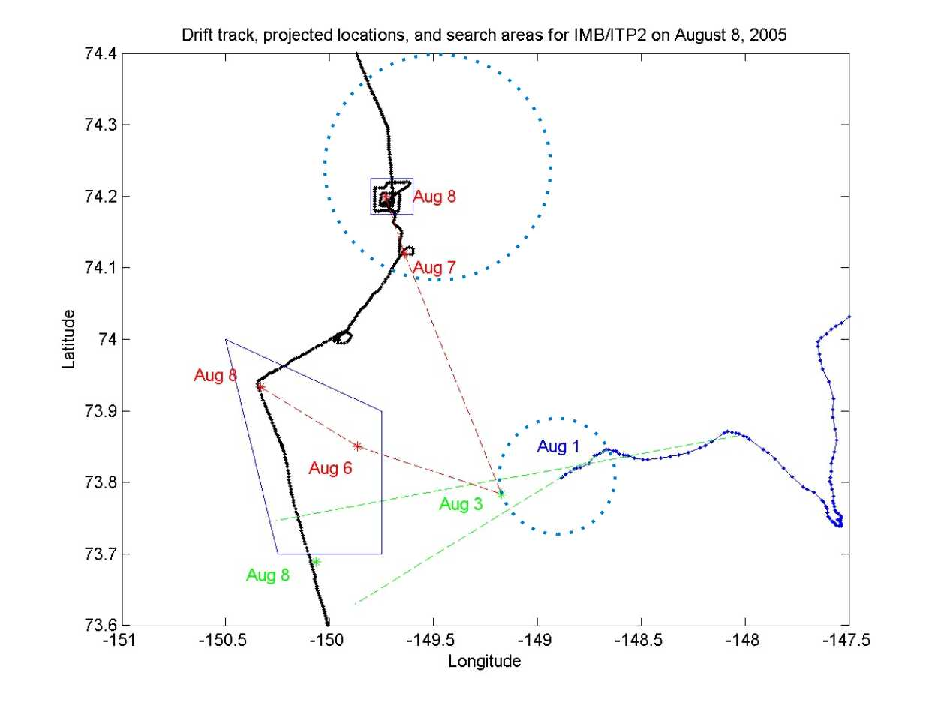
Figure 6. IMB 7413 drift to August 1 (blue line), extrapolated drift projections (green dashed lines), RADARSAT drift projections (red dashed lines), ship track (wide black line), helicopter and ship survey regions (solid boxes), and estimated location uncertainties on August 3 and August 8 (dotted circles).

