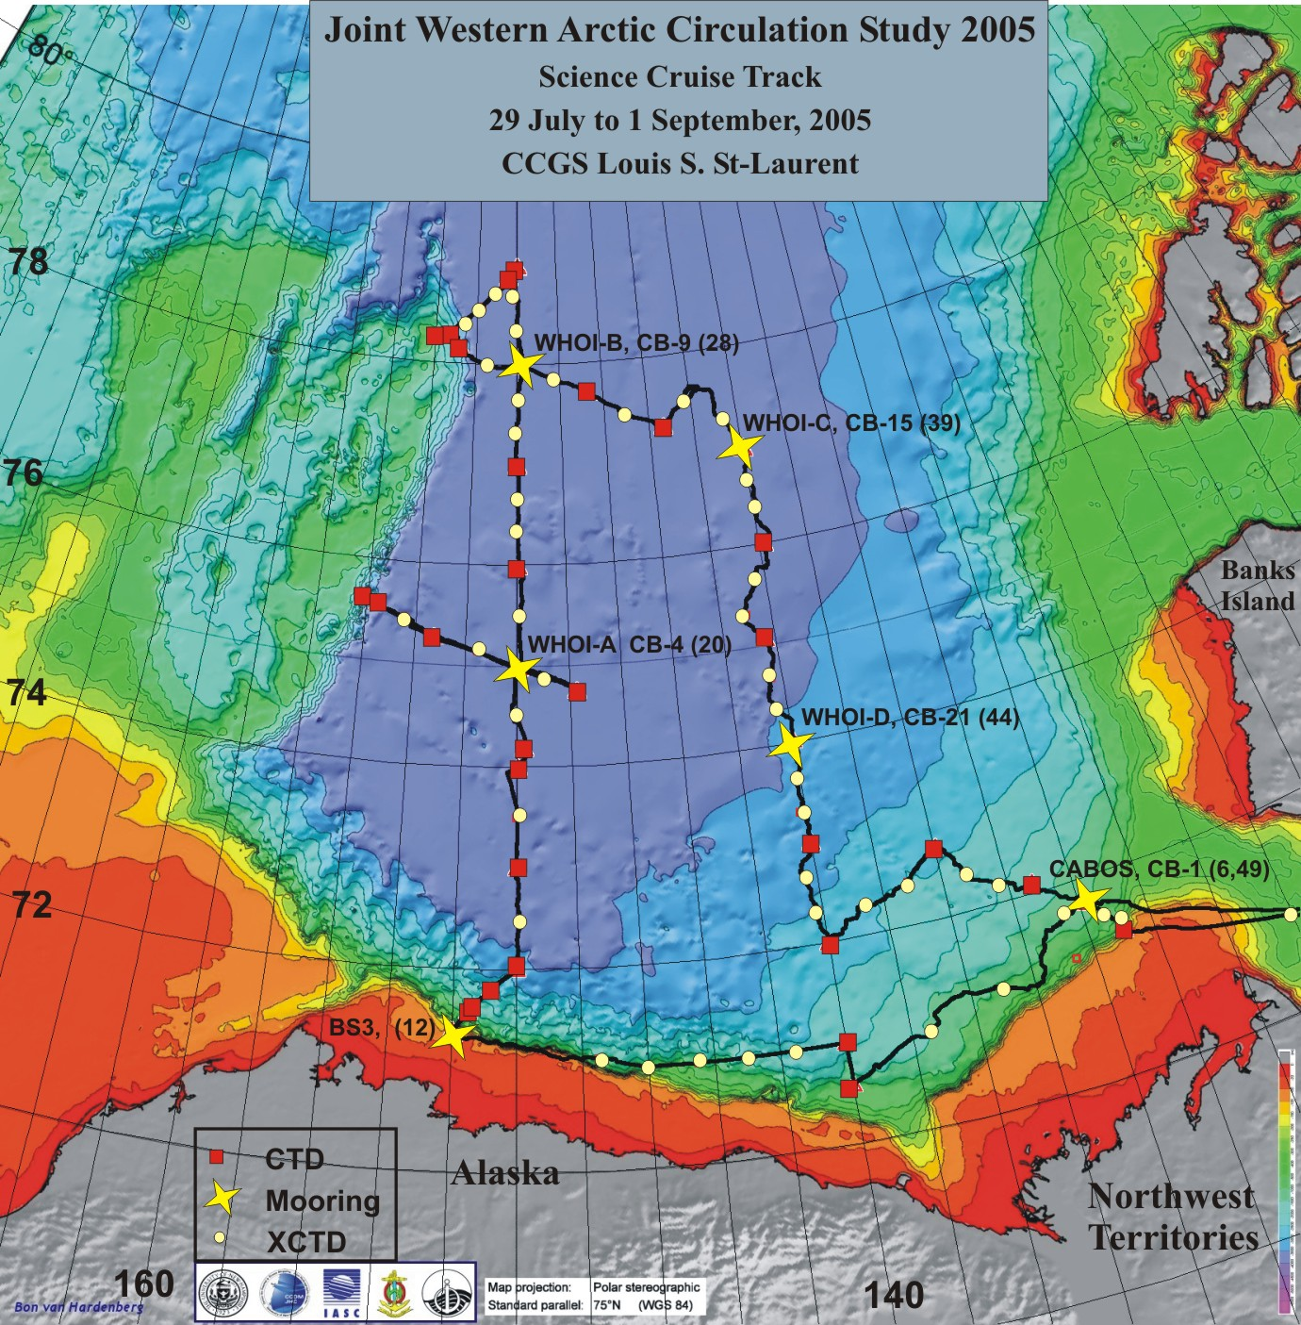
Figure. Cruise track with CTD and Moorings shown. Locations are in the appendices. Boxes denote CTD/Rosette stations, circles show XCTD deployments and stars show mooring locations. Labels show mooring name, station name and cast number.

