2005 Joint Western Arctic Circulation Study and
Beaufort Gyre Observing System

Cruise Report

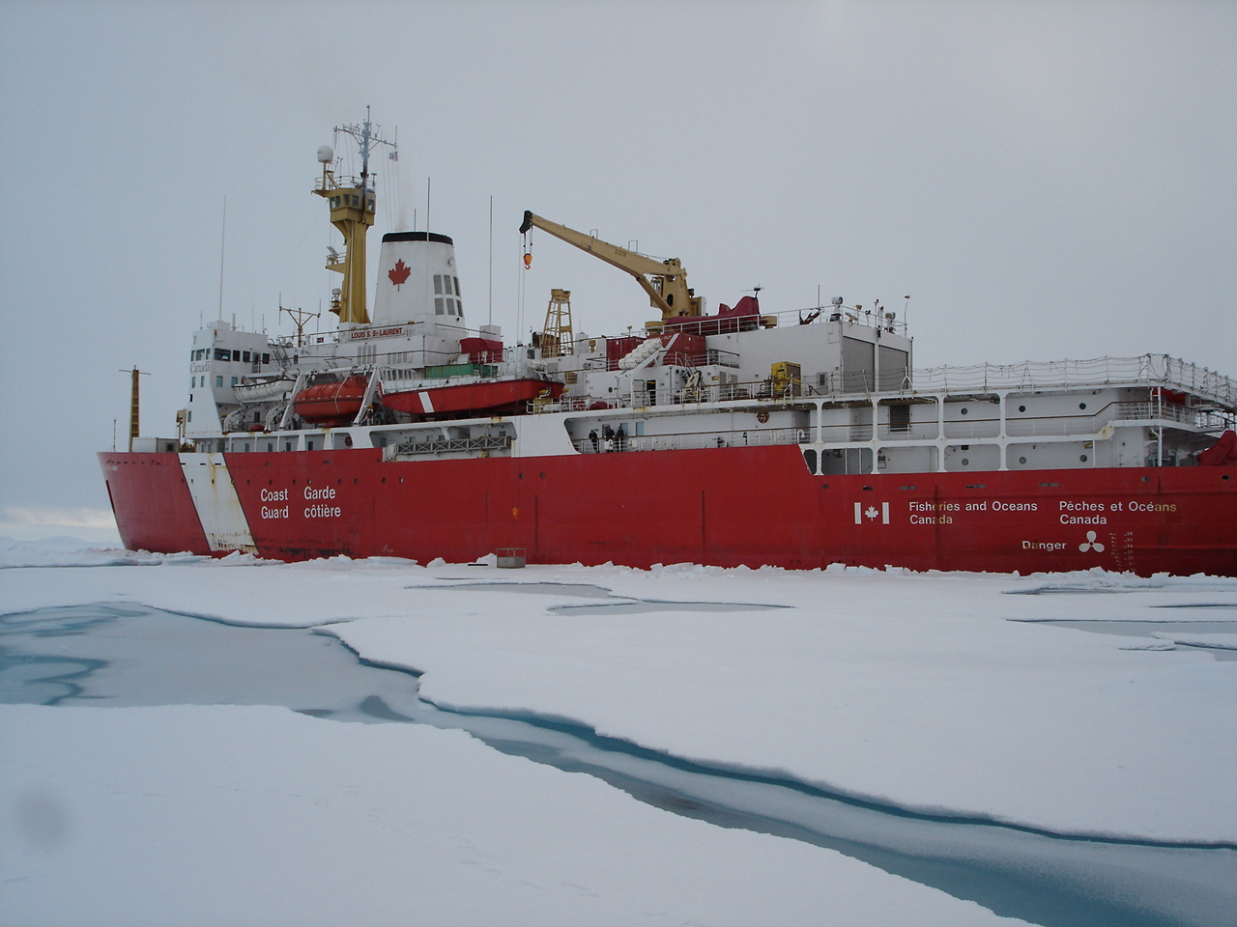

Beaufort Sea and Canada Basin
CCGS Louis S. St-Laurent
29 July – 1 September, 2005

Institute of Ocean Sciences Cruise 2005-04
Sarah Zimmermann, IOS

Table of Contents

- Cruise Summary
- Objectives
- Activity Summary with map
- Methods
4.1 Moorings
4.2 Ice Buoys
4.3 Rosette/CTD casts
4.4 XCTD
4.5 Vertical Net Tows
4.6 LADCP
5. Personnel
6. Goals Not Completed
7. Improvements made by the Ship for the 2005 Field Season
8. Suggestions for 2006 and International Polar Year 2007/2008
9. Acknowledgments
10. Lists of Operations, Positions and Times

Individual Reports
WHOI Moorings and Buoys: BGOS Field Operations in 2005
CABOS Mooring: 2005 CABOS Mooring Recovery and Deployment Notes
LADCP Report

1. Cruise Summary
The research cruise aboard the CCGS Louis S St-Laurent, July 29th to September 1st 2005, studied the circulation and chemistry of the Beaufort Sea and Canada Basin. A group of 18 scientists conducted rosette, mooring, buoy, XCTD and net tow operations. The data will be used to address our standing questions on freshwater storage in the Beaufort Gyre, water mass circulation, inter-annual variability of water properties, and distribution and concentration of bacteria and plankton. This year we had the additional focus of measuring the Atlantic Water intrusions using three supplemental water chemistry tracers ChloroFluoroCarbons (CFCs), Cesium-137 and Iodine-129.
This cruise marked the fourth year of international collaboration under the Joint Western Arctic Circulation Study between the Institute of Ocean Sciences (IOS) and the Japan Marine Sciences and Technology Center (JAMSTEC). This is the third year the Woods Hole Oceanographic Institution (WHOI) has been a leading participant in the project, first with the Beaufort Gyre Freshwater Experiment and now with the Beaufort Gyre Observation System. The principle investigators from these institutions are Fiona McLaughlin and Eddy Carmack (IOS), Andrey Proshutinsky (WHOI) and Koji Shimada (JAMSTEC).
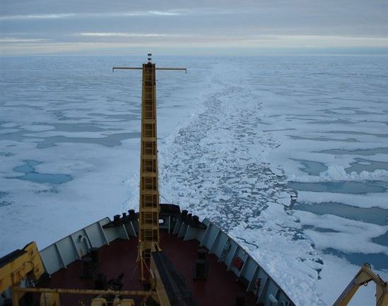
The science program went well. Of the four recovered moorings, the three WHOI moorings preformed flawlessly, completing their year long profiles between 50 and 2000m as scheduled. The fourth, the CABOS mooring, profiled as expected but unfortunately the CTD inside the profiler failed a month after deployment. These four moorings were redeployed along with two more, one on the Beaufort Shelfbreak and the other in the southeast corner of the Canada Basin. The CTD/rosette system worked well with its new altimeter except we did have trouble with the oxygen probe, the transmissometer, and communication with the water sampler. It is hoped that the oxygen sensor’s data can be calibrated to the bottle data although the drift over time was substantial. The transmissometer worked well after it was repositioned from a vertical to a horizontal orientation. The intermittent communication problems with the water sampler required multiple commands to close bottles and occasionally a confirmation was returned even when a bottle had not closed. The XCTDs had a good success rate. Only one site required a second probe due to the wire getting caught in the ice. On board, chemistry analysis was performed for salinity, oxygen, nutrients, alkalinity, CFC, chlorophyll-a and ammonium. The pre-cruise repairs to the salinity system and the new colorimeter for the oxygen system were key to achieving good results. The CFC equipment required repair and maintenance at sea but the system provided quality data for F11 and F12 throughout. Ammonium was sampled at only a few stations, with the main purpose of developing a methodology. Complimenting the data sets of the last two years, this cruise has provided an additional year of high resolution, full ocean-depth data over the Canada Basin.
Figure 1. Following the Oden's track.
Ice and weather conditions were similar to the previous year but with heavier ice in the northeast section of our study area. The thick ice slowed our speed and required the use of more fuel. As last year, we also encountered heavy ice from Resolute to Cambridge Bay through Larsen Sound. This year we were fortunate to have an open track to follow made by the week prior by the research ship Oden. We saved approximately 120 m³ of fuel (based on the previous year) by following the track. The support from the Canadian Ice Service was very helpful. Radarsat imagery was important during the cruise for scheduling the work, choosing our routes to make the best use of time and helping to identify areas of thick ice needed for the ice-drift buoys. Two ice-survey flights from shore were conducted which provided information on ice conditions and ground-truthing radarsat imagery. The second flight was particularly useful as the ship’s helicopter was not operational after August 18th. While operational the helicopter provided valuable ice reconnaissance for an ice-buoy site and assistance in slinging gear to the site. In general, the weather consisted of fog and rain while we were southern Canada Basin with colder temperatures, and less fog further north. Besides slower progress through the fog, the weather was not an issue for the cruise.
A major loss of time to the project (6 days out of the 35 day project) occurred due to engine difficulties in the remote northeast corner of the Canada Basin. Thanks to the dedicated engine department, the massive repair effort was undertaken and completed as quickly as possible, allowing us time to complete our highest priority tasks. Fast turnaround time by the mooring group, long hours from the deck department and faster though less efficient ship speed allowed us to save time for the remaining work. Four rosette casts were not completed due to the delay and two casts shortened to save time, but all of the mooring work and our key rosette stations were accomplished. The helicopter experienced engine trouble as well, taking it out of service the same day the ship’s engine went down. This loss prevented us from deploying the ice-buoy in a preferred location - instead the buoy was deployed in the closest acceptable spot to the ship while waiting for the ship’s engine repair. The helicopter was also missed for ice reconnaissance for route-finding through the ice.
The CCGS Louis S St-Laurent continues to be a great platform for our work. The support from the Captains and crews was much appreciated during the refit period in Dartmouth, the busy days of set up and throughout the long science days of the cruise. The ship invested a good deal of effort to assist the program at sea, to address our suggestions from last year and has shown a continued interest in discussing improvements for next year. The CCGS Louis S St-Laurent is an excellent choice for Arctic science with its icebreaking capability, lab facilities, comfortable living quarters and helpful, accomplished crew.

2. Objectives

Freshwater Storage in the Beaufort Gyre
The inter-annual variability of accumulation and release of fresh water in Beaufort Gyre are under investigation. A broad-scale pattern of wind-forcing over the Arctic is thought to force the accumulation and release of fresh water contained in the upper 250m. Multi-year data from moorings and CTDs will help show where the freshwater is stored, its volume and its connection to the atmosphere.

Water-Mass Circulation, Inter-Annual Variability and Climate Change
The relatively fresh water from the Pacific and warmer water from the Atlantic typically flow in bathymetrically steered currents cyclonically around the Arctic. These pathways as well as the mechanism that bring the Pacific and Atlantic Waters into the basin interior, such as eddies and thermohaline intrusions are being examined. CTD/Rosette casts with a Lowered Acoustic Doppler Profiler (LADCP), XCTDs, and moorings are used to provide a picture of the water mass properties and current speeds. The program’s spatial coverage of the Canada Basin allows for inter-annual comparisons with historical data from the southern region and adds new data to the poorly sampled central and northern basin, ice-covered areas not well studied due to their inaccessibility.

Distribution and Concentration of the Zooplankton, Phytoplankton and Bacteria
The constituents of the lower food chain are being studied by assessing species distribution and concentration over the basin. How ocean circulation, ice cover, and water properties contribute to the distribution and concentration will be examined. Net tows and water from the rosette will be used for this study building a time-series of tows from the same location each year.

3. Activities

Location and times of events are listed below, in section 10.

Transit from Halifax to Resolute
- 30 XCTDs (31 probes) deployed in Baffin Bay

Transit in Canadian Archipelago (Resolute to Amundsen Gulf, 1571km)
- 5 Rosettes in NorthWest Passage (Resolute to Amundsen Gulf) sampling salinity, nutrients and bacteria.

Canada Basin (4936 km)
- 40 Rosettes casts and 5 CTD-only casts
CTD: The CTD was equipped with 2 temperature sensors, 2 conductivity sensors, SBE43 oxygen probe, transmissometer, fluorometer, bottom contact warning and an altimeter.
Rosette: The suite of water chemistry samples regularly sampled from 10-L Niskin bottles were Salinity, Oxygen, Nitrate, Silicate, Phosphate, Freon (11, 12, 113 and carbon-tetrachloride), Chlorophyll-a (filtered at 0.7µm) and Phaeopigment, Alkalinity, Oxygen-18 isotope, Barium, and Bacteria. On selected casts we sampled Cesium-137, Iodine-129, Colored Dissolved Organic Matter, Total Organic Carbon, Dissolved Inorganic Carbon, Carbon-13 isotope and Ammonium.
LADCP: Current measurements were made with each CTD cast using a downward looking lowered acoustic doppler current meter (LADCP).
- 53 XCTDs
- 6 Moorings
  - 3 WHOI moorings serviced (Bottom depths 3824, 3821 and 3722m)
  - 2 new WHOI moorings deployed (Bottom depths 149 and 3515m)
  - 1 CABOS mooring serviced (Bottom depth 1121m)
- 2 Ice Tethered Profiler (ITP) and Ice Mass Balance Buoy (IMBB) pairs deployed and a search for a set deployed last year
- 10 Vertical Net Tows at 4 stations to 100m using mesh sizes 50, 150 and 236 µm.

Other
- Ship stopped for engine shaft repair from 18th August 5pm to 24th August 9pm
- Retirement Party for Doug Sieberg, our Chief Science Technician
- Total distance from Resolute back to the Resolute area (10 September) was 8210km.

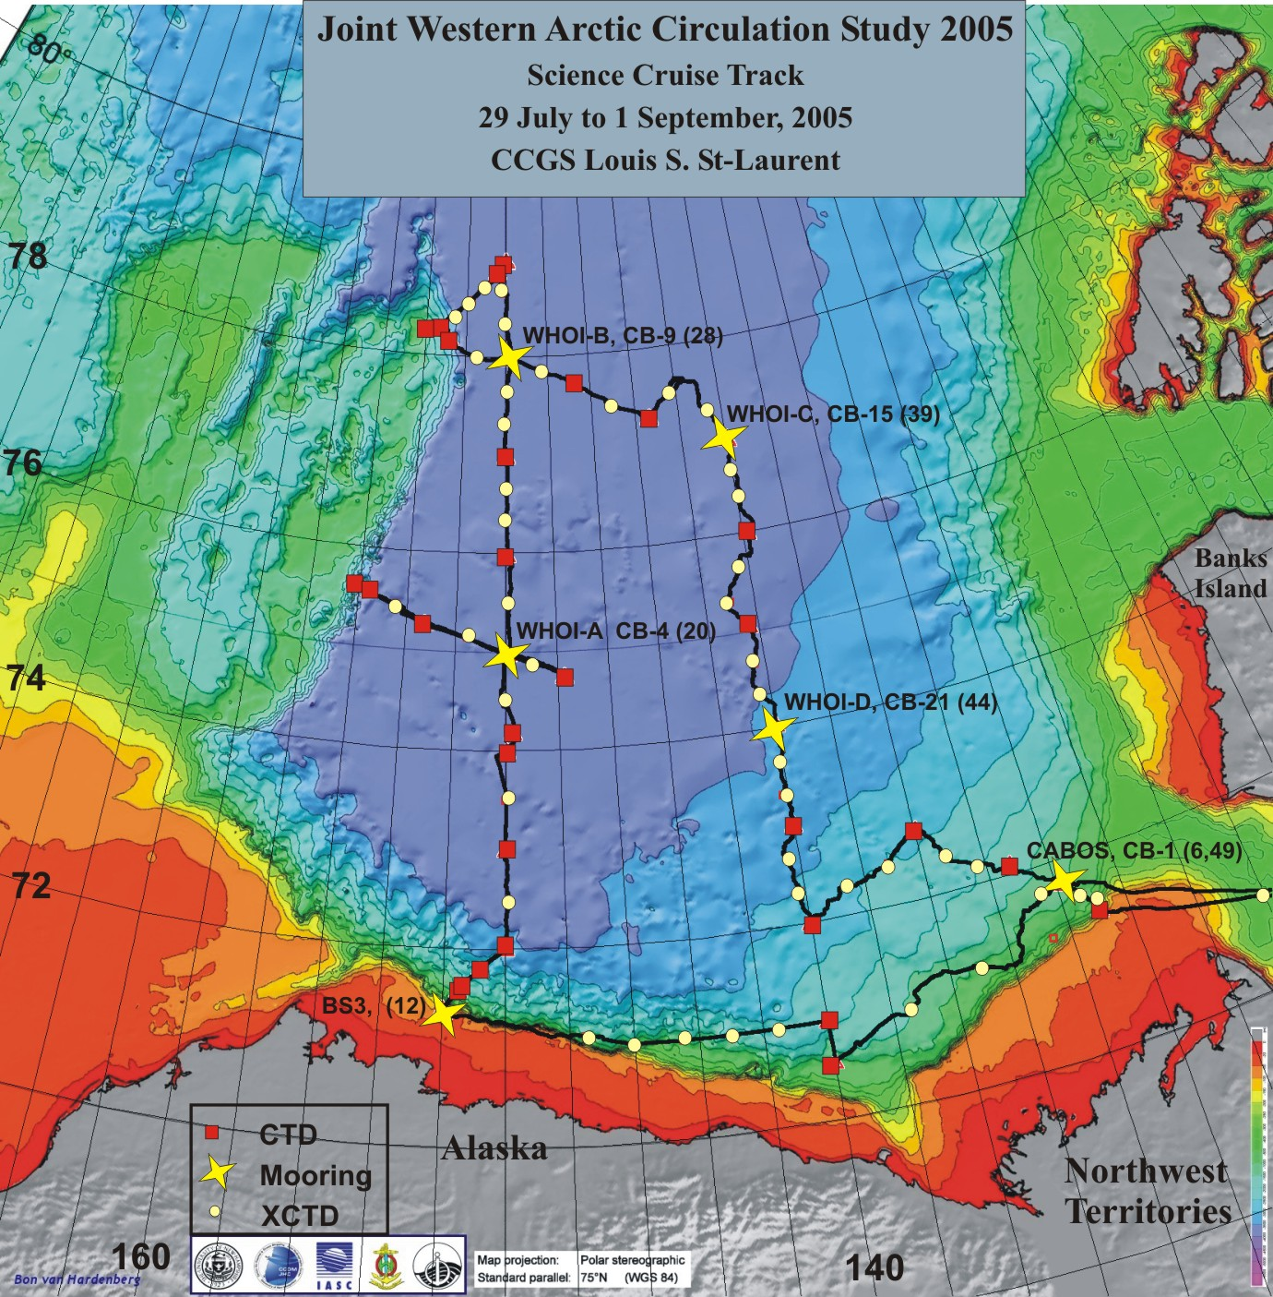
Figure 2. Cruise track with CTD and Moorings shown. Locations are in the appendices. Boxes denote CTD/Rosette stations, circles show XCTD deployments and stars show mooring locations. Labels show mooring name, station name and cast number.

4. Methods
The cruise followed last year’s track, retracing the four lines that criss-cross the Canada Basin. The route is predefined by the moorings already in place. The intent is to repeat this track in successive years building a 6 year time-series for these transects.

4.1 Moorings
Mooring operations were performed from the ship’s foredeck using the starboard A-frame and WHOI provided LEBUS winch. Typical recovery procedure was to confirm the mooring’s location at the mooring site, determine the ship’s drift, open an ice free area and recover the mooring. A rosette cast performed at the site would help for calibration of the mooring’s CTD. The set up for the mooring operation typically began in the morning with the actual release/deployment starting late morning. Three or more survey positions were obtained to pinpoint the mooring’s location. WHOI installed a GPS antenna on the corner of the foredeck lab container and used these positions with the range obtained from their over-the-side tranducer. The ship then broke ice for 1 to 2 hours over the mooring region, taking into account the predicted ice drift. After creating an ice free area over the given location the bridge would signal the deck team to release the mooring. The top float, only 50m below the surface, would appear within 30 seconds of being released. The float was hooked using the foredeck crane, brought on board and the line brought through the A-frame for recovery.
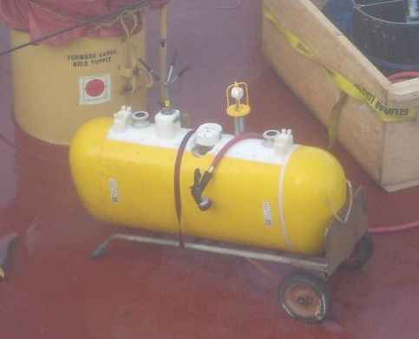
Deployment procedures began with a confirmation of the bottom depth or in the case of deploying in a new region, performing a short bottom survey. Ice was broken in the region and the mooring deployed, anchor first, from the starboard A-frame. It was useful to have a large enough area of broken ice so the bubbler system could be used to keep the deployment area ice free until the operation was finished. Following the deployment the mooring would be ranged on to confirm it final position.
Figure 3. CTD and current meter on the McLane Moored Profiler (MMP)
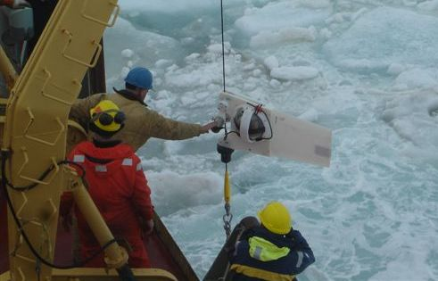
WHOI moorings A, B and C and the University of Alaska Fairbanks CABOS mooring were deployed in August 2004, each carrying a profiling CTD and current meter ( McLane Moored Profiler, MMP). These moorings were recovered, serviced, and redeployed. Servicing included replacing the CTDs and batteries. Two new moorings were deployed this year. WHOI–D, the same configuration as WHOI-A, B, C, was deployed in deep water, completing the ‘box’ pattern over the Canada Basin. WHOI’s BS-3 was deployed on the Beaufort shelf-break in 150m of water to measure the shallow boundary current of Pacific water. BS3 had a profiling CTD but no current meter. All mooring operations were performed in the presence of ice. See WHOI and CABOS mooring reports for more operation details
Figure 4. Profiling CTD on BS3 mooring.

4.2 Ice Buoys
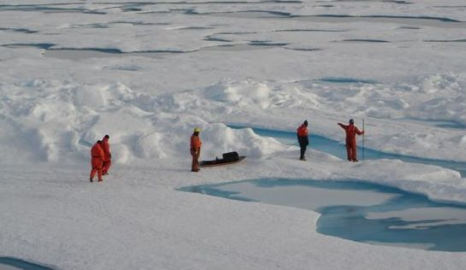
Two sets of bouys were deployed this year, in the northwest and northeast corners of our cruise track. It is hoped the northwest set will stay fairly stationary in the center of the sea-ice gyre while the northeast set will drift southwest through the Canada Basin. The sets consist of an Ice Tethered Profiler (ITP) and an Ice Mass Balance Buoy (IMBB). The ITP is a CTD, set up to profile between 5 and 800m. The IMBB measures ice thickness and temperature, and surface air temperature, pressure and snow accumulation. Both relay data daily to satellite. The first set were deployed 400m from the ship, with equipment and workers flown to the ice by helicopter. The gear was brought back by workboat. The two buoys were anchored into approximately 4m thick ice and by the following day we heard from the shore-based labs that both buoys were successfully transmitting data via satellite to shore. The second set was also deployed about 400m from the ship. The equipment was brought by sled to the site. The operation was temporarily stopped during the hole drilling due to ice leads developing nearby. The operation was completed the next day with confirmation the instruments were working the day after. See WHOI mooring report for more operation details.
Figure 5. Looking for a suitable ice-buoy location.

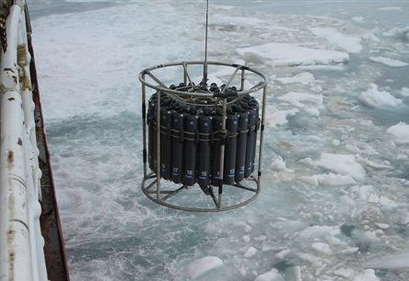
4.3 Rosette/CTD Casts
Figure 6. Rosette deployment.
Rosette casts were taken with a Seabird SBE911+ CTD, equipped with dual temperature sensors, dual conductivity sensors, SBE43 oxygen probe, transmissometer, pumped fluorometer, bottom contact warning device and an altimeter. In addition, an RDI lowered acoustic doppler profiler (LADCP) was mounted on the frame to measure ocean current. The rosette water sampler, SBE32, was configured with 24 10-liter Niskin bottles to take chemistry samples: Salinity, Dissolved Oxygen, Nitrate (NO3), Silicate (SiO4), Phosphate (PO4), Freon (11, 12, 113 and carbon-tetrachloride), Chlorophyll-a (filtered at 0.7 um with chlorophyll-a and phaeopigment values for each), Alkalinity, Oxygen-18 isotope (O18), Barium, and Bacteria. On selected casts we sampled Cesium-137, Iodine-129, Cored Dissolved Organic Matter (CDOM), Total Organic Carbon (TOC), Dissolved Inorganic Carbon (DIC), Carbon-13 isotope (C-13) and Ammonium.
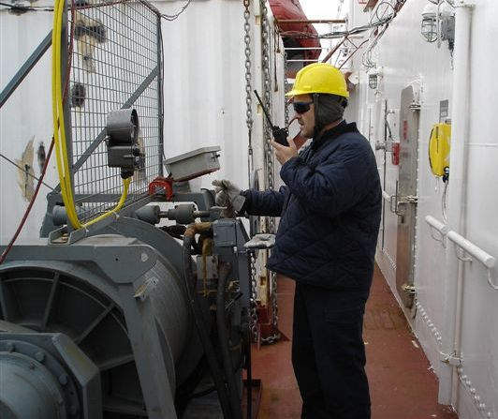
The CTD was powered on while still on the deck. The rosette package was lowered to 10m, the sensor pumps turned on and the package soaked for 3 minutes to equilibrate the oxygen sensor. The package was then raised to just below the surface and then lowered at 60m/minute to within 15m of the ocean floor. After closing the first bottle at the bottom of the cast, the package was raised at 60m/minute then slowed to 30m/minute for the upper 400m. Bottles were closed on the upcast without changing the ascent speed with the thought that this will capture water with a uniform vertical offset (approximately 1 m) instead of stopping the package for bottle closures which can result in variable 0 to 5m offsets, depending on the flow dynamics around the bottles. The bottle flushing around a stopped package is thought to be dependant on the ship rock and relative drift, which are both less favorable for bottle flushing when a ship is in ice.
Figure 7. Neil Jollymore operates the CTD winch.
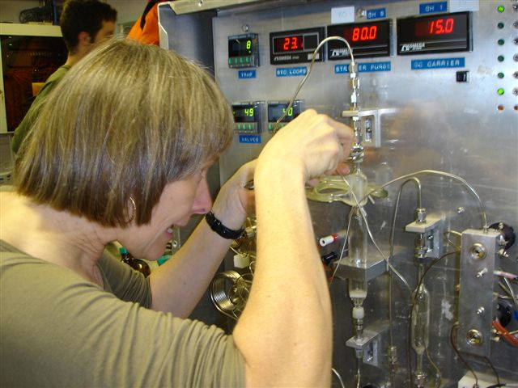
In the upper 400m, the sample depths were chosen to match a set of salinity values. During the downcast, the depths of the salinity values were noted so that on the upcast the bottle could be closed at the pre-determined depths.
Figure 8. Nes Sutherland with the CFC sampling apparatus.
Sampling took place immediately after each cast in the heated rosette room. The order of sampling was fixed, based on sampling water most susceptible to temporal changes first.
Dissolved Oxygen, Nutrients, Salinity, Chlorophyll-a and Phaeopigments, Freons, Alkalinity, and Ammonium were measured in laboratories on board. All other samples were prepared and stored for analysis on shore. Real-time analysis was critical for oxygen and ammonium and important for the others due to the higher accuracy achieved from the methods used with fresh samples. Analysis at sea also allows time to respond to problems with equipment or sampling methods that may only be noticed after looking at results.

4.4 XCTD
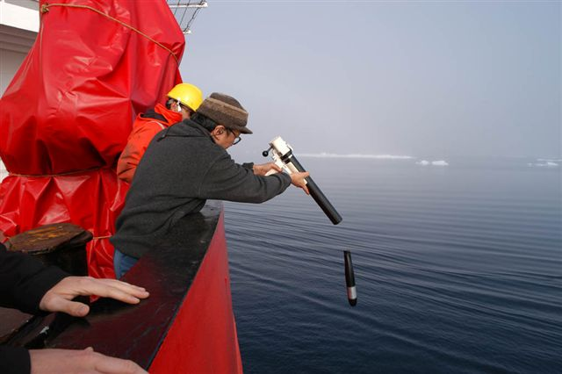
XCTD (eXpendable Conductivity Temperature Depth) probes provided quick water profiles between more time intensive CTD casts. The probes were provided by JAMSTEC (Type XCTD-1 made by Tsurumi Seiki) and WHOI (Type XCTD-3). The probes were deployed from the stern of the ship, falling freely through the water and measuring temperature and conductivity every 0.15 m from the surface to 1100 m. Data were transmitted to the ship during the freefall by a thin conducting wire extending from the XCTD to an onboard computer. To prevent sea ice from cutting the wire of the XCTD, the ship slowed to 12 knots for the deployment in open water areas and completely stopped in heavy ice areas. It took 5 minutes for the XCTD to descend from the surface to 1100m. In Baffin Bay, during the ship’s transit north, 31 probes were deployed at 30 sites. In the Canada Basin, 53 casts were conducted. Locations are listed in the appendix. Accuracy of the XCTDs are ±0.02 degrees in temperature, ±0.03 mS/cm in conductivity (approximately ±0.04psu in salinity) and ±5-20 m in depth. The salinity accuracy of XCTDs are initially poor but are improved to ±0.01psu by calibration to the cruise’s CTD (Conductivity Temperature Depth) data.
Figure 9. Masuo Hosono launches an XCTD. (Photo curtesy Chris Linder)

4.5 Vertical Net Tows
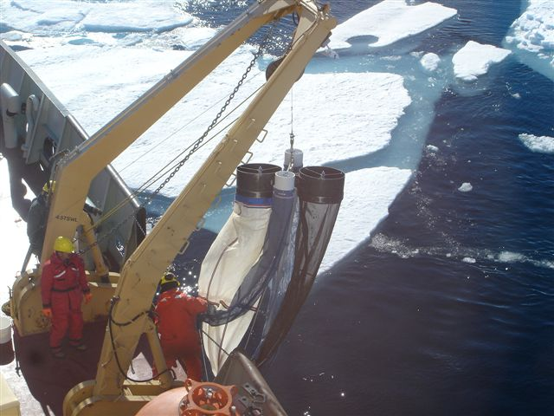
Zooplankton sampling was performed using a modified Bongo net system. Two large bongo hoops were fitted with coarse mesh nets of 150μm and 236μm. A second set of smaller hoops were fitted perpendicular to the large hoops. These smaller hoops were fitted with finer 53μm mesh nets. The four nets were fitted with unidirectional flowmeters which measure the amount of water flowing through the hoops. Between cast the nets were stored on the foredeck in a box, built by the ship specifically to accommodate the bongo net. The vertical net tows were all to 100m.
Figure 10. Zooplankton nets.
Two casts to 100m were performed per station to collect enough samples for identification, DNA analysis and biomass measurements. The samples from the first cast were preserved in formalin with the 53μm samples combined to form one sample. From the second cast, the samples from the 236μm and combined 53μm nets were preserved in 100% ethanol, and the 150μm sample was washed with 4% ammonium formate and dried at 50ºC for 24 hours. 10 casts were performed at 4 stations. Locations are listed in the appendix.
4.6 LADCP (Waldemar Walczowski)
During the 2005_04 cruise of CCGS Louis S. St- Laurent, measurements by means of a Lowered Acoustic Doppler Current Profiler (LADCP) were performed. Measurements were conducted together with the CTD casts. The self recording RDI, 307.2 kHz device nr 3313 were attached to the rosette frame. The down-looking LADCP measured currents in 20 depth cells, each cell 10 m thick. In vicinity of the bottom, bottom track were used. Vertical speed rate of the rosette was always less than 1 m s⁻¹. LADCP data were read directly after profiling. CTD records from Seabird 9/11 device were used to determine the ship position (from NMEA protocol registered every scan) and LADCP depth (from CTD pressure and time records). LADCP data were processed using LDEO software. In the period of 04.08.2005- 30.08.2005, 42 LADCP casts were performed. See LADCP report for more operation details and preliminary results.

5. Personnel

The research team includes both shore and ship components. The principle investigators of this project are Eddy Carmack, Fiona McLaughlin, Andrey Proshutinsky and Koji Shimada.

Table 1. Science Personnel on Board

 | Name | Affiliation | Responsibility
1 | Sarah Zimmermann | IOS | Chief Scientist
2 | Doug Sieberg | IOS | Chief Technician
3 | Hugh Maclean | IOS | CTD watch leader
4 | Jane Eert | IOS | CTD watchstander/ Data manager
5 | Mary Steel | IOS | Oxygen Analysis
6 | Linda White | IOS | Nutrient Analysis
7 | Nes Sutherland | IOS | CFC Analysis
8 | Wendy Richardson | IOS | CFC Analysis
9 | Jeffrey Carpenter | IOS | CTD Watchstander/  Chlorophyll Analysis
10 | Ryan North | IOS | CTD Watchstander/  Ammonium Analysis
11 | William Burt | IOS | CTD Watchstander/  Bacteria Collection
12 | Masuo Hosono | JAMSTEC | CTD Watchstander/ XCTD Technician
13 | Michiyo Kawai | IOS | Alkalinity Analysis
14 | Waldemar Walczowski | IOP | CTD Watchstander/  LADCP Analysis
15 | Rick Krishfield | WHOI | WHOI Mooring Operations
16 | John Kemp | WHOI | WHOI Mooring Operations
17 | Kris Newhall | WHOI | WHOI Mooring Operations
18 | Chris Linder | WHOI | Outreach

Table 2. Investigators on Shore

 | Name | Affiliation | Program
1 | Fiona McLaughlin | IOS | CTD and chemistry
2 | Eddy Carmack | IOS | CTD and chemistry
3 | Andrey Proshutinsky | WHOI | WHOI moorings
4 | Koji Shimada | JAMSTEC | XCTD
5 | Chris Guay | OSU | Barium samples
6 | C.S. Wong | IOS | DIC, C13 samples
7 | Bill Li | BIO | Bacteria samples
8 | Celine Guegen | UBC | CDOM samples
9 | John Smith | BIO | Cs-137 and I-129 samples
9 | Russ Hopcroft | UAF | Zooplankton net tows
10 | John Nelson | UVic/DFO | Zooplankton net tows
11 | Igor Polyakov | IARC | CABOS mooring
12 | Rob Chadwell | IARC | CABOS mooring technician
13 | Robert Pickart | WHOI | BS-3 mooring

Affiliation Abbreviation
BIO | Bedford Institute of Oceanography, NS
DFO | Department of Fisheries and Oceans, Canada
IARC | International Arctic Research Center, Alaska
IOPAN | Institute of Oceanology Polish Academy of Sciences, Poland
IOS | Institute of Ocean Sciences, BC
JAMSTEC | Japan Agency for Marine-Earth Science Technology, Japan
UAF | University of Alaska Fairbanks, Alaska
UBC | Univerisity of British Columbia, BC
UVic | University of Victoria, BC
WHOI | Woods Hole Oceanographic Institution, Massachusetts

6. Goals Not Completed

JAMSTEC Stations and mooring in the western Beaufort Sea.
The provisional list of CTD stations at the start of the cruise included a collection in the southwest Beaufort Sea that was removed due to restrictions on time and fuel. During the planning stage, it was understood the timing would be tight, and the work would only be possible if we were making faster than planned progress. Ice conditions were similar to the previous year which meant there was no extra time for these stations. There was also the hesitation to use extra time at the beginning of the cruise that might be needed to complete the higher priority CTD casts and mooring work at the end of the cruise. Unfortunately this turned out to be true so it was to our benefit that these lower priority CTD casts were removed. Fuel consumption was also an issue. The balance between speed and fuel efficiency meant that it was not practical to try for a quick transit to collect these stations.

CTD Casts in the southeastern Canada Basin
The loss of 6 days while the ship’s shaft bearings were repaired took a toll on the planned science however the impact was greatly moderated by the quick turnaround of the mooring work, the use of overtime and increased ship speed. All mooring work was completed as well as the key CTD stations. Only four of the planned CTD stations in the southeast Canada Basin were not accomplished and two CTD casts were not full depth to save time. By completing the majority of this work we were able to maintain the time-series and add new sample analysis (CFC, alkalinity, CS-137, I-129) to the 140W line. Again, many thanks to the dedicated engine department for taking on this repair job at sea, giving science the opportunity to complete our work.

7. Improvements made by the Ship for the 2005 Field Season

CTD Lab Container Restoration
The CTD Lab container was repaired by the ship. The bottom was replaced and the container was mounted up off the deck to allow proper drainage. The deck underneath the container was also repaired. The container had been set up in 1994 and without plans for permanent placement had ended up located in the same spot, with inadequate drainage for 11 years. These repairs have extended the life of the lab and are much appreciated.

Rosette Deck
The wooden rosette landing pad beneath the A-frame, extending to the Rosette Lab Container and winch was replaced by the ship during the 2005 yard period. The old deck had begun to rot making the new deck a necessity. Care was taken to match the height of the old deck, allowing the Rosette to be conveniently wheeled in and out of the Rosette Lab.

CTD Winch
The newly refurbished and installed CTD winch with 4500m of new single conductor (0.316) wire worked well during our science mission. We were able to lower and raise at a speed of 1 m/s even to our deepest depth of 4000m. The extended vertical rollers kept the wire from laying tension on the upper horizontal roller which had been a concern during the initial setup. The system was much quieter than the previous Swann winches. Operationally, the rosette was lowered to 900m, the low speed swapped to high speed until the rosette returned on the upcast, again swapping speeds at 900m.
There were a few problems encountered, not unexpected for a brand new setup, which hopefully can be addressed back in Dartmouth. During the descent a strong vibration from the braking system began around 2000m. The brake was tightened which reduced the vibration partially and a wood block was braced between the brake and the bulkhead to reduce the vibration more. The Chief Engineer suggests this may be a hydraulic issue. The other problem was a progressive misalignment in the spooling. The misalignment grew large enough to put a bad wrap on the drum near ~3800m wire out. I don’t believe we reached that depth again and were not able to completely fix the wrap during the rest of the cruise. In addition the wire was not lying well at the ends of the drum. Hugh Maclean from the science group was able to adjust the spooling to realign the feed and drum but the intake speed was slowed at the ends of the drum to make sure the wire continued to lay properly.
The block and counter were provided by IOS and modified by BIO. The modification, adding Teflon cheeks to the block to prevent the wire from getting caught outside the block’s groove worked well. The wire was protected, kept in good shape and did not require retermination. As discussed below in suggestions for 2006, it would compliment the new winch for the ship to have its own block and counter, thereby completing the system.

Additional Chemical Locker
A new acid/corrosive chemical locker was purchased by the ship prior to our science leg. It was mounted outside to provide storage for formaldehyde, however, due to freezing outdoor temperatures, the formaldehyde was stored inside the ship. The inside chemical lockers are at capacity so this additional chemical locker would be quite useful moved indoors.

Air Conditioning unit with fan in after lab
The AC unit was purchased by the ship in 2004 and set up in the afterlab window. The goal was to maintain a constant room temperature to perform accurate salinity measurements. The room was found to be too small, and even with the AC unit, the temperature could not be well maintained. This year the outboard room was opened up to the neighboring inboard room. A wall fan was installed to help push the air between the two rooms which worked well for maintaining a constant room temperature in the inboard room where the salinity analysis equipment was installed.

Ship Network
The ship’s network was improved this year. Installing science computers on the network went very smoothly, certainly helped by having an experienced electronics technician on board.

Talk-Back System
Several talk-back units were installed to remove the dependence on radios for the CTD and foredeck work. However, two problems were encountered which kept us from using the system. First, the volumes between winch, CTD lab and the bridge were uneven, perhaps dependant on distance. From the CTD lab, setting the volume to communicate with the winch operator meant the volume for the bridge was much too quiet. Second, spikes in the CTD data were coincident with the talk-back system use. The pylon was later replaced due to a seawater leak shorting the cable, but the talk-back system was not retested with the new pylon to determine if spikes were still an issue. The system is a good idea, and convenient for those in the main lab who are kept updated by listening to the cast’s progress.

8. Suggestions for 2006 and International Polar Year 2007/2008

Below is an extensive wish-list of repairs and additions for science work areas. The list is long, just in case IPY funds become available for lab improvement. The important issues to be addressed for next season are the: echo sounder, CTD winch vibration, Rosette lab container, fume hood, and a block for the CTD wire.

Lab Space, General
- Fume hoods. We are working with chemicals that should be vented from the lab. If that is not possible then the filter and recirculation hood system can be used although there have been problems with this system’s filters needing replacement too often. There is also the problem that only one type of filter can be used at a time whereas we swap between acids, solvents and formaldehyde during the cruise. Ideally we would have a fume hood in the main lab and another in the afterlab so chemicals would not need to be transferred between the two spaces. The chemical lockers would ideally be configured beneath or next to the fume hoods for ease of chemical storage and use. Fume hoods in level of priority:

- In main lab.
Chemicals used:
Phosphoric Acid, Hydrochloric acid, Sulphuric acid, Ammonium hydroxide, Sodium hydroxide, Ammonium chloride. Reagent preparations of Oxalic acid, Sulphanilimide, Ammonium molybdate, Ascorbic acid.
Mercuric chloride solution preparations.

- In afterlab (or if starboard AVGAS area was turned into lab space) for formalin work with zooplankton, fish, mammal work. Formaldehyde solutions contaminate labware and utensils. It is advisable to keep all formalin work separate from all other areas.

- Organic solvents such as: Acetone, methanol, require a fumehood, ideally located by the aft entrance to the main lab. The chemical locker for organic/flammable solvents should be installed beneath this fumehood.

- Install chemical resistant sink and drainage system near/inside primary fumehood.

- Air circulation and temperature control in all lab spaces.

- Beneath all fume hoods, it would be good to have two chemical lockers: one for acids (acid and corrosion) and one for organic solvents (flammable proof). Bases could be put into the organic solvents locker, which would keep them separate from the acids. Lockers should be vented through the fumehood (use vent hole in locker or add hole to top of locker to fume hood). Fume hoods should be vented to outside (rather than scrubbed and recirculated). If the ship obtained one more flammable locker, there would be two sets of each.

- Label all outlets clearly as to whether they are UPS or not.

- Safety shower installed in lab areas that will have chemicals (one in main lab, one in afterlab). The ship has identified two showers close to the lab spaces that could be used: the shower in the first cabin forward of the mainlab and the shower in the hospital.

- Eyewash buttons on taps (one in main lab, one in after lab).

Equipment
- CTD Winch
  - Address the brake vibration that develops while spooling wire out under load.
  - Respool wire to clean off salt water and re-grease (lanolin compound currently on wire worked well).
  - Add a wire counter and block. The block and counter used this year were provided by IOS and modified by BIO. The modification, adding Teflon cheeks to the block to prevent the wire from getting caught outside the block’s groove worked well. The wire was protected, kept in good shape and there was never a need to reterminate. To compliment the ship’s winch, it would be ideal for the ship to have its own block and counter. As it is now, IOS needs to bring out the correct block for the wire which means there must be a large enough lead time to acquire and ship out the right block. If the ship had its own block and counter, they would be able to use the winch with any group that came on board with a rosette/CTD. The Chief Mate’s quote for the block alone is $6000 and so must go to tender. It would be good to include tension, speed, and meters wire out with the counter unit. Ideally this feed also runs into the CTD lab and is logged so that questions like what was the maximum tension can be answered. The block and counter together would be roughly $20,000.

- Echo Sounder
An accurate depth sounding (over the range 50m to 5000m) recorded electronically with integrated GPS is necessary for science work. The ship has submitted an A and A for a new sounder however, funds were not available to purchase the new sounder prior to the 2005 field season. The ship’s existing sounder failed to work in depths over 1000m for the 2005 trip. WHOI brought out their own portable sounder which meant we were still able to take discreet soundings at CTD stations and moorings. A member of the International Bathymetric Chart of the Arctic Ocean requested depth information from our trip to add to their data base, but besides the depths at the 50 Rosette casts we were unable to supply him with data although we had covered a large area of the Canada Basin. We should definitely take advantage of the ship’s last dry-dock period before the IPY cruises to install a new transducer and sounder system. Installing the system this spring will provide what we need for our summer 2006 program as well as give us a chance to test the system before the IPY projects begin the following year.
Regarding the installation, the WHOI team suggests: If the shipboard transducer is upgraded, it would be good if there was a place (perhaps in the main lab) were we could tie into it with our Edgetech deck units for surveying on the moorings so that we didn't have to put the transducer over the side. Ideally wherever we connect with our deck unit we could also have a GPS location readout. Contact person at WHOI is John Kemp: jkemp@whoi.edu

- Meteorlogical data (wind, temperature, pressure, solar radiation, and any other standard parameter) recorded electronically with position and time.

- Restore the fifth engine’s generator to bring the ship back to its full working capacity.

- Explosion proof refrigerator for use with organic solvents, 20 cubic feet (Chief Mate has quote $3716)

Inner and Outer Boardrooms
Add computer desks with power and local area network drops. This will take the computers out of the main lab, giving more room for lab equipment.

After Lab
There are four rooms in the afterlab area that could be more functional with some adjustment. The rooms could be restructured to turn the second washroom outside the hospital into a lab with plumbing and combining the outboard labs with the inboard rooms would make the space more functional. An addition of a window to the aft outboard lab would make a better working space.

Possible uses for the afterlabs include:
Zooplankton, fish, mammal work requires a fume hood for the preservatives formalin and ethanol. A sink is also needed.
Salinity analysis requires constant temperature and ideally a sink.
Electronics lab, no requirements.
Trace metal work sets up plastic sheeting to make a ‘clean room’ with positive pressure.
Sediment sampling requires room for a nitrogen glove chamber and cooler storage for samples.

Forward Deck
- A-frame needs repair.

- The 10’ white container may need replacing. Its bottom is in bad shape. With the restored/new container it would be good to have feedthroughs for running wires to the outside, a phone or squawk box for communicating with the bridge instead of having to use radios, have a power/terminal strip above the desk for conveniently plugging into and finally, have the option for water.
Rosette Lab
- Deck is rotting out beside the CTD shack. The Chief Mate suggests the wood be removed.
- Container Lab. It is likely that the two by 20’ container rosette lab will need replacing. The current layout is good and can be repeated. The shelves should be made stronger with more points to lash to. We typically rinse down the rosette with fresh water after every cast, so a working sink with a tap for a hose attachment would be very useful. It will be important to keep the floor height close to the current height to make it possible to wheel the Rosette into the lab (more difficult with a higher ramp angle and also the rosette frame is close to the height of the door). The rosette work is the main part of our program so if the lab is not deemed repairable, it will be necessary to put something together for the next field season.

- The railing around CTD area could be raised to above waist height.

Sample storage
Refrigerator and freezer should be dedicated for science to prevent possibility of food contamination.

Networking and email
- It would be good to have LAN and power outlets near the desks in all cabins on main and boat decks.

- Currently when an email message is being sent to more than one address, the message is billed for every recipient in a new domain. It would be more cost effective if only one message was sent and it was split out into the multiple addresses after reaching the server on shore.

- If ship data (meteorlogical, other underway data systems) is being collected, the files could be written to/ copied to the shared drive, making them readily accessible for the science group.

After Deck
- The addition of an A-frame on the afterdeck would allow for projects that required towed equipment. An A+A is currently in for this and a ringmaid system (switch for hydraulics to go to system that needs power). The cost is roughly $150,000 and is unlikely to be funded. An alternative for a lighter weight towed system (under 1000 pounds) would be to fabricate a crutch for the after crane and use the crane to lift and tow the equipment. The crutch would be necessary to take the sideways force off of the crane.
Equipment commonly towed:
Hydrographic towed-arrays
The ‘moch-ness’ or ‘bio-nets’ (a stacked suite of electronically opened and closed nets)
Gliders/Seasoar (towed profiling CTDs)

- The AVGAS area could be used as lab space for aft-deck work, perhaps as an area to examine and prepare the net samples. A deck could be created, even with the top of the staircase, for more lab space. Counter tops, sink area, porthole (?), space under counters for storage would be useful. The AVGAS could be a good space for biology or a mammal lab because it is distant from the main area of the ship and can be ventilated more easily. A formalin fume hood could be installed here.

9. Acknowledgements

We would like to thank the ship’s captains and crew for all the work put into the trip and its preparation. The extra effort to make it a successful and enjoyable trip, from the engine repair to the assistance with river sample collection, was greatly appreciated. In addition we would like to thank: The Canadian Ice Service for their support with the ice and weather information; the CGCS Amundsen for the use of their helicopter during our offloading; and to the CGCS Sir Wilfred Laurier for accepting a transfer of science equipment and samples to be brought back to Victoria, BC.

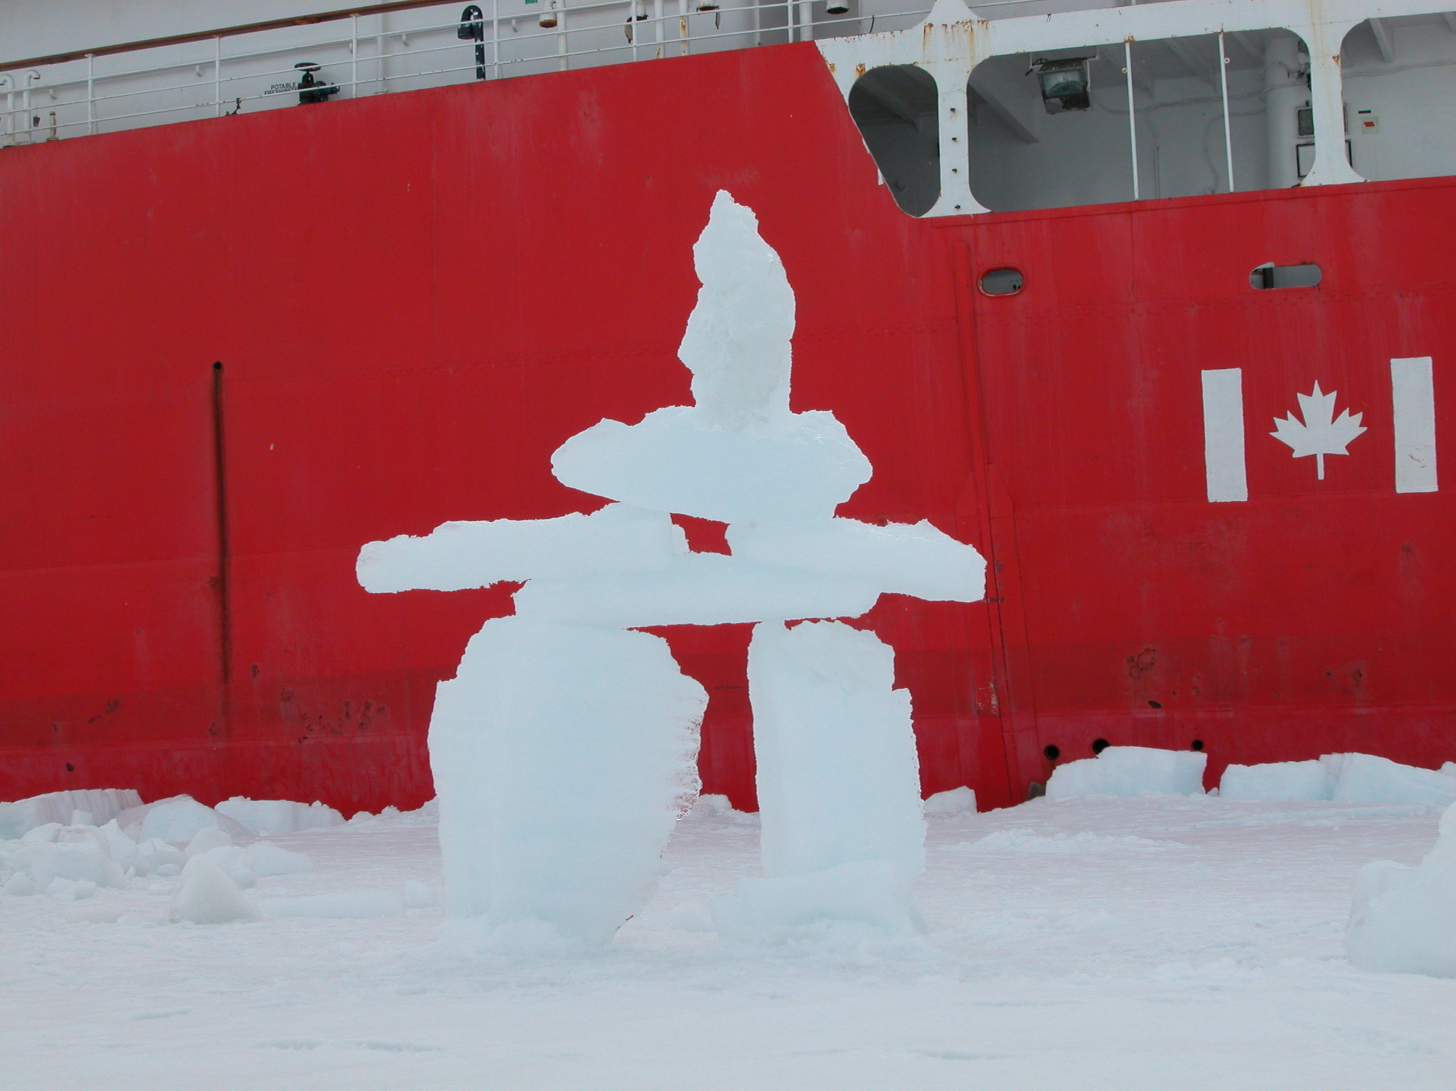

10. Lists of Operations, Positions and Times

Table 3. Mooring Locations

Mooring Designation | Investigator | Water  Depth (m) | Recovery  Time | Recovery Location | Deployment Time | Deployment Location
CABOS | IARC | 1112 | 4-Aug-05 | 71° 46.506'N | 30-Aug-05 | 71° 49.676'N
 | I. Polyakov |  | 14:46 UTC | 131° 52.711'W | 21:12 UTC | 131° 45.663'W
BS-3 | WHOI | 149 | Na | na | 6-Aug-05 | 71° 23.732'N
 | R. Pickart |  |  |  | 22:12 UTC | 152° 02.175'W
BGOS-A | WHOI | 3825 | 9-Aug-05 | 75° 00.251' N | 12-Aug-05 | 75° 00.304' N
 | A. Proshutinsky |  | 18:40 UTC | 149° 58.108'W | 20:05 UTC | 149° 53.413'W
BGOS-B | WHOI | 3821 | 14-Aug-05 | 78° 01.084'N | 17-Aug-05 | 77° 59.585'N
 | A. Proshutinsky |  | 15:08 UTC | 149° 52.459'W | 19:25 UTC | 149° 57.866'W
BGOS-C | WHOI | 3722 | 26-Aug-05 | 76° 59.452'N | 26-Aug-05 | 76° 58.251'N
 | A. Proshutinsky |  | 00:01 UTC | 139° 58.307'W | 20:50 UTC | 139° 59.539'W
BGOS-D | WHOI | 3510 | Na | na | 28-Aug-05 | 74° 00.146'N
 | A. Proshutinsky |  |  |  | 21:10 UTC | 139° 58.985'W
ITP1 & | WHOI | 3830 | Na | na | 15-Aug-05 | 78° 51.1'N
IMB 07949 | A. Proshutinsky |  |  |  | 22:00 UTC | 150° 15.9'W
ITP3 & | WHOI |  | Na | na | 23-Aug-05 | 77° 36.1'N
IMB 07950 | A. Proshutinsky |  |  |  | 18:00 UTC | 142° 11.8'W

Table 4. Rosette Casts

Cast | Station | Latitude (N) | Longitude (E) | Date (UTC) | Time (UTC) | Water Depth (m) | Max CTD Depth (m) | Sample Numbers | Comment
1 | 1 | 74.2647 | -95.3890 | 29-Jul-05 | 16:19 | 205 | 200 | 1-8 | Northwest Passage
2 | 2 | 68.8733 | -101.4435 | 31-Jul-05 | 14:14 | 46 | 40 | 9-13 | Northwest Passage
3 | 3 | 68.7062 | -102.7630 | 31-Jul-05 | 18:06 | 105 | 100 | 14-18 | Northwest Passage
4 | 4 | 68.7000 | -103.7700 | 31-Jul-05 | 21:04 | 105 | 100 | 19-24 | Northwest Passage
5 | AG5 | 70.5515 | -122.9032 | 3-Aug-05 | 12:41 | 641 | 638 | 25-45 | Northwest Passage
6 | CB-1/ CABOS | 71.7688 | -131.8172 | 4-Aug-05 | 05:47 | 1098 | 1093 | 46-68
7 | CB-1/ CABOS | 71.7710 | -131.8670 | 4-Aug-05 | 10:31 | 1118 | 250 | 69-73 | Repeat cast for bottle flushing test
8 | CB-1/ CABOS | 71.7657 | -131.8603 | 4-Aug-05 | 11:25 | 1120 | 1000 | 74-91 | Repeat cast for bottle flushing test
9 | CB-28a | 70.5850 | -139.9967 | 5-Aug-05 | 15:04 | 866 | 871 | 92-112
10 | CB-28b | 71.0000 | -139.9997 | 5-Aug-05 | 17:33 | 2079 | 2073 | 113-136
11 | BS-3a | 71.3650 | -151.9708 | 6-Aug-05 | 20:21 | 97 | 90 | na | CTD only, no bottles
12 | BS-3 | 71.3977 | -151.9948 | 7-Aug-05 | 01:37 | 150 | 151 | 137-146
13 | BS-3b | 71.5802 | -151.5175 | 7-Aug-05 | 04:52 | >1500 | 1000 | 147-166 | Repeat cast for Cesium/Iodine samples
14 | BS-3b | 71.6237 | -151.4912 | 7-Aug-05 | 10:58 | >1500 | 1513 | 167-187
15 | BS-3c | 71.7958 | -150.8415 | 7-Aug-05 | 14:44 | 2462 | 2456 | 188-210
16 | BS-3d | 72.0035 | -150.0002 | 7-Aug-05 | 19:18 | 3115 | 3108 | 211-234
17 | CB-2 | 73.0020 | -149.9920 | 8-Aug-05 | 08:25 | ~3670 | 3564 | 235-258
18 | CB-3 | 74.0035 | -149.9597 | 8-Aug-05 | 21:13 | 3830 | 1000 | 259-278 | Repeat cast for Cesium/Iodine samples
19 | CB-3 | 74.1898 | -149.7422 | 9-Aug-05 | 03:42 | 3818 | 3812 | 279-302
20 | CB-4 | 74.9793 | -149.9347 | 10-Aug-05 | 00:43 | 3830 | 3820 | 303-326
21 | CB-5 | 75.2777 | -153.2465 | 10-Aug-05 | 10:13 | 3843 | 3838 | 327-337
22 | CB-5a | 75.5718 | -155.5615 | 10-Aug-05 | 17:46 | 3846 | 3836 | 338-361
23 | CB-5b | 75.6188 | -156.1637 | 10-Aug-05 | 23:20 | 2130 | 2094 | na | CTD only, no bottles
24 | CB-6 | 74.7533 | -147.7518 | 11-Aug-05 | 19:39 | 3802 | 3796 | 362-385
25 | CB-4 | 74.9882 | -149.8727 | 12-Aug-05 | 21:55 | 3840 | 850 | 386-409 | Repeat cast for thermohaline intrusion study
26 | CB-7 | 75.9878 | -149.9657 | 13-Aug-05 | 08:07 | 3829 | 3821 | 410-433
27 | CB-8 | 76.9888 | -150.0138 | 13-Aug-05 | 19:22 | 3830 | 3800 | 434-457
28 | CB-9 | 78.0018 | -149.8377 | 14-Aug-05 | 07:33 | 3824 | 3816 | 458-481
29 | CB-11 | 78.9722 | -149.9947 | 15-Aug-05 | 03:31 | 3831 | 800 | 481-492 | Repeat cast for Cesium/Iodine samples
30 | CB-11 | 78.9750 | -149.9952 | 15-Aug-05 | 04:48 | 3831 | 3812 | 493-516
31 | Ice_floe | 78.8655 | -150.4713 | 15-Aug-05 | 10:10 | 3830 | 3810 | na | Cast at Ice Buoy deployment; CTD only, no bottles
32 | CB-10 | 78.2875 | -153.2477 | 16-Aug-05 | 08:52 | 2450 | 800 | 517-528 | Repeat cast for Cesium/Iodine samples
33 | CB-10 | 78.2852 | -153.2527 | 16-Aug-05 | 10:19 | 2504 | 2436 | 529-552
34 | CB-10a | 78.2615 | -153.9487 | 16-Aug-05 | 16:09 | 946 | 937 | na | CTD only, no bottles
35 | CB-10b | 78.1778 | -152.8525 | 16-Aug-05 | 19:21 | 3123 | 3095 | na | CTD only, no bottles
36 | CB-9 | 77.9822 | -150.0460 | 17-Aug-05 | 10:23 | ~3800 | 1580 | 553-572 | Repeat cast thermohaline intrusion study
37 | CB-12 | 77.7020 | -146.7030 | 18-Aug-05 | 01:59 | 3814 | 3802 | 573-596
38 | CB-13 | 77.2982 | -143.3703 | 18-Aug-05 | 13:19 | 3782 | 3776 | 597-620
39 | CB-15 | 76.9850 | -139.9865 | 26-Aug-05 | 07:04 | 3725 | 3719 | 628-651
40 | CB-15 | 76.9810 | -139.9955 | 26-Aug-05 | 12:54 | 3725 | 800 | 652-671 | Repeat cast for Cesium/Iodine samples
41 | CB-15 | 76.9652 | -139.9618 | 26-Aug-05 | 21:59 | 3732 | 600 | 672-691 | Repeat cast for thermohaline intrusion study
42 | CB-17 | 75.9977 | -139.7845 | 27-Aug-05 | 11:18 | ~3700 | 1004 | 692-715 | Shortened cast to save time
43 | CB-18 | 75.0633 | -140.3732 | 27-Aug-05 | 21:59 | 3660 | 3644 | 716-739
44 | CB-21 | 74.0343 | -140.0165 | 28-Aug-05 | 11:05 | 3520 | 3514 | 740-763
45 | CB-27 | 73.0067 | -139.9983 | 29-Aug-05 | 05:15 | 3234 | 2000 | 764-787 | Shortened cast to save time
46 | CB-29 | 71.9972 | -139.9877 | 29-Aug-05 | 15:08 | 2680 | 2673 | 788-811
47 | CB-23a | 72.7005 | -135.9668 | 30-Aug-05 | 03:39 | 2630 | 2624 | 812-835
48 | CB-31a | 72.1098 | -133.2298 | 30-Aug-05 | 13:39 | 1767 | 1761 | 836-859
49 | CB-1/CABOS | 71.7558 | -131.7378 | 30-Aug-05 | 18:10 | 1061 | 1055 | 860-883
50 | CB-1a | 71.3938 | -130.9020 | 31-Aug-05 | 00:11 | 248 | 243 | 884-895

Table 5. XCTD Casts in Baffin Bay

XCTD Cast | Latitude (N) | Longitude (W) | Date (UTC) | Time (UTC) | Water Depth (m) [Depth with * is from chart] | Max XCTD Depth (m) | Note | Probe s/n | File name
1 | 64.0038 | 54.9979 | 24-Jul-05 | 04:05 | 1280 |  |  | 05022376 | 0507240401
2 | 64.3406 | 55.5441 | 24-Jul-05 | 06:08 | 1140 | bottom |  | 05022377 | 0507240605
3 | 64.6695 | 56.0708 | 24-Jul-05 | 08:00 | 780 | bottom |  | 05022378 | 0507240755
4 | 64.9984 | 56.6014 | 24-Jul-05 | 09:45 | 650 | bottom |  | 05022379 | 0507240942
5 | 65.3352 | 57.1384 | 24-Jul-05 | 11:30 | 600 | bottom |  | 05022380 | 0507241126
6 | 65.6689 | 57.6720 | 24-Jul-05 | 13:20 | 580 | bottom |  | 05022381 | 0507241314
7 | 66.0027 | 58.1984 | 24-Jul-05 | 15:43 | 555 | bottom |  | 05022382 | 0507241538
7 | 66.0256 | 58.2360 | 24-Jul-05 | 15:50 | 566 | bottom | Repeat cast; both casts good | 05022383 | 0507241548
8 | 66.3372 | 58.7322 | 24-Jul-05 | 17:31 | 626 | bottom |  | 05022384 | 0507241725
9 | 66.6680 | 59.2732 | 24-Jul-05 | 19:25 | 907 | bottom |  | 05022385 | 0507241919
10 | 67.0076 | 59.7911 | 24-Jul-05 | 21:53 | 990 | bottom |  | 05022386 | 0507242152
11 | 67.3358 | 60.3316 | 25-Jul-05 | 00:05 | 1000 * |  |  | 05022387 | 0507250003
12 | 67.6675 | 60.3710 | 25-Jul-05 | 01:47 | 1767 * |  |  | 05022388 | 0507250141
13 | 68.3335 | 60.3498 | 25-Jul-05 | 06:39 | 1540 * |  |  | 05022389 | 0507250639
14 | 69.0024 | 60.7204 | 25-Jul-05 | 10:27 | 1700 * |  |  | 05022390 | 0507251020
15 | 69.6684 | 60.8636 | 25-Jul-05 | 13:40 | 1880 * |  |  | 05022391 | 0507251330
16 | 70.3499 | 61.1993 | 25-Jul-05 | 17:03 | 1118 * |  |  | 05022392 | 0507251658
17 | 71.0109 | 61.8643 | 25-Jul-05 | 20:01 | 1920 * |  |  | 05022393 | 0507251955
18 | 71.6818 | 62.0694 | 25-Jul-05 | 22:56 | 2260 * |  |  | 05022394 | 0507252251
19 | 72.3289 | 62.5271 | 26-Jul-05 | 01:53 | 625 * |  |  | 05022395 | 0507260149
20 | 72.9966 | 61.8441 | 26-Jul-05 | 04:55 | 1120 * | bottom |  | 05022396 | 0507260542
21 | 74.7168 | 68.4999 | 26-Jul-05 | 19:27 | 1525 * |  |  | 05022397 | 0507261926
22 | 74.6158 | 69.9836 | 26-Jul-05 | 21:50 | 1000 * |  |  | 05022399 | 0507272146
23 | 73.8176 | 70.9999 | 27-Jul-05 | 01:29 | 1250 * | bottom |  | 05022398 | 0507270122
24 | 73.8007 | 71.9969 | 27-Jul-05 | 03:00 | 1095 * | wire cut 1035 |  | 05032436 | 0507270300
25 | 73.8363 | 73.0689 | 27-Jul-05 | 04:42 | 865 * | bottom |  | 05032437 | 0507270436
26 | 73.9022 | 73.9971 | 27-Jul-05 | 06:05 | 833 * | bottom |  | 05032438 | 0507270558
27 | 74.0040 | 75.0726 | 27-Jul-05 | 07:22 | 806 * | bottom |  | 05032439 | 0507270715
28 | 74.0849 | 80.0133 | 27-Jul-05 | 13:15 | 803 * | wire cut 607 |  | 05032440 | 0507271303
29 | 74.2015 | 84.9995 | 27-Jul-05 | 19:15 | 534 * | bottom |  | 05032441 | 0507271913
30 | 74.3331 | 90.0055 | 28-Jul-05 | 00:57 | 284 | bottom |  | 05032442 | 0507280051

Table 6. XCTD Casts in the Canada Basin

XCTD Cast | Latitude (N) | Longitude (W) | Date(UTC) | TIME (UTC) | Water Depth (m) Depth with * is from chart | Max XCTD Depth (m) | Probe Type (XCTD-1 or XCTD-3) | File name
1 | 71.7005 | 132.5667 | 4-Aug-05 | 17:33 | 1200 | 1100 | 3 | 0508041724
2 | 71.1846 | 134.9633 | 5-Aug-05 | 03:08 | 750 | bottom | 1 | 0508050305
3 | 70.9430 | 137.3866 | 5-Aug-05 | 08:38 | 1450 | 1100 | 1 | 0508050838
4 | 70.9996 | 141.4992 | 5-Aug-05 | 21:06 | 2526* | 1100 | 1 | 0508052101
5 | 71.0002 | 142.9968 | 5-Aug-05 | 23:31 | 1400* | 1100 | 1 | 0508052325
6 | 70.9983 | 144.4999 | 6-Aug-05 | 01:47 | 600* | bottom | 1 | 0508060146
7 | 70.9983 | 146.0329 | 6-Aug-05 | 04:19 | 1400* | 1100 | 3 | 0508060414
8 | 71.1109 | 147.4928 | 6-Aug-05 | 06:56 | 1050 | 1100 | 3 | 0508060653
9 | 72.4806 | 149.8959 | 8-Aug-05 | 02:39 | 3600* | 1100 | 3 | 0508080238
10 | 73.4987 | 150.0078 | 8-Aug-05 | 14:40 | 3800* | 1100 | 3 | 0508081438
11 | 74.4993 | 150.0020 | 9-Aug-05 | 08:50 | 3800* | 1100 | 3 | 0508090849
12 | 75.1452 | 151.5512 | 10-Aug-05 | 06:47 | 3800* | wire cut 1020 | 3 | 0508100647
13 | 75.4499 | 154.4839 | 11-Aug-05 | 04:31 | 3800* | 1100 | 3 | 0508110428
14 | 74.8810 | 148.9973 | 12-Aug-05 | 09:13 | 3800* | 1100 | 3 | 0508120913
15 | 75.4892 | 149.8986 | 13-Aug-05 | 03:04 | 3800* | 1100 | 3 | 0508130255
16 | 76.3315 | 149.9918 | 13-Aug-05 | 13:29 | 3800* | 1100 | 3 | 0508131330
17 | 76.6627 | 149.9740 | 13-Aug-05 | 16:23 | 3800* | 1100 | 3 | 0508131624
18 | 77.3285 | 150.0328 | 14-Aug-05 | 00:40 | 3800* | 1100 | 3 | 0508140038
19 | 77.6408 | 150.0573 | 14-Aug-05 | 03:42 | 3800* | 1100 | 3 | 0508140341
20 | 78.3237 | 150.0135 | 14-Aug-05 | 21:36 | 3800* | 1100 | 3 | 0508141234
21 | 78.6488 | 150.1135 | 15-Aug-05 | 00:58 | 3800* | 1100 | 3 | 0508150055
22 | 78.7108 | 151.1083 | 16-Aug-05 | 02:17 | 3500* | 1100 | 3 | 0508160214
23 | 78.5699 | 151.7807 | 16-Aug-05 | 04:48 | 3835 | 1100 | 3 | 0508160444
24 | 78.4211 | 152.6110 | 16-Aug-05 | 06:58 | 3840 | 1100 | 3 | 0508160658
25 | 77.9842 | 151.4705 | 17-Aug-05 | 00:31 | 3840 | 1100 | 3 | 0508170024
26 | 77.8563 | 148.3788 | 17-Aug-05 | 22:30 | 3800* | 1100 | 3 | 0508172230
27 | 77.4613 | 145.0493 | 18-Aug-05 | 09:13 | 3800* | 1100 | 3 | 0508180913
28 | 77.5228 | 142.1789 | 18-Aug-05 | 20:20 | 3700* | 1100 | 3 | 0508182019
29 | 77.9735 | 141.5782 | 19-Aug-05 | 20:59 | 3700* | 1100 | 3 | 0508192102
30 | 77.2933 | 140.6195 | 25-Aug-05 | 15:40 | 3700* | 1100 | 1 | 0508251537
31 | 76.6651 | 140.0708 | 27-Aug-05 | 03:19 | 3500* | 1100 | 1 | 0508270317
32 | 76.3713 | 139.8372 | 27-Aug-05 | 06:50 | 3500* | 1100 | 1 | 0508270647
33 | 75.6632 | 140.4230 | 27-Aug-05 | 16:12 | 3500* | wire cut 1043 | 1 | 0508271610
34 | 75.3342 | 141.0020 | 27-Aug-05 | 19:04 | 3500* | 1100 | 1 | 0508271901
35 | 74.6724 | 140.4287 | 28-Aug-05 | 05:04 | 3600* | 1100 | 1 | 0508280503
36 | 74.3403 | 140.3605 | 28-Aug-05 | 07:57 | 3500* | 1100 | 1 | 0508280756
37 | 73.6656 | 140.0901 | 28-Aug-05 | 23:53 | 3400* | 1100 | 1 | 0508282351
38 | 73.3151 | 140.1932 | 29-Aug-05 | 02:30 | 3300* | wire cut 755 | 1 | 0508290230
39 | 73.3140 | 140.1941 | 29-Aug-05 | 02:37 | 3300* | 1100 | 1 | 0508290237
40 | 72.6638 | 140.3997 | 29-Aug-05 | 09:30 | 2900* | 1100 | 1 | 0508290927
41 | 72.3337 | 140.1768 | 29-Aug-05 | 11:51 | 2700* | 1100 | 1 | 0508291150
42 | 72.3084 | 138.6368 | 29-Aug-05 | 20:14 | 2700* | 1100 | 3 | 0508292012
43 | 72.4264 | 137.1248 | 29-Aug-05 | 23:15 | 2500* | 1100 | 3 | 0508292314
44 | 72.3647 | 135.1958 | 30-Aug-05 | 09:01 | 2250* | 1100 | 3 | 0508300901
45 | 72.1955 | 134.2690 | 30-Aug-05 | 11:19 | 2000* | 1100 | 3 | 0508301118
46 | 71.2668 | 132.5862 | 30-Aug-05 | 16:12 | 1200* | 1100 | 3 | 0508301611
47 | 71.5878 | 131.3183 | 30-Aug-05 | 22:33 | 727 | bottom | 3 | 0508302235
48 | 71.5027 | 130.9598 | 30-Aug-05 | 23:33 | 441 | bottom | 3 | 0508302332
49 | 71.3471 | 130.7453 | 31-Aug-05 | 01:07 | 152 | bottom | 3 | 0508310106
50 | 70.9200 | 126.0093 | 31-Aug-05 | 06:58 | 389 | bottom | 3 | 0508310657
51 | 70.3736 | 122.0011 | 31-Aug-05 | 12:02 | 455 | bottom | 3 | 0508311200
52 | 69.5788 | 118.0053 | 31-Aug-05 | 18:50 | 400 | bottom | 3 | 0508311849
53 | 68.8506 | 114.4962 | 1-Sep-05 | 00:55 | 86 | bottom | 1 | 0509010054

Table 7. Zooplankton Casts

Net event | Station  (CTD Cast) | Latitude (N) | Longitude (W) | Date (UTC) | Time (UTC) | Approx. Max Net Depth (m) | Approx. Water Depth (m) | Notes
1 | CB-1 (6) | 71.78 | 131.87 | 04-Aug-05 | 7:15 | 100 | 1100
2 | CB-1 (6) | 71.78 | 131.87 | 04-Aug-05 | 7:31 | 100 | 1100
3 | CB-4 (20) | 74.98 | 149.93 | 10-Aug-05 | 0:02 | 100 | 3830 | Contamination: Rinsed inside net with seawater hose
4 | CB-4 (20) | 74.98 | 149.93 | 10-Aug-05 | 0:11 | 100 | 3830 | Contamination: Rinsed inside net with seawater hose
5 | CB-4 (20) | 75.00 | 150.00 | 12-Aug-05 | 12:03 | 100 | 3830 | Station CB-4 repeated. Location from Bridge Log
6 | CB-4 (20) | 75.00 | 150.00 | 12-Aug-05 | 12:20 | 100 | 3830 | Station CB-4 repeated. Location from Bridge Log
7 | CB-9 (28) | 78.00 | 149.84 | 14-Aug-05 | 6:50 | 100 | 3824
8 | CB-9 (28) | 78.01 | 149.84 | 14-Aug-05 | 7:07 | 100 | 3824
9 | CB-15 (39) | 76.98 | 140.00 | 26-Aug-05 | 9:45 | 100 | 3700
10 | CB-15 (39) | 76.98 | 140.00 | 26-Aug-05 | 10:01 | 100 | 3700

Table 8. Bucket Samples for Surface Water

Station Name | Latitude (N) | Longitude (E) | Date (UTC) | Time (UTC) | Water Depth (m)
XCTD 30 | 77.2933 | 140.6195 | 25-Aug-05 | 15:41 | 3700+
XCTD 31 | 76.6651 | 140.0708 | 27-Aug-05 | 03:19 | 3500+
XCTD 32 | 76.3713 | 139.8372 | 27-Aug-05 | 06:50 | 3500+
XCTD 33 | 75.6632 | 140.4230 | 27-Aug-05 | 16:12 | 3500+
XCTD 34 | 75.3342 | 141.0020 | 27-Aug-05 | 19:04 | 3500+
XCTD 35 | 74.6724 | 140.4287 | 28-Aug-05 | 05:04 | 3600+
XCTD 36 | 74.3403 | 140.3605 | 28-Aug-05 | 07:57 | 3500+
XCTD 37 | 73.6656 | 140.0901 | 28-Aug-05 | 23:53 | 3400+
XCTD 40 | 72.6638 | 140.3997 | 29-Aug-05 | 09:30 | ~2900
XCTD 41 | 72.3337 | 140.1768 | 29-Aug-05 | 11:51 | ~2700
XCTD 42 | 72.3084 | 138.6368 | 29-Aug-05 | 20:14 | 2700+
XCTD 43 | 72.4264 | 137.1248 | 29-Aug-05 | 23:15 | 2500+
XCTD 44 | 72.2147 | 135.1958 | 30-Aug-05 | 09:01 | 2250
XCTD 45 | 72.1955 | 134.2690 | 30-Aug-05 | 11:19 | 2000
XCTD 46 | 71.2668 | 132.5862 | 30-Aug-05 | 16:12 | 1200
XCTD 47 | 71.5878 | 131.3183 | 30-Aug-05 | 22:33 | 715
XCTD 48 | 71.5027 | 130.9598 | 30-Aug-05 | 23:33 | 440
XCTD 49 | 71.3471 | 130.7453 | 31-Aug-05 | 01:07 | 152
XCTD 50 | 70.5867 | 126.0093 | 31-Aug-05 | 06:58 | 389
XCTD 51 | 70.3736 | 122.0011 | 31-Aug-05 | 12:02 | 455
XCTD 52 | 69.5788 | 118.0067 | 31-Aug-05 | 18:50 | 400
XCTD 53 | 68.8506 | 114.4962 | 1-Sep-05 | 00:55 | 86
Coppermine River 1 | 67.7206 | 115.4110 | 7-Sep-05 | 23:30 | 0.5
Coppermine River 2 | 67.7495 | 115.3583 | 8-Sep-05 | 00:15 | 0.5
Coppermine River 3 | 67.7603 | 115.2653 | 8-Sep-05 | 00:45 | 0.5
Coppermine River 4 | 67.7947 | 115.1241 | 8-Sep-05 | 01:00 | 0.5
East of Kugluktuk | 68.3678 | 112.9308 | 9-Sep-05 | 03:00 | 138
West of Cambridge Bay | 68.7833 | 107.9383 | 9-Sep-05 | 14:30 | 88
East of Cambridge Bay | 68.8704 | 105.2838 | 10-Sep-05 | 01:00 | 70
Larsen Sound | 70.3425 | 98.8450 | 10-Sep-05 | 15:00 | 199

