Processing Notes for the Year 2004 Nanoose Bay Data 30 July, 2026

Ron Perkin

The processing was done with Seabird's Windows software from scratch after overcoming some start-up problems and following the same "wildedit,filter, align, loopedit, binavg" procedure as was used in 2004.Some profiles were not converted because they had no position information which generally comes in the .act files.
n4081201
n4121402

Processing was done into d:\nanoose\seasoft\hex\2004\From Wally\...Inspection of profiles using SeaPlot showed spikes occurring every 50 m on many profiles:
n4013001
n4013002
n4020301
n4081201
n4091501
n4092101
n4111801

Some had bad data and were eliminated:
n4111901
n4111903

Some had bad conductivity and were eliminated:
n4081201org

Some could be salvaged with hand editing:
n4052101
n4052601

The spikes every 50 m were eliminated by edjusting the wildedit parameters:
Scans/Block=15
Std.Dev. Pass1=2
Std. Dev. Pass2=2
Include scan marked bad (for LoopEdit)

This left 71 profiles which were converted to IOSSHELL.

Visual Basic Nanoose.sln was used to add positions from the .act files and assign sequential numbers: "2004-99-xxxx.ctd"

Ocean Data View .o4x file was produced and station numbers were assigned for inclusion into Nanoose.var under OceanDataView(mp)/Ron/Nanoose.

Data was sent on to Diane, Roy and Joe for archiving.
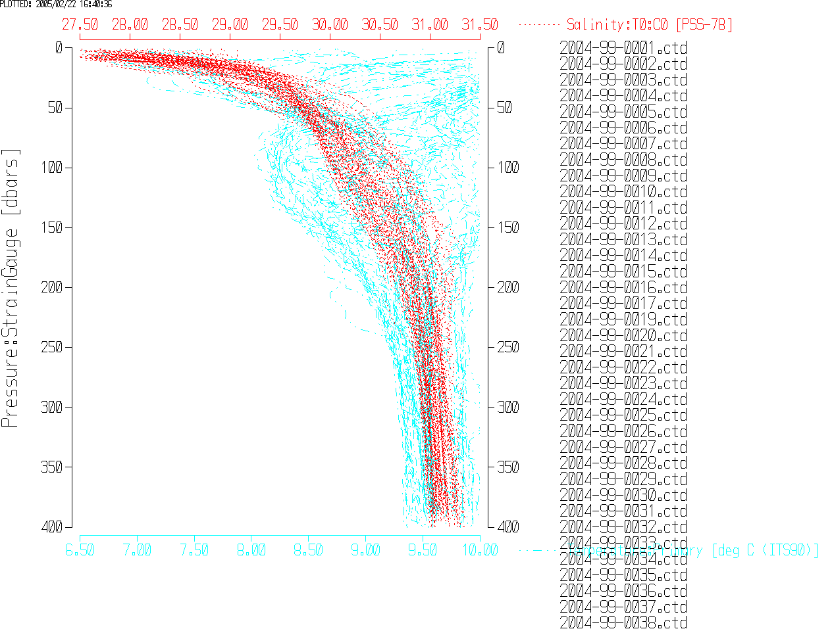

Coordinates were taken from the .act files as distance in metres, x' and y', along range 2 which was inclined at an angle of 11.2º south of east. Conversion into easting and northing coordinates was done according to (output was .ctd files):

X = x'cos(11.2) + y'sin(11.2)
Y = -x'sin(11.2) + y'cos(11.2)

Conversion to lat/long was done according to:

Lat = 49º (21.05' +Y*60/111120)
Long = 124º + (9.55 - X*60/72387)

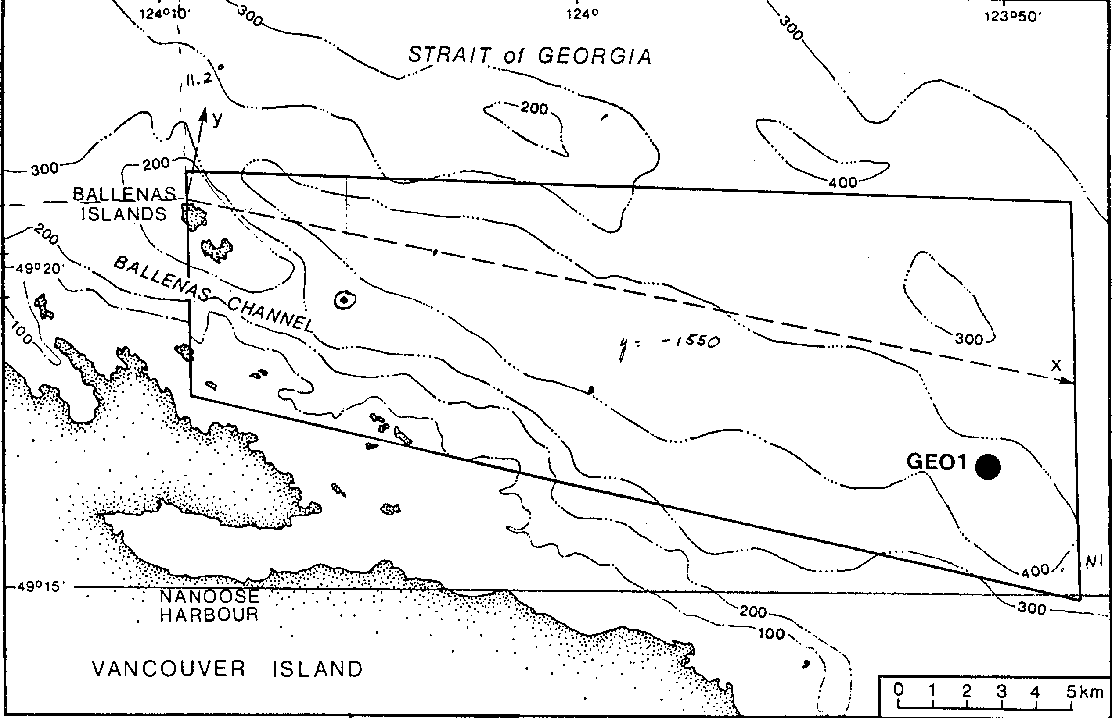
The data were inspected in CTDedit and small corrections were made to:
2003-99-0015.ctd
2003-99-0016.ctd.

