REVISION NOTICE TABLE
DATE | DESCRIPTION OF REVISION

PROCESSING NOTES
Cruise: 2004-41
Agency: OSAP
Location: Strait of Georgia
Project: Beamish
Chief Scientist: Beamish R.
Platform: W. E. RICKER
Date: September 22, 2004 – October 18, 2004

Processed by: Germaine Gatien
Date of Processing: 7 June 2005 –13 June 2005
Number of original CTD casts: 36 (in original processing) +28 processed later
Number of casts processed: 36 +25 (1 of the casts found later was empty and 2 had pumps off)

INSTRUMENT SUMMARY
A SeaBird Model SBE 911+ CTD (#0506) was mounted with Transmissometer #197 and Seapoint Fluorometer (#2228). The deck unit is believed to have been a SeaBird model 11 (S/N 0471.)

SUMMARY OF QUALITY AND CONCERNS
There was no Log Book available.
There was no salinity calibration sampling. Recalibration was based on a post-cruise calibration drift estimate.
The downcast conductivity and fluorescence data were bad.
The quality of the data is lower than usual since upcast data was selected.

PROCESSING SUMMARY

Seasave
This step was completed at sea; the raw data files have extension DAT.

Preliminary Steps
There was no log book, nor any records about this cruise. There was no bottle data available.
The configuration files were obtained. The sensors used had not been recalibrated since April 2002. It is known that there was a lot of drift during that time, since there were post-cruise calibrations in November 2004 for the T and C sensors. So the post-cruise calibrations will be used for conversion. (2004-41-CTD.con contains the post-cruise calibrations.) It is expected that the drift over the 1.5 months between use and post-cruise calibration will be less than 0.001psu.
The sensor history was found.

Conversion of Raw Data
The raw data were converted using configuration file 2004-41-CTD.con.
All expected channels were present.
There are severe problems with the data.
The secondary temperature looks odd near the surface of upcasts. The problem was present for most casts, but is not seen at the end of the cruise.
The conductivity channels are very different in the top 50m of both the upcast and downcasts.
The fluorescence looks bad during the downcasts; upcast fluorescence is generally not considered very useful. The transmissivity looks ok.

Similar problems were noted with this equipment during other autumn Ricker cruises, but not during the upcasts, and not in the temperature channel. It is likely that the problem in the downcast conductivity and fluorescence was due to blocked bleed values in the pump systems. The upcast problem is likely not in the pump since it does not seem to affect the fluorescence. The upcast secondary temperature is bad, at least at the surface, so this is likely the cause of the conductivity problem as well.

WILDEDIT
Program WILDEDIT was used to remove spikes in the pressure and temperature channels only. Parameters used were: Pass 1 Std Dev = 2 Pass 2 Std Dev = 5 Points per block = 50

CELLTM
Tests were run on casts #23 and 34 running CELLTM with choices of (0.01,7), (0.01,9), (0.02,7), (0.02,9), (0.03,7) and (0.03,7) for (alpha, 1/beta). The best results were using (0.02, 7) or (0.02, 9). No tests were done on the secondary conductivity since the secondary channels look problematic; further, this sensor had not been selected for archiving from any other cruise in 2004 despite many deployments.
For 2004-32 and 2004-42 the best choice for the primary sensors was (0.02, 7).
CELLTM was run using (0.02, 7) for the primary conductivity.

DERIVE
Program DERIVE was run twice:
on all casts to calculate primary and secondary salinity.
on all casts to calculate the differences between primary and secondary channels for temperature, conductivity and salinity and to calculate the descent rate. These were placed in a test directory and will not be archived.

Test Plots and Channel Check
Three casts that sampled to at least 370m were plotted to check for agreement between the pairs of T and C sensors. The differences were extremely noisy and varied from cast to cast and from one part of the cast to another; as was noted for the 2004-42 data, these casts are too shallow for us to expect good results from this type of study, but are still noteworthy for the high variability. The temperature differences for cast #11 are about -0.001Cº from 300-400m and ~-0.0002 at 450m with no change in descent rate to account for it. The conductivity and salinity show similar variations.
The descent rate was generally steady and high.

Conversion to IOS Headers
The IOSSHELL routine was used to convert SEA-Bird 911+ data to IOS Headers.
CLEAN was used to add event numbers based on the last 4 numbers of the files name and to remove pad values in the pressure channel using linear interpolation based on record number.

Checking Headers
A header check was run and no errors found.
A header summary was produced.
The cruise track was plotted and the positions look reasonable.
The average surface pressure is 2.4db which is lower than found on High Seas Salmon cruises, but there is no indication of a Niskin bottle being attached so the routine on this cruise was probably quite different. There has been no problem in the past with drift in the pressure calibration for this sensor. The minimum pressure was for cast #3 at 0.2db; the conductivity at that pressure indicates that the CTD was very close to the surface.

SHIFT
Fluorescence
The usual test for fluorescence alignment will not work well. The downcast data looks bad so cannot be compared to the upcast. This channel is likely to be removed, but since a few casts may be ok, SHIFT will be run using the value that has been used for other cruises using this equipment during 2004.
SHIFT was run using a setting of +24 records for all casts.

Conductivity
For all 2004 cruises using this equipment a SHIFT setting of -1.2 records for the primary conductivity was found effective in minimizing salinity spiking without oversmoothing. The secondary salinity has not been archived in recent cruises and is not expected to be archived for this cruise, so tests will not be done for secondary conductivity. Tests were run on cast #12 using advancements of from -1 to -1.4 records for the primary conductivity. The results were examined in T-S space with the best results those that minimize unstable spiking in salinity without oversmoothing. The setting of -1.2 looked best for both upcast and downcast data.
All data were put through SHIFT using -1.2 for the primary conductivity.

DELETE
Because the upcast files may be needed for this cruise the SHFC files were put through REVERSE, then DELETE was run twice, once on the SHFC files and once on the REV files. The output files were named DEL and DELREV.
The following DELETE parameters were used:
Surface Record Removal: Last Press Min
Maximum Surface Pressure (relative): 10.00 Minimum Salinity: 0
Pressure Tolerance: 1.0 Pressure filtered over 15 points
Swells deleted. Warning message if pressure difference of 2.00
Drop rates < 0.30m/s (calculated over 11 points) will be deleted.
Drop rate applies in the range 10.00 decibars to 10 decibars less than the maximum pressure
Sample interval = 0.042 seconds. (from header)
COMMENTS ON WARNINGS: There were no warnings.

DETAILED EDITING
Both salinity channels look poor near the surface for many downcasts, though the primary is generally worst. Temperatures look reasonable at the surface and the salinity channels look quite good below 50m, suggesting clogged bleed valves in the pumps are causing the problem. The fluorescence is fairly low, but the downcast shape is suspicious with near-zero values for the first 10db then rising suddenly to peak values; this is a further suggestion of a pump problem.
The upcast salinity looks better for the primary, but there are frequent severe problems in the secondary.
Looking at the temperature we find bad upcast data for the secondary sensor near the top for many casts, with the problem appearing no deeper than 80m. The conductivity has the same problem. The bad temperature data is sufficient to explain the problems in conductivity and salinity.

A preliminary look at climatology suggests that most of the upcast primary salinity is within the historic range. The temperature is high, but this was observed during other cruises in 2004 in this region, and is especially unsurprising when keeping in mind that many of the casts are close to shore and may not be well represented in the climatology.

Looking at the data on a T-S surface confirms that only upcast data from the primary sensors produce reasonable results.

The primary sensors from the DELREV files were selected for editing.
Page plots were produced using T0, S0. These plots were examined for spikes and instabilities and used to guide the use of CTDEDIT. Salinity generally needed light editing to remove spikes due to electrical noise and small “overshoots” in large T gradient areas due to imperfect alignment of T and C.
The descent rate was generally kept high and very steady so there was little corruption by shed wakes.

All casts required light editing.
The following casts required removal of at least 5db of data from the surface because the pumps were turned off early or temperature data was bad: 17, 24 and 26.
Note was made in the headers about any editing done.
The edited files were copied to the EDT file.

Recalibration
Based on the drift estimate during the post-cruise calibration, the primary salinity is probably high by about 0.001psu, so file 2004-41-rcal.ccf was prepared to subtract 0.001psu from the salinity. (Output: COR)

BIN AVERAGE of CTD files
The following Bin Average values were applied to the COR files (output AVG):
Bin channel = pressure
Averaging interval = 1.000 Minimum bin value = .000
Average value will be used. Interpolated values are NOT used for empty bins.
After averaging, page plots were examined on screen and no further editing was deemed necessary.

Other comparisons
Previous experience with these sensors – This equipment has been used many times since the last recalibration, but there was generally little salinity sampling and a lot of scatter.

Historic ranges – Climatology was available only for casts 19-29 plus 36. The salinity was within the historic ranges except for being slightly high around 60-70m at cast #28. The temperatures are above the historic maxima in the top 10 to 70m at many casts. Similar results were seen frequently in 2004, particularly in the Queen Charlotte Strait area in September. Cast 2004-41-0036 was compared with 2004-20-0069 from September Line P cruise and the two are in reasonable agreement given differences in time and position.
None of these excursions can be considered evidence of problems with the sensors.

Final Plots
THIN and DERIVE were run to obtain values for tables and page plots were prepared using the edited data and displaying T, S and Transmissivity profiles.

FINAL CTD files steps (REMOVE and HEADEDIT)
Upcast fluorescence is generally considered unreliable. For this cruise the downcast fluorescence is considered bad near the surface and there are no extracted chlorophyll bottle data. So in the absence of any check on the quality the fluorescence channel will be removed.

The Scan_Number, Temperature:Secondary, Salinity:T1:C1, Conductivity:Primary, Conductivity:Secondary, Fluorescence:Seapoint, Status:Pump, Descent_Rate and Flag channels were removed from all casts.

HEADER EDIT was used to fix formats and header entries and to add the following comments:
The data were processed without access to any log records,
so times and positions are unconfirmed.
The transmissivity data are nominal and unedited except
that some records were removed in editing T and S.
There was no bottle calibration sampling available, so
calibration of salinity was based on the post-cruise calibration
drift estimate.
Because the data in this file were collected during the upcast,
resulting in lower quality than usual, only 3 decimal places
are given for salinity.
The final files were named CTD.
The Standards Check routine was run and HEADEDIT adjusted until all format problems were resolved.

Producing final files
A cross-reference listing was produced.
The sensor history was updated.

Particulars
17. Top 5m of temperature data looks bad, quite different from secondary and from upcast.
24. Pumps turned off at around 7.4db of upcast.
25. Pumps turned off at around 6.6db of upcast.

*************************************************************************************************
UPDATE February 2006
The data for 28 extra casts were found in late 2005. In February 2006 these were processed following the methods described for the original 36 casts except as noted below. A plot of the extra casts is at the end of this document.

There were 28 data files, but one was empty (2004-41-0056.dat).
The average surface pressure was 2db.
Upcast data was used for consistency with the rest of the cruise with the exception of cast #60 which had bad temperature during the upcast.
File #51 contained only downcast data and cast #52 only upcast data at the same site. The data was extremely noisy in both because the pumps were not turned on, so neither cast was processed further.
File #60 also contained extremely noisy salinity. The upcast data was worst; the downcast salinity is very noisy between 30 and 60db with no corresponding noise in temperature. This is suggestive of problems with the pump.
The only warning in DELETE concerned cast #51.

CTDEDIT was used to edit the DELREV files, except for cast #60 when the DEL file was chosen.
The following casts required no editing: 42, 48, 59. All other casts required light editing.
The header comment for cast #60 was adapted to reflect that the data came from the downcast and to mention that the quality of the salinity data is lower than usual for an SBE 911+.
When HEADEDIT was run file 2004-41-hdr-part2.txt was used to add a comment to the header.
Institute of Ocean Sciences
CRUISE SUMMARY

Cruise ID#: 2004-41
Dates: Start: September 22, 2004 End: October 18, 2004
Location:
Vessel: W.E. Ricker
Party Chief:

CTD# | Make | Model | Serial# | Used with Rosette? | CTD Calibration Sheet Competed?
1 | SEABIRD | 911+ | 0506 | No | Yes

Institute of Ocean Sciences

CTD Calibration Information
Make/Model/Serial#: SEABIRD/911+/0506 Cruise ID#: 2004-41

Calibration Information
Sensor |  | Pre-Cruise |  | Post Cruise
Name | S/N | Date | Location | Date | Location
Temperature | 2668 | 20/06/02 | Factory | 18nov04 | Factory
Conductivity | 2424 | 16/04/02 | “ | 19nov04 | “
Secondary Temp. | 2374 | 20/06/02 | “ | 18nov04 | “
Secondary Cond. | 2399 | 16/04/02 | “ | 19nov04 | “
Transmissometer | 197 | 16/01/03 | IOS
Fluorometer | 2228 |  | IOS
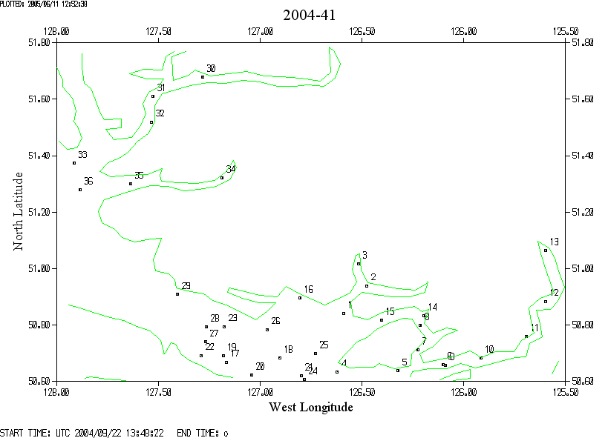
Note that useful data from 25 more casts were found later and a plot of those are found on the next page
