PACIFIC REGION CCG VESSEL -POST CRUISE REPORT

NAME OF SHIP/PLATFORM: CCGS John P Tully

DATE: FROM: August 20, 2004 TO: September 2, 2004

SCIENCE CRUISE NUMBER: 2004-20 SHIP’S PATROL NUMBER: 04-06

CHIEF SCIENTIST[S]: Frank Whitney, Fisheries and Oceans

AREAS OF OPERATION: Gulf of Alaska (Line P), Rivers Inlet and Queen Charlotte Sound

INTRODUCTION/
PROGRAM BACKGROUND:

- Line P is a long standing program which surveys a 1400 km long section 3 times annually. Data has been collected along this line since 1956 and shows evidence of the impact of climate variability on ocean productivity.
- Argo profilers have been extensively deployed in the Gulf of Alaska over the past several years. These floats are providing excellent temperature and salinity data on 10 day intervals that is allowing us to understand changes in this area much better than ever before.
- Sponge reefs on the BC coast are unique in the world. Understanding oceanographic conditions in their vicinity is crucial in understanding how human activities might impact these fragile communities.
- Historically, sockeye salmon runs in Rivers Inlet were second largest on the BC coast. For more than a decade, the stock has declined to levels that no longer permit fishing. Sampling in the QCS and Rivers Inlet area helps describe processes that affect primary productivity, and therefore fish growth on the central coast.

CRUISE OBJECTIVE/OBJECTIVES:

- Survey of Line P, measuring water properties and collecting zooplankton samples
- Survey along the return section, Line R.
- Slope and shelf sampling through Queen Charlotte Sound and into Rivers Inlet.
- Recovery and deployment of Argo profilers west of Station Papa.
- Measure biologically active gas concentrations in surface waters along all sections (UBC)
- Survey seabirds and marine mammals throughout cruise (Environment Canada)

DAYS ALLOCATED: 14 DAYS OF OPERATION: 14

DAYS LOST DUE TO WEATHER: none.

RESULTS:
- Completed Line P survey past Station Papa to 50N, 148 W. Found warmest waters ever observed between 127 and 133 W (as warm as 18.8 C). The survey provides evidence of early stages of El Niño and transport northward of subtropical waters. Tuna were caught in this water. Zooplankton and dissolved inorganic carbon samples were collected along line P at major stations.
- Deployed an Argo profiler with oxygen sensor at 50 N, 148 W. With assistance of satellite positions and Howard Freeland, we recovered an Argo profiler near 146.5 W that had a failed oxygen sensor. This float will be returned to the manufacturer so that the cause of failure can be determined.
- Line R was completed and also found warm waters (to 17.3 C). A ship’s mate noticed anomalous surface currents that indicated we passed through the southern edge of the Haida-2004 mesoscale eddy.
- Completed a shelf survey up Goose Island Trough, the same area surveyed in June and early August this year by M. Robert and D. Ianson. This survey included basic water properties, not the suite of carbon and nitrogen measurements undertaken on earlier surveys.
- Completed a water properties survey of Rivers Inlet.
- Completed seabird and marine mammal surveys during daylight hours. Along Line R as we neared the coast of Queen Charlotte Islands, we sailed past more than 100 northern right whale dolphins frolicking (feeding?). Also a Baird’s beaked whale was sighted near the 200 mile limit on Line R.

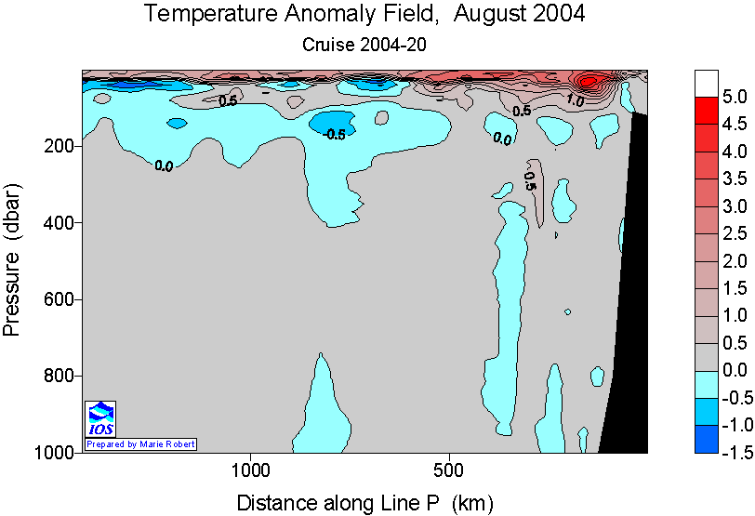

Figure 1. Temperature along Line P shows a surface layer that is >4 C warmer in some areas than normal for August (based on a 1959 to 1991 climatology). Additionally, cool waters underlay the mixed layer further from shore in the subarctic domain. The result is strong stratification of the upper ocean that may impede winter mixing and consequently reduce nutrient supply to the upper ocean. Conditions are reminiscent of the early El Niños periods in 1994 and 1997.

Radioisotope Use: Decommission lab and report use to IOS RSO (Radioisotope Use & Wipe test forms attached)
none

PROBLEMS [SCIENTIFIC GEAR AND OPERATIONS]:
Primary CTD had several problems – bad up casts on transmissometer, data spikes at shallow depths, temperature discrepancies of up to 0.5 C on upcasts through the thermocline, salinity offset between sensors of 0.014 which was constant throughout the cruise. The secondary CTD could not be powered up by deck units. These CTDs need attention. The dimethyl sulphide analytical system of CS Wong failed after station P4 and did not operate the rest of the cruise.

SUCCESSES [SCIENTIFIC]:
All scheduled work completed. New findings include the warmest sea surface temperatures observed along Line P in almost 50 years of observations.

PROBLEMS [SHIP’S EQUIPMENT/OPERATIONS/PLATFORM SUITABILITY]:
The heave compensator leaked air past a main control valve, creating problems during casts. Tully engineers replaced this valve, correcting the problem. The ship will check that adequate spare parts are available for the heave compensator.

SUCCESSES [SHIP]:
All work completed as scheduled. Successfully tracked and recovered an Argo profiler. Doesn’t get better than this.

DELAYS [OTHER THAN WEATHER]:
Usual time required for loading. No delays.

SAFETY CONCERNS:
none

HAZARDOUS OCCURRENCES:
None

DATE OPERATIONS

Aug 19 load Tully at Pat Bay
Aug 20 test cast in Saanich Inlet. Depart for Line P
Aug 20-26 Line P survey
Aug 27 Deploy Argo profiler at 148 W, recover a failed profiler at 146.5 W
Aug 28-31 Line R and coastal ocean surveys into Rivers Inlet
Sep 1 Complete onboard analyses, compile cruise data.
Sep 2 Change science crews in Port Hardy
EVENT LOG:

SCIENCE CREW:
Marie Robert, Hugh Maclean, Wendy Richardson, Peter Chandler, Marty Davelaar, James Zwiers, Mike Bentley (seabirds), Maaike van der Steen, Liz Grant, Evan Seal, Celine Gueguen (biogenic gases).

SUMMARY/FINAL COMMENTS:
Thanks to ships officers and crew for an enjoyable cruise. Three volunteers helped us complete this program, a great help when funding is weak. Thanks to Maaike van der Steen, Evan Seal and Liz Grant for joining us and helping carry out our sampling program. Also, I recognize the great work of our DFO regulars from IOS.

