Project Report

Department of Fisheries and Oceans
Institute of Ocean Sciences
Sidney, B.C., Canada

To: Regional Science Director. Final: Yes

1. Cruise/Project No.: 2004-10 2. Dates: June 1 to June 18, 2004
3. Project Name: Line P
4. Area(s) of Operation: N.E. Pacific to Station P – West of Queen Charlotte Islands – Rivers and Smith Inlets
5. Platform: John P. Tully 6. Master: Bill Noon
7. Days Allocated: 21 (18) 8. Days at Sea: 18
9. Days lost to weather: None
- Days lost to other causes: 2 days lost for acoustics inspection of the ship in Pat Bay.
11. Appropriateness of platform: great 12. Safety issues: None
13. Cruise/Project Results (see appendix for details):
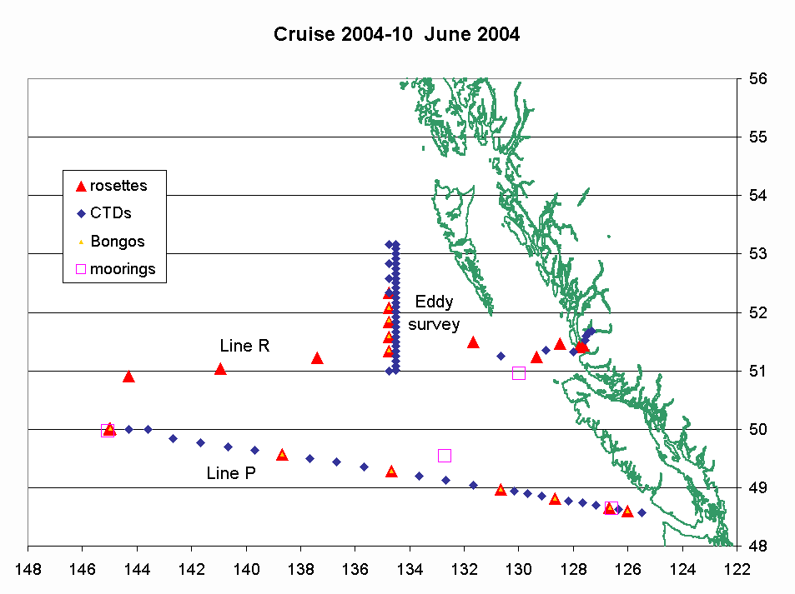

- The Line P survey was very successful. The CTD survey shows that the stratification of the upper layer of the ocean keeps strengthening.
- We collected surface samples along the route for T, S, nutrients, chlorophyll, and coccolithophores. The problem we have with the thermosalinograph not maintaining the correct time is still not fixed.
- Seabird and marine mammals surveys along Line P and Line R for CWS.
- The mooring work was really successful. Three moorings had to be recovered and re-deployed, one mooring was deployed, and one mooring was recovered.
- The sampling using the “skimmer” was not totally successful (see appendix).
- Four Argo floats were successfully deployed.
- We had a wonderful opportunity to sample a “young” Haida eddy that was close to our cruise track. Once analyzed, the results should be very interesting.
- Only 3 of the 4 SCOR nets at Station Papa could be done, the noon cast had to be abandoned because of mooring work.
- 4 extra stations were sampled in preparation for a different project that will take place on the Tully by mid-August.

14. Primary Institute: Institute of Ocean Sciences, DFO
15. Associated Institutes: University of British Columbia, University of Victoria, Canadian Wildlife Service

16. Chief Scientist/Affiliation: Marie Robert, IOS

17. Science Staff/Affiliations:

Mike Arychuk | IOS | Ken Morgan | CWS
Janet Barwell-Clarke | IOS | Tim Soutar | contract
Nick Hall-Patch | IOS | Cheryl Martin | UBC
Marie Robert | IOS | Nina Nemcek | UBC
David Timothy | IOS | Philippe Tortell | UBC
Sheila Toews | IOS | Jean Lachapelle | McGill
Darren Tuele | IOS | Lindsay Richier | UVic
Svein Vagle | IOS | Wendy Wiggins | UVic
Doug Yelland | IOS

18. Equipment: ADCP: yes Other: sounder, thermosalinograph, SCS

19. Winches: .
type | ID No | Wire type | Wire Condition/Spooling | No Casts/  Depth max
Hawboldt 3242 | 17026 | CTD | Good | 86/4300m
Hawboldt 3242 | 17027 | CTD | Had problems | 2/1000m
Swann | 1207 | Bongo/moorings | Good | 14/250m
Swann | 1450 | Moorings | Good
Swann | 1451 | Moorings | Good
See winches manuals for comments.

20. Equipment Deployed/recovered:

Sediment trap mooring at P4, recovered and redeployed
PATC3 Whale mooring deployed on Union Seamount
Sediment trap mooring at P26, recovered and redeployed
SOLAS mooring at P26, recovered and redeployed
PATC1 whale mooring recovered.

21. Comments and recommendations:

Science issues:
- To make the best use of ship time, many projects are attempted during most Line P cruises. For example on this cruise we turned around a SOLAS mooring, deployed and recovered 2 other moorings, sampled in-detail a Haida eddy, and got some samples in preparation for another cruise that will take place at the end of the summer. All this work could not be achieved without the participation of everyone on board. It is important to note that the team effort during this cruise was quite remarkable. The “new” people worked really hard, as well as the “usual” ones, and all the work got done on time.

- A minor chemical spill incident happened during loading day. Here is the report by Nina Nemcek:

Cheryl and I were carrying carboys up to the Hydrography room for storage, and I was carrying one wrapped in a bag when the bag broke and the carboy fell. The bottom of it cracked and 10% HCl started leaking in the hallway outside Cabin F. Janet assisted us in mopping up the spill with absorbent towels and we used a chemical neutralizer to clean the entire area before using water to remove all traces of the neutralizing powder. The majority of the acid from the leaking carboy was collected in a bucket and washed down the sink in the lab with copious amounts of water.

- I feel that I have reached the proverbial “straw that broke the camel’s back” with regards to the far too numerous sarcastic / negative comments about the work that the bird and mammal observers do. As the person in charge of this program I feel that the time has come to speak out against this. While the comments were directed at me this trip, the observers I have employed in the past have also received and complained (to me) about these types of remarks.
Regardless of whether or not certain individuals from IOS understand the value of or even see the need for collecting these data; whether or not they realize that standing on Monkey Island (or less frequently in the Bridge) looking day after day through binoculars for hours on end is in fact physically and mentally demanding; whether or not they think that the observer should stand a watch in addition to attempting to conduct surveys; or in fact whether they feel that the observer is simply having a paid holiday; it would be far better if those comments were left unspoken.
Ken Morgan

Science/Ship issues:
- It will be wonderful when the forward part of the “data room” (deck below the bridge deck, port side) will be temperature controlled. The salinity sample analysis was difficult to perform because of the variation in temperature.

- 2004-10 Network Report
Email is now fully functional for the Chief Scientist, no longer requiring forwarding by the bridge computer operator. ScienceLab users (a common mailbox shared by all other Science users on board) no longer need to “CC:” a copy of their outgoing messages to the bridge. No apparent progress has been made on providing individual email for Science users on board however.

Installation of a Web Server on an experimental basis was found to be potentially useful and should be pursued and expanded. Web cam installation (and feed from the bridge camera) would provide a way for users to quickly ascertain deck or lab operations from any computer on board. The portal software used has the ability for passing News reports on to other users, or nearly any other information types wanted (data, satellite photos, personal photos, ship-board announcements, etc.).

Navmux data provided from the bridge has been interfaced to the web server computer and is now being served out over TCP/IP. With the installation of a small resident program, any computer on the network can get a GPS string, allowing users to run charting software in order to monitor ship’s position, speed, course, etc. Also, a remote computer can run a VNC client to “see” a copy of the server’s screen. If, for instance, Nobeltec is running on the server, the remote computer can simply view a copy of the screen without the necessity of running Nobeltec locally.

The SCS system has had some problems getting certain strings logged (Thermosalinograph, Simrad Sounder, and Wind direction). The Thermosalinograph string is .not logging reliably, that is being looked into. The earlier problems with Wind Direction were sorted out just prior to departing this leg but during the cruise the wind direction again began experiencing problems (spiking incorrect directions). It will work properly for several hours before spiking again. Cause of the failure was not determined.
Doug Yelland

- With regards to improvements to aid observing of birds and mammals, the Captain and I briefly discussed the design of an observer “platform” to be built on Monkey Island (during the mid-life refit). I will be sending my ideas and recommendations on to the Captain and to Doug Yelland.
Ken Morgan

- We have a problem with all this black grease falling from the winch wire, often landing directly onto the rosette. If the rosette spigots are covered with grease they will need to be cleaned with isopropyl alcohol, then flushed with sample before any samples are drawn. This should probably be pointed out to anyone drawing samples - just another thing to be made aware of.
Janet Berwell-Clarke
Ship issues:
- Some discussions were started regarding the re-design of the officers’ lounge. I believe that the scientists as well as the ship’s crew have to start thinking about ways to improve the layout of the main lab as well.

General issues:

- Many thanks to the crew of the Tully for all their help during the cruise, especially during the mooring work. Congratulations to the bosun Randy Sanderson for training the new crew members so efficiently. Thanks also to the science staff that got ‘volunteered’ to stand a watch or to attack other duties. Special thanks to Captain Noon (and his eagle eye during mooring recovery) for his usual help and great knowledge of our programs, as well as for his interest in making “science and Coast Guard work together”.

- As per usual, the officers and crew of the Tully were extremely professional, helpful and friendly; I greatly enjoyed meeting new people from the Coast Guard and from UBC and UVIC. And on that level, the cruise was highly enjoyable.
Ken Morgan

Appendix: Reports from Participants

1. Physical properties – Marie Robert

The Line P section of the cruise was completed very successfully. Every station was surveyed, which means we performed 20 CTD casts, 14 rosette casts, and 7 bongo casts. As mentioned previously, the surface waters along Line P are very strongly stratified, as can be seen in Figure 1.
The nutrient and chlorophyll samples were run on board the ship but will be better analyzed later at the Institute.

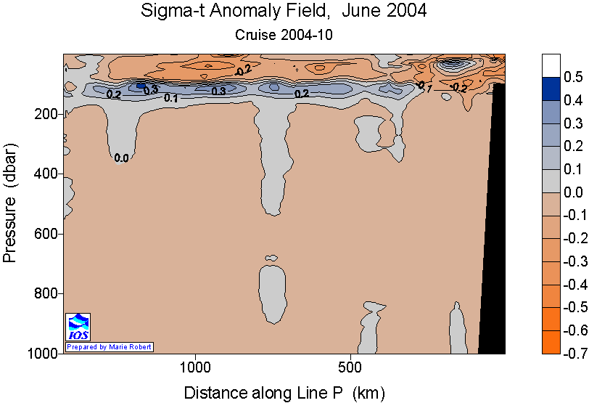

Figure 1. Anomaly of sigma-t along Line P with respect to the averages for 1956-1991.

During this cruise we also sampled a young Haida Eddy. It was quite interesting to notice the first signs of the eddy even before starting its study: the officers on the bridge could feel a strong current moving the ship towards the north-west while we were doing the last station of Line R (south-west vicinity of the eddy). Similarly, an Argo float deployed at that location moved rapidly to the west (29 cm/s) and to the north (19 cm/s). We did a shallow high-density survey of CTD casts, as well as a deep lower-density survey of CTD/Rosette casts. It will take time to analyze all rosette data, but the deep CTD casts show clearly the signature of an eddy (warmer and fresher waters in the core, see figures 2 and 3).

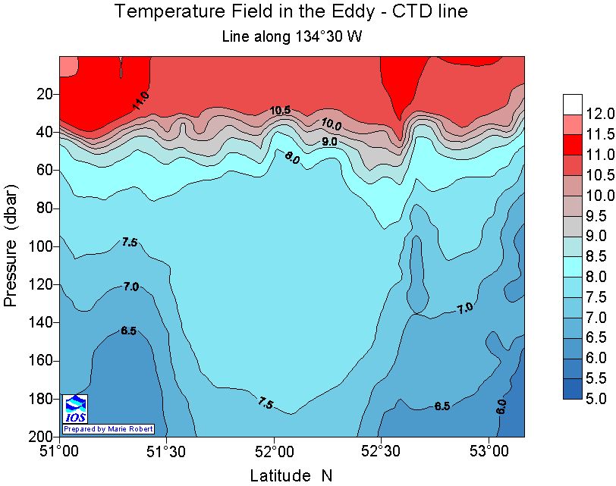

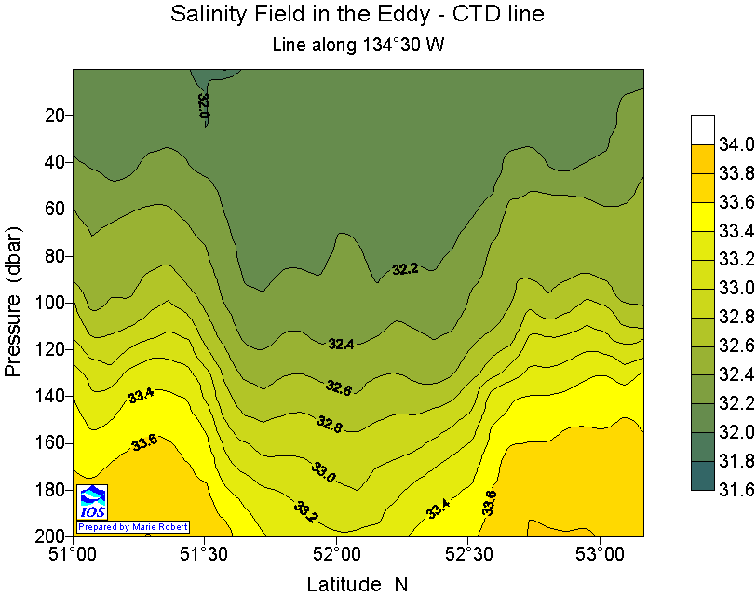

Figure 2: high-density 200m survey of the eddy, temperature field (top) and salinity field (bottom)
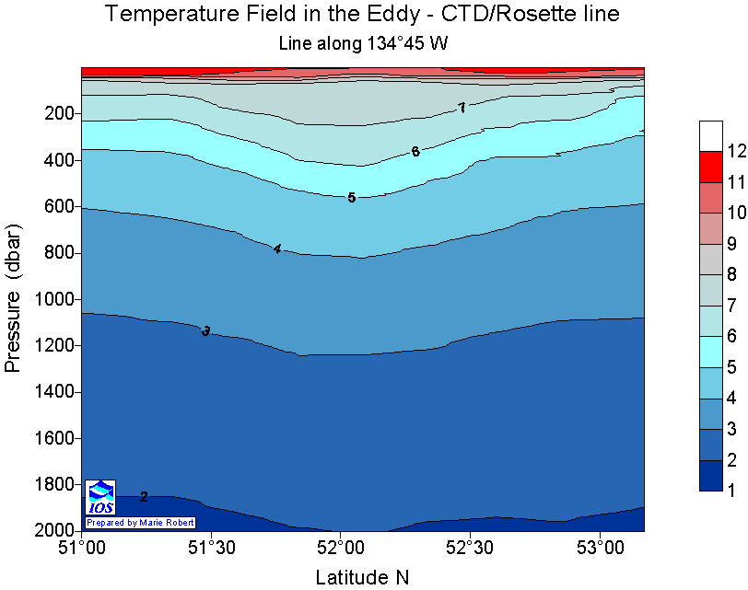

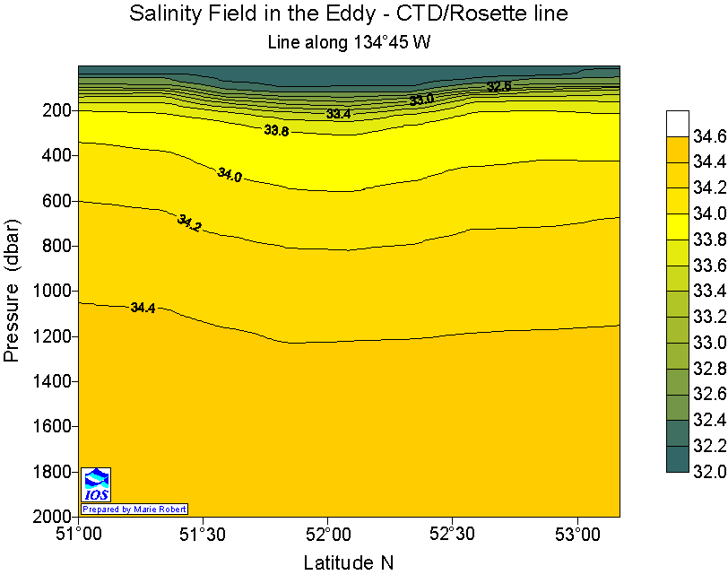

Figure 3: low-density 2000m survey of the eddy, temperature field (top) and salinity field (bottom)

C-SOLAS Mooring recovery and redeployment
Svein Vagle

The northeast Pacific C-SOLAS (Surface Ocean Lower Atmosphere Study) mooring which was deployed close to Station P (50 01.68N 144 56.17W) Wednesday September 4, 2002 and successfully turned around during cruise 2003-11 in June 2003 was again recovered, serviced and redeployed during this cruise.
The mooring is equipped with sensors for studies of air-sea gas exchange processes, especially during periods with high winds when subsurface bubbles become important. For these types of observations it is essential that sensors are deployed as close to the surface as possible. During the first nine months of the mooring deployment (Sep 2002 to June 2003) the top sensor ended up at a depth of 47m which was marginally too deep for measurements in the mixed layer except for a period in the middle of the winter when the mixed layer depth increased to more than 100 m. Based on the information from this first deployment period Darren Tuele reconfigured the mooring lengths perfectly, and the inverted echo sounder at the top of the mooring ended up at a depth of 8m (Figure 1) with excursions to 35m during high current periods.
All significant instruments on the mooring with the exception of the pCO₂ sensor, which cannot be downloaded at sea, functioned properly, and a first look at the data indicates that we have a very interesting dataset.
The mooring was redeployed in the same location for another 12 months with similar instrumentation configuration as last year (Figure 1), but with the addition of a 300kHz ADCP for current profiles and an acoustic rain gauge (ARG) for indirect measurements of wind speed and rainfall rates.

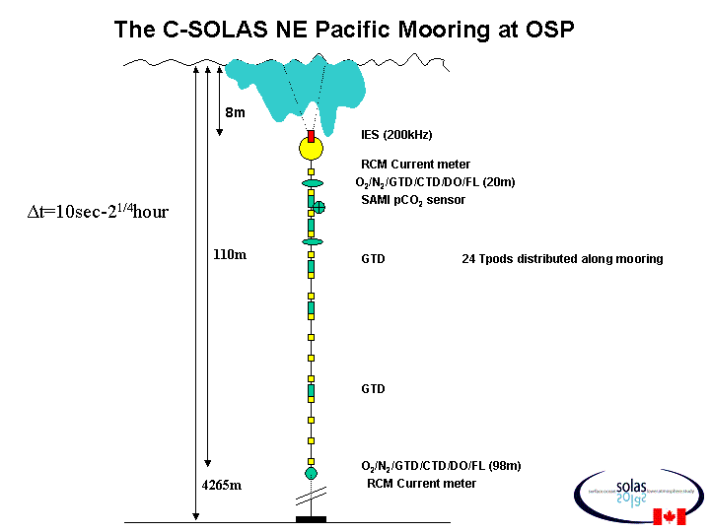
Figure 1. Ocean Station PAPA (OSP) (50 01.679N 144 56.173W), NE Pacific SOLAS mooring. (September 02-June 04). Sensors on the mooring had sampling intervals between 10seconds and 2.25 hours.

Continuous saltwater loop O₂ and N₂ measurements

Based on the experiences from last June’s trip (2003-11) a more permanent system using a combination of a Gas Tension Device (GTD) and an oxygen sensor (SBE43) was installed successfully on this trip to measure O₂ and N₂ concentrations in the loop water approximately every 3 minutes throughout the trip. Last year the oxygen sensor was fouled when arriving at OSP, presumably due to contamination from the ship during periods when the ship was not moving. We therefore designed and built a system where the ship’s speed is being used to control two valves to make sure the water bypasses the sensors when the ship is stopped. This worked very well.
The data will be combined with the thermosalinograph data and the O₂ titrations for data analysis and interpretation.

Microlayer sampling

The IOS built microlayer sampler (“the skimmer”) was deployed three times during the trip. Once at OSP (Figure 2) and two times near the Queen Charlotte Islands. Due to steady winds above 7 m/s and significant whitecapping during the line P portion of the trip the conditions were not suitable for skimmer operations. However, some microlayer samples were collected and these will be analysed at IOS and UVIC in the coming months.

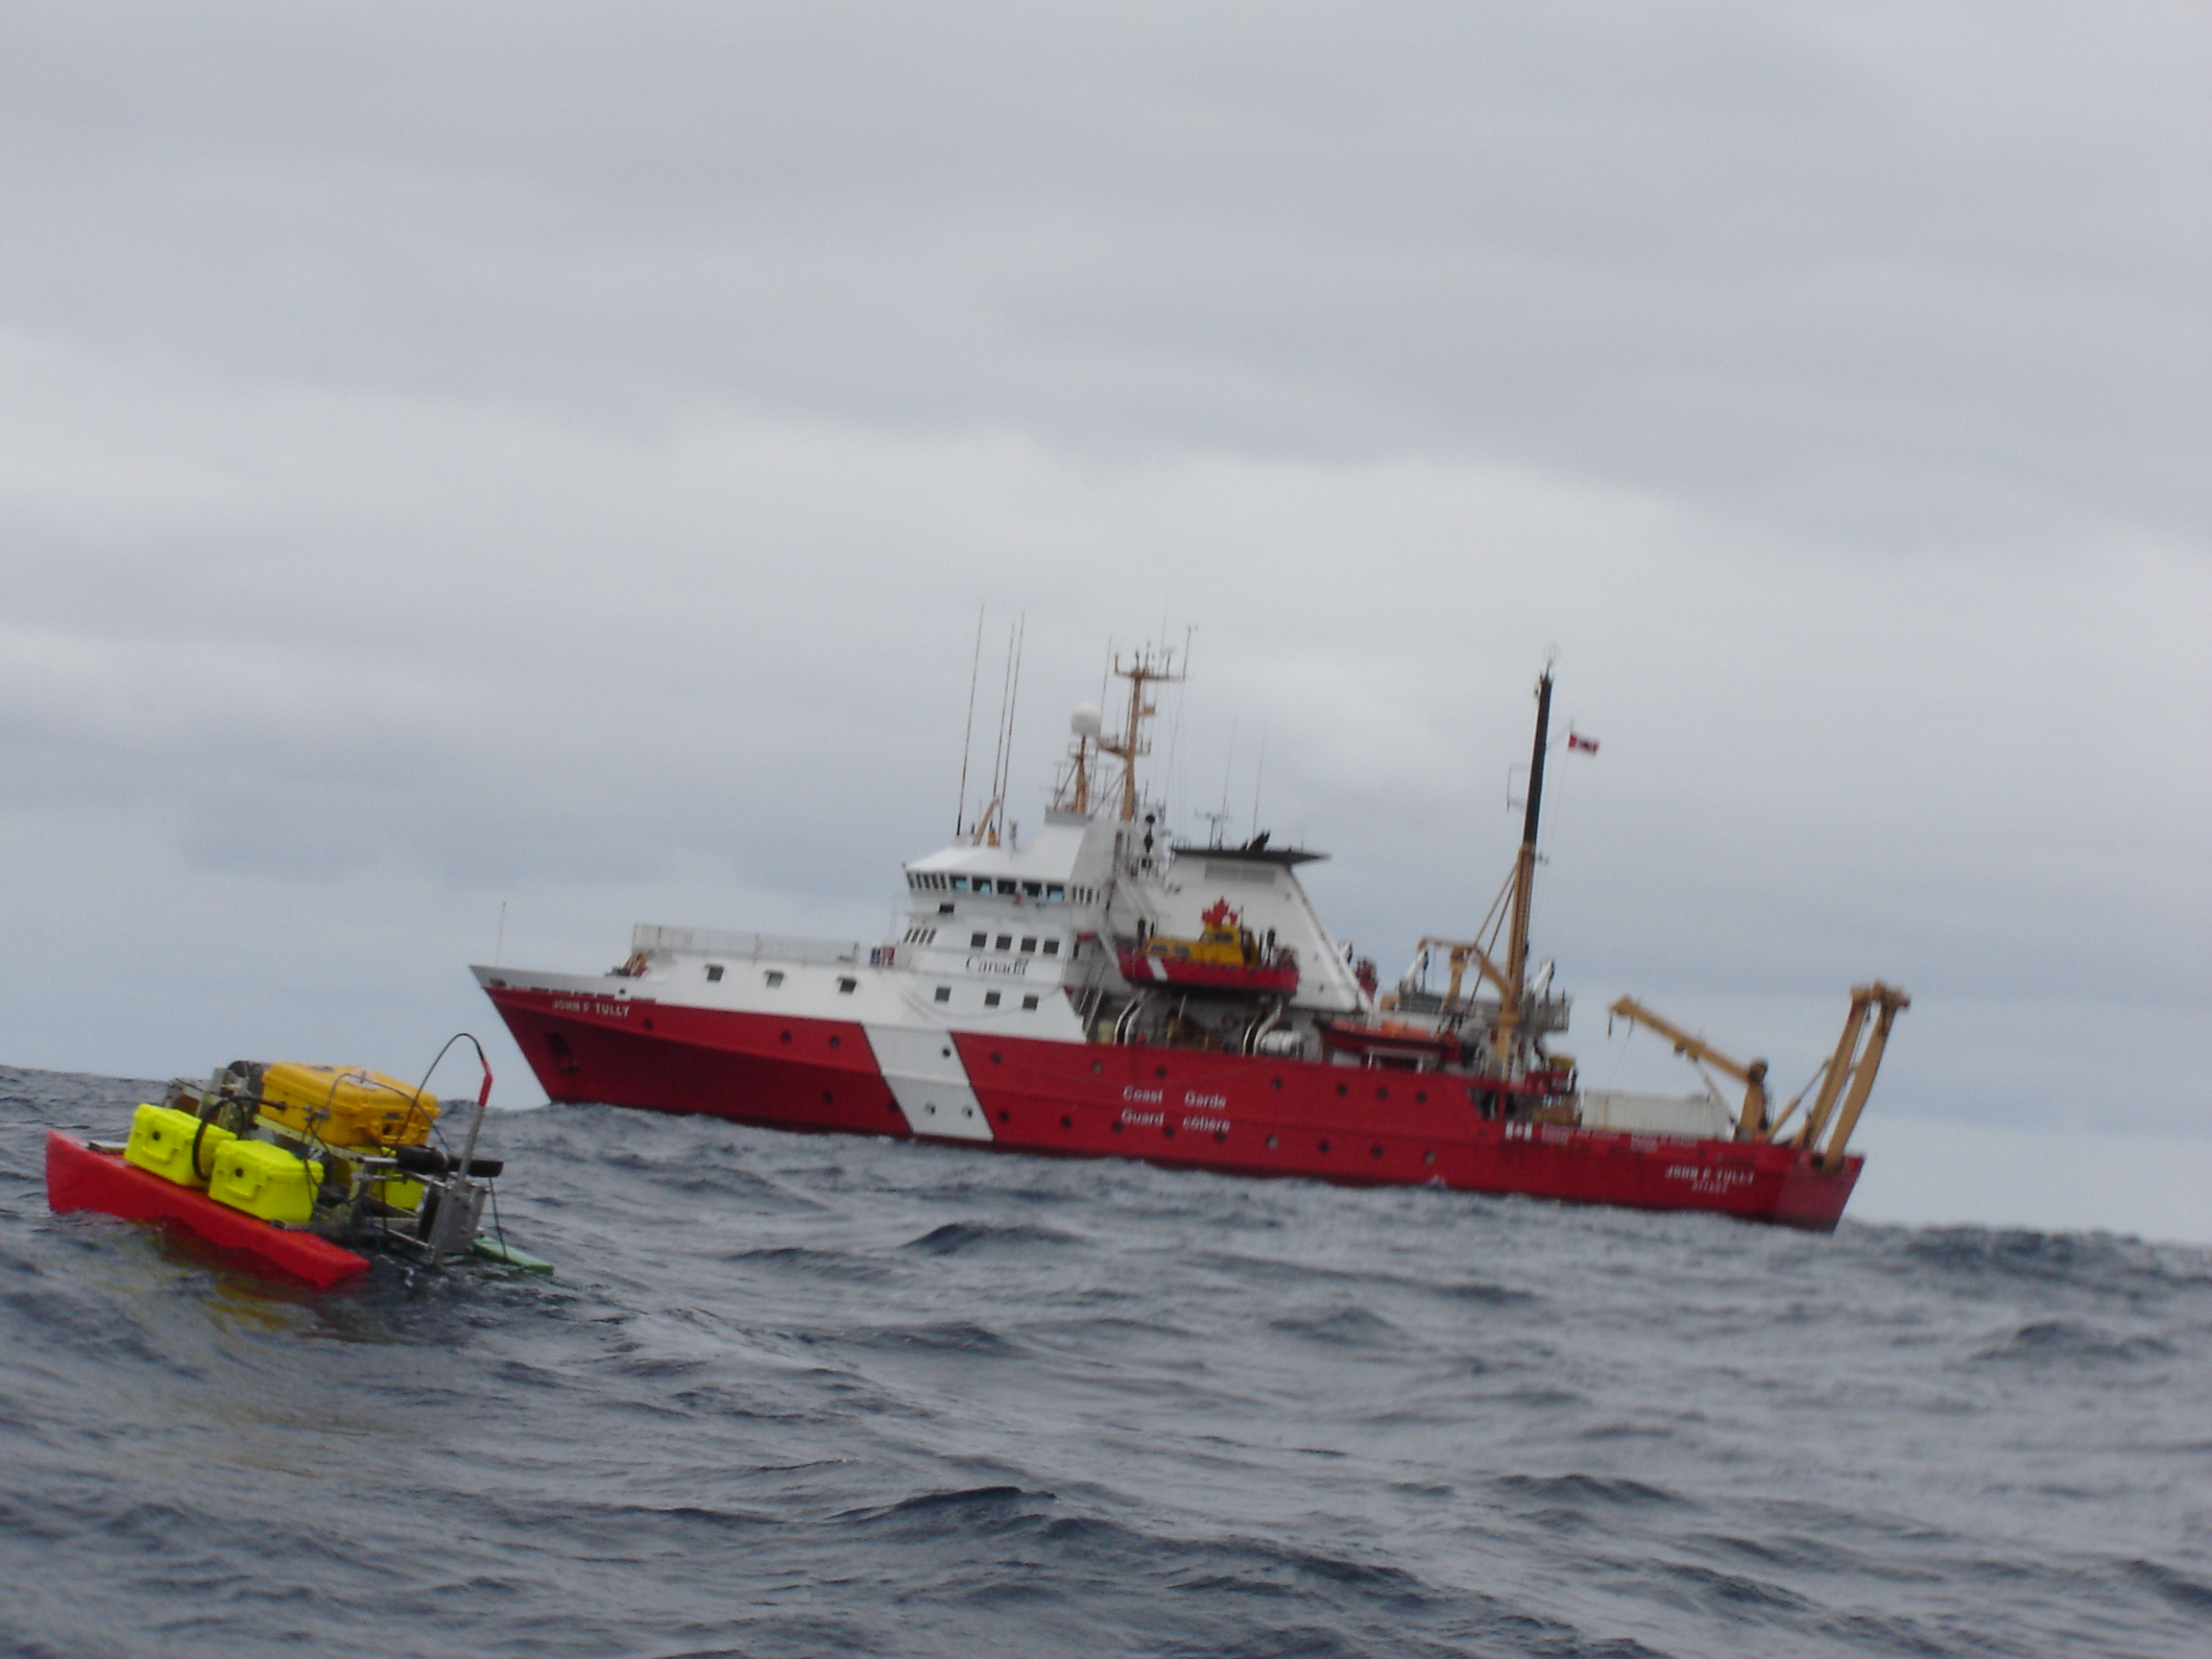
Figure 2. IOS microlayer sampler shown skimming air-sea interface at OSP.

HIVOL sampling

Throughout the cruise we used a HIVOL air sampler to filter air on the starboard side of the helicopter deck. Nick Hall-Patch and Wendy Wiggins replaced filters approximately every 10 hours for the three-week period. Control software using relative wind speed and direction halted sampling whenever the relative wind speed dropped below 10 knots (5 m/s) or the relative wind direction was more than 45 degrees of the bow on either side of the ship. The filters will be analysed for pollutants by Kevin Telmer at UVIC.

Line P – June 1 – 18 ’04 Cruise Report
Ken Morgan, CWS

Over the 17 days of observing marine birds and mammals, 620 transects were surveyed. During that time, 4,335 seabirds comprising 25 species, and 84 marine mammals (9 species) were counted while on survey. This does not include birds that were seen beyond 250m of the vessel or birds/mammals that were observed while on station.

Six species accounted for over 95% of all birds observed – they were: Sooty Shearwater (29.2%); Cassin’s Auklet (23.1%); Leach’s Storm-Petrel (21.9%); Common Murre (11.1%); Fork-tailed Storm-Petrel (6.6%); and Rhinoceros Auklet (3.8%).

Dall’s Porpoise was the most frequently observed mammal with 33 animals seen while on survey, followed by Killer Whale (17), Fin Whale (9), Baird’s Beaked Whale (8), Harbour Porpoise (6), Northern Fur Seal (5), Humpback Whale (4), Sperm Whale (1) and Harbour Seal (1). Again, these totals exclude the mammals that were seen while we were on station and/or other times when I had stopped surveying.

With regards to improvements to aid observing of birds and mammals, the Captain and I briefly discussed the design of an observer “platform” to be built on Monkey Island (during the mid-life refit). I will be sending my ideas and recommendations on to the Captain and to Doug Yelland.

As per usual, the officers and crew of the Tully were extremely professional, helpful and friendly; I greatly enjoyed meeting new people from the Coast Guard and from UBC and UVIC. And on that level, the cruise was highly enjoyable.

However, I feel that I have reached the proverbial “straw that broke the camel’s back” with regards to the far too numerous sarcastic / negative comments about the work that the bird and mammal observers do. As the person in charge of this program I feel that the time has come to speak out against this. While the comments were directed at me this trip, the observers I have employed in the past have also received and complained (to me) about these types of remarks.

Regardless of whether or not certain individuals from IOS understand the value of or even see the need for collecting these data; whether or not they realize that standing on Monkey Island (or less frequently in the Bridge) looking day after day through binoculars for hours on end is in fact physically and mentally demanding; whether or not they think that the observer should stand a watch in addition to attempting to conduct surveys; or in fact whether they feel that the observer is simply having a paid holiday; it would be far better if those comments were left unspoken.

UBC Cruise Report: Participants Philippe Tortell, Cheryl Martin, Nina Nemcek.

Our research goals for this trip were to (a) monitor the distrubtion of dissolved gases (O2, N2, Ar, CO2, and DMS) along the cruise track, and (b) examine the physiological mechanisms of C acquisition by natural phytoplankton assemblages. Progress on the first goal was hindered by significant equipment problems. Our membrane inlet mass spectrometer did not function well, most likely due to contamination of the ion source chamber. We were able, however, to collect samples from rosette casts at the major stations for subsequent analysis of particulate DMSP concentrations. These measurements will provide information on the distrubution of the precursor molecule to DMS. For the second goal, we collected concentrated phytoplankton samples at many locations along the cruise track (coastal and open ocean) and conducted 14C photosynthesis experiments. The experiments are designed to quantify the relative proportions of HCO3- and CO2 that are taken up by cells. In conjuction with these experiments, we also collected many filter samples that were frozen in liquid nitrogen for subsequent laboratory analysis of several major photosynthetic enzymes.

Other than the equipment problems, we encountered no difficulties during this cruise.

