EXPEDITION PLAN AND ITINERARY

DEPARTMENT: DFO, Ocean Sciences and Productivity Division

MISSION NO: 2004-10 CCG PATROL NO: 04-03

MISSION AREA: Line P, Station Papa, North-East Pacific, Rivers & Smith Inlets

MISSION OBJECTIVE: Repeat hydrography section, service moorings.

SHIP: John P. Tully

DATE, FROM: ~June 1 TO: June 21 2004

SENIOR SCIENTIST: Marie Robert

SCIENTIFIC PERSONNEL: 17 berths required
Female | Male
Janet Barwell-Clarke | Mike Arychuk
Cheryl Martin (UBC) | Jean Lachapelle
Nina Nemcek (UBC) | Ken Morgan
Lindsay Richier (UVic) | Nick Hall-Patch
Marie Robert | Tim Soutar
Sheila Toews | David Timothy
Wendy Wiggins | Philippe Tortell
 | Darren Tuele
 | Svein Vagle
 | Doug Yelland

SHIP EQUIPMENT REQUIRED: depth sounder, sea water supply to lab and heli-deck, heave compensator, tugger winch, Zodiac

DECK MACHINERY REQUIRED:

Note: The details are on the deck plan, to follow.

OTHER EQUIPMENT TO BE LOADED: Scientific gear (lab instruments, sampling equipment, etc.), mooring gear, containter.

ANTICIPATED LOADING TIME: already loaded prior to Mackas cruise 2004-09.

DANGEROUS CHEMICALS:
[INCLUDING MATERIAL SAFETY DATA SHEETS AND WHMIS LABELS]
Sodium Azide – Mercuric Chloride – Methanol – Hexane – Acetone – Isopropyl Alcohol – Formaldehyde Solution – ¹⁴C Bicarbonate – Miscellaneous acids, reagents, and air tanks.
More complete list to follow.

Station List:

Station | Latitude  deg min N | Longitude  deg min W | Bottom Depth m | St'n  Time h | Sampling
Line P CTD and water sampling survey
P1 | 48 34.5 | 125 30.0 | 120 | 0.5 | CTD B-10
P2 | 48 36.0 | 126 00.0 | 114 | 1 | Rosette B-10
P3 | 48 37.5 | 126 20.0 | 730 | 1 | CTD B-10
P4 | 48 39.0 | 126 40.0 | 1300 | 10.0 | Rosette B-10, Bongo, Mooring
P5 | 48 41.5 | 127 10.0 | 2100 | 1.5 | CTD 2000 m
P6 | 48 44.6 | 127 40.0 | 2500 | 1.5 | CTD 2000 m
P7 | 48 46.6 | 128 10.0 | 2450 | 1.5 | CTD 2000 m
P8 | 48 49.0 | 128 40.0 | 2440 | 2.0 | Rosette 2000 m, Bongo
P9 | 48 51.4 | 129 10.0 | 2340 | 1.5 | CTD 2000 m
P10 | 48 53.6 | 129 40.0 | 2660 | 1.5 | CTD 2000 m
P11 | 48 56.0 | 130 10.0 | 2700 | 1.5 | CTD 2000 m
P12 | 48 58.2 | 130 40.0 | 3300 | 6.0 | Rosette B-10, Bongo
P13 | 49 02.6 | 131 40.0 | 2875 | 1.5 | CTD 2000 m
P14 | 49 07.4 | 132 40.0 | 3275 | 1.5 | CTD 2000 m
PATC3 | 49°35.172 | 132°45.552 | 300 |  | Mooring
P15 | 49 12.0 | 133 40.0 | 3200 | 1.5 | CTD 2000 m
P16 | 49 17.0 | 134 40.0 | 3550 | 6.0 | Rosette B-10, Bongo
P17 | 49 21.0 | 135 40.0 | 3200 | 1.5 | CTD 2000 m
P18 | 49 26.0 | 136 40.0 | 3775 | 1.5 | CTD 2000 m
P19 | 49 30.0 | 137 40.0 | 3850 | 1.5 | CTD 2000 m
P20 | 49 34.0 | 138 40.0 | 3890 | 6.0 | Rosette B-10, Bongo
P21 | 49 38.0 | 139 40.0 | 3840 | 1.5 | CTD 2000 m
P22 | 49 42.0 | 140 40.0 | 3880 | 1.5 | CTD 2000 m
P23 | 49 46.0 | 141 40.0 | 3970 | 1.5 | CTD 2000 m
P24 | 49 50.2 | 142 40.0 | 3910 | 1.5 | CTD 2000 m
P25 | 50 00.0 | 143 36.3 | 3890 | 1.5 | CTD 2000 m
P35 | 50 00.0 | 144 18.2 | 4170 | 1.5 | CTD 2000 m
P26 | 50 00.0 | 145 00.0 | 4250 | 5 days | Rosette, Bongo, Moorings
West of P26 |  |  |  |  | CTD 2000m, Argo
P41 | 50 27.00 | 145 00.00 | 4270 | 1.5 | CTD 2000 m
P32 | 50 54.00 | 145 00.00 | 4270 | 1.5 | CTD 2000 m
P49 | 50 54.00 | 144 17.20 |  | 1.5 | CTD 2000 m
P33 | 50 54.00 | 143 35.50 | 3660 | 2.0 | Rosette 2000m, Argo
R20 | 50 55.70 | 143 01.00 | 3620 | 1.5 | CTD 2000 m
R19 | 50 58.00 | 142 20.00 | 3930 | 1.5 | CTD 2000 m
R18 | 51 00.00 | 141 39.00 | 3900 | 1.5 | CTD 2000 m
R17 | 51 02.00 | 140 56.00 | 3900 | 2.0 | Rosette 2000m
R16 | 51 04.00 | 140 14.00 | 3800 | 1.5 | CTD 2000 m
R15 | 51 06.00 | 139 30.50 | 3000 | 1.5 | CTD 2000 m

R14 | 51 09.00 | 138 47.50 | 2910 | 1.5 | CTD 2000 m
R13 | 51 11.00 | 138 06.00 | 3680 | 2.0 | Rosette 2000m, Argo
R12 | 51 13.00 | 137 23.00 | 3670 | 1.5 | CTD 2000 m
R11 | 51 15.00 | 136 40.30 | 3650 | 1.5 | CTD 2000 m
R10 | 51 17.00 | 135 57.60 | 3660 | 1.5 | CTD 2000 m
R9 | 51 19.00 | 135 15.00 | 3515 | 2.0 | Rosette B-10
R8 | 51 21.20 | 134 32.70 | 3370 | 1.5 | CTD 2000 m
R7 | 51 23.50 | 133 49.60 | 3200 | 1.5 | CTD 2000 m
Argo | ~ 52 00.00 | ~ 134 00.00 |  |  | CTD to 2000m, Argo
Eddies | ~ 52 15.00 | ~ 133 45.00 |  | 2 days?
R6 | 51 25.50 | 133 06.60 | 3000 | 1.5 | CTD 2000 m
J5 | 51 27.50 | 132 24.00 | 2765 | 1.5 | CTD 2000 m
SS1 | 51 30.00 | 131 40.00 | 1395 | 1.5 | Rosette B-10
SS2 | 51 15.00 | 130 40.00 | 490 | 1.0 | Rosette B-10
PATC1 | 50°57.496 | 129°59.609 | 2105 |  | Mooring recovery
SS3 | 51 00.00 | 129 42.00 | 295 | 1.0 | Rosette B-10
SS4 | 51 12.00 | 129 21.00 | 240 | 1.0 | Rosette B-10
SS5 | 51 21.00 | 129 00.00 | 200 | 1.0 | Rosette B-10
SS6 | 51 28.00 | 128 30.00 | 160 | 1.0 | Rosette B-10
SS7 | 51 19.50 | 128 00.00 | 125 | 1.0 | Rosette B-10
SS8 | 51 24.87 | 127 47.32 |  |  | Rosette B-10
CC | 51 25.2 | 127 49.8 | ~135 | 1.0 | Rosette B-10
RI1 | 51 26.4 | 127 38.1 | 327 | 1.0 | Rosette,B-10
RI2 | 51 31.25 | 127 33.6 | 322 | 0.5 | CTD B-10
RI3 | 51 35.9 | 127 32.1 | 316 | 0.5 | CTD B-10
RI4 | 51 38.9 | 127 26.7 | 294 | 1.0 | Rosette B-10
RI5 | 51 40.7 | 127 19.9 | 194 | 0.5 | CTD B-10
Sm 1 | 51 18.7 | 127 29.9 | 208 | 0.5 | CTD B-10
Sm 2 | 51 18.0 | 127 22.1 | 364 | 0.5 | CTD B-10
Sm 3 | 51 18.5 | 127 14.6 | 315 | 0.5 | CTD B-10
Sm 4 | 51 21.6 | 127 09.0 | 179 | 1.0 | Rosette B-10
Sm 5 | 51 21.3 | 127 06.2 | ? | 0.5 | CTD B-10

Itinerary

May 24 Load at IOS.

May 25 Tully departs for Dave Mackas’ La Perouse cruise.

~June 1 Scientific crew change at Port Renfrew. Start sampling Line P
(Station P1)

June 7 Arrive at Station Papa. Spend 5 days at Papa (weather depending), doing mooring work and other Papa work.

June 12 Start Line R

~June 16 Depending on its location, sample an eddy.

June 18 Sample Rivers/Smith Inlets.

June 20 Return to IOS and off-loading.

Cruise track
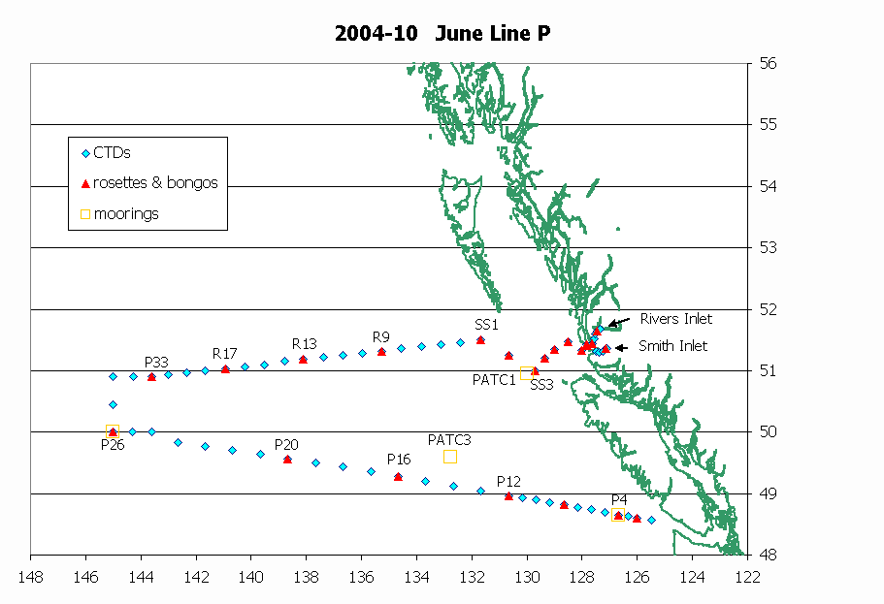

Tasks:

Mike Arychuk: DMS
Janet Barwell-Clarke: Nutrients
Jean Lachapelle: SOLAS mooring, skimmer, half-watch
Nick Hall-Patch: SOLAS mooring, half-watch
Ken Morgan: Birds and mammals observation
Marie Robert: Chief scientist, salinity analysis, data
Tim Soutar: PCO2, moorings, watch
David Timothy: Moorings, half-watch
Sheila Toews: CTD, oxygen analysis, watch
Philippe Tortell: Chlorophyll
Darren Tuele: Moorings, watch
Svein Vagle: SOLAS mooring, half-watch
Doug Yelland: Eddy study, LAN, watch
List of rosettes casts, Cruise 2004-10, June Line P:

Station | depth | samples | # of niskins
P2 | 114 | Oxy, Nut, Sal, Chl (6) | 8
P4 | 400 | Nut, DMS, Chl (12) | 14
P4 | 1300 | Oxy, TCO₂, Nut, Sal | 19
P8 | 2000 | Oxy, Nut, Sal, Chl (6) | 20
P12 | 400 | Nut, DMS, Chl (12) | 14
P12 | 3300 | Oxy, TCO₂, Nut, Sal | 23
P16 | 400 | Nut, DMS, Chl (12) | 14
P16 | 3550 | Oxy, TCO₂, Nut, Sal | 24
P20 | 400 | Nut, DMS, Chl (12) | 14
P20 | 3890 | Oxy, TCO₂, Nut, Sal | 24
P26 | 400 day | Nut, DMS, Chl (12) | 14
P26 | 400 night | Nut, DMS, Chl (12) | 14
P26 | 4250 | Oxy, TCO₂, C¹³, Nut, Sal | 24
P26 | 1500 calib | TCO₂, Sal | 24
P26 | 100 Prim Prod | Nut, Chl (8) | 8
P33 | 3660 | Oxy, Nut, Sal, Chl (6) | 24
R17 | 3900 | Oxy, Nut, Sal, Chl (6) | 24
R13 | 2910 | Oxy, Nut, Sal, Chl (6) | 22
R9 | 3515 | Oxy, Nut, Sal, Chl (6) | 23
SS1 | 1395 | Oxy, Nut, Sal, Chl (6) | 19
SS2 | 490 | Oxy, Nut, Sal, Chl (6) | 14
SS3 | 295 | Oxy, Nut, Sal, Chl (6) | 13
SS4 | 240 | Oxy, Nut, Sal, Chl (6) | 12
SS5 | 200 | Oxy, Nut, Sal, Chl (6) | 11
SS6 | 160 | Oxy, Nut, Sal, Chl (6) | 10
SS7 | 125 | Oxy, Nut, Sal, Chl (6) | 9
SS8 | 150 | Oxy, Nut, Sal, Chl (6) | 10
CC | 135 | Oxy, Nut, Sal, Chl (6) | 9
Ri1 | 327 | Oxy, Nut, Sal | 14
Ri4 | 294 | Oxy, Nut, Sal | 13
Sm4 | 180 | Oxy, Nut, Sal | 11

Number of loop samples (# of CTD stations): 43
Oxygen samples: ~ 380
Salinity samples: ~ 447
Nutrient samples: ~ 515
Coccos samples: ~55 (1 per station except in the inlets)

PLEASE NOTE: there will be other rosette casts done for the eddy study, but I don’t know how many yet. Please provide for a possibility of 10 more full rosettes, just to be on the safe side. Also, the number of samples corresponds to what is written in the table. If you want to take duplicates or any other samples, you have to provide for those.

CTD setting:

The instruments needed on the primary CTD are the oxygen sensor, the PAR sensor, the fluorometer, the transmissometer, and the altimeter. Please make sure that all those instruments can be mounted on the secondary CTD if needed.

Argo floats:

There is a possibility that 4 Argo profilers will be deployed during this cruise:
West of Papa; P32; R13; Close to the eddy.

