PACIFIC REGION CCG VESSEL CRUISE PLAN

DEPARTMENTS: DFO – STAD/OSAP

SCIENCE CRUISE NUMBER: 2004-06 SHIP’S PATROL NUMBER:

NAME OF SHIP/PLATFORM: W.E. RICKER

SURVEY AREA/AREA OF OPERATION:
Strait of Georgia and mainland inlets; Queen Charlotte Sound, Hecate Strait

CRUISE OBJECTIVE[S]:
Leg 1:

- Examine the distribution and abundance of Pacific hake and plankton in the Strait of Georgia and mainland inlets using acoustics.
- Conduct midwater trawls and bongo tows to identify acoustic sign and provide biological samples of hake, incidental catch, and plankton.
- Collect synoptic oceanographic data (CTD and ADCP) to relate to distribution of hake and zooplankton.

DATE: FROM: March 2 TO: March 13
Leg 2:

- Conduct bottom trawling for catch and release tagging operations of large skate in Hecate Strait and Queen Charlotte Sound to examine stock discrimination of species in the study area.
- Conduct biological sampling of skate and incidental catch.

DATE: FROM: March 13 TO: March 30
SENIOR SCIENTIST[S]/CONTACT TEL. #’S:

Ken Cooke (250) 756-7125 (Leg 1)
Sandy McFarlane (250) 756-7052 (Leg 2)

SCIENTIFIC PERSONNEL: BERTHS REQUIRED: 10
MALE [NAMES] Leg1
Ken Cooke (Mar 2-13) SIC Leg 1 Bill Andrews (Mar 3-13)
John Holmes (Mar 3-8) Steve Romaine (Mar 3-13)
Matt Thompson (Mar 3-13) Tom Therriault (Mar 3-8)
Dennis Sodeberg (Mar 10-13) (possible) Brian West (Mar 8-13) CG (possible)
Andreas Winters (Mar 8-13) Laurier Fleet (Mar 8-10) (possible)
Brian Kriska (Mar 3-13)

FEMALE [NAMES] Leg 1
Kristen Daniel (Mar 3-13) Vanessa Hodes (Mar 3-13)
IOS CTD Tech (Mar 3-13)

MALE [NAMES] Leg2
Sandy McFarlane (Mar 13-30) SIC Leg 2

FEMALE [NAMES] Leg 2
Jackie King (Mar 13-30) PBS Bio tech (Mar 13-30)

SHIP EQUIPMENT REQUIRED:
Fishing sounders and plotters
Scientific freezers
EK500 and associated transducers
Simrad ITI trawl mensuration sensors
Simrad FS20/25 and Wesmar TCS770 trawl sonars

DECK MACHINERY REQUIRED: [ATTACH DECK PLAN AT END OF DOCUMENT]
Midship oceanographic winch and stern HIAB for bongo
Starboard hydrographic winch for CTD
Main trawl winches , net drums, fish hopper conveyor belts and fish disposal system.

FISHING GEAR REQUIRED: [INDICATE NET TYPE/TYPES]
- midwater trawl (Groundfish)
- bottom trawl (Groundfish)

OTHER EQUIPMENT TO BE LOADED:
- Bongo

SPECIAL REQUIREMENTS:
[INCLUDE LAUNCH/SMALL BOAT
REQUIREMENTS AND SPECIAL POWER REQUIREMENTS]

DANGEROUS CHEMICALS: [INCLUDING MSDS/WHMIS LABELS]
GAS CYLINDERS:
ACIDS:
TOXIC:
FLAMMABLES: 10 gal. formaldehyde

RADIOISOTOPES: [INCLUDING CERTIFICATES]

ANTICIPATED LOADING TIME: ½ day

LOGISTICS:
COMMENCE LOADING [DATE/TIME]: March 2 0730

SAILING [DATE/TIME]: March 3 1400

EXPECTED OPERATIONS PROFILE: [24 HR./12 HR/OTHER]
12 hr acoustics/fishing (day) 6 hr CTD/Bongo (night)

RETURNING [DATE/TIME]: PBS March 13 1600; departing 1630 for QCS

OFFLOADING: [DATE/TIME]: PBS March 30 0800-1200

SCIENTIFIC CREW CHANGES: [DATES/TIMES/LOCATIONS]
March 8 2000 drop-off; return to survey ops (Departure Bay)
March 13 1600 change Leg 1/Leg 2; dockside PBS; 2000 return survey ops

PROPOSED CRUISE
ITINERARY: N.B.: ALSO ATTACH LIST OFSTATIONS, MOORING OPERATIONS, OR SURVEY LINES IDENTIFYING EXACT POSITIONS. THIS LIST CAN BE ATTACHED TO END OF
DOCUMENT.

DATE | OPERATION/EVENT
March 2 | Load at PBS. systems/gear check.
March 3-12 | Depart PBS in afternoon for system calibration, Departure Bay; after completion begin survey ops in Strait of Georgia and mainland inlets. Possible night ops for CTD and plankton sampling.
March 8 | Science crew transfer at anchor Departure Bay.
March 13-14 | End Leg 1, start Leg 2; Science crew change 1600 at PBS; Depart 2000 for skate study area (QCSound and Hecate Strait)
March 15-28 | Conduct bottom trawl/tagging survey ops QCS and Hecate Strait
March 29-30 | In transit to PBS; arrive PBS 0800 March 30
March 30 | Offload PBS 0800-1200

Fig1. Proposed Leg 1 Survey Area; Strait of Georgia; Jervis Inlet

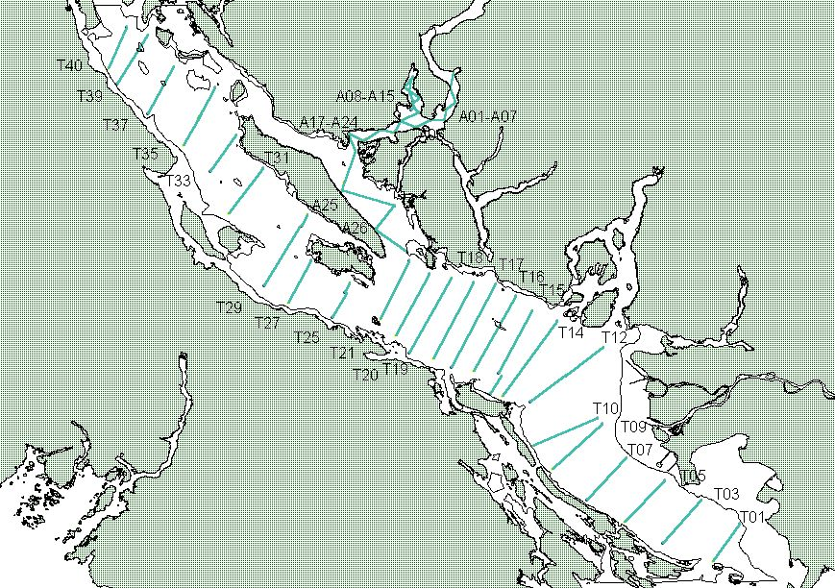

Fig2. Leg 2 Survey Area (shaded region); Queen Charlotte Sound, Hecate Strait
NOTE: cruise track shown not applicable to this survey

