Cruise 2004-05: February Line P 2004

CTD/Rosette:

31 casts done, 0001 to 0048.
11 ‘real rosette casts’, 20 CTD casts.
All the casts were done with CTD 0585 and deck unit 0424; Mid-ship winch; CTD/rosette package.

Cast 44 has the wrong station name in header, should be ~P26, is P44.
Cast 48 is actually event number 50, should be renamed 0050.

Casts 1 to 23 had very noisy transmissometer/fluorometer signals. Then the cables got changed, and casts 24 to 47 are ok.

There is an important pressure-dependant difference between the 2 salinity signals from the CTD. For example, the difference for the deep cast at Stn Papa looks like this:

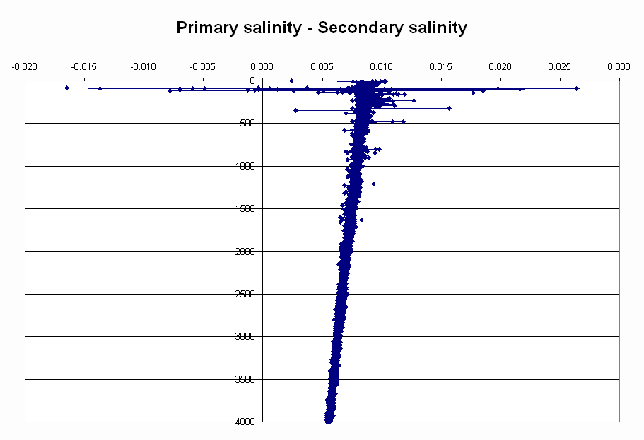

There is also a pressure dependant difference between the 2 temperature sensors. Again at Station P:

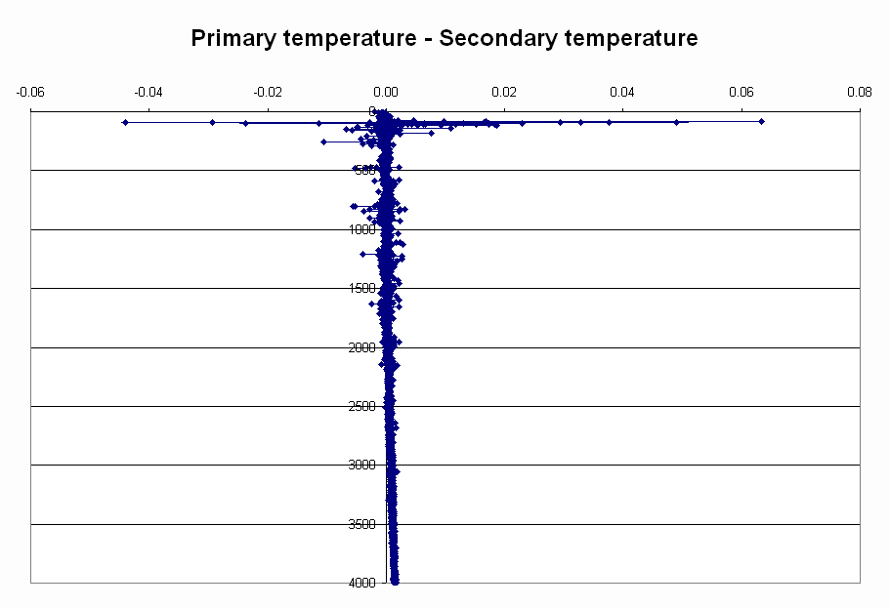

Here are Doug Anderson’s notes about that, taken from the cruise report:

6. 2004-05 CTD Report – Doug Anderson

Seabird CTD s/n 0585 was the CTD probe used throughout cruise 2004-05.
There was a drift in the primary conductivity cell, s/n 2278 that occurred early on in the cruise. This drift stayed stable at about .004 to .006 PSU low during the cruise. The secondary conductivity cell, s/n 1764 remained closer to the bottle salinity at P12.
There were also some problems experienced with auxiliary sensors on the CTD. The altimeter didn’t work well at all during the cruise. I think this is due to the sensor seeing the weight hanging below the rosette, which is probably a little larger than usual.
Transmissometer s/n 333DR experienced some problems earlier on. This was due to a missing piece in the mounting block which didn’t securely mount the transmissometer allowing it to move a little during the cast. This problem was solved once discovered.
The fluorometer also had some problems for the first part of the cruise. The data from the fluorometer looked better once the cable was changed.
There were numerous salinity samples taken throughout the cruise.
Here are also his notes about the thermosalinograph:

5. 2004-05 Thermosalinograph Report – Doug Anderson

S/N 2488 thermosaligraph was installed on the Tully’s sea water loop for mission no. 2004-05. The s/n 2487 thermosalinograph that is usually on the Tully has had some problems with the time that is logged with its data. S/N 2488 was installed this time to see if the time logged problem is do to with the thermosalinograph itself or some other part of the system.
S/N 2488 seems to have less problems with time logged but the problem still existed. A short time after the thermosalinograph was started for 2004-05 the NMEA time displayed be the Seasave program was 2 minutes behind the reference time. The problem reoccurred once again during the cruise.
The other problem with the thermosalinograph experienced during 2004-05 was due to bubbles in the sea water loop on the Tully, and S/N 2488’s problem with its sensitivity to bubbles adhering to its conductivity cell. On 2004/2/23, 0330 UTC I flushed the conductivity cell with a Triton solution but bubbles continued to adhere to the cell. This problem continued throughout the cruise. I suspect 2488 is more sensitive to bubbles adhering to its conductivity cell than 2487 due to 2488’s many cleaning and replatinization procedures. 2004-05 was the first cruise that 2488 was used on since its most recent cleaning and replatinization. By draining the thermosalinograph’s reservoir bubbles were cleansed several times from 2488’s cell. The salinity readings then almost immediately begin to ramp down again due to new bubbles accumulating on the conductivity cell.

The salinity samples were not analyzed on board, they will be analyzed in the lab at IOS.

Loop Station JF2 has wrong position in the logbook.

There’s a note in the logbook about station P23 having the wrong file number: 0019 instead of 0022. That was corrected.

A calibration cast was done (0044) where all the Niskins were closed at 1500 m.

Bongos:

There was a problem with the winch counter of the bongo winch. So the bongos might not all have been done to 150m. Hopefully the flowmeter can help with that problem.

