EXPEDITION PLAN AND ITINERARY

DEPARTMENT: DFO, Ocean Sciences and Productivity Division

MISSION NO: 2004-05

MISSION AREA: Line P, Station Papa, North-East Pacific

MISSION OBJECTIVE: Repeat hydrography section, try to recover an Argo float.

SHIP: John P. Tully

DATE, FROM: Feb 9 TO: Feb 27, 2004

SENIOR SCIENTIST: Marie Robert

SCIENTIFIC PERSONNEL: 9 berths required
Female | Male
Marie Robert | Andrew Macdonald
Sheila Toews | Doug Anderson
Stephanie King | Darryl Hodgson
Wendy Richardson
Nes Sutherland
Alice Ewing

SHIP EQUIPMENT REQUIRED: depth sounder, sea water supply to lab, heave compensator, tugger winch, Zodiac or 733

DECK MACHINERY REQUIRED:

Note: The details are on the deck plan, to follow.

OTHER EQUIPMENT TO BE LOADED: Scientific gear (lab instruments, sampling equipment, etc.)

ANTICIPATED LOADING TIME: 1.5 day for scientific gear.

DANGEROUS CHEMICALS:
[INCLUDING MATERIAL SAFETY DATA SHEETS AND WHMIS LABELS]
Potassium Carbonate – Hydrochloric Acid – Ammonium Hydroxyde – Hydrogen Peroxyde – Formic Acid – Sulfuric Acid – Phosphoric Acid – Oxalic Acid – ¹⁴C – Sodium Thiosulfate – Isopropyl Alcohol – Formaldehyde Solution – Manganous Chloride – Alkaline Iodide – Potassium Iodate

Station List:

Station | Latitude  deg min N | Longitude  deg min W | Bottom Depth m | St'n  Time h | Sampling
Saanich Inlet
S3 | 48 35.6 | 123 30.0 | 225 | 3 | 2 Rosette casts
Victoria mooring
#1 | 48 17.8 | 123 20.9 | 110 | 1 h | Deploy mooring
OR #2 | 48 19.7 | 123 12.7 | 100 | 1 h | Deploy mooring
Juan de Fuca Surface Samples
JF1 | 48 16.0 | 123 30.0 | 150 | 0 | underway
JF2 | 48 18.0 | 124 00.0 | 180 | 0 | underway
JF3 | 48 27.0 | 124 30.0 | 230 | 0 | underway
JF4 | 48 32.3 | 125 00.0 | 60 | 0 | underway
Line P CTD and water sampling survey
P1 | 48 34.5 | 125 30.0 | 120 | 0.5 | CTD, B-10
P2 | 48 36.0 | 126 00.0 | 114 | 1 | Rosette, Bongo
P3 | 48 37.5 | 126 20.0 | 730 | 1 | CTD, B-10
P4 | 48 39.0 | 126 40.0 | 1300 | 6 | Rosette, Bongo
P5 | 48 41.5 | 127 10.0 | 2100 | 1.5 | CTD, 2000 m
P6 | 48 44.6 | 127 40.0 | 2500 | 1.5 | CTD, 2000 m
P7 | 48 46.6 | 128 10.0 | 2450 | 1.5 | CTD, 2000 m
P8 | 48 49.0 | 128 40.0 | 2440 | 8 | Rosette (2000m), Bongo
P9 | 48 51.4 | 129 10.0 | 2340 | 1.5 | CTD, 2000 m
P10 | 48 53.6 | 129 40.0 | 2660 | 1.5 | CTD, 2000 m
P11 | 48 56.0 | 130 10.0 | 2700 | 1.5 | CTD, 2000 m
P12 | 48 58.2 | 130 40.0 | 3300 | 8 | Rosette, Bongo
P13 | 49 02.6 | 131 40.0 | 2875 | 1.5 | CTD, 2000 m
P14 | 49 07.4 | 132 40.0 | 3275 | 1.5 | CTD, 2000 m
P15 | 49 12.0 | 133 40.0 | 3200 | 1.5 | CTD, 2000 m
P16 | 49 17.0 | 134 40.0 | 3550 | 8 | Rosette, Bongo
P17 | 49 21.0 | 135 40.0 | 3200 | 1.5 | CTD, 2000 m
P18 | 49 26.0 | 136 40.0 | 3775 | 1.5 | CTD, 2000 m
P19 | 49 30.0 | 137 40.0 | 3850 | 1.5 | CTD, 2000 m
P20 | 49 34.0 | 138 40.0 | 3890 | 8 | Rosette, Bongo
P21 | 49 38.0 | 139 40.0 | 3840 | 1.5 | CTD, 2000 m
Argo** | 48°05.00?? | 140°00.00?? |  | 8 | Recover Argo float,  CTD 2000m
P22 | 49 42.0 | 140 40.0 | 3880 | 1.5 | CTD, 2000 m
P23 | 49 46.0 | 141 40.0 | 3970 | 1.5 | CTD, 2000 m
P24 | 49 50.2 | 142 40.0 | 3910 | 1.5 | CTD, 2000 m
P25 | 50 00.0 | 143 36.3 | 3890 | 1.5 | CTD, 2000 m
P35 | 50 00.0 | 144 18.2 | 4170 | 1.5 | CTD, 2000 m
P26 | 50 00.0 | 145 00.0 | 4250 | 10 | Rosette, Bongo, PP exp.
P41 | 50 27.0 | 145 00.0 | 4275 | 1.5 | CTD, 2000 m
P32 | 50 54.0 | 145 00.0 | 4275 | 1.5 | CTD, 2000 m
P49 | 50 54.0 | 144 17.2 | 3975 | 1.5 | CTD, 2000 m
P33 | 50 54.0 | 143 34.5 | 3430 | 1.5 | CTD, 2000 m
R20 | 50 55.7 | 143 01.0 | 3620 | 1.5 | CTD, 2000 m
R19 | 50 58.0 | 142 20.0 | 3930 | 1.5 | CTD, 2000 m
R18 | 51 00.0 | 141 39.0 | 3900 | 1.5 | CTD, 2000 m
R17 | 51 02.0 | 140 56.0 | 3910 | 1.5 | CTD, 2000 m
R16 | 51 04.0 | 140 14.0 | 3815 | 2.5 | Rosette, Bongo
R15 | 51 06.0 | 139 30.5 | 3075 | 1.5 | CTD, 2000 m
R14 | 51 09.0 | 138 47.5 | 2910 | 1.5 | CTD, 2000 m
R13 | 51 11.0 | 138 06.0 | 3680 | 1.5 | CTD, 2000 m
R12 | 51 13.0 | 137 23.0 | 3670 | 1.5 | CTD, 2000 m
R11 | 51 15.0 | 136 40.3 | 3655 | 1.5 | CTD, 2000 m
R10 | 51 17.0 | 135 57.6 | 3660 | 1.5 | CTD, 2000 m
R9 | 51 19.0 | 135 15.0 | 3520 | 2.5 | Rosette, Bongo
R8 | 51 21.2 | 134 32.7 | 3370 | 1.5 | CTD, 2000 m
R7 | 51 23.5 | 133 49.6 | 3175 | 1.5 | CTD, 2000 m
R6 | 51 25.5 | 133 06.6 | 2985 | 1.5 | CTD, 2000 m
New 1 | 51 20.0 | 132 00.0 |  | 2.5 | Rosette, Bongo
New 2 | 51 15.0 | 131 00.0 |  | 1.5 | CTD, 2000 m
SS1 | 51 08.0 | 129 53.5 | 1395 | 1.5 | Rosette, Bongo
SS3 | 51 14.5 | 129 21.0 | 295 | 1.0 | Rosette, Bongo
SS5 | 51 28.0 | 128 30.0 | 201 | 1.0 | Rosette, Bongo
SS7 | 51 24.8 | 127 47.5 | 125 | 1.0 | Rosette, Bongo
RI1 | 51 26.4 | 127 38.1 | 327 | 1.0 | Rosette B-2
RI2 | 51 31.25 | 127 33.6 | 322 | 0.5 | CTD B-2
RI3 | 51 35.9 | 127 32.1 | 316 | 0.5 | CTD B-2
RI4 | 51 38.9 | 127 26.7 | 294 | 1.0 | Rosette B-2
RI5 | 51 40.7 | 127 19.9 | 194 | 0.5 | CTD B-2
Sm 1 | 51 18.7 | 127 29.9 | 208 | 0.5 | CTD B-2
Sm 2 | 51 18.0 | 127 22.1 | 364 | 0.5 | CTD B-2
Sm 3 | 51 18.5 | 127 14.6 | 315 | 0.5 | CTD B-2
Sm 4 | 51 21.6 | 127 09.0 | 179 | 1.0 | Rosette B-2
Sm 5 | 51 21.3 | 127 06.2 | ? | 0.5 | CTD B-2
** the position of the float will be better known on February 9th.

Itinerary

Feb 9 Load at IOS.

Feb 10, 1300 Test the CTD/Rosette in the water at the dock, then depart for a test station in Saanich Inlet, then proceed towards Line P.
(Depart as soon as the Rosette/CTD gear is ready and working)

Feb 16 Try to recover the Argo float 4900116

Feb 19 Depart Station Papa and start Line R

Feb 23 Do Rivers Inlet

Feb 24 Do Smith Inlet

Feb 26 Back to Pat Bay and offload (lots of the gear stays on board for Peña's cruise, leaving Mar 1).

Cruise track

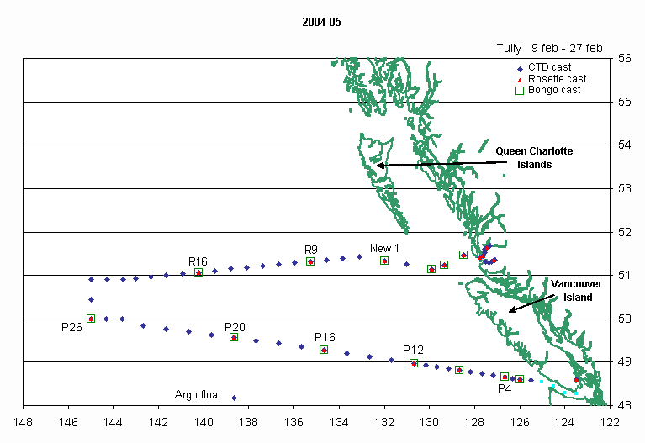

Tasks

Sheila Toews Watch, Oxygen
Stephanie King Watch, Chlorophyll
Doug Anderson Watch, CTD/Rosette, Cables Indentification, Thermosalinograph, Salinity
Andrew Macdonald Watch, pCO₂ systems
Wendy Richardson Nutrients, Help with sampling carbonates
Nes Sutherland Iron, Help with sampling carbonates
Alice Erwin Bird & Mammal Observer
Marie Robert Watch, Data, Help with sampling carbonates

