Processing Notes for the Year 2003 Nanoose Bay Data 30 July, 2026

Ron Perkin

.hex and .con files were inspected. It was found that the old Seabird software and batch files could not be used to process the data so IOSshell was used to convert the data, as .cnv files, to a usable form so that Diane could get a quick look. Later, the processing was done with Seabird's Windows software from scratch after overcoming some start-up problems and following the same "filter, align, loopedit, binavg" procedure. This was done into d:\nanoose\seasoft\hex\2003\... IOSshell was used to create .ios files which went into nanoose\ios\2003\.... . After viewing the profiles, I found a density inversion on March 30 and April 1. Not thinking it to be an April Fool's joke, I left the inversion in the data because it appeared on both days and seemed to leave a remnant on the next two casts. I corrected a couple of casts that had bad .con files and eliminated the following bad casts: n3100801.*, n3101001.* and n3111301.*. Positions and times were added using the Visual Basic routine at Desktop\My Documents\Visual Studio Projects\Nanoose\NanooseProcessing.sln. One cast with a bad hex file was patched together using the .act file.

An o4x file was created for Ocean Data View through IOSshell with the usual problems in that it had no station numbers. Station numbers were added through Desktop\My Documents\Visual Studio Projects\Nanoose\NanooseProcessing.sln, and archive files were created for the cruise number 2003-99-xxxx where xxxx goes from 0001 to 00069 with a few deletions. Then that data was added to the Ocean Data View file c:\Program Files\Ocean Data View\Data\OldData\Data\WOCE\Wocebtl\Ron_2001\Nanoose.var. Some bad data was edited out and the contour plot was recorded as a .png file.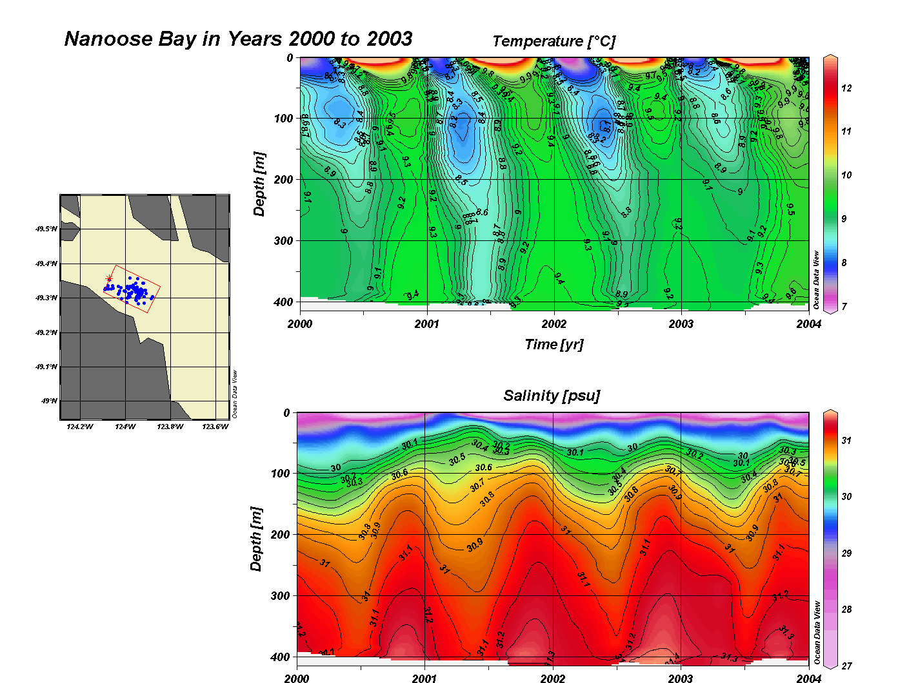

Coordinates were taken from the .act files as distance in metres, x' and y', along range 2 which was inclined at an angle of 11.2º south of east. Conversion into easting and northing coordinates was done according to (output was .ctd files):

X = x'cos(11.2) + y'sin(11.2)
Y = -x'sin(11.2) + y'cos(11.2)

Conversion to lat/long was done according to:

Lat = 49º (21.05' +Y*60/111120)
Long = 124º + (9.55 - X*60/72387)

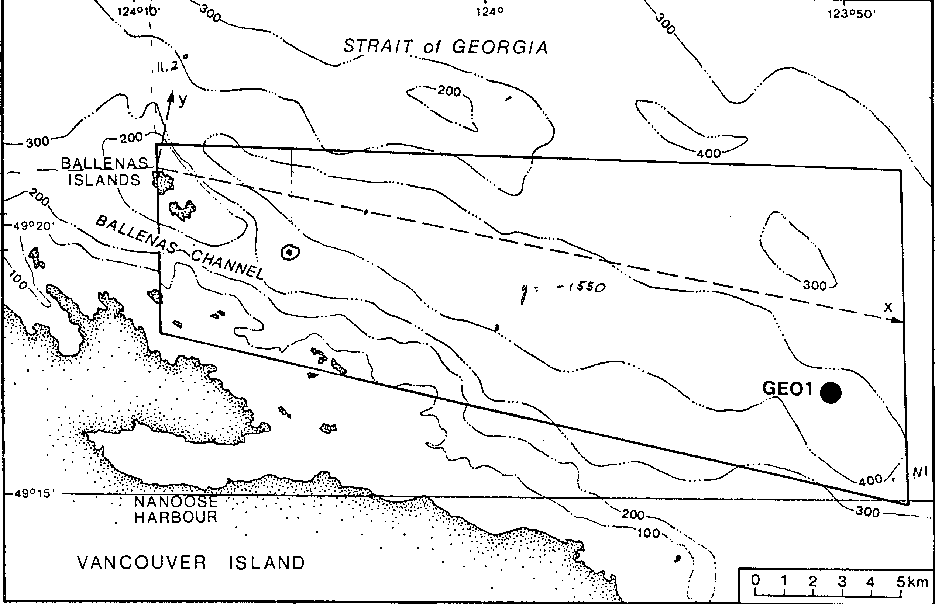
The data were inspected in CTDedit and small corrections were made to:
2003-99-0015.ctd
2003-99-0016.ctd.

