Cruise Plan & Itinerary:

Cruise #IOS-2003-24 CCGS Vector June 16 - June 21, 2003

Area of Operation: Juan de Fuca Strait and Strait of Georgia

Summary of Objectives: CTD, bottle sampling, sediment coring

Specific objectives:
- CTD/rosette along standard Juan de Fuca and Strait of Georgia lines (76 stations). The water from the rosette will be used for dissolved oxygen, nutrients and total and dissolved organic carbon measurements.
- Collect sediment box cores at stations GVRD-1, GVRD-2 and GVRD-6

Chief Scientist: Sophia Johannessen - phone (250) 363-6616

Additional personnel:

Bernard Minkley (IOS)
David Paton (IOS)
Sheila Toews (IOS)
Lizette Beauchemin (contractor)
Cynthia Wright (contractor)
Sébastien Mancini (student - ISITV)
Maxime Lanoelle (student - ISITV)

Ship’s equipment required:
GPS positioning
Depth sounder
Loran C
Radar

Deck machinery required:
CTD/Rosette winch
Sediment core winch

Other equipment to be loaded:
Laboratory instruments and computers
CTD/rosette
Freezers
Sediment corer, wide block

Provisional schedule:

Monday, June 16: Load the equipment at IOS. When loading is completed and equipment tested, sail to the mouth of Juan de Fuca Strait and start CTD stations. A first test station will be done in Saanich Inlet near the Met buoy.

Monday - Friday (June 16-20): proceed with the list of stations, including the three sediment core stations.

Friday, June 20: Complete the stations in the northern Strait of Georgia. As soon as completed, sail back to Pat Bay and unload material.
Station list:

CTD/R Stations:

Sta | Lat | Lat_mn | Lon | Lon_mn | Depth | Activity
1 | 49 | 20.30 | 124 | 12.10 | 247 | CTD
2 | 49 | 24.10 | 124 | 9.30 | 289 | CTD Ox
3 | 49 | 26.60 | 124 | 20.20 | 327 | CTD Ox
4 | 49 | 24.50 | 124 | 22.10 | 344 | CTD
5 | 49 | 27.40 | 124 | 30.80 | 315 | CTD
6 | 49 | 30.60 | 124 | 27.80 | 192 | CTD Ox
7 | 49 | 34.40 | 124 | 24.20 | 357 | CTD
8 | 49 | 39.30 | 124 | 33.00 | 355 | CTD
9 | 49 | 35.50 | 124 | 38.30 | 170 | CTD Ox
10 | 49 | 40.70 | 124 | 47.30 | 95 | CTD
11 | 49 | 42.40 | 124 | 43.40 | 289 | CTD
12 | 49 | 43.60 | 124 | 40.80 | 357 | CTD Ox
13 | 49 | 55.30 | 124 | 55.20 | 219 | CTD
14 | 49 | 53.00 | 124 | 59.60 | 311 | CTD Ox
15 | 49 | 51.60 | 125 | 1.60 | 143 | CTD
16 | 49 | 57.70 | 125 | 8.80 | 146 | CTD Ox
17 | 49 | 58.80 | 125 | 4.30 | 265 | CTD
18 | 49 | 59.20 | 124 | 58.90 | 146 | CTD
19 | 50 | 1.20 | 124 | 52.90 | 283 | CTD
20 | 49 | 47.20 | 124 | 32.30 | 311 | CTD
23 | 50 | 15.0 | 125 | 23.0 | 240 | CTD Ox
22 | 49 | 40.20 | 124 | 16.30 | 358 | CTD
21 | 50 | 2.0 | 125 | 13.6 | 72 | CTD
24 | 49 | 30.30 | 124 | 6.00 | 430 | CTD
25 | 49 | 27.70 | 124 | 7.50 | 320 | CTD
26 | 49 | 14.30 | 123 | 50.80 | 256 | CTD
27 | 49 | 19.10 | 123 | 48.00 | 347 | CTD Ox
28 | 49 | 24.10 | 123 | 45.30 | 134 | CTD
37 | 49 | 13.60 | 123 | 20.70 | 219 | CTD
38 | 49 | 12.00 | 123 | 26.40 | 296 | CTD
39 | 49 | 9.80 | 123 | 33.00 | 388 | CTD Ox
40 | 49 | 8.60 | 123 | 36.80 | 146 | CTD
41 | 49 | 3.30 | 123 | 22.30 | 247 | CTD
42 | 49 | 1.80 | 123 | 26.20 | 326 | CTD Ox
43 | 49 | 0.20 | 123 | 30.10 | 187 | CTD
44 | 48 | 56.80 | 123 | 6.00 | 119 | CTD
45 | 48 | 53.90 | 123 | 8.40 | 128 | CTD
46 | 48 | 51.40 | 123 | 10.80 | 179 | CTD Ox
47 | 48 | 49.30 | 123 | 6.20 | 188 | CTD
48 | 48 | 51.70 | 123 | 3.20 | 220 | CTD
49 | 48 | 55.00 | 122 | 59.60 | 132 | CTD
50 | 48 | 57.70 | 122 | 56.10 | 26 | CTD
51 | 48 | 46.70 | 122 | 51.60 | 155 | CTD
52 | 48 | 38.90 | 122 | 43.30 | 91 | CTD
53 | 48 | 33.20 | 122 | 45.00 | 73 | CTD
54 | 48 | 26.60 | 122 | 44.30 | 77 | CTD
56 | 48 | 46.40 | 123 | 1.60 | 214 | CTD Ox
57 | 48 | 44.00 | 123 | 8.10 | 141 | CTD
58 | 48 | 43.00 | 123 | 14.30 | 338 | CTD
59 | 48 | 37.80 | 123 | 14.60 | 227 | CTD Ox
60 | 48 | 33.90 | 123 | 12.80 | 298 | CTD
61 | 48 | 29.20 | 123 | 9.20 | 274 | CTD
62 | 48 | 22.80 | 123 | 2.60 | 150 | CTD Ox
63 | 48 | 14.60 | 122 | 58.50 | 154 | CTD
64 | 48 | 12.80 | 123 | 5.80 | 97 | CTD
65 | 48 | 15.90 | 123 | 9.80 | 121 | CTD Ox
66 | 48 | 19.30 | 123 | 14.10 | 104 | CTD
67 | 48 | 22.80 | 123 | 18.10 | 106 | CTD
68 | 48 | 12.20 | 123 | 43.00 | 137 | CTD
69 | 48 | 15.60 | 123 | 43.20 | 174 | CTD Ox
70 | 48 | 19.20 | 123 | 43.20 | 154 | CTD
71 | 48 | 22.20 | 123 | 59.40 | 115 | CTD
72 | 48 | 18.60 | 124 | 4.00 | 192 | CTD Ox
73 | 48 | 15.00 | 124 | 6.70 | 157 | CTD
74 | 48 | 25.10 | 124 | 35.60 | 192 | CTD
75 | 48 | 28.20 | 124 | 32.80 | 230 | CTD Ox
76 | 48 | 31.40 | 124 | 30.00 | 93 | CTD
101 | 48 | 25.40 | 124 | 45.14 | 143 | CTD
102 | 48 | 30.00 | 124 | 44.00 | 260 | CTD Ox
103 | 48 | 33.00 | 124 | 43.00 | 125 | CTD
104 | 48 | 20.00 | 123 | 18.00 | 70 | CTD
105 | 48 | 11.00 | 123 | 19.00 | 80 | CTD
ADC | 48 | 14.00 | 123 | 18.00 | 113 | CTD Ox
GVRD-1 | 49 | 35.50 | 124 | 38.30 | 170 | Core  (stn 9)
GVRD-2 | 49 | 19.87 | 123 | 18.50 |  | Core
GVRD-6 | 48 | 56.20 | 123 | 18.80 |  | Core

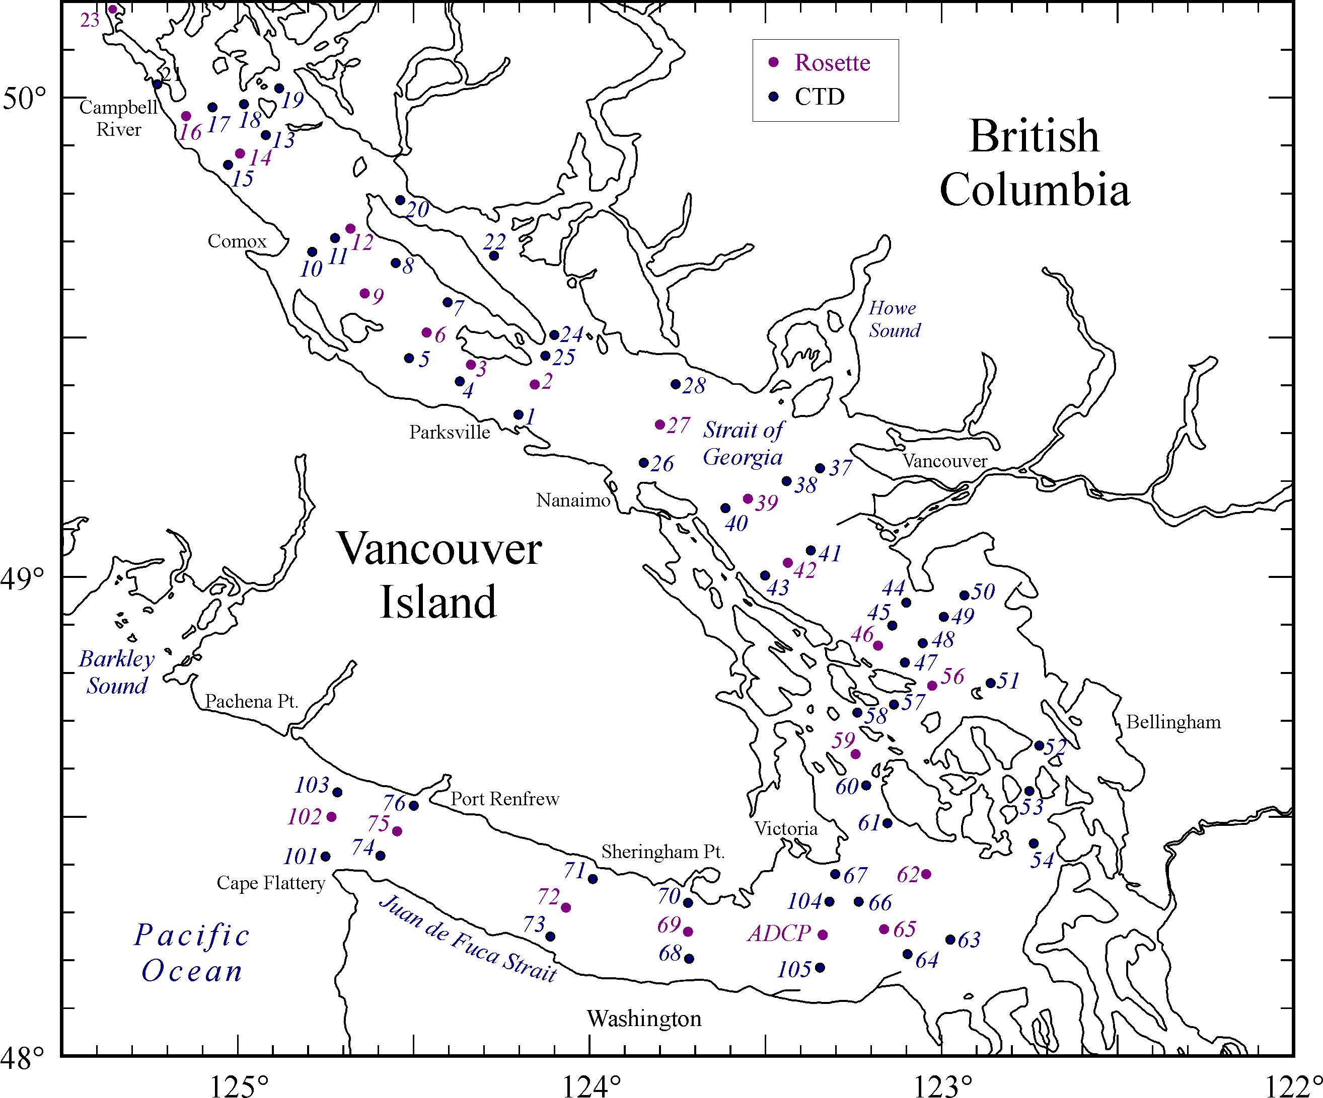
GVRD-1
GVRD-2
GVRD-6
Sediment Core

