Cruise Report:

Pack Ice Thickness & Climate Study

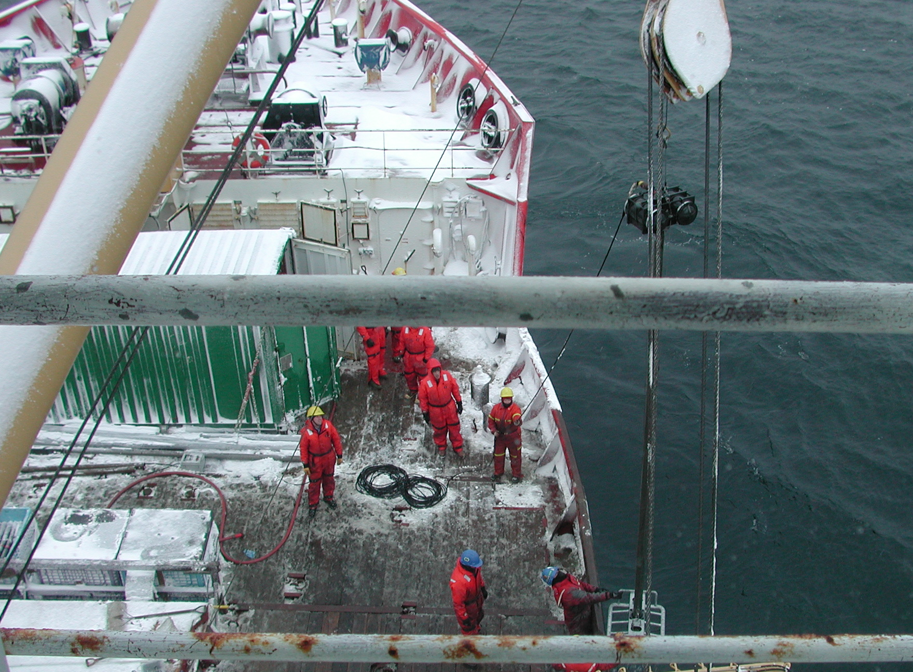
Mackenzie Shelf Gas Hydrate Study

Beaufort Sea

CCGS Sir Wilfrid Laurier

August 29 – September 23, 2003

Institute of Ocean Sciences Cruise 2003-19

Humfrey Melling – Chief Scientist

Pack Ice Thickness and Climate Study

Mackenzie Shelf Gas Hydrate Study

Beaufort Sea

CCGS Sir Wilfrid Laurier

August 29 – September 23, 2003

Chief Scientist: Humfrey Melling

Overview
The CCGS Sir Wilfrid Laurier supported the activities of two over-lapping research projects in the Beaufort Sea during September 2003, the Pack Ice Thickness and Climate study, which maintains sonar to monitor ice over the continental shelf of the Beaufort Sea, and the Mackenzie Shelf Gas Hydrate study which is a new initiative on the role of gas hydrates in the formation of sub-sea pingos and pock-marks in the same area. Both projects are multi-disciplinary, exploring seabed geomorphology, seawater and sediment geochemistry, shelf circulation, the thermal regime of shelf waters, pack ice ridging and motion, seabed scouring and methane-associated benthic biology.
Concurrent activities of the CCGS Nahidik were important to the coring of pingo and pock marks from CCGS Sir Wilfrid Laurier. The multi-beam sonar deployed on a launch carried by the CCGS Nahidik produced high-resolution maps of the seabed in the vicinity of features on the Mackenzie shelf selected for detailed study by coring.
The Pack Ice Thickness and Climate study is a Canadian component of the international Arctic Ice Thickness Project of the WCRP. It is supported by Fisheries and Oceans Canada, the federal Programme of Energy Research and Development (PERD), the Canadian Climate Change Action fund and the US National Oceanic and Atmospheric Administration. Time-series of observations were initiated in 1990. At present Canadian scientists are using the data to explore the physics that determines the thickness and topography of ice fields on various time scales. In the future these observations will reveal trends in the thickness of Arctic pack ice.
The Mackenzie Shelf Gas Hydrate study is a collaborative project involving the Monterey Bay Aquarium Research Institute (MBARI), the US Geological Survey (USGC), the Geological Survey of Canada (GSC) and Fisheries and Oceans Canada (IOS). The US National Science Foundation, PERD, DFO and NRCan provided funding and in-kind support.

Goal
The primary goal of the ice-thickness study on the CCGS Sir Wilfrid Laurier was the recovery, servicing and re-deployment of internally recording instruments. These measure ice and ocean properties from sub-surface moorings for 1-2 years before retrieval. The primary variables recorded are ice thickness, ice ridging, storm waves, sea level, ocean current, temperature and salinity. The instruments operate autonomously, recording new data at intervals ranging between 1 second (for ice) and 30 minutes. A secondary goal was the mapping of temperature, salinity and the concentrations of various hydrographic tracers on several established oceanographic sections in the Beaufort Sea. This research contributes to understanding of variability and change in the Beaufort Sea. Do the dramatic changes in the Arctic Ocean of the 1990’s indicate an anthropogenic shift in the climate, or do they reflect natural decadal variability in the ocean-ice-atmosphere system?
The goal of the gas-hydrate project was the sampling of sediment and of gases in the sediment and water column over selected sub-sea pingos and gas vents and in “background” areas. Such sampling advances understanding of the geological setting and of sediment geochemistry on a number of fronts – geological origin and evolution of the features, their association with fluids and permafrost, their unique habitat, their contribution to greenhouse-gas emissions, their geo-hazard and their association with commercial hydrocarbons.

Methods
Oceanographic moorings in ice-covered waters are entirely sub-surface to reduce risk from drifting ice. Most moorings are recovered through acoustic activation of an electromechanical hook that separates the buoyant part of the mooring from a dead-weight anchor. A successful recovery is contingent on the ship being able to reach the site (not always practical in heavy ice) and on the presence of sufficient ice-free surface over the mooring to ensure its appearance at the sea surface following release. A careful assessment of risk based on ice cover and acoustic ranging precedes each decision to release. All IOS moorings are equipped with tandem releases (Mesotech 501AR) for increased reliability. Since the moorings of this project are simple in design, they can be deployed in relatively small ice-free patches, free falling to the seabed from the surface.
Low-cost seabed temperature recorders were deployed around the Mackenzie Delta in 2001. To reduce the potential loss of equipment at these risky locations in shallow (2-10 m) water, draglines were used in preference to acoustic releases. Such moorings are retrieved (with a little patience) by trailing grappling hooks from a small boat as it moves across the dragline.
A CTD and rosette sampler (12 8-litre bottles, General Oceanics) was used to measure hydrochemical sections following conventional oceanographic practice. The CTD system (SeaBird-25) provided continuous profiles of temperature, salinity, dissolved oxygen, light transmission and chlorophyll fluorescence. The variables measured from sampled water were salinity, oxygen-isotope ratio, dissolved oxygen, dissolved nutrients (nitrate, nitrite, phosphate, silicate), dissolved barium and at some stations dissolved methane, ethane, propane, etc. Only the analyses for dissolved oxygen (colourimetric titration) and dissolved hydrocarbons (gas chromatography) were completed on board the ship.
Cores of sediment were acquired using a vibracorer with a 6-m steel core barrel about 10-cm in diameter. The barrel accomodates a close fitting liner of transparent plastic pipe that contains the sediment for permanent storage. A core shoe of stainless steel penetrates the sediment as the core barrel is vigourously shaken vertically at its upper end. The vibration is generated by unbalanced flywheels driven by two synchronized counter rotating electric motors in a housing at the core head. The core shoe is fitted with retention ‘fingers’ that retain the core as the barrel is pulled from the seabed. The vibracorer was deployed from the ship’s main boom using a 50-HP winch for wire handling. The highest wire tension noted when pulling the core on this expedition was about 3600 kg.
The cores were cut into 1-m (sometimes 0.5-m) lengths and a 5-cm slice was removed at each cut. Sediment from each slice was squeezed to collect pore water. The pore-water samples were analyzed on board for chlorine and sulphate using ion chromatography and for methane using gas chromatography. Mud samples were stored for later analysis of DIC, carbon isotopes (¹³C/¹⁴C), sulphur isotopes, sediment percent organic carbon, C/N and ¹⁵N.
A Van Veen grab was used to acquire samples of surface sediment for collection of benthic organisms by sieving. The collecting area was about 0.50x0.25 m.
Maps of sub-bottom sediment stratigraphy were generated using a 3.5-kHz echo sounder while the ship navigated a survey pattern of closely spaced parallel lines at 4 knots. Echoes were recorded on a wide bed electrostatic plotter, annotated with information on course changes and GPS fixes. Soundings from a Simrad 12.5-kHz sounder were recorded digitally, integrated with GPS fixes at 1-second intervals.
Two ROVs used from the Laurier on this cruise, DFOs TARS submersible and MBARIs Phantom on loan from NASA. Both were deployed in the same fashion. A 500-lb weight was lowered from the A-frame on the well deck to within about 10 m of the seabed. The umbilical of the ROV was secured to this down line using cable ties, leaving 10-30 metres of freedom for the ROV at the lower end. Laurier held station while the seafloor within ranges of the clump weight was explored. The ship was then moved a few tens of metres to access a new area. With TARS we recovered a mooring with malfunctioning acoustic releases, which was deployed in ice-prone waters in 1999 and evaded retrieval on earlier attempts in 2001 and 2002. The ROV was used to find the mooring and attach a lifting line.

Personnel

Joining at Kugluktuk on August 29 (16 persons)
From Fisheries and Oceans Canada, Institute of Ocean Sciences
Humfrey Melling, Peter Gamble, Ron Lindsay, Jane Eert, John Harris
From Natural Resources Canada, Geological Survey of Canada
Bob Macdonald (Institute of Ocean Sciences)
Mark Nixon (Ottawa)
From Monterey Bay Aquarium Research Institute, California
Bill Ussler, Rendy Keaton, Rich Whitmarsh, Patrick Mitts, Bob Fuhrmann
From US Geological Survey, Menlo Park California
Tom Lorenson, Jennifer Dougherty, Kevin O’Toole, Walt Olson

Joining by helicopter from Tuktoyaktuk on September 18 (1 person)
From Monterey Bay Aquarium Research Institute, California
Charlie Paull

Activities
- 81 sediment cores, some more than 5-m long, were collected in water between 10 and 110-m deep. These cores characterize the sediments of pingos, pock-mark fields and the surrounding sea floor. Short cores specifically from hard sands found along the 50-m isobath were also acquired. Sections were cut from each core and pore waters were analyzed for natural gas, Cl⁻ and SO₄⁼ and sampled for later isotopic, carbon and nitrogen analyses
- 26 samples of surficial sediment were collected from pingos and from the surrounding sea floor using a Van Veen grab. Samples were sieved to isolate benthic organisms, which were frozen for later analysis of biodiversity
- Grid surveys using 3.5 kHz and 12 kHz sonar were completed over several pingos, to establish their topographic profiles and sub-bottom sedimentary structure
- Video surveillance using an ROV-mounted camera was completed on sections running from moat to crest of four pingos
- The ROV facilitated the collection of gas samples from bubbles emerging from the seabed at the Admiral’s Finger B pingo
- 72 CTD-rosette casts were completed. The SBE25 CTD was equipped with several supplementary sensors and recorded pressure, temperature, conductivity, dissolved oxygen, light transmission and chlorophyll fluorescence
- Water was sampled from the rosette on 60 of the CTD-rosette casts. For the regional hydrochemical study, samples were withdrawn for salinity, dissolved nutrients, dissolved oxygen, dissolved barium and oxygen isotope analyses. DO analysis was completed on board ship, but other analyses will be conducted on samples stored for transport to the Institute of Ocean Sciences. For the pingo study, samples were withdrawn for on-board analysis of dissolved methane using a gas chromatograph
- 7 oceanographic moorings were retrieved after deployments ranging between 1 and 4 years. One was lifted from the seabed following attachment of a lifting line using the IOS TARS tethered submersible. Instruments measured seabed temperature, water-column temperature, salinity and current, ice drift, surface waves, sea level, storm surge, ice thickness, ice topography and biogenic acoustic scattering
- 10 oceanographic moorings were deployed for periods of 1-2 years, following on-board servicing of the instruments and mooring components. The instruments will extend the time series of ice observations that was initiated in 1990 and of ocean observations dating back to the mid 1970s. Strings of seabed temperature recorders were draped across three sub-sea pingos, Kaglulik, Admiral’s Finger B and Kopanoar, to document the thermal environment of these features.
- 1 satellite-tracked weather reporting buoy was deployed on old ice to the west of Banks Island on behalf of the Arctic Weather Centre Environment Canada.

Summary of the Methane Hydrate Study
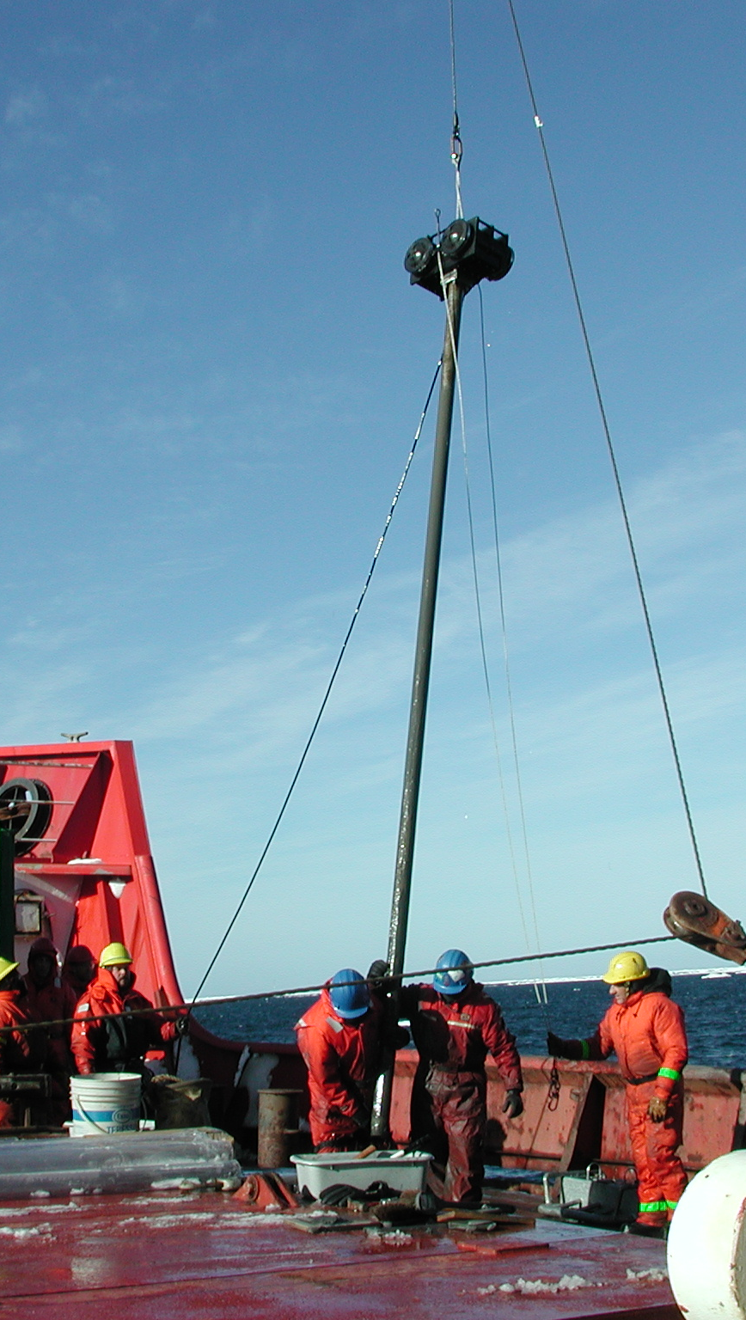
81 vibracores were collected. The longest was 5.2 m and the the average length was on the order of three meters. The cores came from Kaglulik, Admirals Finger A, B, and C, Kopanoar, Kugmallit Bay pockmarks, Paktoa pockmarks, and two of the Pingo Z pingo-like feature (PLF). Background cores were taken at various places, especially around the Admiral’s Finger pingos and on a partial transect across the shelf that was intended to run out to the shelf edge. However, the inner end of this was transect was not completed.
About 305 pore water samples were successful extracted from 78 of these cores. These were taken at either 50 cm or 1 m intervals through most of the core with an additional sample taken near the bottom. Bill Ussler measured sulphate and chloride concentrations in the waters, extracted headspace methane samples and analyzed them shipboard. Bill also preserved samples of the waters and gases for measurement of DIC concentration and isotopes, methane isotopes, and water isotopes.
The cores from the crest of the PLFs were very distinct from the surrounding sediments. Ice was found in virtually every core from the crest of a PLF. Ice was only observed in one core from the flanks of a PLF and none in the moat or surrounding background sediments. The ice was composed of fresh water as shown by Bill's shipboard ion chromatographic measurements. There were very shallow sulphate-methane interfaces in the cores from the tops of the PLFs, and more moderate gradients in the surrounding sediments. Methane concentrations were systematically elevated in the cores from the PLF. The core temperature data show the lowest temperatures came from the tops of the PLF.
The colour and texture of the sediments observed in the whole-round core samples, and described on deck suggest that there are four basic lithologies:
- The cores from the crest of the PLF are composed of clay, which was generally stiff and contained textures that are altered by the presence of ice. The ice occurred either as 2-3 cm-thick perfectly clear nodules or layers, millimetre-thick veins that were randomly oriented or vertical, ice-bounded sediment, or some sub-centimetre granular clear crystals. The PLF crest samples are generally olive-tan (i.e., lighter in colour than the moat sediments). Penetration and recovery in the PLF crest cores was good, and apparently the permafrost was easily penetrated with the vibracorer.
- The sediments in the moats are composed of softer clays and generally darker coloured (charcoal), suggestive of high organic carbon composition. Penetration in the moats was excellent.
- Background cores showed two lithologies. In the eastern areas (Admirals Finger and Kaglulik) the cores were a very stiff, fine- to medium-grained sand. Grain size data are needed, but Dharlie Paull suspects that these had a significant fine silt tail. Penetration was poor in these and the cores were typically between 1 and 2 m. The low penetration is curious, as vibracorers are particularly good at penetrating sand. Thus, while we continue to question whether these sands were frozen, there is no evidence for freezing in the core temperature data nor were they characterized by fresh pore waters, based on Bill's ion chromatographic analyses. Thus, probably these are especially tough lithologies comprised of over-consolidated sands that probably have been erosionally exposed (Steve's Unit C).
- On the transect across the self and near shore, most of the background cores were clay or silty clay. These ranged from soft at the top to somewhat stiff and very sticky below. These clays were noted to be surprisingly dry. They are likely to be post-transgression.
The cores, sealed in 1-m or shorter sections of plastic tube, were stored in bins that that were left on the Laurier. Core catcher samples were stored in plastic bags in grey tubs. A split of the core catchers has already been made. The pore water squeeze cakes were frozen. One of the core catcher splits and the cores will stay at PGC. The squeeze cake samples and one of the splits of the core catchers will returnto MBARI.
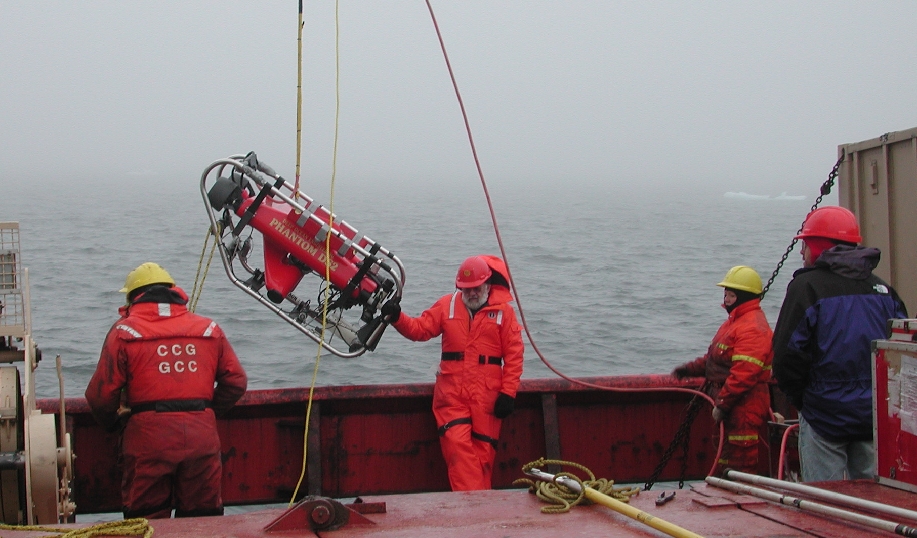
We conducted eight dives with the Phantom ROV.
Some short surveys were conducted with the Laurier's hull mounted 3.5 kHz system at Kaglulik, Admirals Finger A, B, and C, Kopanoar, and Pingo-Z area. These were primarily conducted at night to confirm the location of the features in the previously surveyed areas (Kaglulik and Kopanoar) and to locate the coring targets (Admirals Finger and Pingo-Z areas). These surveys were not part of our initial plan, but they proved to be very useful, especially because we did not have site survey data for all core sites. However, these surveys were very difficult to conduct for several reasons: 1) We needed all the help we had during the day and thus there not enough people to stand watch through the night. 2) The EPC recorder was not in good condition. 3) The weather was poor and many of the lines required the ship to pass through ice flows. 4) The coordination between the recorder which was in the green van, the bridge and our ArcView navigation (forward lab) was difficult. In retrospect, the digitally-collected 12 kHz data from the “science” sounder on CCGS Sir Wilfrid Laurier proved to be as useful.
Gas was observed to be coming out of the bottom in four areas:
- Gas bubbles were seen at the surface over the Kugmallit Bay pockmarks. These vents were active enough so that the gas was sampled from a boat using an overturned water-filled pail that was attached to a pole and held in the water over the side of the boat where bubbles were seen breaking the surface. The accumulated gas was extracted without coming into contact with the atmosphere.
- Some gas bubbles were observed at the surface at Paktoa. However, the gas venting was not adequate to merit collection with the boat.
- ROV dive tapes show gas bubbles emerging from the crest of Admirals Finger Pingo B.
- The ROV images showed that streams of gas bubbles are coming from the western most of the Pingo-Z features. The ROV was used to sample in situ the gas from this area (see ROV descriptions). Shipboard analyses of the two gas samples show that both are nearly pure methane (e.g., volumetrically trivial ethane and higher hydrocarbons). These samples are stored in the MBARI pore water van.
Gas data exists for essentially all the pore water samples. Gas voids were sampled from cores at both the Kopanoar and Pingo-Z-18 m. A gas can gas sample was taken from the core catcher of essentially all cores. Initial C1-C5 hydrocarbon gas analyses preformed on many of these samples by John Harris showed that they are almost exclusively composed of methane with traces of C2 to C5 compounds. Of all the areas explored only the crest of the Kopanoar pingo had traces of propane although even here the gas void analyses contained only a maximum of 2 ppm. Thus, the preliminary assessment is that these gas sources must be either biogenic or the result of methane hydrate decomposition.

Ice conditions across the Arctic, summer 2003
Anomalously high ice concentration in the Canadian Beaufort Sea and in the European sector of the Arctic

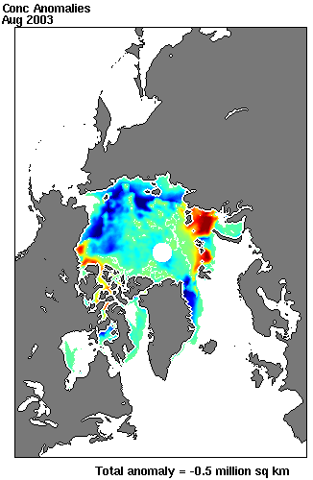
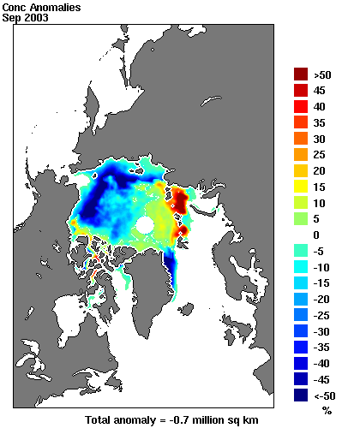

Locations of moorings serviced by CCGS Sir Wilfrid Laurier during September 2003

Locations of CTD-rosette casts from the CCGS Sir Wilfrid Laurier during September 2003

Locations of sediment cores acquired from the CCGS Sir Wilfrid Laurier during September 2003

Details of sampling at gas-hydrate study sites

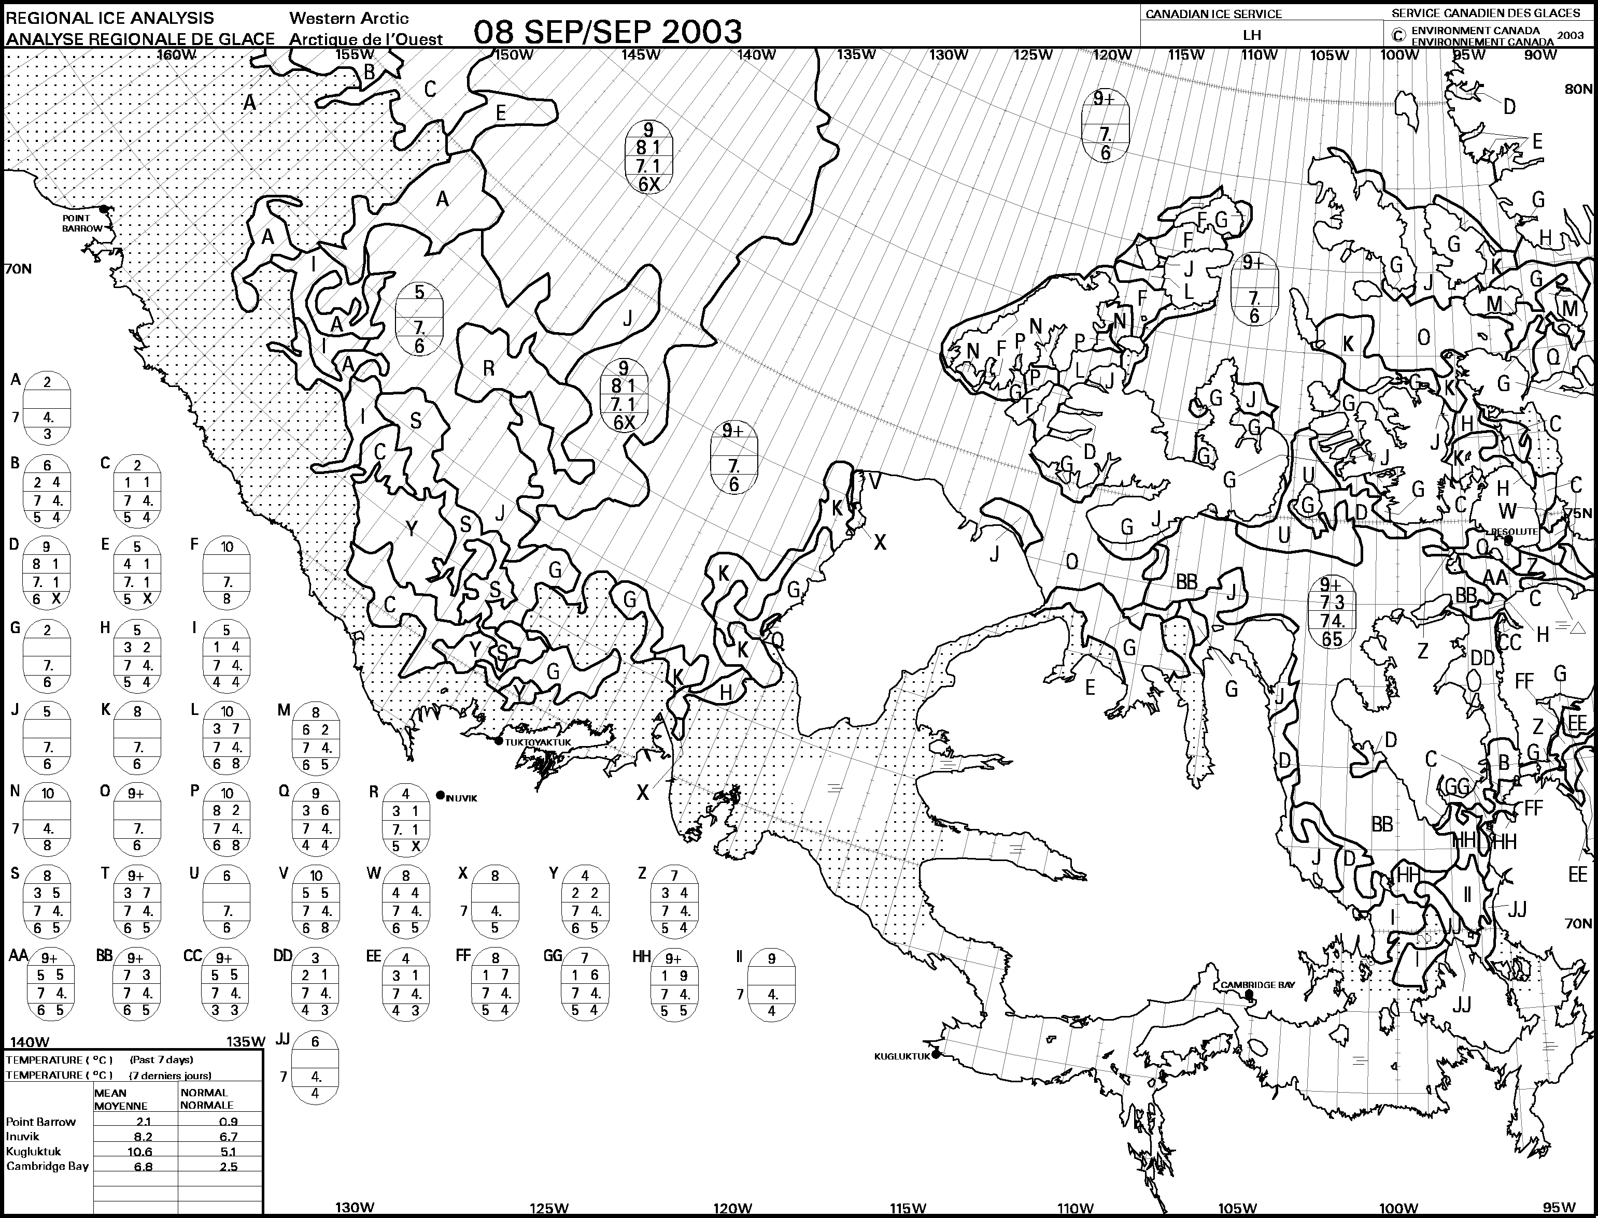
Ice conditions in the Beaufort Sea in mid-September 2003

Median ice conditions in the Beaufort in mid September
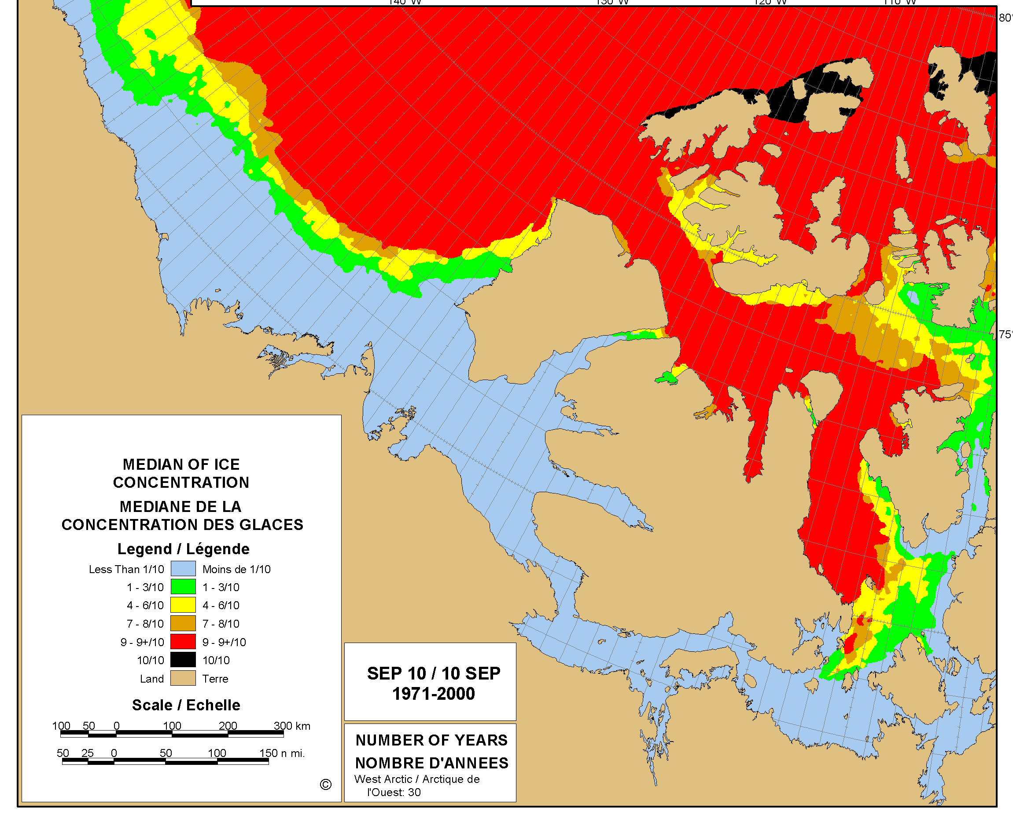

Impact of ice conditions and weather
Except in eastern Amundsen Gulf, ice provided a continuing challenge to the progress of the ship and conduct of the science programme. The preceding figure, which depicts median ice cover for the area in early September, indicates that the conditions in September 2003 (see the regional ice charts for September 8 from the Canadian Ice Service) were appreciably worse than average. Much of the ship’s scientific work was completed in areas of significant (more than 5-tenths ice concentration). Daily work was frequently re-planned several times to accommodate rapidly changing conditions. The successful completion of most of the scientific plan is a credit to the resolve and navigational skills of the captain and officers of the white crew of the CCGS Sir Wilfrid Laurier.
The prevalence of pack ice precluded the development of high sea state despite the frequent occurrence of high winds. Work from the foredeck was suspended only once and only for a few hours because of hazard from ship motion when vibracoring.
The activities of the CCGS Nahidik were more seriously affected by ice and wind. Since this vessel is not ice capable and since multi-beam surveys were conducted from a launch, ice and wind frequently prevented either access to operating areas or operations within them. For this reason, it was not possible to map several of the sites where coring was conducted from CCGS Sir Wilfrid Laurier.

Planned activities that were not completed
A few components of the Mackenzie Shelf Gas Hydrate study were left unfinished.
Time did not permit completion of coring in the southern part along a north-south “background” section in Kugmallit valley. Similarly, an east-west section across the front of the Mackenzie (15-m isobath) is incomplete.
No activities were conducted at the Garry Knolls and Ukalerk sites because the CCGS Nahidik was unable to reach these areas to complete the high resolution surveys by multi-beam sonar that were needed to select sites for coring.

CCGS Sir Wilfrid Laurier
CCGS Sir Wilfrid Laurier is well suited to the work carried out during this expedition. The large, low working deck, high-lift crane and the buoy-tending skills of the ship’s officers and crew contributed to straightforward and efficient deck operations.
Built-in laboratory and workshop space was augmented by the addition of an 8’x8’ container on the well deck (port side) and a 20’ laboratory container on the boat deck (starboard side) where the barge is normally carried. A temporary workspace was built from plywood and plastic on the fantail beneath the helicopter deck. With these additions, the scientific workspace was fully utilized but adequate.
Modern scientific field studies are increasingly dependent on the real-time distribution of navigational and scientific information on the LAN. There were some challenges in the effective provision of this information where it was required for the conduct of science, some associated with missing hardware and some with technical support. Electronic communication with the outer world via e-mail was effective, but showing signs of strain from increased scientific traffic at times.
Two years ago, discussions of improved scientific capacity for the CCGS Sir Wilfrid Laurier centred on three issues: lab space, shelter for CTD-rosette work and storage space. These requirements have largely been addressed through additions and modifications since 2001: lock-downs for a scientific container on the starboard boat deck, a heated shelter for the CTD-rosette, albeit temporary, the temporary installation of small containers and climate controlled storage in the hold as required by individual scientific programmes and the fabrication of short-term temporary shelter on the fantail.
Safe and effective operation of the Hawboldt CTD winch in cold weather, when the pulley, spooling gear and drum accumulate ice remains unresolved. We had no cold (-10°C) weather this year to test a prototype compressed air diffuser for stripping the cable clean of water before it reaches the pulley. In the longer term, the replacement of the temporary CTD rosette shelter with a permanent structure is desirable. Installation of a weather-tight personnel door (and ventilation) in the workshop container on the well deck would be convenient for access and for comfort in cold weather. Standard ISO lock-downs beneath the barge davits that could accommodate containers of various standard lengths would be an advantage.
There would be an obvious benefit to both scientific and hydrographic programmes in continuous logging of data from the 12-kHz scientific echo sounder and in linking these data to various workstations around the ship, including the bridge.
On the whole, we judge CCGS Sir Wilfrid Laurier to be an excellent platform for multi-tasked operations that include scientific research in the Canadian Arctic. The advantage of multi-tasking in reducing the average cost per operational science day should not be over-looked. Cost comparisons with dedicated Arctic science vessels such as Amundsen or USCG Healy are very favourable, particularly for on-going small-science activities such as conducted traditionally from the multi-tasked 1100-class and 1200-class vessels.
It is my pleasure at this time to acknowledge the hard work and competence of the Laurier’s White Crew. The members of this crew, in their diverse capacities, must take credit for the success of this expedition and the exciting scientific knowledge that will emerge from it. The credit belongs not only to the bridge and deck crews who are seen working directly on the scientific activities but also to those less obvious. In the engine room, logistics office, bingo palace, canteen, and galley, the crew’s efforts kept us mobile, well equipped for science, comfortable, entertained, (too?) well fed and ready for work. We have all felt like honoured guests.
I thank Captain Mark Taylor for his strong interest in and focus on the scientific programme. Sometimes he kept us working after we felt like quitting after a long day. In consequence of his hard work, strong motivation and seamanship, we accomplished a great deal in less than four weeks despite the adverse and challenging ice conditions in the eastern Beaufort Sea this year.

Narrative

September 5
Work has gone well during the first week of the scientific programme on the CCGS Sir Wilfrid Laurier. We joined the ship earlier than we expected, 29 August rather than 4 September, thanks to heavy ice in Peel Sound. This ice prevented the Laurier from completing Navaids maintenance along the coast up to Bellot Strait. Captain Taylor could have taken us on board two days earlier, but shortage of time since return from the Healy precluded our taking advantage of this offer. Sixteen members of the scientific team, from DFO GSC USGS MBARI and two consulting firms, joined at Kugluktuk. Missing was Charlie Paull from MBARI, who was working with Steve Blasco on the Nahidik at this time.
As it turned out, delays in transferring scientific equipment from Healy to Laurier, via Scotia Air Force Base in upstate NY, kept us an extra 18 hours at Kugluktuk - evidence for the obvious advantage in having duplicate equipment when working sequentially from several ships at widely separated locations.
We have since worked WNW down the centre of Amundsen Gulf, completing a hydrographic section through a series of five silled basins culminating in the Canada Basin. We have sampled for dissolved oxygen, nutrients, oxygen isotopes and dissolved barium at all stations. We added dissolved methane at the site (AG05) in the deep (650 m) basin of Amundsen Gulf. At the present time Laurier is 70 n mi west of Sachs Harbour in 9+ tenths ice, striving for the last sill before the Canada Basin. This section, occupied annually since 1998, is providing information on deep-water renewal in the basins of the western Archipelago and on the modification of Arctic surface waters (freshwater) flowing through the Archipelago into the Labrador Sea.
Partway through the Amundsen Gulf section we completed a northward diversion to Site 8 at the shelf edge west of Banks Island. IOS had two moorings here to observe the characteristics of and trend in the thickness of pack ice. One mooring was deployed four years ago and not recovered because of release malfunction in 2001 and one was deployed in 2001 and not serviced last year because of impenetrable pack. This time, with the co-operation of weather and ice, we were able to pluck the latter mooring from among the floes within a few minutes. We retrieved the former using the IOS submersible TARS, benefiting greatly from precise and patient ship handling by Captain Taylor and from the expertise of the MBARI AUV pilot, Robert Fuhrmann. I am reassured that TARS is still capable of such operations, despite its early 1980s vintage. We learned a few things about operating TARS from a ship (all of our prior use has been through the ice) and have some good ideas for fine-tuning this resource for future use in under-ice mooring recoveries.
The salvaged mooring has a value of about $130,000, and contained perfect data records for the period August 1999 - September 2001. Although slightly damaged from dragging operations two years ago, we are presently servicing the instruments for re-deployment later in the cruise. We have deployed a replacement mooring at Site 8, to continue monitoring the stream of heavy old ice from the northwest Archipelago at this location for the next two years and to supplement the CASES array of moored instruments.
The break in the weather at Site 8 also permitted the deployment of a weather-reporting buoy on behalf of the Arctic Weather Centre of MSC and of the International Arctic Buoy Programme (IOS is a member of the latter). This buoy was installed on a floe of old ice within the pack west of Banks Island (73 09', 128 57'), 45 miles from the ship. Data from this buoy are now appearing on the GTS.
We anticipate that the ship's helicopter will collect Charlie Paull from Sachs Harbour this afternoon. He was dumped in Tuk by the Nahidik a few days ago and has been awaiting an opportunity to join the Laurier since then. Laurier was in Sachs Harbour yesterday for repair to Navaids but the flight from Inuvik was cancelled because of poor visibility.
Following completion of the Amundsen Gulf section, the Laurier will commence geochemical surveys for seabed and water-column methane at Kaglulik, north of McKinley Bay. The site is not encumbered by ice at present. The geochemical work is a collaboration between IOS, GSC and MBARI/NSF. It involves seabed survey by multi-beam and sub-bottom sonar, sediment coring (vibracore), water sampling by rosette for methane analysis and seabed inspection and sampling by ROV.

September 15
We have been kept on our toes in the effort to optimize accomplishments in relation to encroaching ice.
At the time of my last message ten days ago, Laurier had left Sachs Harbour and was pushing west through heavy ice in the effort to complete the Amundsen Gulf section to the 1000-m isobath on the seaward side of the sill. We fell short of this objective by about 200 m in depth, but managed a station on the basin side of the sill. Our compressing of styrofoam cups at this station was appreciated by the crew. During the approach to and withdrawal from this location, we completed a CTD section across the Gulf, just behind the sill. As last year, this section reveals active renewal of deep waters in the outer basin of the Gulf (warmer, saltier, more oxygenated) via the continental slope from the southwest. As last year, the section reveals negligible penetration of this renewal beyond the second sill found NNW of Cape Parry.
On leaving the ice near 71N 130W we went straight to the Kaglulik site (70.5N 131.W) to begin the collaborative methane study (DFO, GSC, MBARI, USGS). This study involves seabed survey by multi-beam and sub-bottom sonar, sediment coring (vibracore), water sampling by rosette for methane analysis, benthic grabs and seabed inspection and sampling by ROV. At the Kaglulik site we had the advantage of a detailed seabed map from surveys by multi-beam sonar in late August. Moreover, favourable weather allowed the ship's helicopter to pick up Charlie Paull (MBARI) for the start of this work via a long run to Tuktoyaktuk on September 6.
The first day (7 September) of the methane programme was hectic. Since sampling equipment worked flawlessly, a large number of cores and samples came on board in a short time, keeping everyone hopping. There was excitement from the discovery of pure freshwater ice only 1-m deep into the sediment at the crest of the feature (and no ice in cores taken from the plain surrounding the feature). We measured elevated concentrations of methane in the seawater at the crest of the feature, and on two of the four headings explored at modest ranges (500 m) from it.
On the second day (8 September), the Phantom ROV dove on the Kaglulik site. Unfortunately, since several sub-systems (auto-focus, compass) were not performing correctly, the survey turned up nothing startling. Before leaving Kaglulik, we deployed a string carrying tiny Vemco recorders to measure temperature at the seabed between the crest of the feature and the surrounding plain.
In late evening Laurier arrived at the Admiral's Finger pingos where a survey grid was followed overnight to compile a map of sub-bottom targets using the 3.5 kHz sounder. Coring and sampling activities at pingos A & B occupied 9 September. Again ice was detected at the crest of the features cored, and elevated concentrations of methane were measured in some of the water samples.
Laurier continued overnight to the Kugmallit pock-mark field, on the 10-m isobath at the mouth of Kugmallit Bay. On 10 September, with calm sea conditions, the breaking of gas bubbles at the surface was clearly seen. Gas collected using sophisticated samples techniques (plastic pail) was predominately methane. The absence of significant fractions of ethane or propane argue for a source in the decomposition of gas hydrates in the seabed. Coring of the pock marks and surrounding seabed was supplemented by water sampling, CTD profiles and benthic grabs for biodiversity. High silt concentrations and resultant poor visibility precluded ROV dives here. However, the RHI-733 was deployed in an attempt to retrieve seabed temperature recorders deployed in 2001 on drag lines in shallow water to the south. Failure in this attempt has been attributed to inadequate grappling equipment.
At the end of this day, as Laurier proceeded north, we retrieved an IOS ice and wave monitoring mooring and site BMH02-9. Our intent to recover similar moorings at IOS Site 1 (mid shelf) on the morning of 11 September was subverted by heavy ice. Laurier continued northeast, then north, in an attempt to reach moorings at IOS Site 2 (shelf edge). This effort was aborted when obvious, because of slow progress in ice, that the site would not be reached before the end of the working day. We completed a "background" station for methane (core, benthic grab, rosette drop) in the Kugmallit Valley before changing course for the Kopanoar pingo. This site offered the possibility of day's productive sampling in advance of the arrival of the pack, driven by 25-knot northwest winds. A colourful Circle Crossing ceremony was conducted in the afternoon. King Walrus and his hence-creatures were both angered and delighted by the large number of uninitiated within the scientific group. Much wingeing and mewling was heard, bribes were offered and fairness was as usual a subjective matter. Body and soul were re-warmed by hot grog and a all-you-can-eat barbecue on the fantail. The evening was calm, if a chilly 0C. Entertainment was provided by a bear whose curiousity brought him (her) within 10 m of the ship!
We started coring and sampling at Kopanoar early on 12 September. With strong west winds, ice conditions deteriorated rapidly. Cores, grabs and water sampling was completed, but the sub-bottom survey was curtailed and conditions were too risky for an ROV dive. Laurier retreated to the northeast.
The mooring at IOS Site 2 was retrieved early on 13 September in snow, 20-knot winds and encroaching ice. When a reconnaissance by helicopter to the south showed no improvement in ice conditions at IOS Site 1, Laurier took advantage of an embayment in the advancing pack to complete an 80-km six-station hydrographic section to the 1500-m isobath in the Canada Basin. On completing this, the best opportunity for work without interference from high seas and ice was a return to Admiral's Finger.
The focus at Admiral's Finger on 14 September was initially Pingo-B, where a programme of sub-bottom survey, coring and ROV inspection was completed by mid afternoon. A string of Vemco recorders was deployed to measure temperature at the seabed between the crest of the feature (23-m depth) and the surrounding plain. Attention then turned to Pingo-B and to the Kugmallit-Z pingo, 10 km to the North, where sub-bottom surveys continued for the remainder of the day.
Today we are coring and sampling water at both Pingo-C and the Kug-Z features. A transit to IOS Site 2, now emergent from ice, and two mooring recoveries are planned for later in the day.
With five working days left in the cruise, we are well on the way to concluding a productive, novel and therefore successful scientific programme from the CCGS Sir Wilfrid Laurier. With the strongly pro-active participation of the officers and crew of the ship, this expedition is an excellent example of efficient and cost-effective use of multi-tasked government vessels for Arctic marine science.

September 22
At the time of my last message, the scientific team on Laurier was beginning an examination of Pingo-C at Admiral's Finger and the Kugmallit-Z pingo, 10 km to the North. These features lie roughly on the 50-m isobath 100 km NNE of Tuk.
The weather during the past week has had a distinct flavour of winter, including all of the following - overcast, fog, snow, strong winds and temperature below 0C. Ice has been our constant companion and the final arbiter of the viability of plans for the day. However, we have been more fortunate than the Nahidik, whose modest ocean-going capability has kept her holed up out of the waves and ice while we have continued to work.
From Admiral's Finger, we proceeded SW to IOS moorings at ITC02-1, where we had been blocked by ice on two previous attempts. The tactical value of up-to-date ice imagery and expert interpretation from the MSC on-board ice specialist has been very clear on this trip. Instruments on these moorings were recovered in the evening, turned around overnight and redeployed on the following morning. Laurier then proceeded northward to the shelf edge to re-deploy at IOS site ITC03-2. However since heavy ice blocked access to the intended location, we were content to deploy on the same (115-m) isobath about 15 km to the NNE.
On the night of 16-17 September, Laurier sailed back to Kopanoar. Here, a video reconnaissance by ROV from crest to trough was informative without spectacular findings. We draped a string of bottom-temperature recorders across this feature before heading south to the Paktoa pock mark field, in a Devon Canada Resources lease area to the NW of Garry Island. Gas bubbles were sighted here at the surface, but they could not be re-located for sampling. We completed cores and water sampling, within sight of the Nahidik working at the site of Minuk artificial Island, before heading east around the Delta along the 15-m isobath. Cores for background characterization were acquired at intervals along this transit. We found time to recover a string of seabed temperature recorders from TA-1, deployed north of Hooper Island in 2001, but deteriorating weather forced cancellation of an anticipated recovery at TA-2.
On the morning of September 19 we were back at Kugmallit-Z pingo for seabed inspection by video camera. There was lots of excitement on board that day. The Phantom ROV captured video of gas bubbles emerging from small pits in the seafloor on top of Kugmallit-Z pingo. In the video that I saw, a large amphipod (10 cm) was bustling around in the pit, dislodging bubbles and puffs of silt. An ingenious "World's longest syringe" was rigged to follow the ROV's umbilical from the deck to an inverted funnel in the camera's field of view on the submersible. The ROV then dove and positioned the funnel over a bubble vent. A 'skilled' operator on deck had merely to draw water up the tube into the syringe to capture gas in the tubing, from which it was later retrieved. As with the gas sampled at Kugmallit pocks, this sample was almost entirely methane. According to the experts, this purity is highly suggestive of an origin in gas hydrate decomposition. The excitement stimulated some additional rosette casts around the feature to acquire samples for methane analysis.
With such euphoria in the air, it was straightforward to bully the MBARI PI Charlie Paull into providing free Scotch in the Lounge that night. Charlie told me yesterday that, on reviewing video from other dives, he had also discovered gas venting at Admiral's Finger B pingo. Unfortunately we were not able to release a second flood of free drinks from this information. How quickly scientists lose their excitement!
On the 20th, ROV activities were repeated at the Kaglulik pingo further to the east. The video here revealed what is apparently a dormant feature, perhaps in a later inactive stage of life (like DFO Arctic scientists?). Surprisingly for a feature whose crest is at 40-m depth, there was little evidence of ice scouring . Perhaps Kaglulik, though presently dormant, has been active as a "mud volcano" at times more recent than when lower sea level permitted scouring at such depth?
Under pressure of the crew-change schedule at Cambridge Bay, we started our 1000-km transit in the afternoon, stopping briefly to deploy a wave-ice sonar north of Liverpool Bay. This prototype instrument was finally operable, after a period of intense trouble-shooting and in situ testing during the past week. Another brief stop yesterday in eastern Amundsen Gulf was mandatory for the conduct of the annual regatta of the Royal Arctic Yacht Club. Unfortunately, entries by Science in both sail and power classes did not prosper. We drowned our sorrows during the evening barbecue on the fantail, enjoying clear, calm warm (2C?) weather, the best in a week. In the late evening, we were treated to a spectacular display of the aurora, graced by a sliver of the old moon of the northern horizon.
Tonight we arrive in Cambridge Bay, for flights south tomorrow.

Appendix 1: Locations of Moorings in the Beaufort Sea

Appendix 2: Locations of CTD and CTD/rosette profiles

# | Station | Date | Time (UTC) | Lat Deg N | Lat Min | Lon Deg W | Lon Min | Depth (m) | Cast Depth (db) | Sample Numbers | Activity | Sampling
1 | DU01 | Aug 30 | 20:27 | 68 | 17.950 | 113 | 29.800 | 88 | 82.4 | 19001-19005 | ROS | Basic
2 | DU02 | Aug-31 | 00:18 | 68 | 48.150 | 114 | 00.200 | 63 | 62.3 | 19006-19009 | ROS | Basic
3 | DU03 | Aug 31 | 03:33 | 69 | 06.100 | 115 | 24.000 | 117 | 115.4 | 19010-19015 | ROS | Basic
4 | DU04 | Aug 31 | 06:58 | 69 | 12.043 | 117 | 00.474 | 232 | 225.6 | 19017-19026 | ROS | Basic
5 | CP05 | Aug 31 | 11:05 | 69 | 39.217 | 118 | 35.425 | 523 | 520.7 | 19027-19038 | ROS | Basic
6 | DT05 | Aug 31 | 15:21 | 69 | 58.791 | 120 | 04.641 | 485 | 484.0 | 19039-19048 | ROS | Basic
7 | DT05 | Aug 31 | 15:53 | 69 | 58.791 | 120 | 04.641 | 485 | 49.3 | 19049-19050 | ROS | Basic
8 | AGT4 | Aug 31 | 19:28 | 70 | 14.950 | 121 | 40.080 | 432 | 426.5 | 19051-19062 | ROS | Basic
9 | AG05 | Aug 31 | 23:00 | 70 | 36.630 | 122 | 55.660 | 583 | 552.3 | 19063-19074 | ROS | Basic + methane
10 | AGT | Sep 01 | 03:42 | 70 | 59.040 | 125 | 10.800 | 354 | 346.9 | 19075-19086 | ROS | Basic
11 | AGT3 | Sep 01 | 09:02 | 71 | 26.525 | 126 | 20.223 | 454 | 448.1 | 19087-19098 | ROS | Basic
12 | CK5 | Sep 01 | 17:59 | 71 | 52.660 | 127 | 37.420 | 421 | 412.3 | 19099-19110 | ROS | Basic
13 | ITC03-8 | Sep-03 | 20:59 | 72 | 34.640 | 127 | 27.440 | 114 | 109.0 | 19111-19111 | CTD | Salt
14 | AS-01 | Sep-03 | 01:26 | 72 | 22.790 | 127 | 48.170 | 94 | 89.0 | 19112-19112 | CTD | Salt
15 | AS-02 | Sep-04 | 04:53 | 72 | 10.770 | 128 | 18.390 | 378 | 379.0 | 19113-19113 | CTD | Salt
16 | AS-03 | Sep-05 | 13:10 | 71 | 59.960 | 128 | 43.580 | 412 | 408.0 | 19114-19114 | CTD | Salt
17 | B2 | Sep-05 | 20:24 | 72 | 09.370 | 129 | 39.620 | 366 | 361.0 | 19115-19126 | ROS | Basic
18 | SOL1 | Sep-06 | 06:58 | 71 | 58.070 | 130 | 50.900 | 784 | 787.0 | 19127-19138 | ROS | Basic
19 | AS-04 | Sep-06 | 16:03 | 71 | 49.160 | 129 | 07.850 | 332 | 331.0 | 19139-19139 | CTD | Salt
20 | AS-05 | Sep-06 | 18:58 | 71 | 38.300 | 129 | 32.260 | 287 | 280.0 | 19140-19140 | CTD | Salt
21 | AS-06 | Sep-06 | 21:10 | 71 | 25.320 | 130 | 01.530 | 83 | 82.0 | 19141-19141 | CTD | Salt
24 | KAG01 | Sep-07 | 04:09 | 70 | 52.800 | 130 | 50.390 | 62 | 59.0 | 19142-19147 | ROS | Salt + methane
23 | KAG02 | Sep-07 | 06:51 | 70 | 52.100 | 130 | 52.030 | 45 | 44.0 | 19148-19152 | ROS | Salt + methane
24 | KAG03 | Sep-07 | 07:16 | 70 | 52.550 | 130 | 50.510 | 43 | 38.0 | 19153-19157 | ROS | Salt + methane
25 | KAG04 | Sep-08 | 01:15 | 70 | 52.860 | 130 | 50.100 | 62 | 58.0 | 19158-19163 | ROS | Salt + methane
26 | KAG05 | Sep-08 | 05:17 | 70 | 53.880 | 130 | 46.070 | 44 | 41.0 | 19164-19168 | ROS | Salt + methane
27 | KAG06 | Sep-08 | 06:03 | 70 | 51.310 | 130 | 54.160 | 46 | 42.0 | 19169-19173 | ROS | Salt + methane
28 | VC14 | Sep-08 | 20:40 | 70 | 52.690 | 130 | 50.476 | 56 | 52.0 |  | VVG | Biodiversity
29 | VC02 | Sep-08 | 20:51 | 70 | 52.558 | 130 | 50.365 | 42 | 37.5 |  | VVG | Biodiversity
30 | VC07 | Sep-08 | 21:25 | 70 | 52.929 | 130 | 48.973 | 52 | 47.4 |  | VVG | Biodiversity
31 | BG01 | Sep-09 | 02:43 | 70 | 48.030 | 131 | 47.660 | 53 | 48.1 | 19174-19184 | ROS | Basic + methane
32 | VC19 | Sep-09 | 16:52 | 70 | 40.780 | 132 | 38.000 | 37 | 34.7 | 19185-19189 | ROS | Salt + methane
33 | VC18 | Sep-09 | 17:16 | 70 | 40.770 | 132 | 39.240 | 45 | 40.5 | 19190-19194 | ROS | Salt + methane
34 | VC20 | Sep-10 | 01:51 | 70 | 40.788 | 132 | 38.612 | 23 | 23.0 |  | VVG | Biodiversity
35 | VC16 | Sep-10 | 02:02 | 70 | 40.795 | 132 | 38.509 | 23 | 23.0 |  | VVG | Biodiversity
36 | VC18 | Sep-10 | 02:25 | 70 | 40.779 | 132 | 39.318 | 47 | 47.0 |  | VVG | Biodiversity
37 | AF02 | Sep-10 | 03:06 | 70 | 40.780 | 132 | 38.470 | 24 | 18.6 | 19195-19197 | ROS | Salt + methane
38 | AF01 | Sep-10 | 03:31 | 70 | 41.090 | 132 | 38.560 | 46 | 42.3 | 19198-19201 | ROS | Salt + methane
39 | AF03 | Sep-10 | 03:47 | 70 | 40.470 | 132 | 38.530 | 38 | 35.8 | 19202-19205 | ROS | Salt + methane
40 | PM01 | Sep-10 | 15:07 | 69 | 45.010 | 133 | 21.820 | 14 | 9.7 | 19206-19209 | ROS | Salt + methane
41 | PM01a | Sep-10 | 15:28 | 69 | 44.990 | 133 | 21.810 | 16 | 14.8 | 19210-19213 | ROS | Salt + methane
42 | PM02 | Sep-10 | 16:26 | 69 | 45.000 | 133 | 21.800 | 14 | 12.8 | 19214-19217 | ROS | Salt + methane
43 | PMBG | Sep-10 | 21:15 | 69 | 46.571 | 133 | 21.769 | 11 | 11.0 |  | VVG
44 | PM01 | Sep-10 | 21:46 | 69 | 44.996 | 133 | 21.824 | 18 | 18.0 |  | VVG
45 | PM02 | Sep-10 | 21:59 | 69 | 45.008 | 133 | 21.824 | 12 | 12.0 |  | VVG
46 | PM03 | Sep-10 | 22:18 | 69 | 45.000 | 133 | 21.700 | 12 | 9.7 | 19218-19219 | ROS | Salt + methane
47 | PM03 | Sep-10 | 22:28 | 69 | 45.008 | 133 | 21.695 | 13 | 13.0 |  | VVG
48 | PM05 | Sep-10 | 22:40 | 69 | 45.214 | 133 | 22.213 | 10 | 10.0 |  | VVG
49 | PM07 | Sep-10 | 22:50 | 69 | 45.212 | 133 | 22.198 | 10 | 10.0 |  | VVG
50 | PM06 | Sep-10 | 22:55 | 69 | 45.201 | 133 | 22.211 | 10 | 10.0 |  | VVG
51 | PM11 | Sep-10 | 23:05 | 69 | 45.211 | 133 | 22.177 | 10 | 10.0 |  | VVG
52 | PM09 | Sep-10 | 23:10 | 69 | 45.199 | 133 | 22.168 | 10 | 10.0 |  | VVG
53 | BMH02-9 | Sep-11 | 02:34 | 70 | 04.980 | 133 | 29.820 | 37 | 31.5 |  | CTD
54 | BG02 | Sep-11 | 20:10 | 70 | 39.950 | 133 | 25.520 | 63 | 61.0 | 19220-19225 | ROS | Basic + methane
55 | BG02 | Sep-11 | 20:30 | 70 | 39.960 | 133 | 25.680 | 65 | 65.0 |  | VVG
56 | KC01 | Sep-12 | 14:22 | 70 | 23.390 | 135 | 25.100 | 39 | 35.0 | 19226-19230 | ROS | Salt + methane
57 | KC04 | Sep-12 | 15:46 | 70 | 23.000 | 135 | 26.310 | 60 | 56.9 | 19231-19235 | ROS | Basic + methane
58 | KC01 | Sep-12 | 18:09 | 70 | 23.383 | 135 | 25.047 | 41 | 41.0 |  | VVG
59 | KC07 | Sep-12 | 18:20 | 70 | 23.331 | 135 | 25.255 | 61 | 61.0 |  | VVG
60 | KC05 | Sep-12 | 19:12 | 70 | 23.160 | 135 | 25.804 | 61 | 61.0 |  | VVG
61 | KC22 | Sep-12 | 19:32 | 70 | 23.390 | 135 | 25.330 | 64 | 57.0 | 19236-19241 | ROS | Salt + methane
62 | KC21 | Sep-12 | 21:07 | 70 | 23.520 | 135 | 25.010 | 75 | 69.0 | 19242-19247 | ROS | Salt + methane
63 | KC23 | Sep-12 | 23:37 | 70 | 23.370 | 135 | 24.570 | 68 | 65.0 | 19248-19253 | ROS | Salt + methane
64 | KC20 | Sep-13 | 03:11 | 70 | 23.270 | 135 | 25.050 | 62 | 43.0 | 19254-19259 | ROS | Salt + methane
65 | OpTest1 | Sep-13 | 04:07 | 70 | 24.800 | 135 | 23.350 | 62 | 55.5 |  | CTD
66 | ITC01-2 | Sep-13 | 15:04 | 70 | 59.230 | 133 | 44.150 | 106 | 102.0 | 19260-19266 | ROS | Basic
67 | KC0400 | Sep-13 | 19:09 | 71 | 07.370 | 133 | 58.920 | 444 | 439.0 | 19267-19278 | ROS | Basic
68 | KC1800 | Sep-13 | 23:45 | 71 | 41.410 | 134 | 39.360 | 1522 | 1000.0 | 19279-19290 | ROS | Basic + methane
69 | KC1500 | Sep-14 | 01:34 | 71 | 30.900 | 134 | 32.520 | 1350 | 1000.0 | 19291-19302 | ROS | Basic
70 | KC1200 | Sep-14 | 03:48 | 71 | 21.840 | 134 | 18.420 | 1140 | 1000.0 | 19303-19314 | ROS | Basic
71 | KC0800 | Sep-14 | 05:49 | 71 | 14.350 | 134 | 08.260 | 833 | 837.0 | 19315-19326 | ROS | Basic
72 | AFZ1 | Sep-15 | 19:48 | 70 | 46.070 | 132 | 51.950 | 30 | 29.0 | 19327-19328 | ROS | Basic
73 | AFZ2 | Sep-15 | 21:11 | 70 | 45.890 | 132 | 51.220 | 40 | 45.0 | 19329-19334 | ROS | Basic
74 | AFZ3 | Sep-15 | 21:40 | 70 | 46.220 | 132 | 50.990 | 57 | 54.0 | 19335-19339 | ROS | Basic
75 | ITC02-1 | Sep-16 | 02:16 | 70 | 19.990 | 133 | 44.480 | 56 | 52.0 |  | ROS | Bottom water
76 | BG08 | Sep-16 | 14:18 | 70 | 09.960 | 133 | 44.850 | 42 | 39.0 | 19340-19344 | ROS | Basic
77 | BG07 | Sep-16 | 15:59 | 70 | 19.990 | 133 | 44.840 | 56 | 50.0 |  | ROS | Bottom water
78 | ITC03-1 | Sep-16 | 16:33 | 70 | 19.980 | 133 | 44.440 | 56 | 52.0 |  | ROS | Bottom water
79 | BG06 | Sep-16 | 18:48 | 70 | 29.990 | 133 | 44.880 | 65 | 59.0 | 19345-19349 | ROS | Basic + methane
80 | BG05 | Sep-16 | 21:23 | 70 | 43.030 | 133 | 30.550 | 65 | 60.0 |  | ROS | Bottom water
81 | BG04 | Sep-16 | 23:07 | 70 | 50.630 | 133 | 02.300 | 65 | 59.0 |  | ROS | Bottom water
82 | BG03 | Sep-17 | 00:51 | 70 | 58.720 | 133 | 11.560 | 75 | 72.0 |  | ROS | Bottom water
83 | ITC03-2 | Sep-17 | 02:44 | 71 | 02.370 | 133 | 24.320 | 125 | 119.0 | 19350-19356 | ROS | Basic
84 | PV01 | Sep-18 | 16:41 | 69 | 37.910 | 136 | 18.120 | 11 | 9.1 |  | ROS
85 | PV01 | Sep-18 | 16:55 | 69 | 37.900 | 136 | 18.120 | 11 | 8.6 | 19357-19359 | ROS | Salt + methane
86 | PP07 | Sep-18 | 19:55 | 69 | 37.838 | 136 | 17.654 | 10 | 10.0 |  | VVG
87 | PP07 | Sep-18 | 19:59 | 69 | 37.836 | 136 | 17.665 | 10 | 10.0 |  | VVG
88 | PP01 | Sep-18 | 20:15 | 69 | 37.909 | 136 | 18.127 | 10 | 10.0 |  | VVG
89 | OpTest2 | Sep-19 | 04:15 | 70 | 05.900 | 134 | 55.160 | 35 | 30.0 |  | CTD
90 | AFZ4 | Sep-19 | 18:05 | 70 | 46.020 | 132 | 52.090 | 30 | 23.2 | 19360-19365 | ROS | Salt + methane
91 | AFZ5 | Sep-20 | 01:02 | 70 | 46.080 | 132 | 51.940 | 38 | 35.9 | 19366-19369 | ROS | Salt + methane
92 | AFZ6 | Sep-20 | 01:26 | 70 | 45.990 | 132 | 52.090 | 39 | 36.9 | 19370-19373 | ROS | Salt + methane
93 | AFZ7 | Sep-20 | 01:48 | 70 | 46.000 | 132 | 51.900 | 37 | 34.1 | 19374-19377 | ROS | Salt + methane
94 | OpTest3 | Sep-20 | 05:10 | 70 | 47.730 | 132 | 21.100 | 56 | 50.2 |  | CTD
95 | BMH03-10 | Sep-20 | 21:30 | 70 | 53.740 | 129 | 45.570 | 33 | 30.5 |  | CTD

Appendix 3: Locations of vibracores

Core ID | Longitude | Latitude | Depth (m) | Time & Date | Region
VC01 | -130.614490 | 71.082380 | 50 | 23:34 06-Sep | Background Core
VC02 | -130.839735 | 70.875903 | 44 | 14:12 07-Sep | Kaglulik Pingo
VC03 | -130.842638 | 70.875067 | 42 | 14:31 07-Sep | Kaglulik Pingo
VC04 | -130.865425 | 70.868598 | 46 | 14:31 07-Sep | Kaglulik Pingo
VC05 | -130.829855 | 70.878688 | 61 | 16:39 07-Sep | Kaglulik Pingo
VC06 | -130.821997 | 70.880845 | 60 | 17:11 07-Sep | Kaglulik Pingo
VC07 | -130.817173 | 70.882032 | 63 | 17:40 07-Sep | Kaglulik Pingo
VC08 | -130.814362 | 70.882775 | 51 | 18:04 07-Sep | Kaglulik Pingo
VC09 | -130.825400 | 70.879942 | 64 | 19:23 07-Sep | Kaglulik Pingo
VC10 | -130.834192 | 70.878697 | 50 | 20:47 07-Sep | Kaglulik Pingo
VC11 | -130.837073 | 70.877817 | 44 | 21:26 07-Sep | Kaglulik Pingo
VC12 | -130.852930 | 70.872175 | 51 | 22:40 07-Sep | Kaglulik Pingo
VC13 | -130.840583 | 70.877920 | 46 | 23:12 07-Sep | Kaglulik Pingo
VC14 | -130.841650 | 70.878305 | 63 | 23:43 07-Sep | Kaglulik Pingo
VC15 | -130.835068 | 70.880782 | 64 | 01:02 08-Sep | Kaglulik Pingo
VC16 | -132.640810 | 70.679822 | 24 | 19:23 09-Sep
VC17 | -132.644598 | 70.679867 | 29 | 19:49 09-Sep
VC18 | -132.654850 | 70.679822 | 48 | 20:28 09-Sep
VC19 | -132.633622 | 70.679820 | 44 | 21:05 09-Sep
VC20 | -132.643228 | 70.679838 | 26 | 21:36 09-Sep
VC21 | -132.655143 | 70.679868 | 49 | 22:00 09-Sep
VC22 | -132.634132 | 70.679852 | 43 | 23:03 09-Sep
VC23 | -132.635915 | 70.686510 | 30 | 23:22 09-Sep
VC24 | -132.645718 | 70.686577 | 30 | 23:47 09-Sep
VC25 | -132.614850 | 70.686462 | 48 | 01:02 10-Sep
VC26 | -132.652428 | 70.686402 | 48 | 01:30 10-Sep
VC27 | -133.363692 | 69.750108 | 16 | 15:45 10-Sep | Kugmallit Pockmarks
VC28 | -133.363633 | 69.750087 | 14 | 16:16 10-Sep
VC29 | -133.363590 | 69.750152 | 13 | 16:39 10-Sep | Kugmallit Pockmarks
VC30 | -133.363675 | 69.749970 | 18 | 17:26 10-Sep | Kugmallit Pockmarks
VC31 | -133.362020 | 69.749975 | 15 | 18:09 10-Sep
VC32 | -133.363488 | 69.770137 | 11 | 19:18 10-Sep | Kugmallit Pockmarks
VC33 | -133.362288 | 69.771978 | 12 | 19:49 10-Sep | Kugmallit Pockmarks
VC34 | -133.362532 | 69.774048 | 12 | 20:35 10-Sep | Kugmallit Pockmarks
VC35 | -133.362498 | 69.776260 | 11 | 20:59 10-Sep | Kugmallit Pockmarks
VC36 | -133.423107 | 70.667563 | 66 | 19:56 11-Sep | Background Core
VC37 | -135.418071 | 70.389618 | 41 | 14:36 12-Sep | Kopanoar Pingo
VC38 | -135.419122 | 70.389948 | 40 | 15:04 12-Sep | Kopanoar Pingo
VC39 | -135.416767 | 70.389172 | 41 | 15:19 12-Sep | Kopanoar Pingo
VC40 | -135.439193 | 70.383540 | 57 | 16:05 12-Sep | Kopanoar Pingo
VC41 | -135.430537 | 70.385977 | 63 | 16:35 12-Sep | Kopanoar Pingo
VC42 | -135.424082 | 70.387558 | 60 | 17:06 12-Sep | Kopanoar Pingo
VC43 | -135.420645 | 70.388658 | 62 | 17:27 12-Sep | Kopanoar Pingo
VC44 | -135.422830 | 70.391955 | 75 | 20:04 12-Sep | Kopanoar Pingo
VC45 | -135.412947 | 70.390887 | 70 | 20:23 12-Sep | Kopanoar Pingo
VC46 | -135.410888 | 70.391605 | 71 | 20:47 12-Sep | Kopanoar Pingo
VC47 | -135.416752 | 70.392305 | 75 | 21:30 12-Sep | Kopanoar Pingo
VC48 | -135.398533 | 70.395020 | 68 | 21:49 12-Sep | Kopanoar Pingo
VC49 | -135.416495 | 70.389285 | 42 | 22:13 12-Sep
VC50 | -133.735597 | 70.987080 | 110 | 15:28 13-Sep | Background Core
VC51 | -132.616007 | 70.679745 | 46 | 21:36 14-Sep
VC52 | -132.658608 | 70.679788 | 50 | 21:51 14-Sep
VC53 | -132.658090 | 70.666540 | 46 | 22:21 14-Sep
VC54 | -132.642927 | 70.657622 | 51 | 22:53 14-Sep
VC55 | -132.641550 | 70.693197 | 48 | 23:36 14-Sep
VC56 | -132.656420 | 70.654113 | 41 | 15:09 15-Sep
VC57 | -132.658738 | 70.652995 | 42 | 16:19 15-Sep
VC58 | -132.659118 | 70.654380 | 31 | 16:43 15-Sep
VC59 | -132.696345 | 70.762882 | 61 | 17:56 15-Sep
VC60 | -132.690907 | 70.763025 | 44 | 18:36 15-Sep
VC61 | -132.865597 | 70.767320 | 24 | 20:06 15-Sep
VC62 | -132.809135 | 70.762200 | 49 | 20:39 15-Sep
VC63 | -132.866113 | 70.767683 | 31 | 22:21 15-Sep
VC64 | -133.750093 | 70.166583 | 42 |  | Background Core
VC65 | -133.749627 | 70.333205 | 58 | 16:12 16-Sep | Background Core
VC66 | -133.750303 | 70.499833 | 68 |  | Background Core
VC67 | -133.507038 | 70.718633 | 68 |  | Background Core
VC68 | -133.037058 | 70.843693 | 67 |  | Background Core
VC69 | -133.194088 | 70.979052 | 79 |  | Background Core
VC70 | -136.301685 | 69.631728 | 11 |  | Paktoa Pockmarks
VC71 | -136.303062 | 69.631405 | 11 |  | Paktoa Pockmarks
VC72 | -136.300740 | 69.631275 | 11 |  | Paktoa Pockmarks
VC73 | -136.301612 | 69.631503 | 11 |  | Paktoa Pockmarks
VC74 | -136.315035 | 69.632830 | 11 |  | Paktoa Pockmarks
VC75 | -136.307737 | 69.632065 | 11 |  | Paktoa Pockmarks
VC76 | -136.294028 | 69.630722 | 11 |  | Paktoa Pockmarks
VC77 | -136.334065 | 69.816543 | 19
VC78 | -135.333643 | 69.866762 | 18 |  | Background Core
VC79 | -132.866385 | 70.767117 | 25 | 19:23 19-Sep | Background Core
VC80 | -132.700143 | 70.763083 | 72 | 19:59 19-Sep
VC81 | -132.693815 | 70.763507 | 44 |  | Background Core

