CRUISE PLAN FOR CGCS SIR WILFRID LAURIER CRUISE, JULY 2003
(Dutch Harbor to Barrow, AK)

Jackie M. Grebmeier and Lee W. Cooper (Co-PIs), NSF-funded “An Arctic Environmental Observatory in Bering Strait, The University of Tennessee, Department of Ecology and Evolutionary Biology, Marine Biogeochemistry and Ecology Group, 10515 Research Dr., Bldg. A, Suite 100, The University of Tennessee, Knoxville, TN 37932; ph. (865) 974-2592; fax (865) 974-7896; email:jgrebmei@utk.edu; grant NSF-OPP 9910319

I. PURPOSE

Annual hydrographic and benthic sampling at select sites north and south of Bering Strait are part of our NSF-funded Bering Strait Long-Term Observatory project. These studies extend our existing 19-year time-series of sediment flux measurements of dissolved oxygen, benthic biomass, and other chemical and biological parameters at productive benthic stations, both north and south of Bering Strait (Fig. 1) using the CGCS Sir Wilfred Laurier transiting through Bering Strait. A major premise for our sediment-based work in the Bering and Chukchi seas is that appropriate chemical and isotopic indicators in the benthos and bottom waters in this shallow, productive continental shelf ecosystem can provide accurate indications of the locations of particulate deposition and overlying water column processes. We have taken advantage in our past work of the longer-term integration of oceanographic change that is reflected in many benthic indices, which might vary as a result of changes in particle sedimentation, the strength of pelagic-benthic coupling, changes in apex predator populations, or other physical and biological events. The tools we have been using to evaluate possible changes in the Bering and Chukchi benthic ecosystem have included sediment oxygen demand, deposition patterns of the particle-reactive natural radionuclide ⁷Be, the stable carbon isotope composition of sediment organic matter, elemental carbon/nitrogen ratios, sediment grain size, as well as more direct benthic metrics such as macrofaunal biomass and community ecological structure. Annual July sampling since 1998 has been supported in collaboration with Dr. Eddy Carmack (IOS) and the Canadian Coast Guard ship Sir Wilfrid Laurier enroute to resupply communities in the Canadian Arctic.

In addition to the core LTO sampling, Dr. Jack DiTullio (University of Charleston) has been collaborating on the project since 2001 to investigate DMSP and sulfur cycling in the Bering and Chukchi seas. Several trace biogenic gases have been implicated in significantly affecting global climate change processes. Water collections during the cruise allow measurement of the production of dimethylsulfide (DMS), dimethylsulfoxide (DMSO) and their precursor dimethyl-sulfoniopropionate (DMSP by bloom-forming algal species during bloom periods during the cruise.

In 2003 we will place a mooring in the SLIP region southwest of St. Lawrence Island as part of a NOAA collaborative project with Drs. Jim Overland (Pacific Marine Environmental Laboratory, PMEL) and Terry Whitledge (University of Alaska Fairbanks, UAF).

II. CRUISE PLAN

Sampling is planned at 27 stations in the Bering and Chukchi seas, including 6 water column stations in transit from Dutch Harbor to the A-SLIP region (Figure 1) as part of the annual IOS sampling plan. The core LTO sites include 16 water column and benthic stations in areas A, B,
and D and 5 hydrographic stations in the US-portion of Bering Strait (Area C). In 2002 a mooring will be emplaced in the A-SLIP region near stations SLIP-1 and SLIP-2. The following information lists the planned participants and site of embarkation and disembarkation for the science party.
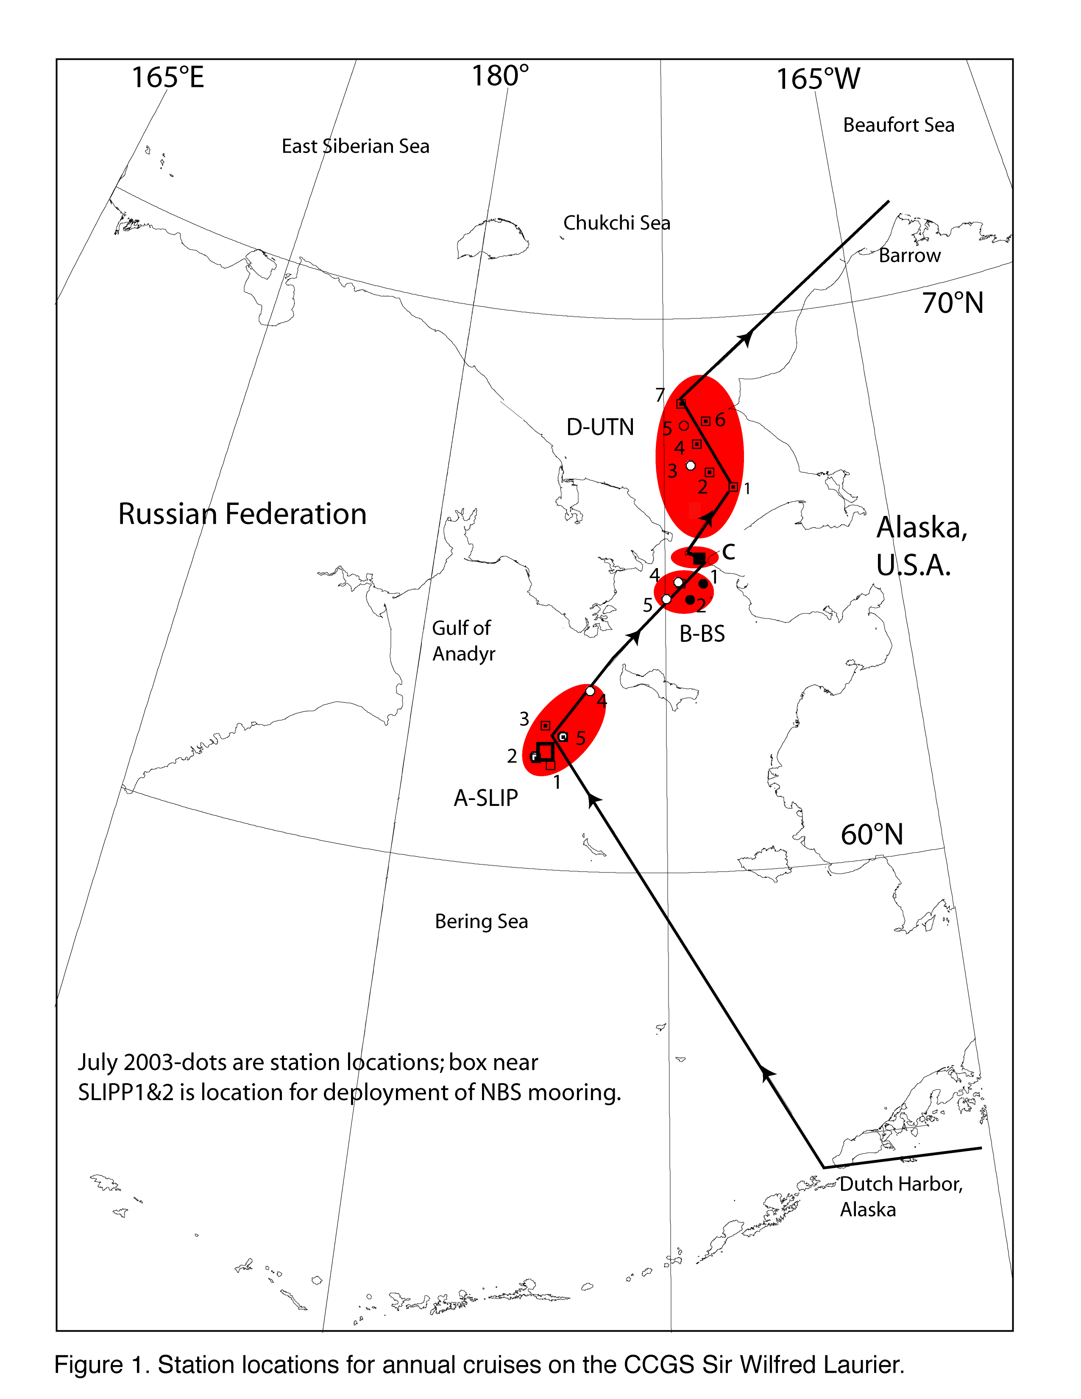
Figure 1. Station cruise track for July 2003 cruise on the CCGS Sir Wilfrid Laurier

A. Participants

Embark Dutch Harbor, Alaska (11/12July 2003) and Disembark Barrow, AK (22/23 July 2003), 12 days; total participants=10
- Dr. Jackie Grebmeier (F)-U Tennessee, Chief Scientist
- Jane Eert (F)-DFO/IOS Co-Chief Scientist
- Dr. Lee Cooper (M)-U Tennessee
- Arianne Balsom (F)-U Tennessee
- Rebecca Pirtle-Levy (F)-U Tennessee
- Betty Carvellas (F)-TEA teacher, Essex High School, Vermont
- David Brown (M)-TEA teacher, St. Peter School, Quincy, IL
- Dr. Peter Lee (M)-U of Charleston, SC
- Nathan Garcia (M)- U of Charleston, SC
- Sarah Thornton (F)-U Alaska Fairbanks
- Sigrid Salo (F)-PMEL (Dr. Jim Overland, PI)

B. Science Station Planning
The following plan includes station locations for planned sampling (see Fig. 1):

- five long-term sites south of St. Lawrence in a “hot spot” region (A) where we have been observing bivalve and upper trophic level declines over the past decade [1 day sampling];

2. deployment of NBS mooring near stations SLIP1 and SLIP 2 [<1 day, likely part of #1]

- four stations in the NE Bering Sea (B); [1 day sampling]

- five station CTD transect across Bering Strait (C) (U.S. waters only), with a 12 hr stop at Little Diomede Island in Bering Strait for site survey [1 day total time]; and

- seven stations in the SE Chukchi Sea (D) as completed previously during 1998, 1999, 2000 and 2001 [2 days on-site sampling time total];

C. Standard Station Sampling Within The SLIPP01 Station Grid

1. Water column CTD with rosette deployment for S/T/D and water column collections at 5 m depth intervals to bottom of deployment (one deployment). Note that the CTD should be collected continuously for physical oceanographic collections during the descent, then stopped at designated intervals on the ascent for water collections. Two bottom-water bottles will be collected for experimental purposes. Once returned to the deck, seawater will be collected from each rosette bottle on the CTD for the following measurements:
- nutrients-subsamples collected in acid-washed plastic vials and frozen shipboard
- chlorophyll-subsamples collected and processed shipboard on a Turner fluorometer
- oxygen-18-subsample collected in glass vials and sealed for land-based analyses
- DMS-seawater subsamples filtered to measure DMS back on land using cryogenic purge and trap gas chromatography later in the land-based laboratory (DiTullio)
- algal species-subsamples collected for HPLC pigment analyses.

Table 1. LTO station locations to be occupied in 2003 (note BS stations are part of IOS hydrographic sampling where DMSP samples are also collected.
Station  (2003) | Historical  Station | Latitude  (°N) | Longitude  (°W) | Depth (m) | Sampling
BS-1 | same | 56.312 | -172.824 |  | water
BS-2 | same | 56.418 | -172.793 |  | water
BS-3 | same | 56.476 | -172.779 |  | water
BS-4 | same | 56.546 | -172.756 |  | water
BS-5 | same | 56.645 | -172.732 | 36 | water
BS-6 | same | 59.320 | -173.500 |  | water
SLIP1 | VNG1 | 62.013 | -175.056 | 80 | water, sediment
SLIP2 | NWC5 | 62.051 | -175.207 | 82 | water, sediment
NBS | no | 62.150 | -175.400 | 78 | Draft mooring site
SLIP3 | NWC4 | 62.394 | -174.570 | 73 | water, sediment
SLIP5 | VNG3.5 | 62.563 | -173.556 | 65 | water, sediment
SLIP4 | NWC2.5 | 63.029 | -173.457 | 72 | water, sediment
UT-BS5 | OK93-038 | 64.683 | -169.099 | 47 | water, sediment
UT-BS2 | HX73-075 | 64.667 | -169.922 | 45 | water, sediment
UT-BS4 | Laurier1999 | 64.959 | -169.883 | 50 | water, sediment
UT-BS1 | HX59-120 | 64.992 | -169.135 | 50 | water, sediment
BRS5 | HX171-69 | 65.652 | -168.217 | 40 | water
BRS4 | HX171-70 | 65.668 | -168.400 | 46 | water
BRS3 | HX171-71 | 65.682 | -168.567 | 51 | water
BRS2 | HX171-72 | 65.700 | -168.717 | 50 | water
BRS1 | HX171-73 | 65.717 | -168.900 | 50 | water
10 hr stop | Little Diomede Is. |  |  |  | site survey, offload
UTN-1 | Stoker-172 | 66.709 | -168.400 | 36 | water, sediment
UTN-2 | Laurier1998 | 67.051 | -168.733 | 47 | water, sediment
UTN-3 | HX189-076 | 67.333 | -168.998 | 52 | water, sediment
UTN-4 | HX74-010 | 67.501 | -168.913 | 51 | water, sediment
UTN-5 | HX171-076 | 67.671 | -168.958 | 54 | water, sediment
UTN-6 | AK47-055 | 67.736 | -168.439 | 50 | water, sediment
UTN-7 | HX85-090 | 67.999 | -168.933 | 60 | water, sediment

2. Quantitative benthic samples will be undertaken using the following equipment and sampling protocol:
  - Five 0.1 m2 van Veen grabs at each station, with:
i. The first grab will be used for surface sediment subsampling for:
- chlorophyll-two surface sediment sample collected by syringe, and processed for fluorometric analyses shipboard
- TOC/TON, C-13, grain size-subsamples collected, bagged, and frozen
- HPLC pigment analyses-subsample collected, placed in vials, and frozen (DiTullio)
- 7-Beryllium-subsample collected and frozen for land-based analyses on gamma counter

ii. The remaining 4 van Veen sediment collections will be sieved for faunal collections. Each van Veen sediment sample is placed in a 1 mm stainless steel screen box and sieved using regular seawater, the remaining animals subsequently preserved in 10% sea water formalin, buffered with hexamethylenetetramine, stored in plastic Whirl-pak bags, and saved for laboratory analyses back at the University of Tennessee.

b. Three deployments of a single hole HAPS sediment corer (number of deployments depends on sediment conditions). The following methods are used for analyses:

i. Two cores are used for sediment respiration experiments The two cores collected for shipboard incubation will be maintained in the dark at in situ bottom temperatures in the low temperature stand-up incubators for 10-12 hours. Subsamples from the overlying water in these cores will be analyzed in the shipboard chambers for dissolved oxygen, , nutrients, denitrification, alkalinity, pH and total CO2. Subsequent to the end of the experiment, cores are sieved and fauna packaged and preserved with formalin for land-based identification.
ii. One core for subsampling for vertical sediment parameters at the following intervals:
- first, 1cm subcores for DMSP, sediment chlorophyll, and bacterial abundance, then sectioning 1 cm down to 4 cm, 2 cm down to 20 cm, 4 cm below to bottom of core for TOC and grain size;
- remaining sediments placed in 90 cc aluminum cans and frozen. Subsequent land-based analyses include TOC/TON, C-13, and grain size determinations.

NOTE: Both the van Veen grab and single Haps corer weigh about 150 lbs each and are easily deployed on a side-winch cable with a 50-60 m/min descent/assent rate.

D. Mooring Deployment Near Slip 1 And Slip2

In summer 2003, we will deploy a subsurface mooring in 75-78 m of water near SLIP-1 and SLIP-2 in the northern Bering biological hot spot (Region A). This mooring will consist of two seacats and ten microcats to measure profiles of temperature and salinity, two fluorometers to assess chlorophyll (phytoplankton biomass), two current meters and a nutrient meter (Table ). In the second year, we will recover the first-year mooring and procure and deploy a second system to provide a multi-year continuous capability. Table 1 provides the mooring deployment array.

E. Site Survey At Little Diomede Island (10 Hrs)

During a 10 hr stop at Little Diomede Island, we will need assistance and use of a small boat from the Sir Wilfrid Laurier to transport equipment and personnel to the island and to undertake a site survey around the proposed outlet of the submerged seawater pipeline for the observatory. We have "key" measurements to make as part of our Bering Strait Observatory study that need to be measured at approximately 0800, 12 noon, and 1600 at Diomede Island for the pipeline site.

03STL-1A, July-03  Project:  St. Lawrence Is.  Location:  Bering Sea  Latitude:  Longitude:  Seafloor:  75 meters  Currents:  70 cm/s  Instruments:  Seacat  2  Micro cat  2  Nitrate Meter  1  RCM-9  2  SBE-39  8  release  1  Mooring:  Instrument  Depth  Seacat (FL/P)  11m  RCM-9-C  14m  SBE-39  17m  Nitrate Meter  18m  SBE-39  20m  SBE-39  23m  Seacat (FL/P)  27m  SBE-39  30m  SBE-39  35m  SBE-39  40m  Micro Cat  45m  SBE-39  50m  RCM-9-C  55m  Micro Cat  60m  SBE-39  65m  Release  seafloor  75m  Previous Deployments: None  Mooring Design Change: N/A | 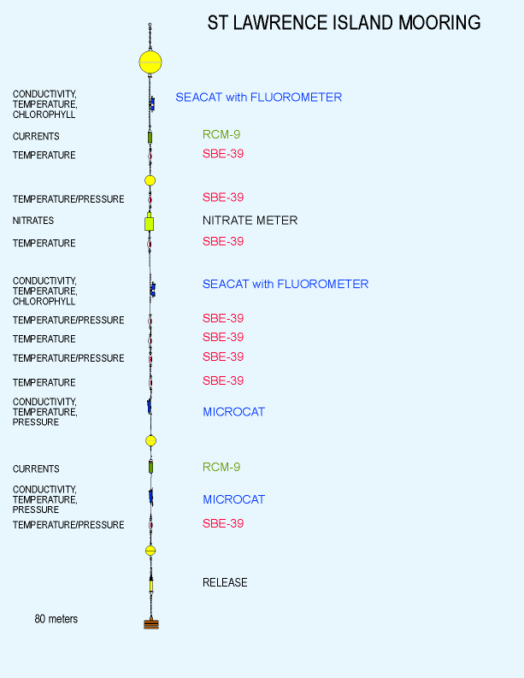

Figure 2. NBS mooring deployment array sensor location (left panel) and location on mooring (right panel).
Thus, we will need a small boat form the SWL and 1-2 two crew to help us periodically through the day.

Table 2. Coordinates for site survey at Diomede Island.
 |  | Decimal Minutes |  | Decimal Degrees
Place | Alternate Name | Lat | Long | Lat | Long
North Perpendicular 0 (Beach) | North Beach | 65°45.546' | 168°57.101' | 65.7591 | -168.9517
North Perpendicular 1 (Pump Hole) | Pump | 65°45.583' | 168°57.239' | 65.7597 | -168.9540
Northern Lead Edge | Lead | 65°47.182' | 168°56.340' | 65.7864 | -168.9390
North Parallel A (northmost) | Grey | 65°47.068' | 168°56.440' | 65.7845 | -168.9407
North Parallel B | Orange | 65°46.886' | 168°56.512' | 65.7814 | -168.9419
South Perpendicular 0 (Beach) | South Beach | 65°45.357' | 168°57.069' | 65.7560 | -168.9512
South Perpendicular 1 | Dud (no hole) | 65°45.428' | 168°57.122' | 65.7571 | -168.9520
South Perpendicular 2 | Box | 65°45.324' | 168°57.398' | 65.7554 | -168.9566
South Perpendicular 3 | Lake | 65°45.296' | 168°57.672' | 65.7549 | -168.9612
South Perpendicular 4 | Two Stick | 65°45.289' | 168°57.931' | 65.7548 | -168.9655
South Perpendicular 5 | 2x4 | 65°45.261' | 168°58.328' | 65.7544 | -168.9721
South Parallel A (northmost) | Baton Rouge | 65°44.878' | 168°59.044' | 65.7480 | -168.9841
South Parallel B | New Orleans | 65°44.794' | 168°59.112' | 65.7466 | -168.9852
International Date Line at Diomedes |  |  | 168°58.370' |  | -168.9728
Intnatl Date Line North | IDLN | 65°47.182' | 168°58.370' | 65.7864 | -168.9728
Intnatl Date Line South | IDLS | 65°44.794' | 168°58.370' | 65.7466 | -168.9728

F. Grebmeier Cargo, Chemicals And Needs From IOS
Most of the LTO cargo are stored at IOS in Canada from the Laurier 22002 or will be sent in May 2003:

1. Cargo stored at IOS (fall 2002)
Box 1 of 14 labelled to offload to Healy, but left in Canada (misc. supplies)
Box 1 of 20: Deep black rubbermaid: plastic cups
Box 2 of 20: Small Black Rubbermaid: cans, lids, ziplock bags
Box 3 of 20: Small Black Rubbermaid: lab supplies
Box 4 of 20: Shallow Black Rubbermaid: plastic cups, lab supplies
Box 5 of 20: Shallow Black Rubbermaid: raingear
Box 6 of 20: Green Box: canner
Box 7 of 20: White Bucket: cubitainers

Box 8 of 20: Stacked Buckets
Box 9 of 20: Bucket Lids
Box 10 of 20: Black Rubbermaid: lab supplies
Box 11 of 20: Deep Black Rubbermaid: nutrient vials, plasticware, GF/C filters, chl filter rig
Box 12 of 20: none, taken to Healy 2002
Box 13 of 20: metal wash basin
Box 14 of 20: metal wash basin
Box 15 of 20: HAPS corer brace
Box 16 of 20: van Veen grab brace
Box 17 of 20: wooden sieve box
Box 18 of 20: small van Veen grab
Box 19 of 20: large van Veen grab
Box 20 of 20: white wooden Haps corer box

2. Chemicals at IOS (labeled Grebmeier, Hold for Laurier2003), should be transferred to chemical locker on Laurier
PI:Laurier 20030-Leg 1 | Box Label  (c=chemical)  of 12 boxes | Chemical | Quantity | Type  (storage location)
Grebmeier-UTN | c-1 | Formaldehyde (37%) | 16 L ( 4x4L) | Base room
Grebmeier-UTN | c-2 | Hexamethylenetetramine | 1100g:5x200gplus 1x200g | Base room
Grebmeier-UTN | c-3 | Acetone (100%) | 16 L | Base room
Grebmeier-UTN | c-4 | Methanamine | 500g | Base room
Grebmeier-UTN | c-6 | Proponal | 3 L | Base room
Grebmeier-UTN | c-8 | Contains:  a. cubitainer of 90% acetone  b. Rose Bengal stain  c. isopropanol  d. methanol | Contains:  a. 1 L  b. 2 g  c. 2 L  d. 1 L | Base room
Grebmeier-UTN | c-9 | Methanol | 500 mL | Base room
Grebmeier-UTN | c-11 | Formaldehyde (37%) | 14 L (3x4L, plus 1x2L) | Base room
Grebmeier-UTN | c-5 | Sulfuric acid (10N) | 500 mL | Acid room
Grebmeier-UTN | c-7 | Hydrochloric acid (0.1N) | 1.4 L | Acid room
Grebmeier-UTN | c-10 | Hydrochloric acid (0.1N) | 1 L | Acid room
Grebmeier-UTN | c-12 | Sulfuric acid (10N) | 500 mL | Acid room

