Project Report

Department of Fisheries and Oceans
Institute of Ocean sciences
Sidney, B.C., Canada

To: Regional Science Director. Final: Yes

1. Cruise/Project No.: 2003-11 2. Dates: May 26 to June 18, 2003
3. Project Name: Line P - Argo
4. Area(s) of Operation: N.E. Pacific to Station P – West of Queen Charlotte Islands – Rivers and Smith Inlets
5. Platform: John P. Tully 6. Master: John Anderson
7. Days Allocated: 28 8. Days at Sea: 21
9. Days lost to weather: None
- Days lost to other causes: 3 hours, looking for a drifting mooring
11. Appropriateness of platform: great 12. Safety issues: None
13. Cruise/Project Results (see appendix for details):

- The deployment aspect of the Argo project was very successful. We did all the rosettes and bongos planned at Argo stations, and all the floats behaved properly when woken up. Unfortunately, we could not recover the mal-functioning float because of problems with timing (the floats resurface only every 10 days).
- The Line P survey was very successful. The CTD survey shows a Haida eddy centered around station P12, roughly 400 miles offshore.
- We collected surface samples along the route for T, S, nutrients and chlorophyll. The problem we had with the thermosalinograph not holding the right time seems to be fixed.
- Seabird and marine mammals surveys along Argo line and Line P for CWS (Bridget Watts).
- There were no major problems with mooring work, except for one instrument (NAS) not ready on time to be deployed (see appendix). Also, the acoustic rain gauge (ARG) on the SOLAS mooring case was found to be damaged and flooded uopn recovery. It was not re-deployed.
- The sampling using the “skimmer” was also successful (see appendix)

14. Primary Institute: Institute of Ocean Sciences, DFO
15. Associated Institutes: University of British Columbia, Canadian Wildlife Service
16. Chief Scientist/Affiliation: Marie Robert, IOS

17. Science Staff/Affiliations:

Marie Robert | IOS | Nick Hall-Patch | IOS
Darren Tuele | IOS | David Barclay | IOS
Wendy Richardson | IOS | David Timothy | IOS
Tim Soutar | IOS | Philippe Tortell | UBC
Doug Anderson | IOS | Nina Nemcek | UBC
Mike Arychuk | IOS | Michelle Li | UofA
Svein Vagle | IOS | Bridget Watts | CWS contract
Magnus Eek | IOS

18. Equipment: ADCP: yes Other: sounder, thermosalinograph, SCS

19. Winches: .
type | ID No | Wire type | Wire Condition/Spooling | No Casts/  Depth max
Hawboldt 3242 | 17026 | CTD | Had problems | 31/4300m
Hawboldt 3242 | 17027 | CTD | Good | 39/2000m
Swann | 1207 | Moorings | Good
Swann | 1450 | Moorings | Good
Swann | 1451 | Moorings | Good
Swann | 1432 | Bongo | Good | 14/250m

20. Equipment Deployed/recovered:

Sediment trap mooring at P4, recovered and redeployed
Sediment trap mooring at P26, recovered and redeployed
SOLAS mooring at P26, recovered and redeployed
Single sediment trap mooring at P26, recovered.

21. Comments and recommendations:

Science issues:

The mid-ship winch (Hawboldt 17027) started to give us problems after the 7th cast (got shorted out). Since there had been a problem with the starboard winch (Hawboldt 17026) during the previous cruise (2003-12) we attached a train wheel at the end of the cable and deployed 900m of cable to measure the diameter of the cable. Since it seemed ok, we switched to winch 17026. But the problems did not go away. We kept having spikes in the data, misfire in the bottle cast, etc. We tried using the spare deck unit, but that did not fix the problems. In order to go back to winch 17027, the cable had to be re-terminated. Since we had no 6-pin connector on board, we had to reterminate with a 2-pin connector. Once we were back to the mid-ship winch (17027) all the problems were solved. Winch 17026 will have to be examined to find out what the problem is, since it is still not fixed.

The science work was completed 5 days earlier than planned. The reasons are as follows:
- We had planned to recover an Argo float that is mal-functioning. 36 hours had been reserved for this recovery. But the float started to drift to the North West, which made the recovery non practicable (it would have taken much too long to sail there and back). So we gained 36 hours then.
- Since the mooring work at Station Papa was VERY important, many days had been set aside for weather. The weather being good, we did not have to use those spare days.
- We were supposed to sail to Port Hardy in order to pick-up an instrument that was to be installed on the mooring deployed at Cape Calvert. The instrument did not get ready on time, so the detour to Port Hardy got cancelled. We gained some more hours there.

Science/Ship issues:

The cables behind the deck units in the lab were in a considerable state of mess. Most of the cables are non-identified, some of them were not even used, but were mixed with the important cables. It would be great to have a system that would un-clutter that part of the lab, either some hooks on the bulkhead to hang the cables, or otherwise. Greater care should be taken when setting up these systems.

Ship issues:

The Tully should be recognized as primarily a science vessel and be supported to complete science programs. We discussed needs that could be addressed during mid-life refit that would greatly enhance the productivity of cruises and improve the safety of personnel. Ideas include isolating some procedures (radioisotope use, noxious chemistries) from the main lab in containers on the aft and boat decks, improving power to the lab (UPS), improving seawater supplies to lab and heli deck, replacing the aft deck crane and refurbishment of transducers and sounders. The Tully will need such modifications to support some of the emerging work that IOS and other institutes are undertaking.

General issues:

Many thanks to the crew of the Tully for all their help during the cruise, especially during the mooring work. Thanks also to the science staff that got ‘volunteered’ to stand a watch or to attack other duties. Special thanks to Captain Anderson for his usual help and great knowledge of our programs. And a very special “farewell” to Tim Soutar, who was doing his last “official” (Station Papa) cruise. Tim, we’ll miss you.

Appendix: Reports from Participants

CTD Survey – Marie Robert

The Line P section of the cruise was completed very successfully. Every station was surveyed, which means we performed 21 CTDs casts, 13 rosette casts, and 9 bongos. As mentioned previously, we traversed a Haida Eddy situated around Station P12. The temperature profile of Figure 1 shows the eddy very well.
The nutrient and chlorophyll samples were processed on board but will be analysed in greater detail at the institute.

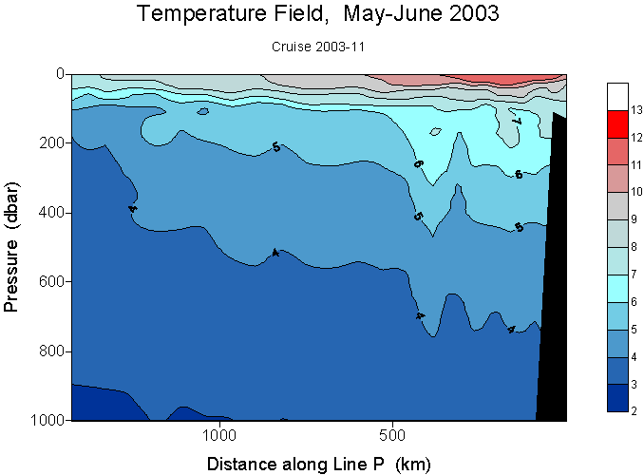
Figure 1: Temperature Profile along Line P

Moorings – Darren Tuele

The mooring portion of the trip was carried out without incident. The sediment trap moorings P-4 and P-26 were recovered, serviced and re-deployed. The SOLAS mooring was also recovered, serviced and re-deployed. The winch problems encountered last year with the anchor first SOLAS mooring were not an issue this year, that combined with favourable weather conditions made for a problem free deployment. As usual, the experience of the Tully deck crew were responsible for the safe and smooth operations during mooring deployments and recoveries.

SOLAS Mooring recovery and redeployment – Svein Vagle

The North East Pacific SOLAS (Surface Ocean Lower Atmosphere Study) mooring which was deployed close to Station P (50 01.679N 144 56.173W) Wednesday September 4, 2002 was successfully recovered June 4. The mooring was equipped with sensors to allow for studies of air-sea gas exchange processes for longer periods and especially periods with high wind and sea states (Figure 1). This complicated subsurface mooring had been deployed in waters near 4200m deep and the closest sensor ended up at a depth of 47m.
The different sensors and information about recording period and sampling intervals are summarized in the Table below.

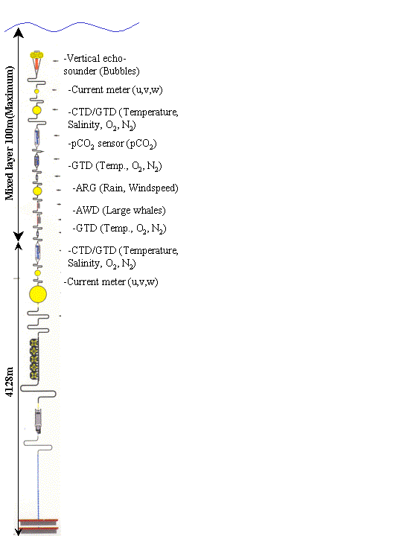
Figure 1. Station PAPA (50 01.679N 144 56.173W), NE Pacific SOLAS mooring. (September 02-June 03).
Sensor | Parameter(s) | Mean depth | Start time (UTC) | End time (UTC) | Sampling interval (sec)
WASP | 200kHz upward looking sounder | 47m to surface | 03:00 Sep 5 02 | 4 June 03 | 10
Tpod(9118) | Temperature | 47m | 03:00 Sep 5 02 | 4 June 03 | 20
S4 (SN1846) | Current meter | ~52m | ?? | ?? | ??
Tpod(9121) | Temperature | 54m | 03:00 Sep 5 02 | 4 June 03 | 20
Tpod(9123) | Temperature | 61m | 03:00 Sep 5 02 | 4 June 03 | 20
CTD (SN4119) | Temp., Sal.,Depth, Fluorometer,DO | 61m | 03:00 Sep 5 02 | 17 Jan 03 | 3600
GTD | O₂ & N₂ | 61m | 03:00 Sep 5 02 | 17 Jan 03 | 3600
GTD/N | N₂ | 61m | 03:00 Sep 5 02 | 17 Jan 03 | 3600
SAMI A | PCO₂ | 62m | ?? | ?? | 3600
SAMI B | PCO₂ | 63m | ?? | ?? | 3600
Tpod(9127) | Temperature | 62m | 03:00 Sep 5 02 | 4 June 03 | 20
Tpod(9128) | Temperature | 63m | 03:00 Sep 5 02 | 4 June 2003 | 20
Tpod(9130) | Temperature | 64m | 03:00 Sep 5 02 | 4 June 03 | 20
GTD | O₂ & N₂ | 64m | 03:00 Sep 5 02 | 17 Jan 03 | 3600
Tpod(9131) | Temperature | 66m | 03:00 Sep 5 02 | 4 June 03 | 20
Tpod(9133) | Temperature | 68m | 03:00 Sep 5 02 | 4 June 03 | 20
GTD | O₂ & N₂ | 70m | 03:00 Sep 5 02 | 17 Jan 03 | 3600
Tpod(9134) | Temperature | 70m | 03:00 Sep 5 02 | 4 June 03 | 20
Tpod(9136) | Temperature | 72m | 03:00 Sep 5 02 | 4 June 03 | 20
Whale listener | Sound recorder | 74m | ?? | ?? | Misch.
Tpod(9137) | Temperature | 74m | 03:00 Sep 5 02 | 4 June 03 | 20
Tpod(9139) | Temperature | 76m | 03:00 Sep 5 02 | 4 June 03 | 20
Tpod(9141) | Temperature | 79m | 03:00 Sep 5 02 | 4 June 03 | 20
Tpod(9143) | Temperature | 84m | 03:00 Sep 5 02 | 4 June 03 | 20
Tpod(9144) | Temperature | 87m | 03:00 Sep 5 02 | 4 June 03 | 20
Tpod(9145) | Temperature | 90m | 03:00 Sep 5 02 | 4 June 03 | 20
Tpod(9146) | Temperature | 93m | 03:00 Sep 5 02 | 4 June 03 | 20
Tpod(9147) | Temperature | 96m | 03:00 Sep 5 02 | 4 June 03 | 20
Tpod(9148) | Temperature | 98m | 03:00 Sep 5 02 | 4 June 03 | 20
Tpod(9149) | Temperature | 98m | 03:00 Sep 5 02 | 4 June 03 | 20
Tpod(9150) | Temperature | 101m | 03:00 Sep 5 02 | 4 June 03 | 20
Tpod(9151) | Temperature | 106m | 03:00 Sep 5 02 | 4 June 03 | 20
Tpod(9152) | Temperature | 109m | 03:00 Sep 5 02 | 4 June 03 | 20
Tpod(9153) | Temperature | 112m | 03:00 Sep 5 02 | 4 June 03 | 20
CTD (SN4118) | Temp., Sal.,Depth, Fluorometer,DO | 112m | 03:00 Sep 5 02 | 17 Jan 03 | 3600
S4 (SN1467) | Current meter | ~115m | ?? | ?? | ??
Data from sensors with question marks have not yet been downloaded.

Very preliminary analysis of the data indicates that we have a very interesting and scientifically useful data set. An example of the raw temperature data from the 24 temperature-pods is plotted in Figure 2, clearly showing the depth of the mixed layer during the deployment period.
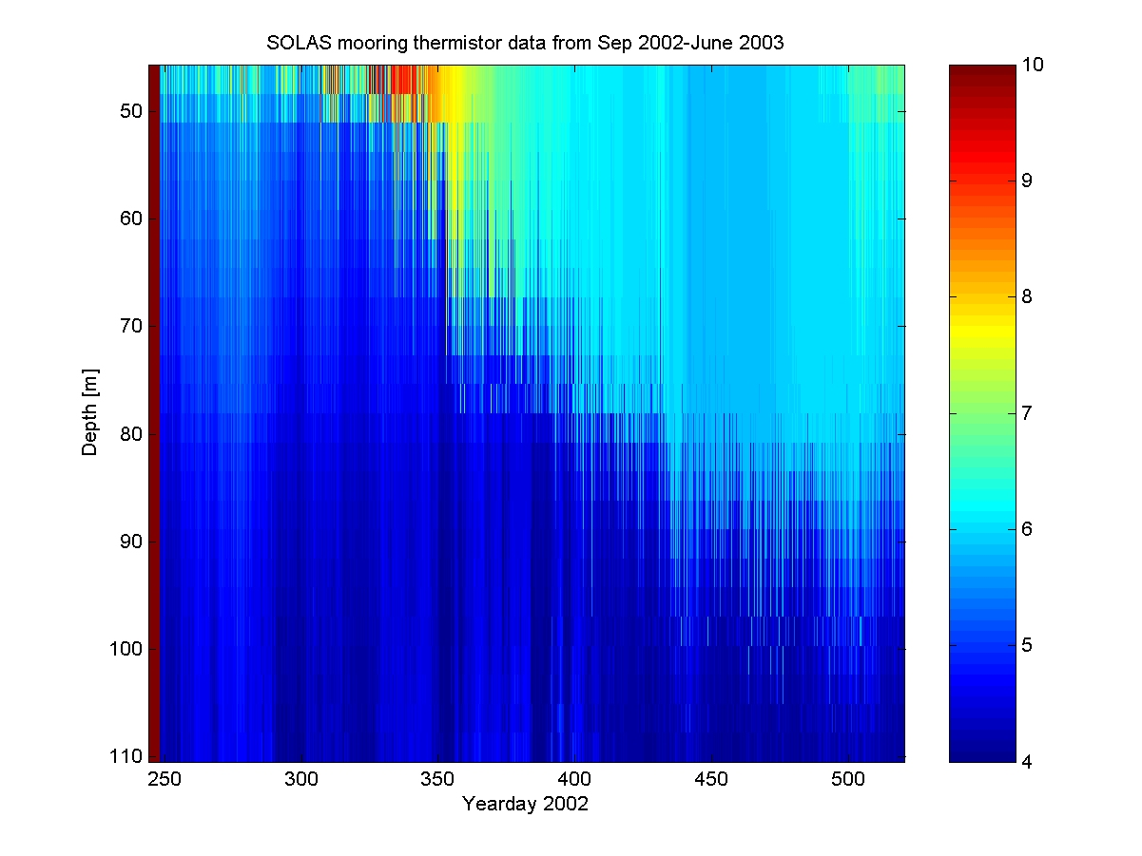
Figure 2. Raw temperature data from internally recording temperature sensors mounted on the SOLAS mooring. Twenty-four loggers measured temperature every 20 seconds for the 9 month period.

All instruments were either serviced or replaced during the period from June 4 to June 7 and the mooring was deployed in position 50 01.688N 144 56.180W for another year. (Except for the ARG, see previous note). The most probable depth of the shallowest sensor is probably between 15 and 20m, well suited for tracking of the mixed layer even during the summer months. A great effort by all science and ship personnel involved in recovery, instrument servicing, and redeployment.

Continuous Oxygen and Nitrogen measurements onboard the ship – Svein Vagle

Throughout the cruise Oxygen and Nitrogen were continuously measured from the saltwater loop in the lab using a SBE43 DO sensor and a ProOceanus GTD to evaluate the usefulness of such measurements and to explore the possibility of constructing a more permanent system for such gas measurements on the ship.

Sea-Surface Microlayer sampling – Magnus Eek, Svein Vagle

A device for sampling the sea surface microlayer was successfully deployed at three stations (P4, P26 and New 4) during 2003-11. An unsuccessful attempt was also made in Rivers Inlet, but was aborted due to a malfunction in the skimmer’s steering mechanism. During each deployment approximately 20 L of microlayer and 14 L of sub-surface (~ 10–30 cm) water was collected. The samples were frozen shortly after collection and brought back to IOS, where they will be analyzed for both contaminants and naturally occurring lipids and carbohydrates.
The device or microlayer skimmer has been designed and constructed at the Institute of Ocean Sciences. This cruise was also the first time the skimmer has been tested for deployment in the open ocean, a test it passed after only a few adjustments.

Sea-bird and marine mammals survey – Bridget Watts

Early on, Pink-Footed Shearwaters and Sooty Shearwaters were the most common birds seen. These were common from about 48d 36m N and 125d 39m W to 126d 15m W. Sootys were seen occasionally during the rest of the trip. Several Buller's Shearwaters were seen, but at a distance. Interspersed early, Sabine's Gulls were occasionally seen as singles, with two group sightings of 8 and 17 birds.
Black-Footed Albatross were often seen, most usually alone or in pairs. Laysan were seen
by several people, but not by the birder!
Leach's and Fork-Tailed Storm-Petrels were the most prevalent birds for the majority of the trip. We had occasional hitchhikers, in the laundry room, in the inflatable boat, and in Tim's boot.
Tufted Puffins were sighted occasionally in pairs. Two Horned Puffins were seen during the trip.
Common Murres, Ancient Murrelets, and Cassin's Auklets became more prevalent as we traveled towards the Charlotte Islands. Two Kittlitz's Murrelets were seen at very close range at about 53d 30m, 133d 42m. Rhinoceros Auklets and Glaucous-Winged Gulls became very common from River's Inlet down through the Johnstone Straight. Through the Strait of Georgia, few birds were seen, and most were gulls of various year classes (probably Glaucous-Winged and GW-Western hybrids). Several flocks of Brandt's Cormorants were seen in this area, as well as two hummingbirds on swift fly-bys.
Northern fur seals were the most commonly seen pinniped, and Dall's Porpoise the most often encountered cetacean. Captain Anderson saw a single sperm whale at distance, and several possible beaked whales were seen, but only quick glimpses during the end of dives. Humpbacks were seen off the Charlotte's. A school of approximately 200 Pacific White-Sided Dolphins were seen in Georgia Strait.

Cruise Report – Philippe Tortell, Nina Nemcek UBC
Marine microorganisms can affect global climate through the production and consumption of various trace gases that alter the earth’s heat and water budgets. Though many methods exist to measure trace gases in seawater, many of these are rather laborious and time consuming, and they are generally specific to single compounds. Our research during the cruise focused on the development of a new trace gas detection method based on membrane inlet mass spectrometry (MIMS). In this method, seawater flows past a silicone membrane through which gases permeate into the ion source of the mass spectrometer for subsequent analysis. We used MIMS to measure the concentration of dissolved CO2, O2, N2, Ar, and dimethylsulfide in discrete rosette samples, and also to monitor the change in these gases in underway samples collected from the ship’s seawater line. We also used MIMS to measure the concentration of particulate DMSP (the precursor of DMS) produced by marine algae. As part of our sampling, we also collected samples for phytoplankton cell counts, bacterial numbers, and primary productivity.

