Processing Notes for the Year 2002 Nanoose Bay Data 29 July, 2026

Ron Perkin

.hex and .con files were inspected then used to create .cnv files using the Sea Bird software and the recommended processing for the SBE19 using the following batch file. The new Seabird software would not process this data; I had to use the "oldseasoft" directory.

cd d:\nanoose\oldseasoft
echo use Ctrl-Break to interrupt processing
datcnv -i%1 -oraw -c%1
if errorlevel 1 goto abort
filter -iraw -o%1
if errorlevel 1 goto abort
alignctd -i%1 -o%1
if errorlevel 1 goto abort
loopedit -i%1 -o%1
if errorlevel 1 goto abort
split -i%1 -oddown -ouup
if errorlevel 1 goto abort
binavg -i%1 -o%1 -d
if errorlevel 1 goto abort
derive -i%1 -o%1 -c%1
if errorlevel 1 goto abort
strip -i%1 -o%1
if errorlevel 1 goto abort
goto end
:abort
echo batch process interrupted by user
:end

.cnv files were converted to .ios files.

The old Visual Basic program was converted to .NET format and positions were added from the .act files. Coordinates were taken from the .act files as distance in metres, x' and y', along range 2 which was inclined at an angle of 11.2º south of east. Conversion into easting and northing coordinates was done according to (output was .ctd files):

X = x'cos(11.2) + y'sin(11.2)
Y = -x'sin(11.2) + y'cos(11.2)

Conversion to lat/long was done according to:

Lat = 49º (21.05' +Y*60/111120)
Long = 124º + (9.55 - X*60/72387)

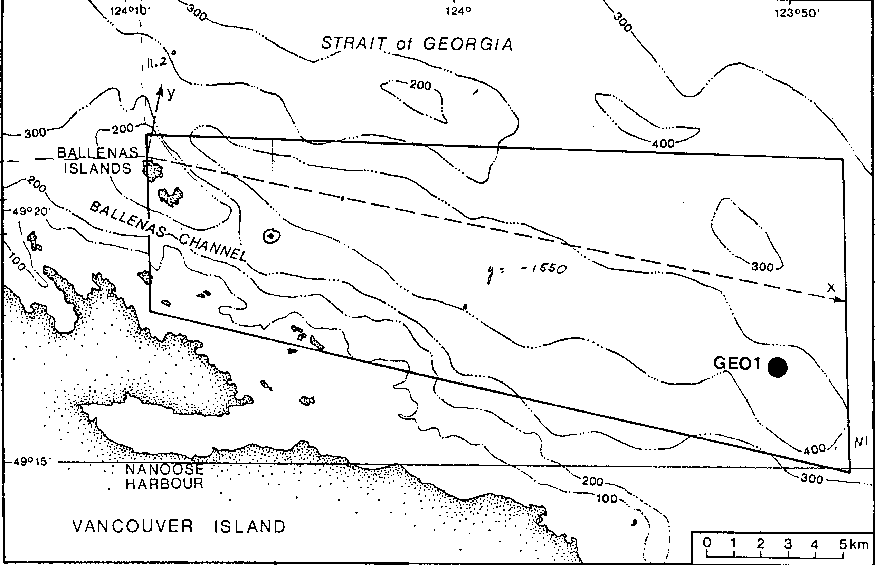
The data were inspected in CTDedit and small corrections were made to:
N2012301.ctd bad cast; discard
N2102301.ctd, a few glitches caused by rapid temperature change.
N2091001.ctd, 102 m deleted at the bottom.
N2090401.ctd, a few glitches caused by rapid temperature change.
N2082901.ctd, a few glitches caused by rapid temperature change.
N2021301.ctd, a few glitches caused by rapid temperature change.
The data was exported to a .o4x file(station name was added) and was inspected in Ocean Data View. Outliers were removed and the time sequence was contoured.
Fixed .ctd files. Posted with the IOS sequential numbering.
Made .o4x with station numbers and imported into ODV.

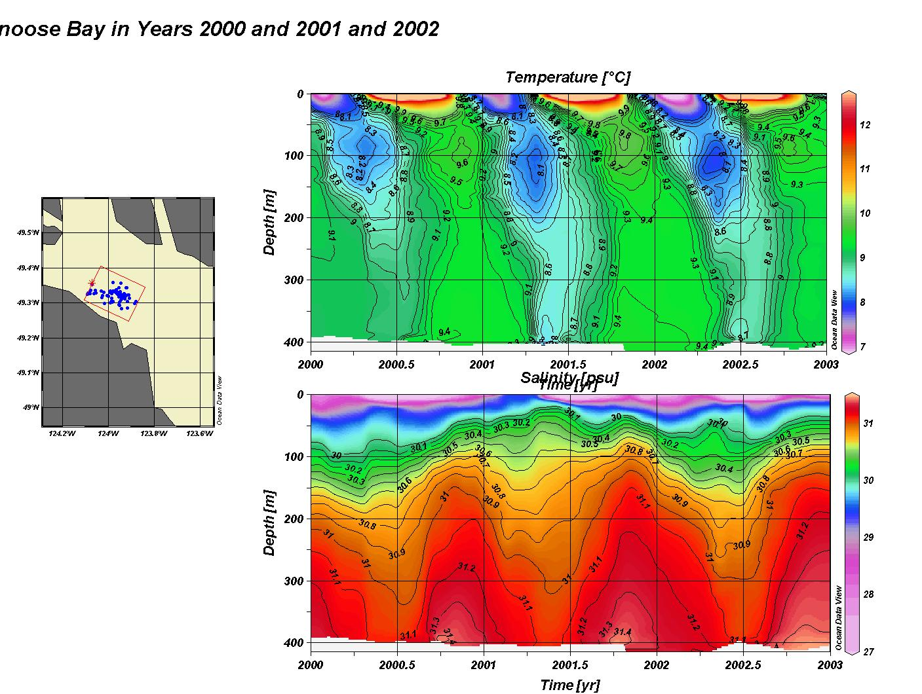
Figure 1

