REVISION NOTICE TABLE
DATE | DESCRIPTION OF REVISION

PROCESSING NOTES
Cruises: 2002-42
Agency: Ocean Sciences Division, Sidney, B.C.
Project: Quesnel Lake
Area: Quesnel Lake
Chief Scientist: Carmack E.
Platform: A variety of small boats were used for this multi-year project
Date: 30 July 2002 – 31 July 2002

Processed by: Germaine Gatien
Date of Processing: 28 November 2014 –1 December 2014
Number of original CTD casts: 9
Number of casts processed: 9

INSTRUMENT SUMMARY
A Sea Bird Model SBE 19 SEACAT CTD (S/N#2688) was pumped with a 30s delay.

SUMMARY OF QUALITY AND CONCERNS
A spreadsheet with positions and map was available.

The soak period for the CTD was ~2 minutes as recommended by the manufacturer.

Comparisons of data converted using pre-cruise and post-cruise calibrations show that by February 2003 the temperature was higher by ~0.0004C° and the salinity lower by ~0.0002. These drifts are well within the accuracy of the instrument.

A correction of +1.7db was applied to pressure based on plots of when conductivity showed the CTD moved from air to water. The same offset was seen as the CTD moved out of water at the end of casts. (In 2001 an offset of +1.4db was found appropriate.)

The data from Event #1 look reasonable from the surface to ~26db, but below that and through much of the upcast they do not. Only the data from the surface to 26db will be archived.

PROCESSING SUMMARY
1. Seasave - This step was completed at Quesnel Lake; the raw data files are *.hex.

2. Preliminary Steps
The hex file names were changed to standard format.
There was no log, but there was a spreadsheet containing station names, latitude, longitude and a cruise map. No bottom depths were given. The vessel used is unknown.
The CTD was turned on in air, put in the water and soaked for ~2 minutes before lowering as recommended by the manufacturer.
The CTD sampled 2 times per second.

- Conversion of Raw Data
The configuration file provided was checked against records kept for the Arctic pool of instruments, and the only error found was in the date of calibration for one sensor. This was corrected and the file was saved as 2002-42-ctd.xmlcon.

A second configuration file had been prepared in 2002 with a pressure offset of +1.7db. Based on the results of 2001-46 when the same sensor was used, the pressure likely does need a significant offset applied; for the earlier cruise an offset of +1.4db was applied. For both that cruise and this one, there had been only slight drift in the pressure calibration between factory checks, but there are other sources of pressure error and SeaBird suggest allowing the CTD to equilibrate for 5 hours before deployment and then determine what offset is needed. That may be how the 1.7db offset was determined in 2002. Accuracy for this sensor type is given as ±0.25% of the maximum which is ±2.5db for the range of this sensor.

All files were converted using file 2002-42-ctd.xmlcon without a pressure offset. Plots were made to determine when there is a sign of the CTD moving from air to water and that is seen in several files at about 1.7db. So the conversion file was updated with that value and the data were converted again.

An initial examination of the data shows a very large difference between downcast and upcast for temperature and conductivity for event #1, though the conductivity range is extremely small. The temperature profile suggests an unstable water column. Perhaps there was a a problem with the pump.

There were some small reversals in pressure. It is possible that the upcast is ok. Some casts are very shallow.

Profile plots show a very small conductivity range. For the deeper casts there is a large temperature gradient with a high gradient in the top 30db. Some other casts have lower surface temperature, so the gradient is much lower. The descent rate was usually quite low but quite steady, ~0.2 or 0.3m/s.

- FILTER
The conductivity was low-pass filtered with a time constant of 0.5 seconds to force it to have the same response as the temperature and pressure was filtered with time constant 2s. Derivation of salinity shows it is smoother after this step and the small reversals are gone from the pressure.

- Align CTD
Tests were run to find appropriate advancements for T. For 2001-46 a setting of +0.5s brought the temperature traces into better alignment with conductivity (using features in plot of T and C versus scan #). As for the earlier cruise the results are not easy to interpret, but a value of +0.5s for temperature is likely best and is recommended by SeaBird.
ALIGNCTD was run applying the +0.5s advance to temperature.

- DERIVE
Program DERIVE was run to calculate salinity.

7. Conversion to IOS Headers
The IOSSHELL routine for Sea Bird ASCII files was used to convert the Sea-Bird data to IOS Headers.
CLEAN was run to add event numbers.
The station names, bottom depths and positions are missing from the headers. That information is available from a spreadsheet provided. Spreadsheet 2002-42-hdr-merge.csv was prepared with that information.
Program MERGE CSV FILE TO HEADERS was run to add the headers to the CLN files.

8. Checking Headers
The surface check was run. The average surface pressure is -0.14db; 3 of the 4 negative surface pressures are associated with zero conductivity values and the other has extremely low conductivity, so these are either out of water or right at the surface. The offset used in conversion looks appropriate.

A cross-reference list was produced. The times look like local time, probably PDT. They run from 10:50 to 20:51 which look like reasonable sampling times in July if they are PDT, but rather late if it is PST.
ADD TIME CHANNEL was used to add 7 hours to each header time to get times in UTC.
The cross-reference list was produced again.
Header Check was run and showed some negative pressure and conductivity values; no other problems were noted.

A track plot was produced but the coastline is not available for that site. It looks reasonable in comparison to a map that was provided with the raw data.

9. SHIFT
SHIFT was not run as alignment was done earlier.

10. Inter-comparisons
Previous Use of CTD – These sensors were used during 2001-46 but they were recalibrated between those uses.
Post Cruise Calibration – All sensors were recalibrated in December 2004 or February 2005. A second configuration file was prepared with post-cruise calibrations to check the calibration drift between the two factory checks. The temperature was higher in late 2004 by 0.0007C° and the conductivity was lower by <0.0003S/m. The errors are thus insignificant even if all the drift occurred by July 2002. The surface pressures were higher by about 0.3db in the top 50m.
Repeat Casts – There were no repeat casts.
Historic ranges – There is no local climatology for this area.

11. Test Plots
Profiles were plotted for all casts.
The profiles mostly look ok with temperature decreasing, but some are very shallow and cast #1 looks very strange. All casts were put through REVERSE so upcasts could be put through DELETE and examined.

12. DELETE
There remain a few records with negative pressure values so CLIP was run to remove the first 60 records. These are all before or during the soak period.
Then DELETE was run on the CLIP files using the following parameters:
Surface Record Removal: Last Press Min Maximum Surface Pressure (relative): 10.00
Surface Swell Pressure Tolerance: 1.0 Pressure not filtered (Done Earlier)
Swells deleted. Warning message if pressure difference of 2.00
Minimum Drop Rate 0.2m/s over 5 records between 10db and 10db above maximum pressure
There were no warnings in the Delete log.
The reversed files were also put through DELETE to produce DELREV upcast files.

For cast #1 the upcast looks worse than the downcast. Event #6 which was nearby has much higher surface temperatures, suggesting that something was wrong during the first cast, but event #2 looks similar near the surface. Local variability could be very high, so the top 26m of cast #1 may be ok and is stable, but below that the profiles look unstable.

The station names were removed because the same names were used in 2001 for different sites and were likely used at other sites for other years as well. They only serve as event #s which are already listed in the headers. Given there is no consistency, this could be misleading to users.

13. CTDEDIT
CTDEDIT was used to remove a few bad records from the tops of all casts plus a few bottom records from cast #4 and bad data between 27 and 45db from cast #1.
Notes were entered in the headers about editing applied.

14. BIN AVERAGE
The following Bin Average values were used:
Bin channel = pressure
Averaging interval = 1.000 Minimum bin value = .000
Average value will be used. Interpolated values are NOT used for empty bins

15. REMOVE and HEADEDIT
The following channels were removed from all casts: Scan_Number, Conductivity, Oxygen, Descent_Rate and Flag.

The HEADEDIT routine was used to fix channel names, units and formats and to add the following comment to the headers:
There was no salinity calibration sampling, but a post-cruise factory
check indicates that there was no significant drift in conductivity
or temperature calibration.

The standards check routine was run and the only problems noted were the lack of a platform name. A number of vessels were used over the years and it is not known which was used in 2002.

16. Producing final files
The final files were renamed *.ctd.
b.) A cross-reference listing was produced.
c.) The sensor histories were updated.

Particulars
1. Temperature and conductivity look bad from about 27m to bottom of downcast and most of upcast.

Institute of Ocean Sciences
CRUISE SUMMARY

Cruise ID#: 2002-42
Dates: Start: 30 July 2002 End: 31 July 2002
Location: Quesnel Lake Vessel: ? Party Chief: Carmack E.

CTD Calibration Information
Make/Model/Serial#: SEABIRD/SEACAT v1.6b / 2688 Cruise ID#: 2002-42

Calibration Information
Sensor |  | Pre-Cruise |  | Post Cruise
Name | S/N | Date | Location | Date | Location
Temperature | 2688 | 20Feb02 | Factory | 15Dec04 | Factory
Conductivity | 2688 | 20Feb02 | Factory | 15Dec04 | Factory
Pressure Sensor | 192787 | 23Feb02 | Factory | 4Jan05 | Factory

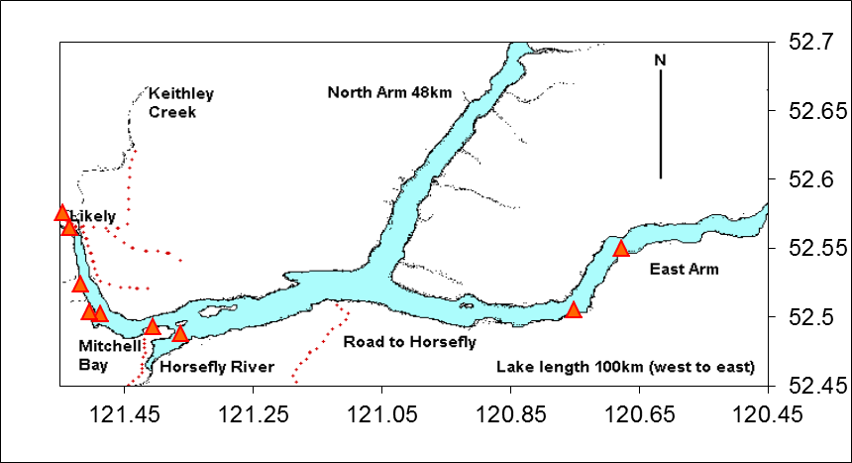
The map above was prepared by the project participants in 2003.

