PACIFIC REGION CCG VESSEL CRUISE PLAN

DEPARTMENTS: Fisheries and Oceans; Central Research Institute for the Electric Power Industry (CRIEPI, Japan); National Institute for Environmental Studies (NIES, Japan); University of B.C.

SCIENCE CRUISE NUMBER: 2002-30 SHIP’S PATROL NUMBER: 02-06

NAME OF SHIP/PLATFORM: John P Tully

SURVEY AREA/AREA OF OPERATION: NE Pacific Ocean, to 50N, 145 W; Hecate Strait area.

CRUISE OBJECTIVE[S]: Survey water properties along Line P, look for the iron patch from July, return along Line P to Hecate Strait then sample in Rivers Inlet.

DATE: FROM: Aug 22 TO: Sep 16, 2002

SENIOR SCIENTIST[S]/CONTACT TEL. #’S: Frank Whitney, 250 363-6816

SCIENTIFIC PERSONNEL: BERTHS REQUIRED: 15 to 17

Chief Scientist | Frank Whitney
Male | Female
Marty Davelaar (IOS) | Wendy Richardson (IOS)
Tim Soutar (IOS) | Nes Sutherland (IOS)
Darren Tuele (IOS) | Cheryl Martin (UBC)
Bernard Minkley (IOS) | Julie Granger (UBC)
Takeshi Egashira (NIES)
Philippe Tortell (UBC)
Mike Bentley (CWS)
Jeff Christe, SFU student
Jun Nishioka (CRIEPI)
Takeshi Yoshimura (CRIEPI)
Keith Johnson (IOS)

SHIP EQUIPMENT REQUIRED:
Seawater to Heli deck for incubators
Seawater supply to main lab and aft deck for sampling and net cleaning
Accurate Gyro (please check accuracy during cruise, contact Doug Yelland)
Heave compensator and tugger winch
Zodiac for sampling surface ocean
Crane to assist with mooring deployment

DECK MACHINERY REQUIRED:
[ATTACH DECK PLAN AT END OF DOCUMENT]
Winches and wire to support water sampling, net tows, mooring servicing, etc.
Deck plan to follow (from Tom Juhasz)

FISHING GEAR REQUIRED: none

OTHER EQUIPMENT TO BE LOADED:
Mooring gear (anchors, floatation, hardware)

SPECIAL REQUIREMENTS:
[INCLUDE LAUNCH/SMALL BOAT REQUIREMENTS AND SPECIAL POWER REQUIREMENTS]
zodiac for transport of samples between ships at sea
440 v for lab trailer
seawater for incubators (heli deck)

DANGEROUS CHEMICALS:

GAS CYLINDERS:
- Nitrogen and air – 8

ACIDS and Bases:
- Hydrochloric Acid, 20 L
- minor amounts of nitric, sulfuric and phosphoric acid, ammonium hydroxide

TOXIC:
- Mercuric chloride – 1 L saturated solution
- Sodium Azide – 500 g
- Formaldehyde – 2 L
- Glutaraldehyde – 1 L
- Oxalic acid – 500 g

FLAMMABLES:
- Acetone – 10L
- iso-propanol – 20 L

RADIOISOTOPES:
[INCLUDING CERTIFICATES]
- 14C sodium bicarbonate – 10 mCi

ANTICIPATED LOADING TIME:
1 day loading, 12 h offloading

LOGISTICS:
COMMENCE LOADING [DATE/TIME]: Aug 22, 8 pm at IOS
SAILING [DATE/TIME]: Aug 24, 10 am
EXPECTED OPERATIONS PROFILE: 24 h
RETURNING [DATE/TIME]: Sep 15
OFFLOADING: [DATE/TIME]: Sep 15-16
SCIENTIFIC CREW CHANGES: none

DATE GENERAL AREA OF OPERATIONS
[LINES/MOORINGS/STATIONS]

Aug 23 Load
Aug 24 Depart, test cast in Saanich Inlet
Aug 25-Sep 6 Line P survey
Sep 7-10 Return leg, Line R
Sep 11-13 Hecate Strait, Rivers Inlet
Sep 14-15 Return to IOS
Sep 15-16 offload at IOS

PROPOSED CRUISE
ITINERARY:

N.B.: ALSO ATTACH LIST OF
STATIONS, MOORING
OPERATIONS, OR SURVEY LINES

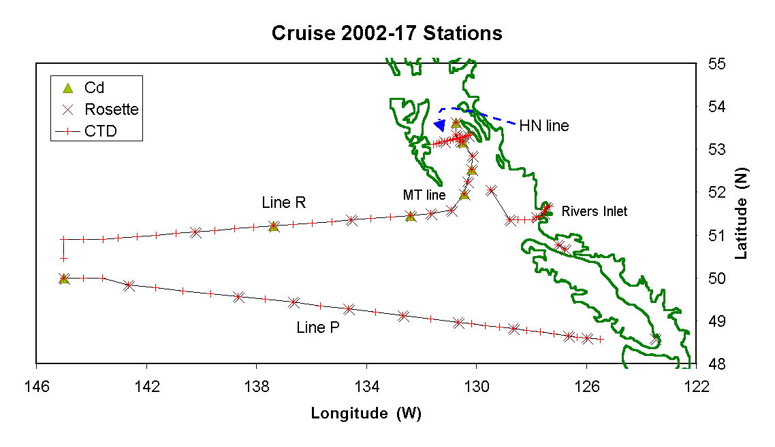
Station List:

St'n | Lat | (N) | Long |  | (W)
Saanich Inlet
S3 | 48 | 35.33 | 123 |  | 30.13 | Saanich Inlet test cast
Line P
JF01 | 48 | 16.00 | 123 |  | 30.00 | sail through
JF02 | 48 | 18.00 | 124 |  | 00.00 | sail through
JF03 | 48 | 27.00 | 124 |  | 30.00 | sail through
JF04 | 48 | 32.30 | 125 |  | 00.00 | sail through
P1 | 48 | 34.50 | 125 |  | 30.00
P2 | 48 | 36.00 | 126 |  | 0.00
P3 | 48 | 37.50 | 126 |  | 20.00
P4 | 48 | 39.00 | 126 |  | 40.00 | 500 m mooring recover and redeploy
P5 | 48 | 41.60 | 127 |  | 10.00
P6 | 48 | 44.60 | 127 |  | 40.00
P7 | 48 | 46.60 | 128 |  | 10.00
P8 | 48 | 49.00 | 128 |  | 40.00
P9 | 48 | 51.40 | 129 |  | 10.00
P10 | 48 | 53.60 | 129 |  | 40.00
P11 | 48 | 56.00 | 130 |  | 10.00
P12 | 48 | 58.20 | 130 |  | 40.00
P13 | 49 | 2.60 | 131 |  | 40.00
P14 | 49 | 7.40 | 132 |  | 40.00
P15 | 49 | 12.00 | 133 |  | 40.00
P16 | 49 | 17.00 | 134 |  | 40.00
P17 | 49 | 21.00 | 135 |  | 40.00
P18 | 49 | 26.00 | 136 |  | 40.00
P19 | 49 | 30.00 | 137 |  | 40.00
P20 | 49 | 34.00 | 138 |  | 40.00
P21 | 49 | 38.00 | 139 |  | 40.00
P22 | 49 | 42.00 | 140 |  | 40.00
P23 | 49 | 46.00 | 141 |  | 40.00
P24 | 49 | 50.20 | 142 |  | 40.00
P25 | 50 | 0.00 | 143 |  | 36.30
P35 | 50 | 0.00 | 144 |  | 18.20
P26 | 50 | 0.00 | 145 |  | 0.00 | 4200 m moorings, recover and deploy
iron patch |  | locate and sample if possible, Argos drifter
Return leg
MP41 | 50 | 27.00 | 145 |  | 0.00
MP32 | 50 | 54.00 | 145 |  | 0.00
MP49 | 50 | 54.00 | 144 |  | 17.20
MP33 | 50 | 54.00 | 143 |  | 34.50
MR20 | 50 | 55.70 | 143 |  | 1.00
MR19 | 50 | 58.00 | 142 |  | 20.00
MR18 | 51 | 0.00 | 141 |  | 39.00
MR17 | 51 | 2.00 | 140 |  | 56.00
MR16 | 51 | 4.00 | 140 |  | 14.00
MR15 | 51 | 6.00 | 139 |  | 30.50
MR14 | 51 | 9.00 | 138 |  | 47.50
MR13 | 51 | 11.00 | 138 |  | 6.00
MR12 | 51 | 13.00 | 137 |  | 23.00
MR11 | 51 | 15.00 | 136 |  | 40.30
MR10 | 51 | 17.00 | 135 |  | 57.60
MR09 | 51 | 19.00 | 135 |  | 15.00
MR08 | 51 | 21.20 | 134 |  | 32.70
MR07 | 51 | 23.50 | 133 |  | 49.60
MR06 | 51 | 25.50 | 133 |  | 6.60
MJ05 | 51 | 27.50 | 132 |  | 24.00
MT1 | 51 | 30.00 | 131 |  | 40.00 | Moresby Trough section
MT2 | 51 | 35.00 | 130 |  | 55.00
MT3 | 51 | 57.00 | 130 |  | 27.00
MT4 | 52 | 14.35 | 130 |  | 19.00
MT5 | 52 | 31.40 | 130 |  | 11.00
MT6 | 52 | 46.00 | 130 |  | 0.00
MT7 | 53 | 8.305 | 130 |  | 28.572 | 205 m, PGC mooring recovery
MT8 | 53 | 9.680 | 130 |  | 26.029 | 188 m, PGC mooring recovery
MT9 | 53 | 19.94 | 130 |  | 44.02
MT10 | 53 | 37.00 | 130 |  | 45.00
launch pick-up:
oyster trays, 53.4964 N, 130..6333 W
oyster bags, 53.4926 N, 130.6345 W
Hecate Line
HN16 | 53 | 07.00 |  | 131 | 33.50
HN15 | 53 | 08.30 |  | 131 | 26.60
HN14 | 53 | 09.00 |  | 131 | 21.50
HN13 | 53 | 10.50 |  | 131 | 15.20
HN12 | 53 | 11.00 |  | 131 | 09.40
HN11 | 53 | 12.10 |  | 131 | 02.80
HN10 | 53 | 13.00 |  | 130 | 56.90
HN09 | 53 | 13.90 |  | 130 | 51.20
HN08 | 53 | 14.90 |  | 130 | 45.30
HN07 | 53 | 15.50 |  | 130 | 41.00
HN06 | 53 | 16.30 |  | 130 | 37.40
HN05 | 53 | 16.50 |  | 130 | 34.00
HN04 | 53 | 17.30 |  | 130 | 29.60
HN03 | 53 | 18.30 |  | 130 | 24.00
HN02 | 53 | 19.20 |  | 130 | 18.10
HN01 | 53 | 19.80 |  | 130 | 13.70
SP4 | 52 | 2.478 |  | 129 | 25.385 | 196 m, PGC mooring recovery
SP5 | 51 | 21.00 |  | 128 | 46.80
SS1 | 51 | 21.00 |  | 128 | 30.00
SS2 | 51 | 21.00 |  | 128 | 15.00
SS3 | 51 | 21.00 |  | 127 | 57.00
SS4 | 51 | 25.00 |  | 127 | 50.00
Rivers Inlet
RI 1 | 51 | 26.40 | 127 |  | 38.10
RI 2 | 51 | 31.25 | 127 |  | 33.60
RI 3 | 51 | 35.90 | 127 |  | 32.10
RI 4 | 51 | 38.90 | 127 |  | 26.70
RI 5 | 51 | 40.70 | 127 |  | 19.90
RI 2 | 51 | 31.25 | 127 |  | 33.60 | Resample station
QC Sound stns
QCS1 | 50 | 40.00 | 126 |  | 46.3
QCS2 | 50 | 46.6 | 127 |  | 2.3

CTD or rosette casts at most stations, moorings at P4, P26 and three Hecate Strait stations. At P26, the mooring is 4200 m long, other moorings are a few hundred meters or less.

Clean sampling for trace metals at about 12 stations. Please avoid maintenance operations that could produce metal dust (sanding and chipping).

