2002 Cruise Report

Arctic Canada Ocean Watch

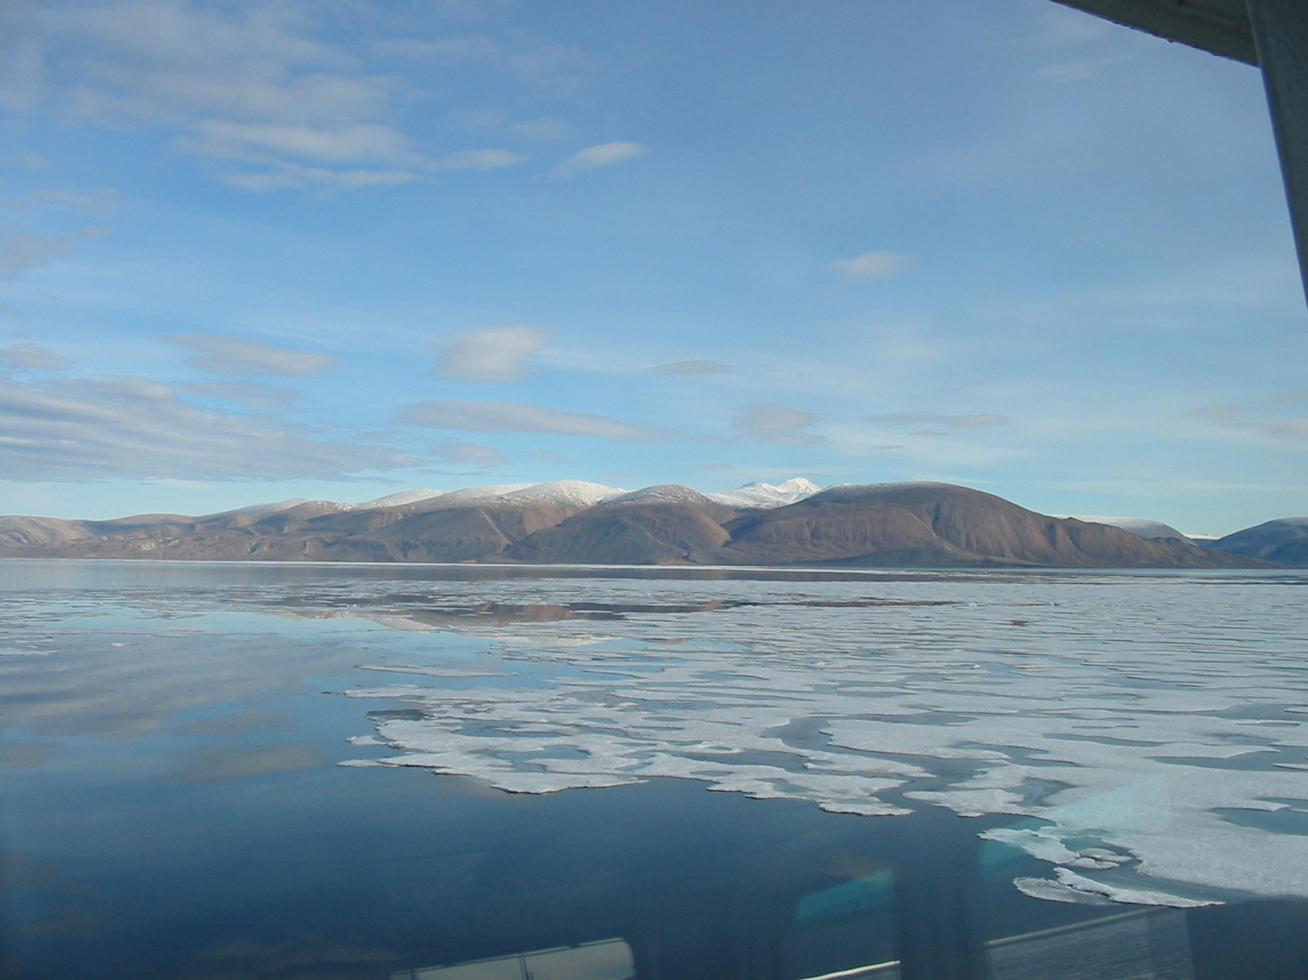
Hell Gate and Cardigan Strait

NGCC des Groseilliers

August 16 – September 1, 2002

Institute of Ocean Sciences

Humfrey Melling – Chief Scientist

Arctic Canada Ocean Watch

NGCC des Groseilliers

August 16 – September 1, 2002

Chief Scientist: Humfrey Melling

Overview
The Arctic Canada Ocean Watch was established in 1997 to monitor change in ice and ocean conditions within the Canadian Arctic Archipelago. It is a Canadian project affiliated with the ongoing Joint Ocean Ice Study (JOIS). ACOW shared moorings with the International North Water Project in northern Baffin Bay in 1997-99.
The Arctic Canada Ocean Watch has short-term (1-3 year) and long-term goals. In the short term, ACOW is exploring the seasonal and interannual variability of currents through the Canadian Arctic Archipelago and evaluating new technology for such measurements. Long term goals are 1) to develop an effective and affordable method for monitoring fluxes of ice and water through the Canadian Arctic Archipelago; 2) to understand the forcing of and controls on these fluxes so that they may be incorporated in global climate models.
The Arctic Canada Ocean Watch has initiated field programmes in both winter and summer. Since 1997 the Canadian Coast Guard has provided icebreaker support to Arctic Canada Ocean Watch in conjunction with its mandated summertime Arctic Patrols.
Figure 1. Areas of interest to the Arctic Canada Ocean Watch: 1) Byam Martin Channel. 2) Penny Strait. 3) Cardigan Strait, Hell Gate, Fram Sound. 4) Nares Strait. 5) Barrow Strait. 6) Wellington Channel. The locations of the two moorings to be recovered from the NGCC des Groseilliers are marked (Melling moorings).
At present, the Institute of Ocean Sciences maintains moorings to measure current in Cardigan Strait and Hell Gate as part of the Arctic Canada Ocean Watch. These moorings complement installations by the Bedford Institute of Oceanography in Barrow Strait. The Cardigan/Hell Gate moorings are maintained on a biennial cycle in even numbered years.
Each mooring carries Doppler sonar (RD Instruments WorkHorse) positioned about 3 m above the seabed. This sonar measures ocean current at levels 8-m apart between the depth of the instrument and the surface. Each mooring carries a Sea Cat (SBE37) instrument that measures seawater properties (temperature and conductivity, for salinity) 2 m above the seabed. Since both instruments record data internally, they must be recovered before any information is obtained.
The Doppler sonar operates using sound scattered from small (millimetre-sized) organisms in the water. A deployment in Cardigan Strait during 1998-2000 revealed that these organisms are relatively scarce during January to April, and the range of the WorkHorse is reduced from 110 m to 60 m at this time. During 2000-2002, we tried two innovations to extend the working range to the full depth of the strait, 200 m in Cardigan Strait and 120 m in Hell Gate. In Cardigan Strait we used a sonar operating at lower frequency (75 kHz), where the attenuation of sound with distance is much smaller than at the 300-kHz standard frequency for the WorkHorse. In both straits, we set up the sonar to operate in the pseudo-narrow-band mode which reduces the instrument noise level.
The mooring was designed at the Institute of Ocean Sciences to operate effectively in this area of very high current speed, and of no suitable geomagnetic reference for current direction. The mooring is torsionally rigid, so that all currents measurements are made relative the same fixed, but unknown heading. This heading is deduced from the orientation of the tidal flow during subsequent data processing.
During 1997-1999, moorings were installed also in Nares Strait, the third principal channel connecting the Arctic to the Atlantic. The servicing of these moorings by icebreaker was a significant challenge because fast-moving, thick ice dominates this area in summer. A renewed attempt to measure fluxes through this channel will be initiated in 2003, using aircraft to retrieve and replace moorings at the southern end of Kennedy Channel.

Goal
The objective of the Arctic Canada Ocean Watch during 2000-2002 was the measurement of current simultaneously in Cardigan Strait and Hell Gate, which together constitute one of the three principal routes for flow from the Arctic Ocean through the Canadian Arctic; the others are Barrow Strait and Nares Strait. The observations during 2000-2002 in Cardigan Strait/Hell Gate were concurrent with complementary measurement in Barrow Strait by the Bedford Institute of Oceanography (Jim Hamilton & Simon Prinsenberg). An earlier deployment, from September 1998-2000 in Cardigan Strait, initiated the time series while demonstrating the viability of our approach to current measurement in this unique environment.
The goals of the activity from the NGCC des Groseilliers during August 2002 were:
- Completion of oceanographic sections by CTD, with sampling for dissolved nutrients, oxygen isotopes and barium, in the two straits and in Fram Sound, with reference stations upstream in Norwegian Bay; the chemical constituents are used as tracers of place of origin for seawater
- Recovery of the two moorings, one in Hell Gate and one in Cardigan Strait
- Retrieval and assessment of data from the instruments; servicing of the instruments and moorings
- Deployment of both instruments on moorings in Cardigan Strait, for the period 2002-2004
- Evaluation of underway photographic methods for deriving the thickness of pack ice along the ship’s route

Setting
Typical ice conditions along the route from Nanisivik to Tanquary Fjord in late August are illustrated on the right. Ice is first encountered in western Jones Sound at about 3 tenths concentration. Concentrations of 7-9 tenths are typical in Norwegian Bay, with less difficult conditions on the western side of Graham Island. Lighter ice predominates in Eureka Sound and eastern Nansen Sound, but concentrations build again in Greely Fjord.
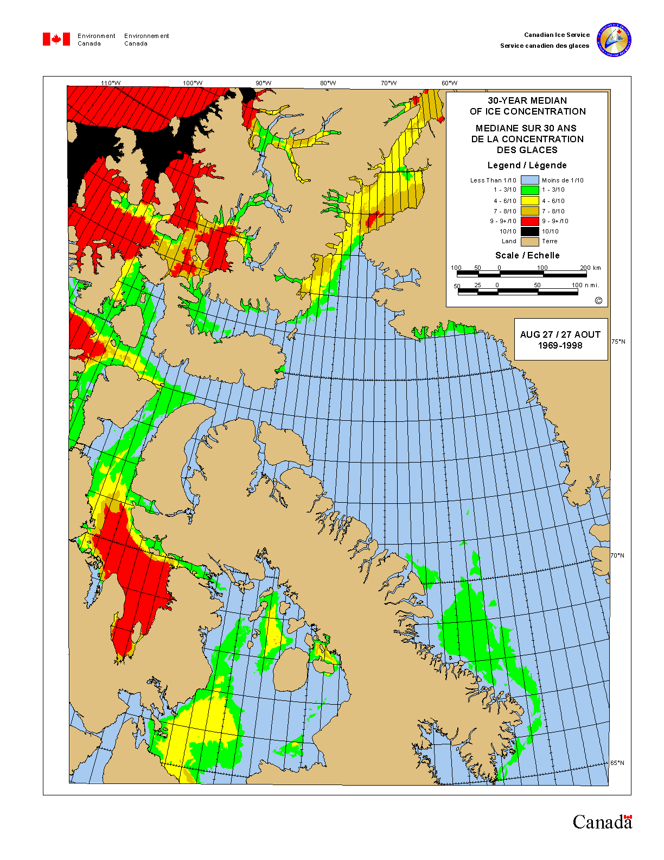
Hell Gate and Cardigan Strait connect Norwegian Bay to Jones Sound via Fram Sound. Strong tidal currents in these straits prevent consolidation of ice in winter but old ice is absent at this time because the potential sources of such ice to the north and south are land-fast. However, a stream of thick old floes (green area in the adjacent figure) moves into the straits as the ice of Norwegian Bay breaks up in late July. Ironically, ice conditions for navigation are worst in this region during August and September.
The time frame for the work of the Arctic Canada Watch was dictated by ice conditions, for navigation up the western coast of Ellesmere Island and for unloading cargo at Eureka. These are most favourable during the last two weeks of August, but the risk of ice hindering or even preventing our work in the straits was not trivial. In fact, ice conditions throughout the cruise were similar to the climatological median depicted in the figure and posed no serious challenges to the scientific programme.

Equipment and Activities
We designed the technical aspects of the project so that no specialized oceanographic deck equipment was needed on the ship to complete the work.
The moorings were equipped with a tandem acoustic release assembly for redundancy in both transponder and release functions. The transponders permitted positioning of the mooring in relation to ice floes and the ship through communication via a hydrophone deployed over the rail from the fore deck. A coded acoustic command from the control unit caused the separation of the dead weight and buoyant components of the mooring. When the mooring was sighted at the surface, the ship’s boat was deployed to secure it to the ship’s crane. Each mooring came on board as a single lift. At deployment, moorings were assembled on deck, lifted over the side as units and deployed to free fall to the seabed. The free-fall approach was essential because station keeping is difficult and unproductive in the very strong currents (5 knots) of this area.
Observations of ice were acquired using digital still-frame and video cameras deployed in several ways. Photographs for determining the thickness of ice were acquired by the video camera, mounted looking downwards at the starboard rail just forward of the house works. Here, blocks of ice broken by the ship and rotated on edge were photographed at they slid along the hull. The set-up was calibrated by photographing a target grid lowered to the water line.
Oblique-view photographs of ice around the ship were taken at intervals using the still-frame camera. At these times, an ice-classification system developed by Australian scientists for the estimation of pack-ice thickness in open seas was tested.
We had planned to determine floe size from photographs with a downward looking camera mounted on the ship's helicopter. Unfortunately, our camera mount did not meet the complete MOT certification requirement. Instead, we obtained oblique views of sea ice using a hand-held camera in the helicopter.
The CTD was deployed via a block suspended from the ship’s crane on the fore deck. A lightweight electrically powered winch designed for aircraft deployment, with 1500-m of conducting wire, was used. Water for chemical analysis could be acquired using a single bottle attached to the wire just above the CTD. Samples at various depths could be obtained by lowering the CTD repeatedly to target depths and dropping a weight (messenger) to close the bottle. This weather sensitive operation was conducted in the open air. Fortunately, weather was fine and the air temperature stayed above freezing. Under adverse conditions, or for a more ambitious sampling programme, a more sophisticated approach would be needed to safeguard data quality.

Personnel

Humfrey Melling (scientist), Peter Gamble (mechanical technologist) and Rob Reed (electronic technologist), all from the Institute of Ocean Sciences, were responsible for the mooring project. Jackie Dumas (University of Victoria) and Humfrey Melling worked together on ice-thickness observation and on measurements with the CTD.

All scientific personnel left Victoria on Friday August 16, spent the night in Ottawa and travelled north on Saturday, bound for Nanisivik. Unfortunately because adverse weather caused cancellation of the landing at Nanisivik, the scientific party opted to disembark at Resolute Bay. A charter flight was arranged to complete the 240-mile trip to Nanisivik when the weather cleared sufficiently on August 19th (Monday). The NGCC des Groseilliers was loading cargo at this time. Leaving at 20:00 on the following evening, the ship reached Hell Gate on the 21st and Eureka late on the 22nd. Leaving late on the 25th for Tanquary, the ship was back in Cardigan Strait by mid-day on the 28th and at Nanisivik in the early morning of the 31st.
The science party had the good fortune of fine weather on September 1st, leaving Nanisivik by air for Ottawa late in the day. Personnel reached Victoria by noon of the following day.

Challenges of Air Cargo
Heavy equipment for the project was shipped by truck to Quebec in time for the ship’s departure on June 24th. Scientific instruments, equipment for electronic diagnosis and last-minute items were shipped by air for Nanisivik on August 2nd. The airport at Nanisivik is more than 1000 m above sea level and frequently in cloud. Moreover, a fire at the airport in early August had damaged the landing aids. Because of poor weather, our freight had not reached Nanisivik by August 20th despite several attempts to bring it in from Iqaluit (flights are scheduled on Wednesdays and Saturdays).
Realizing that the ship would have left Nanisivik by the time of the next flight on August 21st, we arranged to have the freight re-routed to Resolute Bay, from where transfer to the ship with the assistance of PCSP could be readily accomplished. On the 21st, the freight reached Resolute, and was unloaded there, only to be re-loaded when ground crew noticed the labelling for Nanisivik, which had not been changed. The freight was left at Nanisivik.
When notified of the error, First Air kindly arranged that their normal flight sequence (Iqaluit, Resolute, Nanisivik, Iqaluit) be reversed on their Saturday flight (August 24th) so that our freight could be picked up at Nanisivik and transferred to Resolute. The pick-up occurred as planned, but since the freight was not unloaded at Resolute it made its way back to Iqaluit.
On Sunday, the freight finally reached the North on an unscheduled freight flight to Resolute. Our luck turned. PCSP had scheduled a Twin Otter to travel to Tanquary Fjord on Monday August 26th to pick up Parks Canada staff at the end of their season. The aircraft, travelling north empty, brought our freight in as the NGCC des Groseilliers was unloading fuel and supplies for the park at Tanquary camp.

Mooring Component
The NGCC des Groseilliers reached ACW00-5, the site of the mooring in Hell Gate, late on the afternoon of August 21st. Although a few small floes in the vicinity posed no serious problems, the ship was drifting south-east at about 1 kt despite a strong (25-kt) opposing wind. The mooring was quickly located, released and recovered. We were not able to measure a profile of temperature and salinity at the site because the CTD instrument required for this was part of the shipment yet to reach the ship.
The ship backtracked down Hell Gate and proceeded west and then north-west up Cardigan Strait. Here again, it was windy but ice was not a problem. We quickly located the mooring at ACW00-3 by transponder, but were unable, despite repeated attempts, to transfer a complete release code to either of the transponders. Believing that the noise from the ship or wind waves were the source of the problem, we placed the acoustic equipment in the 733 for operation remote from the ship. This approach was also unsuccessful. Not having our spare acoustic command unit (it was part of the freight yet to reach the ship), we abandoned the site, with intent to try again on our return leg.
In the interim, two problems in the acoustic command unit were identified. First, the rotary switches that select the release code had been damaged by infiltration of salt water and would only select one code of the 32 codes possible (the wrong one). Second, salt water had entered the command unit to cause corrosion on the contacts of the large capacitors that power the transmitter. The result was a low source level for transmissions from the surface hydrophone.
We returned to Cardigan Strait around mid-day on August 28th. At this time there was 5-tenths ice made up of floes typically less than 20-m diameter, although a few were 30 m across. There was 3-knot current to the south-east, but wind was light. The mooring was located with ease, and released following a wait of about 30 minutes for ice conditions to improve.
The schedule of the ship required a rapid turn-around of the moorings and instrument for redeployment. Turn-around involved up-loading and inspection of data, replacement of instrument batteries, thorough testing of instrument function, programming of instruments for new deployments, replacement of anodes, servicing of mooring hardware and re-assembly.
The 300-kHz ADCP retrieved from Hell Gate a week earlier was destined for site ACW02-4 at 130-m depth on the eastern side of the Cardigan Strait. It was deployed in the early afternoon.
Preparation of the 75-kHz ADCP was completed at 01:30 am on August 29th. The mooring was dropped soon after sunrise at site ACW02-2, the deepest point (209 m) of the sill in Cardigan Strait. The photograph shows this mooring being lifted from the deck in preparation for deployment.
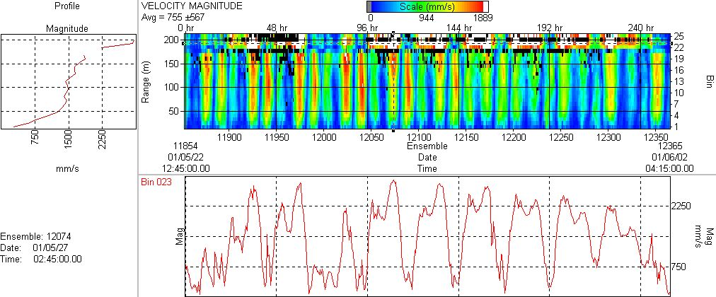
The fastest currents observed in both channels were on the ebb tide, and represent the combined effect of the spring tide, mean current and wind drift. The fastest flow occurred at the surface and reached 3 m/s in both straits. The figure below illustrates the variation of current over a 12-day interval in late May 2001, in Cardigan Strait (top) and Hell Gate (bottom).

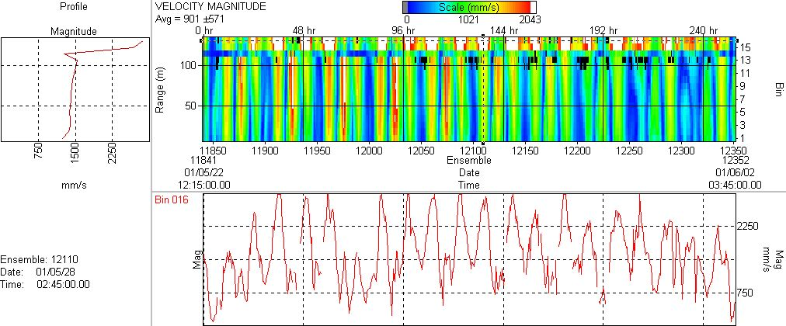
Ice Measuring Component
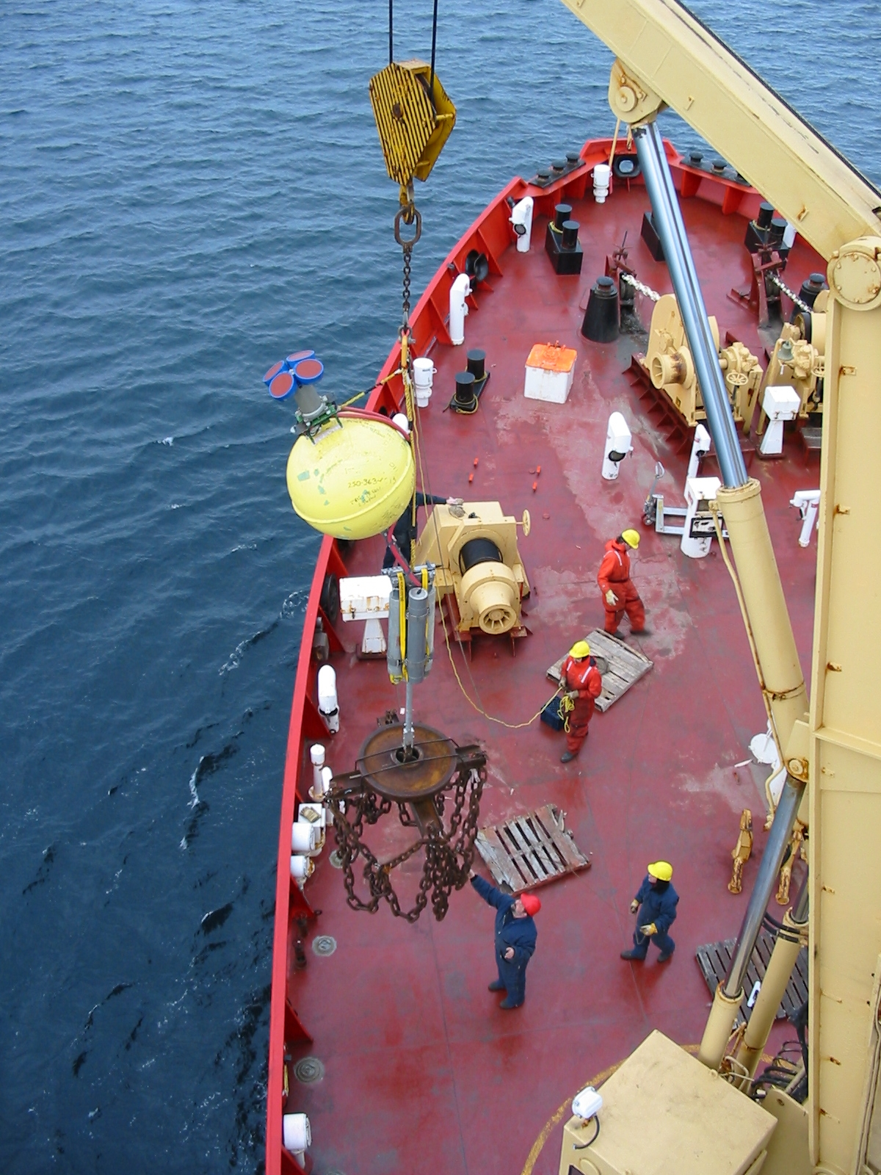
Ice was encountered at significant concentration only in Strathcona Sound, Norwegian Bay and Greely Fjord. We were not yet prepared for thickness observations in Strathcona Sound when we passed along it very early in the trip. However, continuous video was acquired with the downward looking camera during our passage through the two other areas of ice.
The ice in all areas was either thick first-year or second-year ice with extensive coverage by melt ponds. Only traces of old ice were encountered. This is in part because a route that avoids old ice is almost followed if at all possible. This bias to light ice is intrinsic to this method of observation, making the results relevant to navigation, but less so to climatological studies.
Vast areas of undeformed ice prevailed. Ridges were scarce and of low elevation. Thaw holes were common.
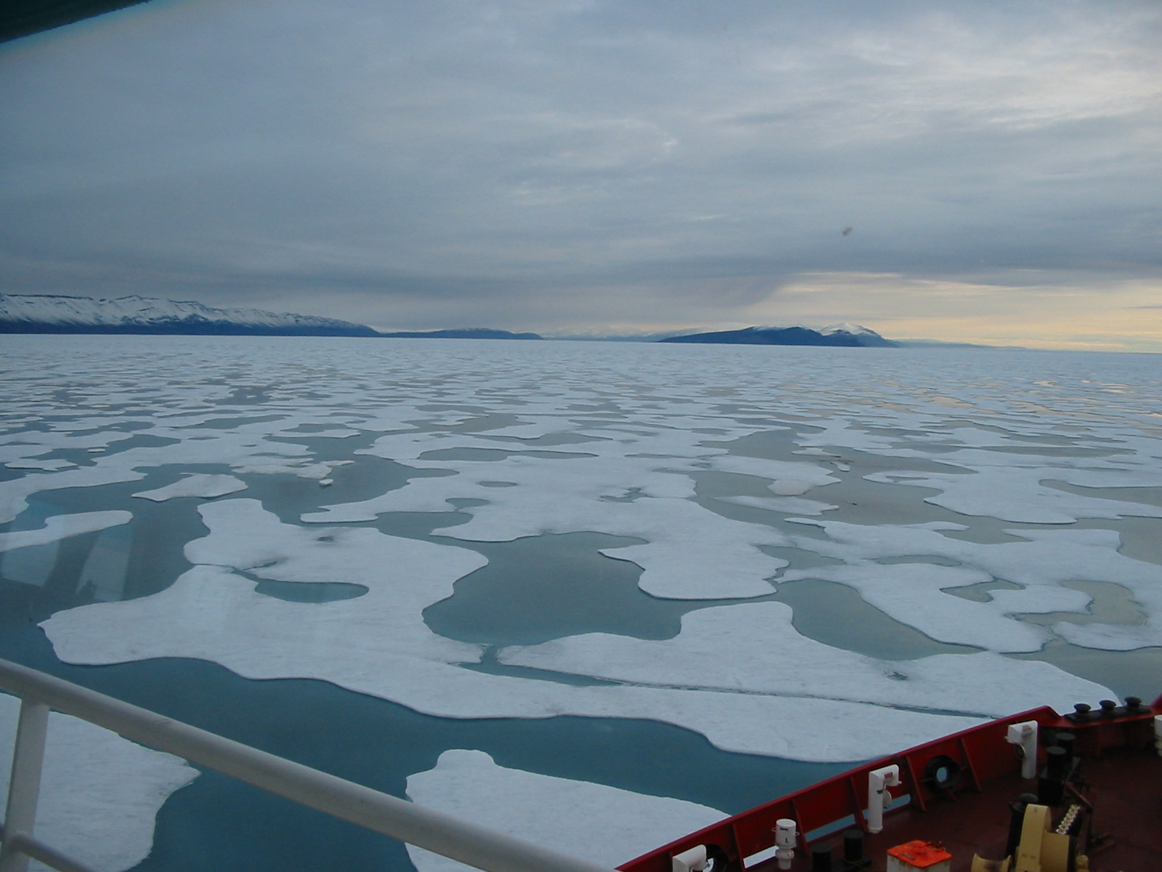
The adjacent photograph shows the ice encountered in northern Norwegian Bay at the entrance to Eureka Sound.

CTD and Sampling Component
Our plan was to complete several oceanographic sections in the vicinity of the straits in conjunction with sampling for geochemical tracers. Receipt of the CTD equipment was long delayed, and its surface read-out capability was found to be non-functional when it was first tested. Water sampling was not possible without this capability, and the ship’s schedule allowed us insufficient time to make repairs. Therefore, water samples were not obtained.
The CTD probe was operated at 15 locations, recording data internally for later inspection. We occupied 2 reference stations in Norwegian Bay, a section of 4 stations in Cardigan Strait and one of 8 stations in Fram Sound. Locations are shown on the map to the right.

Assessment
On balance, this was a successful trip. Most of the planned activities were completed. Exceptions were the water sampling and the helicopter flights for floe-size measurement.
All of the moored instruments worked flawlessly over the 2-year deployment, yielding complete and exciting data records for scientific study. The rushed turn-around of moorings and instruments before re-deployment, a consequence of multi-tasking, certainly may have increased the probability that errors were made. The consequence of one small error to a long-term mooting programme can be the loss of expensive instruments or a long data gap in a time series. However, we are optimistic that all equipment was conscientiously serviced and should yield good results two years from now.
The science schedule was cramped by the operational schedule of the Coast Guard, which was primarily concerned with cargo contracts. We did oceanography for 2 days of the 17-day expedition, which included 6 days of travel to and from the ship. The cost to Science of the ship’s use was a few thousand dollars, for crew’s overtime and our room and board – an excellent price. However, the cost to the Science labour pool per unit effort was high. Clearly there are several ways of looking at the cost effectiveness of multi-tasked cruises in the Arctic.
Weather is always a challenge to field projects. Poor weather at Nanisivik this year had serious impact on our work through the three-week delay of the air cargo shipment that contained our duplicate acoustic instruments and electronic diagnosis equipment. The lack of this equipment contributed to the cramped schedule later in the trip. Without it we were unable to recover both moorings when northward bound, when they could have been serviced at our leisure. Without it we were unaware of the CTD malfunction until there was no time to repair the fault before use (we have since discovered that the fault arose from damage of the CTD during air shipment). Equipment was shipped by air at the last possible moment, because it was needed in Victoria until late July. The impact of weather could be reduced if we had funds to purchase duplicate equipment for advance shipment.
For the second year in succession, the viability of a field trip has been threatened at the last minute by serious illness of a field-going person or spouse. The threat has arisen because we have absolutely no redundancy in the skill sets, experience and project familiarity of our Arctic field-going personnel. Since this project was relatively straightforward we were able to borrow a very recently recruited electronics technician who did meet those of our needs that were not too specialized. On a more ambitious project, the viability and success of our a field project with several year’s investment of time and money, and several $100,000s of equipment could be at extreme risk. Our present lack of redundancy in field0going personnel is a very serious problem, which will only get worse without new hiring. Fieldwork demands a relatively high level of fitness and stamina. This is especially true under the harsh conditions encountered in the Arctic. Our field-going employees are all in their 50s or 60s, and are understandably less and less able to muster what is required.
Mooring work from ships is very ice sensitive, especially at recovery. The completion of a mooring project may be impractical because of ice, even though the ship has the capability to reach the spot. Experienced judgement and patience are demanded of both the scientific leadership and the ship’s officers, to achieve as much of the cruise plan as practical without losing equipment. There may be a need for lengthy waits near moorings for transient openings in the pack ice that are adequate to complete the work.
To reduce the ice sensitivity of mooring recovery, we are now testing new approaches to the recovery moorings from ships in heavy ice and summertime surface conditions. For several decades we have recovered moorings through 10 tenths ice under winter conditions, which are in some ways less challenging. The presence of melt ponds and thaw holes inhibits mobility and access on the ice surface in summer.
Scientists must recognize that oceanographic mooring activity within the Canadian Arctic Archipelago may be curtailed or prevented by adverse ice conditions in any particular year. Moorings must be designed to be operable for at least 3 years with respect batteries and anodic protection. If instruments can also be powered to record data for this full period, then so much the better.
The scientific and logistic costs of failed acoustic deck control units and release transponders on Arctic moorings are very high. Redundancy in both is very highly recommended.

Acknowledgements
The support to our science work from Captain Tremblay, officers and crew of the NGCC des Groseilliers was of the very highest quality. We are very appreciative of this support, fully realizing the often conflicting demands of multi-tasking on Arctic cruises. Moreover, the opportunities for shore visits were greatly appreciated from a personal perspective, included the opportunity for a most northerly polar-bear swim at almost 81.5° N.

Locations of Moorings in Cardigan Strait, 2002-2004 (WGS84)

Site | Latitude | Longitude | Water Depth
ACW02-2 | 76 32.300' N | 090 24.980' W | 210 m
ACW02-4 | 76 32.796' N | 090 17.368' W | 130 m

