Cruise Report:

Joint Western Arctic Climate Study 2002

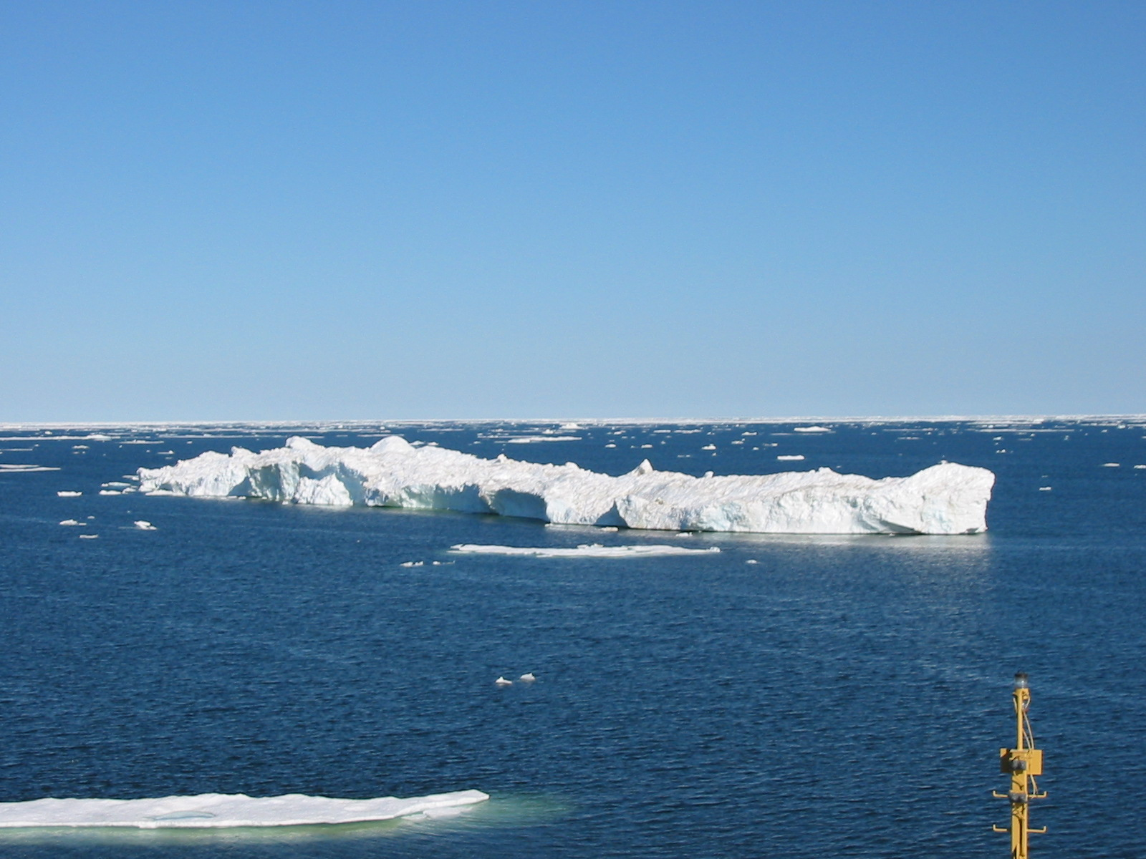
Canadian Arctic Shelf Exchange Study

Beaufort Sea

CCGS Sir Wilfrid Laurier

September 6 – September 24, 2002

Institute of Ocean Sciences Cruise 2002-21

Humfrey Melling – Chief Scientist

Joint Western Arctic Climate Study

and

Canadian Arctic Shelf Exchange Study

Beaufort Sea

CCGS Sir Wilfrid Laurier

September 6 – September 24, 2002

Chief Scientist: Humfrey Melling

Overview
The Joint Western Arctic Climate Study (JWACS) is a bilateral research initiative (Canada and Japan) in the Canada Basin of the Arctic Ocean. The principal agencies are the Japan Marine Science and Technology Centre (JAMSTEC) and the Canadian Institute of Ocean Sciences. In 2002, the study was conducted simultaneously in both the ice-covered and ice-free zones of the southern Canada Basin in late summer. The scope was multi-disciplinary, embracing study of seabed geomorphology, physical oceanography, sea ice, tracer geochemistry and marine biology in the benthic, pelagic and epontic domains. Collaborators joined from university and other governmental agencies in Canada, Japan, USA and the UK.
Three ships were involved in JWACS: the Mirai, the CCGS Louis S St-Laurent and the CCGS Sir Wilfrid Laurier. The Mirai worked in the ice-free part of the study area, the Louis in the heavy ice and the Laurier along the interface between the two zones. The primary responsibilities of the CCGS Sir Wilfrid Laurier within JWACS were the recovery and deployment of the oceanographic moorings used in collecting long time series of ocean and ice data in the Beaufort Sea.
The Canadian Arctic Shelf Exchange Study (CASES) was initiated in 2002 with the deployment of oceanographic moorings in the eastern Beaufort Sea and the conduct of a baseline survey of the marine ecosystem and its relationship to ice extent in the autumn. The mooring component of CASES was completed from the CCGS Sir Wilfrid Laurier, employing the experienced mooring team already on board for the JWACS mooring work. The CASES oceanographic survey was conducted from the CCGS Pierre Radisson, between September 23 and October 16 2002.

Goal
The primary objective of the research in 2002 was an improved understanding of the character and causes of variability and change in Canada Basin. We do not yet know whether the dramatic changes in the oceanography and ice cover of the Arctic Ocean during the 1990’s were consequences of an anthropogenic shift in the climate of the North Polar Region, or whether they reflect natural decadal variability in the ocean-ice-atmosphere system.
The secondary objective was improved understanding of the influence of topography on the exchange of waters between the continental shelf and the ocean basin. Moorings were sited to measure circulation and upwelling in two large sea valleys that cut deeply into the continental shelf of the Beaufort Sea, namely Barrow Canyon and Herschel Canyon. Hydrographic surveys explored nutrient regeneration, oxygen depletion and the renewal of deep waters in the three sub-basins of Amundsen Gulf. A mooring in the deep central basin of Amundsen Gulf carried instruments to measure the carbon flux and associated oceanographic conditions.

Activities
The observational approach during 2002 was based on physical and hydrochemical measurements. Ancillary observations by acoustic backscatter and sediment collection provided proxy monitors of biological cycles and their relationship to physical forcing.
The scientific plan for the CCGS Sir Wilfrid Laurier included:
- A geochemical section along the axis of Amundsen Gulf from the sill 60 miles west of Sachs Harbour to Coronation Gulf.
- Profiles by CTD at stations along the shelf edge from Barrow Canyon to Banks Island, with emphasis on a section across the mouth of Amundsen Gulf.
- Maintenance of an array of moored instruments to measure ocean and sea-ice properties throughout the year, stretching along the edge of the continental shelf between Barrow Canyon and Amundsen Gulf.
- Benthic sampling at the locations of long-term moorings, to explore the relationship between benthic fauna and monitored properties of the physical environment – ice cover, ocean current, temperature and salinity.
- Measurements of ocean turbulence and mixing at the locations of long-term moorings.
- Deployment of the CASES array of moorings in the domain of the Cape Bathurst polynya, to establish a short history of ocean conditions in advance of the intensive field phase of CASES during Oct 2003-Oct 2004.
- Deployment of a weather-reporting buoy onto perennial ice off the west coast of Banks Island, on behalf of the Arctic Weather Centre (Ed Hudson) as contribution to the International Arctic Buoy Programme (IABP).
- Assistance in the transfer of scientific personnel to and from the Mirai at Barrow on September 6 and at Tuktoyaktuk on September 20. The Mirai carries no helicopter.
Water properties were surveyed to assist in the identification and mapping of five important elements of Arctic hydrography: river inflow, ice, Pacific-derived inflows and Atlantic-derived inflows via both Fram Strait and the Barents Sea. The balance between inflows from various sources and outflows establishes the present oceanographic climate of the Arctic Ocean, its ice cover and its biological productivity.
The variables measured from sampled water during the JWACS-2002 cruise were salinity, oxygen-isotope ratio, dissolved barium, dissolved oxygen, dissolved nutrients (nitrate, nitrite, phosphate, silicate). A profiling CTD system (SeaBird-9/11) provided continuous profiles of temperature, salinity, dissolved oxygen, light transmission and chlorophyll fluorescence.
Instruments deployed on moorings measured the following oceanic properties over 12-24 months: temperature, salinity, current, acoustic back-scattering (related to zooplankton abundance) and sediment accumulation.
Other moored instruments recorded data related to the ocean surface: ice drift, ice draft and ridging, leads, storm waves and storm surge

Personnel

10 Joining at Barrow Alaska on September 6
Humfrey Melling (Chief Scientist), Trish Belchamber, Kathy Conlan, Peter Gamble, Takashi Kikuchi, Doug Sieberg, Makoto Sampei, Hiroshi Sumata, Hirokatsu Uno, David Walsh

1 Joining at Tuktoyaktuk on September 12
Ron Lindsay

11 Leaving at Cambridge Bay on September 25

Ice Conditions
Median ice conditions in mid-September, based on 30 years of observations are mapped in the next figure. At this time, ice at low concentration is typically present within 50 km of Barrow and heavy ice within 150 km. Farther east, the edge of heavy pack approximately follows 72°N latitude to within 100 km of Banks Island, where it veers north to meet the coast at 74°N.
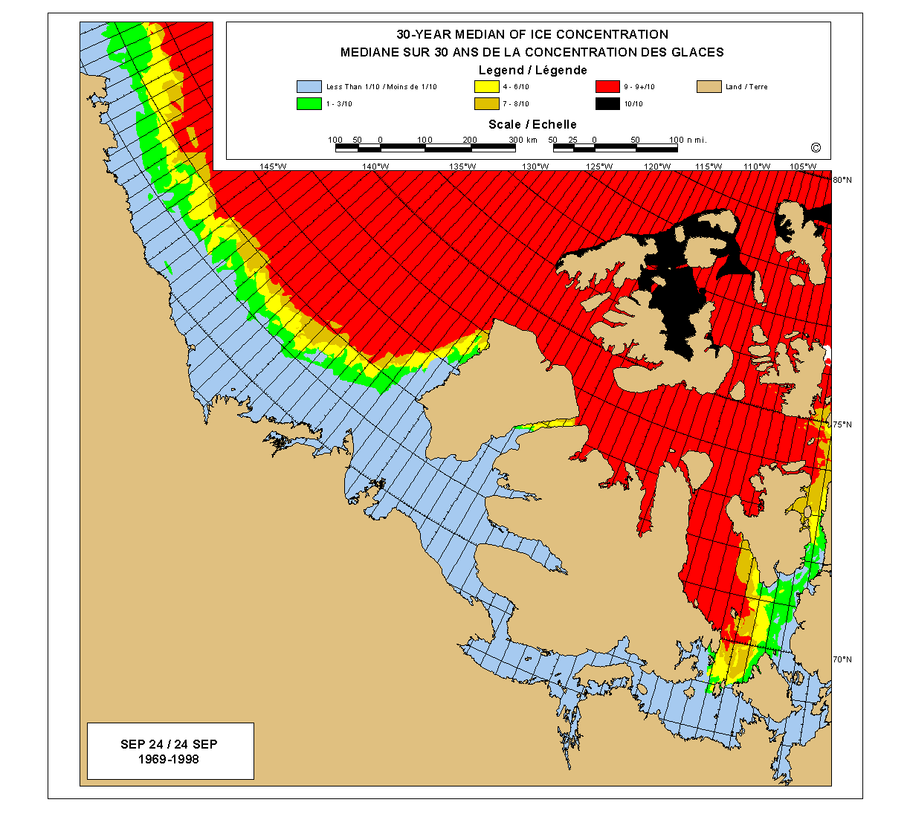
In 2002, ice was first encountered 400 km of Point Barrow. The edge of compact ice was 100 km beyond that. Along the coast of Banks Island, ice conditions were worse than usual, with no navigable waters north of 72° 15’N. At his longitude, the southern limit of ice was typical, but further west the ice edge was well north of the median position at all longitudes. In addition, a broad (200 km) zone of relatively loose ice skirted the heavy pack.
In consequence of these unusual conditions, the CCGS Sir Wilfrid Laurier encountered very little ice in the conduct of the scientific programme. At all sites where moorings were deployed there was sufficient ice-free area to permit anchor-last deployment. Ice was a problem only in the eastern Beaufort Sea. Here it prevented passage by the ship to site ITC01-8, where moorings were already in place, and to two of the planned sites for CASES moorings, which were re-located.
Median ice conditions in the Beaufort Sea at the time of historical minimum ice extent in in late
September

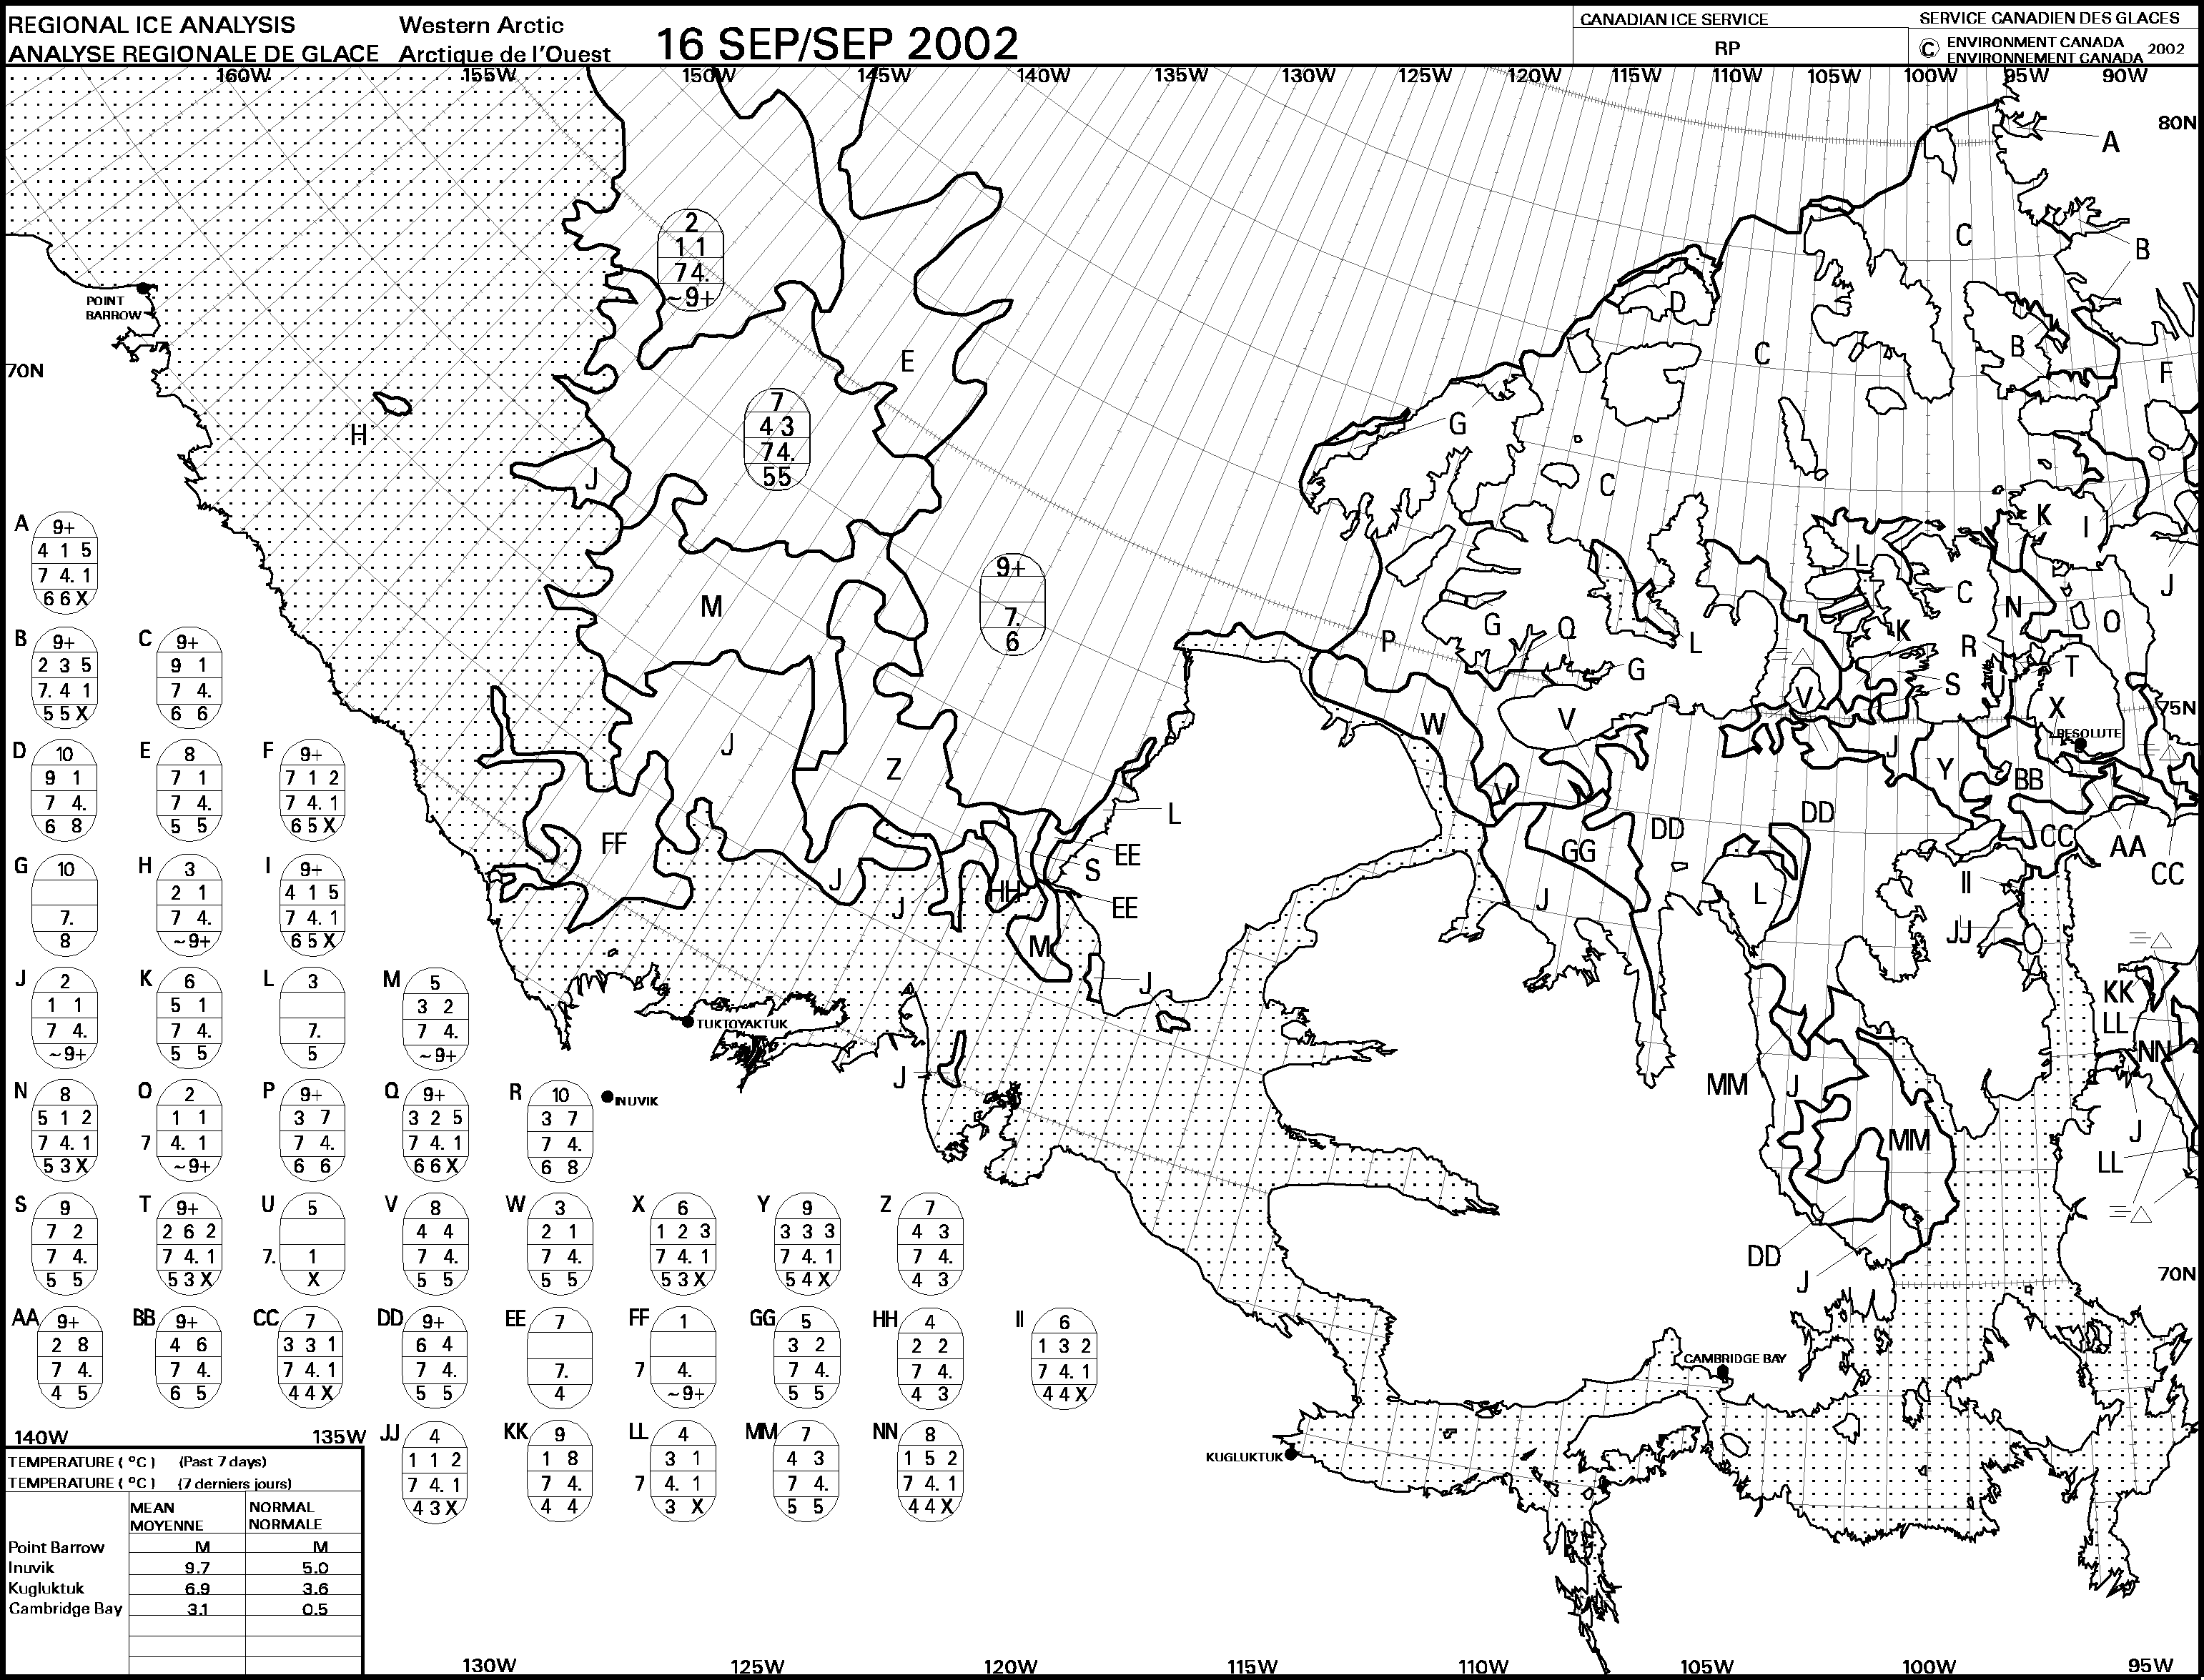
Ice conditions in the Beaufort Sea in mid-September 2002

Locations of mooring and sampling stations for JWACS/CASES occupied by the CCGS Sir Wilfrid Laurier in September
Open circles mark rosette/CTDs, crosses mark CTD casts, filled circles mark moorings and dark centres mark grab samples

Assessment

Impact of Weather
The weather during the 18-day cruise was unusually good. Temperature remained at or above freezing for all but the last two days. There were no storms of consequence in the Beaufort Sea during this time. Strong winds were encountered only during the last two days, when the ship was bound for Cambridge Bay.
There was thick fog during 16-17 September, when the ship was to the west of Sachs Harbour. Poor visibility hindered the ship’s further penetration into the heavy ice in this area, and precluded the deployment of a weather-reporting buoy on behalf of the Arctic Weather Centre of Environment Canada.

Achievements in Relation to the Science Plan
During the 18 days this cruise, the CCGS Sir Wilfrid Laurier travelled more than 1600 nautical miles, from Point Barrow to Cambridge Bay.
The science team completed 11 rosette/CTD casts, sampling seawater on a hydrochemical section along the length of Amundsen Gulf. Three hydrographic sections were completed by CTD, one along the axis of Kugmallit Channel between the 10-m and 1300-m isobaths, one across the mouth of Amundsen Gulf, just east of the sill separating the Gulf from the Canada Basin and a third running north from Pearce Point in central Amundsen Gulf. In addition, profiles were acquired by CTD at all locations where moorings were recovered and deployed. The total number of profiles by CTD is 37. Ten and twenty-litre samples of water were acquired at 26 stations for the Japanese Institute of Polar Research (NIPR). These samples were filtered for later analysis for chlorophyll-A concentration. (IOS, Melling; NIPR, Sampei)
Sediment samples for faunal census were acquired in triplicate at 24 sites using an 18-inch van Veen grab sampler. The light wire on the hydrographic winch available for this task limited sampling to a maximum depth of 500 m (National Museum of Nature, Conlon)
Sediment samples for contaminant analysis were acquired at three sites in Kugmallit Bay on behalf of Kavik-Axys Environmental Consultants and Devon Petroleum.
Repeated casts to measure microstructure in the vertical profiles of temperature and salinity were acquired over 2-3 hours at 9 locations, typically near mooring sites. The SCAMP profiler was deployed from the 733 rigid-hull inflatable, remote from the ship in order to avoid any disturbance of the upper ocean caused by the ship itself (International Arctic Research Center, Walsh)
Eleven oceanographic moorings were recovered at ten sites. Since all sites were free of ice, the release and recovery of all but two moorings was swift and straightforward. The two most troublesome moorings were those deployed with ground lines and recovered by grappling in relatively shallow water (Jamstec, IOS, IARC, Geological Survey of Canada).
Fifteen oceanographic moorings were deployed at 14 sites between 126° and 155°W. Three deployments were for Jamstec, three for IOS, one for IARC and eight for CASES. The retrieval of most of these moorings is planned for the late summer of 2002, after a year-long deployment. It should be noted that benign ice conditions should not be expected in future years at most of these mooring sites, even in mid-September.
There was an oversight in the assembly of the moorings deployed by Jamstec in Barrow Canyon early in the cruise. Since the inadvertent omission of galvanic isolators (titanium to stainless steel) placed the moorings at risk, they were retrieved during the Laurier’s westbound traverse, repaired and re-deployed. We congratulate Hirokatsu Uno on his efficiency in completed this task in a single day (October 2). The activity brings the total of mooring recoveries to 14 and of deployments to 18.
In early August the CCGS Sir Wilfrid Laurier encountered a massive ice feature grounded in about 25 m of water west of the Booth Islands near Cape Parry. This feature had an established freeboard of about 5 m, but had been lifted by at least 10 m out of the water in grounding. We estimate its thickness to have been about 45 m and identify its probable origin as a fragment of the ice shelf along the northern coast of Ellesmere Island. A rind of crushed sea-ice adhering to the face of the fragment (see picture) was indicative of strong forces exerted on it by the moving pack ice during winter. Suspecting a deep scour in the seabed, such as may threaten future buried pipelines in the Mackenzie delta, we re-visited the site on September 19 to search by sounder for scour marks. Unfortunately, the ice-shelf fragment had drifted away and we were not able to reference our survey to the precise location of grounding. However, we criss-crossed the area and recorded soundings and positions for later examination and analysis. If nothing else, we did discover an uncharted shoal (70° 07.1’N, 125° 23.1’ W).
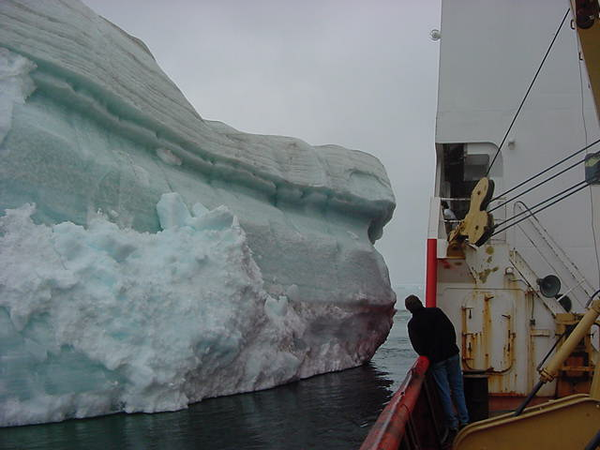

Planned activities that were not completed

Hydrochemical Sections
2 stations at the seaward end of the Amundsen Gulf section (on top of the sill near 72°N 131°W and in the Canada Basin) were beneath heavy ice and could not be reached

Box Cores
The original plan for benthic sampling called for use of a shallow-penetration box corer of 0.25 m² area. This was not provided by IOS as originally agreed. A van Veen grab of smaller cross section was available (University of Tennessee) and was used instead.
Samples of sediment were to have been acquired at all mooring locations. However, the winch provided by IOS for deploying the corer/grab was non-operable. Instead, a hydrographic winch with lightweight wire was used. This limited sampling to waters less than 500 m deep. In particular, samples could not be acquired at the location of the IOS mooring with sediment traps in the centre of Amundsen Gulf (650 m depth).
Sieving grab samples for organisms is heavy work, carried out solely by Kathy Conlon on this cruise. Kathy’s serious back pain from this work precluded the sieving of samples at some of the CASES mooring sites in Amundsen Gulf.

SCAMP
The buoyancy modules on SCAMP were constructed of open cell foam, which flooded progressively with use. In consequence, the probe became heavier in water with repeated use and began to fall too fast. Attempts were made to drive out the water by heating in the microwave oven and to reseal the float surface with paint. These were only partially successful.

Moorings not recovered
The IOS mooring at site ITC01-8, 50 nautical miles north-west of Sachs Harbour, lay beneath heavy ice and could not be reached by the CCGS Sir Wilfrid Laurier.
Bottom-temperature recorders on drag-line moorings were deployed at ten sites around the Mackenzie delta in August 2001. There was time to recover only two of these moorings (T-5, T-6) during this cruise. The remaining moorings lie on two lines, one running south-east from 69° 51.5’N 134° 53.5’W in depths shallower than 11 m (T-1 to T-4) and the other running south into Kugmallit Bay from 69° 39.2’N 133° 20.5’W in depths shallower than 6 m (T-7 to T-10).

Mooring not salvaged at IOS Site ITC99-8
The Institute of Ocean Sciences mooring at Site 8, deployed in 1999, did not surface on command when recovery was attempted in September 2001. The top instrument (an ice-profiling sonar) was subsequently cut free with a dragging line. The lower instrument (ADCP with a 2-year data record) and the releases were to be salvaged using the Tars ROV this year. Unfortunately, the CCGS Sir Wilfrid Laurier was stopped by heavy ice 15 miles from the site. We will make a final attempt to recover this mooring next summer, after four years at sea.

Moorings deployed in alternate locations
Two moorings were deployed at alternate locations because of adverse ice conditions. CASES mooring CA-07, intended for a location (71° 50’N 130° 40’W) north of McKinley Bay was moved to the 500-m isobath on the Kugmallit Channel line at 134°W. The Maclean Moored Profiler (MMP, or Monkey) mooring, intended for a location (73° 20’N 129° 45’W) west of Banks Island was moved to the 1100-m isobath on the same line.
Three CASES moorings, CA-01, CA-02 and CA-03, were moved as much as 15 miles into deeper (63 m) water because their designs were incompatible with the depth of water (50 m) at the target locations.
One CASES mooring, CA-06, was deployed without a temperature-salinity recorder (SBE37), since the instrument provided had not been serviced.

Deployment of IABP Buoy
Heavy fog on September 17 prevented the deployment of the weather-reporting buoy via helicopter onto a vast multi-year floe in the polar pack west of Banks Island.

Rendezvous with the Mirai
The planned rendezvous of the CCGS Sir Wilfrid Laurier and Mirai at Tuktoyaktuk on September 20 was not compatible with the scheduled crew change for the CCGS Sir Wilfrid Laurier on September 24 in Cambridge Bay.

Highlights
Much of the shipboard work on this cruise was routine. The recovery and deployment of moorings is a technical activity. The scientific outcome of the activity is often not known until months later, when researchers have had time to examine and interpret the long records of data recovered with the instruments. However, there were three obvious highlights of the cruise.
Last year, an MMP (or Monkey) was deployed on a specially designed mooring at the mouth of Mackenzie Canyon. The Monkey is a novel instrument designed to acquire CTD profiles four times daily over a 12-month deployment. This monkey was recovered in September, having operated successfully for more than 8 months – a first in Arctic research. The record reveals a strong and enigmatic signal with a period of about 5 months, as well as oscillations over a range of shorter periods. This success opens new possibilities for unattended hydrographic observations in remote areas (Walsh, International Arctic Research Center).
Wave sonar, adapted from the successful IOS ice-profiling sonar, was deployed in shallow water north of Tuktoyaktuk in 2001. It was one component of collaborative research into coastal erosion of weak ice-bounded coastal bluffs along the Peninsula. This instrument returned excellent wave data throughout the stormy weather that precedes freeze-up. Unlike the wave-rider buoy, this instrument is deployed at the seabed and is essentially invulnerable to ice. Its success enables year-round wave measurements is ice-prone seas (Melling, IOS)
Geochemical measurements revealed the occurrence of deep-water renewal in Amundsen Gulf at the time of the September cruise. An intrusion of warmer, more saline and more oxygen rich water was mapped as it spilled over the sill from the Canada Basin in the outer basin of the Gulf. The intrusion was confined to the outer basin. The concentration of dissolved oxygen in the deep waters of the middle and inner basins was 25% below that of the outer basin (Melling and McLaughlin, IOS)

Operation of Moored Instruments
IRIS is an internally recording imaging sonar, designed and built at IOS for the observation of ocean surface processes in plan view. IRIS was successfully tested under land-fast ice near Resolute Bay in April 2001, and deployed near the edge of the polar pack in the Beaufort Sea in September 2001. It was programmed to acquire an image of the surface over a disk of 1-km diameter, every 3 hours for a year. Unfortunately, a glitch in the power management firmware caused the instruments microprocessor to ‘hang’ early in the deployment and few images were acquired (Melling, IOS).
The battery of the wave sonar was damaged during installation, allowing leakage of current to ground via the pressure housing. The battery failed prematurely, shutting down the echo sounder after 7 months, and the temperature and pressure recordings after 10 months (Melling, IOS)

Equipment Problems

Ship speed
Interrelated concerns about excessive vibration of the propulsion system and fuel consumption limited the maximum speed of the CCGS Sir Wilfrid Laurier to about 8 knots for much of this cruise. Since we travelled about 1600 miles, approximately half the cruise time was spent in transit. Had the ship been capable of normal operation, several more days could have been available for scientific activities.

Winch for box coring
No 329 Dragging Winch (s/n 1578) was unserviceable because of a broken circlet clip when it was lifted from the hold for installation on deck in late August. The winch started to wind at full speed with the control in neutral. Bolts attaching the speed selector valve were stripped and fell out without turning. Inspection revealed that other bolts were too long and came against the bottom before compressing lock washers. Repair was not practical.
Recommendation: Better protection is required for winches during handling, shipping and storage for Arctic programmes. Winches are stowed in crowded holds, moved from ship to ship and trucked across the country prior to use on ships-of-opportunity in the Arctic.

CTD winch
CTD Winch SPR75-A-3242 is mounted above the operator's level on the boat deck of the Laurier, and cannot be seen from the operator's station. The drum of this winch started to pay out cable slowly as the rosette was prepared for launch. Several wraps jumped the drum and tightened onto the hub as the operator attempted to lift the rosette from the deck. The resulting cable snarl destroyed the sensors for the Scantrol speed control. Tangled cable was cut away and a re-termination was required. Fortunately there was no serious damage to equipment and no injury. The science program continued after a 3-hour hiatus. I understand that the same problem had already occurred with a Hawboldt winch on the Tully, where the winch is visible to the operator.
Recommendation: If the winch brake needs frequent adjustment, as may be the case with the Hawboldt winches, then Winch Maintenance should have advised ship's personnel of this requirement and recommended a schedule for checking it.
Recommendation: It is essential that up-to-date manuals, maintenance records and maintenance advisories travel with the winches from ship to ship, and are delivered to the ship's engineering office when a winch is installed.

Block for the CTD/rosette
A growing tendency for the CTD wire to rub against the yoke holding the pulley was traced to excessive free play between the pulley and its axle. On dismantling the block, we discovered that (1) the pulley did not rotate on bearings, (2) the steel pulley turned directly on an axle of the same metal, contrary to accepted engineering practice, and (3) there was no grease fitting to enable adequate lubrication of the wear surfaces.
Recommendation: Install bearings and lubrication fittings on the CTD block.
Recommendation: Canadian Coast Guard should establish a regular maintenance schedule for scientific gear installed on the CCGS Sir Wilfrid Laurier.

SCAMP floatation
The buoyancy modules on SCAMP were constructed of open cell foam, which flooded progressively with use.
Recommendation: A more suitable, closed cell floatation must be identified for use with this instrument, so that ship resources for this time-consuming activity are put to best use.

Sieving set-up
The sieving table built on the CCGS Louis S St Laurent and transferred to the CCGS Sir Wilfrid Laurier was functional but not ergonomic. The potential for back injury was realized after a week of intensive use.
Recommendation: A sieving table based on ergonomic principals should be designed and built. In particular, the height of the working surface should be adjustable, and a hose suspension should be arranged so that the operator merely directs the stream of water from above, without having to handle the weight and resistance of the hose.

Ground lines on shallow moorings
Bottom-temperature recorders were deployed last summer on moorings in shallow water of the Mackenzie delta. Despite precise positioning by GPS and 100 m of ground line, these moorings were difficult and time-consuming (3⁺ h) to grapple and recover.
Recommendation: Review and improve the design of these moorings and the method and equipment used for their retrieval.

Technique of anchor-last mooring deployment
When ice conditions permit, oceanographic moorings have been deployed from the well deck of the CCGS Sir Wilfrid Laurier by streaming components over the side from the top of the mooring down, while applying tension to the mooring using the 733 fast-response craft. Keeping constant tension on the mooring can be difficult, particularly when the ship itself is drifting. There is risk to deck crew if the tension is too great and risk to the mooring if it is too small. The tension is lost when the 733 lets go of the mooring, for reasons of safety, just before the anchor is dropped.
Over the past few years, we have accumulated evidence of problems with this procedure. An embedment anchor attached to a Jamstec mooring deployed in 1999 swung up during the drop and hitched a higher part of the mooring, preventing its release. An IOS mooring deployed in the same year failed to surface on command in 2001, although both releases appeared operable. A Jamstec mooring recovered in 2002 was missing 3 of 5 floats installed above the releases, apparently in consequence of impact with something massive (the anchor weight?). The synthetic line of one of the Jamstec moorings retrieved from Barrow Canyon in October was seriously chafed line where it had formed a hitch around one of the instrument frames during anchor-last deployment.
Recommendation: Review the anchor-last method of deploying moorings, as used on the CCGS Sir Wilfrid Laurier. Design a revised recommended procedure to increase the safety of the operation and eliminate the defects of the methods used to this date.

Documentation and handling of dangerous chemicals after use at sea
Under the present circumstances, there is a reasonable degree of care taken at the beginning of Arctic cruises to package and document properly the chemicals used at sea. Sadly though, the situation is very different at the end of the cruise. At this time, chemicals are poorly boxed and labelled, MSDS sheets are not with the chemicals, no record of the quantity of the chemical remaining is provided and information on who owns the chemicals and on their intended disposition is very sparse. There is an assumption that ‘someone’ will take care of it ‘somehow’.
Recommendations to improve the handling of chemicals during our arctic field work:
- Each group should assign one person to oversee and take responsibility for the chemicals brought onboard and MSDS sheets should be with the chemicals.
- MSDS sheets should be provided to the ship’s personnel and another copy provided for the ship’s lab
- Each group should submit a list of the chemicals and clearly specify the quantities of chemicals that they have brought onboard.
- At the end of the cruise chemicals should be re-packed in the boxes in which they were originally packed. The following information should be written clearly on the box: owner, name of chemical, amount of chemical remaining, clear instructions on the disposition of the chemical when the ship is unloaded. MSDS sheets should be attached to each box. Old labels are confusing and should be removed from the boxes.
- When chemicals are transferred between ships, there should be clear information about the source and destination of the chemicals. Current procedures are very casual.
- At the end of the cruise, each group should submit a list of the chemicals and their quantities that are to be taken off the ship along with instructions about what is to be done with them.
7) The assumption that it is ok to just abandon chemicals should be doused!!!!!!

Report on Improvements to Science Capacity of the CCGS Sir Wilfrid Laurier

Storage space
Prior to the 2002 Arctic patrol, lock-downs were fitted on the starboard boat deck to secure a 16-foot shipping container under the barge davit. A container supplied with power and light was carried here during 2002. It was used to shelter a box freezer (-18°C) and an upright freezer (-80°C) for the storage of water, mud and biological samples, cases of unused sample bottles and miscellaneous oceanographic equipment. This additional shelter for storage and potentially for lab work greatly facilitated science work. The convenience of this space to the rosette station and the science labs was a time saver. In earlier years, much equipment was carried back and forth to the hold, and samples were stored in the ship’s refrigerator and freezer.

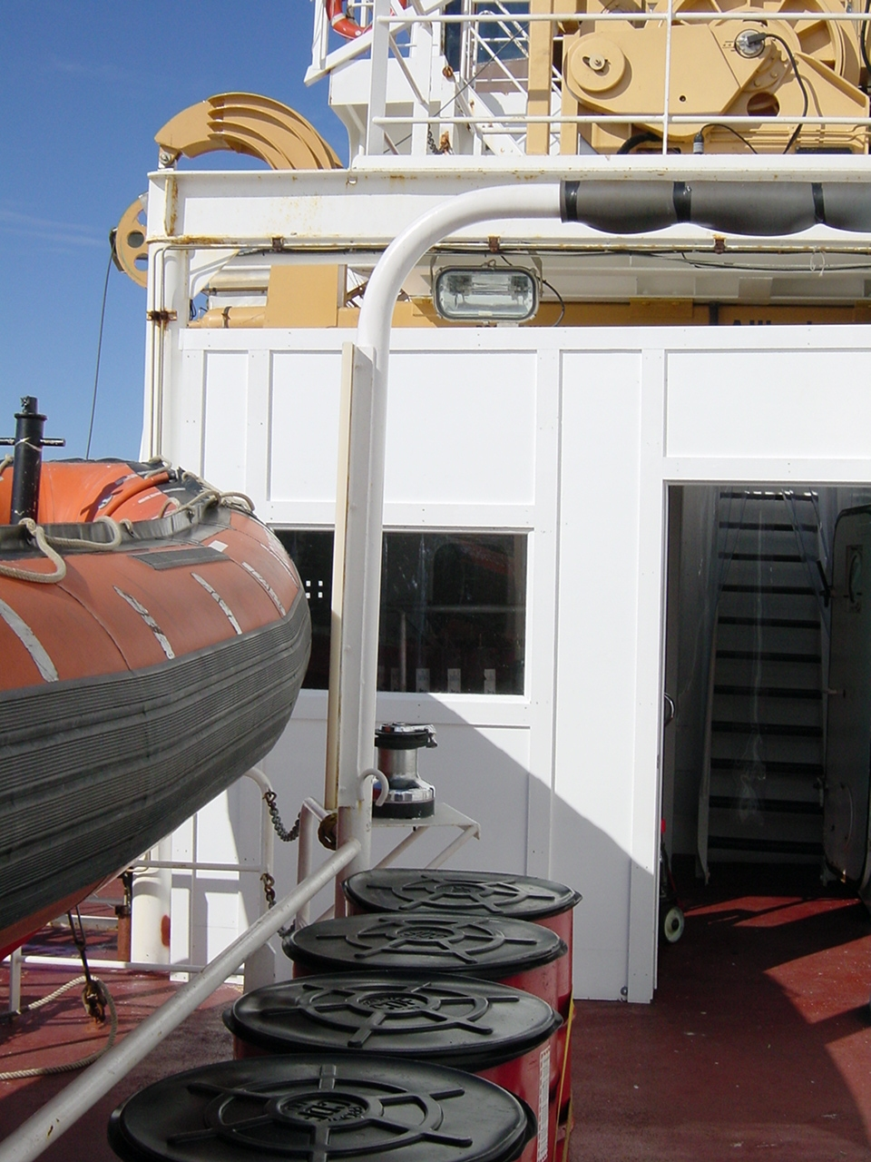
Rosette shelter:
The prefabricated shelter built around the rosette-CTD station prior to 2002 field season is pictured at the right. The shelter is well lit and weather proof. Warmed only by heated air through the open door to the interior of the ship, the shelter remained at +5°C when the outside temperature dropped to -2°C. Although slightly cramped when using a 24-bottle rosette, the set-up banishes the primitive working conditions of earlier years to the realm of bad memories.
The installation of a door across the passage between the science lab and the winch room effectively blocks the hurricane that otherwise blows up to the bridge.
Good sight lines remain between the CTD operator and winchman.
A powerful heat blower has been acquired to warm the shelter under cold conditions. We had no occasion to use this blower during 2002.

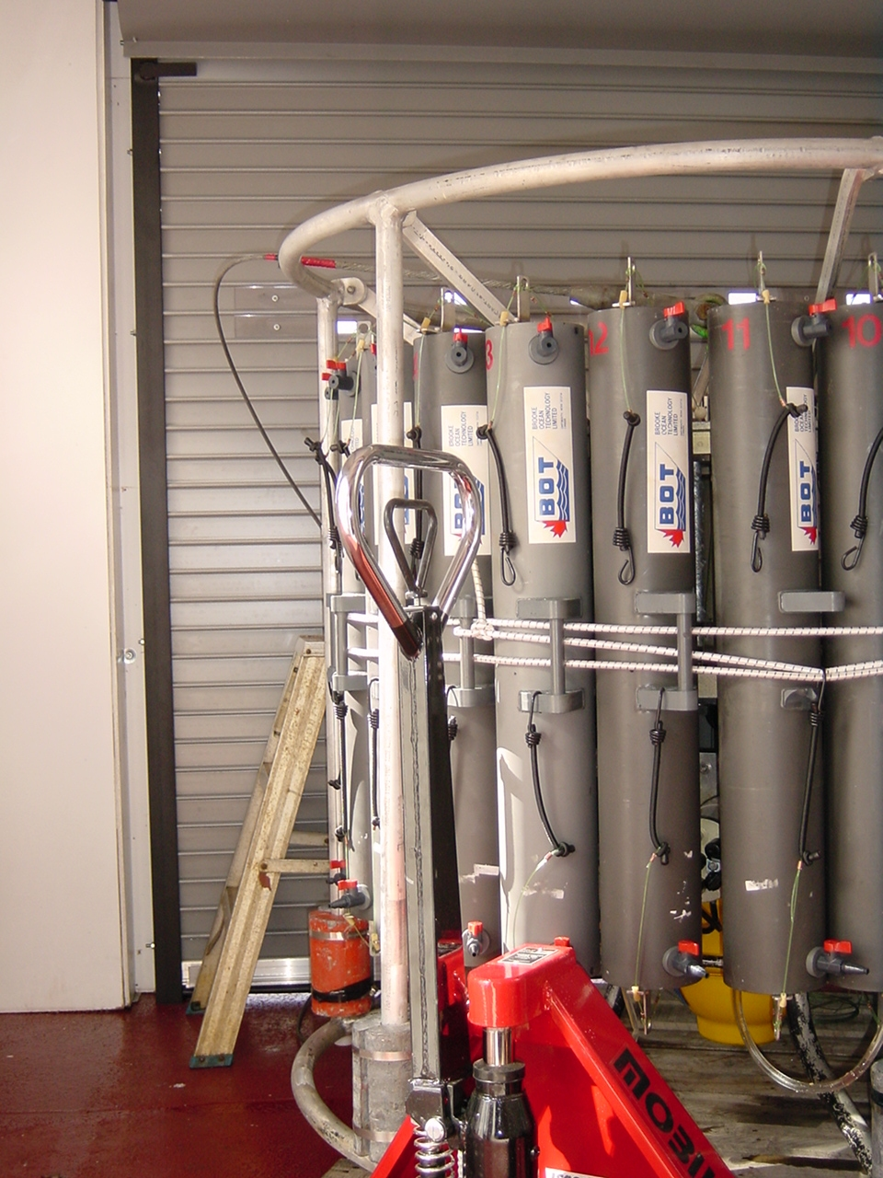
Forward container lab
A standard-size sea-proof entrance door and ventilators have not yet been installed.

Hydrography lab
Working space in this lab has been greatly improved by re-location of the bulky Simrad echo sounder over the work bench.
Our inability to control this sounder (needs to be off when transponding and releasing moorings) and to read depths on the bridge is an inconvenience. Perhaps the unit could be interfaced to the ship’s LAN to provide remote access?

Forward science lab
Additional shelving installed above the sink counter is greatly appreciated.
New shelves high enough to accommodate 3-ring binders in a vertical position are greatly appreciated.
Stools in the lab: There were so many stools that a purge was necessary.
The flat-screen monitor relaying the video display from the Aldebaran navigation on the bridge and from the CTD computer is ideal – no footprint on the counter at all.
The amount of UPS power is adequate for small science programmes, provided that it is used only for essential applications. For larger programmes, or if indiscriminate use remains the norm, a greater capacity is required.
New tie-downs in lab countertops were appreciated.

Activity by Date

6-Sep | Embarkation of science team at Barrow Alaska. Transfer of personnel and equipment from the CCGS Louis S St Laurent
7-Sep | Liaison with JWACS science team on the CCGS Louis S St Laurent and the Mirai at Barrow
8-Sep | Grab samples, SCAMPing and CTDs. Retrieval of Jamstec mooring BCW-01 in Barrow Canyon
9-Sep | Retrieval of Jamstec moorings BCC-01 & BCE-01 in Barrow Canyon. Deployment of BCC-02 & BCE-02.  Overnight transit to Jamstec mooring NSJ-01
10-Sep | Retrieval of Jamstec mooring NSJ-01. Grab samples and CTD.  Overnight transit to Mackenzie Canyon
11-Sep | Retrieve IARC ‘Monkey’ mooring at site ASB. Confirmation of location of Jamstec mooring MCJ-01. Grab samples, SCAMPing and CTD.  Overnight transit to CASES site CA-01
12-Sep | Deploy mooring at CA-01. Recover IOS moorings at ITC01-1, BMH-01-9 and TA-06. Grab samples, SCAMPing and CTDs.  Load ROV and scientific equipment from Tuktoyaktuk by helicopter. Ron Lindsay joins the ship.
13-Sep | Acquire mud samples at Nayak-1 & Nayak-2 for Devon Resources. Recover mooring at TA-05. Grab samples and SCAMPing.
14-Sep | Deploy IOS moorings at BMH-02-9 and ITC02-1. Deploy CASES mooring at CA-02. Grab samples, SCAMPing and CTDs.  Overnight transit to CASES site CA-04
15-Sep | Retrieve IOS mooring with IRIS at ITC01-2.  Deploy CASES moorings at CA-04 & CA-07. Grab samples, SCAMPing and CTDs.
16-Sep | Deploy IARC ‘Monkey’ mooring at the 1100-m isobath. SCAMPing and CTDs.  Overnight transit to AS CTD section across Amundsen Gulf.
17-Sep | Complete AS CTD section across Amundsen Gulf at the outer sill. Grab samples.  Cancel deployment of IABP buoy because of fog. Cancel mooring work at IOS site 8 because of ice.
18-Sep | Overnight start to hydrographic section along Amundsen Gulf, skipping two most westerly stations because of ice.  Deploy CASES moorings at site CA-05, CA-03 and CA-06. Grab samples, SCAMPing and CTDs.
19-Sep | Deploy CASES mooring at site CA-08. Continue hydrographic section along Amundsen Gulf.  Survey grounding site of ice-shelf fragment on shoal west of Booth Islands.  Overnight transit to Pearce Point
20-Sep | Shore visit at Pearce Point.  CTDs north to IOS site AG05. Recover IOS mooring at Amundsen Gulf-05. SCAMPing  Continue hydrographic section along Amundsen Gulf overnight.
21-Sep | Continue hydrographic section along Amundsen Gulf. SCAMPing
22-Sep | Continue hydrographic section in western Coronation Gulf.  Overnight transit to Cambridge Bay
23-Sep | At anchor in Cambridge bay
24-Sep | Science team disembarks and flies back to Victoria.

Appendix 1: Locations of moorings associated with the JOIS-2001 in the Beaufort Sea
Moorings that were recovered in 2002 are in faint type.

Appendix 2: Locations of CTD and CTD/rosette profiles

