Processing Notes for the Year 2001 Nanoose Bay Data 30 July, 2026

Ron Perkin

.hex and .con files were inspected then used to create .cnv files using the Sea Bird software and the recommended processing for the SBE19.

.cnv files were converted to .ios files.

Using a Visual Basic program, positions were added. They were taken from the .act files as distance in metres, x' and y', along range 2 which was inclined at an angle of 11.2º south of east. Conversion into easting and northing coordinates was done according to:

X = x'cos(11.2) + y'sin(11.2)
Y = -x'sin(11.2) + y'cos(11.2)

Conversion to lat/long was done according to:

Lat = 49º (21.05' +Y*60/111120)
Long = 124º + (9.55 - X*60/72387)

The data was exported to a .o4x file(station name was added) and was inspected in Ocean Data View. Outliers were removed and the time sequence was contoured.

Cast N103281 was deleted as bad. (Probe 4)
Cast N1051801 was deleted as bad. (Probe 4)
Cast N1091101 was deleted as bad. (Probe 8)
Cast N1051701 was deleted as bad. (Probe 4)
Cast N1042401 was deleted as bad. (Probe 6)

Cast N1091102 was edited at 183 m.
Cast N1052201 was edited at 40 m.

Cast N1120501 was inspected at 358 m and was passed.

Cast N1071001 had its salinity removed.(Probe 4)
Cast N1062601 had its salinity removed. (Probe 4)

Fixed .ios files were converted to .ctd files with the IOS sequential numbering.

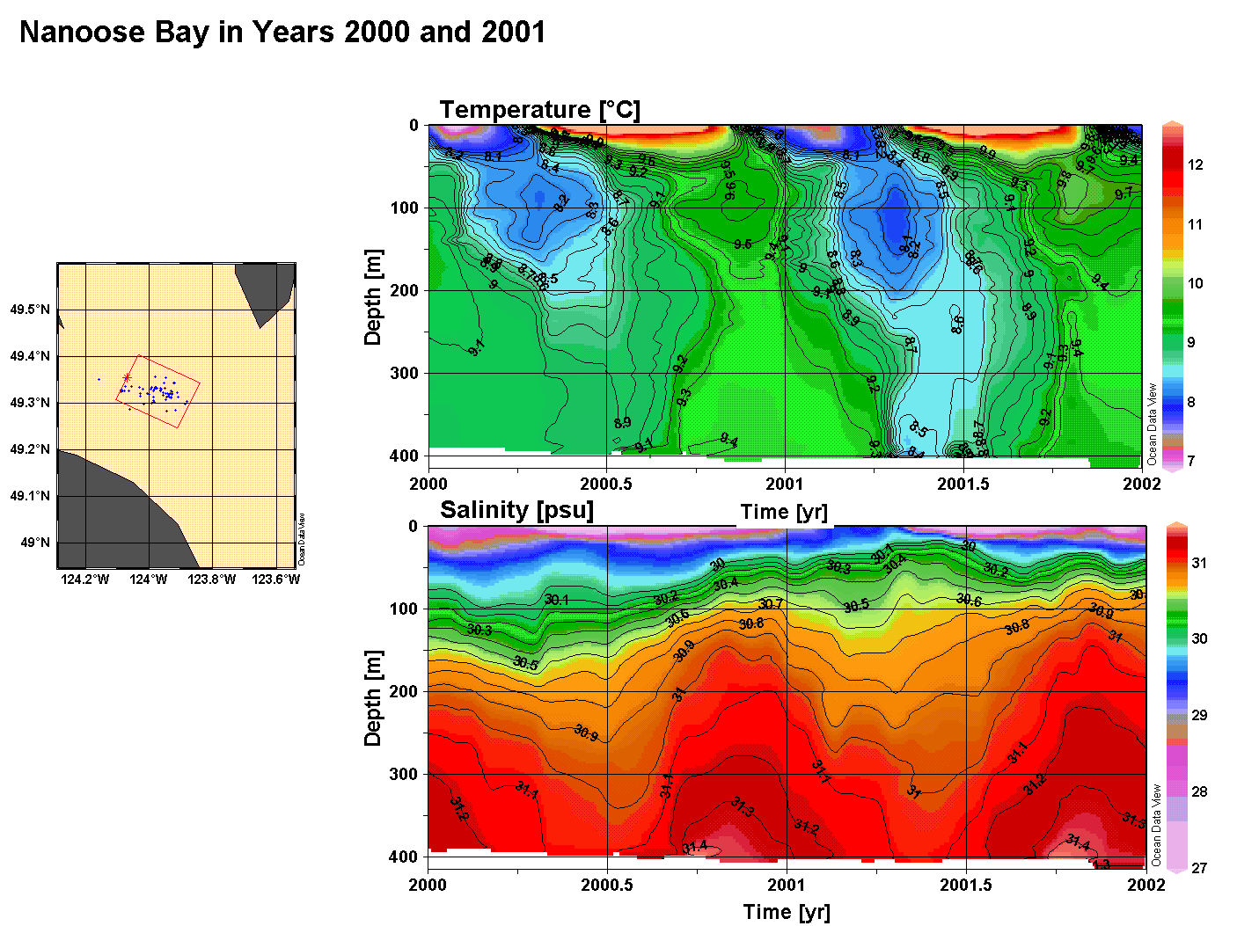
Figure 1

