Project Report

Department of Fisheries and Oceans
Institute of Ocean sciences
Sidney, B.C., Canada

To: Regional Science Director. Final: Yes

1. Cruise/Project No.: 2001-29 2. Dates: August 20 to September 17, 2001
3. Project Name: Line P
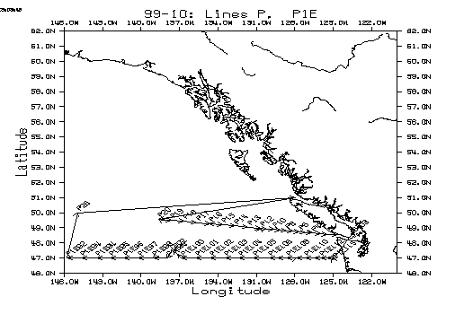
4. Planned Area(s) of Operation: Line P(50N, 145W to 48 34N, 125 30W)
Along 47N from the Washington State coast to 151 W
Juan de Fuca Strait to Victoria, B.C.

5. Platform: John P. Tully 6. Master: Paul Frost
7. Days Allocated: 28 8. Days at Sea:
9. Days lost to weather: none
- Days lost to other causes: 1 day for loading, 5 days for medical evacuation, 4 days for union job action, 3 days for ship maintenance.
- Appropriateness of platform: very appropriate except for propulsion system(engine clutch and shaft seal)
- Safety issues: (attach narrative if required):
none
- Cruise/Project Results (see appendix for details):
Nutrient results were mixed between average and low values at the various depths sampled and require detailed analysis. At some stations, low nutrients and iron combined with high chlorophyll or zooplankton levels suggesting that the spring bloom had recently come to an end.

Data Collected:
Rosette/CTD casts for chemical sampling were completed at P4, P12. Onboard chemical analyses included salinity, oxygen, nutrients, alkalinity, total CO2, chlorophyll, and dissolved inorganic carbon. The P1E data will be combined with concurrent Japanese data along 47N spanning the entire Pacific Ocean.
CTD/O2/fluormetry/transmissometry survey was completed at 19 stations along Line P.
Primary productivity experiments were carried out at P16, P12 and P4.
Iron sampling and analysis were completed at P4, P12 and P16.
Underway measurements include PCO2, temperature, salinity, fluorometry and ADCP profiles.
Net tows for zoo plankton and phytoplankton along Line P were completed.

14. Primary Institute: Institute of Ocean Sciences, DFO
15. Associated Institutes: UBC

16. Chief Scientist/Affiliation: Ron Perkin, IOS (Ocean Sciences and Productivity)

17. Science Staff/Affiliations:
Ron Perkin | IOS
Keith Johnson | IOS | Nes Sutherland | Casual
Shiela Toews | IOS | Rob Campbell | UBC
Maeve Lohan | IOS | Hugh Maclean | UBC
Tim Soutar | IOS | Adrian Marchetti | UBC
Marie Robert | IOS | Joe Needoba | UBC
Janet Barwell-Clarke | IOS | Mike Henry | Bird survey

18. Equipment:
Sail: no ADCP: yes Other: sounder

- Comments and recommendations:

This mission lost most of its working time to a combination of union job action, a medical emergency and down time due to ship’s maintenance issues, particularly a leaking seal on the propeller shaft. The main goals of the mission were not accomplished and an effort should be made to provide ship time later in the season to make up for the shortfall.

Summary
This was a rather trying cruise with a lot of time wasted due to union job action, a medical emergency and ship downtime. Of these causes, the only one under local control is ship’s maintenance and it might be worth reviewing the standard of maintenance afforded this ship. The ship sailed with one engine disabled because of a faulty clutch and the main shaft seal in questionable condition. Perhaps a more thorough annual refit is needed as the ship ages.
Thanks are due to the UBC and bird-watching crew for assisting with watch keeping through the period of intensive sampling and analysis. The major objectives of the cruise such as the occupation of Station P, the launching of ARGO floats and the completion of the UBC experiments on iron enrichment were regrettably not met.
Captain Frost and all the officers and crew have our heartfelt thanks for their competent and efficient seamanship and untiring efforts toward the goals of this cruise.
CTD/Transmissivity
Ron Perkin
A total of 26 CTD/Transmissivity profiles were taken at the following stations, many combined with chemical sampling.
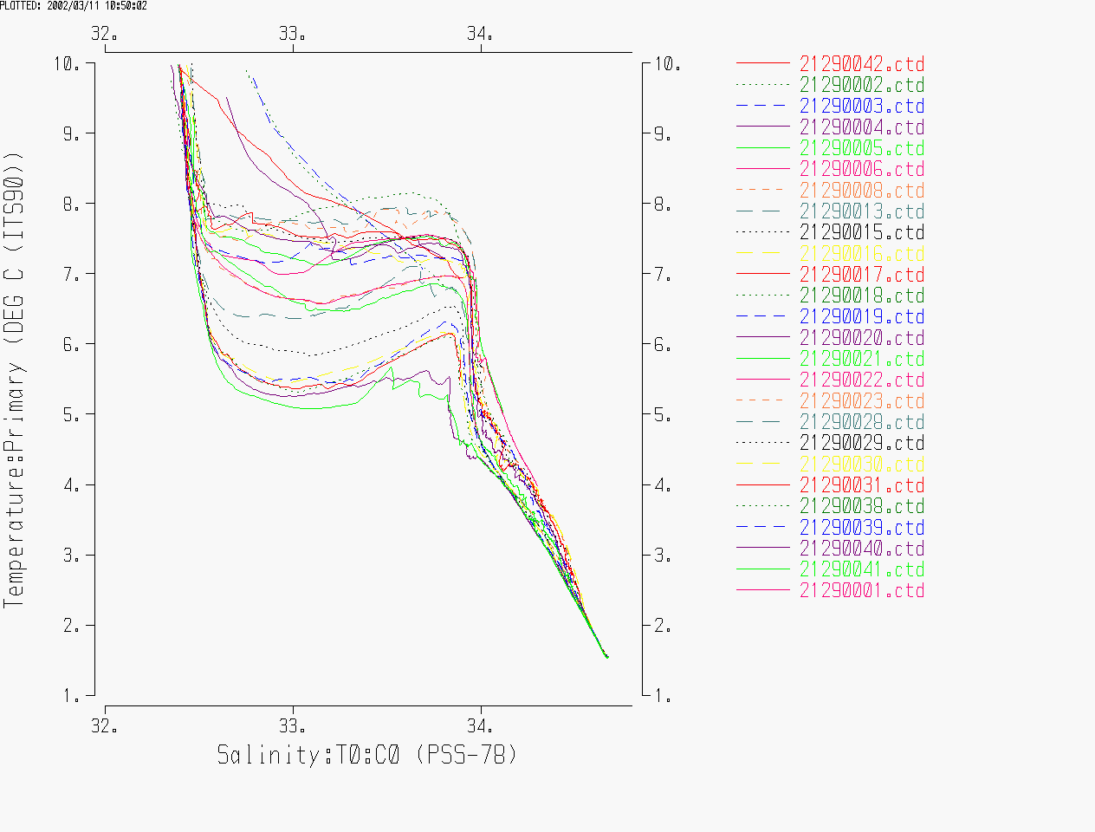
Figure 1

Table 1
File Name | Station | Cast # | Time (UTC) | Latitude | Longitude | Max Pressure (dbar) | Water Depth(m)
21290001.ctd | SI 03 | 1 | 2001/8/21 23:30 | 48.599 | -123.501 | 217 | -9991
21290002.ctd | MP 1 | 2 | 2001/8/22 13:59 | 48.575 | -125.501 | 113 | -9991
21290003.ctd | UBC2 | 3 | 2001/8/22 14:58 | 48.534 | -125.595 | 72 | -9991
21290004.ctd | P2 | 4 | 2001/8/22 19:28 | 48.6 | -126.001 | 110 | -9991
21290005.ctd | UBC3 | 5 | 2001/8/22 21:53 | 48.528 | -126.2 | 552 | -9991
21290006.ctd | MP 3 | 6 | 2001/8/23 1:20 | 48.624 | -126.336 | 804 | -9991
21290008.ctd | P4 | 8 | 2001/8/23 6:49 | 48.648 | -126.667 | 1301 | 1324
21290013.ctd | P4 | 13 | 2001/8/23 14:49 | 48.649 | -126.668 | 254 | 1321
21290015.ctd | P5 | 15 | 2001/8/23 19:34 | 48.693 | -127.166 | 1501 | 2100
21290016.ctd | P6 | 16 | 2001/8/23 22:54 | 48.743 | -127.666 | 2563 | 2530
21290017.ctd | P 7 | 17 | 2001/8/24 2:24 | 48.776 | -128.167 | 2538 | 2490
21290018.ctd | P 8 | 18 | 2001/8/24 6:04 | 48.818 | -128.665 | 2544 | 2500
21290019.ctd | P 9 | 19 | 2001/8/24 9:54 | 48.857 | -129.165 | 2379 | 2500
21290020.ctd | P 10 | 20 | 2001/8/24 13:31 | 48.894 | -129.666 | 2679 | 2625
21290021.ctd | P 11 | 21 | 2001/8/24 18:28 | 48.934 | -130.166 | 2727 | 2736
21290022.ctd | P 12 | 22 | 2001/8/24 22:21 | 48.969 | -130.666 | 404 | 3300
21290023.ctd | P 12 | 23 | 2001/8/25 2:04 | 48.968 | -130.671 | 3153 | 2964
21290028.ctd | P 13 | 28 | 2001/8/25 18:24 | 49.043 | -131.667 | 3057 | 2958
21290029.ctd | P14 | 29 | 2001/8/29 3:50 | 49.122 | -132.664 | 3368 | 3295
21290030.ctd | P15 | 30 | 2001/8/29 9:29 | 49.201 | -133.668 | 3443 | 3250
21290031.ctd | P16 | 31 | 2001/8/29 15:39 | 49.284 | -134.664 | 255 | 3604
21290038.ctd | P16 | 38 | 2001/8/30 0:25 | 49.283 | -134.665 | 3678 | 3604
21290039.ctd | P17 | 39 | 2001/8/30 6:55 | 49.349 | -135.665 | 3605 | 3604
21290040.ctd | P18 | 40 | 2001/8/30 12:48 | 49.434 | -136.665 | 3897 | 3801
21290041.ctd | P19 | 41 | 2001/8/30 18:46 | 49.5 | -137.666 | 3971 | 3895
21290042.ctd | UBC1 | 42 | 2001/9/5 6:32 | 48.385 | -124.337 | 196 | 203

Header Summaries

Input parameter file: C:\windows\TEMP\iosshell\IS203.inp
Log file: d:\lineP_01\summary.log

************************************************
* Program: HSUMMARY *
* Version: 1.4 Date: November 19, 2001 *
* *
* Copyright 2001 Government of Canada *
* Department of Fisheries and Oceans *
* *
* Time of run: 2002/03/11 09:57:55 *
************************************************

Input file is in ASCII format.
Input path = J:\CTD\2001\2001-29\
Output path =
List file: D:\LineP_01\filename.lst
Input extension = ctd
Summary listing will be produced.
1

Input file: J:\CTD\2001\2001-29\21290042.ctd
1

Cruise 2000-

Cast no: 42 Station UBC1 Project Line P
Latitude 48 23.08 N Longitude 124 20.22 W
Start 2001/09/05 Start time 06:32 UTC
Maximum depth 195 No. of records 194
No. of channels 7 Channel desc P % #

Comments:

Input file: J:\CTD\2001\2001-29\21290002.ctd

Cast no: 2 Station MP 1 Project Line P
Latitude 48 34.50 N Longitude 125 30.08 W
Start 2001/08/22 Start time 13:58 UTC
Maximum depth 113 No. of records 114
No. of channels 7 Channel desc P % #

Comments:

Input file: J:\CTD\2001\2001-29\21290003.ctd

Cast no: 3 Station UBC2 Project Line P
Latitude 48 32.06 N Longitude 125 35.70 W
Start 2001/08/22 Start time 14:58 UTC
Maximum depth 71 No. of records 71
No. of channels 8 Channel desc P % #

Comments:

Input file: J:\CTD\2001\2001-29\21290004.ctd

Cast no: 4 Station P2 Project Line P
Latitude 48 36.00 N Longitude 126 0.03 W
Start 2001/08/22 Start time 19:27 UTC
Maximum depth 109 No. of records 109
No. of channels 8 Channel desc P % #

Comments:

Input file: J:\CTD\2001\2001-29\21290005.ctd

Cast no: 5 Station UBC3 Project Line P
Latitude 48 31.67 N Longitude 126 11.99 W
Start 2001/08/22 Start time 21:52 UTC
Maximum depth 551 No. of records 552
No. of channels 8 Channel desc P % #

Comments:

Input file: J:\CTD\2001\2001-29\21290006.ctd

Cast no: 6 Station MP 3 Project Line P
Latitude 48 37.46 N Longitude 126 20.17 W
Start 2001/08/23 Start time 01:20 UTC
Maximum depth 803 No. of records 804
No. of channels 8 Channel desc P % #

Comments:

Input file: J:\CTD\2001\2001-29\21290008.ctd
1

Cruise 2000-

Cast no: 8 Station P4 Project Line P
Latitude 48 38.91 N Longitude 126 40.03 W
Start 2001/08/23 Start time 06:49 UTC
Maximum depth 1300 No. of records 1291
No. of channels 7 Channel desc P % #

Comments:

Input file: J:\CTD\2001\2001-29\21290013.ctd

Cast no: 13 Station P4 Project Line P
Latitude 48 38.96 N Longitude 126 40.10 W
Start 2001/08/23 Start time 14:49 UTC
Maximum depth 253 No. of records 253
No. of channels 8 Channel desc P % #

Comments:

Input file: J:\CTD\2001\2001-29\21290015.ctd

Cast no: 15 Station P5 Project Line P
Latitude 48 41.56 N Longitude 127 9.94 W
Start 2001/08/23 Start time 19:33 UTC
Maximum depth 1500 No. of records 1497
No. of channels 7 Channel desc P % #

Comments:

Input file: J:\CTD\2001\2001-29\21290016.ctd

Cast no: 16 Station P6 Project Line P
Latitude 48 44.57 N Longitude 127 39.97 W
Start 2001/08/23 Start time 22:53 UTC
Maximum depth 2562 No. of records 2560
No. of channels 7 Channel desc P % #

Comments:

Input file: J:\CTD\2001\2001-29\21290017.ctd

Cast no: 17 Station P 7 Project Line P
Latitude 48 46.57 N Longitude 128 10.00 W
Start 2001/08/24 Start time 02:23 UTC
Maximum depth 2537 No. of records 2537
No. of channels 7 Channel desc P % #

Comments:

Input file: J:\CTD\2001\2001-29\21290018.ctd

Cast no: 18 Station P 8 Project Line P
Latitude 48 49.06 N Longitude 128 39.91 W
Start 2001/08/24 Start time 06:03 UTC
Maximum depth 2543 No. of records 2537
No. of channels 7 Channel desc P % #

Comments:

Input file: J:\CTD\2001\2001-29\21290019.ctd
1

Cruise 2000-

Cast no: 19 Station P 9 Project Line P
Latitude 48 51.41 N Longitude 129 9.93 W
Start 2001/08/24 Start time 09:54 UTC
Maximum depth 2378 No. of records 2374
No. of channels 7 Channel desc P % #

Comments:

Input file: J:\CTD\2001\2001-29\21290020.ctd

Cast no: 20 Station P 10 Project Line P
Latitude 48 53.62 N Longitude 129 39.96 W
Start 2001/08/24 Start time 13:30 UTC
Maximum depth 2678 No. of records 2672
No. of channels 7 Channel desc P % #

Comments:

Input file: J:\CTD\2001\2001-29\21290021.ctd

Cast no: 21 Station P 11 Project Line P
Latitude 48 56.02 N Longitude 130 9.95 W
Start 2001/08/24 Start time 18:27 UTC
Maximum depth 2726 No. of records 2727
No. of channels 7 Channel desc P % #

Comments:

Input file: J:\CTD\2001\2001-29\21290022.ctd

Cast no: 22 Station P 12 Project Line P
Latitude 48 58.14 N Longitude 130 39.96 W
Start 2001/08/24 Start time 22:21 UTC
Maximum depth 403 No. of records 396
No. of channels 8 Channel desc P % #

Comments:

Input file: J:\CTD\2001\2001-29\21290023.ctd

Cast no: 23 Station P 12 Project Line P
Latitude 48 58.07 N Longitude 130 40.24 W
Start 2001/08/25 Start time 02:03 UTC
Maximum depth 3152 No. of records 3104
No. of channels 7 Channel desc P % #

Comments:

Input file: J:\CTD\2001\2001-29\21290028.ctd

Cast no: 28 Station P 13 Project Line P
Latitude 49 2.59 N Longitude 131 39.99 W
Start 2001/08/25 Start time 18:23 UTC
Maximum depth 3056 No. of records 3053
No. of channels 7 Channel desc P % #

Comments:

Input file: J:\CTD\2001\2001-29\21290029.ctd
1

Cruise 2000-

Cast no: 29 Station P14 Project Line P
Latitude 49 7.32 N Longitude 132 39.82 W
Start 2001/08/29 Start time 03:49 UTC
Maximum depth 3367 No. of records 3365
No. of channels 7 Channel desc P % #

Comments:

Input file: J:\CTD\2001\2001-29\21290030.ctd

Cast no: 30 Station P15 Project Line P
Latitude 49 12.07 N Longitude 133 40.10 W
Start 2001/08/29 Start time 09:28 UTC
Maximum depth 3442 No. of records 3443
No. of channels 7 Channel desc P % #

Comments:

Input file: J:\CTD\2001\2001-29\21290031.ctd

Cast no: 31 Station P16 Project Line P
Latitude 49 17.01 N Longitude 134 39.82 W
Start 2001/08/29 Start time 15:39 UTC
Maximum depth 254 No. of records 253
No. of channels 8 Channel desc P % #

Comments:

Input file: J:\CTD\2001\2001-29\21290038.ctd

Cast no: 38 Station P16 Project Line P
Latitude 49 17.00 N Longitude 134 39.87 W
Start 2001/08/30 Start time 00:25 UTC
Maximum depth 3677 No. of records 3676
No. of channels 7 Channel desc P % #

Comments:

Input file: J:\CTD\2001\2001-29\21290039.ctd

Cast no: 39 Station P17 Project Line P
Latitude 49 20.93 N Longitude 135 39.91 W
Start 2001/08/30 Start time 06:54 UTC
Maximum depth 3604 No. of records 3604
No. of channels 7 Channel desc P % #

Comments:

Input file: J:\CTD\2001\2001-29\21290040.ctd

Cast no: 40 Station P18 Project Line P
Latitude 49 26.04 N Longitude 136 39.91 W
Start 2001/08/30 Start time 12:48 UTC
Maximum depth 3897 No. of records 3897
No. of channels 7 Channel desc P % #

Comments:

Input file: J:\CTD\2001\2001-29\21290041.ctd
1

Cruise 2000-

Cast no: 41 Station P19 Project Line P
Latitude 49 30.03 N Longitude 137 39.98 W
Start 2001/08/30 Start time 18:46 UTC
Maximum depth 3970 No. of records 3968
No. of channels 7 Channel desc P % #

Comments:

Input file: J:\CTD\2001\2001-29\21290001.ctd

Cast no: 1 Station SI 03 Project Line P
Latitude 48 35.92 N Longitude 123 30.04 W
Start 2001/08/21 Start time 23:30 UTC
Maximum depth 216 No. of records 215
No. of channels 8 Channel desc P % #

Comments:

Start of run: 2002/03/11 09:57:55.62
End of run: 2002/03/11 09:57:59.36

