Cruise Report: Joint Ocean-Ice Study 2001

North American Arctic

Japan/Canada/U.S
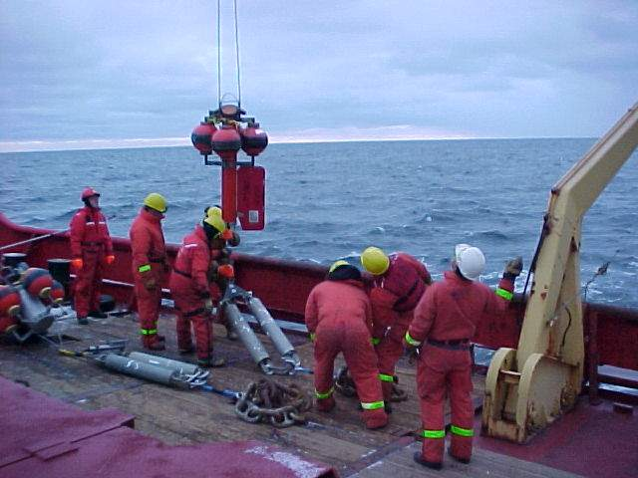

CCGS Sir Wilfrid Laurier

Leg 2: September 6 – October 6, 2001

Institute of Ocean Sciences Cruise 2001-22

Joint Ocean-Ice Study (North American Arctic)

Japan/Canada/U.S

CCGS Sir Wilfrid Laurier

Leg 2: September 6 – October 6, 2001

Chief Scientist: Humfrey Melling

Overview
The fourth oceanographic cruise of the Joint Ocean-Ice Study (JOIS) occurred during July-October 2001. The cruise was supported by the Canadian Coast Guard on the CCGS Sir Wilfrid Laurier as a component of its annual western Arctic Patrol. Scientific collaboration was trilateral – Canada, Japan and the USA. The Canadian Institute of Ocean Sciences (DFO), the Japan Marine Science and Technology Centre, the US Pacific Marine Environmental Laboratory (PMEL), the US Army Cold Regions Research Engineering Laboratory (RREL) and the International Arctic Research Center (Fairbanks) were partners in the science programme of Leg 2.

Goal
The objective of the research in 2001 was an improved understanding of the character and causes of variability and change in the Beaufort Sea and Canada Basin. There were dramatic changes in the waters and ice cover of the Arctic Ocean during the 1990’s. However, it is not yet clear whether these changes were an anthropogenic shift in the climate of the North Polar Region, or whether they reflect natural decadal variability in the ocean-ice-atmosphere system. The observational approach during 2001 was based on physical and hydrochemical measurements. Ancillary observations by acoustic backscatter and sediment collection provided proxy monitors of biological cycles and their relationship to physical forcing.

Methods
The objective of JOIS-2001 was addressed through (1) a ship-based survey of waters across the southern Beaufort Sea between Dolphin and Union Strait and the Chukchi Rise (115°W - 160°W) during September, and (2) the maintenance of an array of moored instruments to measure ocean and sea-ice properties throughout the year.
Water properties were surveyed to assist in the identification and mapping of five important components of the Arctic cocktail: river inflow, ice, Pacific-derived inflows and Atlantic-derived inflows via both Fram Strait and the Barents Sea. The balance between inflows from various sources and outflows establishes the present oceanographic climate of the Arctic Ocean, its ice cover and its biological productivity. The variables measured from sampled water during the JOIS-2001 cruise were salinity, oxygen-isotope ratio, dissolved oxygen, dissolved nutrients (nitrate, nitrite, phosphate, silicate). Radioactive tracers ¹²⁹I (iodine) and ¹³⁷Cs (cesium), derived from nuclear-fuels reprocessing in western Europe provide time scales for estimating the rate of water circulation at intermediate depths in the Arctic Ocean. A profiling CTD system (SeaBird-25) provided continuous profiles of temperature, salinity, dissolved oxygen, light transmission and chlorophyll fluorescence.
Instruments deployed on moorings measure temperature, salinity, current, ice drift, ice draft, storm waves, storm surge, acoustic backscatter (related to zooplankton abundance) and sediment accumulation over 12-24 months.

Activities
- Servicing of moorings to measure current, temperature and salinity along the continental slope between Banks Island and the Chukchi Rise
- Servicing of moorings to measure circulation and upwelling in two large sea valleys of the Beaufort Sea, Barrow Canyon and Herschel Canyon
- Oceanographic sections with hydro-chemical sampling across the continental slope at intervals between Banks Island and the Chukchi Rise
- A longitudinal oceanographic section through Amundsen Gulf and a transverse section just behind the sill
- Servicing of moorings to measure ice draft, ridging and drift at three locations in the south-eastern Beaufort Sea
- Servicing of a mooring to measure carbon flux and associated oceanographic conditions in Amundsen Gulf
- Installation of an ice-based array to measure ice-cover stress and strain in the central Beaufort Sea and atmospheric wind and temperature

Personnel

9 Joining at Kugluktuk on September 6
Humfrey Melling, Mary O’Brien, Mary-Louise Timmermans, Peter Gamble, Ron Lindsay, Bon van Hardenberg, Shigeto Nishino, Hirokatsu Uno, Darren Tuele,

1 Leaving at Tuktoyaktuk on September 18

Darren Tuele

6 Joining at Tuktoyaktuk on September 18

Doug Sieberg, Jackie Richter-Menge, Bruce Elder, Sigrid Salo, Jim Overland, David Walsh

8 Leaving at Tuktoyaktuk on September 25
Peter Gamble, Ron Lindsay, Bon van Hardenberg, Jackie Richter-Menge, Bruce Elder, Sigrid Salo, Jim Overland, David Walsh

1 Joining at Tuktoyaktuk on September 25

Koji Shimada

6 Leaving at Nome on October 7

Humfrey Melling, Mary O’Brien, Mary-Louise Timmermans, Shigeto Nishino, Hirokatsu Uno, Koji Shimada

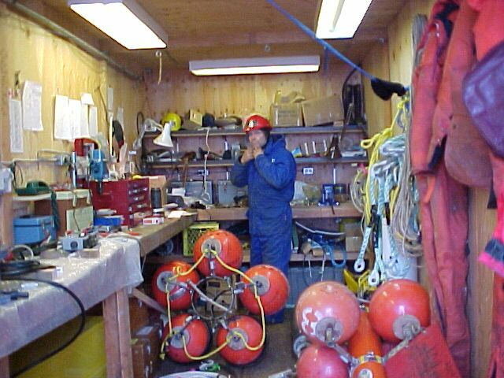
Container workshop on the well-deck of the CCGS Sir Wilfrid Laurier (Peter Gamble, proprietor). This workshop is essential to the preparation of instrumentation prior to its deployment on moorings.

Locations for Leg 2 of the JOIS 2001 cruise aboard the CCGS Sir Wilfrid Laurier, September 2001
Small circles mark CTD’s, filled circles mark X-CTD drops, crosses mark rosette casts, large circles mark mooring recoveries, diamonds mark mooring deployments. The shaded area spans the area of the ice stress-strain array that was deployed to drift on the pack ice of the Canada Basin.

Leg-2 station locations in relation to ice conditions in the Beaufort Sea in early September 2001

Leg-2 station locations in relation to ice conditions in the Beaufort Sea in early October 2001

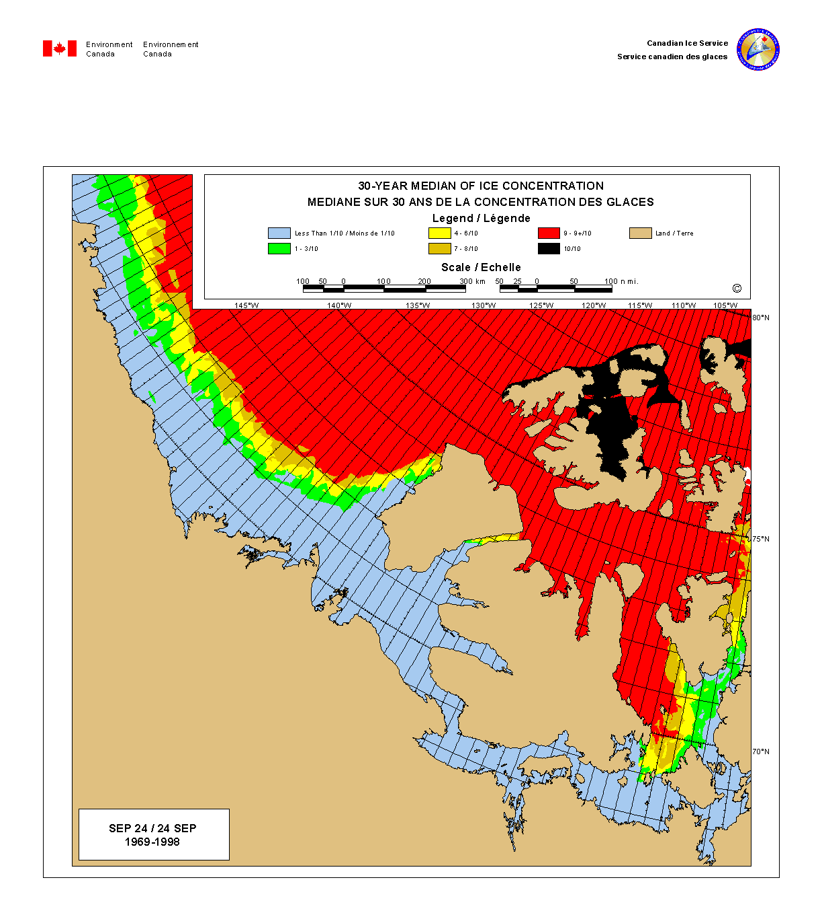
Median ice conditions in the Beaufort Sea at the time of historical minimum ice extent in in late September

Overview

Achievements in Relation to the Science Plan
During the 30-day duration of leg 2, the CCGS Sir Wilfrid Laurier travelled more than 3000 nautical miles.
The science team completed 50 rosette/CTD casts for seawater sampling on 5 hydrochemical sections, and 56 CTD casts on supplementary hydrographic sections and at sites for mooring recovery and deployment. The science team took advantage of the unanticipated penetration into the Canada Basin at 140°W to complete a highly resolved Station-A hydrographic cast at 73°15’N and a Line-A section back to the shelf break in Herschel Canyon. Line-A/Station-A monitoring, which has continued intermittently under Canadian leadership since 1987, has provided valuable insights into the character, origin and significance of recent change in the Canada Basin. Expendable CTD probes were deployed at 36 locations, along Line-A and at 15-mile intervals along the continental slope between 140° and 160°W.
Ten oceanographic moorings were recovered at 8 sites, under conditions ranging from ice-free to challenging. Thirteen oceanographic moorings were deployed at 11 sites between 123° and 155°W. The retrieval of most of these moorings is planned for the late summer of 2002, after a year-long deployment.
A mooring installed at the mouth of Herschel Canyon carried the Monkey, a novel instrument designed to acquire CTD profiles four times daily over a 12-month deployment. A successful operation of the Monkey in the Arctic could open new possibilities for unattended hydrographic observations in such remote areas.
An instrument that acquires images of surface phenomena, such as freezing in leads and the rafting and ridging of sea ice was deployed for the first time on this cruise. This prototype utilizes rotary scanning sonar positioned at 50-m depth in much the same manner as marine radar is used from a ship. Eight images over a 1-kilometre-diameter disc will be acquired and stored daily over the 12 months of the deployment.
An array for the measurement of pack-ice stress and strain was installed using the ship’s helicopter at 9 sites in the vicinity of 73°N 138°W. At the central site, additional instrumentation was deployed to measure surface weather and changes in ice thickness. All instruments in the array will report observations via satellite as they drift westward along the Alaskan coast. The array will not be recovered.

Strike Action
Labour action by PSAC members (ship’s crew and EG scientific staff) caused the loss of 3 days ship time from the science programme.

Impact of September 11
The temporary suspension of air travel delayed the arrival of the IOS, PMEL and CRREL scientific personnel. These delays necessitated a re-profiling of the science programme. With re-profiling, the impact of the delays on the science programme was negligible.

Impact of Ice Conditions and Weather
Except in eastern Amundsen Gulf and in the area of Tuktoyaktuk, ice provided a continuing challenge to the progress of the ship and conduct of the science programme. The preceding figure, which depicts median ice conditions for the area in late September, suggests that the ice conditions encountered in September 2001, displayed in the weekly regional ice charts from the Canadian Ice Service, were slightly worse that average. The over-plotting of stations on these charts reveals that much of the ship’s scientific work was completed in areas of significant (more than 5-tenths ice concentration). Noteworthy in relation to ice cover are the progressions of the CCGS Sir Wilfrid Laurier northward to 73° at 138°W to deploy the CRREL/PMEL ice-stress array and north-westward to 72°N at 160°W to complete a hydrographic section across the long-awaited warming stream of fresher North Atlantic water that is now entering the southern Canada Basin. The completion of both penetrations northward into multi-year ice is a credit to the resolve and navigational skills of the captain and officers of both crews of the CCGS Sir Wilfrid Laurier.
Weather was good throughout leg 2. There were no severe storms, and visibility inhibited planned helicopter use only occasionally. Only at the end of the leg, when the CCGS Sir Wilfrid Laurier was in 10-tenths ice northwest of Barrow, did a forecast of strong southeast wind cause abandonment of the hydrochemical section in this area for fear of ice pressure and ridging. A change in crew via helicopter to Tuktoyaktuk was completed in excellent weather from a location 20 miles out, to the northwest of Toker Point, in less time than anticipated. The success of this operation provided an additional 4-5 days of time for the science programme, since the alternative location for changing crew required a round-trip detour of 1040 nautical miles to Kugluktuk.

Planned activities that were not completed
Some of the activities planned for leg 2 were not completed. In some cases, this is immaterial since alternatives were substituted to meet the exigencies of ice, or to take advantage of unanticipated opportunity (e.g. Line-A, Station-A).

CTDs
2 stations of the section along the sill of Amundsen Gulf were inaccessible in heavy ice

3 stations north of the shelf edge at 134°W were cancelled to advance the schedule
A triangular pattern of close CTD stations over Herschel Canyon was cancelled to advance the schedule

Expendable CTDs
The along-slope section by X-CTD from Herschel Canyon was not completed beyond 160°W to the Northwind Ridge because of the combined influences of heavy ice, worsening weather and schedule

Hydrochemical Sections
Some sections were re-positioned in longitude to maximize access to deeper waters on the continental slope
2 stations at the seaward end of the Amundsen Gulf section (over the sill near 72°N 131°W) were inaccessible in heavy ice
The 2500-m station at the north end of the 160°W section was abandoned because of ice and worsening weather
The Northwind Ridge section at 74°N was inaccessible in heavy ice

Mooring Recoveries
The Institute of Ocean Sciences mooring at Site 8, deployed in 1999, did not come up on command although both releases were communicative. The top instrument (an ice-profiling sonar) was cut free with a dragging line. Pressure from the schedule precluded dragging until the bottom instrument, an ADCP with a 2-year data record, was retrieved. This instrument and the releases remain in position for recovery in 2002.
A non-buoyant fragment of a Jamstec mooring deployed in Barrow Canyon in 1999, and damaged during dragging in 2000, was not recovered. The fragment is about 10 m long in 270 m of water. Extensive new ice at the location in early October permitted the completion of only two grappling operations, neither of which was successful. Dragging at this site will also be required in 2002, if ice conditions permit.

Narrative

September 19
Additional scientific personnel joined the CCGS Sir Wilfrid Laurier last night at Tuktoyaktuk (2 from CRREL, 2 from PMEL, 1 from IARC and Doug Sieberg from IOS). Darren Tuele left the ship to come south.
The CRREL/PMEL work is our first priority now since the weather is excellent for flying, and this work cannot be squeezed opportunistically into scraps of ship time that might be left before crew change. The CRREL/PMEL work requires several days of concentrated effort.
We are presently heading northwest and then north along 139°W, where a passage into the pack is clear on the radar imagery. The ship may be able to reach the 3000-m isobath, where we will have time to complete something like a Stn-A profile, with several casts to provide higher resolution of sampling in the vertical. Louise is planning some yo-yo casts for microstructure below 2000m.
To date we have achieved the following:
1) Longitudinal CTD and geochemical section from Dolphin and Union Strait almost to the sill of Amundsen Gulf SW of Sachs. The station on the sill and the reference station on the 1500-m isobath in the Basin were inaccessible because of heavy ice.
2) Transverse CTD section behind the sill in Amundsen Gulf, with the exception of the station on the northern side-wall. These two sections in combination clearly reveal a ongoing renewal of deeper waters in the westernmost basin - higher temperature, salinity and oxygen - and a hint of some renewal in the central basin where Fiona's mooring is located. The transverse section clearly reveals the rotational nature of circulation in this fiord. The deep inflow over the sill is confined to the southern sidewall, having followed the continental slope as a boundary current from the west.
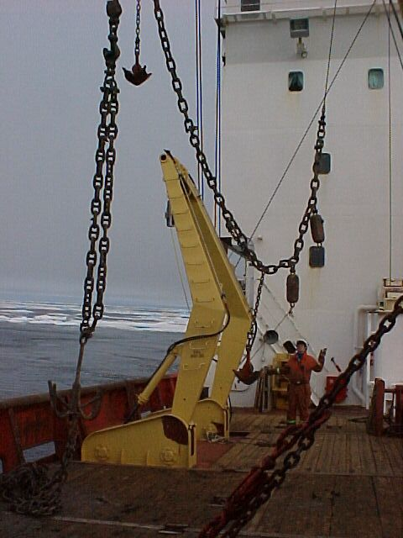Preparation of the grappling gear for dragging up the mooring at Site 8 northwest of Sachs Harbour on Banks Island. Despite operable releases, this mooring did not surface in response to acoustic command from the surface
3) Recovery of the sediment trap mooring at AG05. Sea conditions were good, but recovery was complicated by short ranging distances on the releases. Subsequently we tested all releases on board for successful operation at the depths (600 m) and ranges (1200 m) needed for this location. The poorly performing releases from the mooring are being punished. The Honjo trap appeared to operate correctly, but malfunction of the Baker trap is suspected because virtually no sediment was collected.
4) Trouble-free recovery of the Jamstec mooring north of Cape Dalhousie in cooperative ice conditions. The Laurier was able to bully one 30,000T floe out of harm's way before the release.
5) Trouble-free deployment of the replacement mooring at AG05.
6) Recovery of the ice-profiling sonar from site ITT99-8, but not the ADCP or releases. Releases at this site appeared to operate but the mooring did not surface. We proceeded to set a drag wire several times under definitely uncooperative ice conditions, using a variety of approaches that represented the talents and interest of all on board. The top instrument floated up when the drag wire severed the kevlar line. We had the bottom of the mooring at least twice, and dragged it several hundred metres under higher tension. However the mooring was lost twice on the vertical lift to the rail. Officers, deck crew and IOS folk worked very hard and long on this, and disappointment was high as we turned our backs to address other aspects of the science program. The 2-year data record in the ADCP, its value ($100k), the operable transponders and our precise knowledge of location warrant a return visit next year. The IPS retrieved here contained a full 26-month record.
7) An ADCP/IPS mooring for ice measurements over the next 12 months was deployed at site ITC01- 8. This is a revision of the original plan for a 24-month deployment at this site.
8) Textbook recovery of two ice-measurement moorings at site ITT99-2. All three instruments yielded full 24-month records.
9) Textbook recovery of two ice-measurement moorings at site ITC00-1. All three instruments yielded full 24-month records.
10) CTD section along Kugmallit Sea Valley from the shelf edge to the 15-m isobath north of Tuktoyaktuk.
11) Completion of a 17-station CTD pattern at the head of the Kugmallit Sea Valley.
The ship, officers, crew and scientific complement have done very well under the challenges posed by the events of September. We have a strong commitment and involvement from Captain Mark Taylor in this work. Ice conditions have steadily improved here and along the Alaskan coast and the weather is very good. I am optimistic that the science programme will meet all of its objectives before this leg of the cruise terminates at Barrow in early October.

September 25
Since my last report on progress, also filed from this location, the Laurier has completed an exciting sortie far into the multi-year ice along 139 W. With the blessing of good weather and a lead of reduced ice concentration just where it was needed, we reached the 3100 m isobath and a latitude of 73 14'N. Let's call this ‘Station A’.
On its first deep cast since delivery (to 3000 m), the new Hawboldt winch quickly developed serious spooling problems. We endured several tedious backhauls at less than half a metre per second in order to complete a highly resolved hydrochemical profile at this site. Continued problems with the spooler slowed our progress back to the south. We could not complete as many stations as were planned along the Line-A section back to the shelf edge because of these delays.
Today Bon van Hardenberg, Ron Lindsay and Peter Gamble left for Institute of Ocean Sciences, accompanied by David Walsh who returns to Fairbanks. The CRREL/PMEL team of 4 also departed. Mary O'Brien has volunteered to stay on until Barrow and we gain Koji Shimada from Jamstec. The science complement numbers seven for the next 9 days.
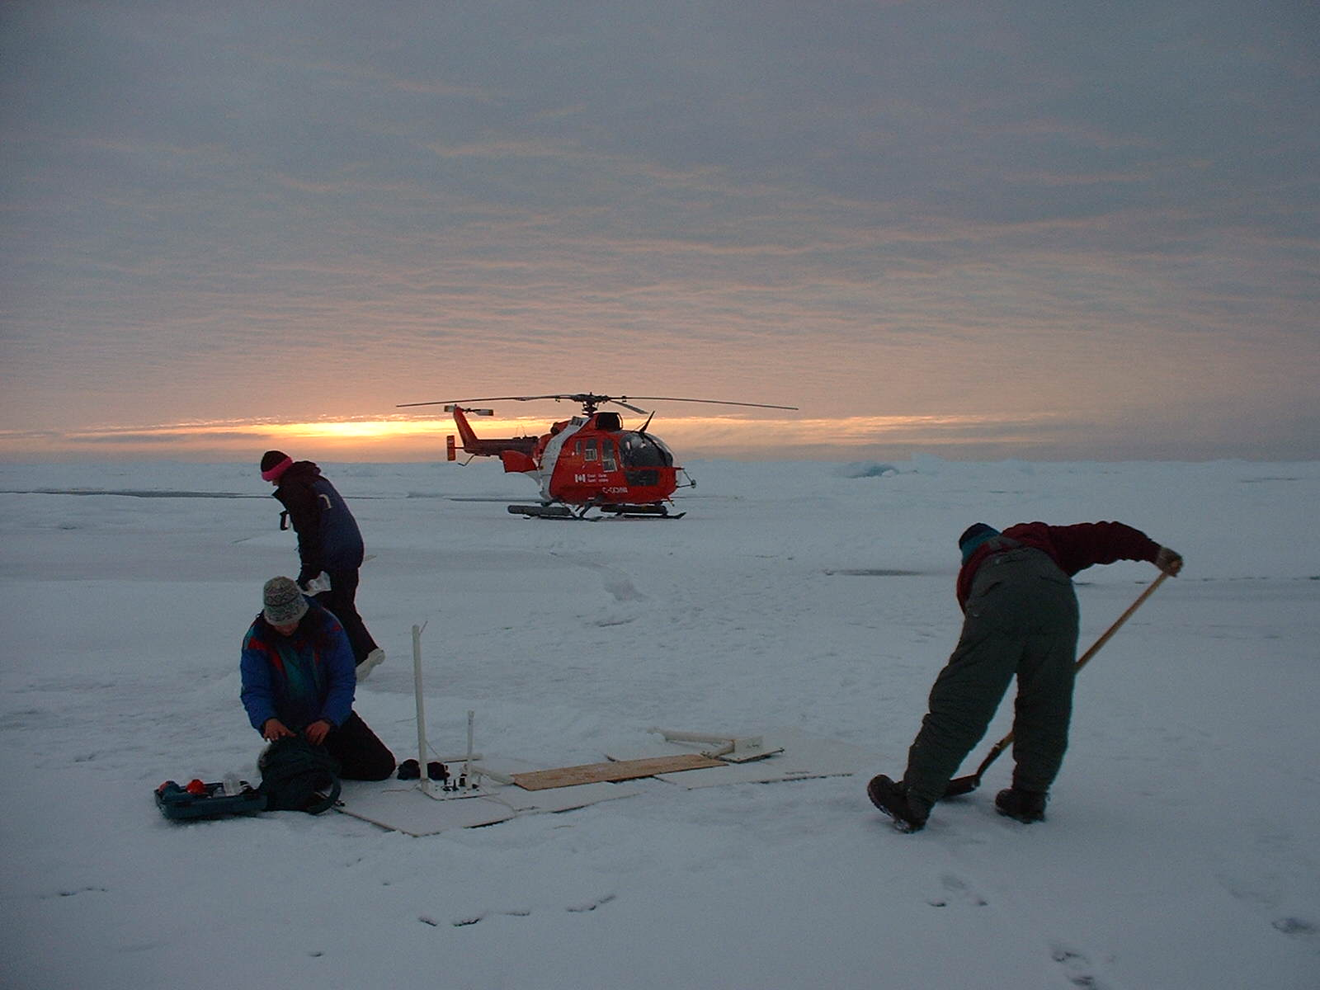
Our list of accomplishments is continued below:
12) A full-depth hydrochemical station at 73 14'N 138 00'W (Station A) for the variables that we were prepared to sample, at 36 levels. An additional drop permitted acquisition of 30-litre samples for cesium analysis at 4 levels.
13) Deployment of 9 stations in a stress-strain array on old ice north of 72°30'N (CRREL/PMEL). These stations were installed by helicopter from the ship during an opportunistic 2-day period of good weather. Sensors, which report position, ice-stress and temperature data via Service Argos, will not be retrieved.
14) Deployment of an ice-mass balance site at the centre of the stress-strain array (CRREL/PMEL), again by helicopter. This station includes a surface meteorological station, snow depth, ice thickness and ice stress, all reported via Service Argos.
15) A full-depth hydrochemical section from Station A to the mouth of Herschel Canyon, comprising 7 stations with the inclusion of Station A. At least 121 levels were sampled at each location. The section was augmented by X-CTD drops interleaved with the rosette stations.
16) Deployment of a Jamstec mooring (MCJ-01) at the mouth of Herschel Canyon (east side) in 500 m of water. This mooring carries an impressive array of instruments to measure temperature, salinity and circulation at the interface between the circulation regimes of the Beaufort shelf and slope.
17) Deployment of the IARC "monkey" mooring (ASB) at the mouth of Herschel Canyon (west side) in 460 m of water. The active component of this mooring is the "monkey", an autonomous CTD package that climbs the wire to acquire four vertical profiles of temperature and salinity each day. The mooring also carries an ice-profiling sonar to measure the thickness of sea ice that drifts over the site.
18) Deployment of the Internally Recording Imaging Sonar IRIS at the shelf edge north of Tuk (125-m isobath). This instrument is a prototype developed at IOS to collect 1-kilometre-diameter images of the ocean surface or the ice at 3-hour intervals throughout the year. The objective is to study freezing in leads, the under-surface geometry of sea ice in three dimensions (with an intent to discriminate first-year floes from old floes) and improve the calibration of ice-draft profiles collected to understand Arctic climate change.
19) Deployment of an ice-monitoring mooring at the same location as the IRIS. This mooring carries ice-profiling and doppler sonars (IPS & ADCP) and a temperature-salinity recorder and will operate for two years before recovery. These instruments record detailed sections of ice draft for study of seasonal and interannual changes in the ice climate, and detection of features of extreme draft that present hazards to offshore and seabed structures.
20) Deployment of an ice-monitoring installation at a mid-shelf location north of Tuk (55-m isobath). This installation comprises two short moorings that carry ice-profiling and doppler sonars and a temperature-salinity recorder. These instruments will be retrieved one year from now.
21) Deployment of a new hybrid sonar designed to measure storm waves during the open-water period and ice draft during the winter. Positioned on the 35-m isobath, this instrument is optimally positioned to observe surface processes in the Cape Bathurst Polynya. This prototype instrument is a collaborative project among DFO(IOS), NRCan(GSC, PERD) and ASL Environmental Sciences Inc. The wave measurements will support the collaborative development of a wave-surge forecast model for the Beaufort Sea and studies of coastal flooding and erosion.
Once again, I am pleased to report that we are delighted with the competent and committed support provided by the officers and crew of the Sir Wilfrid Laurier. Our list of achievements on this cruise has grown steadily over the last 2 weeks and there are happy, if tired, faces throughout the science team.
Following crew change, the Sir Wilfrid Laurier will proceed westward to Herschel Canyon, where a Jamstec mooring awaits recover, and then to the North slope to complete hydrochemical sections across the continental slope and additional mooring work north of Prudhoe and in Barrow Canyon. From Barrow, a push to the northwest will permit completion of a section across the north Chukchi slope and possible a short section at the junction of the Chukchi slope and the Northwind Ridge.

September 28
Here we are at 71°15’N 145°00’W, having lots of fun with Seabird technology in cold weather!
We were up at 7am this morning but have not yet (2 pm) completed a profile to 2500 m. First, the pylon would not trigger the bottles reliably. Our troubleshooting took us from a corroded Impulse under-water connector, through the slip rings, to the deck unit and back to the mechanical components at the top of pylon. It appears that we had a compound problem - poor electrical connectivity to the pylon, and dirt (or salt crystals) interfering with the magnetic activation.
When we got this sorted out, the pylon and the CTD were so chilled that ice formed in the SeaBird plumbing and within the magnetic activation assembly (even though the air temperature is only -2C!). We aborted the cast at 100 m and brought up the rosette for a thorough work-over with a hair dryer and warm water. The engine room has supplied us with heat lamps and tarpaulins to construct a more effective breeze barrier. I think we are now back in business. But we have had a good lesson in the vulnerability of the SBE approach to CTD's in freezing climates.
We are unimpressed with the Impulse underwater connectors that are used in large numbers to tie together the SeaBird CTD. We have already used up several pigtails in preparing a new connecting cable from the pylon to the SBE25. Some new bulkhead connectors are required to replace existing ones with corroded pins.

October 1
We are now (9 am Monday) completing a short CTD section across Barrow Canyon. Louise and I started this section at 2 am following maintenance on the ship's cyclo-convertor on Sunday evening. Skies are overcast and a light snow is driven into our faces by a 20-kt easterly wind. The temperature is -10 C.
This afternoon we will set a dragging wire through the nilas that has spread over much of the sea surface with decreasing temperatures over the past 2 days. On the wire are hooks to snag a section of a mooring deployed in Barrow Canyon in 1999, and not yet recovered. This afternoon, the CIS Dash-7 will fly ice reconnaissance to the area of the Northwind Ridge, in preparation for our push more than 150 miles northwest to complete a hydrochemical survey over the continental slope in this area. To maximize the ship time available for science, the Laurier will subsequently make passage directly from this area to Nome, without detouring to Barrow for disembarkation of scientific staff.
During our passage west over the last week, we have uncovered clear evidence that the warming of the intermediate water in the Arctic, initiated in the Eurasian sector in 1989, has finally penetrated into the North American sector. Temperatures above 0.6 C have been observed in association with temperature maximum at reduced salinity near 350 m as far east as 149 W. We have also sampled a large eddy of Bering/Pacific water in the deep water of the Canada Basin to the northeast of Barrow. Radarsat images clearly show the influence of this warm (6°C) pool in reducing the concentration of pack ice in this area. The existence of this eddy here is consistent with ideas developed by Jamstec colleagues concerning the dispersion of Bering/Pacific water in the Canada Basin. This circulation complements the long recognized advection of Bering/Pacific water eastward along the continental slope during some phases of the north polar atmospheric circulation.
Spooling problems with the new Hawboldt CTD winch have been temporarily resolved through the efforts of the engineering staff of the Sir Wilfrid Laurier. This fix must, however, be regarded as temporary until a more satisfactory resolution of winch problems can be worked out with the manufacturer.
We are encountering significant problems operating the CTD and rosette sampler in the unsheltered area available for this activity on the port-side boat deck. Wind and low temperatures have caused deleterious icing of the CTD, of sample bottles (particularly valves) and of the rosette pylon. The ship's crew has rigged tarpaulins to shelter the area, and have provided radiant heat lamps to cut the chill. With some continuing difficulty at ambient temperature below -4°C, we are managing to operate and sample within this enclosure. The present temperature of -10°C is probably the absolute minimum at which such ad-hoc operations are viable without significant improvement in this facility.
The CTD winch and block are also vulnerable at this temperature. The pulley wheels, which ice up and freeze immobile, will have to be modified and heated to enable safe operation in polar seas in late autumn.
Our list of accomplishments is continued below:
22) Recovery of a Jamstec mooring on the axis of Herschel Canyon in 260 m of water. This mooring carried an array of instruments to measure temperature, salinity and upwelling through this canyon onto the Beaufort shelf.
23) A longitudinal hydrographic section by X-CTD along the 500-1000 m isobath between Herschel Canyon and Barrow Canyon
24) A hydrochemical section across the continental slope at 145°W
25) Deployment of a Jamstec mooring in 500 m of water in a steep sea valley cutting through the continental slope at 149°W. This mooring also carries instruments to measure upwelling onto the the Beaufort shelf .
26) A CTD section across the continental slope at 149°W.
27) A hydrochemical section across the continental slope at 153°W and out to the 2500-m isobath, which clearly shows the interaction between "old" and "new" intermediate waters at 300-1000 m depth, and the dispersal of Pacific-originating waters northward across the continental slope.
28) Recovery of a Jamstec mooring on the axis of Barrow Canyon in 260 m of water. This mooring carried an array of instruments to measure temperature, salinity and downwelling of Pacific-originating waters through this canyon into the Canada Basin.
29) Deployment of three Jamstec moorings in Barrow Canyon, on the east wall, on the axis and on the western side. These moorings continue the study of seasonal and interannual change in fluxes of Pacific-originating waters into the Arctic Ocean.
30) A high-resolution CTD section across Barrow Canyon that reveals the downwelling of two distinct warm water masses into the Canada Basin, and dramatic interleaving structures.
The transition of the science programme to the new crew on September 26 was seamless. Since crew change, the programme has continued to benefit from the expertise and commitment of competent leadership and of capable officers and crew. The seeming ease of mooring deployments and recoveries, in the face of challenging ice conditions and poorly known bathymetry, is a pleasure to behold. The contribution of ship's personnel to winch repair and the weatherproofing of the rosette station is greatly appreciated.

October 3
By last night we had worked our way north through 10/10 ice to the 1000-m isobath at about 159°W. Since the weather was beautiful (high pressure, clear skies, aurora) we stopped working when we finished this station at midnight, expecting to continue north to the 2000-m isobath in the morning. Our plan was to work the two remaining stations on this line while Koji travelled by helicopter to deploy X-CTD's at stations further north, and also along the 700-m isobath to the northwest and southeast, as a continuation of the longitudinal section along the continental slope.
Today was a disappointment. The wind picked up from the southeast overnight, and the speed is forecast to increase to 25-35 knots by afternoon. Captain Thomas is concerned about the ship being caught under pressure in the ice, and we are making our way south without completing the Chukchi-slope section north to the 2000-m isobath. The plan to conduct X-CTD drops using the helicopter has also been abandoned because of concerns expressed by the pilot about search-and-rescue response and about landing on the ice.
We were able to complete five hydrochemical stations between the 150-m and 50-m isobaths on our way south towards Hanna Shoal. Water at 5-6°C on the 31 isohaline, such as observed to the northeast of Barrow, was observed on this section also, but the thickness of the layer was not as great.

Appendix 1: Locations of Moorings associated with the JOIS-2001 in the Beaufort Sea

Appendix 2: Locations of CTD and CTD/rosette profiles (continued)

Appendix 3: Locations of profiles by expendable CTD (X-CTD)

Appendix 4: Suggestions for improvement of the science capability of the CCGS Sir Wilfrid Laurier

Lab space:
The lab space available is quite adequate to meet the needs of this year's science program, but will be seriously stretched by the demands of a full geochemistry program such as might be conducted during Theme-2002 (Canada-Japan). Other components of a multi-disciplinary science program could be left without adequate work space - instrumentation, sediments, plankton biology, hydrography, ... Space for at lleast one 20-foot container lab with full services is a high priority.

Storage space:
Accessible storage space is required for both refrigerated and frozen samples, at least 150 cu ft. A chest freezer could provide the sub-zero storage, but this should not occupy valuable space in the lab.
In addition, accessible guaranteed-no-freeze storage is needed for large volume samples such as iodine and cesium for radioactive tracer analysis, at least 300 cu ft.
These storage needs could be addressed by a second 20-foot container, appropriately equipped, or several smaller containers on the boat deck or higher.

Rosette shelter:
The present rosette-CTD station is a vast improvement over the previous set-up, but it remains completely exposed to wind and cold air. It is also vulnerable to wind-blown spray and precipitation that could contaminate samples for salinity, oxygen isotope and other analyses. The station offers little protection to personnel when drawing samples into containers for shipment and storage. Sampling bottles and CTD must be kept at temperatures above freezing at all times. The lack of shelter is already a problem (18 September, Beaufort Sea), with temperatures only a few degrees below freezing. As temperatures drop to -15 C in October, the present station will be difficult to operate for CTD and sampling work to modern standards.
Fabric drop sheets may be workable on the outboard side of the shelter but I believe solid walls with doors for through traffic may be needed to conserve heat on the side walls. A lowered ceiling would be an advantage.
This shelter must preserve the sight lines for the CTD operator and winchman.
In additions to shelter, a heat blower with significant btu capacity is needed to warm the shelter both when it is in use and when the equipment is in storage in readiness for action. A hot-air feed beneath the rosette could help maintain above-zero-temperature in this crucial area down near the deck.

Forward container lab
Install a standard-size sea-proof entrance door.
Install ventilation.

Clothing
New space for hanging outdoor clothing and footwear.

Rosette deployment

Video camera to monitor fore-aft wire angle c/w video display on the bridge

Hydrography lab
The Simrad echo sounder is poorly positioned on a shelf that compromises the use of quite a bit of space in this small lab. Perhaps the sounder could be re-positioned on the rear bulkhead above the work table?

Forward science lab
The capacity of the pump supplying seawater to the science lab exceeds the capacity of the drain to remove the flow. Refit the supply with a pump of lower capacity.
Install additional shelving above the sink counter. Please make the shelves high enough to accommodate 3-ring binders in a vertical position.
Provide high stools for use in the lab - 5 legs, non slide.
Provide a flat-screen monitor for relaying the video display from the Aldebaran navigation on the bridge and from the CTD computer. Such a monitor will occupy less counter space.
Double the UPS power for lab instruments.
Install flush-mounted T-nuts into the lab counters, or overlay the counters with plywood containing such fittings, in order that eye-bolts may be screwed in where needed to secure heavy instrumentation for seawater analysis. Such fittings will control the ad hoc proliferation of screw eyes over the counter tops.

Appendix 4: Correspondence with respect to the Hawboldt Winch

From: C.C.G.S. John P. Tully [mailto:tullyjp@pac.dfo-mpo.gc.ca]
Sent: September 30, 2001 22:11
To: Bridge - CCGS Sir Wilfrid Laurier
Subject: Att: Chief Engineer Phil Dauphinee
Thanks for keeping us in the loop with problems with similar equipment fitted here. One thing that we were considering was that the scroll drive was out somehow either by teeth or alignment, but it seems that you have found a problem. We have had a few teething problems as well with the winch. Firstly, the thermostatic control valve didn't work and failed to prevent oil from going to the cooler; consequently, the oil got very hot on the deep casts. We simply removed it and put full flow through the cooler until we get a new valve for installation.
Secondly, it was noticed that the scroll, diamond shaft, was getting scored. This was caused from poor machining of the pawls and housing. The areas were dressed up and the damage seems to have subsided. I think they are going to replace the scroll shaft, as it is not in the best of shape.
Hopefully these are only teething problems as we are very happy with the winch for the CTD and other casts vs. our hydraulic system Swan Winches.
In the refit we will install another pump to supply feed water to the winch and then it will be disconnected from the lab sea water supply and reduce fluctuations. I have proposed that we buy the same screw pump that you have, and fit a Variable Frequency Drive thus giving us a range from around 40 GPM to 120 GPM to the lab and incubators. This should meet science requests for some time. It is very costly $10K for pump, $1.1K for spare seal, $2K for Square D VFD. In your pump system I saw a pressure surge valve, How is it plumbed in, relief valve overboard? Is all of your piping SS to the lab manifold?

From: john.huxtable@hawboldt.ns.ca
Sent: Monday, October 01, 2001 10:04 AM
To: 'DFO - IOS - Phil Lobb'
Subject: Laurier CTD Winch
Further to our conversation of this morning and various e-mail transmissions for the Laurier, I believe that the possibility of the cable drum shafting should be investigated. My comments are as follows:
1) The drum is retained only at the motor end, with the bearing at the slip-ring end allowed to float.
2) If the drum has shifted, it will be in a direction away from the motor (towards the aft of the ship).
3) The drum cannot move any more than 0.48" total. After that, the floating bearing stops against a shoulder.
4) A single bolt through the centerline of the motor retains the drum. See drawing 008-0001-01 in the manual. Removing the motor end cover embossed with the “Hagglunds” name permits access to the bolt. Six bolts keep the cover in place. With the cover removed, tighten the central retaining bolt to a recommended torque of 280 lb-ft. This will pull the drum back into position if it is loose. Re-install the cover bolts and torque to 59 lb-ft.
5) If the drum did not shift, the level-wind screw shifted on the set-screws. Since they have re-positioned it back into place, just ensure the set-screws are all tightened.
6) If the drum did shift, please re-check clearance between the speed sensor and the notched plate. It may have changed. Also, you may need to put the screw back where it was before the drum moved (assuming the screw didn't shift).
7) After resetting the position of the drum and / or the screw, check the alignment of the level-wind chains.

From: CCGS Sir Wilfrid Laurier [mailto:laurier@pac.dfo-mpo.gc.ca]
Sent: Sunday, September 30, 2001 1:29 PM
To: 'Phil Lobb'; 'HAWBOLDT'
Cc: Bridge - CCGS Sir Wilfrid Laurier
Subject: Laurier - Hawboldt Winch Spooling
On Saturday morning we moved the spooling shaft using a gear puller so that it was aligned with the cable drum. This appears to have solved the problem of the cable over wrapping when spooling back on the drum. We have since done a number of casts to a deep as 2500 meters without a problem. The reason for the drum shifting should be determined and corrected when the ship returns to Victoria.

