Processing Notes for the Year 2000 Nanoose Bay Data 29 July, 2026

Ron Perkin

.hex and .con files were inspected then used to create .cnv files using the Sea Bird software and the recommended processing for the SBE19.

.cnv files were converted to .ios files.

Using a Visual Basic program, positions were added. They were taken from the .act files as distance in metres, x' and y', along range 2 which was inclined at an angle of 11.2º south of east. Conversion into easting and northing coordinates was done according to:

X = x'cos(11.2) + y'sin(11.2)
Y = -x'sin(11.2) + y'cos(11.2)

Conversion to lat/long was done according to:

Lat = 49º (21.05' +Y*60/111120)
Long = 124º + (9.55 - X*60/72387)

The data was exported to a .o4x file(station name was added) and was inspected in Ocean Data View. Outliers were removed and the time sequence was contoured.

Cast N0307001 was deleted as bad.

Fixed .ios files were converted to .ctd files with the IOS sequential numbering.

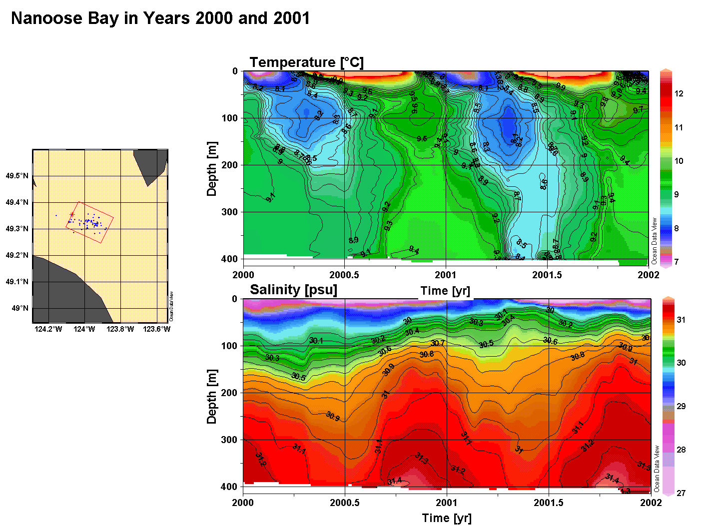
Figure 1

