REVISION NOTICE TABLE
DATE | DESCRIPTION OF REVISION
28-Oct-2013 | - Merged DMS data to bottle casts from Mike Arychuk’s spreadsheet file located in the \DOC directory. For information on methods see file "Method post 1999 for Dimethylsulfide Analysis.doc” in directory \\OSD_Data_Archive\Cruise_Data\Documents\Analysis Reference Papers\
19-Feb-2013 | - Added Iron profile files with cast numbers 8xxx and one surface file from Keith Johnson’s spreadsheet file which can be found in the cruise .DOC directory.
17-Feb-2012 | - Added one productivity cast containing Primary Productivity, Chlorophyll, POC and PON, from Frank Whitney’s Productivity spreadsheet.  - Replaced Alkalinity and DIC data with values from Jim Christian’s DIC files since they contained quality flags, for bottle cast number 57. Jim Christian’s DIC file is located in the \DOC directory. For more information, including quality control analysis see John Page’s spreadsheet files in directory \\OSD_Data_Archive\Cruise_Data\Documents\Station Papa Data Archiving\Alkalinity and DIC.
May 28, 2010 | An error was found in the calibration parameters used in processing this cruise. It is estimated that pressure is low by <0.5db, so no correction was applied. For details see file “Report on Calibration Errors for Pressure Sensor #77511, CTD0585 “ in Osd_Date_Archive\Cruise_Data\DOCUMENTS
June 3, 2004 | Added DIC and Alkalinity data to the archive.
April 21, 2003 | Moved files to new archive.
March 12, 2002 | Fl data was recalibrated for casts #2 through 75. See details at end.
August 31, 2001 | Reprocessed data to filter and calibrate fluorometer channels. Details in notes at end of this document.

PROCESSING NOTES

Cruise: 2000-25
Agency: IOS
Project: Line P
Chief Scientist: Howard Freeland
Platform: J. P. TULLY
Date: 4 September 2000 –21 September 2000

Processed by: Ron Perkin
Date of Processing:
Number of original CTD casts: 39
Number of casts processed: 39

INSTRUMENT SUMMARY

CTD Sensors
CTD | T0 | T1 | C0 | C1
550 | 2023 | 2371 | 2173 | 1766
585 | 2663 | 2668 | 2399 | 2424

A SeaBird Model SBE 911+ CTD (#0550) was used for most rosette casts. Two Wetstar fluorometers (#2229 and #2228(pumped)), Seatech Transmissometer (#333DR) and Par Sensor (GSP-200L4S) were mounted on the CTD. A surface Par sensor (SPAR) was mounted on the container lab and wired into the CTD deck unit but did not work and provided no data.
A second CTD(#585) equipped with transmissometer(192D) was used for CTD casts 21,22,26,27,28 during foul weather.
After the deep rosette cast at station P(cast 57), the secondary temperature sensors were swapped and CTD 585 was mounted on the rosette for casts 65,67(shallow rosette casts) in order to link all the temperature sensors together for confirmation of the temperature calibration. The unpumped fluorometer(#2229) was also mounted on CTD 585 and the pumped flurometer(#2228) was mounted on the seawater loop to calibrate it against the chlorophyll samples.
On the return leg, for casts 68 and 70, two Ph(#180339 and #180923) and sensors were added to CTD as “userpoly 1” and “userpoly 2” respectively. Keith Johnson is working out the calibrations for these two pH sensors.
Table 1. Instrument Summary
Cast No. | CTD | .CON file | Config. File | Sensors | Comment
1 to 20 | 550 | 550_1-57.con | Dat550.cfg | Tx, Fl(2), PAR | PAR on some casts
21 to 28 | 585 | *.con | Dat585.cfg | Tx | No bottles
29-57 | 550 | 550_1-57.con | Dat550.cfg | Tx, Fl(2), PAR | PAR on some casts
65 & 67 | 585 | *.con | Dat585b.cfg | Tx, Fl | bottles
68 | 585 | *.con | Dat585c.cfg | Tx, Fl, pH(2) | pH voltage, bottles
70 | 585 | *.con | Dat585d.cfg | Tx, Fl, pH(2) | pH calibrated
75 | 585 | *.con | Dat585d.cfg | Tx, Fl, pH(2) | PH voltage

SUMMARY OF QUALITY AND CONCERNS
The data was in good order and required only light editing. Header .hdr files on casts 22 and 30 were edited to remove data crossover between Longitude and “Start Time” information entered automatically by the deck unit. Processing was done with ..hdr files overriding the information in the .dat files.
Starting and ending pressure readings were reviewed and it was found that the ending values were consistently negative at the end of the cast although they were about correct at the beginning. It was decided to add 1 dbar to all pressures for CTD 550 – no corrections for CTD 585. This is not significant for most data but is important for comparing surface values with loop samples. This was accomplished using the confile “550_1-57.con”.
Static temperature comparisons at bottle points showed only small differences with 3 sensors agreeing perfectly and sensor 2023(primary of CTD 550) needing a .0005°C correction.
The pressure and temperature corrections were applied at the very beginning, “datcnv”, stage.
Comparison of temperatures(see plot below) measured simultaneously on the CTD’s showed differences of +.002°C and -.002 on down and up casts respectively. This is unlikely to be a time constant problem since the difference in time constants would have to be on the order of .84 seconds. Fouling? Difference in pump speeds? It raises questions on how accurately we are actually measuring temperature in a dynamic regime.

Conductivity noise on the upcast of cast 67 shifted the salinity down by .006. Looks like a fish problem for CTD 585.

PROCESSING SUMMARY
1. Seasave - This step was completed at sea; the raw data files are *.dat,, *.con, * hdr and *.bl.
2. Preliminary Steps
The salinities were analyzed on board and used to calibrate the ctd data. Hydro files were not available at the time of processing.
Prior to leaving IOS, calibrations in the .con files of both CTD’s used for data logging were checked and edited. Some problems (wrong set of cal constants) were corrected.
- Conversion of Raw Data
The raw data were converted (with salinity) using conversion 2025####.con where #### is the cast number. Rossum was run to get the .btl files and the data was summarized using get_btl.exe and entered into spreadsheet 2025_btl.xls. The bottle salinity and oxygen data were obtained from Bernard Minkley and comparisons between bottle and CTD data were made. The main and secondary sensors of CTD #550 were in good agreement: T0-T1 = -.0005, S00-S11 = .010 with the average salinity agreeing with the bottles. The temperature correction to T0 of +.0005 was made in the reprocessing of the data done on Sept. 18. A possible pressure effect in the conductivity sensors of CTD#585 was noted.

Converted data was run through the SeaBird processing schedule using a batch routine; finbatch.bat and process.bat. This was comprised of ALIGNCTD(CTD585 only), WILDEDIT, CELLTM, FILTER, and LOOPEDIT.

4. ALIGNCTD
The deck unit was configured to advance temperature by .073 seconds for both sensor pairs which compensates for the delay in the TC duct and the time constant of the temperature sensor so no alignment should be necessary. A comparison of different alignments between C and T were made and it was decided that no alignment was necessary on CTD #550 but that temperature should be advanced by one scan, .042 s, for CTD #585. The primary sensors on CTD #550 had less noise probably because they were not plumbed into the fluorometer flow.
# alignctd_date = Sep 12 2000 01:30:53, 4.246
# alignctd_in = 20250029.CNV
# alignctd_cond_advSecs = 0.000, 0.000
# alignctd_temp_advSecs = 0.000, 0.042
# alignctd_oxygen_current_advSecs = 0.000, 0.000
# alignctd_oxygen_temp_advSecs = 0.000, 0.000
# alignctd_wetstar_advSecs = 0.000
# filter_date = Sep 12 2000 01:33:18, 4.246
# filter_in = 20250029.CNV

5. WILDEDIT
Program WILDEDIT was used to remove spikes in Pressure. Parameters used were:
Pass 1 Std Dev = 2 Pass 2 Std Dev = 5 Points per block = 50
# wildedit_date = Sep 12 2000 01:31:43, 4.246
# wildedit_in = 20250029.CNV
# wildedit_pass1_nstd = 2.0
# wildedit_pass2_nstd = 5.0
# wildedit_pass2_mindelta = 5.000e-002
# wildedit_npoint = 50
# wildedit_vars = pr
# wildedit_excl_bad_scans = no

6. CELLTM
The conductivity cell thermal mass correction was done for both channels (alpha = 0.03; 1/beta = 9.0.)
# celltm_date = Sep 12 2000 01:32:29, 4.246
# celltm_in = 20250029.CNV
# celltm_alpha = 0.0300, 0.0300
# celltm_tau = 9.0000, 9.0000
# celltm_temp_sensor_use_for_cond = primary, secondary

7. FILTER
Filter pressure as a preliminary for LOOPEDIT.
# filter_date = Sep 12 2000 01:33:18, 4.246
# filter_in = 20250029.CNV
# filter_low_pass_tc_A = 0.150
# filter_low_pass_tc_B = 0.100
# filter_low_pass_A_vars = pr
# filter_low_pass_B_vars =

8. LOOPEDIT
Mean speed was estimated using a 100 second time window and speeds less than 10% of mean were eliminated with a floor of 5 cm/s.
# loopedit_date = Sep 12 2000 01:34:49, 4.246
# loopedit_in = 20250029.CNV
# loopedit_minVelocity = 0.050
# loopedit_excl_bad_scans = yes.

9. BINAVG
To produce 1 dbar averages for analysis.

10. Derive
S(T0,C0) and S(T1,C1) were derived

10. Test Plots and Channel Check
A sample of casts (#8, 45 and 68) was plotted to check for agreement between the pairs of sensors. The temperature variations are very noisy but ignoring spikes are <0.001C° below 150db while the conductivity differences are about 0.001 S/m. Salinity values varied by ~0.01. Primary values were higher in each case. A quick check of CTD salinity versus bottle salinity suggests that the secondary straddle the bottle values, each being off by .005,.
Cast 46 has a huge temperature step at 41 dbar with resulting salinity spike of over 1 ppt..Investigation shows that CTD550 should have been aligned as well as CTD 585 – the SeaBird deck unit compensation is not working. Temperature should be advanced by a further .046 seconds for S00 and .054 seconds for S11 based on this one feature.
Discussions with Germaine led to the conclusion that his may be a second order evvect or cell thermal mass effect and should not change the processing scheme based on smaller gradients.

9. Conversion to IOS Headers
The IOSSHELL routine was used to convert SEA-Bird 911+ data to IOS Headers to produce .ios files. ITS90 temperatures were converted to IPTS68 using the calibrate program to produce .cal files. Records marked bad by the SeaBird software was deleted in this conversion.

10. Checking Headers
A header summary was produced and two header translation errors were found and corrected.
The surface check of CTD 550 was run. The average surface pressure is 1.125db which is a little low, expect about 2 dbar. Also, the upcast produces negative pressures at the last bottle point(also at about 2dbar). Therefore in the re-processing done on Sept.18, a 1 dbar offset was added to the pressures for CTD 550.
The header check was produced.
The cruise track was plotted and looks reasonable.

- DELETE
The following DELETE parameters were used:
Surface Record Removal: None
Pressure filtered over width: 48
Swells deleted. Warning message if pressure difference of 2.00
Drop rates< .3 m/s (calculated over 48 points) was deleted.
Sample interval = .042 seconds.
The log was examined and all warnings found to pertain to the surface or upcast.
Examples of salinity spiking under wavy conditions were plotted in high temperature gradient sections.

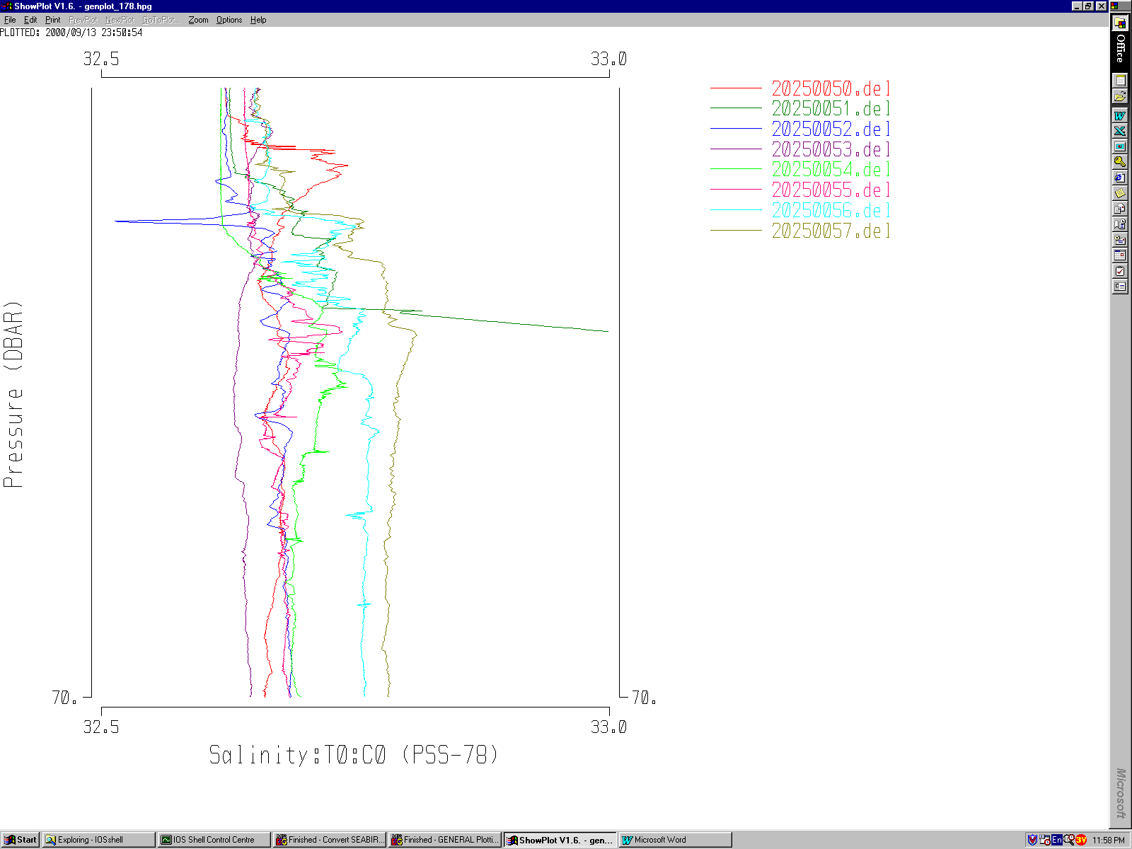The large spike in cast 57 was stable in density and may be real.
The secondary sensors were used for cast 51 because of apparent fouling of the primary conductivity.

12. BIN AVERAGE
The following Bin Average values were used:
Bin channel = pressure

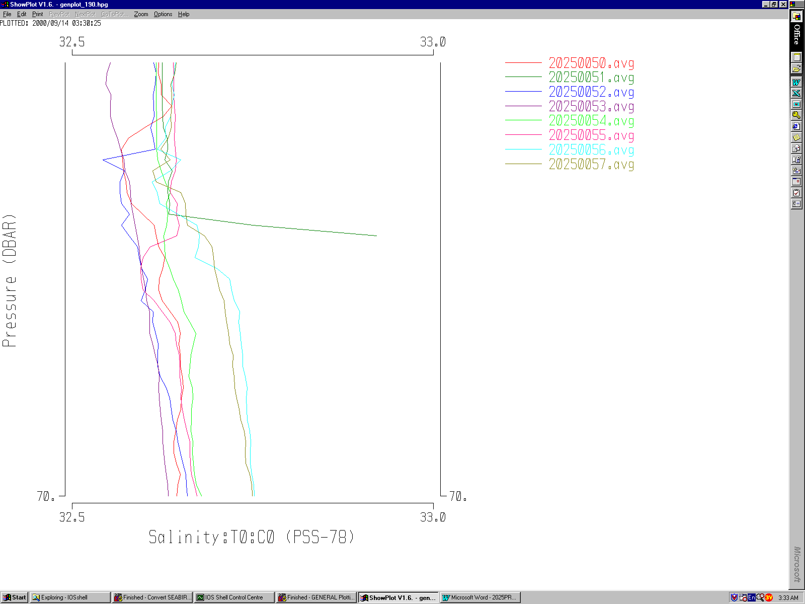Averaging interval = 1.000
Minimum bin value = .000
Figure 1. Some casts showing before and after SeaBird LOOPEDIT and the DELETE program in IOSSHELL. Some bad records have been deleted but many spikes large and small remain through the thermocline. It will be necessary to quote reduced accuracy in the depth range 35m to 55 m where large temperature gradients prevail and slow lowering in high wave states cause the pumps to ingest the rosette wake.. The worst data is connected to cast 52(check lowering rate). Binaveraging will smooth much of the high wavenumber spikes.
Figure 2
Average value will be used
Interpolated values are NOT used for empty bins
- Test Plots
Figure 3
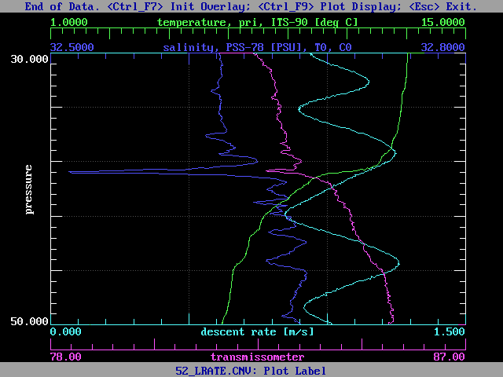
Profiles of all casts were examined for large differences between sets of sensors. The primary sensors in cast 51 were blocked, possibly by a jellyfish, at about 50 m so the secondary sensors were used.

Figure 4
Page plots were produced using T1,S1 for all casts. These plots were examined for spikes and instabilities and used to guide the use of CTDEDIT.
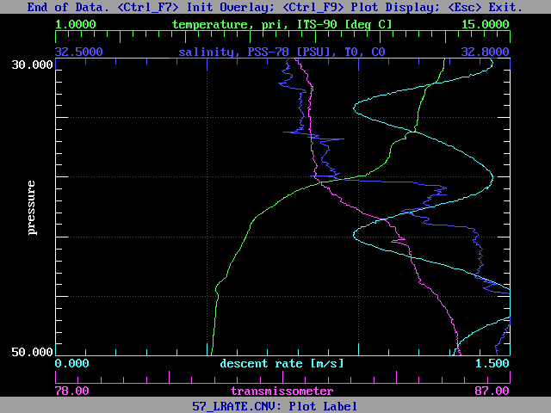
Figure 5 The spikes are sometimes on one sensor pair and sometimes on the other. LOWERING RATE IS NOT A FACTOR. From these plots, one gets the impression that the pumps may be intermittently slowing down leading to sensor mismatches.
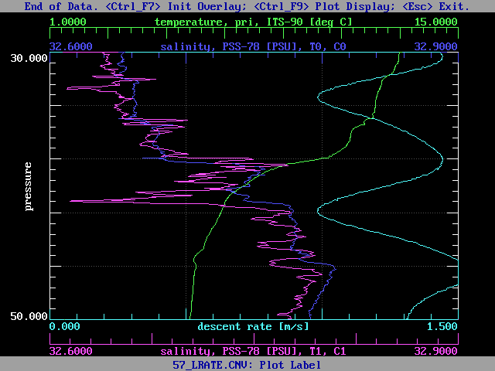
14. CTDEDIT
CTDEDIT was used to clean noise in S and/or T near the surface or at the bottom for the following casts: #2,5,6,15,17,28,30,41,43,45,47,54,55,63,66,68,69,71,72 and 73.
CTDEDIT was used for mid-depth editing of the following casts: #42 and 52.
Note was made of the editing details in the relevant files.

15. Intercomparisons
Secondary temperature sensors were switched between CTD550 and CTD585 at cast 65 on Station P26 to link all the temperature sensors together. T2663 – T2371 = -.00013°C(Cast 68, deeper than 500 dbar), essentially zero. From the deep cast at P26, T2023 - T2371 = -.0005. Therefore, if we take 2663 to be correct because it has the latest calibration and agrees well with 2668 which also has a recent calibration, then we should correct 2371 by +.0000 and 2023 by +.0005. The two T sensors originally used on CTD585, and with recent calibrations, need no correction. This correction was applied to the Sept. 18 re-processing.

16. Compare – A spreadsheet was used to compare bottle salinities with CTD data – 2025_btl.xls.
Cell constants for CTD 550 are shown below: there was no noticeable pressure dependence. Deep bottles are shown next at a higher resolution.
A detailed comparison of the cell constants shows some evolution with time with both cell constants following the same behavior. On inspection of the graph below, it is apparent that most of the change occurred between casts at P20 and P26. There was a fouling event on cast 51(P22), and bottle samples collected at the bottom of casts between P22 and P35 suggest that changes took place between casts 53(P24) and 57(P26), possibly a progressive fouling due to the presence of jellyfish, oil slicks, etc.. It is worthwhile noting that the winch wire was coated with an oily substance which sticks to everything. The first point on the graph represents P4 and because of the small number of deep calibrations, cannot be said to differ significantly from adjacent estimates, diff. < .001 ppt. Therefore, take :
(K0,K1)=(.99990,1.000164) up to cast 52:
(K0,K1)=(.99993,1.000185) cast 53 up to cast 55:
(K0,K1)=(.999978,1.000230) cast 57.
These corrections were applied to the IOSSHELL .cal files to produce .cor files.
*In order to convert to conductivity ratio from conductivity, the SeaBird conductivities were divided by 4.2914.
For CTD 585, the agreement between the sensors was exceptionally good and the temperature sensors agreed well with those on CTD550. One deep bottle cast was achieved at station OE1(cast 68) and yielded the result that the cell constants were both in need of correction by an amount of about 20 ppm in salinity!
Therefore, take (K0,K1) = (1.00045,1.00045).

- Recalibration
The conversion from ITS90 to IPTS68 was done with the CALIBRATE program using 2025orig.ccf cal. control file to produce .cal files. The conductivity correction, and conversion to cond. ratio was done using 2025.ccf to produce .cor files.
Table 2 Cell Constants
CTD | Casts | K0 | K1 | K0, ratio | K1, ratio
550 | 1-52 | 0.9999 | 1.000164 | 0.233001 | 0.233062
550 | 53, 56 | 0.99993 | 1.000185 | 0.233008 | 0.233067
550 | 57 | 0.999978 | 1.00023 | 0.233019 | 0.233078
585 | 21-28, 65-70 | 1.00045 | 1.00045 | 0.233129 | 0.233129

The corrected files were used as input to the following batch process:
Table 3
Batch Step | Output File Extension | Purpose
DESPIKE | .SPK | edit spikes out of T and C channels
DELETE | .DEL | delete swells and droprates less than .3 m/s
REMOVE | .REM | remove flag, SPAR, salinity
DERIVE | .SAL | compute salinity
BINAVG | AVG | 1 dbar averages
DERIVE | DER | add theta, gamma:theta, geo. Anom, T:ITS90

Salinity was recomputed using primary channels; secondary for cast 51 which had fouling in the primary conductivity to produce .sal files.

18. Final Plots
Profile and TS spaghetti plots were examined for problems.
Station P was compared Tabata’s averaqged data.
All OK.

Figure 6. Difference between primary and secondary salinities for downcast, 1 m average files. The bias at the surface is thought to be the effect of a different pumping rate for the secondary salinity duct which included the fluorometer. Only primary salinities were used for the final data.

19. REMOVE
The following channels were removed from all .der files: Number-of-scans, Primary &Secondary Temperature, Primary&Secondary Conductivity, Gamma-Theta, Geopotential anomaly, Theta.
20. Producing final files
a.) The final files were renamed *.ctd.
b.) A cross-reference listing was produced and is appended.

Particulars
Cast 20250051 – The primary duct ingested a fouling substance so the secondary sensors were used.
Cast 2025oe1 was renamed 20250068.

Institute of Ocean Sciences
CRUISE SUMMARY
Cruise ID#: 2025
Dates: Start: 4 Sept. 2000 End: 20 Sept., 2000
Location: Line P
Vessel: CCGS TULLY
Chief Scientist: Howard Freeland

CTD# | Make | Model | Serial# | Used with Rosette? | CTD Calibration Sheet Competed?
1 | SEABIRD | 911+ | 0550 | Yes | No
2 | SEABIRD | 911+ | 0585 | No | No
3 | SEABIRD | 911+ | 0585 | Yes (after cast 57) | No

Institute of Ocean Sciences
CTD Calibration Information
Make/Model/Serial#: SEABIRD/911+/ 0550
Cruise ID#: 2025

Calibration Information
Sensor |  | Pre-Cruise |  | Post Cruise
Name | S/N | Date | Location | Date | Location
Temperature | 2023 | 5 May1999 | Factory
Conductivity | 2173 | 5 May1999 | Factory
Secondary Temp. | 2371 | 13 Mar1999 | Factory
Secondary Cond. | 1766 | 16 Mar1999 | Factory
Transmissometer | 333DR | 14 July 2000 | IOS
Seapoint Fluorometer | 2229
Seapoint Fluorometer | 2228
PAR Sensor GSP-200L4S | 4565 | July 2000
Pressure Sensor | 75636 | 6 Apr, 1999 | Factory

Sensor Calibration Notes:
The configuration file 550_1_57.con has the corrections used in the DATCNV program. 2025orig.ccf and 2025.ccf have the corrections used in IOSSHELL.
To summarize, the pressure on CTD 550 was increased by 1 dbar and the temperature on sensor 2023 was increase by .0005 based only on comparisons with the other sensors.
Cell constants are summarized above.
Casts 75 was taken off Nanaimo after the batch processing was done with a net tow for UBC. It was processed individualyy.

Log file: D:\LineP_00\process\IOSshell\summary.log

==============================================================================
CRUISE HEADER SUMMARY
REPORT GENERATION DATE: 2000/09/19 14:01:20
==============================================================================
------------------------------------------------------------------------------
INPUT PARAMETERS
------------------------------------------------------------------------------
Source File Type : ASCII
Header Type : IOS
Source Directory : D:\LineP_00\process\IOSshell\
Cruise Number : 20-25
Cast Range : 1- 70
File Name Extension: ios
------------------------------------------------------------------------------
MISCELLANEOUS SUMMARY
------------------------------------------------------------------------------
Total Number of Casts Found : 38
The Following Casts are Missing : 6,8-12,18,23-25,31-38,43-45,47
-48,58-64,66,69
The Following Casts have the Wrong Consec # :
The Following Casts have Blank Station #'s :

------------------------------------------------------------------------------
CAST LIMITS
------------------------------------------------------------------------------
Max Water
Event Station Latitude Longitude Date Depth Depth
----- ------- ---------- ----------- -------------------- ----- -----
First 1 SA 3 48 35.59 N 123 29.96 W UTC 2000/09/05 01:05 215 0
Last 70 NOMADPH 51 22.83 N 135 28.35 W UTC 2000/09/17 16:54 503 0
North 70 NOMADPH 51 22.83 N 135 28.35 W UTC 2000/09/17 16:54 503 0
South 2 P 1 48 34.51 N 125 30.05 W UTC 2000/09/05 14:07 111 0
East 1 SA 3 48 35.59 N 123 29.96 W UTC 2000/09/05 01:05 215 0
West 65 MP26 49 59.69 N 145 0.30 W UTC 2000/09/14 22:07 403 4228
Shallow 3 P 2 48 35.98 N 125 59.96 W UTC 2000/09/05 16:48 111 0
Deep 57 MP26 50 0.06 N 144 59.82 W UTC 2000/09/13 20:44 4258 4227

------------------------------------------------------------------------------
SPEED SUMMARY
------------------------------------------------------------------------------
The Following Casts Have Cruising Speeds:
Between 0 and 5 knots: 5-13,16-26,30-39,41,46-50,56-68
Between 5 and 10 knots: 2-4,14-15,27-29,40,42,51-55,70
Between 10 and 15 knots:
Between 15 and 20 knots:
Between 20 and 25 knots:
Between 25 and 30 knots:
Above 30 knots :
------------------------------------------------------------------------------
CHANNEL SUMMARY
------------------------------------------------------------------------------
The Following are the Channels For Casts: 1-20,29-57
Pressure
Temperature:Primary
Temperature:Secondary
Conductivity:Primary
Conductivity:Secondary
Chl_fluorescence:Seapoint
Chl_fluorescence:Seatech
Transmissivity
Irradiance (PAR)
Surface Irradiance (PAR)
Salinity:T0:C0
Flag

The Following are the Channels For Casts: 21-28
Pressure
Temperature:Primary
Temperature:Secondary
Conductivity:Primary
Conductivity:Secondary
Transmissivity
Salinity:T0:C0
Flag

The Following are the Channels For Casts: 65-67
Pressure
Temperature:Primary
Temperature:Secondary
Conductivity:Primary
Conductivity:Secondary
Chl_fluorescence:Seapoint
Transmissivity
Salinity:T0:C0
Flag

The Following are the Channels For Casts: 68
Pressure
Temperature:Primary
Temperature:Secondary
Conductivity:Primary
Conductivity:Secondary
Chl_fluorescence:Seapoint
Transmissivity
Fluorometer:0
Fluorometer:1
Salinity:T0:C0
Flag

The Following are the Channels For Casts: 70
Pressure
Temperature:Primary
Temperature:Secondary
Conductivity:Primary
Conductivity:Secondary
Chl_fluorescence:Seapoint
Transmissivity
ph
Fluorometer:1
Salinity:T0:C0
Flag

------------------------------------------------------------------------------
DATA LIMITS over ALL CASTS
------------------------------------------------------------------------------

Channel Minimum Evnt Station Maximum Evnt Station
---------------------- -------------- ---- ------- -------------- ---- -------
Pressure -0.98 26 P13 4258.606 57 MP26
Temperature:Primary 1.5001 57 MP26 98.9762 54 MP25
Temperature:Secondary 1.4998 57 MP26 16.3924 17 P8
Conductivity:Primary -0.548E-03 21 P11 4.412875 54 MP25
Conductivity:Secondary -0.550096 21 P11 4.136962 19 P9
Chl_fluorescence:Seapo 0.1301E-16 29 P16 14.87 2 P 1
Chl_fluorescence:Seate 0.8674E-18 13 P4 0.9653 29 P16
Transmissivity 0 21 P11 70.33174 13 P4
Irradiance (PAR) 1.54 7 P4 4017 56 MP26
Surface Irradiance (PA -8838 5 P4 0 1 SA 3
Salinity:T0:C0 0.79E-02 21 P11 34.6862 57 MP26
Flag 0 1 SA 3 0 1 SA 3
Fluorometer:0 2.57387 68 OE1 2.78632 68 OE1
Fluorometer:1 2.66422 70 NOMADPH 2.85836 70 NOMADPH
ph 7.334 70 NOMADPH 8.119 70 NOMADPH

------------------------------------------------------------------------------
ADMINISTRATION SUMMARY
------------------------------------------------------------------------------
The Following are the Admin Items For Casts: 1-70
Cruise : 2000-25
Agency : IOS
Project : LineP, Sept., 2000
Scientist: H. Freeland
Platform : J.P. Tully

------------------------------------------------------------------------------
INSTRUMENT SUMMARY
------------------------------------------------------------------------------
The Following Instrument Was Used For Casts: 1-20,29-57
Instrument Type : Sea-Bird CTD
Instrument Model : SBE-911plus
Instrument Serial Number: ctd 550 or 585
Sensor 1 : temperature # primary
Sensor 2 : conductivity # primary
Sensor 3 : pressure # 75636
Sensor 4 : temperature # secondary
Sensor 5 : conductivity # secondary
Sensor 6 : Seapoint
Sensor 7 : transmissometer # 333DR
Sensor 8 : fluorometer # sea tech
Sensor 9 : irradiance # 4565
Sensor 10 : surface # degrees =

The Following Instrument Was Used For Casts: 21-28
Instrument Type : Sea-Bird CTD
Instrument Model : SBE-911plus
Instrument Serial Number: ctd 550 or 585
Sensor 1 : temperature # primary
Sensor 2 : conductivity # primary
Sensor 3 : pressure # 77511
Sensor 4 : temperature # secondary
Sensor 5 : conductivity # secondary
Sensor 6 : transmissometer # 192D
Sensor 7 : surface # degrees =

The Following Instrument Was Used For Casts: 65-67
Instrument Type : Sea-Bird CTD
Instrument Model : SBE-911plus
Instrument Serial Number: ctd 550 or 585
Sensor 1 : temperature # primary
Sensor 2 : conductivity # primary
Sensor 3 : pressure # 77511
Sensor 4 : temperature # secondary
Sensor 5 : conductivity # secondary
Sensor 6 : Seapoint
Sensor 7 : transmissometer # 192D
Sensor 8 : surface # degrees =

The Following Instrument Was Used For Casts: 68
Instrument Type : Sea-Bird CTD
Instrument Model : SBE-911plus
Instrument Serial Number: ctd 550 or 585
Sensor 1 : temperature # primary
Sensor 2 : conductivity # primary
Sensor 3 : pressure # 77511
Sensor 4 : temperature # secondary
Sensor 5 : conductivity # secondary
Sensor 6 : Seapoint
Sensor 7 : transmissometer # 192D
Sensor 8 : userpoly # 180293
Sensor 9 : userpoly
Sensor 10 : surface # degrees =

The Following Instrument Was Used For Casts: 70
Instrument Type : Sea-Bird CTD
Instrument Model : SBE-911plus
Instrument Serial Number: ctd 550 or 585
Sensor 1 : temperature # primary
Sensor 2 : conductivity # primary
Sensor 3 : pressure # 77511
Sensor 4 : temperature # secondary
Sensor 5 : conductivity # secondary
Sensor 6 : Seapoint
Sensor 7 : transmissometer # 192D
Sensor 8 : pH # 180339
Sensor 9 : userpoly # 180293
Sensor 10 : surface # degrees =

------------------------------------------------------------------------------
PROCESSING HISTORY SUMMARY
------------------------------------------------------------------------------
The Following are the Processing Steps For Casts: 1-70
SBE_IOS

------------------------------------------------------------------------------
CALIBRATION SUMMARY
------------------------------------------------------------------------------
The Following are the Calibration Coefficients
For Casts: 1-70

$TABLE: RAW CHANNELS
! Name Units Fmla Pad Coefficients
! ---- ----- ---- ------ ------------
$END

$TABLE: CALCULATED CHANNELS
! Name Units Fmla Pad Coefficients
! ---- ----- ---- ------ ------------
$END

$TABLE: CORRECTED CHANNELS
! Name Units Fmla Pad Coefficients
! ---- ----- ---- ------ ------------
$END
------------------------------------------------------------------------------
------------------------------------------------------------------------------
Report Complete

$TABLE: CORRECTED CHANNELS
! Name Units Fmla Pad Coefficients
! ---- ----- ---- ------ ------------
$END
------------------------------------------------------------------------------
------------------------------------------------------------------------------
Report Complete
------------------------------------------------------------------------------
Input parameter file: C:\windows\TEMP\iosshell\IS192.inp
Log file: D:\LineP_00\process\IOSshell\summary.log

************************************************
* Program: HSUMMARY *
* Version: 1.2 Date: April 12, 2000 *
* *
* Copyright 2000 Government of Canada *
* Department of Fisheries and Oceans *
* *
* Time of run: 2000/09/19 12:11:00 *
************************************************

Input file is in ASCII format.
Input path = D:\LineP_00\process\IOSshell\
Cruise year,cruise number = 20,25
First and last cast number = 1, 70
filename extension = ios
Summary listing will be produced.
1
1

Cruise 2000-

Cast no: 1 Station SA 3 Project LineP, Sept.
Latitude 48 35.59 N Longitude 123 29.96 W
Start date 5/ 9/ 0 Start time 1: 5 UTC
Maximum depth 215 No. of records 19476
No. of channels 12 Channel desc P %

Comments:

SBE HEADER
Sea-Bird SBE 9 Raw Data File:
FileName = C:\data\2000-25\20250001.DAT

Cast no: 2 Station P 1 Project LineP, Sept.
Latitude 48 34.51 N Longitude 125 30.05 W
Start date 5/ 9/ 0 Start time 14: 7 UTC
Maximum depth 111 No. of records 6550
No. of channels 12 Channel desc P %

Comments:

SBE HEADER
Sea-Bird SBE 9 Raw Data File:
FileName = C:\data\2000-25\20250002.DAT

Cast no: 3 Station P 2 Project LineP, Sept.
Latitude 48 35.98 N Longitude 125 59.96 W
Start date 5/ 9/ 0 Start time 16:48 UTC
Maximum depth 111 No. of records 8861
No. of channels 12 Channel desc P %

Comments:

SBE HEADER
Sea-Bird SBE 9 Raw Data File:
FileName = C:\data\2000-25\20250003.DAT

Cast no: 4 Station P 3 Project LineP, Sept.
Latitude 48 37.54 N Longitude 126 19.92 W
Start date 5/ 9/ 0 Start time 18:41 UTC
Maximum depth 808 No. of records 39316
No. of channels 12 Channel desc P %

Comments:

SBE HEADER
Sea-Bird SBE 9 Raw Data File:
FileName = C:\data\2000-25\20250004.DAT

Cast no: 5 Station P4 Project LineP, Sept.
Latitude 48 39.03 N Longitude 126 39.94 W
Start date 5/ 9/ 0 Start time 23: 9 UTC
Maximum depth 202 No. of records 15289
No. of channels 12 Channel desc P %

Comments:

SBE HEADER
Sea-Bird SBE 9 Raw Data File:
FileName = C:\data\2000-25\20250005.DAT
1

Cruise 2000-

Cast no: 7 Station P4 Project LineP, Sept.
Latitude 48 39.04 N Longitude 126 40.02 W
Start date 6/ 9/ 0 Start time 8:18 UTC
Maximum depth 1303 No. of records 70127
No. of channels 12 Channel desc P %

Comments:

SBE HEADER
Sea-Bird SBE 9 Raw Data File:
FileName = C:\data\2000-25\20250007.DAT

Cast no: 13 Station P4 Project LineP, Sept.
Latitude 48 39.09 N Longitude 126 39.98 W
Start date 6/ 9/ 0 Start time 18: 5 UTC
Maximum depth 401 No. of records 25289
No. of channels 12 Channel desc P %

Comments:

SBE HEADER
Sea-Bird SBE 9 Raw Data File:
FileName = C:\data\2000-25\202500013.DAT

Cast no: 14 Station P5 Project LineP, Sept.
Latitude 48 41.56 N Longitude 127 10.19 W
Start date 6/ 9/ 0 Start time 20:47 UTC
Maximum depth 2111 No. of records 87989
No. of channels 12 Channel desc P %

Comments:

SBE HEADER
Sea-Bird SBE 9 Raw Data File:
FileName = C:\data\2000-25\20250014.DAT

Cast no: 15 Station P6 Project LineP, Sept.
Latitude 48 44.64 N Longitude 127 39.94 W
Start date 7/ 9/ 0 Start time 0:10 UTC
Maximum depth 2573 No. of records 124192
No. of channels 12 Channel desc P %

Comments:

SBE HEADER
Sea-Bird SBE 9 Raw Data File:
FileName = C:\data\2000-25\20250015.DAT

Cast no: 16 Station P7 Project LineP, Sept.
Latitude 48 46.58 N Longitude 128 10.06 W
Start date 7/ 9/ 0 Start time 4:15 UTC
Maximum depth 2539 No. of records 118646
No. of channels 12 Channel desc P %

Comments:

SBE HEADER
Sea-Bird SBE 9 Raw Data File:
FileName = C:\data\2000-25\20250016.DAT
1

Cruise 2000-

Cast no: 17 Station P8 Project LineP, Sept.
Latitude 48 48.99 N Longitude 128 39.97 W
Start date 7/ 9/ 0 Start time 8: 2 UTC
Maximum depth 2544 No. of records 122530
No. of channels 12 Channel desc P %

Comments:

SBE HEADER
Sea-Bird SBE 9 Raw Data File:
FileName = C:\data\2000-25\20250017.DAT

Cast no: 19 Station P9 Project LineP, Sept.
Latitude 48 51.46 N Longitude 129 9.95 W
Start date 7/ 9/ 0 Start time 12:50 UTC
Maximum depth 2356 No. of records 111880
No. of channels 12 Channel desc P %

Comments:

SBE HEADER
Sea-Bird SBE 9 Raw Data File:
FileName = C:\data\2000-25\20250019.DAT

Cast no: 20 Station P10 Project LineP, Sept.
Latitude 48 53.55 N Longitude 129 40.05 W
Start date 7/ 9/ 0 Start time 17: 5 UTC
Maximum depth 2682 No. of records 125023
No. of channels 12 Channel desc P %

Comments:

SBE HEADER
Sea-Bird SBE 9 Raw Data File:
FileName = C:\data\2000-25\20250020.DAT

Cast no: 21 Station P11 Project LineP, Sept.
Latitude 48 55.96 N Longitude 130 10.11 W
Start date 7/ 9/ 0 Start time 22:11 UTC
Maximum depth 2702 No. of records 94959
No. of channels 8 Channel desc P %

Comments:

SBE HEADER
Sea-Bird SBE 9 Raw Data File:
FileName = C:\data\2000-25\20250021.DAT

Cast no: 22 Station P12 Project LineP, Sept.
Latitude 48 58.24 N Longitude 130 39.83 W
Start date 1/ 1/** Start time 0:11 UTC
Maximum depth 1505 No. of records 53635
No. of channels 8 Channel desc P %

Comments:

SBE HEADER
Sea-Bird SBE 9 Raw Data File:
FileName = C:\data\2000-25\20250022.DAT
1

Cruise 2000-

Cast no: 26 Station P13 Project LineP, Sept.
Latitude 49 2.64 N Longitude 131 40.07 W
Start date 8/ 9/ 0 Start time 21: 5 UTC
Maximum depth 1504 No. of records 56150
No. of channels 8 Channel desc P %

Comments:

SBE HEADER
Sea-Bird SBE 9 Raw Data File:
FileName = C:\data\2000-25\20250026.DAT

Cast no: 27 Station P14 Project LineP, Sept.
Latitude 49 7.44 N Longitude 132 40.05 W
Start date 9/ 9/ 0 Start time 3:55 UTC
Maximum depth 1506 No. of records 47871
No. of channels 8 Channel desc P %

Comments:

SBE HEADER
Sea-Bird SBE 9 Raw Data File:
FileName = C:\data\2000-25\20250027.DAT

Cast no: 28 Station P15 Project LineP, Sept.
Latitude 49 12.02 N Longitude 133 39.89 W
Start date 9/ 9/ 0 Start time 9:50 UTC
Maximum depth 1503 No. of records 54843
No. of channels 8 Channel desc P %

Comments:

SBE HEADER
Sea-Bird SBE 9 Raw Data File:
FileName = C:\data\2000-25\20250028.DAT

Cast no: 29 Station P16 Project LineP, Sept.
Latitude 49 17.03 N Longitude 134 39.86 W
Start date 9/ 9/ 0 Start time 16:14 UTC
Maximum depth 3673 No. of records 181604
No. of channels 12 Channel desc P %

Comments:

SBE HEADER
Sea-Bird SBE 9 Raw Data File:
FileName = C:\data\2000-25\20250029.DAT

Cast no: 30 Station P16 Project LineP, Sept.
Latitude 49 17.05 N Longitude 134 40.07 W
Start date 1/ 1/** Start time 0:14 UTC
Maximum depth 403 No. of records 26625
No. of channels 12 Channel desc P %

Comments:

SBE HEADER
Sea-Bird SBE 9 Raw Data File:
FileName = C:\data\2000-25\20250030.DAT
1

Cruise 2000-

Cast no: 39 Station P17 Project LineP, Sept.
Latitude 49 21.08 N Longitude 135 39.94 W
Start date 10/ 9/ 0 Start time 17:51 UTC
Maximum depth 1502 No. of records 72555
No. of channels 12 Channel desc P %

Comments:

SBE HEADER
Sea-Bird SBE 9 Raw Data File:
FileName = C:\data\2000-25\20250039.DAT

Cast no: 40 Station P18 Project LineP, Sept.
Latitude 49 25.98 N Longitude 136 40.19 W
Start date 10/ 9/ 0 Start time 23:10 UTC
Maximum depth 152 No. of records 6731
No. of channels 12 Channel desc P %

Comments:

SBE HEADER
Sea-Bird SBE 9 Raw Data File:
FileName = C:\data\2000-25\20250040.DAT

Cast no: 41 Station P18 Project LineP, Sept.
Latitude 49 26.02 N Longitude 136 40.35 W
Start date 10/ 9/ 0 Start time 23:24 UTC
Maximum depth 1503 No. of records 60162
No. of channels 12 Channel desc P %

Comments:

SBE HEADER
Sea-Bird SBE 9 Raw Data File:
FileName = C:\data\2000-25\20250041.DAT

Cast no: 42 Station P19 Project LineP, Sept.
Latitude 49 29.98 N Longitude 137 39.94 W
Start date 11/ 9/ 0 Start time 5:10 UTC
Maximum depth 1504 No. of records 62471
No. of channels 12 Channel desc P %

Comments:

SBE HEADER
Sea-Bird SBE 9 Raw Data File:
FileName = C:\data\2000-25\20250042.DAT

Cast no: 46 Station P 20 Project LineP, Sept.
Latitude 49 33.94 N Longitude 138 40.01 W
Start date 11/ 9/ 0 Start time 13:34 UTC
Maximum depth 4030 No. of records 210602
No. of channels 12 Channel desc P %

Comments:

SBE HEADER
Sea-Bird SBE 9 Raw Data File:
FileName = C:\data\2000-25\20250046.DAT
1

Cruise 2000-

Cast no: 49 Station P 20 Project LineP, Sept.
Latitude 49 34.05 N Longitude 138 39.96 W
Start date 11/ 9/ 0 Start time 21:19 UTC
Maximum depth 403 No. of records 19257
No. of channels 12 Channel desc P %

Comments:

SBE HEADER
Sea-Bird SBE 9 Raw Data File:
FileName = C:\data\2000-25\20250049.DAT

Cast no: 50 Station P 21 Project LineP, Sept.
Latitude 49 37.94 N Longitude 139 39.98 W
Start date 12/ 9/ 0 Start time 14:35 UTC
Maximum depth 1502 No. of records 68497
No. of channels 12 Channel desc P %

Comments:

SBE HEADER
Sea-Bird SBE 9 Raw Data File:
FileName = C:\data\2000-25\20250050.DAT

Cast no: 51 Station MP22 Project LineP, Sept.
Latitude 49 41.91 N Longitude 140 39.95 W
Start date 12/ 9/ 0 Start time 19:43 UTC
Maximum depth 1504 No. of records 64629
No. of channels 12 Channel desc P %

Comments:

SBE HEADER
Sea-Bird SBE 9 Raw Data File:
FileName = C:\data\2000-25\20250051.DAT

Cast no: 52 Station MP23 Project LineP, Sept.
Latitude 49 45.90 N Longitude 141 40.05 W
Start date 13/ 9/ 0 Start time 0:50 UTC
Maximum depth 1502 No. of records 71623
No. of channels 12 Channel desc P %

Comments:

SBE HEADER
Sea-Bird SBE 9 Raw Data File:
FileName = C:\data\2000-25\20250052.DAT

Cast no: 53 Station MP24 Project LineP, Sept.
Latitude 49 50.21 N Longitude 142 39.97 W
Start date 13/ 9/ 0 Start time 5:55 UTC
Maximum depth 1501 No. of records 68540
No. of channels 12 Channel desc P %

Comments:

SBE HEADER
Sea-Bird SBE 9 Raw Data File:
FileName = C:\data\2000-25\20250053.DAT
1

Cruise 2000-

Cast no: 54 Station MP25 Project LineP, Sept.
Latitude 49 59.96 N Longitude 143 36.32 W
Start date 13/ 9/ 0 Start time 11: 2 UTC
Maximum depth 1503 No. of records 75674
No. of channels 12 Channel desc P %

Comments:

SBE HEADER
Sea-Bird SBE 9 Raw Data File:
FileName = C:\data\2000-25\20250054.DAT

Cast no: 55 Station MP35 Project LineP, Sept.
Latitude 50 0.03 N Longitude 144 18.31 W
Start date 13/ 9/ 0 Start time 14:59 UTC
Maximum depth 1501 No. of records 72704
No. of channels 12 Channel desc P %

Comments:

SBE HEADER
Sea-Bird SBE 9 Raw Data File:
FileName = C:\data\2000-25\20250055.DAT

Cast no: 56 Station MP26 Project LineP, Sept.
Latitude 50 0.05 N Longitude 144 59.95 W
Start date 13/ 9/ 0 Start time 20:24 UTC
Maximum depth 202 No. of records 12537
No. of channels 12 Channel desc P %

Comments:

SBE HEADER
Sea-Bird SBE 9 Raw Data File:
FileName = C:\data\2000-25\20250056.DAT

Cast no: 57 Station MP26 Project LineP, Sept.
Latitude 50 0.06 N Longitude 144 59.82 W
Start date 13/ 9/ 0 Start time 20:44 UTC
Maximum depth 4258 No. of records 200259
No. of channels 12 Channel desc P %

Comments:

SBE HEADER
Sea-Bird SBE 9 Raw Data File:
FileName = C:\data\2000-25\20250057.DAT

Cast no: 65 Station MP26 Project LineP, Sept.
Latitude 49 59.69 N Longitude 145 0.30 W
Start date 14/ 9/ 0 Start time 22: 7 UTC
Maximum depth 403 No. of records 21511
No. of channels 9 Channel desc P %

Comments:

SBE HEADER
Sea-Bird SBE 9 Raw Data File:
FileName = C:\data\2000-25\20250065.DAT
1

Cruise 2000-

Cast no: 67 Station MP26 Project LineP, Sept.
Latitude 50 0.04 N Longitude 144 59.79 W
Start date 15/ 9/ 0 Start time 8: 9 UTC
Maximum depth 405 No. of records 18032
No. of channels 9 Channel desc P %

Comments:

SBE HEADER
Sea-Bird SBE 9 Raw Data File:
FileName = C:\data\2000-25\20250066.DAT

Cast no: 68 Station OE1 Project LineP, Sept.
Latitude 51 0.03 N Longitude 144 0.30 W
Start date 16/ 9/ 0 Start time 5: 7 UTC
Maximum depth 1002 No. of records 45643
No. of channels 11 Channel desc P %

Comments:

SBE HEADER
Sea-Bird SBE 9 Raw Data File:
FileName = C:\data\2000-25\2025OE1.DAT

Cast no: 70 Station NOMA Project LineP, Sept.
Latitude 51 22.83 N Longitude 135 28.35 W
Start date 17/ 9/ 0 Start time 16:54 UTC
Maximum depth 503 No. of records 28800
No. of channels 11 Channel desc P %

Comments:

SBE HEADER
Sea-Bird SBE 9 Raw Data File:
FileName = C:\data\2000-25\20250070.DAT
1

Cruise

Start of run: 2000/09/19 12:11:00.42
End of run: 2000/09/19 12:11:18.32

*** Summary Report *** 19-SEP-2000
Page 1

Filename Event Station Latitude Longitude Date Time
---------------- ----- ------- ---------- ----------- ---------- ---------
20250001.thn 0001 SA 3 48 35.59 N 123 29.96 W 2000/09/05 01:05 UTC
20250001.BOT 0001 SA 3 48 35.59 N 123 29.96 W 2000/09/05 01:05 UTC
20250002.thn 0002 P 1 48 34.51 N 125 30.05 W 2000/09/05 14:07 UTC
20250003.thn 0003 P 2 48 35.98 N 125 59.96 W 2000/09/05 16:48 UTC
20250004.thn 0004 P 3 48 37.54 N 126 19.92 W 2000/09/05 18:41 UTC
---------------- ----- ------- ---------- ----------- ---------- ---------
20250004.BOT 0004 P 3 48 37.54 N 126 19.92 W 2000/09/05 18:41 UTC
20250005.thn 0005 P4 48 39.03 N 126 39.94 W 2000/09/05 23:09 UTC
20250007.thn 0007 P4 48 39.04 N 126 40.02 W 2000/09/06 08:18 UTC
20250007.BOT 0007 P4 48 39.04 N 126 40.02 W 2000/09/06 08:18 UTC
20250013.thn 0013 P4 48 39.09 N 126 39.98 W 2000/09/06 18:05 UTC
---------------- ----- ------- ---------- ----------- ---------- ---------
20250013.BOT 0013 P4 48 39.09 N 126 39.98 W 2000/09/06 18:05 UTC
20250014.thn 0014 P5 48 41.56 N 127 10.19 W 2000/09/06 20:47 UTC
20250014.BOT -9991 o *** 0.00 *** 0.00 ****/00/00***:00 o
20250015.thn 0015 P6 48 44.64 N 127 39.94 W 2000/09/07 00:10 UTC
20250015.BOT 0015 P6 48 44.64 N 127 39.94 W 2000/09/07 00:10 UTC
---------------- ----- ------- ---------- ----------- ---------- ---------
20250016.thn 0016 P7 48 46.58 N 128 10.06 W 2000/09/07 04:15 UTC
20250016.BOT 0016 P7 48 46.58 N 128 10.06 W 2000/09/07 04:15 UTC
20250017.thn 0017 P8 48 48.99 N 128 39.97 W 2000/09/07 08:02 UTC
20250017.BOT 0017 P8 48 48.99 N 128 39.97 W 2000/09/07 08:02 UTC
20250019.thn 0019 P9 48 51.46 N 129 9.95 W 2000/09/07 12:50 UTC
---------------- ----- ------- ---------- ----------- ---------- ---------
20250019.BOT 0019 P9 48 51.46 N 129 9.95 W 2000/09/07 12:50 UTC
20250020.thn 0020 P10 48 53.55 N 129 40.05 W 2000/09/07 17:05 UTC
20250020.BOT 0020 P10 48 53.55 N 129 40.05 W 2000/09/07 17:05 UTC
20250021.thn 0021 P11 48 55.96 N 130 10.11 W 2000/09/07 22:11 UTC
20250022.thn 0022 P12 48 58.24 N 130 39.83 W 2000/09/08 10:31 UTC
---------------- ----- ------- ---------- ----------- ---------- ---------
20250026.thn 0026 P13 49 2.64 N 131 40.07 W 2000/09/08 21:05 UTC
20250027.thn 0027 P14 49 7.44 N 132 40.05 W 2000/09/09 03:55 UTC
20250028.thn 0028 P15 49 12.02 N 133 39.89 W 2000/09/09 09:50 UTC
20250029.thn 0029 P16 49 17.03 N 134 39.86 W 2000/09/09 16:14 UTC
20250029.BOT 0029 P15 49 17.03 N 134 39.86 W 2000/09/09 16:14 UTC
---------------- ----- ------- ---------- ----------- ---------- ---------
20250030.thn 0030 P16 49 17.05 N 134 40.07 W 2000/09/09 19:58 UTC
20250030.BOT 0030 P16 49 17.05 N 134 40.07 W 2000/09/09 19:58 UTC
20250039.thn 0039 P17 49 21.08 N 135 39.94 W 2000/09/10 17:51 UTC
20250039.BOT 0039 P17 49 21.08 N 135 39.94 W 2000/09/10 17:51 UTC
20250040.thn 0040 P18 49 25.98 N 136 40.19 W 2000/09/10 23:10 UTC
---------------- ----- ------- ---------- ----------- ---------- ---------
20250041.thn 0041 P18 49 26.02 N 136 40.35 W 2000/09/10 23:24 UTC
20250041.BOT 0041 P18 49 26.02 N 136 40.35 W 2000/09/10 23:24 UTC
20250042.thn 0042 P19 49 29.98 N 137 39.94 W 2000/09/11 05:10 UTC
20250042.BOT 0042 P19 49 29.98 N 137 39.94 W 2000/09/11 05:10 UTC
20250046.thn 0046 P 20 49 33.94 N 138 40.01 W 2000/09/11 13:34 UTC
---------------- ----- ------- ---------- ----------- ---------- ---------
20250046.BOT 0046 P 20 49 33.94 N 138 40.01 W 2000/09/11 13:34 UTC
20250049.thn 0049 P 20 49 34.05 N 138 39.96 W 2000/09/11 21:19 UTC
20250049.BOT 0049 P 20 49 34.05 N 138 39.96 W 2000/09/11 21:19 UTC
20250050.thn 0050 P 21 49 37.94 N 139 39.98 W 2000/09/12 14:35 UTC
20250050.BOT 0050 P 21 49 37.94 N 139 39.98 W 2000/09/12 14:35 UTC
---------------- ----- ------- ---------- ----------- ---------- ---------
20250051.thn 0051 MP22 49 41.91 N 140 39.95 W 2000/09/12 19:43 UTC
20250051.BOT 0051 MP22 49 41.91 N 140 39.95 W 2000/09/12 19:43 UTC
20250052.thn 0052 MP23 49 45.90 N 141 40.05 W 2000/09/13 00:50 UTC
20250052.BOT 0052 MP23 49 45.90 N 141 40.05 W 2000/09/13 00:50 UTC
20250053.thn 0053 MP24 49 50.21 N 142 39.97 W 2000/09/13 05:55 UTC
---------------- ----- ------- ---------- ----------- ---------- ---------
20250053.BOT 0053 MP24 49 50.21 N 142 39.97 W 2000/09/13 05:55 UTC

*** Summary Report *** 19-SEP-2000
Page 2

Filename Event Station Latitude Longitude Date Time
---------------- ----- ------- ---------- ----------- ---------- ---------
20250054.thn 0054 MP25 49 59.96 N 143 36.32 W 2000/09/13 11:02 UTC
20250054.BOT 0054 MP25 49 59.96 N 143 36.32 W 2000/09/13 11:02 UTC
20250055.thn 0055 MP35 50 0.03 N 144 18.31 W 2000/09/13 14:59 UTC
20250055.BOT 0055 MP35 50 0.03 N 144 18.31 W 2000/09/13 14:59 UTC
---------------- ----- ------- ---------- ----------- ---------- ---------
20250056.thn 0056 MP26 50 0.05 N 144 59.95 W 2000/09/13 20:24 UTC
20250057.thn 0057 MP26 50 0.06 N 144 59.82 W 2000/09/13 20:44 UTC
20250057.BOT 0057 MP26 50 0.06 N 144 59.82 W 2000/09/13 20:44 UTC
20250065.thn 0065 MP26 49 59.69 N 145 0.30 W 2000/09/14 22:07 UTC
20250065.BOT 0065 MP26 49 59.69 N 145 0.30 W 2000/09/14 22:07 UTC
---------------- ----- ------- ---------- ----------- ---------- ---------
20250067.thn 0067 MP26 50 0.04 N 144 59.79 W 2000/09/15 08:09 UTC
20250067.BOT 0067 MP26 50 0.04 N 144 59.79 W 2000/09/15 08:09 UTC
20250068.thn 0068 OE1 51 0.03 N 144 0.30 W 2000/09/16 05:07 UTC
20250068.BOT 0068 OE1 51 0.03 N 144 0.30 W 2000/09/16 05:07 UTC
20250070.thn 0070 NOMADP 51 22.83 N 135 28.35 W 2000/09/17 16:54 UTC
---------------- ----- ------- ---------- ----------- ---------- ---------

2000-25 Notes on reprocessing – see also updated Processing Report

General Notes
There were 2 fluorometers on this cruise, one pumped, the other not. In the original processing the fluorometer data was not recalibrated and was not filtered.

When reprocessed in August 2001 it was believed that the 10X cable was used for both instruments. However, further investigations in March 2002 show that the values at Station Papa are too high and that the chlorophyll values from bottles at stations P4, P16, P20 ,P26 and OE1 are much lower than those from the fluorometer. This lead to the conclusion that the 10X cable was only used for the first cast and that the 30X cable was used for all subsequent casts. The calibrations applied in August 2001 were (–0.045μg/l, 1) for #2228 and (–0.06μg/l, 15 for #2229). In March 2022 for casts #2 through 75 all fluorometer values were divided by 3 using calibration file 2025FL2.ccf.

Problems were found with the unpumped fluorometer (#2229) for casts #29 through 57. The data is clearly bad and the channel was removed from those casts. For casts #65 to 75 the pumped fluorometer was removed from the CTD and the configuration file was changed so that the unpumped instrument was then listed as SeaPoint with a 10X gain. This may be confusing since that was how the pumped instrument is listed at the beginning of the cruise.

FILES FOR IOS_LIB ARCHIVE
The output files from CTDEDIT (EDT) were not saved so the usual method of reprocessing can not be used; this will make no difference to the fluorometer data since only T and S were cleaned and no records were removed in the editing process. For Archive purposes the following steps were applied:
REMOVE was run on the IOS files to strip all channels except PRESSURE, and the two FLUOROMETER channels.
DELETE routine was rerun using the same parameters that were used in the original processing.
Both fluorometer channels were then filtered using a median filter size 11.
Bin-average was used with 1m bins and interpolated values for empty bins as in the original processing.
Merge was used to combine all channels from the original CTD files (except fluorometer channels) and the fluorometer channels from the new AVG files.
Those files were then recalibrated using 2025FL.ccf.
Remove was used to delete the data from the #2229 fluorometer from casts 29-57.
The new files were renamed CTD for placement in the archive.

The CHE files from the IOS library archive were recalibrated using 2025FL.ccf and renamed CHE.

As explained above files (CTD and CHE) for casts #2 through 75 were recalibrated in March 2002 using 2025FL2.ccf.

FILES FOR Angelica Pena
Files were prepared for the use of Angelica Pena using the following steps:
DELETE was run on the IOS files using Delete Low Drop Rate parameters 0.3m/s and 15 points. This will remove a little more data than was done in the original processing.
A median filter size 11 was applied to both fluorometer channels.
Recalibration was done using 2025FL.ccf to correct fluorometer data.
NOTE SALINITY HAS NOT BEEN RECALIBRATED IN THESE FILES. The method used in the original processing is complicated and was not important to the researcher.
Bin-average was then run using 0.25m bins and interpolation was not used for empty bins.
Reorder was used to fix formats and remove unnecessary channels.
Casts #21-28 were deleted since there was no fluorometer data.
The unpumped FL data was removed from casts #29-57 since it was bad.

The rosette files saved were not suitable for this analysis (some channels were missing and SPAR channel was empty and name not in Parameter list) so they were reconverted. The fluorometer calibrations were applied using new configuration files 2025fl1.con, 2025FL2.con….20225FL5.con. The files were then converted to IOS SHELL format, and sent to Angelica Pena for her use.

As explained above files for casts #2 through 75 were recalibrated in March 2002 using 2025FL2.ccf.

Moving files to new archive. April 17, 2003 – Joe Linguanti

- Program HEADER EDIT was used to change non-standard channel names and units and add additional metadata to the CTD and Rosette files.

- Program Clean was used to;
- reset number of records, minimum and maximum values
- delete empty channels where applicable
- set channel name initial letters to uppercase

- Files .CLN were copied to new archive and renamed to the new file convention “YYYY-CC-NNNN.* “.

- The loop file was obtained from Frank Whitney. The spreadsheet file was converted to IOS Header format with meta-data added to it. The original .XLS file is in the DOC directory. Bernard’s original loop file is in the HISTORY directory.

- The thermosalinograph files were copied from the TRACKOBS directory in the OSAP Data Archive.
- Program HEADER EDIT was used to change non-standard channel names and units and add additional metadata to the files.
- IOS Header Date and Time channels were added.
- Channels were re-ordered
- Program Clean was used to set the start and end times and the geographical area.

