Report on Project: Adjust CTD data at bottle stops for cruise 2000-22
Sarah Zimmermann
12 Dec 2003

Project:

For Cruise 2000-22 on the Laurier, determine the appropriate CTD data to associate with the bottle data by finding the correct bottle depths.

Both a Guildline and Seabird CTD were mounted on the CTD frame for this cruise. The Guildline data are better and have been kept as the final data. However, the bottle trips were performed with the Seabird so the CTD data at the bottle stops needs to be converted from the Seabird to the Guildline. In addition, the pressure offset due to bottle flushing dynamics needs to be determined and the appropriate correction made.

It was found that:
The SBE-19 matches the Guildline pressure with a +0.6db offset.
The Guildline sensors are matched to the bottle center with a -1.1db offset.
Lastly, the offset due to bottle flushing and fluid dynamics around the package was corrected with a -2db offset for the downcast bottles and +4db for the upcast bottles.
Comparisons between the updated CTD salinity and bottle salinity show a mean offset thus requiring an adjustment of +0.01 to the CTD salinity.
Figures of the results are shown at the bottom of the report.

Data:
Key: N:\ = nogap drive; L:\ = data_lib;
Cruise 2000-22 (Leg 3 of a 4 leg trip)

L:\CTD\2000\2000-22
2020PROC.DOC is the processing file
*.CTD are the data files (with transmissometer) from Guildline
*.CHE are water chemistry files from Guildline? “CTD Pressure Raw”

N:\Final\2000\Cruise Reports
2000-cruise-rept for CG.doc (general with maps and station list)

N:\Final\2000\2022\2000-22 chemistry\2000-22 Final water chemistry
2022chem.xls
Mary O’Brian says 2022chem.xls should be used.
The 2022chem.xls (final water chemistry spreadsheet) has the raw sbe scan number, pressure, temperature, conductivity and descent rate from the Seabird *.xls files and has sorted them according to pressure so that upcast bottles are now positioned between the appropriate downcast bottles.
The 2022chem.xls file also has a column specifying whether the data are from upcast or downcast .

N:\share\2000\2000-sbe
*.bl, *.con, *.hex from SBE with 1994 dates (some computer was offset…)
2 con files: 2688-99b.con and 2688-99b-Poffset.con
subdirectories are empty or do not hold anything of note/help

N:\share\2000\2000-gld
*.acq, *.hdr files from Guildline with dates of 1999 or 2000 (again clock must be off!) *.hdr says pressure has no calibration, only 0, 1.0 applied.

N:\share\2000\2000-22\2000-22_raw_rosette files
*.ROS and *.xls from Sept 2000 (at sea)

The *.bl files have start and stop scan number for each bottle (3 scans per bottle)
The *.ros files have the data scans specified by the .bl scan numbers
Using calibration file: 2688-99B.CON
The *.xls files, made at sea, are just the first scan for each bottle.
The *.che files are then subsets of the 2022chem.xls file.

Guildline CTD data from processing notes:
Temperature
~0.02degC jumps
Salinity
+/- 0.01 for the better casts with errors up to 0.25.
The CTD data, as is, has been calibrated by Germaine Gatien to match the bottle salinities. An offset of 0.018 was found (CTD salinity higher than the bottle salinity). A correction offset of -0.014 was applied to the salinity, chosen to match the offset that was applied to the 1999 data. The calibration was performed on observations after removing the obviously bad stations, data shallower than 100m, and data that were inconsistent with neighboring values (ref. 2020Proc.doc).

Methods and Results

From meeting with Humfrey and Fiona a method was outlined to find the pressure offset.

1. Confirm what starting ‘raw pressure’ is in the water chemistry file and what offset may or may not have been applied.
The pressure is from the Seabird, from the first scan associated with the bottle-fire, as listed in the *.bl and *.ros files. The pressure calibration applied in the *.ros file is 2688-99B.CON, which has the pressure sensor lab calibration of 28 Dec 1999

2. Confirm only 0.5m needs to be added to SBE to get Guildline pressure.
I reprocessed SBE *.cnv files using the existing 2688-99B.con configuration file and compared all bottom depths to the Guildline *.CTD (processed files). The average pressure difference is -0.58db with the SBE shallower than the Guildline. There is no temporal bias but there is a slight pressure bias of 0.2 to 0.4db (see figure). Outliers were removed before calculating the average.
Also, the SBE starting and ending non-zero conductivity (surface value) was found for a subsample of the stations (18 stations) with surface data of -1.4 db.
Because the SBE is mounted 0.5db above the Guildline, the SBE should always read 0.5db less than the Guildline and thus the bottom pressure difference of -0.58 shows the pressure readings in agreement. At the surface, however, the SBE CTD reads -1.4 instead of 0db and thus there is some pressure error. It appears that this surface offset is restricted to the near surface because even the shallow station (30m) has the same 0.6 db (or smaller) difference with the Guildline as in the deeper stations. Part of this surface error could be due to a remaining surface offset in the Guildline CTD. The processed Guildline data has received an offset correction of 0.5db, not 1db as specified in the processing notes. If an additional +0.5db were applied to make the total correction +1 db, the SBE would also need a +0.5db correction to maintain the correct bottom depth agreement. This would reduce the surface SBE reading to -0.9db. However this was not done pursued and the surface offset of -1.4db was left.

Recap of pressure matching prior to adjustments for bottle flushing:
Guildline pressures have +/- 0.5db surface error (listed in processing notes) after a correction of 0.5db offset was applied (from *.CTD header).
SBE and Guildline bottom pressures have 0.6db difference with +/- 0.3 std.
SBE and Guildline are physically separated by 0.5db.
SBE has -1.4db surface offset with +/- 0.4 std which will be ignored.
Thus add 0.6db to Seabird CTD to get Guildline CTD pressure.

Table. Pressure information using all stations possible (from 2000-22_SZsummary.xls)
 | SBE | SBE | SBE-GLD
 | Start Pressure (db) | End Pressure (db) | Bottom Pressure Difference (db)
Average value | -1.40 | -1.50 | -0.58
STD value | 0.40 | 0.48 | 0.32

Cruise 2000-22: Pressure Differences at Cast Bottom
Shown against bottom pressure
-1.4
-1.2
-1
-0.8
-0.6
-0.4
-0.2
0
0.2
0
100
200
300
400
500
600
Bottom Pressure
SBE-GLD

Cruise 2000-22: Pressure Differences at Cast Bottom
Shown against Station Number (time)
-1.4
-1.2
-1
-0.8
-0.6
-0.4
-0.2
0
0.2
0
20
40
60
80
100
120
140
160
180
Station Number
SBE-GLD Pressure Difference

3. Once pressure has been adjusted to Guildline’s pressure, then subtract 1.1 m to match the CTD to the center of the bottle (0.6m from bottle center to bottle bottom and 0.5m from bottom of bottle to bottom of frame where the Guildline is located).

4. Confirm the downcast was taken at 1m/s.

Figure shows rate is 0.5m/s from 0 to 20db; 0.75m/s from 20 to 90db and then 1 m/s from 90db to the bottom.
However, as discussed in Humfrey’s email below, do not adjust pressure offset given the change in rate of descent.

Email to Humfrey:

Hi Humphrey,
I'm wondering at what depths you began applying the 3m pressure offset? The descent rate is 0.5m/s in the upper 25m and increases to 1m/s by 100m. A 3m correction seems like a lot in upper 25m with a slower moving package. Did you follow any set procedure? i.e. Adjust pressure offset by descent rate; apply offset only after 30m; or apply offset to all bottles but set a minimum depth of 1m. It would be nice to keep consistent with what you’ve done in the past. I’m still looking at the results of changing the offset- so I don’t have any input yet on what method would be best.

Cheers, Sarah

Hi Sarah:

The cruise is going pretty well. Ice is around and slowing us down, but we have not been stopped yet. The Louis went charging by last night on the way to Kugkuktuk, but heavy fog precluded a sighting or any transfer of samples, as we had hoped.

To first order, the flushing of bottles seems to depend on a characteristic distance, not a characteristic time. Therefore, the speed of descent has negligible effect on the offset. This statement is difficult to establish through the analysis we do, but has been demonstrated in controlled tests with individual bottles. It also makes sense from a fluid-dynamics perspective. For this reason, I use a constant offset for all bottles, regardless of depth rate of change.

A more significant factor is acceleration, as this changes the relationship between the bottle and the wake of the rosette. Obviously the bottle closed at the bottom of the cast, where the rosette is stopped, will be engulfed in varying degrees by the wake, depending on the interval between stopping and bottle closing. Also, if the rosette has been slowed on approach to the bottom, the faster wake from earlier times will be able to catch up more effectively. Because of the variability here in procedure, I acknowledge a problem, but do not treat the bottom any differently from the others in terms of offset. I do not know what is best in this instance.

Hoping that this helps,

Humfrey

5. Match the CTD to where the water in the bottle actually came from. Do this by examining CTD – Bottle salinity differences for several pressure offsets. Humfrey suggests approximate offsets will be :
Downcast on the fly and at the bottom (assuming 1m/s) -4m
Upcast stationary or on the fly +4m

For the surface bottles, I have set a minimum bottle depth of 1m, thus even if the adjustments say it should come from -1.5m, 1m will be recorded in the file.

6. Take the temperature, salinity and transmissivity from the downtrace Guildline profile at the closest pressure to the computed pressure and copy to the bottle data.

7. Plot a histogram of CTD - Bottle salinity to show if there is any residual offset.

Steps 2-7 are performed in the matlab program matchpressure.m found in
C:\sarahz\data\2000-22\plot_bottle\matchpressure.m See figures of histograms below.

Pressure matching CTD to Bottle on Downcast:
Including all pressure depths, the histogram looks best for 2db. The STD is low and the number of observations within the +/- 0.2 window are high. The mean residual is -0.013. Examining the residual v. pressure shows the distribution of residuals has less shape in the 0-100m range using the 2db offset although from 100-500m, the 0db seems to have less shape than the 2db offset. The residuals of the upper 90m are centered around the median (0-1 are skewed to one side, 3-4 are skewed to the other). The median for all pressures offsets (0-4) is centered near -0.02. The residuals greater than 90m increase in pressure dependent shape and median with the pressure offset

I recommend using 2db and then changing all CTD salinity in the CHE and CTD files by ~ +0.02. This salinity correction would essentially be reversing the calibration of -0.014 that had been applied.

Pressure matching CTD to Bottle on Upcast:
There are only 9 upcast bottles, with one on a strong gradient. Histograms show 4db to be a good offset.

 | All Observations |  |  | Observations with Salinity  Differences w/in +/- 0.2.
Pressure  Offset (db) | Mean | STD | Observations | Mean | STD | Observations | Keep?
Downcast
0 | 0.1797 | 0.5628 | 275 | 0.02 | 0.0646 | 209
1 | 0.0555 | 0.412 | 275 | 0.007 | 0.0656 | 234 | *
2 | -0.0623 | 0.3715 | 275 | -0.0134 | 0.0571 | 218 | *
3 | -0.1419 | 0.4537 | 275 | -0.025 | 0.0634 | 210
4 | -0.2162 | 0.5525 | 275 | -0.0273 | 0.0617 | 200
5 | -0.2768 | 0.6269 | 275 | -0.0343 | 0.0623 | 197
Upcast
0 | -0.2981 | 0.3563 | 9 | -0.0604 | 0.0565 | 5
1 | -0.1881 | 0.2366 | 9 | -0.0625 | 0.0559 | 6
2 | -0.1316 | 0.2219 | 9 | -0.0426 | 0.0698 | 7
3 | -0.0728 | 0.143 | 9 | -0.0309 | 0.0729 | 8 | *
4 | 0.0329 | 0.1384 | 9 | -0.0073 | 0.0725 | 8 | *
5 | 0.1184 | 0.3097 | 9 | -0.0078 | 0.0373 | 7

Salinity offset

After applying the pressure offsets, there remained a mean salinity offset in the data. Using bottles in the low salinity gradient water deeper than 280 db, and where the magnitude of the differences between CTD and bottle was less than 0.06 (chosen by visual inspection to remove outliers) the mean difference was found to be -0.0105 (CTD fresher than bottles) and the standard deviation was 0.0191. This was calculated from 24 bottles.

The deepest casts in Amundsen Gulf, at Site AG5, from cruises between 1998 and 2002 were plotted to verify that a salinity correction would make sense. The plots show that the interannual variability, even in the deep central basin of Amundsen Gulf is too large to determine by what amount 2000-22 should be altered. Theta - salinity properties show a salinity adjustment of ~0.01 would make 2000-22 saltier than the other years by 0.01 between 450 and 650db but overlie 1998, 1999 and 2001 from 250 to 450db.

Below are figures showing the 2000-22 profiles before and after this correction. The figures show only a slight improvement, however it was thought best to apply the correction and remove the 0.01 salinity bias, even though it is approximately the same size as the STD.

Germaine has performed the salinity correction to the CTD files (~8 Dec 2003)
Mary O’Brien was given the edited CTD data (pressure and salinity offsets) for the bottles and she will convert this into the appropriate chemistry file.

Notes to be added to 2000-22 header or processing documents:

CTD salinity:
5 Dec 2003 Comparisons between the updated CTD salinity at bottle stops and bottle salinity show a mean offset thus requiring an adjustment of +0.01 to the CTD salinity.

CTD data at bottle stops:
5 Dec 2003 Data are from the downcast Guildline CTD, found by matching the SBE-19 bottle trip pressures to the Guildline after applying several pressure offsets. The SBE-19 is matched to the Guildline with a +0.6db offset. The Guildline sensors are matched to the bottle center with a -1.1db offset. Lastly, the offset due to bottle flushing and fluid dynamics around the package was corrected with a -2db offset for the downcast bottles and +4db for the upcast bottles.
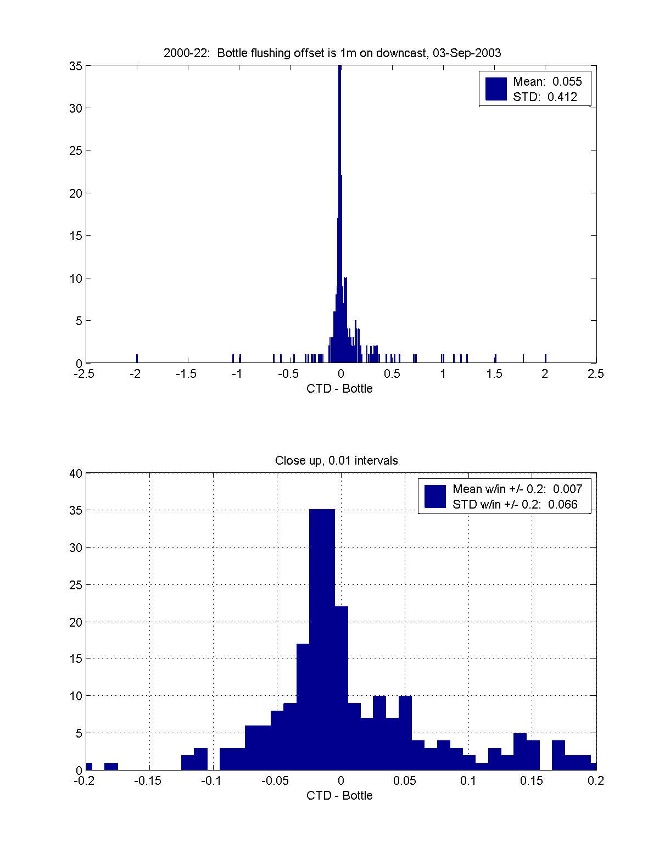
Figure: Historgrams of 1m offset applied to downcast bottles.
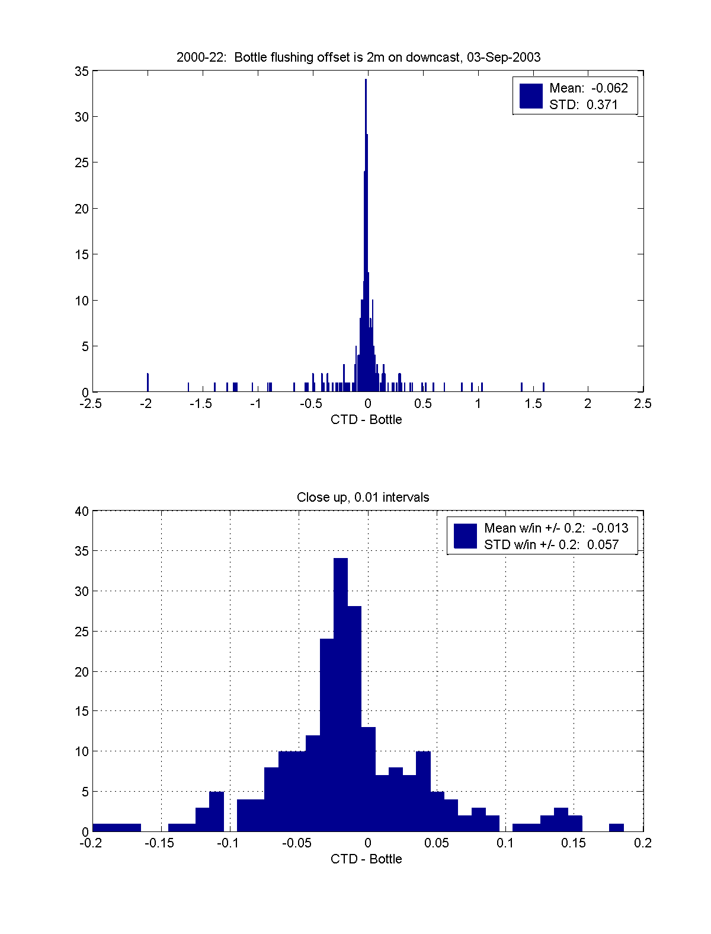

Figure: Historgrams of 2m offset applied to downcast bottles. This histograms has the least skew for the downcast bottles, most noticeable in the 0.1 to 1 range. Bottom histogram shows a -0.013 mean bias in salinity.
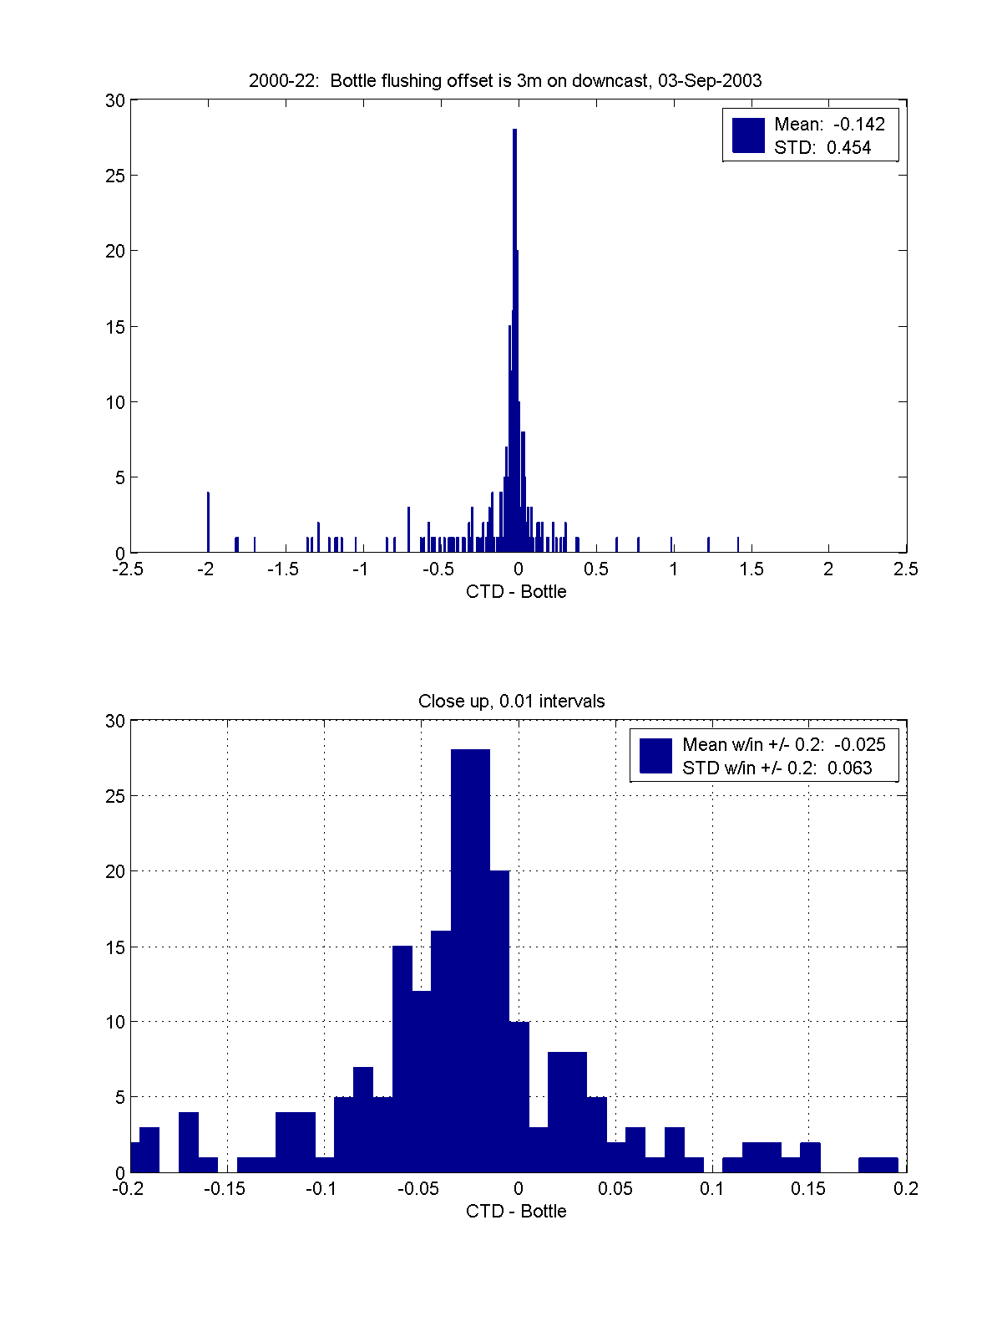
Figure: Historgrams of 3m offset applied to downcast bottles.
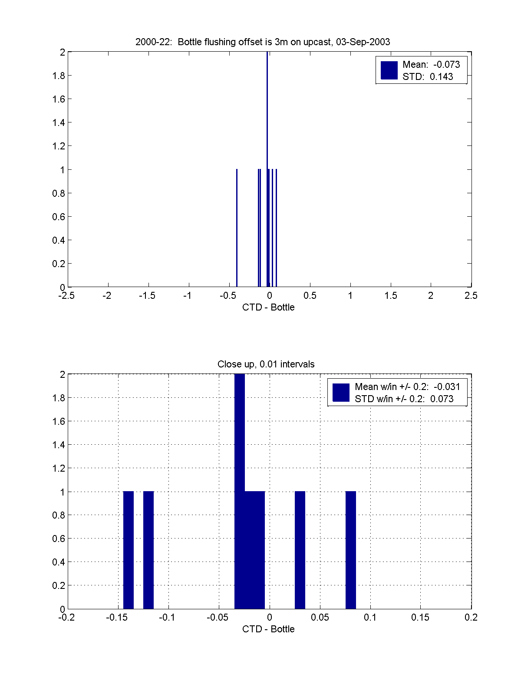

Figure: Historgrams of 3m offset applied to upcast bottles.

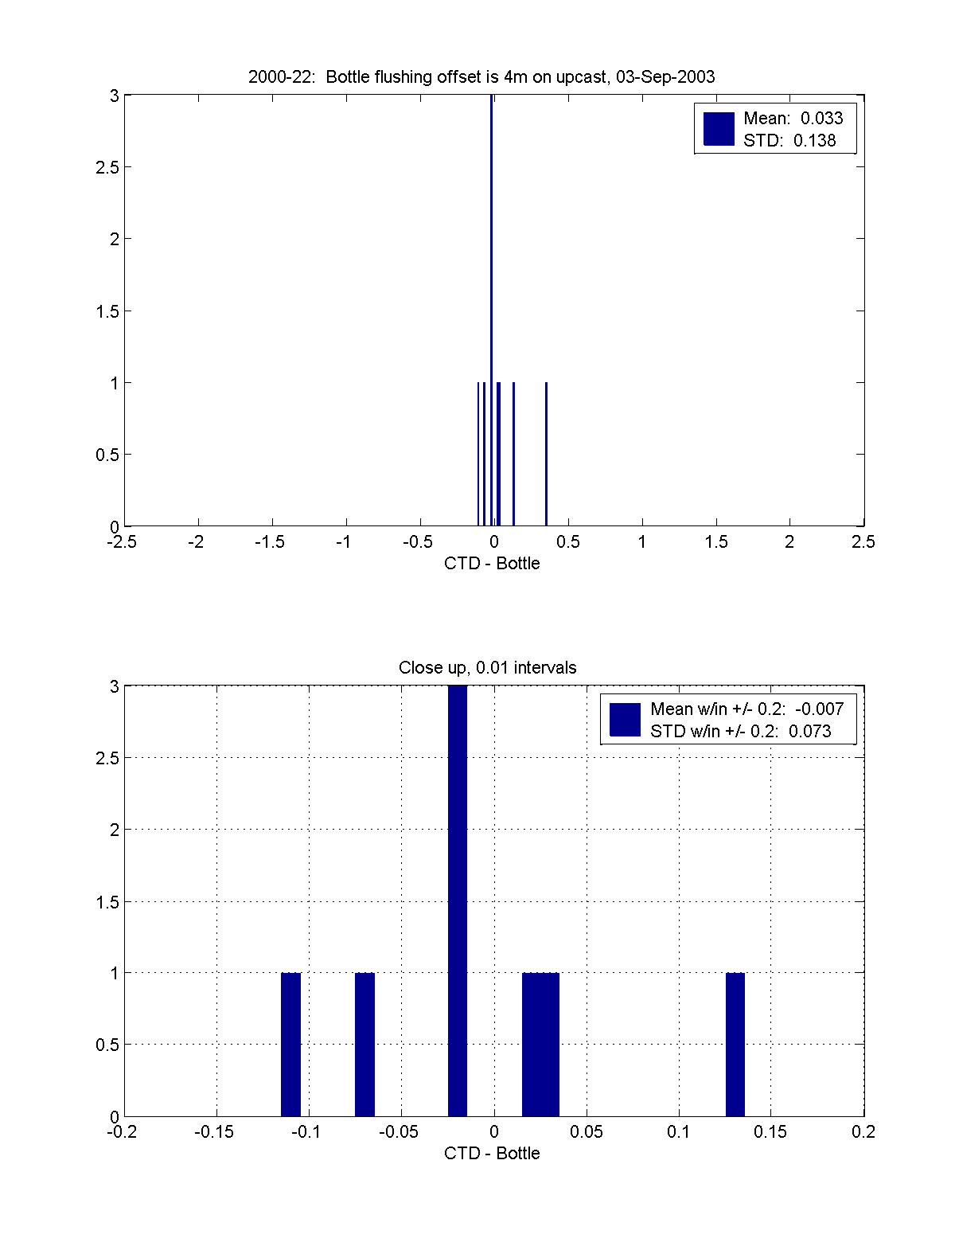
Figure: Historgrams of 4m offset applied to upcast bottles. This histogram has the least skew for the upcast bottles. Bottom histogram shows -0.01 mean bias in salinity.

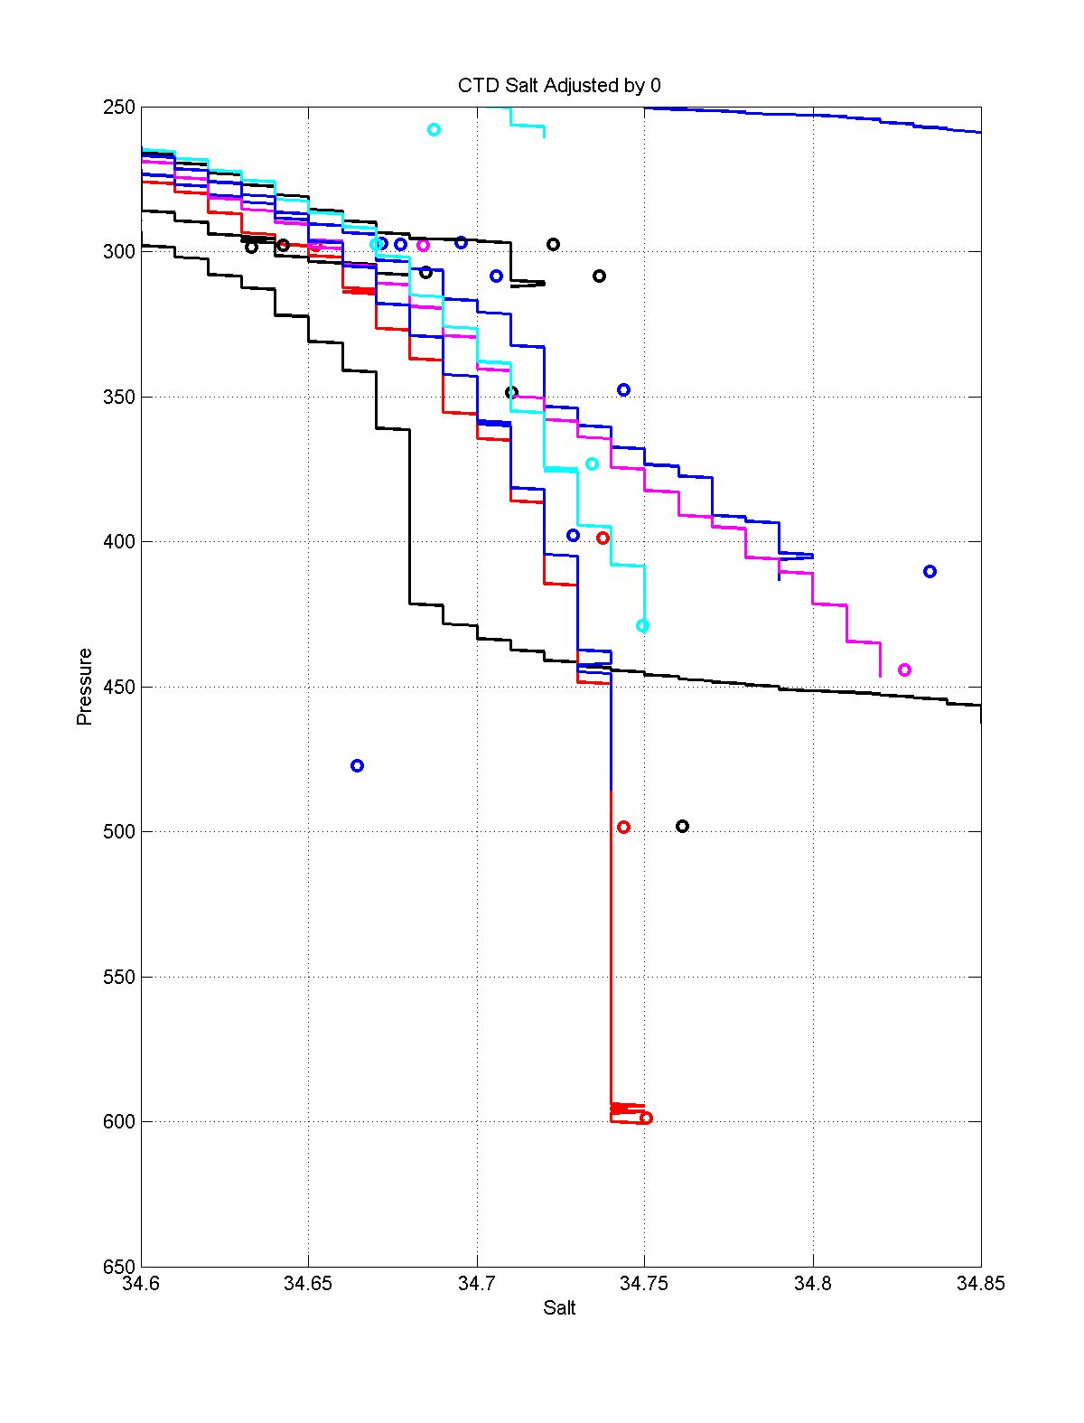
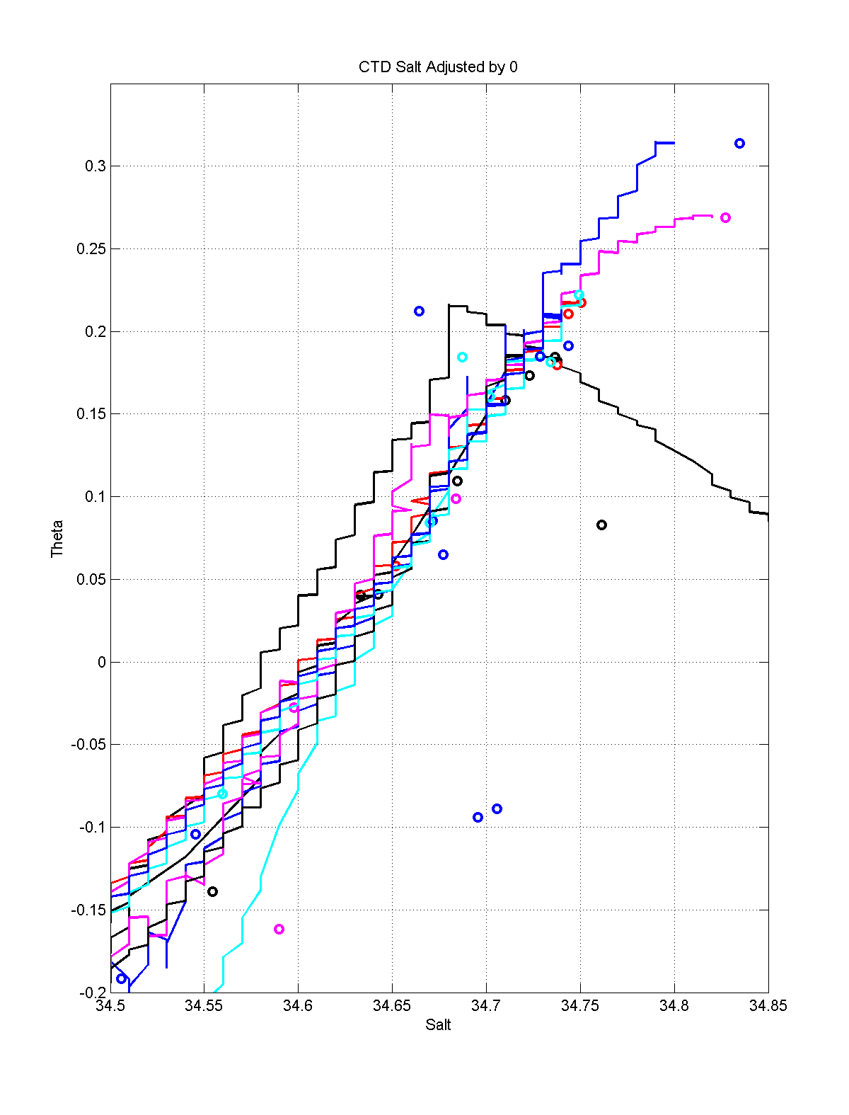
Figures. 2000-22 Stations: Bottle pressure adjusted with no correction to CTD salinity
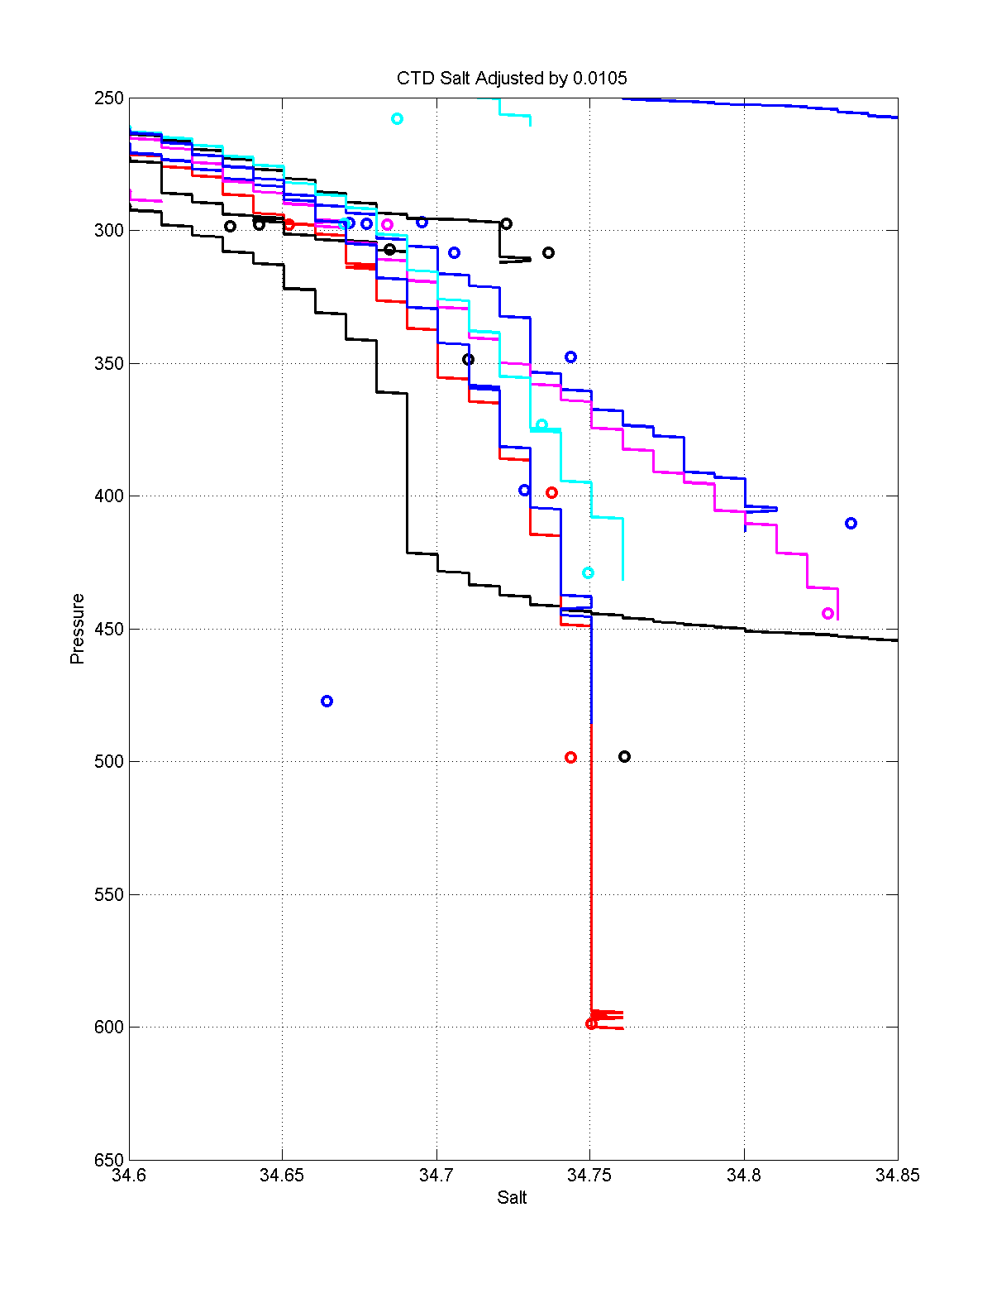
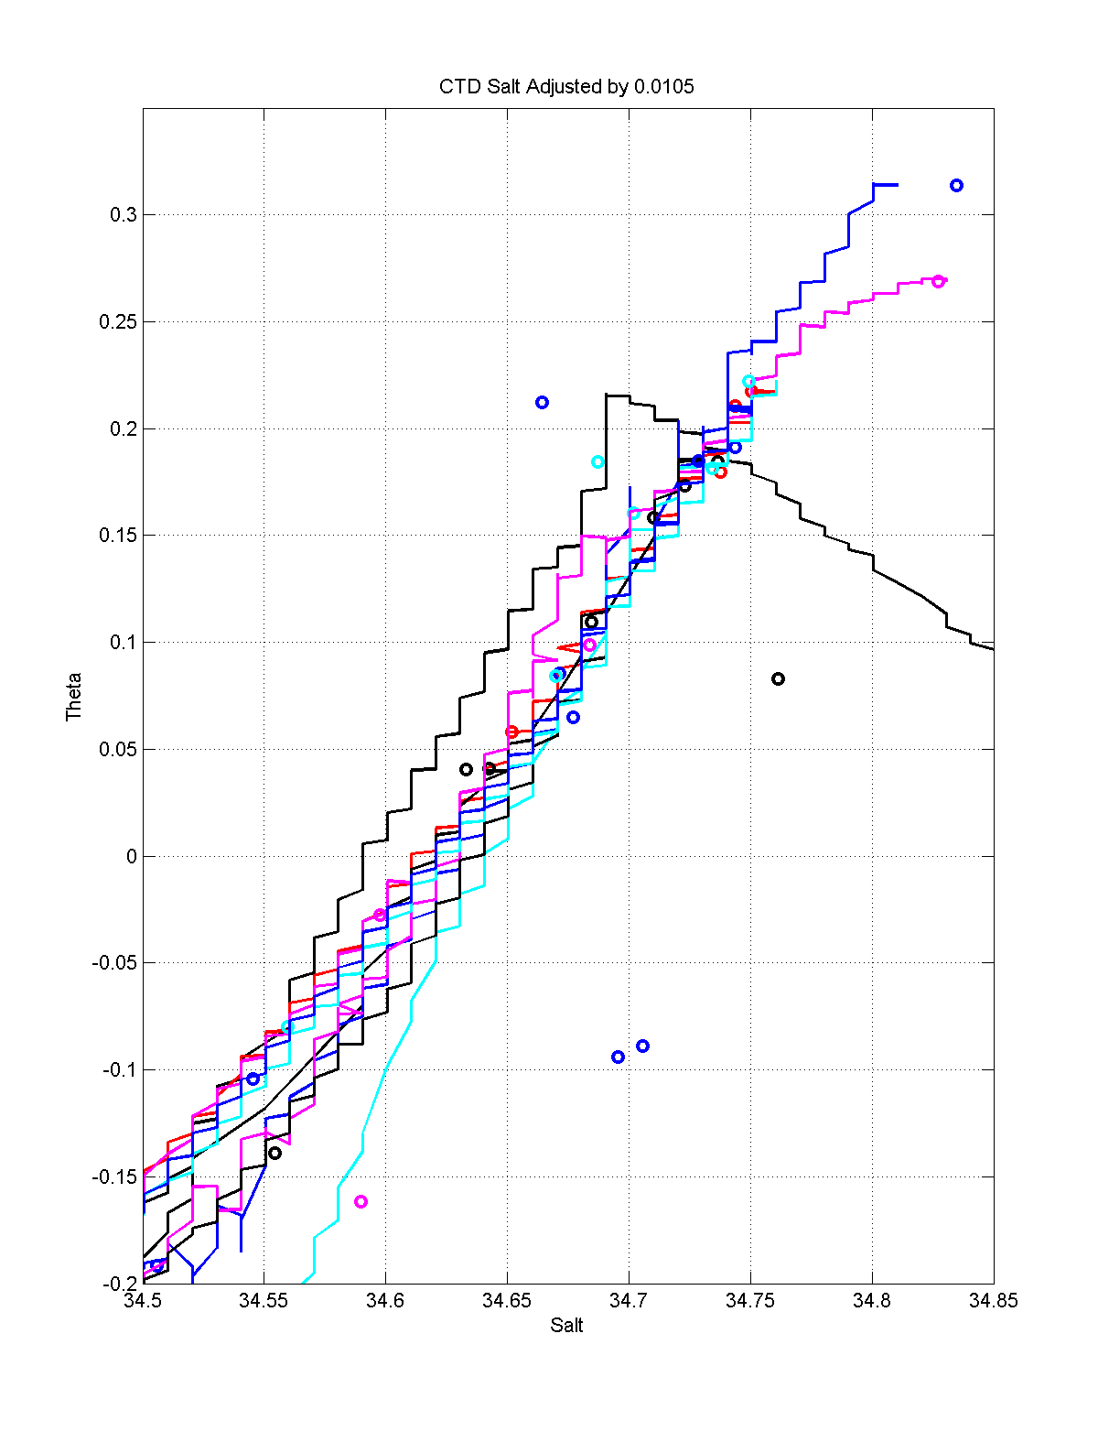
Figures. 2000-22 Stations: Bottle pressure adjusted and 0.0105 change to CTD salinity

