Report on Project: Verify CTD data at bottle stops for cruise 1999-24
Sarah Zimmermann
12 Dec 2003

Project
For cruise 1999-24 on the Laurier, determine the appropriate CTD data to associate with the bottle data by finding the correct bottle depths.

Both a Guildline and Seabird-19 CTD were mounted on the CTD frame for this cruise. The Guildline data are better and have been kept as the final data. Because the bottle trips were performed with the Seabird using the Auto Fire Module (AFM), the CTD data at the bottle stops have been converted from the Seabird AFM files to the Guildline. The pressure offsets applied need to be recorded and the additional pressure offset due to bottle flushing dynamics needs to be determined and the appropriate correction made.

It was found that:
Data are from the downcast Guildline CTD, found by matching the SBE-19 upcast bottle trip pressures to the Guildline after correcting for the SBE-19 surface offset (1 to 2 db depending on station), sensor to bottle center offset (-0.6 db), and an additional offset of +0.2db. [Performed by Julie Bacle and Humfrey Melling] It was determined by looking at the CTD and bottle salinities that no further offset was required to correct for the bottle flushing and fluid dynamics around the package. [Performed by Sarah Zimmermann] The listed pressures are the applied corrections.
Some stations (FT1, FT3, BS2, BS3-test, JR1,JR4, JRL4, EI9, CI1) were missing SBE-19 bottle trip pressures. For these stations, the Guildline CTD data were found by taking the records where bottle salinities matched the CTD salinities. The nature of this method already accounts for the pressure offsets, thus no further corrections were required. [Performed by Mary O’Brien]
Figures, including the histograms are shown below.
Although the pressure offset question has been answered, there is a new question regarding the high CTD salinity of Stations 87, 88, 89, 91 and 92. The CTD is reading higher than the bottles by 0.01. Figures are shown of the stations below however the problem is still being examined.

Data
L:\CTD\1999\1999-24\*.CTD The Guildline CTD data
L:\CTD\1999\1999-24\*.CHE The ‘best as yet’ bottle data
L:\CTD\1999\1999-24\9924proc.doc
Germaine Gatein’s processing notes.
N:\Final\1999\9924\9924chem\9924_final _chemistry\9924chem.xls
This is where the *.CHEs came from. Full descriptive notes are in this file.
N:\Final\1999\9924\9924chem\9924_final _chemistry\AFM-summary.doc
Julie Beacle’s description of how the bottle stop CTD data were arrived at.
N:\Share\MARY\9924_for sarah - Nov 26 2003 (from M)\rosette
Data on Mary O’Brien’s computer moved to nogap so I could examine files. These are Julie’s files starting with the Seabird rosette file to the Guildline pressure match excel file.
trip_pt.xls lists the files and matched pressures

Method

Based on *.ros files from the SBE-19, it is clear bottles were tripped on upcast.

So summarizing what has already been done by Humfrey Melling, Germaine Gatien, Julie Beacle and Mary O’Brien:
AFM, Seabird, and Guildline files all had different cast numbers in the filename so these were matched and a list made of the filenames.
Seabird surface pressure offsets were found (CTD typically read -1 to -2db at the surface).
AFM pressure matched to Guildline pressure adjusting for the surface offset, a 0.6m (db) height difference between the sensor and the center of the bottle and then
an additional unidentified +0.2 db correction (the -0.6 + 0.2 becomes a net -0.4 correction). These new Guildline pressures, and the assosciated Guildline temperature and salinity at these pressures were entered into the water chemistry file.
The deep bottles were compared to CTD to determine CTD salinity correction of
-0.014.
There were missing AFM files, and missing bottle trips within an AFM file. The appropriate CTD pressures were chosen by matching the bottle salinity to the CTD salinity and taking the pressure of the matched point. Because this method matches salinities exactly, it already incorporates the corrections for sensor and CTD height differences and the fluid dynamics of the bottle flushing.

What was still needed:
The CTD data that were chosen by hand are finished and need no further work because all height adjustments have been by-passed by directly matching the salinities. The rest of the CTD data from the AFM files need to be checked to see if there is a pressure offset due to the fluid dynamics around the frame and bottles. This step is done using matchpressure_1999.m

Results
Guildline data of various offsets (-2 to +2m) were tested to see which would create the most evenly distributed residuals (CTD-bottle salinity). All observations from the AFM files (thus excluding the hand matched data) were examined except for the bottom bottles because they experience different fluid dynamic effects.
Historgrams and pressure profiles of the salinity differences show that no correction, 0db offset, was the best. The distribution with no added offset has a more even distribution (no skew) with a mean very close to 0. Adding an offset adds skew to the distribution, particularly noticeable with differences in the 0.5 to 1 range. This range most likely corresponds to the observations in the high-salinity-gradient region from 0 to 50m. The plots with -1, 0 and 1m offsets are shown below.
Mean and standard deviation of the CTD-bottle salinities are shown in the tables below. The bottom bottles are considered to have different dynamical properties and so are excluded from the calculations. The mean and STD are first calculated for all the observations examined and then again for just the observations with differences within +/-0.2. Both groups show that 0m offset has the mean closest to 0.

 | All Observations |  |  | If Salinity Difference is within +/- 0.2
Offset (m) | Mean | STD | Observations | Mean | STD | Observations
-2 | -0.1326 | 0.3605 | 189 | -0.0172 | 0.0613 | 146
-1 | -0.069 | 0.3166 | 189 | -0.0066 | 0.0648 | 147
0 | -0.0015 | 0.2915 | 189 | -0.0015 | 0.0621 | 143
1 | 0.0702 | 0.2859 | 189 | 0.0141 | 0.0613 | 138
2 | 0.1518 | 0.3583 | 189 | 0.0232 | 0.0609 | 134

Summary
Data require no adjustment. Documentation needs be added to the header file stating what type of corrections have been performed.

Add to Header file in chemistry:

CTD data at bottle stops:
5 Dec 2003
Data are from the downcast Guildline CTD, found by matching the SBE-19 upcast bottle trip pressures to the Guildline after correcting for the SBE-19 surface offset (1 to 2 db depending on station), sensor to bottle center offset (-0.6 db), and an additional offset of +0.2db. [Performed by Julie Bacle and Humfrey Melling] It was determined by looking at the CTD and bottle salinities that no further offset was required to correct for the bottle flushing and fluid dynamics around the package. [Performed by Sarah Zimmermann] The listed pressures are the applied corrections.
Some stations (FT1, FT3, BS2, BS3-test, JR1,JR4, JRL4, EI9, CI1) were missing SBE-19 bottle trip pressures. For these stations, the Guildline CTD data were found by taking the records where bottle salinities matched the CTD salinities. The nature of this method already accounts for the pressure offsets, thus no further corrections were required. [Performed by Mary O’Brien]

Question Regarding CTD Salinity Calibration

Five stations (87, 88, 89, 91 and 92) show a 0.01 difference between CTD and bottles in the high salinity, deep water. What should be done about this?
- A slope correction to the salinity calibration
- Apply the post cruise temperature calibration to the later part of the cruise.
- Manually edit just areas of the five stations that differ from the bottles and donèt recalibrate the full profile.
- Determine bottles are bad and CTD is fine.
- Leave as is with error message

To address:
Look at log sheet and salinometer run sheets to search for any clues.
Salinity error probably does not result from erratic temperature shifts that pestered this data set because multiple stations overlie each other in theta – salinity plots.

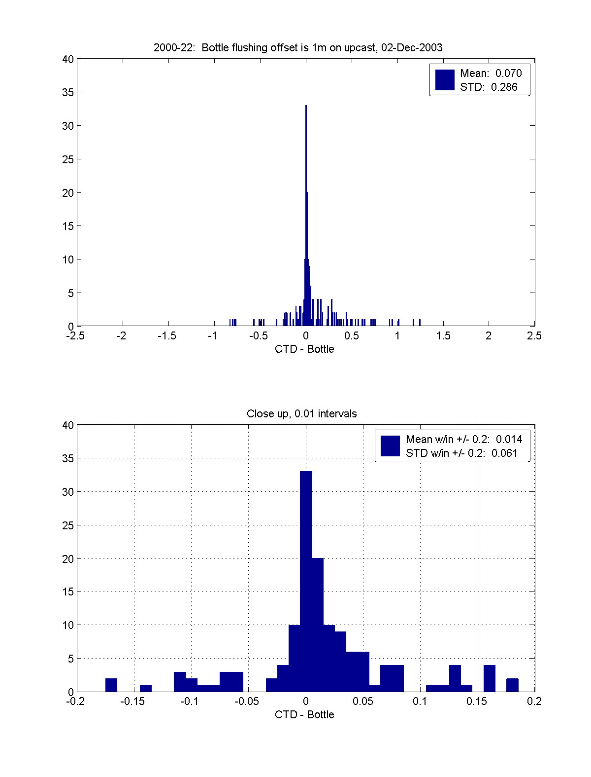
Figure 1. 1m correction for fluid dynamics of package. The title should read 1999-24

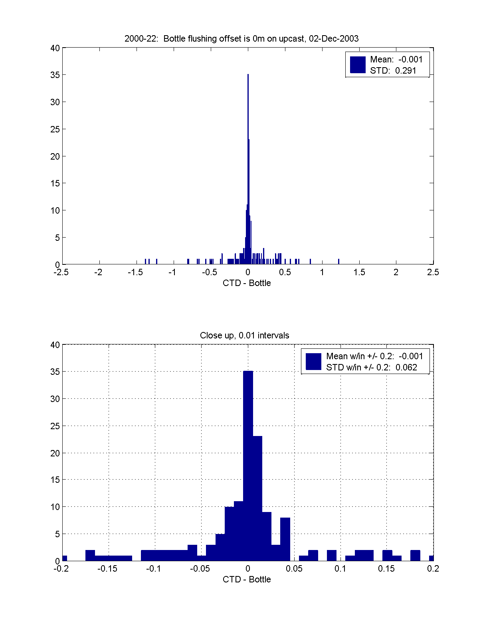
Figure 2. 0m correction for fluid dynamics of package. The title should read 1999-24

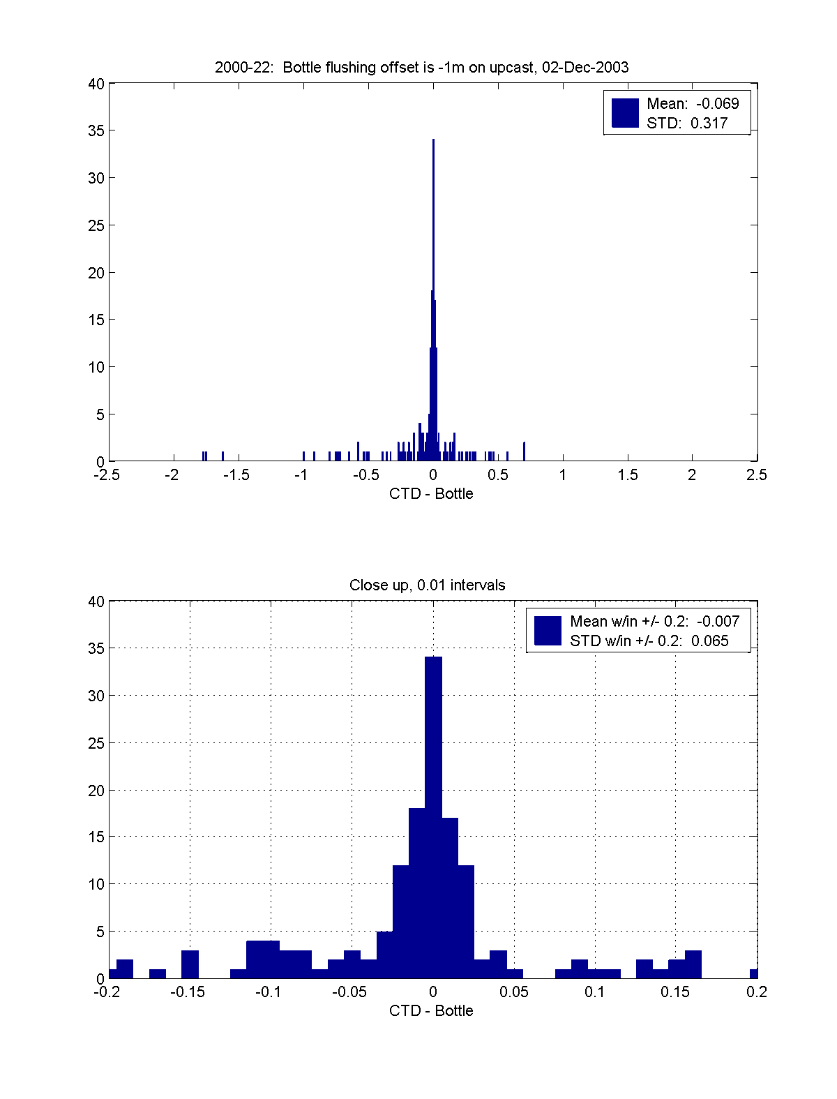
Figure 3. -1m correction for fluid dynamics of package. The title should read 1999-24
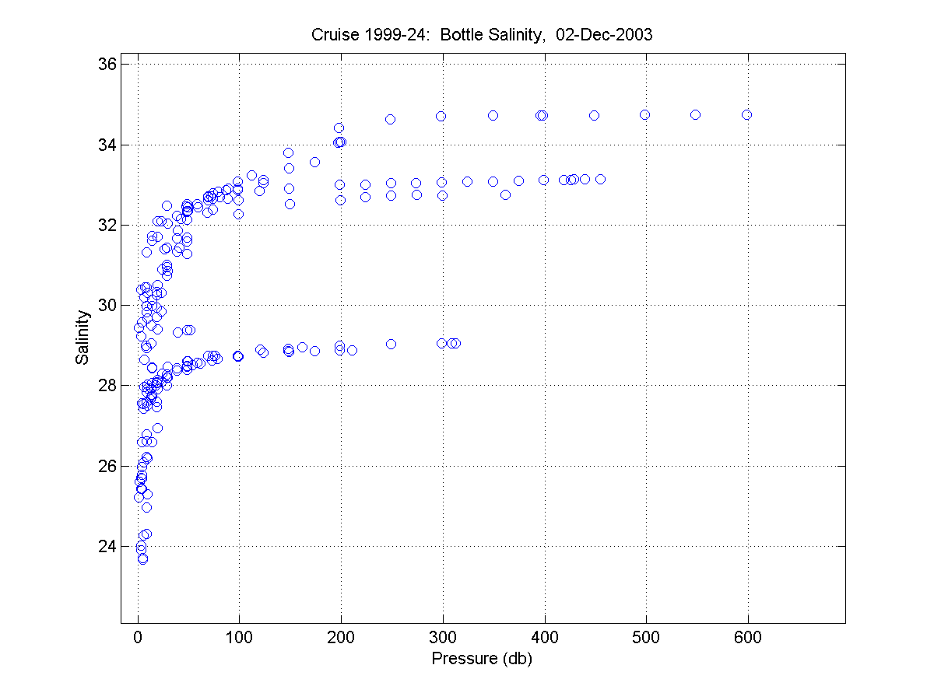
Figure 4. Salinity Profile

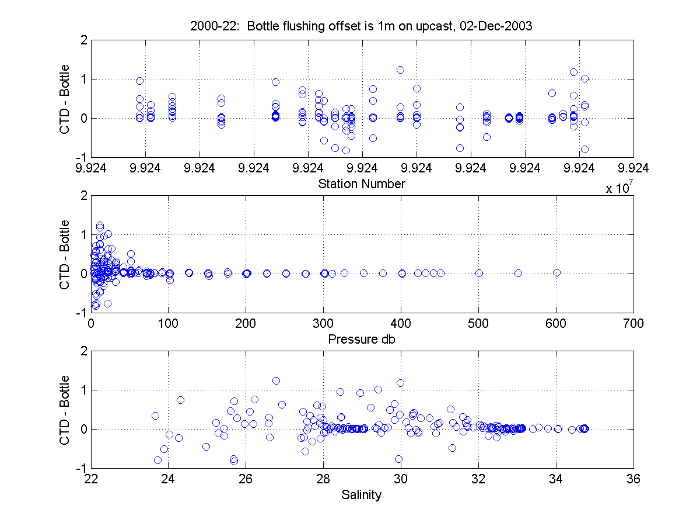
Figure 5. Overview of Salinity Difference with 1m Offset. Title should read 1999-24
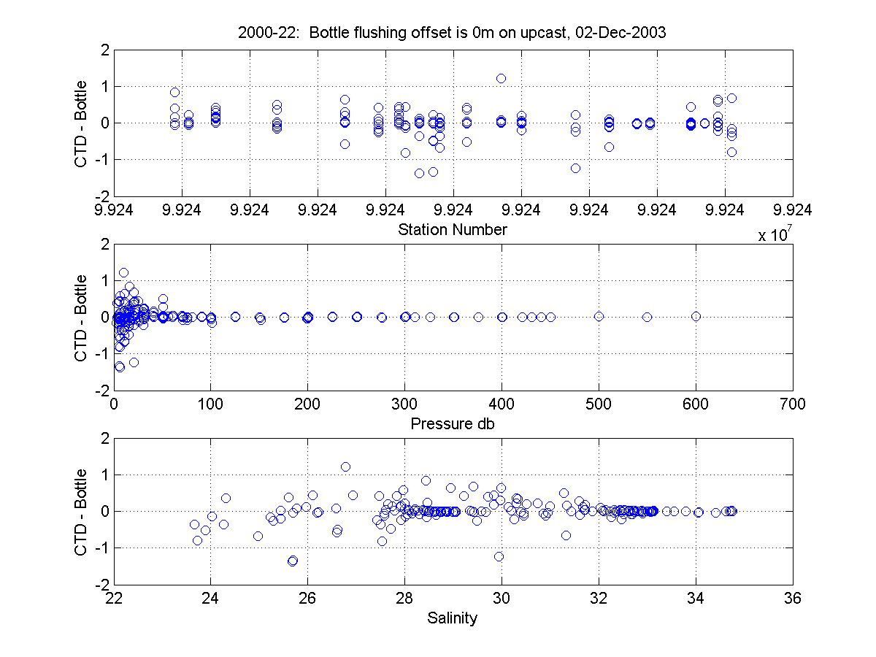
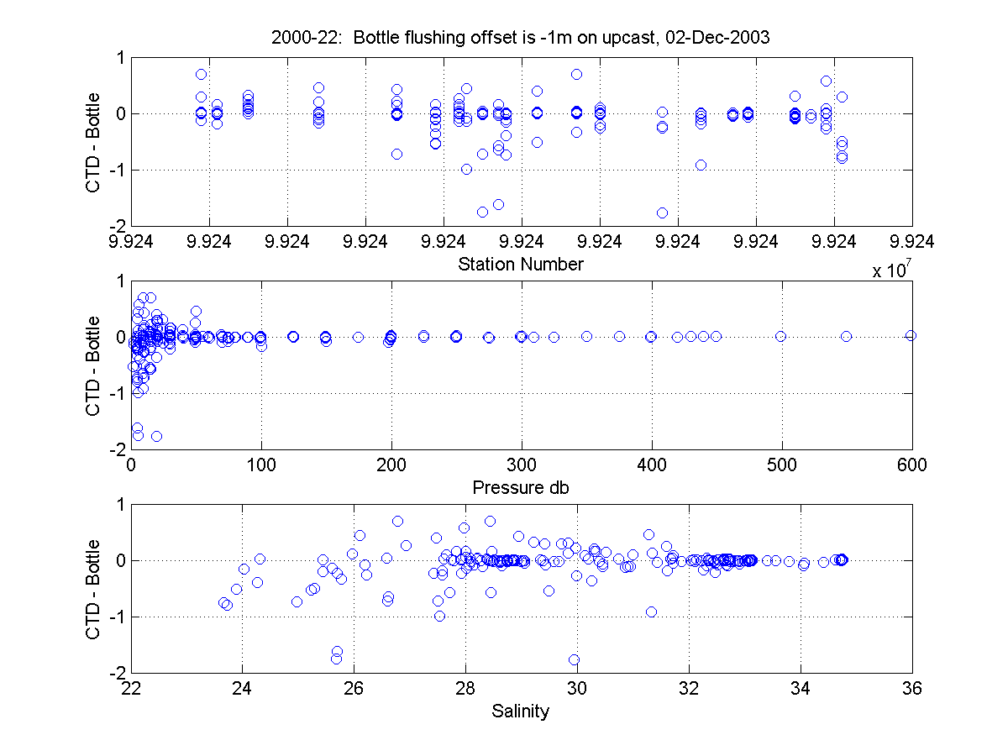
Figure 6. Overview of Salinity Differences with 0 and -1m Offsets. Title should read 1999-24

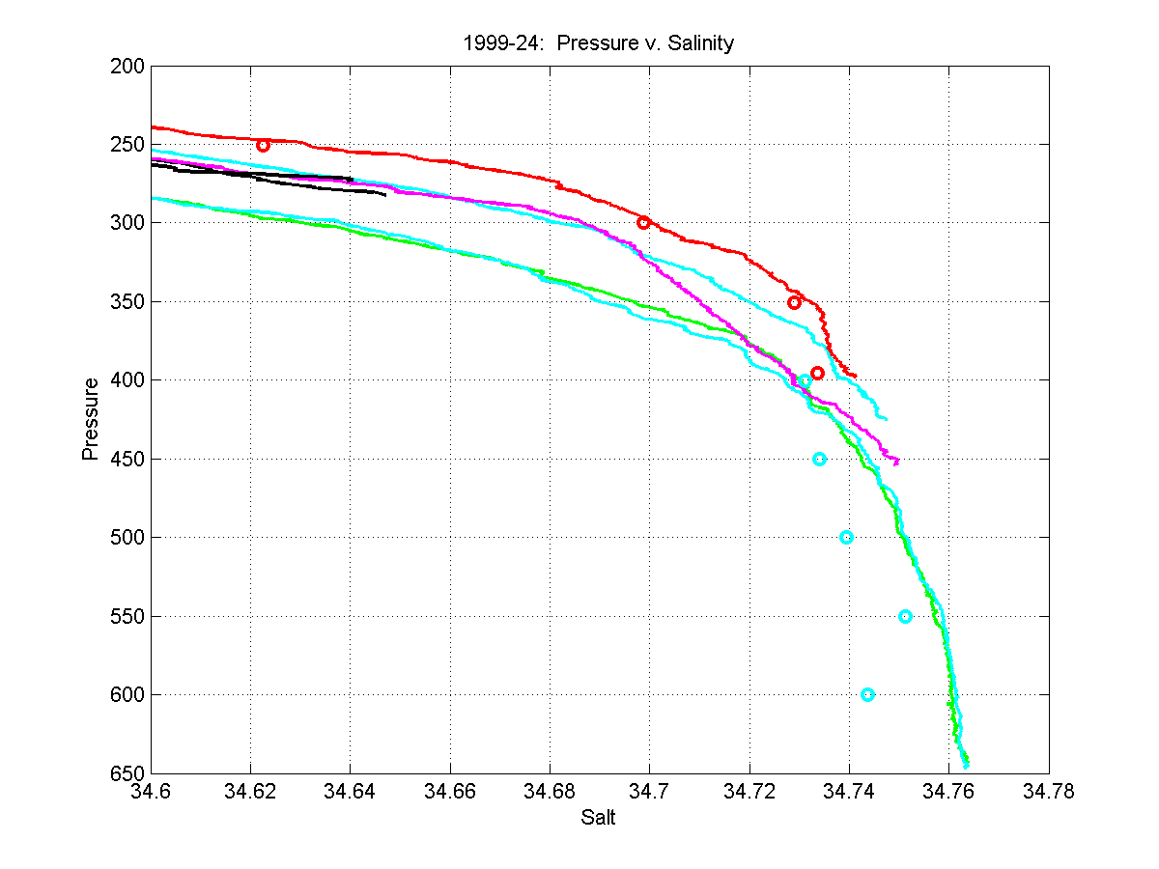
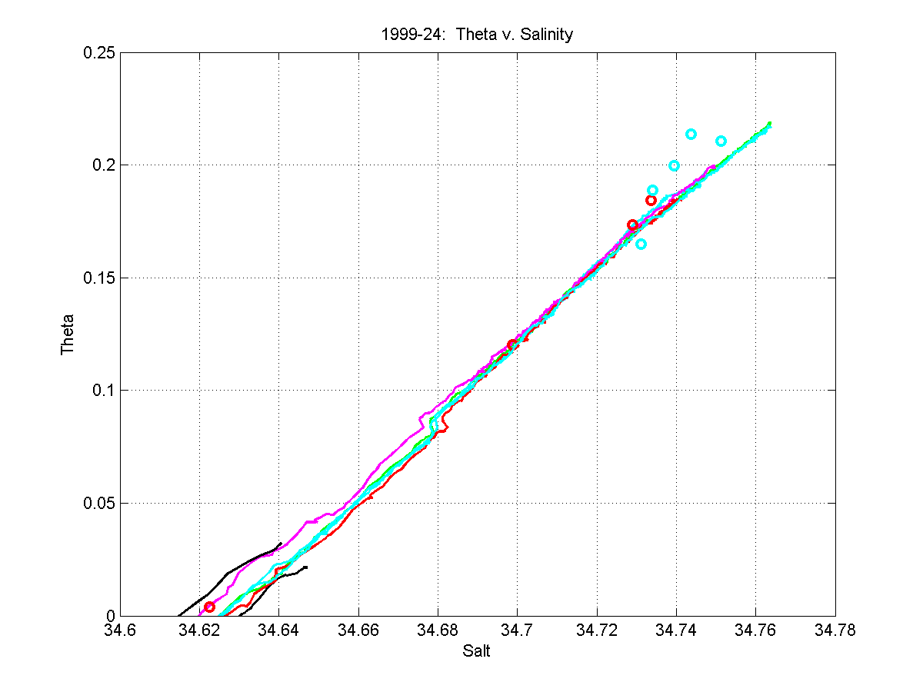Figure 7: Plots of 1999-24 show larger CTD v. Bottle differences in the deep, salty water of Amundsen Gulf.
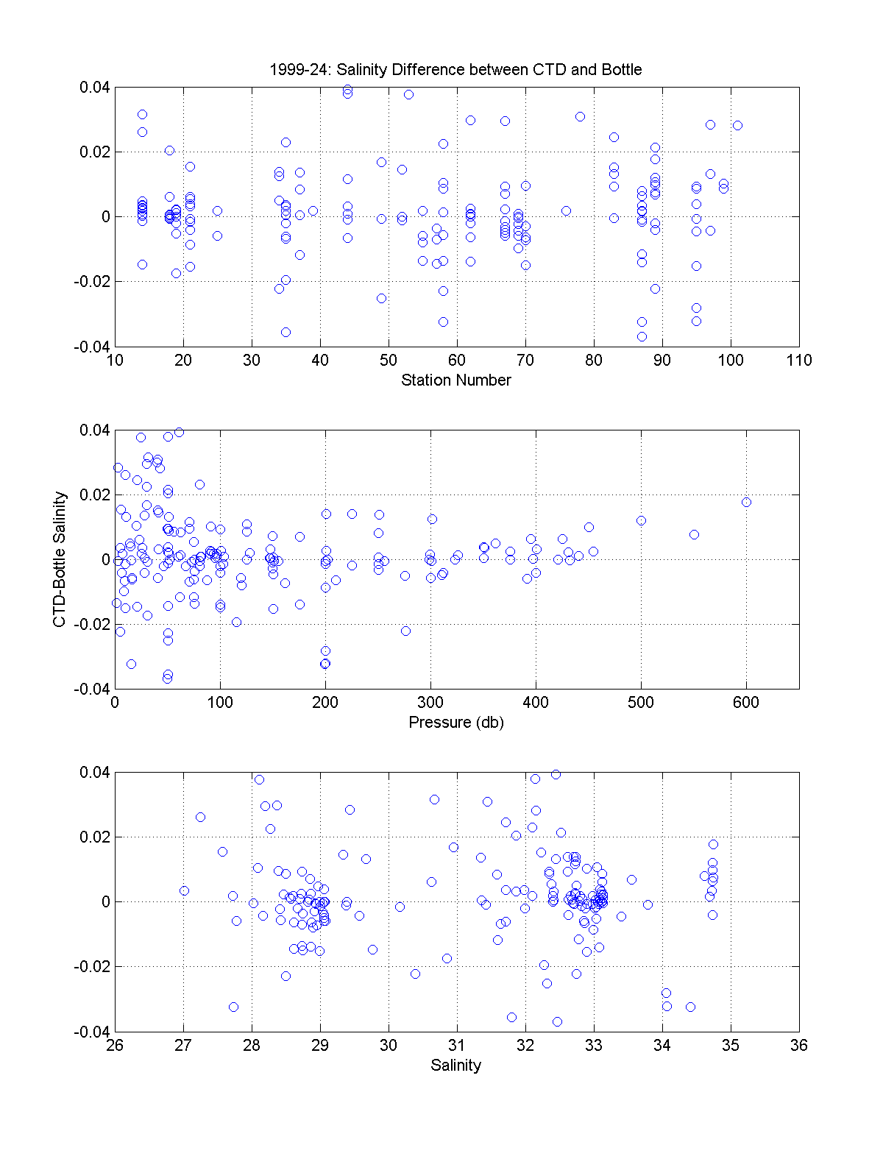
Figure 8. Salinity residuals between CTD and bottles grow with depth and salinity. There are fairly deep stations at salinities of 29, 33 and 34.7, and only the 34.7 waters show the larger residuals.

