Project Report

Department of Fisheries and Oceans
Institute of Ocean sciences
Sidney, B.C., Canada

To: Regional Science Director. Final: Yes

1. Cruise/Project No.: 9910 2. Dates: May 31 to June 24, 1999
3. Project Name: Line P
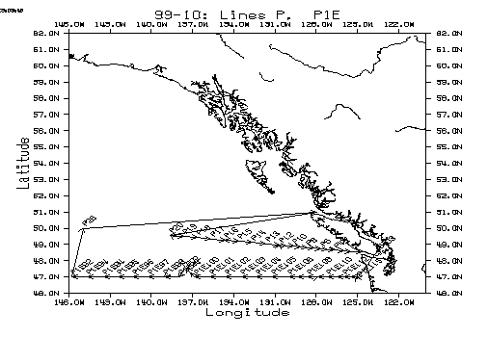
4. Area(s) of Operation: Along 47N from the Washington State coast to 145 W
Line P(50N, 145W to 48 34N, 125 30W)
Juan de Fuca Strait to Victoria, B.C.

5. Platform: John P. Tully 6. Master: Bill Noon
7. Days Allocated: 25 8. Days at Sea: 24
9. Days lost to weather: none
- Days lost to other causes: 1 day for loading, 4 days for medical evacuation.
- Appropriateness of platform: very appropriate
- Safety issues: (attach narrative if required):
The ship’s drainage system was temporarily blocked resulting in drainage water welling up on the aft deck. The planned dilution of radioactive wastes into the ships drainage system was therefore disallowed due to safety concerns. To avoid problems, all radioactive waste was saved in carboys and disposed over the side in accordance with the permit. If, in future, the sink is to be used for dilution of radioactive wastes, it should have a separate drainage pipe not connected with the ships main drainage system.
- Cruise/Project Results (see appendix for details):
Nutrient results were mixed between average and low values at the various depths sampled and require detailed analysis. At some stations, low nutrients and iron combined with high chlorophyll or zooplankton levels suggesting that the spring bloom had recently come to an end.

Data Collected:
Rosette/CTD casts for chemical sampling were completed at P4, P12, P16, P20 and P26 and at 24 stations along 47 N latitude(Line P1E). Onboard chemical analyses included salinity, oxygen, nutrients, freons, alkalinity, total CO2, chlorophyll, dimethyl sulfide, dissolved organic nitrogen. The P1E data will be combined with concurrent Japanese data along 47N spanning the entire Pacific Ocean.
CTD/transmissometry survey was completed at 21 stations along Line P.
Primary productivity experiments were carried out at P26, P20, P16, P12 and P4.
Iron sampling and analysis were completed at P4, P12, P16, P20 and P26.
Primary productivity, Rosette and CTD work was done inside and outside the so-called Haida Eddy, 47 30N, 137 30W.
The P4 and P26 sediment trap moorings were recovered and the P4 mooring was re-deployed.
A mooring to study the re-mineralization of nutrients was recovered at P26.
Free drifting sediment traps were deployed for 2 days at P26.
Underway measurements include PCO2, temperature, salinity and ADCP profiles.
Net tows for zoo plankton and phytoplankton along Line P were completed.
Sixteen casts of CTD/transmissometry/fluometry/PAR casts were done the Straits of Juan de Fuca to aid another DFO science program.
A freon profile in Saanich Inlet was taken as part of an on-going monitoring program.
Halo-acetic acid was profiled at P20 and at the surface at major line P stations.
A barrel of particulate blank water was obtained at P19.
Net tows were done at the ecological monitoring buoy in Saanich Inlet, off Sombrio Point and off Sooke.

14. Primary Institute: Institute of Ocean Sciences, DFO
15. Associated Institutes: UBC

16. Chief Scientist/Affiliation: Ron Perkin, IOS (Ocean Sciences and Productivity)

17. Science Staff/Affiliations:
Ron Perkin | IOS | Janet Barwell-Clarke | IOS
Elaine Baird | IOS | Angelica Pena | IOS
Vince Coronini | IOS | Nes Sutherland | IOS contract
Marty Davelaar | IOS | Melanie Quenneville | IOS contract
Wendy Richardson | IOS
Tim Soutar | IOS | Hugh Maclean | UBC
Darren Tuele | IOS | Michael Lipsen | UBC
Marie Robert | IOS | Cathleen Vestfalls | UBC
Michael Arychuk | IOS | Michael Bentley | Bird survey

18. Equipment:
Sail: no ADCP: yes Other: sounder

Winches: .
type | ID No | Wire type | Wire Condition/Spooling | No Casts/  Depth max
329 CTD | 1579 | 5350 m CTD | good | 70/4790
329 CTD | 1307 | 3000 m CTD | Not used | 0
310 hydro | 1082 | 5400.m 5/32" | good | 70/1000 m
331 work | 1231 | 2500 m ½” | not used | 0
329 work | 1579 | Bare drum | good | 5/mooring
455 Spooling | 1451 | mooring | good | 5/mooring

Equipment Deployed/recovered

Description | Deployment | Recovery
Free drifting traps, 1000 m | June 11 | June 13
Re-mineralization Mooring |  | June 11
Sediment Trap mooring at P26 |  | June 12
Sediment Trap Mooring at P4 | June 22 | June 22
AR Mooring (UBC) |  | not recovered

- Comments and recommendations:

See “Safety Issues” regarding the lab sink drains.

The salinometer should be installed in a room with good temperature control in order to achieve the necessary precision for this instrument. The WOCE manual(Report 68/91) shows that for the Guildline Autosal models, each 1ºC change in room temperature results in an error of .001 in salinity determinations. With so much traffic from the lab to the aft deck, cold outside air frequently sends the lab temperature into wild fluctuations and, although the Portasal may be somewhat less sensitive than the Autosal, it cannot produce WOCE quality data in conditions like that. This was demonstrated with the frequent re-standardizations necessary on this Mission where the outside temperature was often more than 10C colder than normal room temperature.

It should be cleared up as to who is now responsible for the maintenance of the sounder equipment. The control panel for the depth sounder in the lab has developed an intermittent fault in the menu selection joystick and it should be fixed before it becomes a major problem. At present, the depth sounder is needed to detect the proximity of the Rosette to the bottom.

On occasion, the heave compensator was reported to have lost pressure between stations. However, the following cruise(Mission 99-16) reported that there was no pressure loss. This is something that should be monitored on subsequent missions.

The science radios are gradually being replaced as money becomes available. This process should be accelerated as a number of radio failures were reported.
Appendix: Reports from Participants

Overview
Ron Perkin

Cruise Narrative
Departure day, June 1, was taken up largely by work in Saanich Inlet including two anchor installations, a net tow and a freon profile aided by Dave Wisegarver from PMEL in Seattle. After passing through the underway stations in the Straits of Juan de Fuca, the ship sailed directly to the Washington State end of the P1E line along 47N latitude. Intensive sampling to the bottom and on-board analysis proceeded to station P1E100 where the cruise took a brief detour to the center of the large eddy which IOS has been tracking for the last year. Primary productivity and chemical sampling of the eddy was done at the eddy core and, subsequently, outside the eddy at station P1E98. The P1E line was completed to station P1E92(longitude 145 48.5W) and the ship proceeded to Station Papa.
At Station P, some of the mooring deployment and recovery was done on arrival, June 11, but worsening weather limited work to the hydro winch which is mounted amidships. This allowed the primary productivity and iron trace-metal work to be done. A medical emergency limited time at station P to two days, however, a deep rosette cast was completed and the FDSTAR was recovered before returning to Cape Scott. Bad weather made dragging for the UBC mooring impossible and the re-deployment of the sediment trap mooring was put off until September.
The ship returned to the next major Line P station, P20, and, with good weather for the balance of the voyage, finished the remainder of the Line P work in good time.
The last day, June 24th, was spent as planned doing stations in the Strait of Juan de Fuca for the following mission ( 99-16:Strait of Georgia Survey) and the ship docked in Victoria at about 13:30.

Summary
This was a rather busy cruise with a wide assortment of tasks and chores and the challenge of doing WOCE quality chemistry and physics with a minimum of preparation. Thanks are due to the UBC and bird-watching crew for assisting with watch keeping through the period of intensive sampling and analysis. Although some major objectives such as the dragging for the UBC mooring were regrettably not met, the amount of work accomplished was nevertheless quite satisfying.
Captain Noon and all the officers and crew have our heartfelt thanks for their competent and efficient seamanship and untiring efforts to make this cruise not only a success but an enjoyable experience. Their medical competence and concern shown for our ailing science crewmember was amply demonstrated and much appreciated.
CTD/Transmissivity
Ron Perkin
A total of 56 CTD/Transmissivity profiles were taken at the following stations, many combined with chemical sampling. Eleven additional stations were occupied in the Strait of Juan de Fuca with fluorometer and PAR sensors, every third one with chemical sampling.
Comparison with the previous P1 cruise, Talley&Joyce(1983), showed good agreement(see below).

Station | Cast # | Date | Time (PDT) | Latitude | Longitude | Water Depth
SI03 | 2 | 01/06/99 | 18:54 | 48.594 | -123.5 | 227
P1E115 | 4 | 02/06/99 | 18:42 | 46.901 | -124.994 | 777
P1E114 | 5 | 02/06/99 | 21:30 | 47.003 | -125.058 | 822
PIE113 | 6 | 03/06/99 | 00:31 | 47.001 | -125.509 | 1762
PIE112 | 7 | 03/06/99 | 04:36 | 46.999 | -126.001 | 2565
PIE111 | 8 | 03/06/99 | 09:18 | 47.002 | -126.469 | 2565
P1E110 | 9 | 03/06/99 | 14:28 | 47 | -127.201 | 2649
P1E109 | 10 | 03/06/99 | 19:38 | 47.001 | -127.923 | 2712
P1E109 | 11 | 03/06/99 | 23:20 | 47.001 | -127.922 | 2712
P1E108 | 12 | 04/06/99 | 06:11 | 47 | -128.646 | 2741
P1E107 | 13 | 04/06/99 | 12:24 | 46.997 | -129.385 | 2573
P1E106 | 14 | 04/06/99 | 21:42 | 47.001 | -130.018 | 2650
P1E105 | 15 | 05/06/99 | 08:34 | 47 | -131.231 | 2750
P1E104 | 16 | 05/06/99 | 21:01 | 46.998 | -132.366 | 3320
P1E103 | 17 | 06/06/99 | 07:20 | 47 | -133.463 | 3649
P1E102 | 18 | 06/06/99 | 16:24 | 46.998 | -134.612 | 3982
P1E101 | 19 | 07/06/99 | 01:16 | 47.001 | -135.735 | 4137
P1E100 | 20 | 07/06/99 | 09:10 | 46.997 | -136.849 | 4137
ED1 | 21 | 07/06/99 | 13:53 | 47.249 | -137.164 | 4121
ED2 | 22 | 07/06/99 | 17:27 | 47.528 | -137.46 | 4090
ED2 | 23 | 07/06/99 | 18:25 | 47.532 | -137.46 | 4090
P1E99 | 24 | 31/12/79 | 17:00 | 46.997 | -137.964 | 4166
P1E98 | 25 | 08/06/99 | 08:52 | 47.001 | -139.067 | 3527
P1E98 | 26 | 08/06/99 | 09:27 | 47 | -139.069 | 3917
P1E97 | 27 | 08/06/99 | 17:19 | 46.999 | -140.224 | 4325
P1E96 | 28 | 09/06/99 | 00:54 | 47.001 | -141.352 | 4403
P1E95 | 29 | 09/06/99 | 08:21 | 47.001 | -142.439 | 4494
P1E94 | 30 | 09/06/99 | 15:48 | 46.997 | -143.494 | 4597
P1E94 | 31 | 09/06/99 | 23:59 | 46.999 | -144.669 | 4683
P1E92 | 32 | 10/06/99 | 07:55 | 46.996 | -145.809 | 4783
P26 | 33 | 11/06/99 | 19:47 | 50 | -145 | 4200
P26 | 34 | 13/06/99 | 08:35 | 49.999 | -145.005 | 4200
P20 | 35 | 17/06/99 | 12:59 | 49.566 | -138.66 | 3968
P20 | 36 | 17/06/99 | 14:31 | 49.568 | -138.663 | 3968
P19 | 38 | 18/06/99 | 13:02 | 49.498 | -137.665 | 3968
P18 | 39 | 18/06/99 | 18:12 | 49.431 | -136.669 | 3841
P17 | 40 | 18/06/99 | 23:22 | 49.349 | -135.666 | 3661
P16 | 42 | 19/06/99 | 07:09 | 49.271 | -134.654 | 3661
P16 | 43 | 19/06/99 | 09:16 | 49.273 | -134.692 | 3661
P15 | 44 | 19/06/99 | 23:57 | 49.199 | -133.669 | 3422
P14 | 45 | 20/06/99 | 05:09 | 49.123 | -132.665 | 3332
P13 | 46 | 20/06/99 | 10:27 | 49.042 | -131.667 | 3035
P12 | 47 | 20/06/99 | 16:56 | 48.971 | -130.669 | 3027
P12 | 49 | 21/06/99 | 06:35 | 48.972 | -130.669 | 3251
P11 | 50 | 21/06/99 | 11:16 | 48.931 | -130.169 | 2770
P10 | 51 | 21/06/99 | 14:23 | 48.892 | -129.666 | 2659
P9 | 52 | 21/06/99 | 17:32 | 48.857 | -129.167 | 2357
P8 | 53 | 21/06/99 | 20:42 | 48.816 | -128.668 | 2537
P7 | 54 | 21/06/99 | 23:44 | 48.776 | -128.17 | 2524
P6 | 55 | 22/06/99 | 02:55 | 48.743 | -127.665 | 2562
P5 | 56 | 22/06/99 | 05:53 | 48.691 | -127.165 | 2105
P4 | 57 | 22/06/99 | 12:55 | 48.65 | -126.67 | 1342
P4 | 58 | 22/06/99 | 14:36 | 48.65 | -126.668 | 1342
P2 | 0 | 23/06/99 | 09:11 | 48.599 | -125.997 | 118
P1 | 62 | 23/06/99 | 11:29 | 48.572 | -125.499 | 135
103 | 63 | 23/06/99 | 17:29 | 48.55 | -124.717 | 124

Additional stations occupied for Mission 99-16 are shown in the following map.
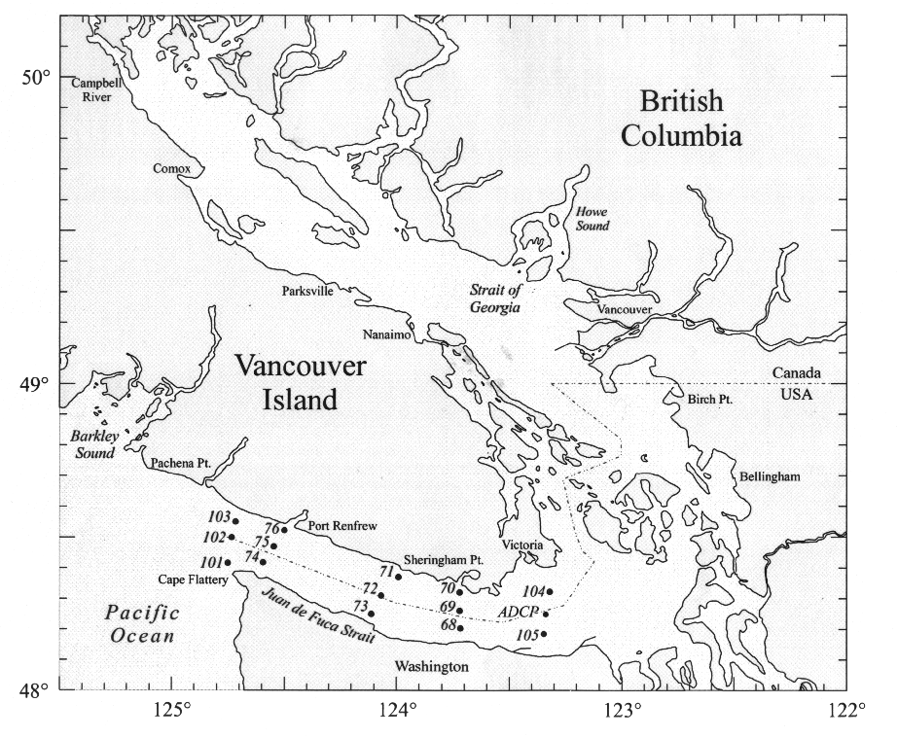

Cruise Report 9910 – Janet Barwell-Clarke and Elaine Baird

Nutrient and chlorophyll samples were analyzed along Line P1E, Line P and the first two stations of Cruise 9916. Silicate, nitrate and phosphate were analyzed for all samples. No ammonia samples were analyzed due to a colourimeter failure. Loop samples were analyzed for nutrients, chlorophyll, and salinity along Line P1E, underway to Stn.P 26, underway to Port Hardy and back to Stn. P20, and along Line P.

A free drifting sediment trap array was deployed for two days to 1000 m at Stn. Papa. The samples were split, filtered and frozen for future C/N, Opal and Trace Metal analysis.

An in situ productivity experiment was conducted at Stn. Papa to 100 m using GOFLO samplers. The samples were filtered, frozen and will be analyzed at IOS. POC/N samples were collected at the same depths and frozen for analysis at IOS. Poor weather prevented collection of deep POC samples.

Sequential sediment traps were recovered at P26 and P04. Many of the P26- 200 m trap samples were filled with copepods and pteropods and smelled extremely foul. The amount of preservative should be increased for the next deployment. The P26-1000 m trap contained a complete set of samples, however the P26-3800 m trap was plugged after only two samples. It was suspected that this would be the case because the remineralization trap (deployed at the same time) was also plugged by September. The P04 trap was recovered with a full set of samples with the trap and bottles themselves covered with a fine hair-like growth of algae.

A remineralization experiment buoy was recovered at Stn. P26 and will be analyzed for POC/N, CaCO3, and Opal.

TCO2 and alkalinity samples were collected and analyzed along Line P1E and Line P. 13C samples were collected for analysis at IOS.

Hydro and Loop data files were generated as well as WOCE –SEA and –SUM files.

Productivity Experiments

Lipsen, Vestfals and Quenneville (IOS and UBC):

Line P Monitoring
As a continuation of our work in 1998, the principal focus along line P was to measure ¹⁴C incorporation into organic and inorganic particulate carbon. Size fractionated chlorophyll a concentrations were also measured at the 6 depths of the productivity samples as well as biogenic silica. P v I curves were also generated from each major station at 55% light depth. Samples were collected at all major stations.
Again as a continuation of last years cruise work, we took samples from all major P stations for epifluorescence microscopy, inverted microscopy and scanning electron microscopy in order to enumerate the principal producers of organic and inorganic particulate carbon.
Phytoplankton net (30 μm mesh) samples were taken from line P stations at the 1% light level as well as 150 m. Samples were preserved immediately for qualitative analysis. Initial examination will focus on the larger phytoplankton species with an emphasis on diatoms.
An experiment was conducted to examine the influence of iron and light limitation of phytoplankton at station P26. Water from station P26 was collected using a teflon pump, supplemented with iron and incubated at various light intensities in the deck mounted incubators, together with appropriate non-supplemented controls. These were incubated for over 1 week and samples taken for chlorophyll, species composition, primary productivity, nutrients and dissolved iron.

Isotope Inventory
5 mCi of ¹⁴C bicarbonate were taken on board. The whole quantity was used in experiments. Low level liquid waste was diluted and disposed over the side following set protocols. No ¹⁴C will be returned to shore with the exception of low level solid waste and filter material.
One μCi of ³²Si was brought on board. 0.91 μCi was used in experiments. Liquid and low level solid waste will be dealt with as above. The remaining 0.09 μCi will be transported back to UBC packed in an appropriate container.

A. Peña (IOS):

Line P
Field experiments were initiated as part of a study of processes regulating the variability of primary production and of carbon fluxes along Line P transect. The main focus was at Station P26 and P4; the two-end members of Line P transect, where experiments were conducted to examine the influence of light intensity on changes in phytoplankton carbon to chlorophyll ratios. Water was collected using 10L GOFLO bottles at two depths (55% and 3.5% light depth) and diluted with filtered sea water from same depth. One set of samples was inoculated with ¹⁴C. All samples were incubated at 6 light intensities in on-deck incubators. Also, chlorophyll and phytoplankton samples for microscopic analyses (epifluorescence and inverted microscope) were obtained from 6 depths for determination of species composition and carbon content.
In all major P stations, samples were collected at 2 depths (55 and 3.5% light depth) for photosynthesis vs. irradiance measurements and chlorophyll concentration.

Eddy site
With M. Quenneville (IOS), primary production was measured at 6 depths at two stations, one outside and one at the center of an eddy in an attempt to document potential enhancement of primary production by eddies.

Isotope Inventory
10 mCi of ¹⁴C bicarbonate was brought on board. 6 mCi were used in the above experiments and 3 mCi in size fractionated primary production work of UBC/ IOS. The remaining 1 mCi was transported back to IOS. Low level liquid waste was diluted and disposed over the side following set protocols. Only ¹⁴C in low level solid waste and filter material was returned to shore.
.

