REVISION NOTICE TABLE
DATE | DESCRIPTION OF REVISION
3-Feb-2014 | The CTD salinity channel was removed from the Bottle files since the salinity data from the rosette files was not processed or calibrated. For details see section “Rosette Files, April 30, 2003” in file “\\OSD_Data_Archive\Cruise_Data\Documents\CS Wong’s Archive\ Station Papa Data Arching 2002.doc”. J.L.
13-Jan-2014 | Added underway pCO2 data from Sophia Johannessen’s Excel files prepared for The Carbon Dioxide Information Analysis Center (CDIAC). The file is located in the cruise .DOC directory.
18-Dec-2013 | Added units to Iron:Filtered:Buffered:0.45 channel. J.L.
18-Jun-2013 | Merged DMS data to bottle casts from Wendy Richardson’s spreadsheet file located in the \DOC directory. For information on methods see file "Method 1996 to 1999 for Dimethylsulfide Analysis.doc” in directory \\OSD_Data_Archive\Cruise_Data\Documents\Analysis Reference Papers\.
5-Jun-2013 | Added Iron profile files with cast numbers 8xxx from Keith Johnson’s spreadsheet file which can be found in the cruise .DOC directory.
14-Feb-2012 | Added one productivity cast containing Primary Productivity, Chlorophyll, Nutrients, POC and PON, from Frank Whitney’s Productivity spreadsheet.

Moving files to new archive. April 30, 2003 – Joe Linguanti

- Program HEADER EDIT was used to change non-standard channel names and units and add additional metadata to the CTD and Rosette files.

- Program Clean was used to;
- reset number of records, minimum and maximum values
- delete empty channels where applicable
- set channel name initial letters to uppercase

- Files .CLN were copied to new archive and renamed to the new file convention “YYYY-CC-NNNN.* “.

- The loop file was obtained from Frank Whitney. The latitude and longitude values were computed to 3 decimal places. The spreadsheet file was then converted to IOS Header format with meta-data added to it. The original .XLS file is in the DOC directory.

- The thermosalinograph files were copied from the TRACKOBS directory in the OSAP Data Archive.
- Program HEADER EDIT was used to change non-standard channel names and units and add additional metadata to the files.
- IOS Header Date and Time channels were added.
- The FLAG channel was removed
- Channels were re-ordered
- Program Clean was used to set the start and end times and the geographical area.

May 7, 2003 J. Linguanti

Added chlorophyll and ammonium data from Frank Whitney’s spreadsheet file, 9815-HYD.xls, to 13 bottle files

CTD Processing Notes

The CTD casts were initially processed immediately after each cast using the most recent SBE calibrations and the batch procedure recommended in the manual. The bottle files, .btl, were summarized in spreadsheet form using “get_btl.bas” , see 9815allbot.xls. This allowed the CTD to be evaluated for internal consistency between the sensors and fouling events to be diagnosed and remedied with cleaning procedures. When the bottle salinities were available, they were added to the spreadsheet and were used to arrive at calibration slopes and offsets for final processing.

Final Processing

Pressure: OK
Temperature: Sensors disagreed by .001C at 2C and by -.002 at 12C so there is a
small error in temperature and a slope error in salinity amounting to about
.003 which cannot be corrected because there is no information on which
sensor is wrong and the errors are small in any case. T0 was used without
modification throughout.

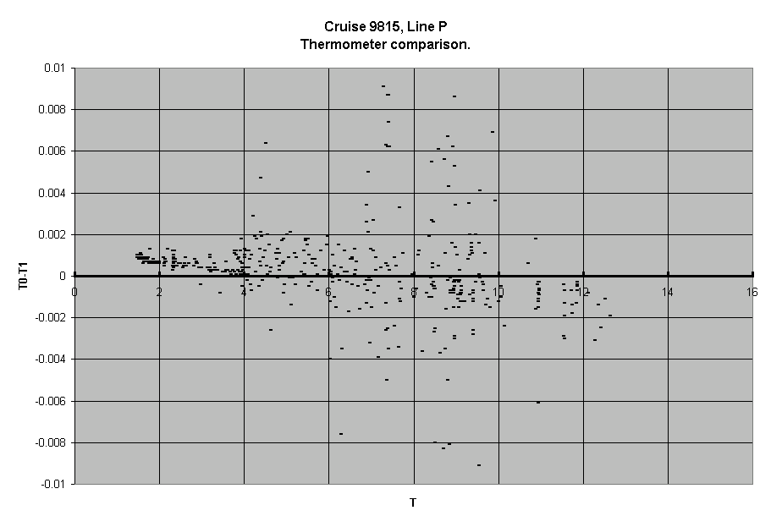

Conductivity: At the outset, these sensors disagreed somewhat with bottles and an initial
slope correction of .99980 for C0 and 1.00018 for C1 were used. Both
sensors subsequently drifted and experienced shifts probably due to
biological fouling.

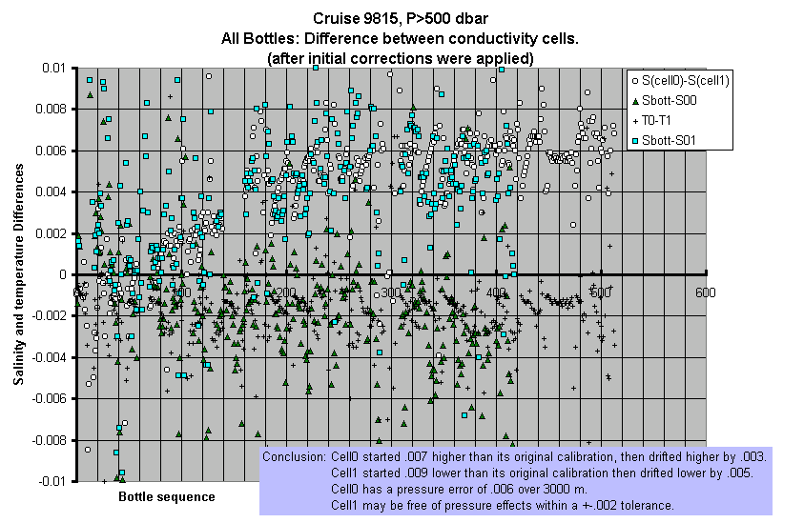
A careful look at the above plot shows a systematic difference between Cell0 and Cell1 changing with pressure in the deep casts. These effects were taken into account in determining the cell slope corrections but could not be addressed in the Seabird software and were left to post processing in IOSShell.
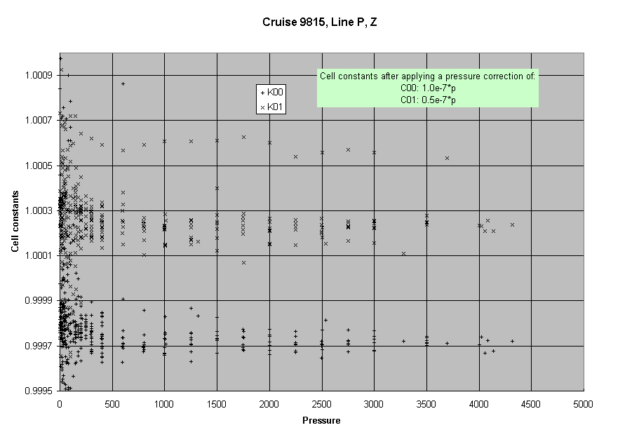
Each cast was given its own slope correction based on bottle salinities. Cell0 seemed to be changing in a consistent way through the cruise so it was decided to use Cell0 and its slope correction K0 with T0 to compute salinity, S00, although Cell1 and T1 were still carried through the various processing stages.

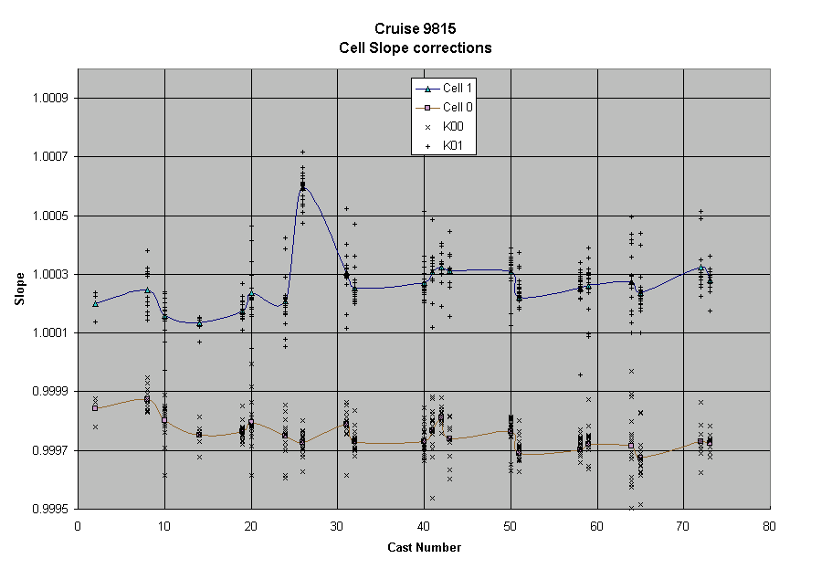

Station | Cast | Slope Correction, K00 | Slope Correction, K01
S3 | 2, 1-5 | .999841 | 1.000199
P4 | 8, 6-8 | .999874 | 1.000246
P4 | 10, 9-12 | .999802 | 1.000159
P8 | 14 | .999753 | 1.000135
P12 | 19, 17-19 | .999763 | 1.000176
P12 | 20, 20-22 | .999795 | 1.000236
P16 | 24, 23-25 | .999748 | 1.000208
P16 | 26,26-28 | .999726 | 1.000597
P20 | 31,29-31 | .999789 | 1.000306
P20 | 32,32-36 | .999732 | 1.000254
P26 | 40,37-40 | .999731 | 1.000270
P26 | 41 | .999769 | 1.000309
P26 | 42 | .999811 | 1.000325
P26 | 43,43-46 | .999738 | 1.000312
Z04 | 50,47-50 | .999766 | 1.000309
Z04 | 51,51-54 | .999689 | 1.000223
Z09 | 58,55-58 | .999702 | 1.000253
Z09 | 59,59-61 | .999720 | 1.000264
Z14 | 64,62-64 | .999715 | 1.000273
Z14 | 65,65-68 | .999674 | 1.000238
Z19 | 72,69-72 | .999731 | 1.000325
Z19 | 73,73- | .999725 | 1.000281

Just before the end of the cruise, the raw data were run again through the SBE batch processing. The calibrated data was brought into a new spreadsheet, 9815allbot_after.xls to check the accuracy of the calibrations. The uncompensated pressure effect now shows up clearly.
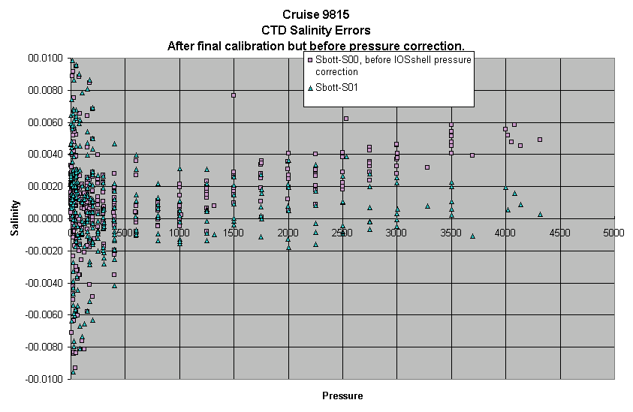

Some bottles in high gradients were taken out of the calibration determinations but are shown below as crosses.
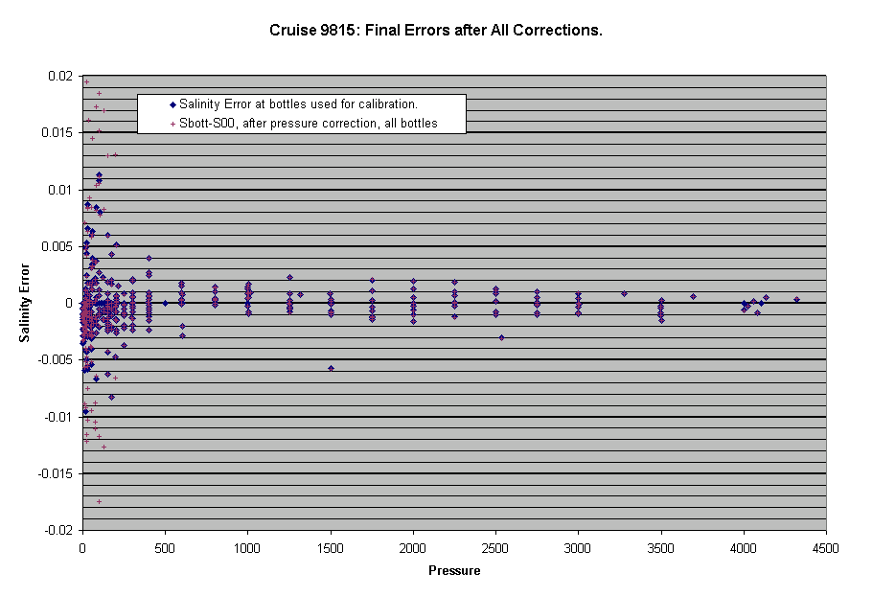
The pressure dependent correction was: 1.0e-7*p for cell0 and 0.5e-7*p for cell1. This correction was applied in IOSSHELL since there is no facility for doing so in the Seabird software.

Data were processed using the procedures recommended in the SBE manual and the following IOSSHELL steps.
- Datcnv to convert the binary data(.dat files) to ascii using the .con files modified with the slope corrections in the table above so that all subsequent files have the correct slope and offset corrections for the raw sensors. The resulting ascii .cnv file was copied to a zip file.
- Rossum was run on the .ros files to produce .btl files with averaged data at the bottle points.
- Wildedit with 2 standard deviations on pass1 and 20 on pass 2 using 10 points; all raw channels.
- Celltm to remove sef-heating with the following parameters
# celltm_alpha = 0.0300, 0.0300
# celltm_tau = 9.0000, 9.0000
- Filter to smooth pressure before loopedit: tau=.15 s.
- Loopedit to remove data affected by wave motion; min. speed=.25 m/s.
- Binave; 1 metre avg both down and up. This file is saved as an .avg file.
- Split to remove upcast was not used since bottle comparisons would be done later.
- Import .avg files into IOSSHELL to get .ios files, apply pressure correction to get .cor files and compute derived quantities to get .ctd files and remove upcast to get .del files.
- Data was thinned to get .thn files then was “Page Plotted” to make up the report.
- Print the header summary; Cast 3 had to be corrected.
- Convert .del files from pressure to gamma-theta cordinate to compress the data into .dyn files.
- Export .dyn files to spreadsheet. Do plots, etc.
- Import into Access data base for analysis.
- Removech was executed on the .del files to remove derived and superfluous channels. The resulting .rem files were renamed .ctd for the final archive.

July 2, 1999 - Joe Linguanti

Salinities in the upper 4 db were found to be too low. The values for 2, 3
and 4 db were replaced with the value at 5 db.
Input parameter file = H:\temp\iosshell\IS1
List file = Summ9815

************************************************
* Program: HSUMMARY *
* Version: 1.1 Date: October 1994 *
* *
* Copyright 1994 Government of Canada *
* Department of Fisheries and Oceans *
* *
* Time of run: 25-JUN-1998 10:40:12 *
************************************************

Input file is in ASCII format.
Input path = h:\linep_98\sb_avg\
Cruise year,cruise number = 98,15
First and last cast number = 1, 82
Filename extension = IOS
Summary listing will be produced.
1
1

Cruise 9815

Cast no: 1 Station S3 Project LineP
Latitude 48 35.60 N Longitude 123 30.15 W
Start date 3/ 6/98 Start time 2:56 UTC
Maximum depth 215 No. of records 214
No. of channels 8 Channel desc P %

Comments:

SBE HEADER
Sea-Bird SBE 9 Raw Data File:
FileName = D:\DATA\9815\98150001.DAT

Cast no: 2 Station S3 Project LineP
Latitude 48 35.60 N Longitude 123 30.15 W
Start date 3/ 6/98 Start time 3: 6 UTC
Maximum depth 215 No. of records 215
No. of channels 8 Channel desc P %

Comments:

SBE HEADER
Sea-Bird SBE 9 Raw Data File:
FileName = D:\DATA\9815\98150002.DAT

Cast no: 3 Station PLC2 Project LineP
Latitude 48 27.61 N Longitude 125 7.81 W
Start date 3/ 6/98 Start time 15: 3 UTC
Maximum depth 159 No. of records 316
No. of channels 8 Channel desc P %

Comments:

SBE HEADER
Sea-Bird SBE 9 Raw Data File:
FileName = D:\DATA\9815\98150003.DAT

Cast no: 4 Station PLC3 Project LineP
Latitude 48 23.46 N Longitude 125 20.84 W
Start date 3/ 6/98 Start time 17:28 UTC
Maximum depth 117 No. of records 229
No. of channels 8 Channel desc P %

Comments:

SBE HEADER
Sea-Bird SBE 9 Raw Data File:
FileName = D:\DATA\9815\98150004.DAT

Cast no: 5 Station P1 Project LineP
Latitude 48 34.49 N Longitude 125 29.98 W
Start date 3/ 6/98 Start time 20:59 UTC
Maximum depth 110 No. of records 217
No. of channels 8 Channel desc P %

Comments:

SBE HEADER
Sea-Bird SBE 9 Raw Data File:
FileName = D:\DATA\9815\98150005.DAT
1

Cruise 9815

Cast no: 6 Station P2 Project LineP
Latitude 48 35.95 N Longitude 125 59.98 W
Start date 3/ 6/98 Start time 23:17 UTC
Maximum depth 102 No. of records 202
No. of channels 8 Channel desc P %

Comments:

SBE HEADER
Sea-Bird SBE 9 Raw Data File:
FileName = D:\DATA\9815\98150006.DAT

Cast no: 7 Station P3 Project LineP
Latitude 48 37.56 N Longitude 126 19.80 W
Start date 4/ 6/98 Start time 1: 3 UTC
Maximum depth 789 No. of records 1575
No. of channels 8 Channel desc P %

Comments:

SBE HEADER
Sea-Bird SBE 9 Raw Data File:
FileName = D:\DATA\9815\98150007.DAT

Cast no: 8 Station P4 Project LineP
Latitude 48 39.07 N Longitude 126 40.17 W
Start date 4/ 6/98 Start time 3:30 UTC
Maximum depth 1320 No. of records 2636
No. of channels 8 Channel desc P %

Comments:

SBE HEADER
Sea-Bird SBE 9 Raw Data File:
FileName = D:\DATA\9815\98150008.DAT

Cast no: 9 Station P4 Project LineP
Latitude 48 39.03 N Longitude 126 39.82 W
Start date 4/ 6/98 Start time 13:47 UTC
Maximum depth 152 No. of records 303
No. of channels 8 Channel desc P %

Comments:

SBE HEADER
Sea-Bird SBE 9 Raw Data File:
FileName = D:\DATA\9815\98150009.DAT

Cast no: 10 Station P4 Project LineP
Latitude 48 38.98 N Longitude 126 40.13 W
Start date 4/ 6/98 Start time 18:12 UTC
Maximum depth 402 No. of records 800
No. of channels 8 Channel desc P %

Comments:

SBE HEADER
Sea-Bird SBE 9 Raw Data File:
FileName = D:\DATA\9815\98150010.DAT
1

Cruise 9815

Cast no: 11 Station P5 Project LineP
Latitude 48 41.52 N Longitude 127 10.13 W
Start date 4/ 6/98 Start time 23:55 UTC
Maximum depth 2111 No. of records 4220
No. of channels 8 Channel desc P %

Comments:

SBE HEADER
Sea-Bird SBE 9 Raw Data File:
FileName = D:\DATA\9815\98150011.DAT

Cast no: 12 Station P6 Project LineP
Latitude 48 44.72 N Longitude 127 40.00 W
Start date 5/ 6/98 Start time 3: 2 UTC
Maximum depth 2572 No. of records 5142
No. of channels 8 Channel desc P %

Comments:

SBE HEADER
Sea-Bird SBE 9 Raw Data File:
FileName = D:\DATA\9815\98150012.DAT

Cast no: 13 Station P7 Project LineP
Latitude 48 46.60 N Longitude 128 10.13 W
Start date 5/ 6/98 Start time 7: 5 UTC
Maximum depth 2526 No. of records 5049
No. of channels 8 Channel desc P %

Comments:

SBE HEADER
Sea-Bird SBE 9 Raw Data File:
FileName = D:\DATA\9815\98150013.DAT

Cast no: 14 Station P8 Project LineP
Latitude 48 48.97 N Longitude 128 39.85 W
Start date 5/ 6/98 Start time 10:32 UTC
Maximum depth 2539 No. of records 5076
No. of channels 8 Channel desc P %

Comments:

SBE HEADER
Sea-Bird SBE 9 Raw Data File:
FileName = D:\DATA\9815\98150014.DAT

Cast no: 15 Station P9 Project LineP
Latitude 48 51.31 N Longitude 129 9.96 W
Start date 5/ 6/98 Start time 14:48 UTC
Maximum depth 2390 No. of records 4775
No. of channels 8 Channel desc P %

Comments:

SBE HEADER
Sea-Bird SBE 9 Raw Data File:
FileName = D:\DATA\9815\98150015.DAT
1

Cruise 9815

Cast no: 16 Station P10 Project LineP
Latitude 48 53.66 N Longitude 129 39.91 W
Start date 5/ 6/98 Start time 18:19 UTC
Maximum depth 2676 No. of records 5350
No. of channels 8 Channel desc P %

Comments:

SBE HEADER
Sea-Bird SBE 9 Raw Data File:
FileName = D:\DATA\9815\98150016.DAT

Cast no: 17 Station P11 Project LineP
Latitude 48 56.10 N Longitude 130 10.00 W
Start date 5/ 6/98 Start time 22:45 UTC
Maximum depth 2791 No. of records 5580
No. of channels 8 Channel desc P %

Comments:

SBE HEADER
Sea-Bird SBE 9 Raw Data File:
FileName = D:\DATA\9815\98150017.DAT

Cast no: 18 Station P12 Project LineP
Latitude 48 58.25 N Longitude 130 39.96 W
Start date 6/ 6/98 Start time 2:21 UTC
Maximum depth 153 No. of records 305
No. of channels 8 Channel desc P %

Comments:

SBE HEADER
Sea-Bird SBE 9 Raw Data File:
FileName = D:\DATA\9815\98150018.DAT

Cast no: 19 Station P12 Project LineP
Latitude 48 58.32 N Longitude 130 39.74 W
Start date 6/ 6/98 Start time 2:38 UTC
Maximum depth 3279 No. of records 6555
No. of channels 8 Channel desc P %

Comments:

SBE HEADER
Sea-Bird SBE 9 Raw Data File:
FileName = D:\DATA\9815\98150019.DAT

Cast no: 20 Station P12 Project LineP
Latitude 48 58.31 N Longitude 130 39.87 W
Start date 6/ 6/98 Start time 17:18 UTC
Maximum depth 402 No. of records 799
No. of channels 8 Channel desc P %

Comments:

SBE HEADER
Sea-Bird SBE 9 Raw Data File:
FileName = D:\DATA\9815\98150020.DAT
1

Cruise 9815

Cast no: 21 Station P13 Project LineP
Latitude 49 2.60 N Longitude 131 39.89 W
Start date 7/ 6/98 Start time 1:20 UTC
Maximum depth 3056 No. of records 6107
No. of channels 8 Channel desc P %

Comments:

SBE HEADER
Sea-Bird SBE 9 Raw Data File:
FileName = D:\DATA\9815\98150021.DAT

Cast no: 22 Station P14 Project LineP
Latitude 49 7.24 N Longitude 132 40.13 W
Start date 7/ 6/98 Start time 7: 2 UTC
Maximum depth 3007 No. of records 6012
No. of channels 8 Channel desc P %

Comments:

SBE HEADER
Sea-Bird SBE 9 Raw Data File:
FileName = D:\DATA\9815\98150022.DAT

Cast no: 23 Station P15 Project LineP
Latitude 49 12.00 N Longitude 133 40.02 W
Start date 7/ 6/98 Start time 12:42 UTC
Maximum depth 3288 No. of records 6573
No. of channels 8 Channel desc P %

Comments:

SBE HEADER
Sea-Bird SBE 9 Raw Data File:
FileName = D:\DATA\9815\98150023.DAT

Cast no: 24 Station P16 Project LineP
Latitude 49 17.00 N Longitude 134 40.10 W
Start date 7/ 6/98 Start time 18:53 UTC
Maximum depth 403 No. of records 803
No. of channels 8 Channel desc P %

Comments:

SBE HEADER
Sea-Bird SBE 9 Raw Data File:
FileName = D:\DATA\9815\98150024.DAT

Cast no: 25 Station P16 Project LineP
Latitude 49 17.02 N Longitude 134 40.01 W
Start date 8/ 6/98 Start time 6: 6 UTC
Maximum depth 3693 No. of records 3693
No. of channels 8 Channel desc P %

Comments:

SBE HEADER
Sea-Bird SBE 9 Raw Data File:
FileName = D:\DATA\9815\98150025.DAT
1

Cruise 9815

Cast no: 26 Station P16 Project LineP
Latitude 49 17.14 N Longitude 134 40.64 W
Start date 8/ 6/98 Start time 7: 3 UTC
Maximum depth 3696 No. of records 3698
No. of channels 8 Channel desc P %

Comments:

SBE HEADER
Sea-Bird SBE 9 Raw Data File:
FileName = D:\DATA\9815\98150026.DAT

Cast no: 27 Station P17 Project LineP
Latitude 49 20.91 N Longitude 135 40.18 W
Start date 8/ 6/98 Start time 20: 4 UTC
Maximum depth 2511 No. of records 5019
No. of channels 8 Channel desc P %

Comments:

SBE HEADER
Sea-Bird SBE 9 Raw Data File:
FileName = D:\DATA\9815\98150027.DAT

Cast no: 28 Station P18 Project LineP
Latitude 49 26.01 N Longitude 136 40.03 W
Start date 9/ 6/98 Start time 1:29 UTC
Maximum depth 3001 No. of records 6000
No. of channels 8 Channel desc P %

Comments:

SBE HEADER
Sea-Bird SBE 9 Raw Data File:
FileName = D:\DATA\9815\98150028.DAT

Cast no: 29 Station P19 Project LineP
Latitude 49 30.08 N Longitude 137 40.02 W
Start date 9/ 6/98 Start time 7:19 UTC
Maximum depth 3006 No. of records 6007
No. of channels 8 Channel desc P %

Comments:

SBE HEADER
Sea-Bird SBE 9 Raw Data File:
FileName = D:\DATA\9815\98150029.DAT

Cast no: 30 Station P20 Project LineP
Latitude 49 33.98 N Longitude 138 40.02 W
Start date 9/ 6/98 Start time 14:34 UTC
Maximum depth 154 No. of records 307
No. of channels 8 Channel desc P %

Comments:

SBE HEADER
Sea-Bird SBE 9 Raw Data File:
FileName = D:\DATA\9815\98150030.DAT
1

Cruise 9815

Cast no: 31 Station P20 Project LineP
Latitude 49 33.97 N Longitude 138 39.98 W
Start date 9/ 6/98 Start time 19:17 UTC
Maximum depth 416 No. of records 830
No. of channels 8 Channel desc P %

Comments:

SBE HEADER
Sea-Bird SBE 9 Raw Data File:
FileName = D:\DATA\9815\98150031.DAT

Cast no: 32 Station P20 Project LineP
Latitude 49 33.99 N Longitude 138 40.02 W
Start date 10/ 6/98 Start time 4:11 UTC
Maximum depth 4023 No. of records 8044
No. of channels 8 Channel desc P %

Comments:

SBE HEADER
Sea-Bird SBE 9 Raw Data File:
FileName = D:\DATA\9815\98150032.DAT

Cast no: 33 Station P21 Project LineP
Latitude 49 38.04 N Longitude 139 39.93 W
Start date 10/ 6/98 Start time 10:53 UTC
Maximum depth 3004 No. of records 6007
No. of channels 8 Channel desc P %

Comments:

SBE HEADER
Sea-Bird SBE 9 Raw Data File:
FileName = D:\DATA\9815\98150033.DAT

Cast no: 34 Station P22 Project LineP
Latitude 49 42.03 N Longitude 140 39.94 W
Start date 10/ 6/98 Start time 17: 8 UTC
Maximum depth 3003 No. of records 6004
No. of channels 8 Channel desc P %

Comments:

SBE HEADER
Sea-Bird SBE 9 Raw Data File:
FileName = D:\DATA\9815\98150034.DAT

Cast no: 35 Station P23 Project LineP
Latitude 49 46.04 N Longitude 141 40.00 W
Start date 11/ 6/98 Start time 2:39 UTC
Maximum depth 3003 No. of records 6005
No. of channels 8 Channel desc P %

Comments:

SBE HEADER
Sea-Bird SBE 9 Raw Data File:
FileName = D:\DATA\9815\98150035.DAT
1

Cruise 9815

Cast no: 36 Station P24 Project LineP
Latitude 49 50.03 N Longitude 142 39.88 W
Start date 11/ 6/98 Start time 8:16 UTC
Maximum depth 3010 No. of records 6015
No. of channels 8 Channel desc P %

Comments:

SBE HEADER
Sea-Bird SBE 9 Raw Data File:
FileName = D:\DATA\9815\98150036.DAT

Cast no: 37 Station P25 Project LineP
Latitude 49 59.95 N Longitude 143 36.31 W
Start date 11/ 6/98 Start time 13:36 UTC
Maximum depth 3002 No. of records 6001
No. of channels 8 Channel desc P %

Comments:

SBE HEADER
Sea-Bird SBE 9 Raw Data File:
FileName = D:\DATA\9815\98150037.DAT

Cast no: 38 Station P35 Project LineP
Latitude 50 .02 N Longitude 144 18.22 W
Start date 11/ 6/98 Start time 18:15 UTC
Maximum depth 3002 No. of records 6001
No. of channels 8 Channel desc P %

Comments:

SBE HEADER
Sea-Bird SBE 9 Raw Data File:
FileName = D:\DATA\9815\98150038.DAT

Cast no: 39 Station P26 Project LineP
Latitude 50 .16 N Longitude 145 .01 W
Start date 12/ 6/98 Start time 2:27 UTC
Maximum depth 105 No. of records 208
No. of channels 8 Channel desc P %

Comments:

SBE HEADER
Sea-Bird SBE 9 Raw Data File:
FileName = D:\DATA\9815\98150039.DAT

Cast no: 40 Station P26 Project LineP
Latitude 50 .20 N Longitude 144 59.94 W
Start date 12/ 6/98 Start time 2:43 UTC
Maximum depth 4319 No. of records 8632
No. of channels 8 Channel desc P %

Comments:

SBE HEADER
Sea-Bird SBE 9 Raw Data File:
FileName = D:\DATA\9815\98150040.DAT
1

Cruise 9815

Cast no: 41 Station P26 Project LineP
Latitude 50 .05 N Longitude 145 .02 W
Start date 12/ 6/98 Start time 13: 8 UTC
Maximum depth 501 No. of records 998
No. of channels 8 Channel desc P %

Comments:

SBE HEADER
Sea-Bird SBE 9 Raw Data File:
FileName = D:\DATA\9815\98150041.DAT

Cast no: 42 Station P26 Project LineP
Latitude 49 59.79 N Longitude 145 .22 W
Start date 12/ 6/98 Start time 22:39 UTC
Maximum depth 403 No. of records 803
No. of channels 8 Channel desc P %

Comments:

SBE HEADER
Sea-Bird SBE 9 Raw Data File:
FileName = D:\DATA\9815\98150042.DAT

Cast no: 43 Station P26 Project LineP
Latitude 50 .00 N Longitude 144 59.94 W
Start date 13/ 6/98 Start time 4:42 UTC
Maximum depth 1503 No. of records 3003
No. of channels 8 Channel desc P %

Comments:

SBE HEADER
Sea-Bird SBE 9 Raw Data File:
FileName = D:\DATA\9815\98150043.DAT

Cast no: 44 Station P26 Project LineP
Latitude 49 59.79 N Longitude 144 59.69 W
Start date 13/ 6/98 Start time 16: 4 UTC
Maximum depth 33 No. of records 64
No. of channels 8 Channel desc P %

Comments:

SBE HEADER
Sea-Bird SBE 9 Raw Data File:
FileName = D:\DATA\9815\98150044.DAT

Cast no: 45 Station P41 Project LineP
Latitude 50 27.06 N Longitude 144 59.85 W
Start date 14/ 6/98 Start time 19:46 UTC
Maximum depth 1505 No. of records 3006
No. of channels 8 Channel desc P %

Comments:

SBE HEADER
Sea-Bird SBE 9 Raw Data File:
FileName = D:\DATA\9815\98150045.DAT
1

Cruise 9815

Cast no: 46 Station P32 Project LineP
Latitude 50 53.92 N Longitude 144 59.79 W
Start date 15/ 6/98 Start time 1:42 UTC
Maximum depth 1504 No. of records 2992
No. of channels 8 Channel desc P %

Comments:

SBE HEADER
Sea-Bird SBE 9 Raw Data File:
FileName = D:\DATA\9815\98150046.DAT

Cast no: 47 Station Z01 Project LineP
Latitude 51 21.02 N Longitude 144 59.96 W
Start date 15/ 6/98 Start time 6:28 UTC
Maximum depth 1501 No. of records 2997
No. of channels 8 Channel desc P %

Comments:

SBE HEADER
Sea-Bird SBE 9 Raw Data File:
FileName = D:\DATA\9815\98150047.DAT

Cast no: 48 Station Z02 Project LineP
Latitude 51 48.09 N Longitude 144 59.93 W
Start date 15/ 6/98 Start time 10:14 UTC
Maximum depth 1507 No. of records 3011
No. of channels 8 Channel desc P %

Comments:

SBE HEADER
Sea-Bird SBE 9 Raw Data File:
FileName = D:\DATA\9815\98150048.DAT

Cast no: 49 Station Z03 Project LineP
Latitude 52 11.95 N Longitude 145 .06 W
Start date 15/ 6/98 Start time 13:45 UTC
Maximum depth 1504 No. of records 3007
No. of channels 8 Channel desc P %

Comments:

SBE HEADER
Sea-Bird SBE 9 Raw Data File:
FileName = D:\DATA\9815\98150049.DAT

Cast no: 50 Station Z04 Project LineP
Latitude 52 38.95 N Longitude 144 59.76 W
Start date 15/ 6/98 Start time 18:34 UTC
Maximum depth 401 No. of records 799
No. of channels 8 Channel desc P %

Comments:

SBE HEADER
Sea-Bird SBE 9 Raw Data File:
FileName = D:\DATA\9815\98150050.DAT
1

Cruise 9815

Cast no: 51 Station Z04 Project LineP
Latitude 52 39.00 N Longitude 144 59.96 W
Start date 16/ 6/98 Start time 1: 4 UTC
Maximum depth 4135 No. of records 8265
No. of channels 8 Channel desc P %

Comments:

SBE HEADER
Sea-Bird SBE 9 Raw Data File:
FileName = D:\DATA\9815\98150051.DAT

Cast no: 52 Station Z05 Project LineP
Latitude 53 6.05 N Longitude 145 .07 W
Start date 1/ 1/80 Start time 0: 0 UTC
Maximum depth 1502 No. of records 3003
No. of channels 8 Channel desc P %

Comments:

SBE HEADER
Sea-Bird SBE 9 Raw Data File:
FileName = D:\DATA\9815\98150052.DAT

Cast no: 53 Station Z06 Project LineP
Latitude 53 32.72 N Longitude 145 .08 W
Start date 16/ 6/98 Start time 19:40 UTC
Maximum depth 1504 No. of records 3003
No. of channels 8 Channel desc P %

Comments:

SBE HEADER
Sea-Bird SBE 9 Raw Data File:
FileName = D:\DATA\9815\98150053.DAT

Cast no: 54 Station Z07 Project LineP
Latitude 54 .08 N Longitude 145 .08 W
Start date 16/ 6/98 Start time 23:18 UTC
Maximum depth 1505 No. of records 3008
No. of channels 8 Channel desc P %

Comments:

SBE HEADER
Sea-Bird SBE 9 Raw Data File:
FileName = D:\DATA\9815\98150054.DAT

Cast no: 55 Station Z08 Project LineP
Latitude 54 26.67 N Longitude 144 59.96 W
Start date 17/ 6/98 Start time 2:51 UTC
Maximum depth 108 No. of records 215
No. of channels 8 Channel desc P %

Comments:

SBE HEADER
Sea-Bird SBE 9 Raw Data File:
FileName = D:\DATA\9815\98150055.DAT
1

Cruise 9815

Cast no: 56 Station Z08 Project LineP
Latitude 54 26.56 N Longitude 144 59.82 W
Start date 17/ 6/98 Start time 3: 4 UTC
Maximum depth 1503 No. of records 3005
No. of channels 8 Channel desc P %

Comments:

SBE HEADER
Sea-Bird SBE 9 Raw Data File:
FileName = D:\DATA\9815\98150056.DAT

Cast no: 57 Station Z09 Project LineP
Latitude 55 .04 N Longitude 145 .12 W
Start date 17/ 6/98 Start time 7:31 UTC
Maximum depth 4106 No. of records 4153
No. of channels 8 Channel desc P %

Comments:

SBE HEADER
Sea-Bird SBE 9 Raw Data File:
FileName = D:\DATA\9815\98150057.DAT

Cast no: 58 Station Z09 Project LineP
Latitude 54 59.93 N Longitude 145 .09 W
Start date 17/ 6/98 Start time 14:43 UTC
Maximum depth 4090 No. of records 8177
No. of channels 8 Channel desc P %

Comments:

SBE HEADER
Sea-Bird SBE 9 Raw Data File:
FileName = D:\DATA\9815\98150058.DAT

Cast no: 59 Station Z09 Project LineP
Latitude 54 59.96 N Longitude 145 1.02 W
Start date 17/ 6/98 Start time 20: 0 UTC
Maximum depth 402 No. of records 799
No. of channels 8 Channel desc P %

Comments:

SBE HEADER
Sea-Bird SBE 9 Raw Data File:
FileName = D:\DATA\9815\98150059.DAT

Cast no: 60 Station Z10 Project LineP
Latitude 55 29.97 N Longitude 145 .08 W
Start date 18/ 6/98 Start time 2:39 UTC
Maximum depth 1502 No. of records 3001
No. of channels 8 Channel desc P %

Comments:

SBE HEADER
Sea-Bird SBE 9 Raw Data File:
FileName = D:\DATA\9815\98150060.DAT
1

Cruise 9815

Cast no: 61 Station Z11 Project LineP
Latitude 56 .03 N Longitude 145 .05 W
Start date 1/ 1/80 Start time 0: 0 UTC
Maximum depth 1504 No. of records 3007
No. of channels 8 Channel desc P %

Comments:

SBE HEADER
Sea-Bird SBE 9 Raw Data File:
FileName = D:\DATA\9815\98150061.DAT

Cast no: 62 Station Z12 Project LineP
Latitude 56 30.09 N Longitude 144 59.93 W
Start date 18/ 6/98 Start time 10:21 UTC
Maximum depth 1501 No. of records 2998
No. of channels 8 Channel desc P %

Comments:

SBE HEADER
Sea-Bird SBE 9 Raw Data File:
FileName = D:\DATA\9815\98150062.DAT

Cast no: 63 Station Z13 Project LineP
Latitude 56 59.98 N Longitude 145 .04 W
Start date 18/ 6/98 Start time 14: 1 UTC
Maximum depth 1503 No. of records 3004
No. of channels 8 Channel desc P %

Comments:

SBE HEADER
Sea-Bird SBE 9 Raw Data File:
FileName = D:\DATA\9815\98150063.DAT

Cast no: 64 Station Z14 Project LineP
Latitude 57 30.03 N Longitude 144 59.92 W
Start date 18/ 6/98 Start time 17:37 UTC
Maximum depth 400 No. of records 796
No. of channels 8 Channel desc P %

Comments:

SBE HEADER
Sea-Bird SBE 9 Raw Data File:
FileName = D:\DATA\9815\98150064.DAT

Cast no: 65 Station Z14 Project LineP
Latitude 57 30.07 N Longitude 145 .02 W
Start date 19/ 6/98 Start time 2:19 UTC
Maximum depth 4058 No. of records 8115
No. of channels 8 Channel desc P %

Comments:

SBE HEADER
Sea-Bird SBE 9 Raw Data File:
FileName = D:\DATA\9815\98150065.DAT
1

Cruise 9815

Cast no: 66 Station Z14N Project LineP
Latitude 57 31.13 N Longitude 144 59.80 W
Start date 19/ 6/98 Start time 14:20 UTC
Maximum depth 3937 No. of records 7872
No. of channels 8 Channel desc P %

Comments:

SBE HEADER
Sea-Bird SBE 9 Raw Data File:
FileName = D:\DATA\9815\98150066.DAT

Cast no: 67 Station Z15 Project LineP
Latitude 58 .06 N Longitude 145 .17 W
Start date 19/ 6/98 Start time 19:31 UTC
Maximum depth 1503 No. of records 3002
No. of channels 8 Channel desc P %

Comments:

SBE HEADER
Sea-Bird SBE 9 Raw Data File:
FileName = D:\DATA\9815\98150067.DAT

Cast no: 68 Station Z15 Project LineP
Latitude 58 29.99 N Longitude 145 .00 W
Start date 19/ 6/98 Start time 23:30 UTC
Maximum depth 1504 No. of records 1847
No. of channels 8 Channel desc P %

Comments:

SBE HEADER
Sea-Bird SBE 9 Raw Data File:
FileName = D:\DATA\9815\98150068.DAT

Cast no: 69 Station Z17 Project LineP
Latitude 58 50.02 N Longitude 144 59.93 W
Start date 20/ 6/98 Start time 2:26 UTC
Maximum depth 104 No. of records 207
No. of channels 8 Channel desc P %

Comments:

SBE HEADER
Sea-Bird SBE 9 Raw Data File:
FileName = D:\DATA\9815\98150069.DAT

Cast no: 70 Station Z17 Project LineP
Latitude 58 50.01 N Longitude 144 59.98 W
Start date 20/ 6/98 Start time 2:37 UTC
Maximum depth 1502 No. of records 3000
No. of channels 8 Channel desc P %

Comments:

SBE HEADER
Sea-Bird SBE 9 Raw Data File:
FileName = D:\DATA\9815\98150070.DAT
1

Cruise 9815

Cast no: 71 Station Z18 Project LineP
Latitude 59 9.98 N Longitude 145 .06 W
Start date 20/ 6/98 Start time 5:33 UTC
Maximum depth 1503 No. of records 3001
No. of channels 8 Channel desc P %

Comments:

SBE HEADER
Sea-Bird SBE 9 Raw Data File:
FileName = D:\DATA\9815\98150071.DAT

Cast no: 72 Station Z19 Project LineP
Latitude 59 26.28 N Longitude 145 .03 W
Start date 20/ 6/98 Start time 8:12 UTC
Maximum depth 1014 No. of records 2025
No. of channels 8 Channel desc P %

Comments:

SBE HEADER
Sea-Bird SBE 9 Raw Data File:
FileName = D:\DATA\9815\98150072.DAT

Cast no: 73 Station Z19 Project LineP
Latitude 59 26.31 N Longitude 145 .11 W
Start date 20/ 6/98 Start time 17:49 UTC
Maximum depth 403 No. of records 801
No. of channels 8 Channel desc P %

Comments:

SBE HEADER
Sea-Bird SBE 9 Raw Data File:
FileName = D:\DATA\9815\98150073.DAT

Cast no: 74 Station Z20 Project LineP
Latitude 59 41.32 N Longitude 145 .09 W
Start date 20/ 6/98 Start time 19:52 UTC
Maximum depth 130 No. of records 258
No. of channels 8 Channel desc P %

Comments:

SBE HEADER
Sea-Bird SBE 9 Raw Data File:
FileName = D:\DATA\9815\98150074.DAT

Cast no: 75 Station Z20 Project LineP
Latitude 59 56.98 N Longitude 144 59.96 W
Start date 20/ 6/98 Start time 21:38 UTC
Maximum depth 150 No. of records 298
No. of channels 8 Channel desc P %

Comments:

SBE HEADER
Sea-Bird SBE 9 Raw Data File:
FileName = D:\DATA\9815\98150075.DAT
1

Cruise 9815

Cast no: 76 Station Q 19 Project LineP
Latitude 53 57.88 N Longitude 133 29.70 W
Start date 23/ 6/98 Start time 5:10 UTC
Maximum depth 209 No. of records 414
No. of channels 8 Channel desc P %

Comments:

SBE HEADER
Sea-Bird SBE 9 Raw Data File:
FileName = D:\DATA\9815\98150076.DAT

Cast no: 77 Station BOWI Project LineP
Latitude 53 16.96 N Longitude 135 39.86 W
Start date 1/ 1/80 Start time 0: 0 UTC
Maximum depth 470 No. of records 939
No. of channels 8 Channel desc P %

Comments:

SBE HEADER
Sea-Bird SBE 9 Raw Data File:
FileName = D:\DATA\9815\98150077.DAT

Cast no: 78 Station GI02 Project LineP
Latitude 51 30.25 N Longitude 129 37.49 W
Start date 24/ 6/98 Start time 20:55 UTC
Maximum depth 134 No. of records 265
No. of channels 8 Channel desc P %

Comments:

SBE HEADER
Sea-Bird SBE 9 Raw Data File:
FileName = D:\DATA\9815\98150078.DAT

Cast no: 79 Station ODAS Project LineP
Latitude 50 51.43 N Longitude 129 54.99 W
Start date 25/ 6/98 Start time 1:46 UTC
Maximum depth 2129 No. of records 4257
No. of channels 8 Channel desc P %

Comments:

SBE HEADER
Sea-Bird SBE 9 Raw Data File:
FileName = D:\DATA\9815\98150079.DAT

Cast no: 80 Station J22 Project LineP
Latitude 50 39.86 N Longitude 129 17.67 W
Start date 1/ 1/80 Start time 0: 0 UTC
Maximum depth 501 No. of records 1001
No. of channels 8 Channel desc P %

Comments:

SBE HEADER
Sea-Bird SBE 9 Raw Data File:
FileName = D:\DATA\9815\98150080.DAT
1

Cruise 9815

Cast no: 81 Station LQ03 Project LineP
Latitude 50 39.80 N Longitude 129 1.82 W
Start date 25/ 6/98 Start time 8:25 UTC
Maximum depth 502 No. of records 1001
No. of channels 8 Channel desc P %

Comments:

SBE HEADER
Sea-Bird SBE 9 Raw Data File:
FileName = D:\DATA\9815\98150081.DAT

Cast no: 82 Station CPE2 Project LineP
Latitude 50 42.83 N Longitude 128 40.14 W
Start date 25/ 6/98 Start time 10:44 UTC
Maximum depth 112 No. of records 221
No. of channels 8 Channel desc P %

Comments:

SBE HEADER
Sea-Bird SBE 9 Raw Data File:
FileName = D:\DATA\9815\98150082.DAT
1

Cruise

Start of run: 1998/06/25 10:40:12.96
End of run: 1998/06/25 10:40:38.83

