**REVISION NOTICE TABLE**

|  |  |
| --- | --- |
| **DATE** | **DESCRIPTION OF REVISION** |
| 21-Sep-2017 | Corrected MISSION metadata field in header. R.H. |

# 1977-1978 Kitimat data recovery

Processing January 30, 2017 – 2 February 2017

Processed by: Germaine Gatien

# DATA SOURCE

The data were obtained by Cindy Wright from data reports in the IOS library. The data were delivered in 2 Excel spreadsheets together with comments on the collection and analysis methods used. The data in the report were only those from the hydro casts, but there were CTD casts run during these cruises.

Data for 1977-54, 1977-55, 1977-56, 1978-52 and 1977-56 were found in report:

Webster, I.T. 1980a. Kitimat Physical Oceanographic Study 1977-1978, Part 2: A Manual for General Data Access. Contract Report Series 80-3 (part 2), Institute of Ocean Sciences, Patricia Bay, B.C., 109 pp.

Data for 1977-57 were found in report:

Macdonald, R.W., D.W. Macdonald, and P.S. Munroe. 1977. Oceanographic Data Report. Kitimat Arm, Porpoise Harbour. February 1977. Pacific Marine Science Report 78-24. 61p.-----------------------------------------------------------------------------------------------------------------------------

# PROCESSING – GENERAL METHOD

The first step was to create individual spreadsheets for each cruise and add a 6-line header.

Getting these data into shape for the archive requires getting times and positions into the right format – always problematic in Excel. Use of functions like LEFT, RIGHT and CONCATENATION were used to format latitude, longitude and time. Conversion was done using a 6-line header format. To get start times in the correct format, date and time were first converted as channels and then CLEAN was used to calculate start time.

Latitude and longitude and water depth were recorded in the headers only by choosing N in the top line of the 6-line header.

For the Dubrocky cruises the data are identified by the station names in the reports. Event numbers were assigned in the order data were acquired. For the McDonald cruise the station names and event numbers are identical.

Track plots were produced to find errors in positions – there were many caused by spaces in latitudes and longitudes that inadvertently got added in the process. Getting the input data correct was an iterative process.

CLEAN was used to derive START TIME based on the DATE and TIME channels. This also produced END TIME which is exactly the same as the start time. CLEAN was also used to remove empty channels since there are some cases where there was no dissolved oxygen sampling.

CHANGE UNITS was used to obtain dissolved oxygen in mass units.

REMOVE was used to remove date and time channels.

Plots were made to look for problems. There were some typos and some cases of blanks where there should be pad values. Those were fixed in the spreadsheet and the process repeated until the data looked reasonable.

EDIT HEADERS was used to remove END TIME, change Depth to DEPTH:Nominal, change Temperature:CTD to Temperature:Reversing and to fix some formats and add or correct some header entries and to add comments that describe the collection and analysis of the data.

# PARTICULARS

The following station names were used for 1977-54, 1977-55, 1977-56, 1978-52 and 1978-53.

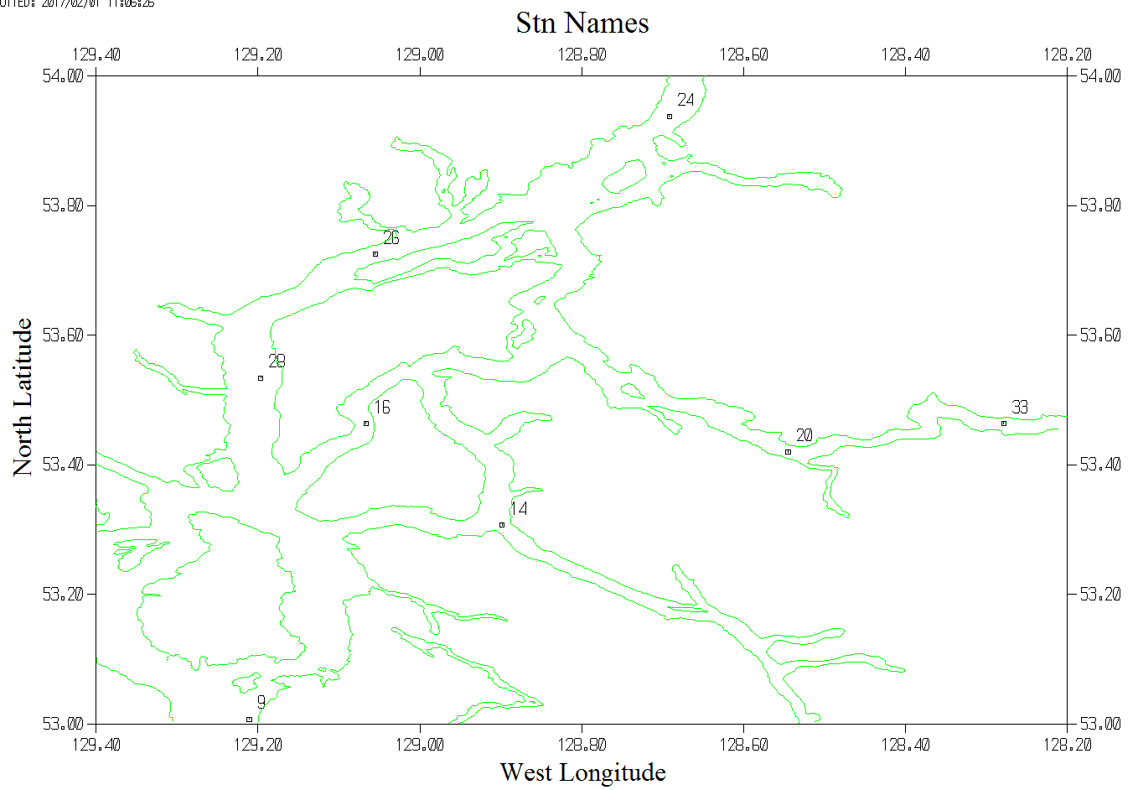

The maps that follow for each cruise show the event numbers. Data for event X can be found in file 197*-**-000X.CHE.

**1977-54**

The data were not collected in the order they are listed in the report, nor in the order of station names. The data in the spreadsheets were sorted on date and time and then event numbers were added in order of data acquisition.

The only problems identified were due to position formatting problems and data entry errors. These were corrected until track plots and profile plots looked reasonable.

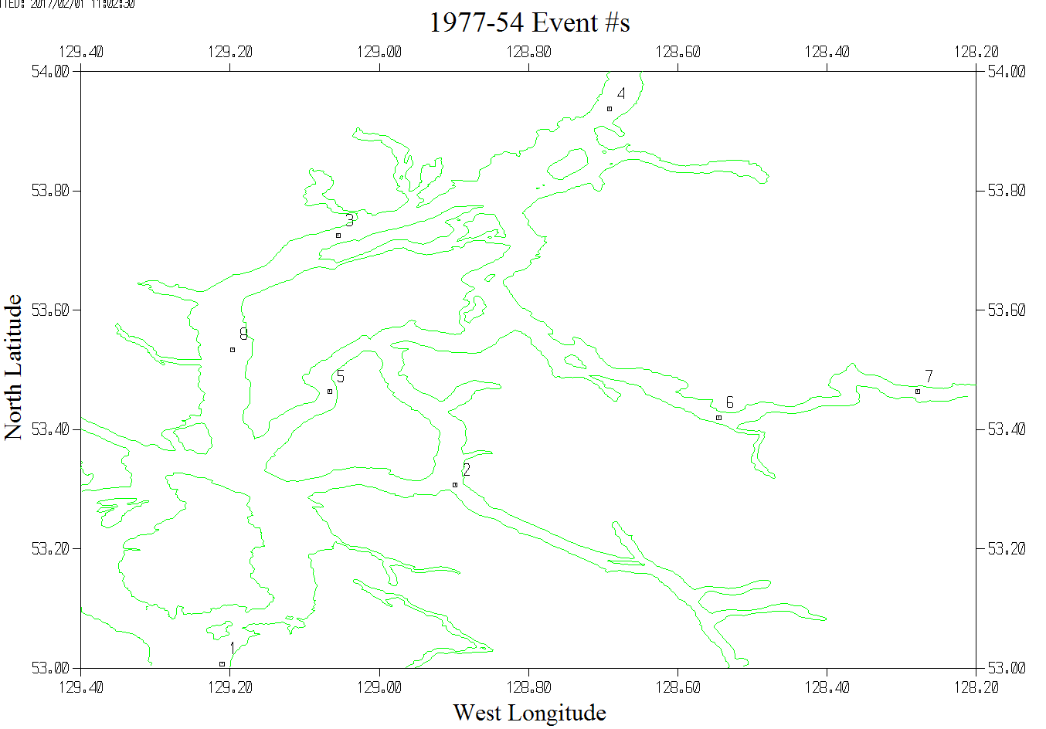

**1977-55**

There was a problem in the spreadsheet data – There was an entry for station 20 but it contained the data from station 24; there was no entry for station 24. The misplaced data were moved to a new entry for station 24 and the correct values were found in the report and entered for station 20.

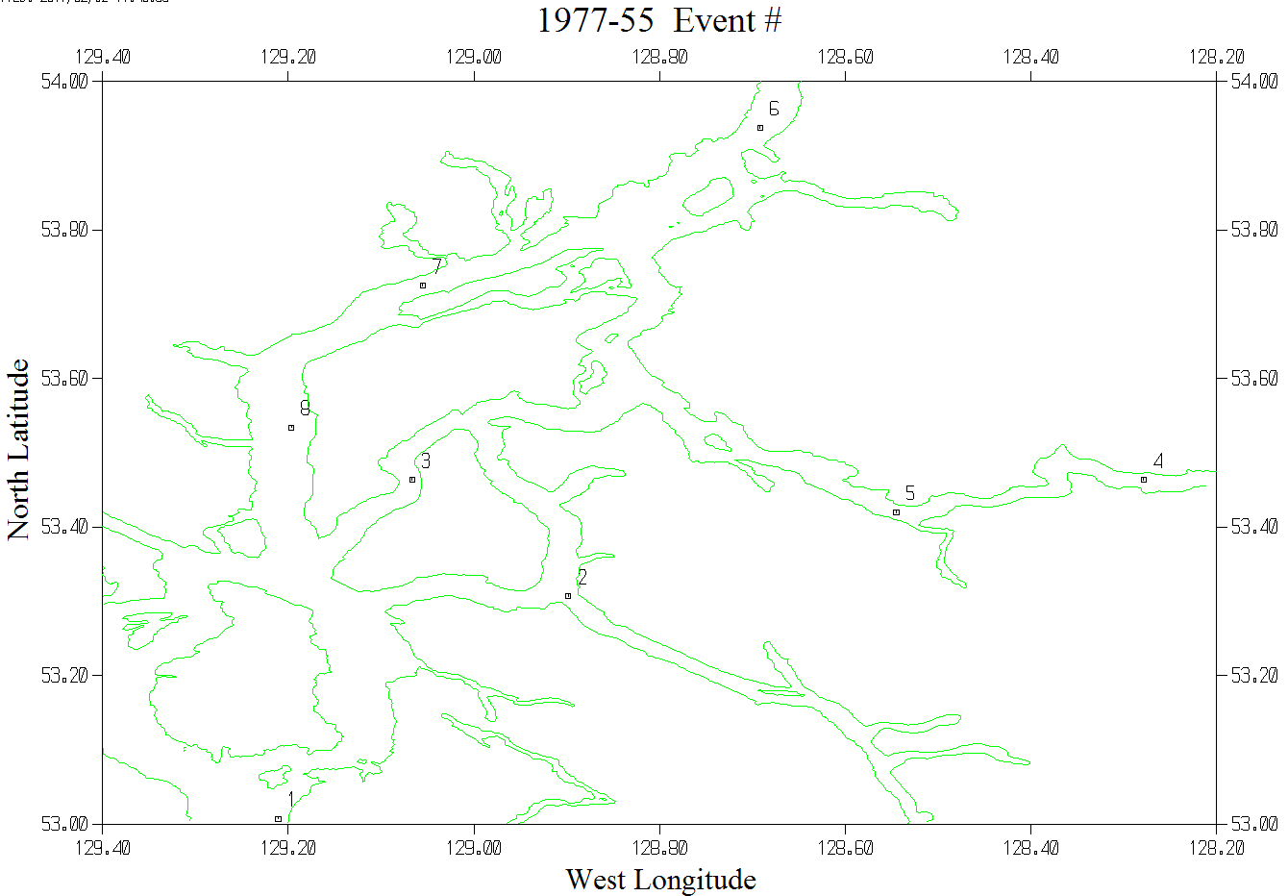

**1977-56**

No problems were found in the data.

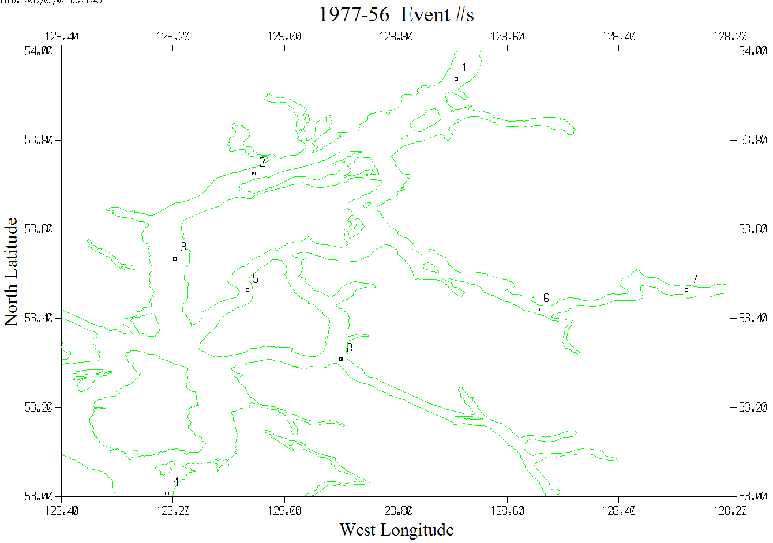

**1978-52**

There was a typo in one position that was corrected.

The salinity for event #7 at 50m was given as 32.28. This is an outlier in profile and unstable in T-S space. A value of 31.28 looks appropriate, so that was substituted. A note was entered in the header listing the value that appears in the report.

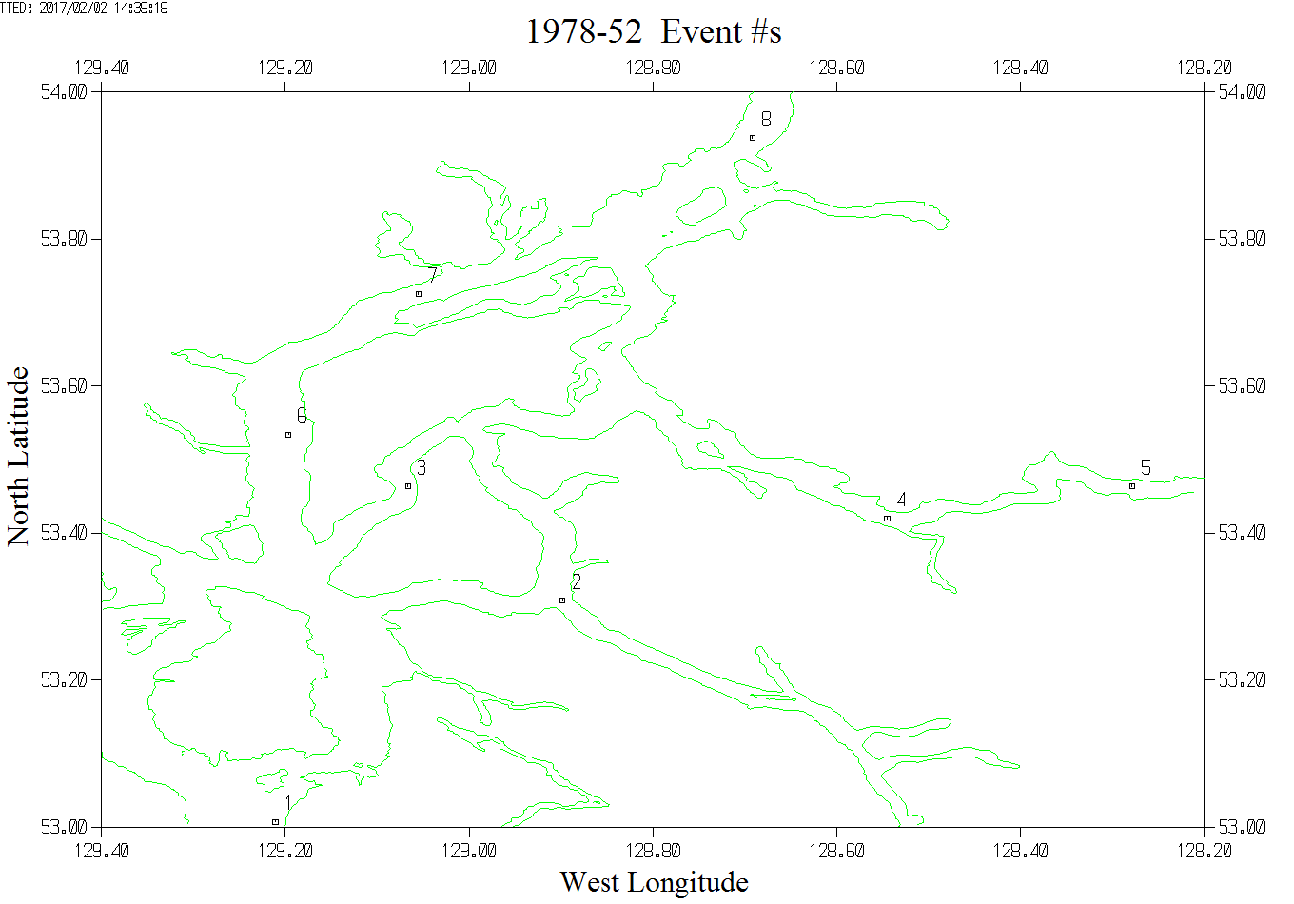

**1978-53**

One longitude read 129˚ 04’ in the report that looked like a typo, but using 4.00’ was confirmed as correct based on a comparison of a track plot with a plot in the report.

There is a typo in the report itself as to the position of the cast at station 33. The positions look wrong on a track plot. Latitude 54 27.8N should be 53 27.8N as it is entered for all other casts at that site.

An error was found and corrected in the dissolved oxygen data for 1978-53-0033. This was just a typo in the transcription and the correct value was found in the report.

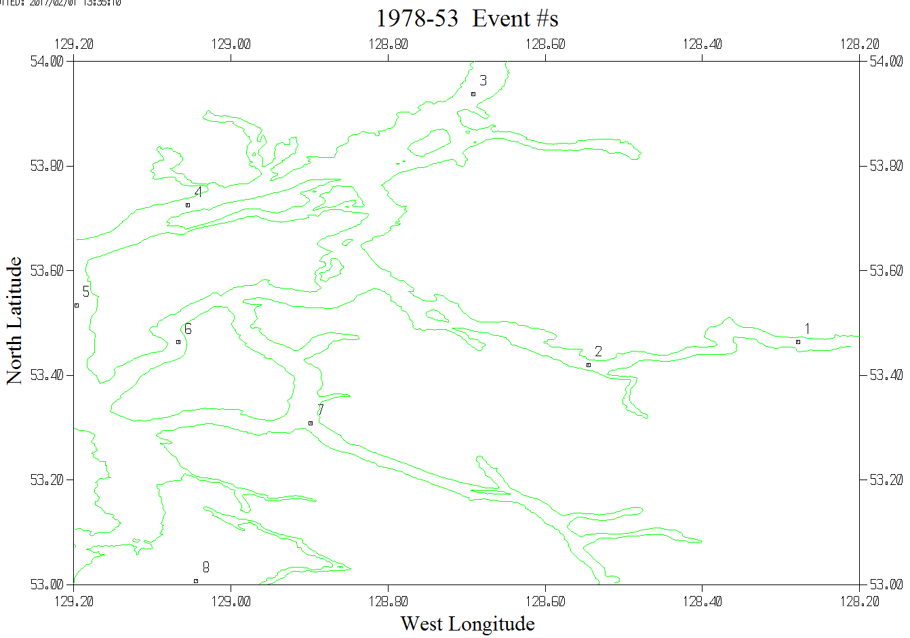

**The following cruise was processed in the same way as cruises 1977-54, 1977-55, 1977-56, 1978-52 and 1977-56, but visited different sites and collected nutrient data as well as temperature, salinity and dissolved oxygen data.**

**1977-57**

The dates had different formats for different casts. There was an error in time (03:88GMT) in the data table for event #5, but a correct value (00:38GMT) was available elsewhere in the report.

The position given for event #6 does not match the chart given in the report (See below). It is close to the position noted as the anchor station for the night before and this was the first daylight activity noted for the next day. But the depth of the cast makes no sense for that position. Fortunately, there is also a section plotted in the report that shows the cast was at the deepest point in Whale channel and there was a sharp rise just south of it. If the position should be (53˚ 6.5’N 129˚ 7.2’W) instead of (53˚ 0.65’N 129˚ 0.72’W) there is a good fit to topography. It is also noted that no other positions have more than 1 decimal point recorded. This position was entered and the following note was put in the header to explain the correction;

*NOTE: The position given in the report for this cast was 53˚ 0.65’N 129˚ 0.72’W, but that position did not match the chart given in the report. Based on an examination of a chart of Whale Channel, a temperature section in the report showing the topography near the station and the chart of station sites, the error looks like it is a case of misplaced decimal points, so the position was changed to 53˚ 6.5’N 129˚ 7.2’W.*

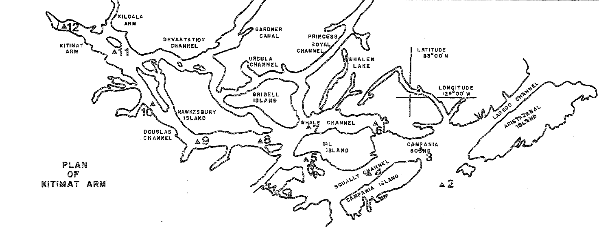

**Chart taken from Macdonald et al.**

REORDER was used before Header Edit to get all the DO channels together.

