## REVISION NOTICE TABLE

|  |  |
| --- | --- |
| DATE | DESCRIPTION OF REVISION |
|  |  |

## PROCESSING NOTES

Cruise: 1967-004

Agency: PBS - POG

Location: Prince Rupert & Contiguous Waters

Project: Pollution Monitoring

Chief Scientist: Waldichuk M.

Platform: CSS Parry

Date: 11 July 1967- 6 August 1967

Digitized by : Jackie Waldrun – April 2022

Prepared for archive by: Germaine Gatien – May 2022

# INSTRUMENT SUMMARY

Water samples were taken with Nansen bottles at the standard depths of 2, 4, 6, 10, 15, 20, 30, 50, 70, 100, 150, 200 and 250 metres or to the maximum depth the bottom would allow. Surface samples were collected with a bucket. Temperatures were obtained, when possible, with paired reversing thermometers at each depth. Surface temperatures were measured in a bucket with a standard 0-30 C surface thermometer. These data were supplemented by continuous temperature records with depth using a bathythermograph. At each station, a Secchi disc reading was taken as a measure of water transparency.

# SUMMARY OF QUALITY AND CONCERNS

Dissolved oxygen data are included in 4 channels. The original data were in mg/L; they were converted to mL/L and umol/L. Also included are surface saturation data from the original document.

Alkalinity data did not include units but based on the detailed description of the analysis and the values the data are in millieq/L, which is the same as millimol/L. The units are listed in the files as mmol/L.

Event numbers were assigned in the order they appear in the report, and are not necessarily in order of time occupied.

Data from events #11 to #35 (designated as stations P-19A*) were taken from the old highway bridge across Galloway Rapids. This series consisted of daily stations, usually occupied at high tide, for 25 days, taken consecutively, except for one missed day. There was no dissolved oxygen, pH or alkalinity sampling at that site.

# PROCESSING SUMMARY

##### Digitization

The data in this file originate from document:

Reference: Waldichuk, M. , J. R. Markert and J. H. Meikle 1968. Physical and Chemical Oceanographic Data from the West Coast of Vancouver Island and the Northern British Columbia Coast, 1957-1967. Volume II, Fisher Channel - Cousins Inlet, Douglas Channel - Kitimat Arm and Prince Rupert Harbour and its Contiguous Waters. https://waves-vagues.dfo-mpo.gc.ca/Library/52055v2.pdf.

The data were digitized by J. Waldrun and saved in individual spreadsheets for each cruise.

Depths were in metres. All times were in PST.

Dissolved Oxygen units were given in mg/L. To get the data in mL/L it was multiplied by 0.7 as stated in the document and confirmed in ICES Data Tools (<https://www.ices.dk/data/tools/Pages/Unit-conversions.aspx>).

Header comments were prepared based on comments in the original document. Further information can be found in the document.

Dr. Lisa Miller was consulted on the units for the alkalinity data and based on the method description and the values said the units were millieq/L, which is the same as millimol/L. Thus, correcting them to the units that are generally used now (micromol/kg), would involve the density and a factor of 1000.

Dr. Miller found the values given were in line with expectations for seawater.

The units were entered as mmol/L.

##### Preparation for Archive

A 6-line header was added to the spreadsheet.

Adjustments had to be made to formats of time

The year had to be changed to a 4-digit version.

Latitude and longitude needed to be changed to decimal format.

Longitude was changed to negative values.

Then a series of steps were taken:

* The 6-line header file was converted to IOS Header format. Most header information was transferred to the headers of the converted files in this process, except that start time cannot be added that way. Time and Date channels were included in the converted files.
* CLEAN was run to create Start Time from date and time channels.
* Add Time Channel was run to add 8 hours to the start time.
* Change Units was run to obtain DO in mass units.
* REORDER was run to get the DO channels together and remove Date and Time channels.
* Header Edit was run to add header comments and remove end time.

##### Quality Checks

A track plot was produced; one site looks like is on land, but it was in very shallow water, so this is likely a case of a coastline map that is not sufficiently accurate.

There are some unstable features in the T-S plots though most are small are near the bottom, so quite possibly real. However, for event #7 at station P-14 the data do look suspicious with a large reversal in salinity but not in temperature. The salinity value at 10m appears unlikely but is what was reported in the document.

Profile plots show a very large range of DO values. For the time series at site P19A most of the DO values are 0.0 mg/l. Elsewhere in the report there are values recorded twice a day for this site at ebb and flood tide; many of the flood tide values are 0.0mg/L. The Nansen bottle samples were taken mostly at high tide. In only 2 cases were the 2 sets of samples close in time. The flood tide samples were 0.53 and 0.0mg/l compared to 0.0mg/l from the Nansen bottle samples. The reported values are assumed to be correct.

Standards check pointed out some formats are non-standard, but the standards fit the time the data were gathered.

A header check were prepared and no problems were found.

A cross-reference report was produced and may be found at the end of this report.

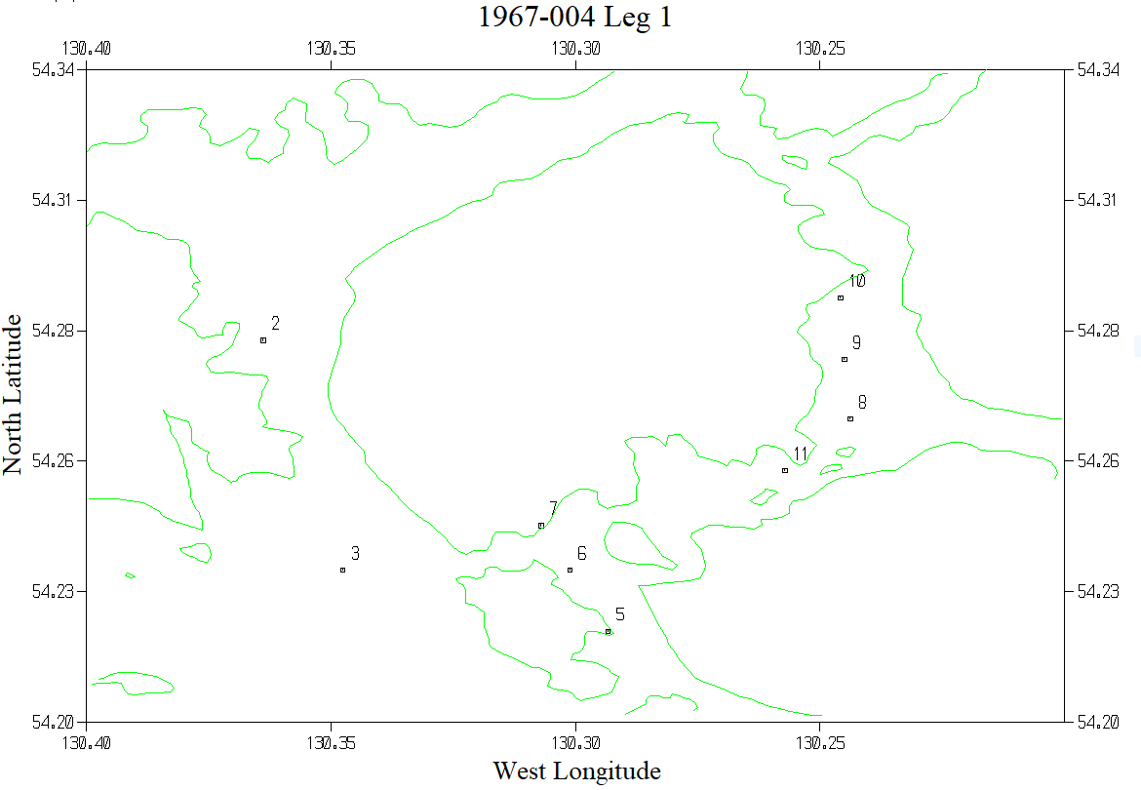

#11 was the site of daily measurements – events #11 to #35.

